**SOYBEAN CROP PROTECTION: AN IPM APPROACH**

**Ramkumari.M.M1, V.Vidhya2  
1,2 UG Scholar, Department of Agriculture, Thanthai Roever Institute of Agriculture and Rural Development (TRIARD),TamilNadu, India**

Corresponding author Mail ID:[nihithamahadevan12@gmail.com](mailto:nihithamahadevan12@gmail.com)

**Abstract**

Soybean (*Glycine max*. (L.)Merr.) is an important leguminous crop cultivated on millions of hectares worldwide. Phyto-biotic stress is an adverse condition which affects a plants growth due to its interaction with other deleterious organisms such as virus, fungi, bacteria, pests, nematodes etc.,. This Biotic stresses are a global concern for soybean growers. Integrated Pest Management (IPM) consists of biological, cultural and chemical practices to control insect pests in agriculture productions.IPM for soybean crop was established in 1970s, since then it was an important tool for sustainable agriculture. It comprises of better agrotechnical practices including crop rotation, selecting disease resistant varieties, fertilizers, inter-row cultivation and so on, which have a special role in IPM. Apart from reducing the risk to humans and environment through these practices, healthy development of soybean crops by decreasing a biotic stress also becomes mandatory. This article highlights the importance of IPM strategies to overcome the biotic stress in soybean crop.

**Key words:** Soybean, Biotic stress, Management, Varieties and Crop.

**Introduction** In India, Since 2005 Soybean has been the number one crop both in terms of its area and production. Soybean occupied 42% of India's total oilseed production and 25% of edible oil production. The crop has an ability of mitigating rampant protein energy malnutrition also becoming an ideal food of the country on account of possessing numerous nutraceutical and functional compounds. At the beginning, in India soybean was free from pest and diseases due to continuous cultivation with simultaneous increase in area has led to increase in phyto-biotic stresses including pest, disease and weed in the crop. Due to which the yield loss resulted about 20 to 100%. By handling the Integrated Pest Management schedule minimization of yield loss and 30 - 35% additional yield could be obtained. There is no reason not to support IPM as defined by the FAO International Code of Conduct on the Distribution and Use of pesticides (Article 2): Integrated Pest Management (IPM) means a pest management system that, in the context of the associated environment and the population dynamics of the pest species, utilizes all suitable techniques and methods in a compatible manner as possible and maintains the pest populations at levels below those causing economicallyunacceptable damage or loss (FAO, 1967). Thus, IPM seems to be the best combination of cultural, biological and chemical measures that provides the most cost effective, environmentally sound and socially adoptable way for managing biotic stress in the crop.

**The Tormentors:**

A pest is an organism which harms man or his property significantly or is likely to do so (Woods, 1976).The agricultural crops are subjected to the attack of many pests which cause considerable damage to their life. Pests include insects, nematodes, mites, snails, slugs, etc. and vertebrates like rats, birds, etc. In which insects are the vexatious organisms to farmers. The common insect pests include fruit, seed or bud borers, gall forming insects sucking pests, leaf rollers, leaf eating caterpillars etc. Although some affect production in nearly all locations, many others are of national and regional significance*.*

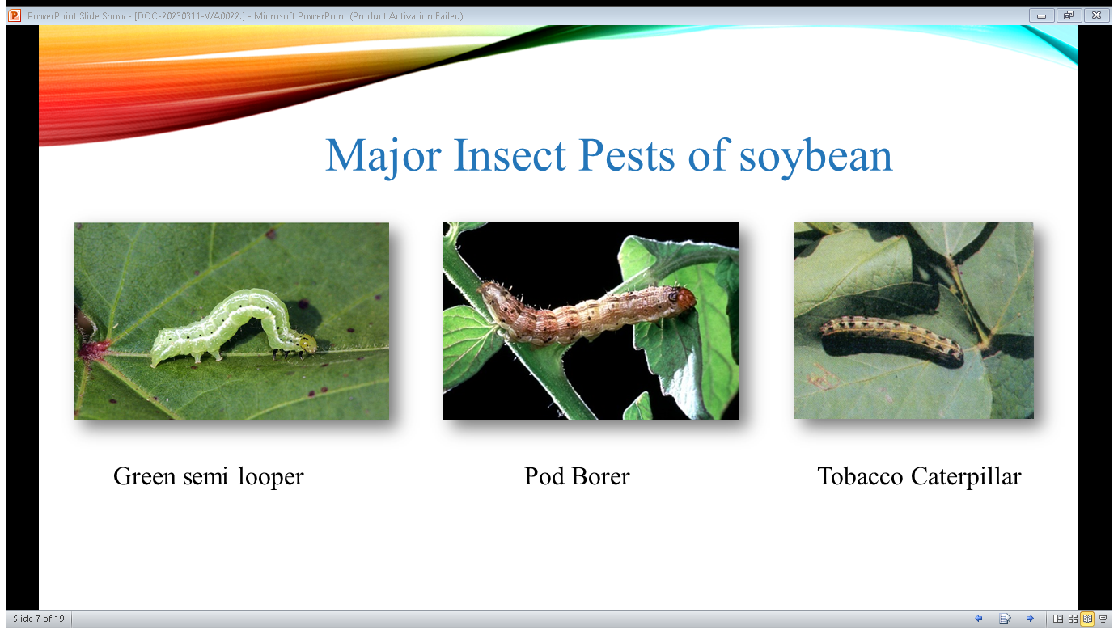

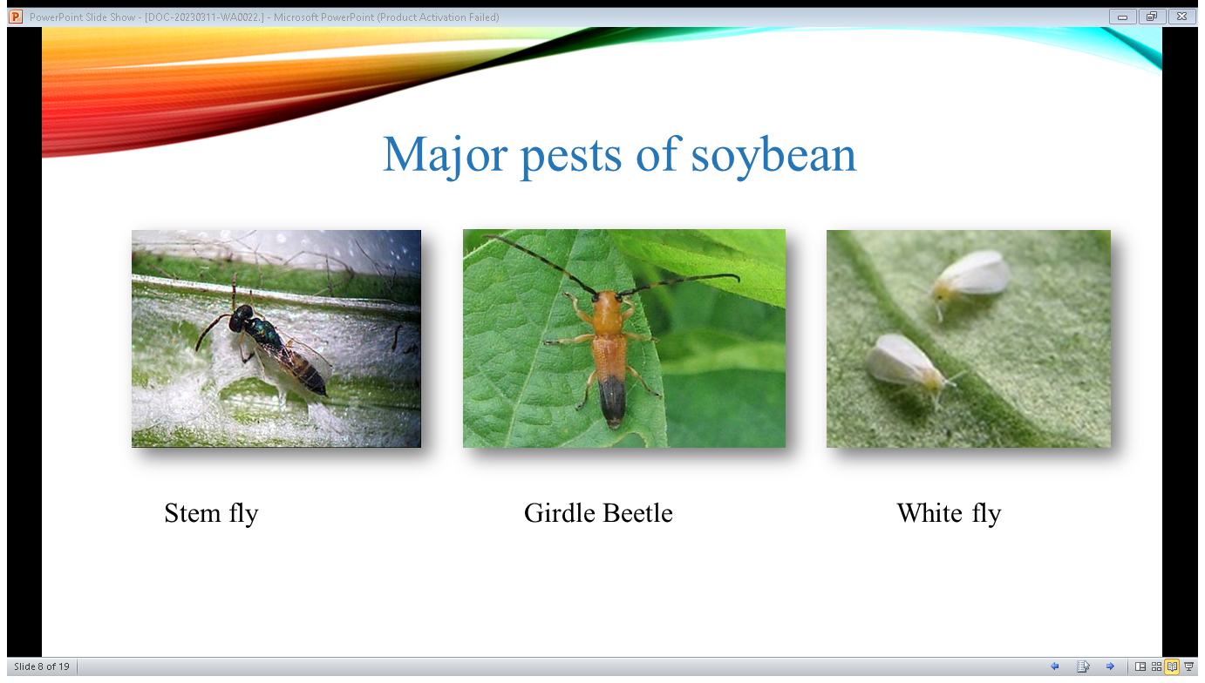

The Major pests of soybean are:

1. Stem fly -Melanagromyza sojae
2. Tobacco caterpillar - *Spodoptera litura*
3. Green Semi loopers - *Chrysodeixis acuta*
4. Griddle beetle - Obereopsis brevis
5. Pod borer - *Helicoverpa armigera*
6. White fly - *Bemisia tabaci*
7. Blue beetle - *Cneorane spp*.
8. Leaf Miner - *Aproaerema modicella*
9. Cotton grey weevil - *Myllocerus* *spp*.
10. Bihar Hairy Caterpillar -*Spilosoma obliqua*
11. Leaf folder -*Hedylepta indicate*
12. Leaf defoliator - *Spodoptera exigua*

**Pest Monitoring:**

1. Pest Monitoring through Field Scouting

Field scouting becomes necessary to detect the early signs and stages of pest attack. For field scouting the farmers should be mobilised to observe the insect pest occurrence at regular intervals. Magnifying glasses can be used for accurate pest identifications.

1. Pest Monitoring through pheromones/light traps etc.

Majority of insect populations can be monitored by fixing and positioning of

Pheromone traps, light traps at appropriate stage of the crop. Blue and yellow sticky traps can be used to control insect pests like white fly & aphids. Pheromone trap @ 5 traps/hectare may be used to monitor *Helicoverpa/Spodoptera* population.

**Cultural practices:**

Cultural practices are agricultural practices used to enhance the crop and prevent the problems without the use of chemicals. The important cultural practices to be done in soybean are cleaning of infected stubbles followed by deep summer ploughing, optimal fertilizer application, timely sowing, proper seedbed conditions and optimum seeding rate and plant population, and destruction of infected crop/plant parts, elimination of collateral/alternate and reservoir hosts, crop rotation and intercropping, cultivation of soybean in rainy season only and avoidance of mono varietal culture. Inter-cropping soybean either with asafoetida (early maturing variety) or maize or sorghum in the sequence of 4 rows of soybean with 2 rows of intercrop should be practiced. In girdle beetle and semilooper endemic areas, intercropping with maize or sorghum should be avoided.

**Fertilizer dose:** NPK and S at the rate of 20:60-80: 30-40:20 kg/ ha should be applied.

**Seed treatment:** Seed treatment by *Trichoderma viride* @ 5g or thiram 37.5% + carboxin 37.5% DS @ 3 g/kg seed for the management of seed, seedling and seed borne foliar diseases. Followed by seed treatment with *Bradyrhizobium* and Phosphate Solubilizing Bacteria (PSB) @ 5 + 5 gm / kg seed.

**Seed Rate:** Optimum seed rate 65-75 kg/ ha should be used depending upon seed size. After every 15 rows, a gap of one row should be given to provide moving space for fertilizer spraying in standing crop.

**Genetic Management**

The below mentioned pest resistant/tolerant varieties can be used**.**

|  |  |
| --- | --- |
| **Insect pest** | **Resistant / Tolerant Varieties** |
| Stem fly | JS 335, PK 262, NRC 12, NRC 37, MACS 124 and MAUS 2, MAUS 47 |
| Tobacco caterpillar | JS 81-21, PS 564 and PK 472 |
| Green semilooper | NRC 7, NRC 37, PUSA 16, PUSA 20, PUSA 24, JS 93-05, JS 97-52, MAUS 47 and JS 80-21 |
| Girdle beetle | JS 71-05, NRC 7, JS 97-52, MAUS 32 and Indira Soya 9 |

**Mechanical Practices**

Mechanical practices are manually done with hands. Here mechanical practices includes the collection and destruction of infested plant parts, egg masses as well as larva.

Installation of pheromone traps for monitoring incidence of *S. litura* and *H. armigera.* Planting Castor as trap crop for tobacco caterpillar and *Dhaincha* for girdle beetle.

**Biological Control**

It involves biological methods. Conserve spiders, coccinellid beetles, tachinid fly, praying mantids, dragon fly, damselfly, meadow grass hoppers and Chrysoperla through minimum use of broad spectrum pesticides, to exploit maximum potential of bio-control fauna. Release *Telenomus remus* @ 50000/ha against *S. litura.* Spray *Bacillus thuringiensis* var. *kurstaki*, Serotype H-39, 3b, Strain Z-52 @ 0.75 to 1.0 kg/ha for the management of semilooper complex (*Chrysodeixis acuta, Gessonia gemma, Diachrysiaorichalcea* and defoliators). Spray SlNPV @ 250 LE/ha. Spray of NSKE @ 5% for management of early stage larvae and sucking pest.

**Major parasitoids of insect pests of soybean**

Host: stem borers and green semilooper. Black small wasps but stout with clear wings and short antennae. Base of the hind leg is brown yellow to red. Female lays 1-20 eggs in each host larva. Immature parasites feed inside the host. Parasite larvae emerge from sides of the dead host and develop white overlapping cocoons near or below the host.

|  |  |  |  |
| --- | --- | --- | --- |
| **S.No** | **Natural enemy category** | **Natural enemy** | **Pest attacked and feeding potential** |
| 1. | Egg Parasitoid | *Trichogramma chilonis* | Egg parasitoid of *Spodoptera*  and *Helicoverpa* |
| *Tetrastichus* | Egg parasitoid of *Spodoptera*  and *Helicoverpa* |
| *Telenomus* | Egg parasitoid of Spodoptera and  *Helicoverpa*, A female parasitizes  20-40 eggs and lives 2-4 days or longer if nectar or sugar solution is provided.  Both *Tetrastichus* and *Telenomus* may parasitize the same egg mass but not the same egg. |
| 2. | Larval parasitoid | *Ichneumon*  promissorius | Larva parasitoid of *Spodoptera* and  *Helicoverpa* |
| *Carcelia* spp | Larval parasitoid of *Spodoptera* and  *Helicoverpa* |
| *Diglyphus isaea* | Larva parasitoid of *Spodoptera*  and *Helicoverpa* |
| 3. | Larval and pupal parasitoid | *Xanthopimpla*  *flavolineata* | Larval borer Adult wasp is medium  Sized yellow orange in color with black ovipositor. |
| 4. | Pupal parasitoids | *Encarsia formosa* | Pupal Parasitoids of white fly |
| *Eretmocerus* spp | Pupal Parasitoids of white fly |
| *Lissopimpla excels* | Pupal Parasitoids of  *Helicoverpa* |

**Chemical control**

Application of pesticides becomes necessary when the pest population crosses the Economic Threshold Level. Depending on insect infesting the crop use one of the following insecticides with recommended doses:

|  |  |
| --- | --- |
| **Insect** | **Insecticides and dosage** |
| Defoliators  (*Spodoptera litura)*  *(Helicoverpa armigera)* | Chlorantraniliprole 18.5% SC @ 150 ml/ha.  Indoxacarb 15.8% EC @ 333 ml/ha  *Bacillus thuringiensis* var. *kurstaki,* Serotype H-39, 3b, Strain Z-52 (Bt) @ 0.75  to 1.0 Kg/ha  Quinalphos 25 EC @ 1000 ml/ha |
| White fly (*Bemisia tabaci*) | Thiamethoxam 30% FS @ 10 Kg/hg |
| Stem fly  (*Melanogromyza sojae*) | Thiamethoxam 30% FS @ 10 Kg/hg  Chlorantraniliprole 18.5% SC @ 150 ml/ha. |
| Pod borer (*Helicoverpa*  *armigera* and *Cydia ptychora*) | Indoxacarb 15.8% EC @ 333 ml/ha  *Bacillus thuringiensis* var. *kurstaki*, Serotype H-39, 3b, Strain Z-52 (Bt) @ 0.75  to 1.0 Kg/ha |
| Girdle beetle  (*Obereopsis brevis*) | Triazophos 40 EC @ 625 ml/ha  Chlorantraniliprole 18.5% SC @ 150 ml/ha. |
| Blue beetle  (*Cneorane* spp.) | Indoxacarb 15.8% EC @ 333 ml/ha |

**Conclusion**

IPM is a broad concept that integrates procedures for economic control over pests. IPM aims to suppress pest populations below the economic damage threshold (EIL). Which means that chemical interventions should only be considered when insect populations or the level of disease have reached or exceeded a certain level that could cause economic damage if left untreated. These thresholds have been determined for most of the major pests and diseases of the soybean plant.Therefore, IPM is not a single product that can be stored on shelves like pesticide, and it does not rely on single method to solve all our pest problems it involves wide range of beneficial and brilliant measures to protect a crop. Pests also co-evolve and adapt very quickly to single control tactics through natural selection, and that multiple methods used. IPM not only derives the management of pest but also for weed and disease management. Thus, by practicing the above mentioned IPM practices escape of soybean crop from phyto-stress due to Insect pests becomes possible.

**Reference**

1. Ahirwar R, Devi P and Gupta R(2015), "Seasonal incidence of major insect-pests and their biocontrol agents of soybean crop (*Glycine max* L. Merrill)". **Academic journal, 10(12)**;402-406.
2. Athow, K.L.(1981)"Soybean pest management".**Journal of the American Oil Chemist’s Society 58**; 130–135.
3. Bueno, Regiane C. O. F.; Raetano, Carlos G.; Junior, Joaz Dorneles; Carvalho and Fernando. K (2017). "Integrated Management of Soybean Pests: The Example of Brazil".**Outlooks on Pest Management, 28(4)** ;149-153.
4. Ahirwar R, Devi P and Gupta R. 2015. Seasonal incidence of major insect- pests and their
5. biocontrol agents of soybean crop (Glycine max L. Merrill). Academic Journal,
6. 10(12): 402-4

Bueno, Regiane C. O. F.; Raetano, Carlos G.; Junior, Joaz Dorneles; Carvalho, Fernando K.(2017) "Integrated Management of Soybean Pests: The Example of Brazil", **Outlooks on Pest Management**, Volume 28, Number 4, August, pp. 149-153(5)

1. Ahirwar R, Devi P and Gupta R. 2015. Seasonal incidence of major insect- pests and their
2. biocontrol agents of soybean crop (Glycine max L. Merrill). Academic Journal,
3. 10(12): 402-406.
4. Ahirwar R, Devi P and Gupta R. 2015. Seasonal incidence of major insect- pests and their
5. biocontrol agents of soybean crop (Glycine max L. Merrill). Academic Journal,
6. 10(12): 402-406.