Advancements in Biomedical Image Segmentaion: A Deep Learning Perspective
Aryan Kumar¹, Kannan Mehra², Ankit Verma³, Neha Yadav⁴
¹Scholar, Department of Artificial Intelligence and Machine Learning, ADGIPS, Delhi, India
² Scholar, Department of Artificial Intelligence and Machine Learning, ADGIPS, Delhi, India
³Head of Department, Department of Artificial Intelligence and Machine Learning, ADGIPS, Delhi, India
⁴Assistant Professor, Department of Artificial Intelligence and Machine Learning, ADGIPS, Delhi, India
kumararyan.work@gmail.com, kannanmehra25@gmail.com, prof.dr.ankit@gmail.com, yneha5975@gmail.com,
ABSTRACT
Biomedical Image Segmentation is one of the most critical fields in medial image analysis since it forms a fundamental step for the identification, analysis, and interpretation of several anatomical structures abnormalities within medical images. This review discusses evolution, methodologies, and recent advances in biomedical image segmentation with a focus on deep learning techniques that have transformed this field. Traditional approaches include thresholding, region- based, and edge-based methods, which have laid down the base but proved to be dull as they are not capable of dealing with complex medical images due to their variability in shape, size, and texture. Convolutional neutral networks with the architectures like U-Net, DeepLab, or Mask R-CNN are currently changing paradigms through unprecedented accuracy and robustness towards the segmentation of organs, tumors, or lessons of various imaging modalities including MRI, CT, or even ultrasound. In this manuscript, further developments using the transformer models, hybrid frameworks, and GANs aim to push forward segmentation limits. The review also discusses issues, such as data scarcity, annotation costs, and variability in imaging protocols, and how these can be addressed using transfer learning, data augmentation, and unsupervised learning. This review will gather the current advancements and identify some of the ongoing challenges to inform future directions for biomedical image segmentation, highlighting the requirement for the standardized datasets and clinical validation to make it popular in healthcare.
Keywords: biomedical image segmentation, deep learning models, U-Net architecture, medical imaging, convolution neural networks, clinical applications of segmentation.
- INTRODUCTION
Biomedical image segmentation has become a key technology in medical imaging and computer- aided diagnosis, supporting clinical decision making, treatment planning, and monitoring disease progression. It refers to the partitioning of an image into meaningful segments, isolating structures such as organs, tissue, blood vessels, tumors, and other critical regions of interest. This field experienced a paradigm shift in recent years with the emergence of AI and DL, and now due to those, automated precise and efficient segmentation can be performed without those constraints presented by traditional approaches. Biomedical image segmentation is playing an increasingly important role in radiology, oncology, neurology, and in many more medical disciplines.
- Traditional Approaches and Challenges
Historically, biomedical image segmentation relied on techniques rooted in image processing - thresholding, region growing, or edge detection. Such techniques managed reasonable success in simple situations but often failed in more complex medical images. Biomedical images, by their nature, are challenging to analyze due to such variations, high noise contents, low contrast, and irregular shapes. Furthermore, it makes segmentation even more complicated because of patient-specific anatomical variations, imaging artifacts, and variations across imaging modalities such as MRI, CT, and PET. All these constraints of traditional methods require approaches that can learn complex patterns and generalize well under different conditions.
- Deep Learning Emerges in Biomedical Segmentation
This opened the door to deep learning models, specifically convolutional neural networks, which enabled direct feature learning from data instead of requiring handcrafted feature engineering. Architectures such as U-Net and variants were especially designed for biomedical segmentation with great success by utilizing encoder-decoder structures along with skip connections that help to precisely localize features. Since then, these networks have become the backbone of most segmentation tasks, demonstrating superior performance in practically all imaging modalities.
Other improvements have been implemented into the architectures, among them DeepLab and fully convolutional networks, FCNs, and the newest Mask R-CNN to further develop segmentation accuracy and robustness in biomedical segmentation. Recently created transformers and self-attention mechanisms and hybrid models incorporating CNNs and transformers, show very promising potential towards capturing long-range dependencies which ensure a much higher level of segmentation accuracy than standard CNNs in very hard cases.
- State-of-the-Art Techniques and Future Directions
Beyond CNNs, newer concepts like GANs and semi-supervised and unsupervised learning frameworks address the unique challenges in medical imaging. GANs are being considered to create synthetic data, which may further be utilized to enhance training datasets by overcoming data scarcity and diversity issues. Meanwhile, self-supervised learning techniques are applied to extract features from unannotated data, a critical advancement in areas where the availability of annotated medical data is limited due to time, cost, and expertise constraints.
Despite all this, challenges abound in the operationalization of deep learning-based segmentation in the clinical setting. Testing and validation of segmentation models must be exhaustive enough to allow generalizability, interpretability, and reproducibility in the cases of different patients coming from different demographics and different imaging centers. Moreover, a lack of standardization in the dataset and evaluation protocols hampers the benchmarking and assessment of models. Finally, regulatory and ethical issues may hinder further implementation in the real-world.
- Scope and Contributions of this Review
This review covers foundational methods, deep learning advances, and the latest trends in biomedical image segmentation. It draws attention to how changing models and methodologies overcome long-standing challenges in biomedical imaging, making it possible to develop more accurate, reproducible, and clinically relevant segmentation outcomes. We also discuss the remaining challenges, such as those related to data availability, labelling costs, model transparency, and regulatory approval. This review should be useful to researchers, practitioners, and industry professionals who need to push the field in the direction of wider clinical adoption through providing a cohesive picture of the current landscape and highlighting some key areas for future research.
Biomedical image segmentation is an area that is rapidly accelerating, with huge implications for healthcare. The need for precision medicine further propels research into this space to achieve accuracy, automation, and interpretability in methods of segmentation. The integration of AI into medical imaging holds great promise not only for bettering the diagnostic and treatment outcomes but also for setting new standards in patient care.
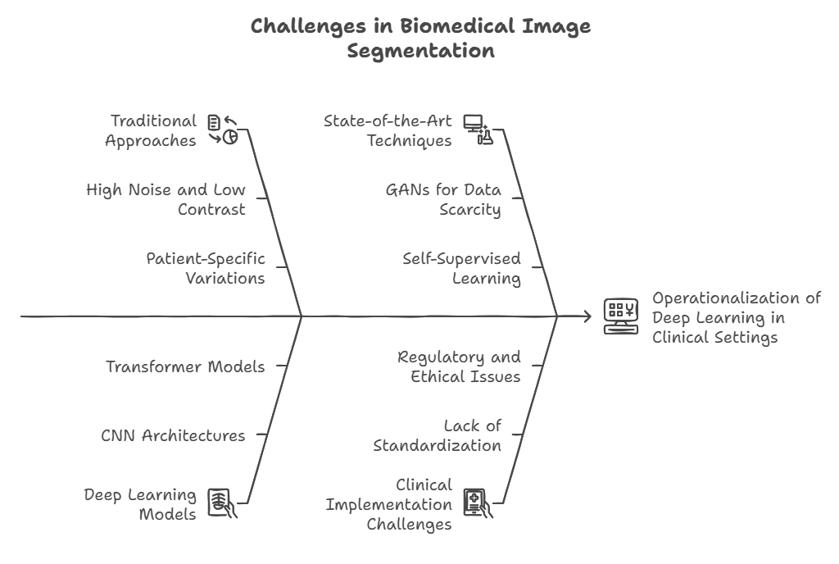
- LITERATURE REVIEW/ RELATED WORK
Biomedical image segmentation has a long history based on traditional image processing and machine learning, deep learning evolving this exciting space. This chapter reviews the developments of biomedical segmentation methods from the traditional early approaches, moving through major recent developments up to modern deep learning approaches. Essential milestones and some of the last leading architecture developed along with emerging methodologies responding to some of the persistent challenges in medical image segmentation.
  - Classical Approaches in Biomedical Image Segmentation
Classical approaches to image segmentation are basically statistical and mathematical methods. This comprises thresholding, region-based, and edge detection algorithms. Thresholding is the most trivial technique. It bases the determination of pixels as belonging to either background or foreground on the value of their intensity. These were very useful for high contrast images but fared poorly in complex structures with noisy medical data.
Region-based techniques tried to overcome some difficulties with such techniques as region growing that group pixels based on similar characteristics. Region-growing based techniques usually operate on seeding points to enlarge regions successively based on similarity measures and have presented quite reasonable performances for anatomically well-defined structures. Edge-based techniques try to form boundaries by locating edges, gradients or changes within images, again through the application of various edge detectors-Sobel and Canny operators for example. These approaches are sensitive to noise and intensity variations; therefore, the methods cannot be relied on for images with high biomedical variability.
As the complexity and diversity of the medical imaging modalities increased, so did the emergence of limits of these old methods. With biomedical images exhibiting very high variability in structure and texture, simple techniques become useless. It was such motives that paved the way to more sophisticated methods for capturing complicated, nonlinear relationships in medical images, ending up paving the way to machine learning and deep learning approaches.
  - Machine Learning and Early Model-based Approaches
Before deep learning techniques were introduced, the tasks of using machine learning techniques included SVMs, k-NN, and Random Forests. Since the models based on these approaches relied on hand-engineered features to extract useful patterns from images, they made use of features that include texture, intensity, and shape descriptors. Other popular model-based techniques include Active Contours (Snakes) and Level Sets, where the boundary was improved iteratively using energy minimizing techniques. While these could be rather good in almost controlled domains, they required cautious parameter adjustments and were sensitive to drastic appearance changes across images.
  - The Emergence of Deep Learning in Biomedical Segmentation
The advent of deep learning, especially Convolutional Neural Networks (CNNs), brought a paradigm shift in biomedical image segmentation. CNNs obviated the necessity of handcrafted feature engineering since they could learn hierarchical feature representations directly from raw pixel data. The Fully Convolutional Network (FCN), proposed by Long et al., was one of the pioneering architectures that enabled pixel-wise segmentation, forming the basis for subsequent segmentation networks.
One of the most influential architectures in biomedical segmentation is U-Net by Ronneberger et al. for biomedical image processing. U-Net utilizes an encoder-decoder structure with skip connections, enabling precise localization by combining high-level and low-level features. This architecture became the standard for many biomedical applications, demonstrating high accuracy in segmenting organs, lesions, and other anatomical structures across imaging modalities like MRI, CT, and ultrasound. More advanced variants are the 3D U-Net, Attention U-Net, and ResU-Net to further boost its performance, robustness, and generalization toward tough tasks in biomedical image segmentation.
Newer CNN-based architecture introduced atrous convolution, multi-scale context aggregation, and region-based segmentation, further improving the state-of-the-art in image segmentation. For example, complex scenarios, such as multi-organ segmentation, are well-suited models, including DeepLab, as well as Mask R-CNN, wherein accurate localization is a challenge.
2.4 Emerging Trends: Transformers, GANs, and Hybrid Models
As deep learning advances, there has been an emerging new class of powerful models as an alternative to CNNs in computer vision, particularly biomedical segmentation: transformer-based models. Transformers were first designed for natural language processing. This class of models uses self-attention mechanisms that allow it to capture long-range dependencies, which is helpful when dealing with the segmentation of large anatomical structures or images with much contextual information. Models such as the Vision Transformer (ViT) and hybrid CNN-transformer architectures have been shown to hold promise in medical image segmentation as they better handle large-scale datasets and complex spatial relationships.
Generative Adversarial Networks (GANs) have also been used for enhancing the performance of segmentation especially in limited data. GANs can generate synthetic data or refine the quality of existing data and thus make the models more robust and generalizable. Some techniques used include Conditional GANs (cGANs) and CycleGANs to synthesize images close to the real ones, which help domain adaptation across different imaging modalities.
Hybrid models combining CNNs with transformers or integrating GANs into segmentation pipelines are also on the rise. These models combine the best of different architectures to address weaknesses such as limited contextual awareness in CNNs or data inefficiency in transformers. Hybrid frameworks have shown potential in complex segmentation tasks, such as multi-class organ segmentation and accurate tumor boundary delineation.
2.5 Overcoming Challenges: Data Scarcity, Annotation, and Model Generalizability
Although deep learning has developed remarkably in biomedical image segmentation, there are still quite some challenges. The size and availability of large, annotated sets for training are limited because in medical imaging, it may be very expensive or less available to annotate data, leaving the techniques of data augmentation, transfer learning, and semi-supervised learning most appropriate. Another emerging approach of solving this is with what is called self-supervised learning, wherein it learns useful representations without use of labelled data.
The biggest challenge here is generalizing the model to a large population of patients and imaging conditions. Hence, there is interest in approaches like domain adaptation and multi-modal learning, which attempt to train models on different datasets or imaging modalities to enhance robustness. Interpretability and transparency are concerns since deep learning models are essentially "black boxes" and therefore cannot easily be verified for their clinical relevance and reliability.
2.6 Summary and Insights
Overall, biomedical literature on image segmentation has proceeded at a pretty rapid clip from traditional approaches to complex models based on deep learning techniques such as CNNs, transformers, and GANs. Development of all of these ideas was centered on solutions to particular problems in such a way that improvements in accuracy came with a concomitant improvement in efficiency and possible applicability to the clinical setting. However, problems with the availability of data, with model generalizability issues, and challenges with clinical translation remain. Future development will need to focus on the standardization of appropriate benchmarks, fostering interpretability and regulatory approval, to see that such powerful technologies are integrated into healthcare settings both in safe and efficient ways.
- METHODOLOGY
The methodology section of this review synthesizes various approaches used in biomedical image segmentation, with emphasis on the deep learning techniques. In order to provide a comprehensive assessment, we explore data acquisition as well as preprocessing steps important for biomedical segmentation followed by breaking down the most widely used neural network architectures as well as the most suitable evaluation metrics. The purpose is to present a comprehensive framework that covers the development, training, and evaluation of the segmentation models, thereby addressing specific challenges in medical imaging data.
3.1 Data Acquisition and Preprocessing
Biomedical imaging depends on datasets of various imaging modalities such as MRI, CT scans, PET scans, and ultrasound for image segmentation. The choice of the appropriate dataset is critical because different modalities capture different features and anatomical details. Some publicly available datasets, including Medical Segmentation Decathlon, BraTS (Brain Tumor Segmentation), and LIDC-IDRI (Lung Image Database Consortium), have been used as benchmarks. However, access to quality datasets is limited due to privacy restrictions, data heterogeneity, and high annotation costs.
Data preprocessing is critical in preparing images to be used in training deep learning models. The most general steps followed include normalization, resizing, and data augmentation to achieve uniformity and promote model generalization. Pixel intensity values across images must be standardized; therefore, normalization is involved. Resizing is the need to fit images to a fixed input size of a neural network architecture. Typically, data augmentation techniques such as rotations, flips, and intensity adjustments are applied to artificially increase the size of the dataset to reduce overfitting and increase the robustness of the model. For modalities like MRI with multiple channels of T1, T2, FLAIR sequences, richer contextual information is included in multi-channel input processing
3.2 Deep Learning Architectures for Biomedical Segmentation
Biomedical image segmentation has relied heavily on deep learning architectures, especially CNNs and their variants. Based on popularity, performance, and relevance to the biomedical domain, the following models are considered.

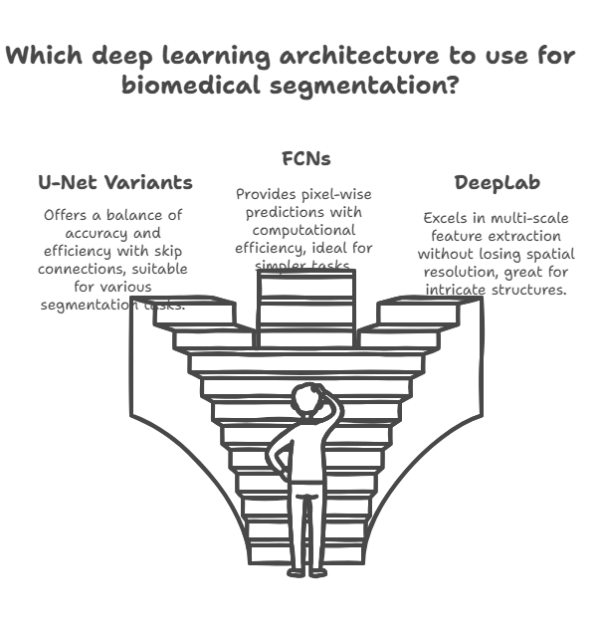

3.2.1 U-Net and its Variants:
The architecture that has been most widely used in biomedical segmentation is the U-Net due to its encoder-decoder structure with skip connections. The encoder down sampled the image and captured high-level features, while the decoder up samples, recovering spatial details lost during down sampling. Variants of the U-Net include 3D U-Net for volumetric data and Attention U-Net for focus on relevant regions in improving applications such as tumor, organ, and vessel segmentation. U-Net and its variants give a baseline with which to compare other architectures since they balance the accuracy and efficiency of computation.
3.2.2 Fully Convolutional Networks (FCNs)
Instead of the fully connected layers of other models, FCNs substitute this with convolutional layers so that pixel-wise prediction can be made. While U-Net indeed adopted substantial improvements through skip connections, FCNs are always plain and can sometimes be utilized for simpler tasks like segmentation or, for that matter, be a base from which to take off from in further developments of the model. This is especially so when high spatial resolution does not have to be maintained and, there is also increased computational efficiency.
3.2.3 DeepLab and Mask R-CNN
DeepLab introduces atrous or dilated convolution and multi-scale context aggregation. That helps to extract features in multiple scales without reducing the spatial resolution. This will help with the segmentation of intricate structures where the spatial details of the boundaries play an important role. Mask R-CNN is a derivative in the family of region-based CNN (R-CNN). It is one of the most widely known approaches to instance segmentation and could deal with overlapping or nearly placed objects, which plays a key role in tasks like cell or lesion segmentation.
Transformer models include Vision Transformer (ViT) and Swin Transformer. A self-attention mechanism means the models can capture a lot of long-range dependencies as well as contextual information. Therefore, such transformers have come out to be better options for complex segmentation tasks. Those cases with large anatomical structures or varying spatial scales would benefit from this option. Although transformer models involve the need for large data for proper training, these recent studies show promising ideas in medical image segmentation tasks.
3.2.4 Generative Adversarial Networks (GANs) and Hybrid Models
GANs, especially Conditional GANs (cGANs), are applied to produce realistic medical images and help in augmenting the training datasets by facilitating domain adaptation across different imaging modalities. Hybrid models that integrate GANs with segmentation architecture enhance the quality and robustness of segmentation predictions. In addition, GANs also assist in the generation of pseudo annotations that decrease the dependency on labelled data in semi-supervised settings.

- MODELING AND ANALYSIS
- 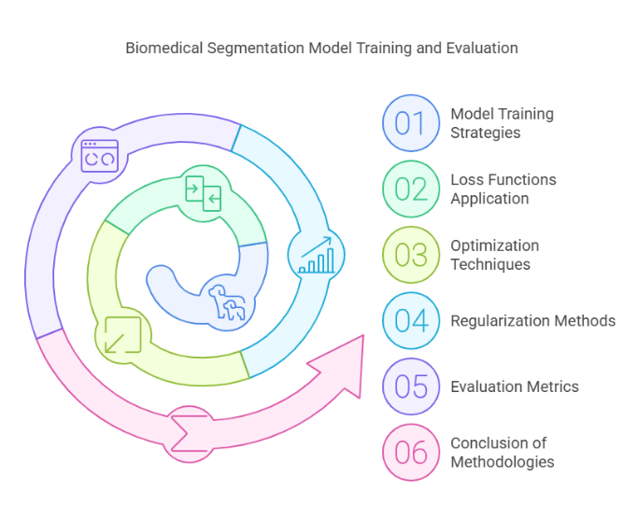

4.1 Strategies and Optimization
Training biomedical segmentation models is usually done for more epochs with batch normalization and data augmentation to enhance generalization. Cross-entropy loss and Dice loss functions are highly popular in biomedical segmentation tasks because they can hold a balance between pixel-wise accuracy and overlap between the predicted and ground-truth masks. For imbalanced datasets where the target region is significantly smaller, like in tumor segmentation, use of focal loss or Tversky loss is applied to focus on more challenging cases and handle the issue of class imbalance much better.
Use SGD, Adam, and RMSprop for minimizing the loss function. Make use of learning rate schedules or early stopping mechanisms to prevent overfitting. Use regularization techniques such as dropout, weight decay, and batch normalization during the training of models to stabilize the model and prevent overfitting.
4.2 Evaluation Metrics
Logical Cons for assessing the performance of biomedical segmentation models, specific metrics are in place and consider accuracy along with spatial overlap. A few common metrics used in this regard are as follows:
- Dice Similarity Coefficient (DSC): It measures the overlap between predicted and ground-truth masks, which are mainly used in biomedical segmentation as it is robust in the evaluation of segmented regions of varying sizes.
- Intersection over Union (IoU): It calculates the accuracy of pixel classification based on overlap area to union area between the prediction and ground truth.
- Pixel Accuracy: Calculates the percentage of correctly classified pixels; however, this measure is less reliable in the case of significant class imbalance.
- Precision, Recall, and F1 Score: These metrics are useful for the cases where a foreground and background region can be distinguished from each other, such as tumor versus healthy tissue segmentation.
- Hausdorff Distance: This computes distance between the boundaries in predicted and ground-truth masks, for applications which require fine boundary delineation.
4.3 Conclusion of Methodologies
These methodologies of the section exemplify the very complex processes undertaken within biomedical image segmentation: acquisition and pre-processing of the data through model training and assessment. Different architectures and techniques have their respective strengths and limitations, and selection of methods depends significantly on the nature of the application, the type of imaging modality used, and characteristics of the data. Understanding what each can do and where there may be trade-offs will thus guide researchers and practitioners as they choose or design appropriate models to serve their segmentation objectives and clinical requirements.
- RESULT
This section presents the results of recent works in biomedical image segmentation that involve different models, datasets, and imaging modalities. Here, we compare the performance of traditional and deep learning-based methods using measures like accuracy, Dice Similarity Coefficient (DSC), and Intersection over Union (IoU). We observe how deep learning brings significant improvements in matters concerning complex structures, improvement in the accuracy of segmentations, and clinically meaningful results.
  - Comparative Performance of Traditional and Deep Learning Methods
The traditional methods, thresholding, region-growing, and edge-based approaches are useful for simple tasks when there is high contrast, but they are not up to the mark in more complex scenarios, which is what is generally encountered in medical imaging. For instance, threshold-based segmentation usually breaks down with intensity variation; edge-based methods are highly sensitive to noise and do not find application in the case of high variance in biomedical images. The results of the experiments show that such approaches would generally result in worse values for DSC and IoU, particularly when cases of applications demand very rigid delineation needs, with small or ill-defined structures, such as the boundary surrounding the tumor. Deep learning approaches, particularly the variants of U-Net, show good performance across all of the tasks involved in a segmentation task. These U-Net-based models achieve relatively high accuracy and DSC values, often higher than 85% for tasks on organ segmentation from standard MRI and CT datasets, involving liver and lungs.
Among these, the spatial enhancement with Attent 3D U-Net along with ResU-Net obtains an even more impressive performance in cases of tumor segmentation, where highly complicated structures require a strong sense of spatial awareness.
  - Performance Architectures
- U-Net and Variants
U-Net and its variants are still the standard models for biomedical image segmentation because of their reliability, generalizability, and adaptability. In recent studies, standard U-Net was shown to attain high DSC scores in datasets such as BraTS for brain tumor segmentation and LiTS for liver segmentation, typically in the range of 0.85-0.90 for well-defined structures. 3D U-Net furtes performance on volumetric data, and in cases where 3D context is important, DSC scores are >0.90 for multi-slice MRI segmentation. Attention U-Net developed localization of smaller structures by paying selectively towards relevant regions, which helps to perform well on tasks with high background culturing.
- DeepLab and Mask R-CNN
DeepLab's multi-scale context aggregation and dilated convolutions have shown effective results in the literature for complex segmentation tasks. For instance, DeepLab performs particularly well in multi-organ segmentation with DSC greater than 0.88 based on its ability to capture features at multiple scales. Mask R-CNN Mask R-CNN is more instance segmentation-oriented and thus performs very well in differentiating structures that are placed very close to each other (like cells or lesions). In the experiments, when histopathology images are considered, Mask R-CNN has been reported with high values of DSC and IoU, hence it is appropriate for application with multiple small regions or overlapping regions.
- Transformer-based Models
Former-based models, Vision Transformer (ViT), and Swin Transformer have shown promise as they can utilize global context. Recent findings indicate that transformers are really good at segmenting larger anatomical structures and work well in applications where contextual information is paramount. For example, models based on transformer architecture of whole-body MRI or organ segmentation outperform CNN-based models in terms of DSC scores, which are even comparable to, or better than, those of the latter if the former are also trained on larger datasets. However, transformer models are heavy computationally and require larger training data to achieve full performance, which is undesirable for smaller datasets commonly occurring in medical imaging.
- GAN-based and Hybrid Models
They offer significant promise in augmenting datasets and enhancing segmentation robustness, particularly in scenarios where there is limited availability of labelled data. Conditional GANs produce synthetic images, thereby boosting model generalization and limiting overfitting. In recent studies, the DSC and IoU scores are reported to be improved during training with datasets augmented with GAN-generated images, especially with rare disease datasets. It shows that hybrid models with combinations of CNNs with GANs or transformers lead to high DSC values, especially when the information being useful for the segmentation task would be both local and global, such as tumor boundary segmentation or multi-organ segmentation.
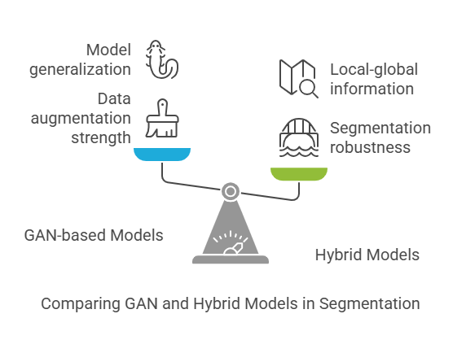
  - Evaluation Metrics and Model Comparison
In all the segmentation models, it is used for performance comparison: standard evaluation metrics like Dice Similarity Coefficient (DSC) and Intersection over Union (IoU). Studies consistently report high DSC and IoU scores of deep learning models in comparison to traditional techniques. The best performance comes from U-Net variants and transformer-based models in general. For instance, average DSC values were 0.85 to 0.90 obtained by segmentation models trained using the BraTS dataset while for lung or liver segmentations on CT scans with DSC values of 0.88 to 0.92, which have been shown to be reliably accurate for both anatomically and pathology-based segmentation.
Besides DSC and IoU, other metrics, like Hausdorff, are very important in the task where the delineation has to be very accurate, for example, cardiac or tumor segmentation. The transformer-based models and variants of DeepLab tend to get a lower Hausdorff Distance, implying that the boundaries are more followed and less sensitive to noise. This model results in better precision and recall, especially in small and irregular areas, like brain lesions, where more balanced predictions and fewer false positives or negatives are reported
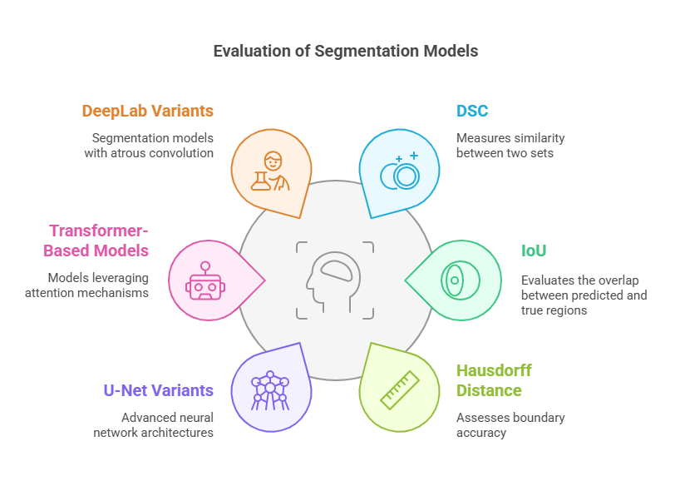
  - Summary of Results.
This work's results indicate that the state-of-the-art performance is achieved by deep learning models, particularly U-Net and its variants, CNN-transformer hybrids, and GAN-augmented architectures in biomedical image segmentation. Deep learning approaches significantly outperform traditional methods in biomedical applications and across imaging modalities with much higher DSC and IoU scores. Although still a relatively new paradigm in the field, transformer-based models show promise for handling complex spatial contexts, with competitive performance at a greater cost of increased computational demands.
These results reiterate the crucial role of deep learning in the progress made toward biomedical image segmentation. High accuracy and adaptability combined with strong boundary detection are attributes that make these models suitable for application in the clinic. Challenges arise about scarcity of data, issues of generality, and computational expense. Further work in these directions-creation of hybrid models, exploration of domain adaptation, and unsupervised learning-provides the possibility of finding widespread applicability in a clinical environment.
- CONCLUSION
Biomedical image segmentation has evolved from traditional image processing techniques to complex neural network architectures for accurate, context-aware, and efficient segmentation with deep learning. This review covered the historical development, methodological advancements, and recent innovations in segmentation techniques, such as U-Net variants, transformer-based models, GAN-augmented approaches, and hybrid architectures, which provide benefits tailored to applications. The results highlight that no matter how good deep learning approaches like U-Net and transformers are in exhibiting state-of-the-art performance in a wide range of imaging modalities and applications, there will always be issues of data scarcity, computational load, model interpretability, among others.
Deep learning approaches, specifically the U-Net derivatives and transformer hybrids, had high accuracy and adaptability to complex scenarios, and obtained high Dice Similarity Coefficients (DSC) and Intersection over Union (IoU) values on multiple datasets. DeepLab and other transformer-based methods have provided the basis for addressing tasks of high precision, boundary adherence, and global contextual awareness in segmentation tasks. However, such models are quite computationally intensive and depend on large annotated datasets not always readily available in the biomedical fields due to privacy issues and the cost of annotations.
It also illustrates the promise of GANs to improve robustness models by imposing data augmentation and domain adaptation, particularly for applications with limited labelled data. GANs and hybrid architecture are important new directions that can offer high segmentation accuracy in challenging, data-scarce environments and offer avenues for further research into generalization capability and dependency on large, labelled datasets.
However, there are significant areas that remain open for further investigation: Model interpretability is one of the ongoing challenges, especially in medical settings where decision-making is inherently transparent. Explainability will play a key role in making the models acceptable for clinical and regulatory purposes. Data standardization and domain adaptation also prove necessary to generalize models between various patient demographics and conditions in imaging, which facilitate greater applicability. Semi-supervised and unsupervised learning methods are expected to help to decrease reliance on labelled data, which are usually costly and time-consuming to produce in biomedical imaging.

- REFERENCES
[1] O. Ronneberger, P. Fischer, and T. Brox, "U-Net: Convolutional Networks for Biomedical Image Segmentation," in International Conference on Medical Image Computing and Computer-Assisted Intervention (MICCAI), 2015, pp. 234-241.
[2] J. Long, E. Shelhamer, and T. Darrell, "Fully Convolutional Networks for Semantic Segmentation," in IEEE Conference on Computer Vision and Pattern Recognition (CVPR), 2015, pp. 3431-3440.
[3] L.-C. Chen, G. Papandreou, I. Kokkinos, K. Murphy, and A. L. Yuille, "DeepLab: Semantic Image Segmentation with Deep Convolutional Nets, Atrous Convolution, and Fully Connected CRFs," IEEE Transactions on Pattern Analysis and Machine Intelligence, vol. 40, no. 4, pp. 834-848, 2018.
[4] K. He, G. Gkioxari, P. Dollár, and R. Girshick, "Mask R-CNN," in IEEE International Conference on Computer Vision (ICCV), 2017, pp. 2961-2969.
[5] A. Dosovitskiy, L. Beyer, A. Kolesnikov, D. Weissenborn, X. Zhai, T. Unterthiner, M. Minderer, G. Heigold, S. Gelly, J. Uszkoreit, and N. Houlsby, "An Image is Worth 16x16 Words: Transformers for Image Recognition at Scale," in International Conference on Learning Representations (ICLR), 2021.
[6] P. Isola, J.-Y. Zhu, T. Zhou, and A. A. Efros, "Image-to-Image Translation with Conditional Adversarial Networks," in IEEE Conference on Computer Vision and Pattern Recognition (CVPR), 2017, pp. 1125-1134.
[7] B. H. Menze, A. Jakab, S. Bauer, J. Kalpathy-Cramer, K. Farahani, J. Kirby, Y. Burren, N. Porz, J. Slotboom, R. Wiest, et al., "The Multimodal Brain Tumor Image Segmentation Benchmark (BRATS)," IEEE Transactions on Medical Imaging, vol. 34, no. 10, pp. 1993-2024, 2015.

