**DEVELOPMENT OF A LOCALLY HANDMADE WATER TREATMENT PLANT FRAMEWORK: A CASE STUDY OF WATER FILTRATION TECHNIQUE IN KUNUKUNUMA COMMUNITY**

**1Otuaro Ebierin Akpoebidimiyen & 2Igoma, Emughiphel Nelson**

1 Department of Civil Engineering, Faculty of Engineering, Nigeria Maritime University, Okerenkoko, Delta State, Nigeria.

2 Department of Marine Engineering, Faculty of Engineering, Nigeria Maritime University, Okerenkoko, Delta State, Nigeria.

**ABSTRACT**

The need for a water treatment plant arises in a local community like Kunukunuma because of the high cost or financial involvement in executing a modern type of it. Therefore, the need for the locally handmade treatment plant framework emanated. The work involves the usage of floater boards in the construction of a cheap water treatment plant for household usage in Kunukunuma community. The floater board was cut into sizes to match the four stages of the filtration process. The stages start from the raw water container, flocculation, sedimentation and stop at the filter bed. Then from the filter bed, the clean water is taken via a container. Before the raw water was put into the raw water container, it was taken to a laboratory for microbial analysis tests and the result showed that it contained bacteria, thereby giving justification for the work. It is recommended that further testing should be conducted on the treated water to ascertain the cleanliness or purity of the water before drinking or usage.

**Keywords:** Development, Locally Handmade, Water, Treatment, Plant, Filtration

1. **INTRODUCTION**

Water treatment processability is a concept that is applicable to the surface water source. A peculiar water treatment plant encompasses intake, pumping, coagulation, flocculation, clarification, absorption, filtration, disinfection, storage together with pumping to treat water for consumptive purposes as depicted in **Figure 1** [1].



**Figure 1**: Water Treatment Process Flow Chart [1]

And in some cases, sedimentation is done after the processes of intake and pumping before coagulation [2, 3, 4]. The development of water treatment is done, putting into consideration the population size together with the need and a lot of work carried out [5, 6, 7, 8, 9].

Precisely, the drinkable water emanates from different sources, amongst which are surface water like lakes, rivers together with reservoirs and well boreholes coupled with rain water. The treatment of water relies on the source surface water, which is vulnerable to environmental components such as wildlife excrement, urban together with agricultural runoff doubled with junk. Exactly, ground water has been documented to be presumed good in the absence of treatment transude through its storage, which is underneath the earth's surface, and it is called aquifers and is more protectable from the environment’s constituents than surface water [10].

Truly, the big predicament facing most Nigerian localities presently is the non-accessibility of good water for usage for both public and domestic purposes. The portable water is appropriate for drinking and this is something that is very rare to achieve in very many localities. Meanwhile, very many localities are endowed with a bountiful surface together with underneath water, but different governments, together with influential personalities, find it very hard to transform accessible natural water into an appropriate or better one that will be good for the public due to several issues like economic, technical together with deficiencies. The water that is usable by the public presently is acquired by individuals themselves via unhygienically media, and it does not meet the standard for potable water. Sincerely, diseases like dysentery, gastroenteritis, typhoid fever together with cholera are caused through the drinking of dirty water [11].

Furthermore, the work will look at the development of a locally handmade water treatment plant framework: a case study of water filtration technique in the Kunukunuma Community thereby giving the community the ability to drink clean water.

1. **METHODOLOGY**
   1. **Material Used**

The materials utilized were sourced locally and they are (See **Figure 2**):

1. 4 -Minutes AB Adhesive gum
2. Transparent Plastic Containers (5)
3. Floater Board
4. Fine sand
5. Coarse Sand
6. Coarse Aggregate
7. Carbon – Charcoal
8. Pipe

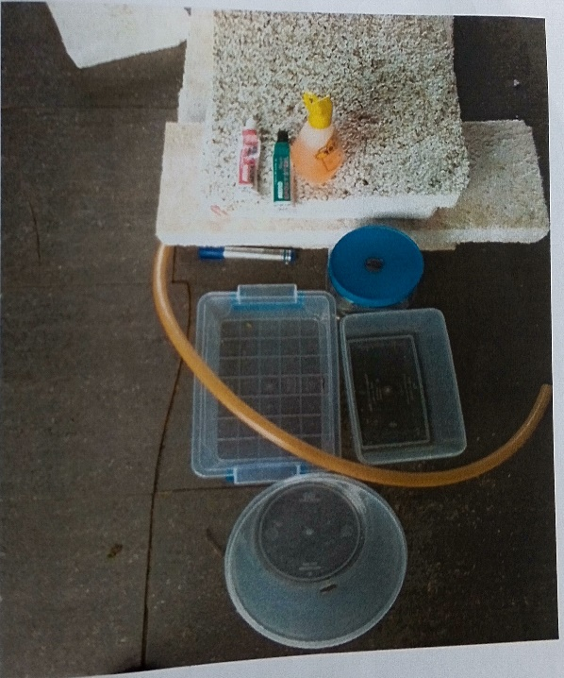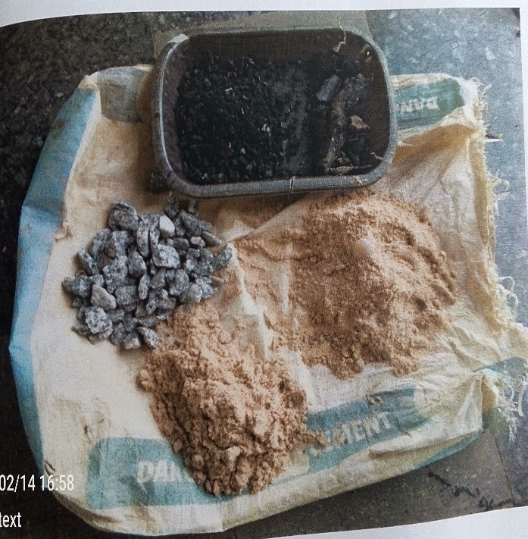

**Figure 2**: Pictorial View of the Locally Sourced Raw Materials

**2.2 Methods – Development Process**

The floater boards were cut into different sizes to house the various containers used for the filtration process and the base on which all these were constructed on top is 70mm x 30mm. The construction is done in such a way that it slopes down to where the clean water container is placed. **Table 1** gives details of the dimensions of the various stages of construction with floater board. Also, the diagrammatical sketch depicting the water treatment plant framework is depicted in **Figure 3**. The drilling of holes was carried out in the four containers in order to facilitate the flow of water between containers. Practically, the assembly was done, and the containers were connected together with the pipes and the sealing within four (4) minutes - AB adhesive gum was used to the connections to ensure structural integrity together with the prevention of leakages as depicted in **Figure 4** [11, 12].

Descriptively, the raw water tank contains the untreated water from the hand-dug well in Kunukunuma. As shown in **Figure 5**, the flocculation tank involves chemical additives such as potash alum or sodium aluminum - induced coagulation. Together with flocculation, the sedimentation tank is where the impurities aggregate into bigger particles and settle at the bottom while the clear water rises on top and the filter bed, where the remaining fine particles are removed, and the clear water is discharged into the clean water tank. Precisely, the raw water container is a rectangular-shaped plastic container of 6.5Litres; the flocculation container is a cylindrical-shaped plastic container of 6litres; the sedimentation container is a rectangular-shaped plastic container of 7 liters; the filter bed container is a spherical- shaped plastic container of 4 liters and finally, the clean water or treated water tank is a rectangular - shaped plastic container of 6 liters.

Experimentally, the water from the Kunukunuma dug well was also taken to the Water/Hydraulic and Environmental Laboratory of the Department of Civil Engineering, Faculty of Engineering, University of Benin, Edo State, Nigeria and results taken and recorded. The experiment conducted was the microbial analysis test, and it was recorded in **Table 2**.

**Table 1**. Detail Dimension of the Construction of the Floater Board.

|  |  |  |  |
| --- | --- | --- | --- |
| S/No. | Stages of the Floater Board | Container to be placed on top | Dimensions |
| 1 | Stage 1 | Raw Water | Cover Base – 30mmx20mm  Height – 40mm x20mm |
| 2 | Stage 2 | Flocculation | Cover Based- 30mm x 30mm  Height – 20mm x 20mm |
| 3 | Stage 3 | Sedimentation | Cover Based- 30mm x 30mm  Height – 20mm x 20mm |
| 4 | Stage 4 | Filter Bed | Cover Based- 30mm x 20mm  Height – 10mm x 10mm |

**Table 2**. Microbial Analysis Test of Kunukunuma Hand Dug Well

|  |  |  |  |  |  |
| --- | --- | --- | --- | --- | --- |
| S/No. | Sample | Total heterotrophic Bacteria count CFU/ML | Total Coli from count | Total E = Coli Counts  CFU/ML | Tentative isolate |
| 1 | Well Water | 3 x 103 | 1 x 103 | 0 x 103 | Bacillus Sp ….  Enterobacter Sp…. |

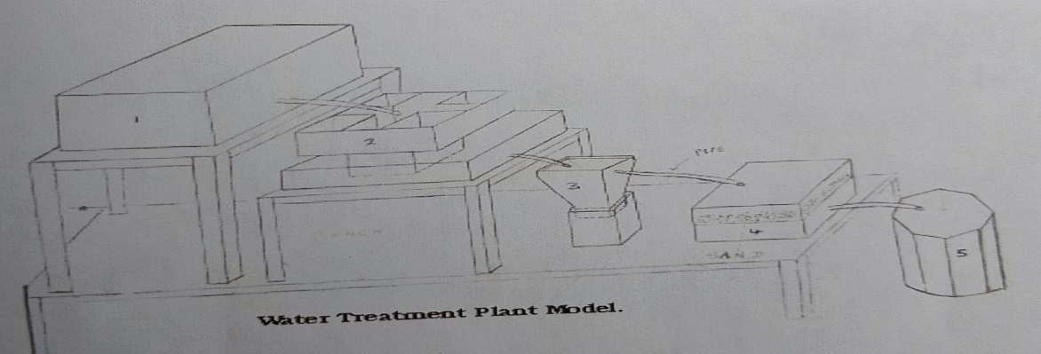

**Figure 3**: Sketch of the Locally Handmade Water Treatment Plant model – Framework Displaying the Different stages of water treatment

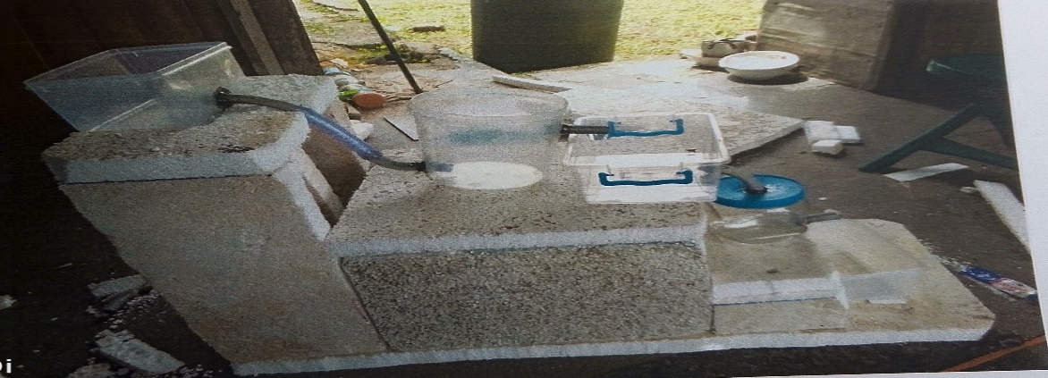

**Figure 4**: Pictorial View of the Assembly of the Water Treatment Framework

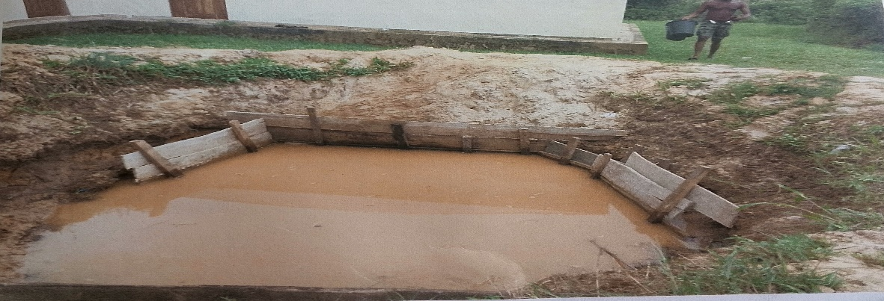

**Figure 5**: Depiction of Hand Dug Well in Kunukunuma

**3.0 RESULTS AND DISCUSSION**

**3.1 Results**

The treatment plant framework or setup is depicted in **Figure 6.** The setup displayed how the different stages of filtration of the untreated water got from the hand well dug in Kunukunuma is being treated. The pictorial view of the treated water is displayed in **Figure 7**.

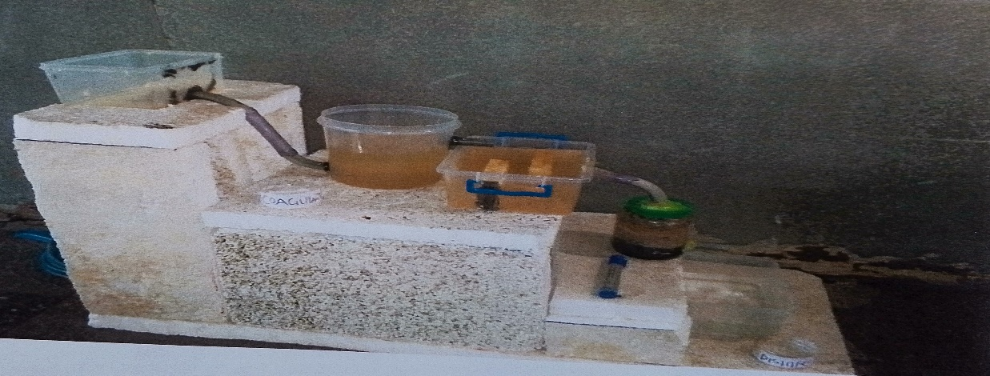

**Figure 6**: Water Treatment Plant Setup

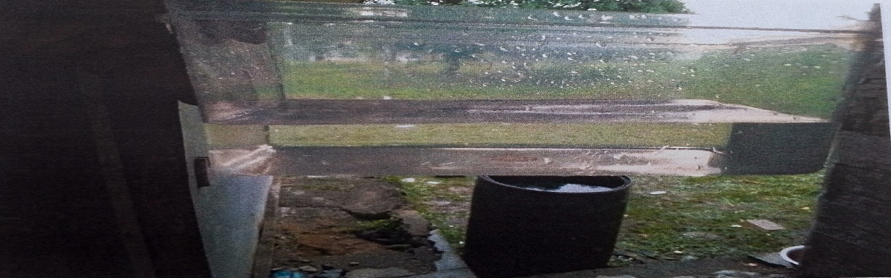

**Figure 7:** Depiction of Treated Water

**3.2 Discussion**

**Table 2** contains the results of the Kunukunuma hand-dug well, and a microbial analysis test was performed, and the results show that it contains bacteria. Because the total heterotrophic bacterial count is high, total coli form and total E. coli, which show signs of faecal contamination and tentative isolate. The presence of bacteria justifies the water treatment plant in order to reduce the bacteria count and also eliminate contamination and Figure 6 depicts the model framework while **Figure 7** displays the treated water.

1. **CONCLUSION**

The development of a locally handmade water treatment plant framework: a case study of water filtration techniques in the Kunukunuma community has been done. The work involves the usage of floater boards in the construction of a cheap water treatment plant for household usage in Kunukunuma community. The floater board was cut into sizes to match the four stages of the filtration process. The stages start from the raw water container, flocculation, sedimentation and stop at the filter bed. Then from the filter bed, the clean water is taken via a container. Before the raw water was put in the raw water container, it was taken to a laboratory for microbial analysis tests and the result showed that it contained bacteria, thereby giving justification for the work. It is recommended that further testing should be conducted on the treated water to ascertain the cleanliness or purity of the water.

**REFERENCES**

1. Q. A. Shuokr & S. M. Jwan, Step-By-Step Design and Calculations for Water Treatment Plant Units, Advances in Environmental Biology, Volume13, No.8, 2019, pp. 1-16.
2. M. J. Hammer & M. J. Hammer,Water and Wastewater Technology. 3rd edition, Prentice–Hall, Inc, 1996.
3. G. Singh & J. Singh, Water Supply and Sanitary engineering. 6th edition, Lomus offset press, Delhi, 2003.
4. M. J. Brandt, K.M. Johnson, A.J. Elphanston & D.D. Ratnayaka, Twort’s Water Supply. 7th Edition, Published by Elsevier Ltd, 2017.
5. J. Y. C. Huang & F. Garcia-Maura F. (1986). Effect of Influent Property on Filter Performance. J. of Envr. Eng. Div, Volume 112, No.4, 1986.
6. O. I. Mohammed, A Comparison Between the Performance of the Conventional and the Dual-Media Filters. M.Sc. Thesis, Civil Engineering Department, University of Basrah, Iraq, 1989.
7. M. A. Rashid, Treatment of Tigris River Water by Direct Filtration. M.Sc. Thesis, University of Baghdad, Iraq, 1989.
8. S. Q. Aziz, Treatment of Greater–Zab Water by Rapid Filtration. M. Sc. Thesis, Department of Civil Engineering, College of Engineering, Salahaddin University–Erbil, Erbil, Iraq, 2000.
9. S. Q. Aziz, Determination of Floc Volume Concentration in Filter Beds by Using New Methods. Thirteenth International Water Technology Conference, IWTC 13, Hurghada, Egypt, 2009.
10. S. B. Adejuyigbe & I.O. Oke, Design, Fabrication and Performance Evaluation of a Domestic Water Treatment Plant Peterson - “Global Water Crises Overview”, Arlington Institute, 2000, Available at:<http://www.arlingtoninstitute.org/wbp/global> -water-crisis/441[Assessed 10/11/12].
11. M .S. Ghazali, J. Alyasa’u & M. Bello, Design and Construction of a Simple Portable Water Treatment Plant FornUse in Rural Areas. International Journal of Advances in Engineering and Management (IJAEM),Volume 3, No. 12 , 2021, pp. 741-747
12. R.H.H. Al-Anbari, Selected Alternatives for Up-Grading Existing Water Treatment- Plants: A Qualitative and Qualitative Improvement. PhD thesis, Building and Construction Department, University of Technology, Iraq, 1997.