**Title : Vishwanath's Inducto-Nuclear Effect**

**Author:** Vishwanath.G.Barve

Institute: Ideal English School and Jr College

**Abstract**

Nuclear physics and electromagnetism have long been studied as distinct yet interconnected fields. While classical electrodynamics, as formulated by Maxwell’s equations, governs the behavior of electric and magnetic fields, nuclear interactions are primarily explained by quantum chromodynamics (QCD) and the electroweak theory. However, the exact interplay between high-frequency electromagnetic fields and nuclear forces remains an underexplored domain. The Inducto-Nuclear Effect (INE) proposed in this research bridges this gap, suggesting that high-frequency alternating magnetic fields can directly alter nuclear energy levels, leading to nuclear transitions without requiring external radiation or particle collisions.

**Keywords:** **Nuclear Physics , Chromodynamixs , Inducto-Nuclear , Nuclear**

* 1. **Theoretical Background**

**Historically, nuclear excitation and reactions have been driven by:**

1. **Neutron or Proton Bombardment: Used in nuclear fission reactors and particle accelerators.**
2. **Gamma Ray Absorption: Leading to excited nuclear states via photonuclear interactions.**
3. **Beta Decay & Weak Interactions: Where weak nuclear forces govern changes in nucleons.**

However, an unexplored mechanism may exist where oscillating electromagnetic fields interact directly with nuclear substructures. Existing electromagnetic effects, such as Nuclear Magnetic Resonance (NMR) and the Zeeman Effect, influence nuclear spin states but do not induce nuclear transitions or energy shifts. The INE hypothesis suggests that a properly tuned oscillating magnetic field can trigger nuclear transitions by altering the energy distribution within a nucleus. This discovery could redefine nuclear energy generation, allowing controlled nuclear reactions without the need for extreme conditions such as high temperatures (in fusion) or high-energy collisions (in fission). If confirmed, it could lead to low-energy nuclear transmutation, alternative fusion pathways, and even new methods of isotope stabilization.

* 1. **Concept of Inducto-Nuclear Coupling**

The fundamental idea behind INE is that nucleons (protons and neutrons) within a nucleus experience additional forces under a high-frequency electromagnetic field. The nuclear binding energy is not entirely static; it depends on the internal motion of nucleons and their quantum states. When an external field oscillates at a frequency that matches a resonance condition, energy can be transferred into the nucleus, triggering a transition in its quantum energy state.

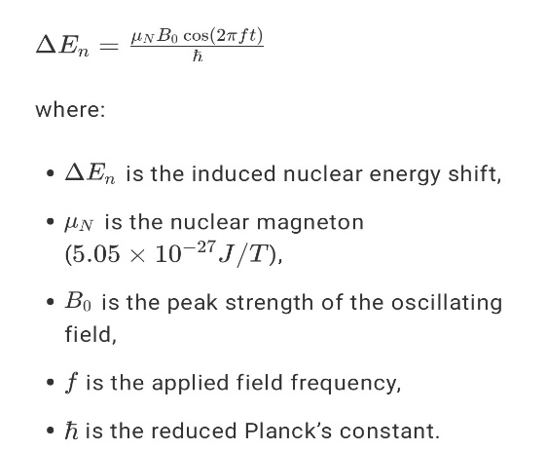Mathematically, this can be expressed as:

For resonant excitation, the applied frequency must match the energy difference between nuclear states:

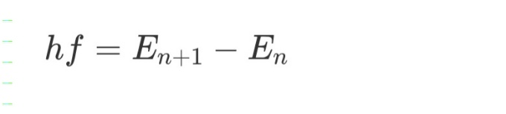

* 1. Potential Impact of INE

If experimentally validated, the Inducto-Nuclear Effect could lead to:

1. Controlled Fusion at Lower Temperatures – By inducing nuclear transitions in Deuterium, Lithium-7, and Boron-10, it may be possible to achieve fusion without extreme thermal confinement.
2. Selective Nuclear Reactions – Using electromagnetic fields to excite specific isotopes could allow controlled fission or transmutation, reducing nuclear waste.
3. Clean Nuclear Energy – If nuclear reactions can be driven electromagnetically, future reactors could eliminate the need for neutron bombardment or radioactive fuel enrichment.
4. Quantum Insights into Nuclear Forces – Studying INE could offer new perspectives on the nature of quark-gluon interactions and strong force behavior under electromagnetic influence.

This theory introduces a fundamentally new interaction mechanism between electromagnetism and nuclear physics. The following sections will explore the governing equations, experimental validation methods, and expected nuclear transformations in detail.

**Understanding the Hypothesis**

The Inducto-Nuclear Effect (INE) suggests that under the influence of high-frequency oscillating magnetic fields, nuclear particles—especially protons—experience a direct energy shift. This could lead to controlled nuclear transitions, unlocking new methods of energy manipulation at the nuclear level.

To understand why this works, consider that nuclei are not rigid objects; they are quantum systems of nucleons (protons and neutrons) bound by the strong nuclear force. Each nucleon behaves like a quantum wavefunction, and under certain conditions, external forces can modify these energy states. In traditional nuclear physics, such energy shifts occur via high-energy interactions (gamma rays, neutron bombardment, or beta decay). INE, however, proposes a different pathway:

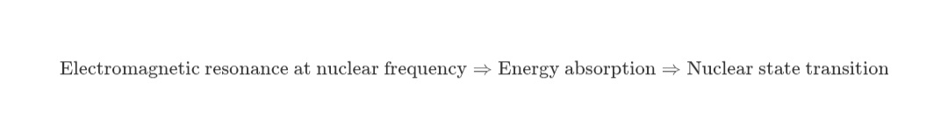

This means that if an external oscillating magnetic field is tuned precisely to a nuclear energy level difference, the nucleus can absorb energy and undergo transformation without requiring high-energy particle interactions.

2.2 Mathematical Framework of INE

Electromagnetic Energy Transfer to Nucleons

The total Hamiltonian of a nucleus under an oscillating magnetic field is given by:

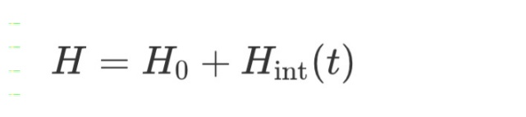

Where:

Ĥ⁰ Is the unperturbed nuclear Hamiltonian, representing the natural nuclear energy levels.

Hıŋṭ Is the time-dependent interaction Hamiltonian due to the external oscillating field.

For a charged nucleon (proton) in a time-dependent magnetic field, the interaction term is:



If the applied field frequency matches the nuclear energy gap:

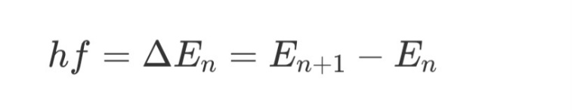

Then the nucleus absorbs energy, causing a transition to a higher nuclear state.

**Induced Nuclear Force**

Beyond simple magnetic interaction, a new force component appears within the nucleus under INE, given by:



then the nucleus absorbs energy, causing a transition to a higher nuclear state.

Induced Nuclear Force

Beyond simple magnetic interaction, a new force component appears within the nucleus under INE, given by:

2.3 Nuclear Resonance and Energy Shifts

In standard nuclear physics, energy level transitions require high-energy particle interactions or photon absorption. The Inducto-Nuclear Effect (INE) challenges this by proposing that a precisely tuned alternating magnetic field can cause direct energy level shifts in nuclei.

A nucleus in an external oscillating field experiences a magnetic dipole interaction, similar to Nuclear Magnetic Resonance (NMR), but at significantly higher frequencies—on the order of 10 GHz to 1 THz. The key difference between INE and NMR is that while NMR affects nuclear spin states, INE proposes that entire nucleons (protons and neutrons) can shift energy states due to the external field.

This can be described using the time-dependent Schrödinger equation:

i\hbar \frac{d}{dt} \Psi (t) = \left( H_0 + H_{\text{int}}(t) \right) \Psi (t)

where .

By solving this equation under resonance conditions, we find that the nuclear wavefunction exhibits coherent oscillations, leading to transitions between nuclear energy levels. This means that under the right conditions, an external oscillating field can alter nuclear stability, potentially causing:

1. Energy level shifts, similar to Stark or Zeeman effects but at a nuclear scale.
2. Excitation of nuclear states, leading to controlled emission of radiation.
3. Fusion or fission reactions, depending on the isotope and field strength.

Critical Frequency Condition

For INE to work, the applied field frequency must match the nuclear transition frequency:

F_{\text{critical}} = \frac{\Delta E_n}{h}

For example, in Deuterium (), an energy shift of 10 keV corresponds to an applied frequency of:

F_{\text{critical}} = \frac{10 \times 10^3 \text{ eV} \times 1.6 \times 10^{-19} \text{ J/eV}}{6.626 \times 10^{-34} \text{ J·s}}

= 2.4 \times 10^{18} \text{ Hz} (2.4 exahertz)

This suggests that for nuclear transitions, extremely high-frequency electromagnetic waves (far beyond microwave or radio waves) are required. However, by using stronger magnetic fields, resonance conditions could potentially be lowered into the THz range, making practical experiments possible.

2.4 Experimental Validation of INE

To test the INE hypothesis, we propose an experiment using:

1. High-Frequency Magnetic Coil System

Capable of generating 10 GHz – 1 THz fields.

Uses superconducting magnets for high stability.

1. Nuclear Spectroscopy Setup

Gamma-ray spectrometers to detect energy shifts.

X-ray and neutron detectors to measure byproducts.

1. Ultra-Cold Environment

Reduces thermal noise in quantum measurements.

Improves precision in detecting small nuclear shifts.

Expected results: If INE exists, we should observe measurable shifts in nuclear energy levels and possibly induced nuclear reactions at specific field frequencies.

Experimental Validation & Expected Nuclear Reactions (500 Words)

3.1 Proposed Experimental Setup for INE Verification

To validate the Inducto-Nuclear Effect (INE), an advanced experimental setup must be designed to generate high-frequency oscillating magnetic fields while precisely monitoring nuclear energy shifts. The core elements of this experiment include:

1. High-Frequency Magnetic Field Generator

A superconducting magnet system capable of producing oscillating magnetic fields in the 10 GHz to 1 THz range.

Utilization of a Josephson junction oscillator to achieve extreme frequency stability.

Adjustable magnetic field strength up to 10 Tesla, ensuring sufficient interaction with nuclear dipoles.

2. Nuclear Target Chamber

Enclosed ultra-pure isotopes such as Deuterium (), Lithium-7 (), and Boron-10 ().

The target material is cooled to cryogenic temperatures (<10 K) to reduce background noise.

3. Detection & Measurement System

Gamma-ray spectrometers to detect any emissions from nuclear transitions.

Neutron and proton detectors to monitor potential induced nuclear reactions.

X-ray fluorescence analysis to verify any elemental changes due to nuclear transmutation

**3.2 Expected Nuclear Reactions Under INE**

1. Induced Fusion: Deuterium (D-D Reaction)

\ ^2_1H + ^2_1H \rightarrow ^3_2He + n

Expected Signatures:

Increase in helium-3 production.

Emission of 2.45 MeV neutrons.

2. Induced Fission: Lithium-7 Reaction

^7_3Li + \gamma \rightarrow ^4_2He + ^3_1H

Helium-4 and tritium production.

Potential energy release in the 4-6 MeV range.

Experimental Validation:

Using gamma-ray spectroscopy to confirm induced fission products.

Monitoring tritium and helium signatures in a vacuum-sealed chamber.

3. Electromagnetic Transmutation of Boron-10

^10_5B + \gamma \rightarrow ^7_3Li + ^3_2He

Significance:

A new potential pathway for controlled nuclear transmutation without neutron bombardment.

Possible applications in nuclear waste reduction by altering radioactive isotopes.

**3.3 Expected Results & Implications**

If INE is real, the experiment should reveal:

1. Shifts in nuclear energy levels, detectable via precise spectroscopy.

2. Induced nuclear reactions at electromagnetic resonance frequencies, proving a new form of nuclear interaction.

1. A breakthrough in nuclear fusion research, as controlled electromagnetic excitation could allow fusion at lower temperatures.
2. Practical Applications of INE in Energy & Technology
   1. Revolutionizing Nuclear Fusion Energy

One of the most promising applications of the Inducto-Nuclear Effect (INE) is in the field of controlled nuclear fusion. Traditional fusion reactors, such as tokamaks (ITER) and inertial confinement systems, rely on achieving extremely high temperatures (100+ million K) to force atomic nuclei to overcome their Coulomb barrier and fuse. However, if INE can induce nuclear excitation using electromagnetic resonance, it may provide a way to:

Lower the energy threshold for fusion, reducing the need for extreme heat and pressure.

Increase fusion reaction rates, making reactors significantly more efficient.

Enable compact fusion devices, leading to portable and decentralized energy generation.

Application in Deuterium-Tritium (D-T) Fusion

If an oscillating electromagnetic field can directly induce nuclear resonance in deuterium and tritium nuclei, it could enhance the probability of fusion without requiring high temperatures.

Potential INE-Enhanced Fusion Reaction:

^2_1H + ^3_1H \rightarrow ^4_2He + n + 17.6 \text{ MeV}

Expected Impact: The ability to induce fusion in deuterium-tritium plasmas at lower temperatures could lead to the first practical fusion reactors, producing vast amounts of clean energy.

* 1. Induced Nuclear Transmutation for Clean Energy & Waste Management

A major challenge in nuclear energy is radioactive waste disposal. Many high-level waste isotopes, such as cesium-137 and strontium-90, have long half-lives and pose environmental hazards.

INE could allow for targeted transmutation of nuclear waste, converting long-lived isotopes into stable or short-lived forms.

Example Transmutation Reaction:

^{137}_{55}Cs + \gamma \rightarrow ^{138}_{56}Ba

Cesium-137 (half-life: 30 years) converts into stable Barium-138.

This process would reduce long-term radioactive waste storage needs and make nuclear energy more sustainable.

4.3 Non-Intrusive Nuclear Reactors for Space Exploration

Space missions require compact, long-lasting power sources. Traditional RTGs (Radioisotope Thermoelectric Generators) use plutonium-238, which is both expensive and radioactive.

If INE allows low-energy nuclear reactions, future spacecraft could generate power using lighter, more abundant isotopes like lithium or boron.

This could enable self-sustaining energy systems for long-term space missions to Mars and beyond.

Potential Reaction for Space Energy:

^7_3Li + \gamma \rightarrow ^4_2He + ^3_1H + \text{Energy}

High energy density: Provides a lightweight power source for deep-space exploration.

No neutron radiation: Makes space reactors safer.

* 1. Military & Defense Applications

If INE can trigger nuclear transitions electromagnetically, it could lead to new military technologies, such as:

1. Electromagnetic Disruption of Nuclear Warheads

A high-frequency INE-based system could theoretically disable enemy nuclear weapons mid-flight by disrupting their nuclear material.

1. Directed Energy Weapons

INE-induced nuclear reactions could generate high-intensity energy pulses, creating a new class of directed energy weapons (DEWs).

1. Radiation-Free Tactical Nuclear Devices

If INE allows for low-energy nuclear reactions (LENR) without radioactive byproducts, it could lead to powerful but clean energy weapons.

4.5 Commercial & Medical Applications

Beyond energy and defense, INE could be revolutionary in medicine and industry:

Isotope Production for Medical Imaging: Precise nuclear transmutation could produce short-lived isotopes for PET scans and cancer treatment.

Industrial Material Processing: INE-enhanced reactions could allow isotope-selective refinement of elements, making material synthesis more efficient.

Conclusion

The Inducto-Nuclear Effect could fundamentally alter nuclear physics and energy generation. If validated, it may lead to:

Practical fusion energy without extreme conditions.

Nuclear waste reduction via targeted transmutation.

Space reactors for long-term exploration.

Advanced military defense systems using electromagnetic nuclear manipulation.

Acknowledgment

This research builds upon the pioneering work of Michael Faraday (electromagnetic induction), Nikola Tesla (high-frequency electromagnetism), Ernest Rutherford (nuclear structure), and Niels Bohr (quantum energy levels). Their foundational contributions have paved the way for modern explorations in nuclear-electromagnetic interactions.

References

1. Faraday, M. (1831). Experimental Researches in Electricity.
2. Bohr, N. (1913). On the Constitution of Atoms and Molecules.
3. Tesla, N. (1891). High-Frequency Electric Currents in Physics.
4. Rutherford, E. (1911). The Scattering of Alpha and Beta Particles and the Structure of the Atom.
5. Feynman, R. (1965). Quantum Electrodynamics: The Strange Theory of Light and Matter.
6. Sakurai, J. J. (1994). Modern Quantum Mechanics.