**“A Review Electric Vehicle / Hybrid Electric Vehicles Technology : Architecture, Energy Storage Technology and It’s Management, Soc Optimization and Control Strategies, Study Of Various Filter Strategies .”**

**Dr. Archana Shirbhate, Mohd. Aasim Ameen, Mohd. Irshadalam, Ninad Shambharkar, Ritik Satpute,**

**Neha Yadav**

Anjuman College Of Engineering & Technology, Sadar Nagpur.

**Mail Id: [archana.shirbhate@rediffmai.com](mailto:archana.shirbhate@rediffmai.com); [aasimameen85@gmail.com](mailto:aasimameen85@gmail.com); [mohammadirshadalam10@gmail.com](mailto:mohammadirshadalam10@gmail.com); [ninadsham27@gmail.com](mailto:ninadsham27@gmail.com); [ritiksatpute2003@gmail.com;](mailto:ritiksatpute2003@gmail.com;)**

[y](mailto:yneha0554@gmail.com)**[neha0554@gmail.com](mailto:yneha0554@gmail.com);**

**Abstract :-**  Technology for EV's and HEV's has become a viable way to reduce reliance on fossil fuels and carbon emissions. The architecture of EV systems is examined in this paper, with a focus on energy distribution, battery integration and power-train variants. Lithium-ion, solid-state and new energy storage technologies as well as their management systems to maximize lifetime and performance are a major area of attention. This study also explores optimization methodologies, control strategies and State of Charge (SoC) estimation methods to improve vehicle performance and energy economy. The use of many filtering techniques, including Kalman filters, particle filters and adaptive filtering methods in EV applications is examined in relation to noise reduction, parameter estimation and vehicle system stability. The aim of this paper is to integrate modern control and optimization techniques in order to help improve EV efficiency, dependability, reliability and sustainability in general.

***Keywords :-*** *Battery Management System, State of Charge(SoC), Kalman Filters, Electric Vehicles.*

1. **Introduction**

Through recent years, EV and HEV technologies has drawn a lot of interest as a sustainable substitute for traditional internal combustion engine (ICE) in automobiles[1]. Research and development of EV systems has intensified because to growing worries about environmental pollution, depletion of fossil fuels and need of energy-efficient transportation. That to improve vehicle economy, performance and dependency, EV technology's fundamental element has been developed its design, energy storage systems, state of charge (SoC) optimization, control schemes and filtering techniques are essential[1]. The engine, battery management system (BMS), motor controllers and charging infrastructure are just a few of the components that built up an EV design[2]. Where as that same component gets grouped with internal combustion engine(ICE) then it designs an HEV. A well planed architecture guarantees the vehicle's smooth functioning and lower energy use that to minimize the losses. The range of travel, charging time of vehicle and general performance of an EV are all significantly influenced by energy storage technology which is mostly focused on lithium-ion batteries, lithium polymer batteries and newly evolved substitutes like solid-state batteries[1][2]. To increase battery longevity, avoid over temperature problems and Boost energy efficiency that effective battery management is used. In order to maximize the vehicle's operating efficiency, precise assessment of the battery charge level requires ScC optimization and management systems[3]. Power distribution is regulation leads to optimization of vehicle performance with the use of advanced control techniques, such as MPC and ML based systems[3]. Further there are several filtering techniques such as Kalman filters, particle filters and adaptive filtering methods are essential for processing sensor signals, reducing noise and enhancing the precision of battery status prediction[1][4]. This paper delivers thorough analysis of EV technology, emphasizing its design, developments in energy storage, ScC optimization, control schemes and filtering methods. This study aim the creation of future EV solutions that are more dependable, efficient and sustainable.

**1.1 History of EV:**

Dated back to the early 19th century, when inventors began experimenting with battery powered transportation. The late 1800’s and early 1900’s, EV becomes popular because they were quieter and easier to use than gasoline-powered cars. However, the mass production of ICE vehicles became more popular that due to continuously developing infrastructure and cheap gasoline, EV began to decline in the middle of the 20th century. Interest in electric mobility was rekindled by the oil crises of the 1970’s and growing environmental concerns which led to modern advancements in battery technology and vehicle efficiency. Today EV’s are at the front line of sustainable transportation which having governments and industries heavily investments in it’s further research, development and adoption[4].

**1.2 History of HEV:**

In an effort to increase efficiency, ICE and electric propulsion were first combined in the early 20th century which giving rise to HEV. In 1899’s Ferdinand Porsche created the first hybrid automobile, which used an ICE to provide power for electric motors installed on the wheels. However that hybrid research declined as gasoline-powered vehicles became more popular the time. Interest in hybrid technology has returned as a result of growing fuel prices and environmental concerns. The goal of researchers in the 1970’s was to lower pollution, to lower the fuel consumption and reduce the dependency of fossil fuels. In the 1990’s Toyota and Honda proposed the HEV trend.The first mass production of HEV in history was the Toyota Prius which debuted in 1997. The Honda Insight followed in 1999. These automobiles showed that hybrid systems were feasible by mixing fuel efficiency with reduced emissions[3].

**1.3 Architecture of EV :**

The several essential subsystems that built up an EV cooperate to effective operations, energy management systems and various vehicle control. The drive-train is powered by the battery pack, which is typically lithium-ion and stores electrical energy. Thermal management, charging and discharging are all monitored and managed by a BMS. A power-train was created by combining the electric motor, inverter and power electronics. The inverter regulates the power flow between the battery and the motor, while the motor transforms electrical energy into mechanical energy. converters, charging ports and on-board and off-board charging. Energy change from AC or DC charging stations is made possible by it. The main processor in charge of controlling torque, power distribution, regenerative braking and inter-subsystem communication. While some EV feature multi-speed gearboxes for optimal performance some vehicles having a single-speed gearbox. Where as the fig.1. shows the basic architectural power-train block diagram of EV[3][4].

**Power Sensor & BMS**

**Battery**

**Transmissions**

**Power Converters**

**Electric Motors**

**Fig.1. Block Diagram of EV Architecture.**

The EV, HEV, PHEV, FCHEV and BEV are all the battery operated vehicles are designed and developed by the planned methods which consisting the several steps that are listed below in the form of flow chart which is shown by fig.2.

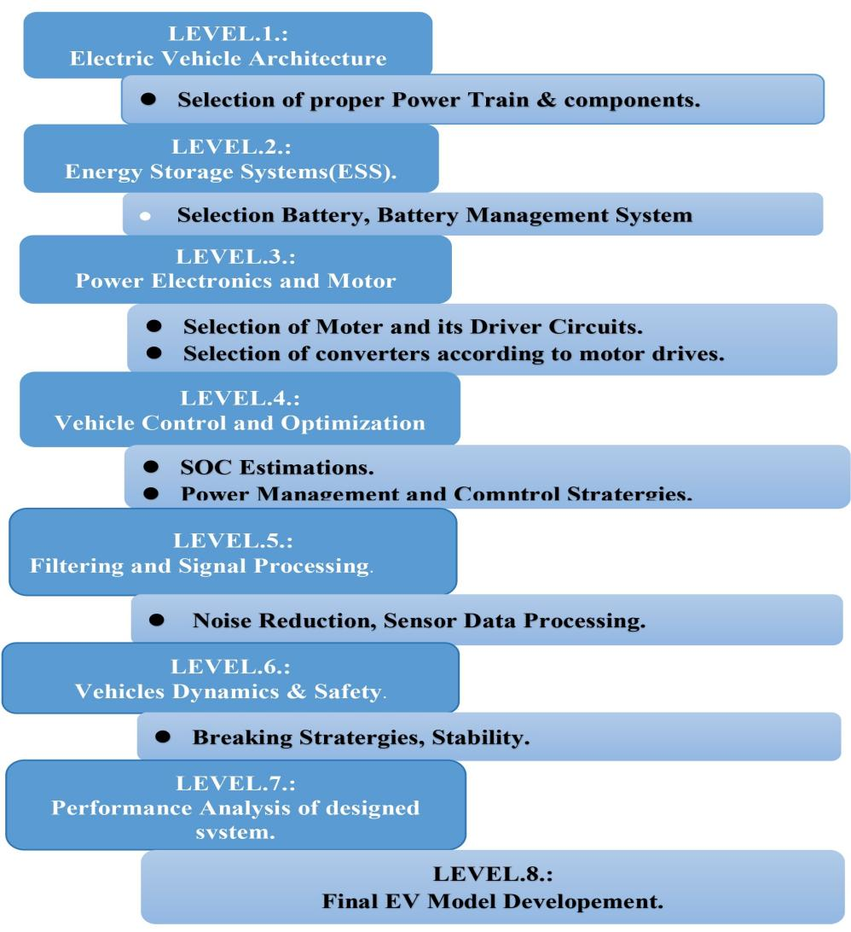

**Fig.2. Flow Chart System Level Design of EV.**

**1.4 Architecture of HEV :**

Now a days, in order to improve fuel economy and lower emissions, HEV has combined an ICE with an electric motor and a battery. The two propulsion sources power distribution is optimized by the HEV architecture. ICE operates in along with the electric motor and supplies the main power. That to helping with propulsion, an electric motor and generator may occasionally operate the vehicle on its own and recover energy through regenerative braking. Storage of energy retains electrical energy, powers the electric motor and is replenished by the ICE or regenerative braking. Power flow between the battery, motor and ICE is controlled by an inverter and converter. The control unit has optimized energy management and switching between gasoline and electric power according to driving nature and according to roads conditions. Where as HEV are further classified in four main categories, such as Series HEV, Parallel HEV, Series-Parallel HEV, Complex HEV[4][5][6]. These configurations are as represented in below fig.3.

**Fuel tank**

**Battery Pack**

**Electric Motor**

**ICE**

**Power Electronics Converter**

**Transmission**

**Fuel tank**

**Generator**

**Battery Pack**

**Electric Motor**

**ICE**

**Power Electronics Converter**

**Transmission**

**Fuel tank**

**Generator**

**Battery Pack**

**Electric Motor**

**ICE**

**Power Electronics Converter**

**Transmission**

**Mech. Coupler**

**Mech. Coupler**

**Fuel tank**

**Generator/ Motor**

**Battery Pack**

**Electric Motor**

**ICE**

**Power Electronics Converter**

**Transmission**

**Power Electronics Converter**

1. (b)

(c ) (d)

0 (b)

**Fig.3. Block Diagrams of different types of power train configurations in HEV: a)Series HEV, b) Parallel HEV, c) Series-Parallel HEV, d) Complex HEV[3].**

The comparative study of four main important power train configurations of HEV and PHEV has been discussed in terms of various parameters are been followed by Table .1.

**Table.1. Comparative study of Series HEV, Parallel HEV , Series-Parallel HEV and Complex HEV[3].**

|  |  |  |  |  |
| --- | --- | --- | --- | --- |
| **Features** | **Series Hev** | **Parallel Hev** | **Series Paralle Hev** | **Complex Hev** |
| **Power flow** | -ICE generates electricity to charge the battery.  -Electric motor drives the wheels. | -ICE and electric motor can power the wheels independently or together. | -Allowing both ICE and motor to drive wheels. | -Advanced control strategies with multiple power sources and energy recovery. |
| **Efficiency** | -High at low speeds, inefficient at high speeds. | -More efficient at high speeds but less in stop-and-go traffic. | -Flexible efficiency depending on driving conditions. | -Highly optimized for dynamic performance and efficiency. |
| **Battery Dependence** | -High.  -Needs a larger battery and generator. | -Lower.  -ICE provides direct power to wheels. | -Balanced.  -Both ICE and electric motor contribute efficiently. | -Complex battery and energy management system. |
| **Regenerative Braking** | -Effective in recovering braking energy. | -Recovers braking energy but not as efficiently as Series HEV. | -Utilizes regenerative braking effectively. | -Advanced regenerative braking for maximum energy recovery. |
| **Complexity** | -Simple design.  -Need of powerful battery and electric motor. | -Less complex.  -Needs of efficient power management. | -More complex.  -Needs of dual power sources. | -Highly complex with multiple power sources and advanced control strategies. |
| **Size** | -Bulky | -Moderate | -Small | -Small |
| **Weight** | -Medium | -Low | -Low | -Medium |
| **CO(g/km)** | -Medium | -Low | -Low | -Low |
| **HC** | -Low | -Medium | -Low | -Low |
| **NOx(g/km)** | -Medium | -Low | -Low | -Medium |
| **Losses** | -High | -Moderate | -Low | -Low |
| **Use in case** | -Best for urban, low-speed applications  -e.g., buses, taxis. | -Suitable for highway and mixed driving conditions. | -Best for hybrid vehicles needing both city and highway efficiency. | -Used in performance hybrids and advanced hybrid systems. |
| **Example Vehicles** | -Chevrolet Volt,  BMW i3 REx | -Honda Insight,  Hyundai Ioniq Hybrid | -Toyota Prius,  Ford Escape Hybrid | -Toyota RAV4 Prime |

**1.5 Architecture of PHEV:**

A **Plug-in Hybrid Electric Vehicle (PHEV)** is show in fig.4., an advanced hybrid vehicle that combines an internal combustion engine (ICE) with an electric propulsion system[3]. Unlike conventional hybrid vehicles, PHEV feature a larger battery pack that can be externally charged through a power outlet or charging station, allowing for extended all-electric driving. The architecture of a PHEV includes key components such as a high-voltage battery, electric motor, power electronics, and a control system that optimizes energy management.PHEV operate in multiple driving modes, including **all-electric mode**, where the vehicle runs solely on battery power, and **hybrid mode**, where both the engine and electric motor work together for optimal efficiency. The regenerative braking system further enhances energy efficiency by recovering kinetic energy during braking and converting it into electrical energy[3][4].The primary advantages of PHEV include **reduced fuel consumption, lower emissions, enhanced energy efficiency, and increased driving range** compared to conventional gasoline vehicles. By integrating electric power with a combustion engine, PHEV serve as a transitional solution towards fully electric mobility while addressing challenges like battery range limitations and charging infrastructure. With continuous advancements in battery technology and charging networks, PHEV are playing a crucial role in reducing carbon footprints and promoting sustainable transportation[4][5].

**Battery**

**Transmission**

**ICE**

**Generator**

**Mech. Coupler**

**Electric Motor**

**Fig.4. Architectural Block Diagram of PHEV**

**1.6 Architecture of FCEV:**

The zero-emission substitute for traditional ICE and battery electric vehicles (BEV) are FCEV and is show in fig.5. Using a hydrogen fuel cell, which uses an electro-chemical process to transform hydrogen into electrical energy with only water as a byproduct, that produce electricity onboard[6]. In contrast to BEV which only use battery storage, FCEV have larger driving ranges and quick refilling periods it usually three to five minutes, which makes them appropriate for heavy-duty trucks, passenger automobiles and public transports. In FCEV electric motor, power management system, hydrogen storage tank and fuel cell stack are the essential parts[6][7]. By supporting peak power needs and storing extra energy from regenerative braking, the addition of a battery or super-capacitor contributes to increased efficiency. Despite its benefits like zero emissions, high energy efficiency and reduced reliance on fossil fuels FCEV face challenges related to **hydrogen production, storage, infrastructure development, and initial costs[7][8]**.

**Motor**

**Inverter**

**Fuel Tank**

**Fuel ell Subsystem**

**DC/DC converter**

Fuel Processor

**Transmission**

**Fig.5. Architecture of FCEV**

The following table.2 discusses the various parameters of EV, HEV and FCEV.

|  |  |  |  |
| --- | --- | --- | --- |
| **Feature** | **Electric Vehicle (EV)** | **Hybrid Electric Vehicle (HEV)** | **Fuel Cell Electric Vehicle (FCEV)** |
| **Power Source** | -Battery-powered only. | -ICE + Electric Motor. | -Hydrogen fuel cell. |
| **Fuel Type** | -Battery. | -Gasoline/Diesel + Battery | -Hydrogen. |
| **Emissions** | -Zero emissions. | -Reduced emissions. | -Zero emissions. |
| **Range** | -150 to 500 km. | -Similar to ICE vehicle. | -400-600 km. |
| **Refueling/Recharging Time** | -Slow (30 min - several hours). | -Slow (30 min - several hours). | -Very Fast (3-5 minutes for hydrogen refueling). |
| **Complexity** | -Simple drivetrain. | -More complex drive-train. | -Highly complex drive-train. |
| **Infrastructure Availability** | -Expanding. | -Well-established. | -Limited. |
| **Efficiency** | -High efficiency. | -Moderate efficiency. | -High efficiency |
| **Cost** | -High initial cost . | -Lower cost than EV, but higher than conventional ICE vehicles. | -Very high due to hydrogen production and fuel cell costs |
| **Best Use Case** | -Urban and short to medium-range travel. | -Mixed city and highway driving. | -Long-range and used as commercial, heavy-duty transport |

|  |
| --- |
|  |

**Table.2. Summery of Architecture of EV[6][7][8].**

**2.Energy Storage system/ Technologies :**

The system which provide effective power management, propulsion, and regenerative braking, energy storage systems (ESS) are an essential part of EV, HEV and FCEV. Lithium-ion batteries, nickel-metal hydride batteries, super-capacitors and hydrogen fuel cells are the main energy storage options each has unique benefits with regard to energy density, power output and lifespan[9]. While nickel-metal hydride batteries are frequently used in HEV, because of their endurance, lithium-ion batteries are the industry standard for EV technology, due to their high energy density, efficiency, and extended cycle life[9]. Super-capacitors are perfect for regenerative braking applications, because of their quick charge-discharge cycles. On the other hand, hydrogen fuel cells, which are utilized in FCEV, provide quick refilling and longer driving ranges, but they also present infrastructural and hydrogen manufacturing issues[9]. By balancing power supply and demand and maximizing thermal performance, efficient BMS and EMS provides the security, durability and effectiveness to energy storage. Developments in solid-state batteries, high-capacity super-capacitors and hydrogen storage are anticipated to improve vehicle range, charging efficiency, and sustainability as EV usage increases.This System can purely used for basic battery oriented EV. Where as there is combined energy storage system which is made up of two different types of storage that may be capacitors, super-capacitors, ultra-capacitors, flywheel, are compared in the following table.3

**Table.3. Summery on Various Storage Systems used in EV's[9][10].**

|  |  |  |  |  |  |
| --- | --- | --- | --- | --- | --- |
| **ESS Type** | **Batteries** | **Super-capacitors** | **Flywheels** | **Hydrogen Fuel Cells** | **Comp. Air Storage** |
| **Energy Density** | -High | -Low | -Moderate | -Very High | -Moderate |
| **Power Density** | -Moderate to High | -Very High | -High | -Moderate | -Moderate |
| **Efficiency** | -High | -Very High | -Very High | -High | -Moderate |
| **Lifespan** | -Moderate to Long | -Very Long | -Very Long | -Long | -Long |
| **Cost** | -Moderate to High | -High | -High | -Very High | -Moderate |
| **Applications** | -BEVs, HEVs, PHEVs | -Regenerative braking,  -peak power needs | -Heavy-duty vehicles, energy recovery | -FCEVs, long-range vehicles | -Energy recovery, specialized applications |
| **Examples** | -Li-ion, NiMH, Lead-Acid, Solid-State | -Ultracapacitors | -Mechanical Flywheels | -Proton Exchange Membrane (PEMFC) | -Pneumatic Energy Storage |

**2.1 Battery Storage Technology:**

The primary energy storage component of EV, HEV and plug-in hybrid electric vehicle (PHEV) are batteries which is also a major factor in determining the range, efficiency and performance of the vehicles. Because of its high energy density, efficiency and extended lifespan, lithium-ion batteries are the most commonly used battery type. Lead-acid and nickel-metal hydride (NiMH) batteries are employed in certain applications[9]. Newly developed solid-state battery technology offer more capacity, quicker charging and improved safety. The SoC, SoH and Depth of Discharge (DoD) optimization depend on the BMS, which provides effective power delivery, effectiveness, thermal safety and stability[11]. The issues that include battery deterioration, infrastructure for charging, cost and sustainability continue to be significant. Battery performance and lifespan in **EV and Hybrid HEV** depend upon the following factors are listed in following table.4. That to improve effectiveness, cost and environmental impact, research is concentrated on solid-state, ultra-fast charging and recycling technologies.Such as examples like lead acid ,Nickle metal Hydride, Li-ion battery, Nickle Zinc battery, Nickle Cadmium and Metal oxides battery,etc. are used. Most commonly used are Li-ion and Li-ion polymer battery are mostly being used in EV and HEV. The mainstream adoption of EV will be fulfilled by advancements in energy density, thermal management, and sustainable materials as battery technology advances, facilitating the shift to efficient and clean transportation. Table.5. show the various battery parameters comparisons[9][10][11].

**Table.4. Comparision of various types of batteries[14][18].**

|  |  |  |  |  |  |  |  |
| --- | --- | --- | --- | --- | --- | --- | --- |
| **Battery Type** | **Lead-Acid** | **Nickel-Cadmium (NiCd)** | **Nickel-Metal Hydride**  **(NiMH)** | **Lithium-Ion (Li-Ion)** | **Lithium-Polymer**  **(Li-Po)** | **Lithium Iron Phosphate (LiFePO4)** | **Solid-State Battery** |
| **Charge-Discharge Cycles** | 300 - 500 | 1000 - 2000 | 500 - 1000 | 1000 - 3000 | 800 - 2000 | 2000 - 5000 | 5000 - 10,000 |
| **Efficiency**  **(in %)** | 70 - 80 | 75 - 85 | 80 - 90 | 90 - 98 | 85 - 95 | 90 - 98 | 95 - 99 |
| **Power Density (W/kg)** | 180 - 300 | 150 - 300 | 250 - 1000 | 300 - 1500 | 400 - 2000 | 500 - 2000 | 1000 - 2000 |
| **Self-Discharge Rate**  **(% per month)** | 5 - 10 | 10 - 20 | 20 - 30 | 1 - 5 | 2 - 10 | <1 | <1 |
| **Energy Density (Wh/kg)** | 30 - 50 | 40 - 60 | 60 - 120 | 150 - 250 | 120 - 220 | 90 - 160 | 300 - 500 |

**2.2 Hybrid Energy Storage Systems (HESS):**

That to maximize power and energy management in EV and HEV, a hybrid energy storage system (HESS) integrates two or more energy storage technologies, such as batteries and super-capacitors ,likewise they will work with power requirement needed by the vehicles during its running condition[12]. It increases longevity and efficiency by utilizing the high power density of super-capacitors for quick charge-discharge cycles and the high energy density of batteries for long-term storage[13]. HESS improves total energy management, regenerative braking effectiveness and vehicle performance.The various hybrid energy storage technologies are as compares below in table.5.

**Table. 5. Comparison on various Hybrid Energy Storage Technologies (HESS) for HEV[14][15][16].**

|  |  |  |  |  |  |
| --- | --- | --- | --- | --- | --- |
| **HESS Type** | **Battery + Supercapacitor** | **Battery +**  **Flywheel** | **Battery +**  **Fuel Cell** | **Battery + Ultra-High Capacity Battery** | **Battery + Compressed Air** |
| **Energy Storage Components** | -Li-ion/NiMH Battery +  Super-capacitor | -Li-ion/NiMH Battery + Flywheel | -Li-ion Battery + Hydrogen Fuel Cell | -Li-ion Battery + Solid-State/Advanced Battery | -Li-ion Battery + Compressed Air Storage |
| **Energy Density** | -High | -Moderate | -Very High | -Very High | -Moderate |
| **Power Density** | -Very High | -High | -Moderate | -Moderate | -Moderate |
| **Efficiency** | -High | -Very High | -High | -High | -Moderate |
| **Lifespan** | -Extended | -Very Long | -Long | -Very Long | -Long |
| **Cost** | -Moderate to High | -High | -Very High | -Very High | -Moderate |
| **Applications** | -Regenerative braking, fast acceleration, HEV. | -Heavy-duty hybrid vehicles, energy recovery | -Fuel Cell HEV (FCHEV), long-range applications | Future HEV, extended range, improved safety | -Energy recovery systems, specialized hybrid vehicles |

From fig.5. it is clear that the why proper management of energy is necessary in any electric vehicles and that may aims the five main blocks such as objectives , ESS efficiency , fuel economy, emissions and last one is durability which further gives certain mutual benefits that is defined in the following tree diagram.

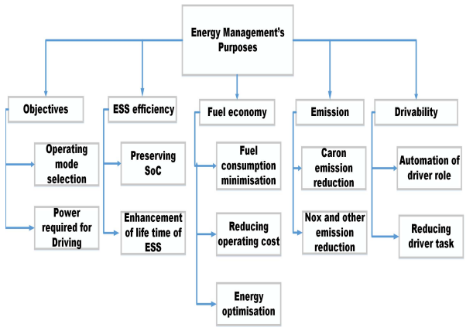

**Fig.5. Block Diagram of EMS Objectives.**

**3.Control Stratergies:**

The vehicle control optimization strategies are crucial in **EV and HEV** to enhance **efficiency, performance and battery life** while reducing energy consumption and emissions. These strategies focus on **power management, energy distribution and real-time control** to optimize vehicle operation[17]. Strategies like **Rule-Based Control (RBC)** strategies are simple and widely used but lacks adaptability to real-time conditions. **Optimization-Based Control (OBC)** strategies provides energy efficiency but requires high computational power[18]. The **Model Predictive Control (MPC) s**trateg**y** improves long-term efficiency by predicting future energy needs. **Fuzzy Logic Control (FLC)** and **Neural Network-Based Control** enhance adaptability and real-time decision-making. The **Stochastic Control** is ideal for handling unpredictable driving conditions[18]. Fig.6 show various adaptive control stratergies for controlling the various parameters in EV.

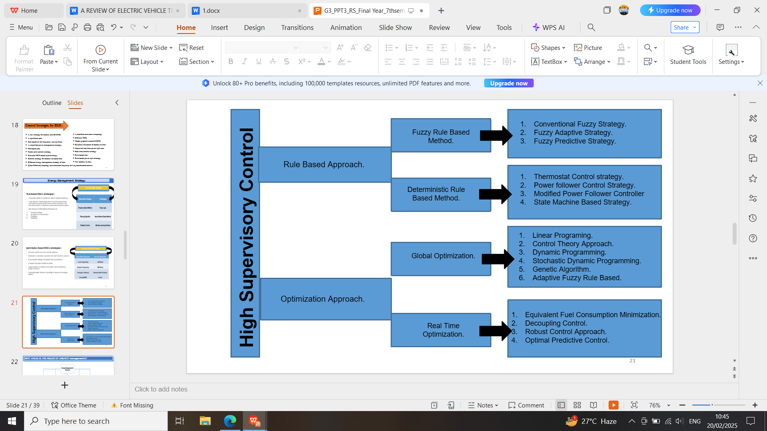

**Fig.6. Classification of various control optimization strategies.**

**3.1 Rule Based Optimization Stratergies:**

These are operates based on predefined rules or logical conditions.That use decision making algorithms to control energy flows and optimize system performance without relying on real time optimization or advances ML techniques..Fig.7. shows the classification of various rule based stratergies. Among them, AI-Driven Control Strategies and Deterministic Rule-Based Control are frequently employed for power distribution and energy management in vehicles[18]. Deterministic Rule-Based Control adheres to preset, unchangeable rules that are derived from system logic and expert knowledge[18]. It is easy to implement, straight forward, and computationally efficient, but not flexible enough to adjust changing driving situations. Conventional HEV and PHEV frequently employ this technique for managing regenerative braking and power-split control. Conversely, AI Rule-Based Control strategies employ fuzzy logic, neural networks and ML to dynamically modify vehicle operations in response to real-time data and predictive modeling[18][19]. Under varied traffic, topography and driving circumstances, these techniques allow for self-learning, adaptive control and increased efficiency. AI-based controls that improve energy management, battery life and the overall driving experience include FLC and neural network-based optimization. Deterministic control guarantees dependability and simplicity, whereas AI-based control provides more flexibility and effectiveness. That to work in an intelligent, real-time energy management systems, hybrid techniques combining deterministic logic and AI-driven predictive control are probably going to be integrated into EV and HEV optimization in the future[19].

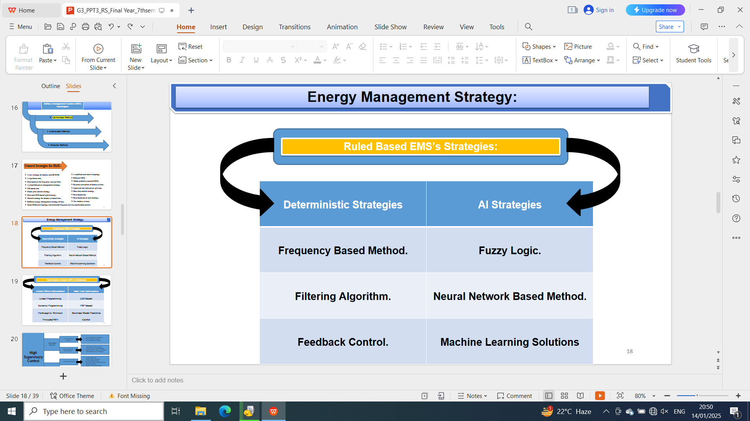

**Fig.7. Classification of Rule Based Stratergies**

**3.2 Optimization Based Stratergies:**

From Fig.8., in EV and HEV, optimization-based solutions are essential for improving power distribution, energy efficiency, and real-time decision-making. Optimization based tactics use computational algorithms and mathematical models to identify the best control actions, which lowers energy consumption and enhances vehicle performance[19]. Global offline optimization and real-time optimization are two main categories into which optimization techniques can be divided. That to determine the most effective control approach, global offline optimization techniques like Pontryagin's Minimum Principle (PMP) and Dynamic Programming (DP) examine the complete driving cycle beforehand. Although it gives best results, but they are not appropriate for real-time applications due to their substantial processing[19][20]. MPC and Adaptive Control are examples of real-time optimization techniques that continually modify vehicle operation using predictive models and real-time sensor data. Although these techniques provides flexibility in response to changing traffic patterns, road slopes and driver behavior, they must strike a balance between judgment accuracy and processing economy[20].The best method for energy-efficient vehicle operating combines offline global optimization for strategy creation with real-time optimization for adaptive control[20]. Further future EV and HEV control systems will significantly improve real-time decision-making as ML and AI resulting in more intelligent, effective and highly autonomous vehicles[20][21].

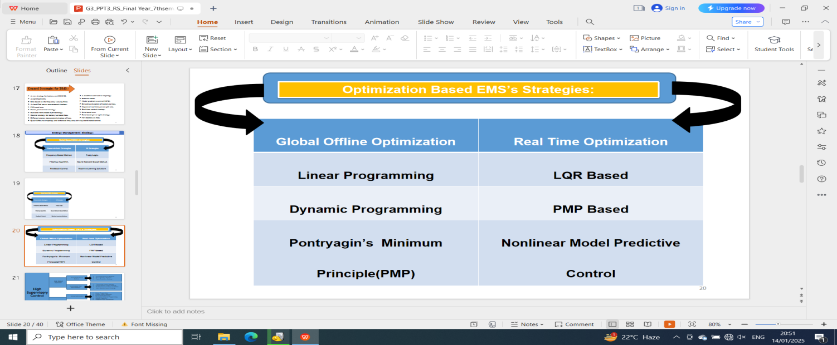

**Fig.8. Classification of Optimization Based Stratergies**

Control stratergies plays an important roles in controlling various parameters , that further leads to get work as a signals to the various converters .These control stratergies are commanded or operated by ECU to perform certain operations according to the data obtained from the analysis of stored data in ECU. Such main stratergies are being discussed in table.6 below.

**Table.6. Summery on various vehicle control stretergies for EV and HEV[19][20]21].**

|  |  |  |  |  |  |  |
| --- | --- | --- | --- | --- | --- | --- |
| **Category** | **Rule-Based Control (RBC)** | | **Optimization-Based Control (OBC)** | | **Stochastic Control** | **AI & Neural Network Control** |
| **Sub-Strategies** | -Deterministic Rule-Based Control | -AI Rule-Based Control (Fuzzy Logic, ML) | **-Global-Offline Optimization**(DP, PMP) | -Real-Time Optimization (MPC,Adaptive Control) | -Markov Decision Process (MDP) | -Self-learning & predictive control |
| **Approach** | -Pre-defined rules | -AI-driven adaptive rules | -Mathematical modeling | -Predictive & sensor-based | -Probability-based | -AI-based adaptive optimization |
| **Complexity** | -Low | -Moderate | -High | -High | -High | -Very High |
| **Stability** | -High | -High | -Low | High | -Moderate | -Very High |
| **Advantages** | -Simple, reliable,east to implement | -Self-learning | -Provides an optimal energy solution | -Adapts to real-time driving conditions | -Handles uncertainty, dynamic adaptation | -Learns from data, continuously improves |
| **Limitations** | -Lacks adaptability | -Requires training data | -Computationally expensive, not real-time | -Requires high computational power | -Complex implementation | -Requires extensive data & processing |
| **Applications** | -Conventional HEV, PHEV | -Next-gen EV, smart vehicles | - EV and HEV stratergy development | -Advanced autonomous driving | -Urban unpredictable driving | -Future autonomous EV |

**4.Battery Managements System (BMS) :**

From fig.9, in EV and HEV, a battery management system (BMS) is an essential piece of technology that guarantees the lifetime, safety and efficiency of the batteries. That to maximize performance, the BMS keeps an eye on and regulates important battery characteristics including DoD, SoC, SoH and State of Power (SoP)[22].The SoC estimate enhances energy efficiency and range prediction by assisting in determining the battery's usable capacity. Battery deterioration is tracked through SoH monitoring, which prompt maintenance and problem identification[23]. DoD control stops severe discharges that can reduce battery life, whereas SoP control controls power output and shields the battery from undue strain[23]. That to stop overcharging, overheating and thermal runaway, the BMS also incorporates thermal management, fault diagnostics and cell balancing strategies.Modern BMS systems are become more adaptable, predictive and efficient due to developments in AI, ML and cloud-based data analytics. This gives improvement in energy usage and a longer lifespan of batteries. For EV to be widely adopted and become more dependable, safe and sustainable, that’s why a strong BMS is necessary[24].

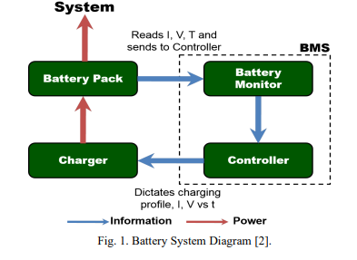

**Fig.9. Block diagram of BMS.**

**4.1.State of Charge (SoC) monitoring :**

Monitoring the SoC is crucial for ensuring the reliability and efficiency of various systems, particularly in EV and power grids. Recent advancements in SoC monitoring techniques have focused on enhancing resource efficiency, security, safety and real-time capabilities. The following sections outline key aspects of SoC monitoring based on the provided research A dual coupled monitoring framework has been proposed for SoC and SOH in electric vehicle batteries, which accounts for dynamics and measurement uncertainties. This framework utilizes prediction and estimation ellipsoids to maintain accurate state assessments, even under potential attack scenarios[24]. An SoC based online automatic monitoring system for partial discharge in power grids has been developed, enabling real-time detection of insulation degradation without human intervention. This system employs AI for automatic alarm generation, enhancing proactive maintenance strategies[24][25]. As SoC architectures grow in complexity, security monitoring becomes essential to validate security policies against hardware threats. The identification of quality attributes for SoC security monitoring solutions highlights the need for robust frameworks to address emerging vulnerabilities. In contrast, while these advancements improve monitoring capabilities, challenges remain in integrating these systems seamlessly into existing infrastructures, particularly regarding compatibility and scalability[25].

**4.2.State of Power(SoP) monitoring :**

The monitoring of SoP in EV is a critical metric that reflects the maximum power capability of lithium-ion batteries, essential for performance during operations such as acceleration and regenerative braking. Recent advancements in SoP estimation methods have improved the accuracy and reliability of power management in EV, addressing challenges posed by varying battery conditions[26]. The m**odel switching algorithm,** a novels iterative algorithm has been developed for SoP estimation under constant power operations, achieving a mean absolute error of less than a specified value[26][25]. The r**eal time estimation is** a linear least squares estimation technique allows for real-time SoP computation, effectively accounting for changes in open circuit voltage and internal resistance across various temperatures. **Dual Kalman Filter method** calculates SoP by analyzing the relationship between open-circuit voltage and state of charge, enhancing the precision of SoP assessments[25]. **Performance Optimization of**  SoP provides a more informative measure than SoC, crucial for optimizing EV performance and ensuring efficient energy used. The accurate SoP estimation aids in effective battery management, prolonging battery life and enhancing vehicle range.

**4.3.State of Health (SoH) monitoring:**

Monitoring the State of Health (SoH) of batteries is crucial for ensuring their longevity and safe operation, particularly in lithium-ion batteries. Various methodologies have been developed to enhance the accuracy and efficiency of SoH monitoring, addressing challenges such as resource constraints and environmental sustainability. The sections outline key approaches and advancements in SoH monitoring[25][26]. A dual coupled monitoring system integrates SOC and SOH, utilizing real-time network conditions to optimize measurement updates. This framework employs prediction and estimation ellipsoids to encapsulate true SoC/SoH states, enhancing reliability against potential attacks. SoH prediction methods are categorized into model-based, data-based and hybrid approaches, each with distinct advantages and challenges[26]. These methods are essential for timely adjustments in BMS, thereby extending battery life and preventing accidents. Ultrasonic detection techniques provide a non-destructive and precise method for SoH estimation, achieving a low Root Mean Square Error in cycle estimations. Chemometric modeling correlates SoH evolution with chemical and physical states, utilizing advanced electrochemical techniques. The Coulomb Counting method, integrated with IoT applications, effectively monitors SoC and SoH, ensuring optimal battery performance and longevity[26][27].

**Table.7. Performance parameters of battery.**

|  |  |  |  |
| --- | --- | --- | --- |
| **Parameter** | **State of Charge (SOC)** | **State of Health (SOH)** | **Depth of Discharge (DOD)** |
| **Definition** | Percentage of available energy relative to full capacity | Measure of battery aging and overall capacity retention | Percentage of total capacity discharged during a cycle |
| **Impact on Battery Performance** | High SOC ensures longer driving range, but extreme high/low SOC accelerates degradation | SOH decreases over time due to charge cycles and thermal effects | High DOD shortens battery life, as deeper discharges increase wear |
| **Optimization Strategies** | Maintain SOC between **20-80%** to extend lifespan | Efficient **Battery Management System (BMS)**, temperature control, and moderate charging speeds | Use **shallow discharge cycles** (avoid full depletion) for longevity |

The above table .7. shows the summery on the SoC, SoH and DoD in respect to the energy storage system and battery management system.

**4.4.Cell balancing:**

Cell balancing is a critical process in BMS that ensures the optimal performance, longevity and safety of battery packs, particularly in lithium-ion batteries. This process involves equalizing the charge levels among individual cells to prevent issues such as overcharging or excessive discharging, which can lead to reduced battery life and safety hazards. The key aspects of cell balancing techniques , p**assive balancing is** utilizes resistive methods to dissipate excess energy as heat. While cost-effective and simple, it suffers from energy inefficiency and thermal issues. And a**ctive balancing i**nvolves energy redistribution among cells using converters, such as flyback or buck-boost converters. This method is more efficient and faster, making it suitable for high-performance applications[26][27][28].

**Table.8.Comaprision of Active Cell Balancing and Passive Cell Balancing.**

|  |  |  |
| --- | --- | --- |
| **Factors** | **Active Cell Balancing** | **Passive Cell Balancing** |
| **Principle** | -Transfers excess energy from higher-voltage cells to lower-voltage ones. | -Dissipates excess energy as heat using resistors. |
| **Efficiency** | -High efficiency  - As energy is reused. | -Low efficiency  -Due to energy loss as heat. |
| **Energy Utilization** | -Conserves energy by redistributing it. | -Wastes energy as heat. |
| **Complexity** | -Complex circuitry with inductors, capacitors, or converters. | -Simple circuit with resistors. |
| **Cost** | -Expensive  -Due to additional components. | -Low cost  -Due to simpler design. |
| **Heat Generation** | -Minimal heat generation. | -Significant heat generation. |
| **Battery Lifespan** | -Extends battery life  -By reducing stress on cells. | -May reduce lifespan  -Due to heat-induced degradation. |
| **Balancing Speed** | -Faster  -As energy is transferred directly between cells. | -Slower  -As energy is dissipated gradually. |
| **Scalability** | -Suitable for large battery packs in EVs. | -Less efficient for large battery packs. |
| **Maintenance & Reliability** | -More components increase maintenance needs. | -Fewer components mean lower maintenance. |

**4.6.Architecture of BMS:**

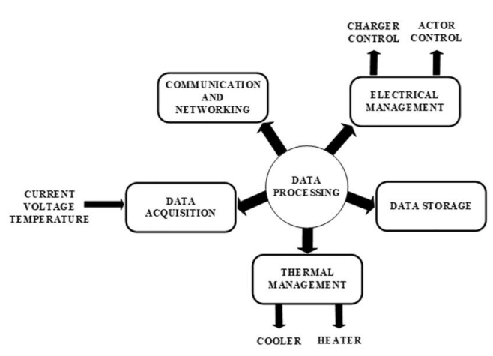

**Fig.10. Architectural block diagram of BMS.**

As shown in fig.10, the architecture of a BMS is made up of a number of essential functional modules that cooperate to guarantee the dependable, safe and effective operation of a battery pack in EV and HEV.

****4.6.1.Data Acquisition:****

Collects real-time **current, voltage, and temperature** data from battery cells. Provides essential input for **SOC (State of Charge), SOH (State of Health), and SOP (State of Power) estimation[30]**.

****4.6.2.Data Processing:****

The **central control unit** that processes collected data and executes control algorithms. Ensures **fault detection, battery balancing, and system optimization[30]**.

****4.6.3.Electrical Management:****

Controls **charging and discharging operations** to maximize battery lifespan. Regulates **charger control and actuator control** to manage power distribution efficiently[30].

****4.6.4. Thermal Management:****

Maintains an **optimal battery temperature** by activating a **cooler or heater** when required. Prevents overheating, which can lead to thermal runaway, and improves overall battery efficiency[30].

****4.6.5. Data Storage:****

Logs historical battery performance data for **predictive maintenance and fault analysis**. Helps in optimizing long-term battery health and efficiency[30].

****4.6.6. Communication and Networking:****

That to **real-time data exchange** with the **Vehicle Control Unit (VCU)** and other vehicle subsystems. Uses **CAN, LIN or wireless communication protocols** for system integration. A **BMS is essential for ensuring safe, efficient and reliable battery operation** in EV. It plays a vital role in **energy management, safety monitoring and improving the lifespan of the battery pack**. Future BMS advancements include **AI-driven predictive maintenance, cloud-based monitoring and real-time adaptive control** for enhanced performance[30].

**5.Motors :**

Electric motors are used electromagnetic interactions to transform electrical energy into mechanical energy. Because of their great efficiency, dependability and precise control capabilities, they are extensively utilized in a variety of applications, including as robotics, EV, industrial automation, and household appliances. A variety of motor types, including brushed and BLDC motors, synchronous and induction AC motors and switched reluctance motors (SRM) are used to meet certain operating needs. Because of their high torque, efficiency and control, induction motors (IM) and permanent magnet synchronous motors (PMSM) are frequently seen in EV. Efficiency, power density and sustainability are the goals of the ongoing development of motor technology which is fueled by developments in power electronics, AI and material sciences[31].

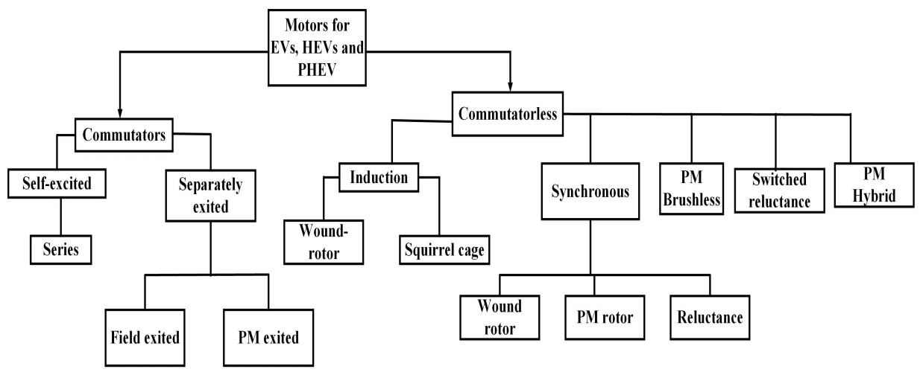**Fig.11. Classifications of Electric motors use for EV / HEV.**

**5.1. Switch Reluctance Motor (SRM) :**

It is appreciated because of their fault tolerance, high reliability and straight forward design. SRM are becoming more and more popular in EV applications. SRM is strong, affordable and appropriate for high-temperature settings since they don't require rotor windings or permanent magnets like conventional motors do. An appealing substitute for PMSM and IM, they operate at high speeds, have a broad range of efficiency and need little rare-earth minerals. Not withstanding the benefits, SRM have drawbacks such increased acoustic noise, torque ripple and intricate control specifications. These problems are being addressed by developments in power electronics, digital controllers and AI-based optimization, which are increasing effectiveness and performance. SRM technology is a viable answer since future advancements will concentrate on lowering noise, increasing power density and incorporating sophisticated control techniques[31][32].

**5.2. Brushless-DC (BLDC) motor :**

The greater efficiency, dependability and precise control capabilities of BLDC motors make them popular in a variety of applications, such as household appliances, industrial automation and EV. Because BLDC motors use electronic commutation instead of mechanical brushes, they run more smoothly and require less maintenance than traditional BLDC motors. BLDC motors are perfect for EV propulsion systems because of their greater torque-to-weight ratio, better thermal control and increased energy efficiency. They improve vehicle performance and battery life by providing high-speed operation, superior dynamic response and regenerative braking compatibility. Not with standing their benefits, BLDC motors need sophisticated power electronics and control algorithms to function well. Their performance is being further enhanced by developments in sensor-less control, AI-based motor optimization, and sophisticated cooling methods. As technology advances, BLDC motors remain essential to the shift to high-performance, environmentally friendly EV. The following Table.8 shows the comparison of common types of motors used in electric and hybrid vehicles[31][32].

**5.3. Induction motor (IM):**

Induction motors play a significant role in electric vehicle (EV) propulsion systems due to their efficiency, durability, and cost-effectiveness. Unlike traditional internal combustion engines, induction motors operate on the principle of electromagnetic induction, where a rotating magnetic field in the stator induces current in the rotor, generating torque. These motors are widely used in EV for their high reliability, minimal maintenance, and ability to operate efficiently over a wide range of speeds. Notably, Tesla initially utilized AC induction motors in its early models, showcasing their potential for high-performance applications. While permanent magnet synchronous motors (PMSM) have gained popularity due to higher efficiency, induction motors remain a viable choice, especially in applications where cost and robustness are critical[31][32]. Following table.9. discusses the common types of motors used in EV.

**Table.9. Summery of Electric Motors used in EV /HEV.[31][32]**

|  |  |  |  |  |
| --- | --- | --- | --- | --- |
| **Motor Type** | **Permanent Magnet Synchronous Motor (PMSM)** | **Induction Motor (IM)** | **Brushless DC Motor (BLDC)** | **Switched Reluctance Motor (SRM)** |
| **Efficiency** | -High | -Moderate to High | -High | -Moderate |
| **Torque Performance** | -High | -High | -High | -Moderate |
| **Cost** | -Expensive | -Moderate | -Moderate | -Low |
| **Control Complexity** | -High | -Moderate to High | -High | -High |
| **Applications** | -Tesla, Nissan Leaf, Toyota Prius | -Tesla Model S (earlier versions), commercial and industrial EVs | -Common in light EV, e-scooters, and motorcycles | -Experimental use in EV, gaining interest due to cost-effectiveness and robustness |
| **Impact on SoC (State of Charge)** | -High efficiency helps maintain SoC for longer driving range. | -Consumes more energy compared to PMSM, leading to faster SoC depletion. | -High efficiency ensures minimal SoC drop for extended range. | -Moderate efficiency can cause higher SoC consumption compared to PMSM. |
| **Impact on SoH (State of Health)** | -Less stress on the battery due to efficient power usage, improving SoH. | -Higher operating temperatures can impact battery longevity, affecting SoH. | -Smooth operation and lower heat generation improve battery SoH. | -Rugged design reduces degradation but torque ripple may affect battery SoH. |
| **Impact on SoP (State of Power)** | -Delivers high power output, enabling better acceleration and torque control. | -Good performance but lower peak efficiency compared to PMSM, affecting SoP. | -Provides high torque and power density, enhancing SoP. | -High fault tolerance but suffers from torque ripple, affecting SoP consistency. |

**6.Power Electronics Converters :**

From fig.12 the power electronics converters are essential, especially in EV and HEV. In order to ensure that electric drive systems operate according to proper and safer operating conditions, these converters are in charge of effective energy conversion, voltage regulation and power management[33][4]. The three main categories of power electronics converters are AC-DC rectifiers is used for charging systems, DC-DC converters is used for controlling battery voltage and DC-AC inverters are being used for controlling motor drives. To improve efficiency, dependability and thermal performance, advanced converter topologies such multi-level converters, bidirectional converters and soft-switching approaches are being developed. Modern converters have greater power density, quicker switching rates and lower energy losses because to developments in wide-bandgap semiconductors (SiC, GaN), AI-based control techniques, and integrated power electronics[33][30].

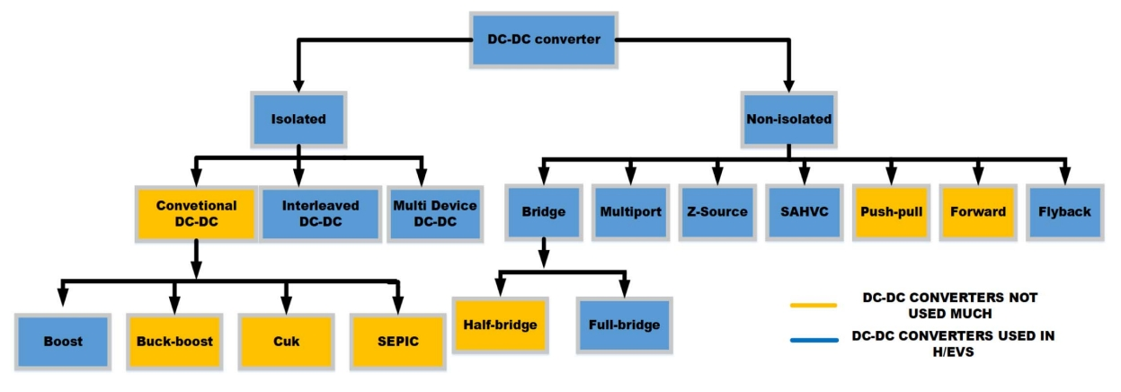

**Fig.12. Classification of DC-DC converters used in EV / HEV[3].**

**6.1. DC- DC converters:**

In EV and HEV, a DC-DC converters are vital parts that are crucial for energy management, voltage regulation and power conversion. In order to guarantee the correct functioning of several subsystems, including battery packs, motor drives, auxiliary systems and onboard chargers, these converters effectively step up or step down voltage levels.Isolated and non-isolated DC-DC converters are the two main types found in EV. Conventional, interleaved, and multi-device DC-DC converters are examples of isolated converters that offer galvanic isolation for increased efficiency and safety[33]. Bridge, multiport, Z-source and push-pull arrangements are examples of non-isolated converters that provide high power density and small designs for automotive applications. Boost, Buck-Boost, Cuk and SEPIC converter topologies are frequently utilized in HEV and EV to provide the required possible power transmission and energy efficiency that to be needed by the system. Where as advanced DC-DC converters increase vehicle economy, lower energy losses and improve thermal performance thanks to developments in high-frequency switching, wide-bandgap semiconductors (SiC, GaN) and sophisticated control algorithms[33].

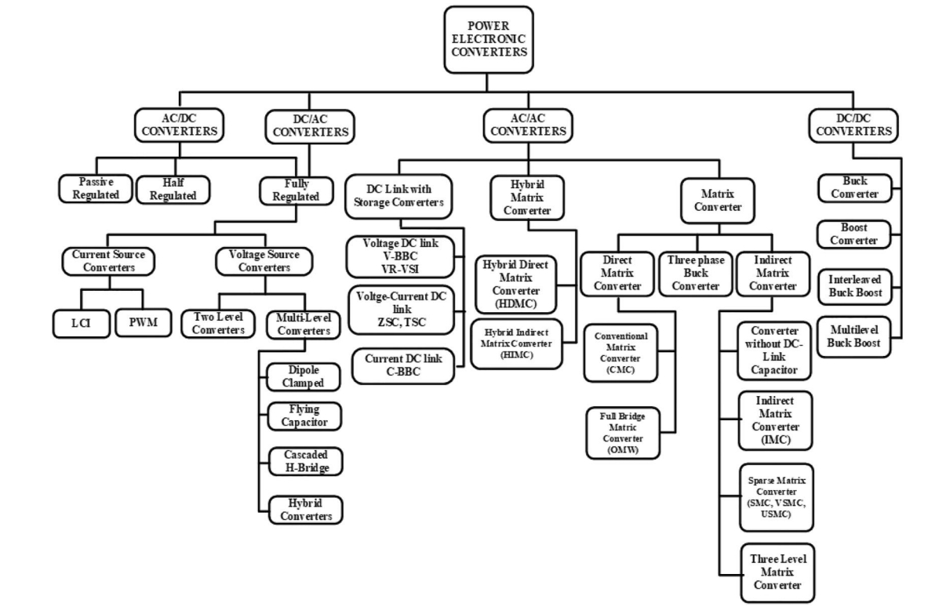**Fig.13. Classification of various types of converters used in EV/ HEV[30].**

**6.2. AC-DC converters:**

By facilitating the effective conversion of energy from AC power sources that is grid or regenerative braking systems to DC power for battery charge and auxiliary systems, AC-DC converters are essential components of EV and HEV. A vital part of both onboard and off-board charging systems, these converters provide steady and effective power transmission while satisfying voltage and current specifications. Unidirectional and bidirectional AC-DC converters are the two main varieties found in EV. While bidirectional converters provide vehicle-to-grid (V2G) and regenerative braking, allowing energy to flow back to the grid or other loads, unidirectional converters are mostly used for charging the battery from the grid. Bridgeless rectifiers, multilayer converters, and resonant converters are examples of advanced topologies that improve efficiency, power factor correction (PFC), and **minimize harmonic distortion[33]**.

**6.3. DC - AC converters :**

The DC-AC converters also known as **inverters** are critical components in **EV** as they convert **direct current (DC) from the battery into alternating current (AC)** to drive electric motors. These converters play a vital role in **propulsion systems**, ensuring efficient power conversion, precise motor control and regenerative braking capabilities. Common inverter topologies used in EV include **two-level, three-level, multi-level and pulse-width modulation (PWM)-based inverters**. Advanced semiconductor technologies, such as **silicon carbide (SiC) and gallium nitride (GaN) devices that** enhance efficiency, reduce switching losses and improve thermal performance, leading to **compact and high-power-density designs**. Furthermore, modern **vector control techniques that is Field-Oriented Control (FOC)** optimize torque and speed control, improving overall vehicle efficiency and performance[33].

**Table.10. Common Converters used in EV/ HEV.**

|  |  |  |  |  |
| --- | --- | --- | --- | --- |
| **Converter Type** | **Function** | **Common Topologies** | **Application in EV** | **Advantages** |
| **DC-DC**  **Converter** | -Converts DC voltage levels | -Buck, Boost, Buck-Boost, Cuk, SEPIC, Z-source | -Battery voltage regulation, auxiliary systems, motor drive | -High efficiency, compact size, improved energy management |
| **AC-DC**  **Converter** | -Converts AC power to DC for charging | -Bridgeless rectifier, PFC, Multilevel, Resonant | -Onboard and off-board charging, regenerative braking | -Grid integration, high power factor, fast charging capability |
| **Bidirectional Converter** | -Allows energy flow in both direction | -Dual Active Bridge (DAB), Bidirectional Buck-Boost | -Regenerative braking, Vehicle-to-Grid (V2G) | -Energy recovery, improved battery life, dynamic energy transfer |
| **Multiport Converter** | -Manages multiple energy sources | -Multiport DC-DC, Hybrid Converters | -Hybrid energy storage, multiple power sources (Battery + Supercapacitor/Fuel Cell) | -Efficient power distribution, optimized energy management |

1. **Filtering Stratergies:**

That for reducing noise and measurement errors, filtering techniques in BMS are crucial for guaranteeing precise assessment of SOC, SOH, SOP and other battery characteristics[34][30][1]. In EV and HEV, these methods increase battery operating efficiency, safety and dependability. Common filtering methods that offer real-time estimate and sensor data rectification include KF, Extended Kalman Filters (EKF), Unscented Kalman Filters (UKF) and Particle Filters (PF). Other than these Wavelet Transform-based filters, Moving Average Filters (MAF) and low-pass filters (LPF) aid in enhancing signal clarity and lowering high-frequency noise. For improved prediction accuracy, sophisticated machine learning-based filtering techniques are also being investigated. That in order to provide optimal performance and safety in vehicle applications, BMS may enhance battery longevity, thermal management and fault detection by putting strong filtering mechanisms into place. Table.10 gives the various filtering stratergies along with its advantages and disadvantages[34].

**Table.10.Various filtering stretergies used in EV/ HEV.**

|  |  |  |
| --- | --- | --- |
| **Filtering Strategy** | **Advantages** | **Disadvantages** |
| **Low-Pass Filter**  **(LPF)** | - Simple to implement - Effective for noise reduction | - Delay in real-time estimation - Cannot handle dynamic signals |
| **Moving Average Filter**  **(MAF)** | - Smooths out fluctuations - Easy to apply | - Loses finer details of signal changes |
| **Kalman Filter**  **(KF)** | - Provides accurate state estimation - Adapts to dynamic conditions | - Requires a precise system model - Computationally expensive |
| **Extended Kalman Filter (EKF)** | - Works well for nonlinear battery models - Real-time correction | - Higher computational cost - Needs accurate initial conditions |
| **Unscented Kalman Filter (UKF)** | - Better accuracy than EKF - More effective for highly nonlinear systems | - More complex than EKF - Computationally demanding |
| **Particle Filter**  **(PF)** | - Handles highly nonlinear systems - Works well with uncertainties | - Very high computational complexity - Slower processing time |
| **Wavelet Transform Filter**  **(WTF)** | - Effectively separates noise from useful signals - Good for transient detection | - Complex to design - Requires high processing power |
| **Artificial Intelligence (AI)-Based Filtering** | - Can adapt and learn from data patterns - High accuracy for complex systems | - Needs large datasets for training - Computationally expensive |

1. **Charging Infrastructure of EV/ HEV:**

The charging of **EV** is a crucial aspect of their widespread adoption, influencing their efficiency, range and user convenience. EV charging is categorized into **AC and DC charging** with different levels such as **Level 1 that is for slow charging, Level 2 is used for fast charging purpose and Level 3 is being used for DC fast charging or ultra-fast charging**. Advanced charging technologies, including **Wireless Charging, Bidirectional Charging that is V2G flow and Battery Swapping** are emerging to enhance efficiency along with the grid integration[35]. Table. 11 shows the level of charging comparison in EV.

**Level Of Charging in EV / HEV**

**LEVEL .1. LEVEL.2. LEVEL.3. LEVEL.4.**

**Fig.14. Classification of Charging Levels in EV**

* 1. ****Level-1 Charging:****

**Level 1 charging is the most basic and widely accessible method of charging EV, utilizing a standard 120V AC household outlet, requires no special installation, making it convenient for home charging. However, it provides a relatively slow charging rate of 3-5 miles of range per hour, making it best suited for overnight charging and low-mileage daily commutes. While Level 1 charging is cost-effective and easy to use, its slow speed limits its practicality for long-distance travel or high-usage scenarios. Despite these limitations, it remains a viable option for EV[35][36].**

* 1. ****Level-2 Charging:****

**Level 2 charging is a widely used and efficient method for replenishing EV batteries, offering a faster alternative to Level 1 charging. Operating at 240V AC, it provides a charging power range of 3.3 kW to 22 kW, allowing EV to gain 10-60 miles of range per hour. Level 2 chargers are commonly installed in homes, workplaces and public charging stations, requiring a dedicated charging unit and proper electrical infrastructure. This charging level balances convenience and speed, making it ideal for daily charging needs while significantly reducing the time required to recharge an EV compared to Level 1.[35][36]**

* 1. ****Level-3 Charging:****

**Level 3 charging, commonly known as DC Fast Charging (DCFC), is a high-power charging solution designed for rapid replenishment of EV batteries. Unlike Level 1 and Level 2, which use AC power, Level 3 charging utilizes DC at power levels ranging from 50 kW to 350 kW, enabling significantly faster charging speeds. It allows EV to achieve 80% charge in 20 to 60 minutes, making it ideal for highway rest stops, fleet operations and long-distance travel. While Level 3 chargers provide unmatched convenience, this require specialized infrastructure, higher installation costs and compatibility with specific EV models. As charging technology advances, Level 3 charging plays a vital role in enhancing EV adoption by reducing range anxiety and improving charging accessibility[35][36].**

* 1. ****Level-4 Charging:****

**Level 4 charging, also known as Ultra-Fast Charging or Extreme Fast Charging (XFC), represents the next evolution in EV charging technology. Operating at power levels exceeding 350 kW, aims to provide full or near-full charge in under 10 minutes, rivaling the refueling time of traditional internal combustion engine vehicles. This high-speed charging technology requires advanced battery systems capable of handling extreme power inputs without compromising longevity or safety. Level 4 chargers are being developed for high-demand applications like high-performance EV and future smart transportation networks[35][36].**

**Table.11.Summery on charging of EV in terms of leves.**

|  |  |  |  |  |  |
| --- | --- | --- | --- | --- | --- |
| **Charging Level of EV/ HEV** | **Power Output**  **(kW)** | **Charging Time**  **(Hrs)** | **Used for** | **Advantages** | **Disvantages** |
| **Level 1** | 1.4 – 2.4 kW | 8 – 20 hours | -Home, low-mileage users | -No extra infrastructure needed | -Very slow |
| **Level 2** | 3.3 – 22 kW | 4 – 8 hours | -Home, workplace, public stations | -Faster than Level 1, widely available | -Requires special equipment |
| **Level 3** | 50 – 350 kW | 15 – 60 minutes | -Highways, public fast charging | -Very fast charging | -Expensive, high power demand |
| **Level 4** | **350 kW +** | <**10 minutes** | -**smart transportation networks** | -Extreme fast charging | -Expensive |

**Conclusion:**

This review provides an overview on history of EV and HEV, along with its architecture , power-train configurations, comparing with its various factors that are inter-dependable. It also gives a views on the the energy storage systems that is ESS and HESS which is used in EV and HEV, that can get maintained the energy and power flow in system through the battery management system which further integrated with various converters like DC-DC, DC-AC and AC-DC converters. It consists of electronic control unit also called as brain of the EV and HEV, that controls all the converters,sensors and various auxiliaries which are assembled along with the drive train. Due to through control it get analyses the data and get feed back to the ECU that can further controls the energy management unit that is BMS. BMS helps to monitor various battery parameters like Soc, SoH, SoP and Balancing of cell. That leads to thermal management of battery and also get improve the charging and discharging of battery. It leads to improve the battery life and helps the system to maintain the system stability during the running of vehicles. That all the BMS and power flow get controlled by the various control stratergies like rule based or optimization based. Where as recently AI based and cloud based stretergies being used to control the power flow through the BMS, which gives the better results, efficient performance of vehicles, long driving ranges and also increase the battery life due to reducing the various sub storage options like ultra-capacitors, super-capacitors,etc being used. Which leads to reduced the burden on battery and also helps to increased driving range of vehicles and gets used for storage of energy is gets flows back from the motor that is regenerated energy ,which is obtained by regenerative breaking. That gets an additional advantage of the well designed BMS. It also provides the various classifications with its advantages and disadvantages in the tabular forms. This overview helps the scholars to understand the concepts of EV and HEV, along with their merits and demerits with comparison of various factors, that are essentials to its further developments and design.

**Abbrivations:**

**EV:** Electric Vehicles.

**HEV:** Hybrid Electric Vehicles.

**MPC:** Model Predictive Control.

**ML:** Michine Learning.

**BMS:** Battery Management System.

**FCHV:**Fuel Cell Hybrid Vehicle.

**ICE:** Internal Combustion Engine.

**BEV:** Basis Electric Vehicle.

**ESS:** Energy Storage System.

**PEMFC:** Proton Exchange Membrane.

**PHEV:** Plug-in Hybrid Electric Vehicles.

**SoC:** State of Charge.

**SoH:** State of Health.

**DoD:** Depth of Discharge.

**NiCd:** Nickel Cadmium.

**NiMH:** Nickel Metal Hydride.

**Li-ion:** Lithium Ion.

**Li-po:** Lithium Polymer.

**LiFePO4:** Lithium Iron Phosphate.

**HESS:** Hybrid Energuy Storahe System.

**FHCEV:** Fuel Cell Hybrid Electric Vehicles.

**RBC:** Rule Based Control Stratergies.

**OBC:** Optimization Based Control Stratergies.

**FLC:** Fuzzy Logic Control.

**PMP:** pontryogin’s Minimum Principle.

**DP:** Dynamic Programming.

**AI:** Artificial Intelligence.

**SoP:** State of Power.

**VCU:** Vehicle Control Unit.

**LIN:** Local Interconnected Network.

**CAN:** Control Area Network.

**SRM:** Switch Reluctance Motor.

**BLDC:** Brushledd DC Motor.

**IM:** Induction Motor.

**PMSM:** Permanent Magnet Synchronous Motor.

**V2G: Vehicle to Grid.**

**PFC:** Power Factor Correction.

**PWM:** Pulse Width Modulation.

**FOC:** Field Oriented Control.

**DAB:** Dual Active Bridge.

**KF:** Kalman Filters.

**EKF:** Extended Kalman Filter.

**VKF:** Vscented Kalman Filter.

**PF:** Practicle Filter.

**MAF:** Moving Average Filters.

**LPF:** Low Pass Filter.

**AC:** Alternating Current.

**DC:** Direct Current.

**DCFC:** DC Fast Charging.

**XFC:** Ultra Fast or Extreme Fast Charging.

**References:**

1. Macharia, V.M., Garg, V.K., Kumar, D.: A review of electric vehicle technology: architectures, battery technology and its management system, relevant standards, application of artificial intelligence, cyber security, and interoperability challenges. *IET Electr. Syst. Transp*. e12083 (2023). <https://doi.org/10.1049/els2.12083>.

[2] V. Tomar, A. Chitra, D. Krishnachaitanya, N. S. R. Rao, I. V and W. Raziasultana, "Design of Powertrain Model for an Electric Vehicle using MATLAB/Simulink," 2021 Innovations in Power and Advanced Computing Technologies (i-PACT), Kuala Lumpur, Malaysia, 2021, pp. 1-7, DOI 10.1109/i-PACT52855.2021.9696518.

[3] M Ehsani, K. V. Singh, H. O. Bansal and R. T. Mehrjardi, "State of the Art and Trends in Electric and Hybrid Electric Vehicles," in Proceedings of the IEEE, vol. 109, no. 6, pp. 967-984, June 2021, doi: 10.1109/JPROC.2021.3072788.

[4] John Malata and Sam Sichilalu.:Modelling and Simulation of the Fuel Cell/Battery Hybrid Electric Vehicle Drive Train,Vol.8,Issue 2,February,2023,IJISRT: [IJISRT23FEB944_(1).pdf](https://ijisrt.com/assets/upload/files/IJISRT23FEB944_(1).pdf)

[5] Un‐Noor, F., et al.: A comprehensive study of key electric vehicle (EV) components, technologies, challenges, impacts, and future direction of development. Energies 10(8), 1217 (2017). MDPI AG. https://doi.org/ 10.3390/en10081217

[6] C. C. Chan, “The state of the art of electric, hybrid, and fuel cell vehicles,” Proc. IEEE, vol. 95, no. 4, pp. 704–718, Apr. 2007, doi: 10.1109/JPROC.2007.892489

[7] C C. Chan, A. Bouscayrol, and K. Chen, “Electric, hybrid, and fuel-cell vehicles: Architectures and modeling,” IEEE Trans. Veh. Technol., vol. 59, no. 2, pp. 589–598, Feb. 2010, doi: 10.1109/TVT.2009.2033605

[8] E Vehicles, Electric and Hybrid Vehicles: Power Sources, Models, Sustainability, Infrastructure and the Market, 1st ed. 2010, pp. 1–18. [Online]. Available: https://www.elsevier.com/books/elec tric-and-hybrid-vehicles/pistoia/978-0-444- 53565-8

[9] Njema, George G., Ouma, Russel Ben O., Kibet, Joshua K., A Review on the Recent Advances in Battery Development and Energy Storage Technologies, *Journal of Renewable Energy*, 2024, 2329261, 35 pages, 2024. <https://doi.org/10.1155/2024/2329261>

**[10] Vishal Ram**, **Infantraj** ,**Surender Reddy Salkuti.:**Modelling and Simulation of a Hydrogen-Based Hybrid Energy Storage System with a Switching Algorithm, No.188,Vol.13, World Electr. Veh. J., 2022, MDPI:  <https://www.mdpi.com/2032-6653/13/10/188>

[11] X. Gao and L. Fu, "SOC Optimization Based Energy Management Strategy for Hybrid Energy Storage System in Vessel Integrated Power System," in IEEE Access, vol. 8, pp. 54611-54619, 2020, doi: 10.1109/ACCESS.2020.2981545.

[12] Xiangyang Xia1, Xinxin Zhao1, Heqing Zeng,Xiaoyong Zeng.:A Novel Design of Hybrid Energy Storage System for Electric Vehicles,Vol.4, No.1, March 2018, Chinese Journal of Electrical Engineering.

[13] A Khaligh and Z. Li, "Battery, Ultracapacitor, Fuel Cell, and Hybrid Energy Storage Systems for Electric, Hybrid Electric, Fuel Cell, and Plug-In Hybrid Electric Vehicles: State of the Art," in IEEE Transactions on Vehicular Technology, vol. 59, no. 6, pp. 2806-2814, July 2010, doi: 10.1109/TVT.2010.2047877.

[14] K P. Arun Raj Kumar, M. L. Sreedevi, G. R. Mineeshma, R. V. Chacko and S. Amal, "Hybrid Energy Storage System interface for Electric Vehicles," 2020 IEEE International Conference on Power Electronics, Smart Grid and Renewable Energy (PESGRE2020), Cochin, India, 2020, pp. 1-6, doi: 10.1109/PESGRE45664.2020.9070367.

[15] Rodney H. G. Tan, Ganesh Kumar Tinakaran.:Development of battery energy storage system model in MATLAB/Simulink,November,27,2018; revised October 8,2019,IJSGCE DOI: 10.12720/sgce.9.1.180-188

[16] Ghoulam Yasser,Paul Théophile,Mesbahi Tedjani,Durand Sylvain.:Modeling, Identification and Simulation of Hybrid Battery/Supercapacitor Storage System Used in Vehicular Applications, 6th ICEVT,November 18-21, 2019, Research Gate: <https://www.researchgate.net/publication/339262276>

[17] S. Zhou, Z. Chen, D. Huang and T. Lin, "Model Prediction and Rule Based Energy Management Strategy for a Plug-in Hybrid Electric Vehicle With Hybrid Energy Storage System," in IEEE Transactions on Power Electronics, vol. 36, no. 5, pp. 5926-5940, May 2021,DOI: 10.1109/TPEL.2020.3028154

[18] Georgia State University and Physics and Astronomy Department: Lead‐acid batteries. http://hyperphysics.phy-astr.gsu.edu/hbase/ electric/leadacid.html. accessed 17 Aug. 2022

[19] A Geetha & C.Subramani.:A comprehensive review on energy management strategies of hybrid energy storage system for electric vehicles,Int. J. Energy Res. (2017),DOI:10.1002/er.3730

[20] A K. Podder, O. Chakraborty, S. Islam, N. Manoj Kumar and H. H. Alhelou, "Control Strategies of Different Hybrid Energy Storage Systems for Electric Vehicles Applications," in IEEE Access, vol. 9, pp. 51865-51895, 2021, doi: 10.1109/ACCESS.2021.3069593.

# [21] Pablo García, Juan P.Torreglosa, Luis M.Fernández,  Francisco Jurado.:Control strategies for high-power electric vehicles powered by hydrogen fuel cell, battery and supercapacitor,[Volume 40, Issue 12](https://www.sciencedirect.com/journal/expert-systems-with-applications/vol/40/issue/12" \o "Go to table of contents for this volume/issue), 15 September 2013, Pages 4791-4804, ELSEVIER: <https://doi.org/10.1016/j.eswa.2013.02.028>

[22] Oluwaseun Isaiah Ekuewa, Basit Bolaji Afolabi, Samson Oluwasina Ajibesin, Oluwaseun Sodiq Atanda, Muideen Ayomipo Oyegoke, and Jamaaldeen Mahamud Olanrewaju.:Development of Internet of Things-Enabled Smart Battery Management System,Vol 6, Issue 6, November 2022,EJECE, DOI:http://dx.doi.org/10.24018/ejece.2022.6.6.467

**[23] Sadam Hussain**,**Muhammad Umair Ali**,**Gwan-Soo Park**,**Sarvar Hussain Nengroo**,**Muhammad Adil Khan** ,**Hee-Je Kim.:**A Real-Time Bi-Adaptive Controller-Based Energy Management System for Battery–Supercapacitor Hybrid Electric Vehicles, No.4662,Vol. 12, Energies, 2019, MDPI : <https://www.mdpi.com/1996-1073/12/24/4662>.

[24] A S.Bharat, M.Tejaswini,Dr. M.Srinivasan.:MATLAB/SIMULINK BASED STUDY ON BATTERY MANAGEMENT SYSTEM,Vol.14, Issue No.1,June2022.,Research Gate.

[25] Muhammad Nizam1, Hari Maghfiroh1, Rizal Abdulrozaq Rosadi1,Kirana, D. U. Kusumaputri1.:Battery Management System Design (BMS) for Lithium Ion Batteries,*AIP Conf. Proc.* 2217, 030157 (2020), API Publishing : [https://doi.org/10.1063/5.0000649](https://doi.org/10.1063/5.0000649" \t "https://pubs.aip.org/aip/acp/article-abstract/2217/1/030157/1025261/_blank)

[26] I Made Budi Suksmadana1 , I Nyoman Wahyu Satiawan1 , I Ketut Wiryajati1 , Warindi1 , Supriyatna1 , Supriono1 , Ida Bagus Fery Citarsa1,:Electric Vehicle (EV) Power Consumption (Battery) On Uphill Road Conditions,Vol. 10, No. 1, February 2023, pp. 72-81,Research Gate:[(PDF) Electric Vehicle (EV) Power Consumption (Battery) On Uphill Road Conditions](https://www.researchgate.net/publication/368876922_Electric_Vehicle_EV_Power_Consumption_Battery_On_Uphill_Road_Conditions)

[27] G Krishna Teja, S. R. S Prabhaharan,:Smart Battery Management System with Active Cell Balancing,Indian Journal of Science and Technology, Vol 8(19), IPL104, August 2015.

[28] Baskar P and Raghuraman DRS.:Development of a New Battery Management System for Maximizing Battery Performance, 26 June 2023,Research Gate: DOI:[10.20944/preprints202306.1764.v1](http://dx.doi.org/10.20944/preprints202306.1764.v1" \t "https://www.researchgate.net/publication/_blank)

[29] Punyavathi, R., Pandian, A., Singh, A.R. *et al.* Sustainable power management in light electric vehicles with hybrid energy storage and machine learning control. *Sci Rep* 14, 5661 (2024). <https://doi.org/10.1038/s41598-024-55988-5>

[30] Macharia, V.M., Garg, V.K., Kumar, D.: A review of electric vehicle technology: architectures, battery technology and its management system, relevant standards, application of artificial intelligence, cyber security, and interoperability challenges. *IET Electr. Syst. Transp*. e12083 (2023). <https://doi.org/10.1049/els2.12083>.

[31] A Baltatanu and L. M. Florea, “Comparison of electric motors used for electric vehicles propulsion,” in Proc. Int. Conf. Sci. Paper, 2013, pp. 1–5.

[32] Tahir,A.Z., Galadima,A.A.,Aminu, M.A.:Areviewof motorsfor electric vehicles. Journal of Scientific Research and Reports 24(6), 1–6 (2019)

[33] Fang, Y., Zhang, T.: Sound quality investigation and improvement of an electric powertrain for electric vehicles. IEEE Trans. Ind. Electron. 65(2), 1149–1157 (2017). https://doi.org/10.1109/TIE.2017. 2736481

[34] **Hoai-Linh T. Nguyen**,**Bảo-Huy Nguyễn**,**Thanh Vo-Duy** ,**João Pedro F. Trovão.:** A Comparative Study of Adaptive Filtering Strategies for Hybrid Energy Storage Systems in Electric Vehicles, Vol. 14, No.3375, Energies, 2021. MDPI: <https://www.mdpi.com/1996-1073/14/12/3373>

[35] Savari, G.F., et al.: Assessment of charging technologies, infrastructure and charging station recommendation schemes of electric vehicles: a review. Ain Shams Eng. J. 14(4), 101938 (2022). Ain Shams University. <https://doi.org/10.1016/j.asej.2022.101938>

[36] Yilmaz, M., Krein, P.T.: Review of battery charger topologies, charging power levels, and infrastructure for plug‐in electric and hybrid vehicles. IEEE Trans. Power Electron. 28(5), 2151–2169 (2013). https://doi. org/10.1109/TPEL.2012.2212917

[37] S, Bhagat & C, Archana & Talele, Virendra & K, Khade & A, Budukh & A, Bhosale & VK, Mathew. Simulation of Li-ion Battery using MATLAB-Simulink for Charging and Discharging.E3S Web of Conferences 353, 03001 (2022),https://doi.org/10.1051/e3sconf/202235303001

[38] Alvarez Anton, J.C., et al.: Support vector machines used to estimate the battery state of charge. IEEE Trans. Power Electron. 28(12), 5919–5926 (2013). <https://doi.org/10.1109/TPEL.2013.2243918>

[39] Liu, K., et al.: A brief review on key technologies in the battery management system of electric vehicles. Front. Mech. Eng. 14(1), 47–64 (2019). Higher Education Press. https://doi.org/10.1007/s11465-018- 0516-8

[40] Hossain Lipu, M.S., et al.: Intelligent algorithms and control strategies for battery management system in electric vehicles: progress, challenges and future outlook. J. Clean. Prod. 292, 126044 (2021). Elsevier Ltd. <https://doi.org/10.1016/j.jclepro.2021.126044>

[41] Yaramasu, V., et al.: High‐power wind energy conversion systems: state‐ of‐the‐art and emerging technologies. Proc. IEEE 103(5), 740–788 (2015). <https://doi.org/10.1109/JPROC.2014.2378692>

[42] J Moreno, M. E. Ortuzar and J. W. Dixon, "Energy-management system for a hybrid electric vehicle, using ultracapacitors and neural networks," in IEEE Transactions on Industrial Electronics, vol. 53, no. 2, pp. 614-623, April 2006, doi: 10.1109/TIE.2006.870880

[43] Muhammad Sifatul Alam Chowdhury, Khandakar Abdulla Al Mamun,Al Mahmudur Rahman.:Modelling and simulation of power system of battery,solar and fuel cell powered Hybrid Electric Vehicle,ICEEICT, 2016, Research Gate: <https://www.researchgate.net/publication/310770981>

[44] Bhawna Chauhan.:MATLAB/SIMULINK BASED MODEL AND SIMULATION OF A BATTERY CHARGING & DISCHARGING,Vol.07,Issue.08,4640,Aug 2020, IRJET: [IRJET-V7I8796.pdf](https://www.irjet.net/archives/V7/i8/IRJET-V7I8796.pdf)

[45] Dina M. Khorshied, Ibrahim Ahmed, Ahmed Azzam,:On Controlling the Lithium-ion Battery Charging,IJISD, Vol.4,Issue 1,2023,[article_315379_8ccfca3a3d0838243085d86ca9b6f772.pdf](https://ijisd.journals.ekb.eg/article_315379_8ccfca3a3d0838243085d86ca9b6f772.pdf)

[46] Raj Patel, Seema Talmale.:Battery Management System Hardware Design, Vol.09, Issue:04,Apr 2022, IRJET: [IRJET-V9I493.pdf](https://www.irjet.net/archives/V9/i4/IRJET-V9I493.pdf)

[47] Abhishek Raj Nakarmi, Basant Ale,Dipesh Budhathoki.:Modeling and Performance Analysis of a Converted Electric Vehicle Using Forward Approach Method in MATLAB/Simulink and Analyzing the Experimental Results,Vol.09,Issue: 12,Dec 2022,IRJET: [IRJET-V9I1260.pdf](https://www.irjet.net/archives/V9/i12/IRJET-V9I1260.pdf)

[48] Yu, D., et al.: The impact of charging battery electric vehicles on the load profile in the presence of renewable energy. In: IEEE Canadian Conference of Electrical and Computer Engineering (2019)

[49] Jacobson, M.Z.: Review of solutions to global warming, air pollution, and energy security. Energy Environ. Sci. 2(2), 148–173 (2009). https:// doi.org/10.1039/b809990c.

[50] M Ehsani, K. M. Rahman, and H. A. Toliyat, “Propulsion system design of electric and hybrid vehicles,” IEEE Trans. Ind. Electron., vol. 44, no. 1, pp. 19–27, Feb. 1997, doi: 10.1109/41.557495.