**The Theory of Military Democracy: A Way to**

**Re-Establish the Democracy**

**Dr. Mina Manjurul Hossain Reza**

Assistant Professor

Department Business Administration

Trust University, Barishal, Bangladesh

Mail: reznman@gmail.com

**Abstract:**

When the country and people are under threat because of the worst political disturbance of the dictatorial government, the army and the army chief should overthrow it and take the army's power into their own hands for a few days to re-establish the country's democracy. Military democracy is characterized by a blend of military leadership and civil leadership decision-making, particularly in societies where military power plays a key role in governance. A military-backed democratic framework may help curb corruption and political volatility, which have historically plagued the nation. Based on some defense and democracy articles, books, military theories, comprehensive argument, and researcher’s theory with model this article showed in which way a new government formed through democracy and army discipline with power, where army officers and intellectual civilians will run the administration of the country to re-establish democracy.

***Keywords:*** *Military; Democracy; Civilian; Theory; Qualities; Re-establish.*

**1. Introduction:**

Military democracy is a term used to describe a form of social and political organization in which military leadership and governance play a central role, and decision-making is often a mix of democratic principles and the influence of military elites. In societies with military democracy, political authority is frequently derived from military power, but decisions on governance, war, and peace may involve collective participation, usually from a council or assembly made up of military leaders (Sadık, 2013).

Historically, military democracy has been observed in early tribal societies, where the community's military leaders also played key roles in political decision-making (May & Selochan, 2004). This term is also used by some scholars, like Friedrich Engels, to describe a transitional stage between tribal organizations and fully developed state systems (Ecevit, 2020). In such societies, power isn't centralized in one person or a ruling elite, but is shared among those who lead the community in warfare and defense, making the society a blend of military authority and democratic processes (Maigre, 2009).

The dynamics of interactions between civilian leaders and the military encompass a wide range, and any assertion of being ‘democratic’ reflects the term's significant resonance in global political discussions. This popularity illustrates how the term serves as a tool for political validation in a context where democracy is, at least in theory, regarded as a universal virtue. The recurring rise of military leaders to power is frequently driven by a belief that they must rescue their countries from ineffective, corrupt, and undisciplined civilian governance (May, Lawson, & Selochan, 2004).

After the downfall of the dictatorial government, until the formation of the next elected and democratic government, the army will take power and rule the country through military democracy, where the army officers and the educated common citizens of the country will participate in the role of governing the country The main objective of military democracy is to restore law and order to the country with the common people first and bring the country to a stable state, then to strengthen the economy of the country, and to organize the country by holding a democratic election. Then transfer power to the winning party for a fixed period of time by taking oath in a constitutional process.

The military government will continue with the combination of military power and democracy. This military democratic government will not be a dictatorial government like other military governments. It will be a new government formed through democracy and army discipline, where the administration of the country will be run by army officers and educated civilians. This is military democracy.

The purpose of this study is to depict the theory of military democracy and show its implementation criteria for politically unstable countries like Bangladesh.

**2. Demand of Situations of Military Democracy:**

Military democracy is not an ideal form of governance in modern contexts, as it often contradicts democratic principles like civilian oversight and the rule of law. However, in certain situations, military intervention or military-dominated governance can be seen as essential by some groups, especially in cases where:

**2.1 National Security and Breakdown of Civil Governance:**

In cases of severe internal conflict (like breakdown of civil government or civil wars or insurgencies) or external threats (like invasions), a military-dominated government might be seen as necessary to restore order and protect national sovereignty. Some argue that the military is better equipped to handle crises, ensuring security before handing power back to civilians (Frank & Ukpere, 2012).

When civilian governments are seen as incompetent, corrupt, or unable to function properly, the military may step in under the pretext of maintaining stability. In situations where civil governance has completely collapsed, some people might support military rule temporarily, as a way to restore order, prevent further decay, and create conditions for eventual civilian rule. The military, as an institution, embodies distinct values and norms that contribute to its uniqueness. Under military rule, these standards and values are propagated across the broader community (Frank & Ukpere, 2012).

**2.2 Protecting Democratic Institutions:**

Paradoxically, the military may intervene to protect democracy if they believe that elected officials are undermining democratic principles, like violating the constitution or extending their rule indefinitely. In such cases, military intervention might be portrayed as essential to safeguard the future of democracy, although this is highly controversial (Olapeju, Kolapo, & ADENIYI, 2024).

After revolutions, there is often a power vacuum that must be filled before a stable civilian government can be established. In these cases, a military democracy or military-led government may be temporarily essential to oversee a transition period, ensuring that the state doesn't descend into chaos or factional fighting. Sometimes in deeply divided societies where ethnic, religious, or sectarian conflict is rampant, the military may be seen as the only institution capable of being neutral or suppressing tensions. Military rule can sometimes serve as a way to impose stability and prevent violent clashes among rival groups (Olapeju, Kolapo, & ADENIYI, 2024).

**2.3 Interim Governments for Stability:**

In some instances, a military-led interim government may be necessary to stabilize the country, particularly after disputed elections, political stalemates, or violent unrest. The military may act as a temporary arbitrator until elections or reforms can be held, with the goal of restoring civilian rule (May & Selochan, 2004).

Military democracy can pave the way for more inclusive political participation, as it encourages collaboration between civilian leaders and military authorities. This collaboration can lead to more comprehensive policies that reflect the diverse needs of the population. The emphasis on national unity and discipline can also mitigate political polarization, fostering a more cohesive society (May & Selochan, 2004).

**3. Process of the Military Democracy in Bangladesh Context:**

The journey towards political, economic, and social development underscores the importance of establishing robust civilian governance, which stands as a fundamental element in strengthening democracy while also enhancing socio-economic conditions. The complexity of this process intensifies as developing nations strive to achieve both political and economic modernization at the same time. Political reforms often clash with established norms in developing societies, and this divergence concerning the nation's overall well-being can result in significant internal conflicts that ultimately jeopardize the entire modernization effort. In light of the underdeveloped economies and fragile civil societies in developing nations, the core of civil-military relations and military democracy stands out as a pivotal factor in either fostering or obstructing political transformation (Sadık, 2013).

**1.** The current army chief will be the head of state or prime minister and of course there will be a president, either military or civilian.

**2.** The army chief as well as the head of state will be the supreme power holder of the country.

**3.** Army officers and intellectual civilians will be appointed to various posts in the administration to run the country.

**4.** The country should be restored to a stable state by restoring law and order.

**[5.** All decisions will be taken in consultation with army officers and knowledgeable civilians.

**6.** As Bangladesh has become a very important country geographically, the eyes of all the big powerful countries are on Bangladesh, so no decision will be taken on the seat of emotion and any big powerful country should be handled tactfully.

**7.** This military democracy will be established for a certain period - 1 year, maximum 2 years or more maximum 2.5 years.

[

**8.** General elections should be held after a certain period ensuring the participation of all political parties in the country.

**9.** Restoring democracy by handing over power to the political party that wins the election.

Military Democracy could lead to a more secure environment for investment and economic growth, ultimately benefiting the populace. Furthermore, such a system could prioritize national development initiatives and social welfare programs, addressing critical issues like poverty, education, and healthcare.

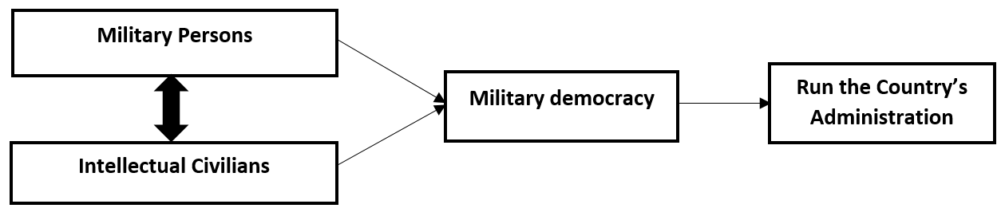**Fig 1:** Process of Establish Administration through Military Democracy

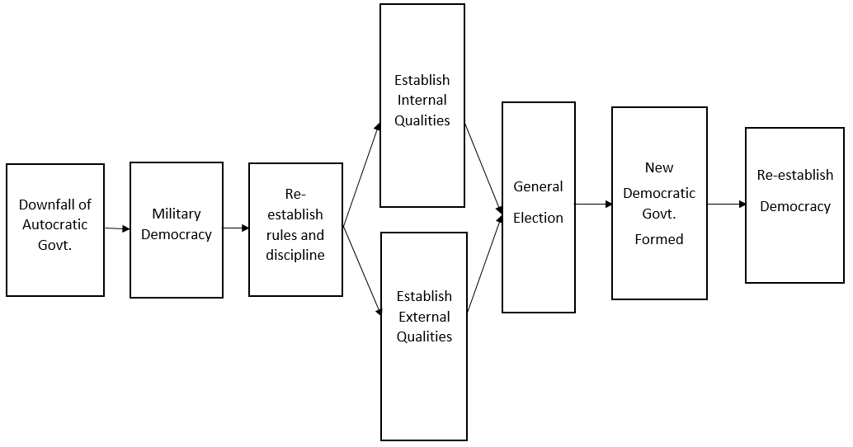

**Fig 2:** Process of Military Democracy in the Context of Bangladesh

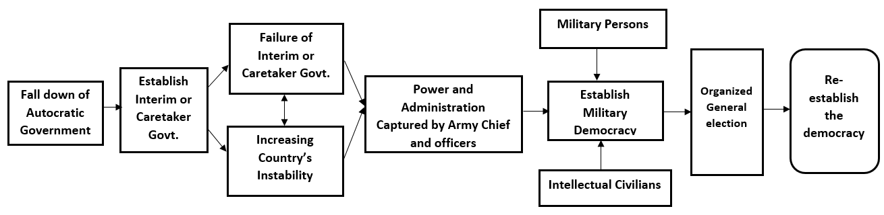

**Fig 3:** Process of Military Democracy If the Failure of Interim or Caretaker Govt.

**4. Effectiveness of Military Democracy in Bangladesh:**

The effectiveness of military democracy depends on the context in which it is applied. The distinctive goals it set forth, including “effective governance, oversight and accountability systems,” reflect traits commonly associated with military democracy in democratic nations (Blair, 2012). In these situations, it could be effective which are significant.

**1.** **Crisis or Conflict Situations:** Military democracy can be effective in times of war or external threats, where rapid decision-making, unity, and strong leadership are necessary for survival. The military structure helps maintain order, while the democratic element ensures leaders remain accountable to the people.

**2.** **Meritocratic Leadership:** Leaders in military democracies are often chosen based on ability rather than birthright, ensuring that leadership is based on merit and competence. This can create a system where the most capable individuals are in charge.

**3.** **Short-Term Governance:** As a temporary solution during upheaval, military democracy may provide stability and defense in a volatile environment, helping societies transition from one form of government to another.

**5. Qualities of Military Persons to Establish the Military Democracy to Re-establish Democracy:**

Engaging military leaders in governance could also serve to unify diverse political factions, encouraging collaboration and consensus-building in policymaking. As Bangladesh faces pressing challenges such as climate change and economic inequality, a stable governance model that incorporates disciplined military oversight could be instrumental in driving progressive reforms. To re-establish democracy the military persons should keep these qualities strong.

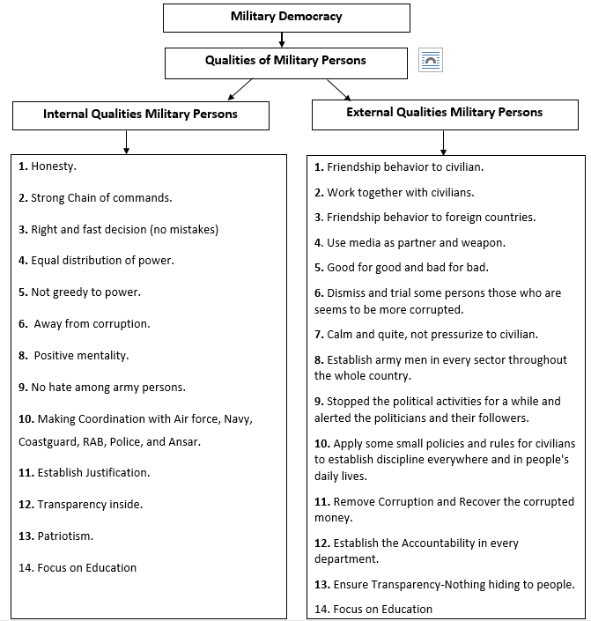

**Fig 4:** Qualities of Military Persons

**6. Factors Supporting the Possibility of Military Democracy in Bangladesh:**

The establishment of military democracy in Bangladesh-defined as a governance model where the military holds significant power in political affairs-presents both possibilities and challenges. In Bangladesh, the military has been instrumental during various dictatorial challenges on the journey toward democratic consolidation. Civilian control refers to the allocation of decision-making authority between civilians and military forces (Wolf, 2013). Here is an analysis of the current situation regarding this potential shift:

**1. Political Disturbance:** Bangladesh has experienced prolonged political instability, marked by violent confrontations between major political parties, particularly the Awami League and the BNP (Wolf, 2013). This ongoing conflict can create public sentiment favoring a military-led solution to restore order and stability.

**2. Public Trust in the Military:** Historically, the military in Bangladesh has been viewed as a stabilizing force. In times of crisis, there may be a significant portion of the population willing to support military intervention if it promises to restore order and effective governance (Wolf, 2013). Issues such as terrorism, regional instability, and natural disasters can exacerbate public support for a military role in governance, especially if the military is seen as effective in addressing these challenges.

**3. Weakness of Political Institutions:** If political institutions are perceived as ineffective, corrupt, or unable to address pressing issues like economic challenges, crime, and social unrest, the military may be seen as a viable alternative. This sentiment can pave the way for acceptance of a military-backed government. The historical precedent of military interventions (e.g., the 2007-2008 caretaker government) demonstrates that the military can step in during political turmoil (Wolf, 2013). If a similar scenario arises, there may be increased calls for military involvement.

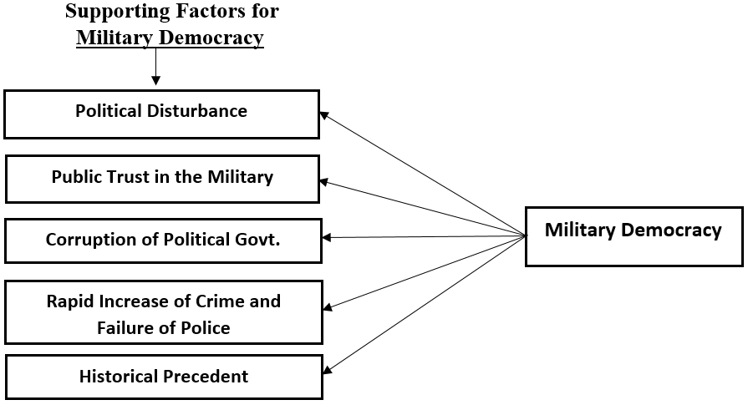

**Fig 5:** Supporting Factors for Military Democracy

**7. Challenges to Establishing Military Democracy in Bangladesh**

There are many inquiries regarding the complexities of civil-military democracy that can be posed in relation to the case presented. Huntington posits that officers bear a threefold duty to the state due to their roles as representatives, advisors, and executors (Starčević & Blagojević, 2021). The establishment of military democracy in Bangladesh may seem feasible under certain circumstances-such as political instability, public disillusionment with civilian governance, and perceived security threats-it is fraught with challenges. The potential for significant opposition from civil society, international scrutiny, and the risk of authoritarianism may deter both the military and the populace from embracing such a governance model. The future of governance in Bangladesh will depend on a complex interplay of political dynamics, public sentiment, and the military's own calculations regarding its role in society.

Bangladesh has a vibrant civil society, including political activists, human rights organizations, and students, who strongly advocate for democracy and human rights. Any attempt to establish military democracy could face significant opposition from these groups. Military regimes often curtail civil liberties, freedom of expression, and political pluralism. If military leaders were to establish a governance model, it could lead to long-term authoritarianism, which may provoke widespread dissent.

The legacy of previous military regimes in Bangladesh, which often led to human rights abuses and socio-political strife, could make the population wary of returning to military rule, complicating any attempts to establish military democracy. The current political landscape, characterized by entrenched party loyalties and identities, makes it difficult for any new governance model to gain widespread acceptance without significant conflict.

Military personnel can mitigate the above challenges to re-establish the democracy by adhering to internal and external qualities.

**8. Possible Scenarios for the Supports of UN (Limited Engagement):**

The prospect of the UN supporting military democracy in Bangladesh is highly unlikely due to its commitment to democratic governance, human rights, and international norms. Instead, any engagement with a military-led government would likely focus on humanitarian assistance, stability, and promoting a return to democratic governance rather than endorsing military rule.

If a military regime were established in the context of severe instability or humanitarian crises, the UN might provide humanitarian assistance or support for rebuilding efforts while advocating for a return to democratic governance. Stability and Peacekeeping: In cases where regional stability is threatened, the UN may engage with a military government to help maintain peace and security, particularly if there are concerns about extremist groups or civil unrest. The UN could offer to monitor human rights conditions and assist in creating a framework for a transition back to democracy. This could involve engagement with the military government while pressuring it to adhere to international norms and standards. The UN might facilitate dialogue between the military regime and opposition parties, promoting reconciliation and a peaceful transition to a more democratic form of governance. This would align with the UN's role in conflict resolution and peacebuilding.

**9. Potential Foreign Supports about Military Democracy in Bangladesh:**

While it is challenging to definitively identify foreign countries that openly support military democracy in Bangladesh, several countries have historical and strategic interests in the region that could influence their stance towards military governance through military democracy.

**1. China:**

China has significant economic interests in Bangladesh, particularly through investments in infrastructure as part of its Belt and Road Initiative (BRI). A stable military government could be viewed as beneficial for maintaining these investments. China may support military governance indirectly to counterbalance India’s influence in the region, particularly if a military regime is seen as more favorable to Chinese interests.

**2. Pakistan:**

Pakistan has maintained historical military-to-military relations with Bangladesh. Given their shared military legacy, Pakistan might support a military-led government, especially if it promotes regional stability or counters Indian influence.

**3. Saudi Arabia and Gulf States:**

These countries may have an interest in supporting military regimes in regions where they perceive threats, particularly from extremist groups. Stability in Bangladesh could be aligned with their broader security interests in South Asia.

**4. United States of America:**

While the U.S.A officially supports democratic governance, it has a history of cooperating with military regimes when it aligns with national security interests, particularly regarding counterterrorism efforts and regional stability. In cases of significant security threats or instability, the U.S.A may engage with military leaders to ensure stability in the region, although this would likely come with demands for eventual democratic reforms.

**5. India:**

While India traditionally supports democratic governance, it might engage with a military-led government in Bangladesh if it perceives that such a regime could better manage security issues related to insurgency or terrorism in the region. India may also prefer a stable government in Bangladesh, whether civilian or military, to prevent the rise of hostile entities.

**6. Russia:**

Russia aims to strengthen its influence in South Asia as part of its broader strategy to counter U.S.A dominance in this region. Supporting a military government in Bangladesh could be seen as a way to expand its geopolitical footprint. Russia might support military governance in Bangladesh to counter Western influence, particularly from the United States and European countries that advocate for democratic governance and human rights.

Russia has a history of military cooperation with Bangladesh, including arms sales and military training. A military government might enhance opportunities for Russia to deepen its defense ties and establish military bases or cooperative agreements in the region. A stable military government might be seen as conducive to investment in infrastructure and energy projects, areas where Russia has expressed interest, particularly in natural gas and power generation. Strengthening ties with a military government could provide Russia with access to Bangladeshi markets, which are strategically important in South Asia.

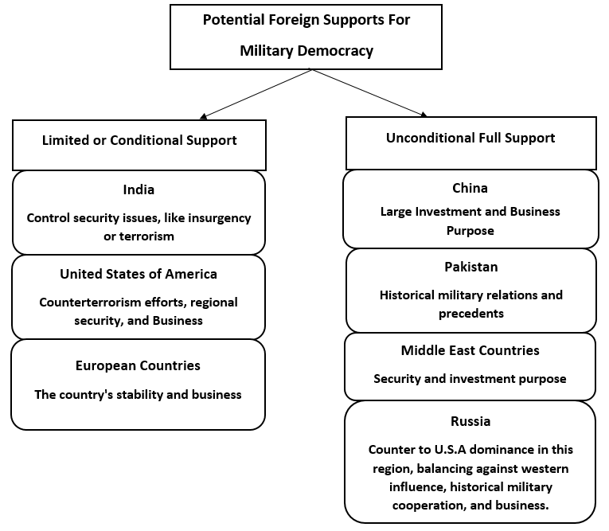

**Fig 6:** Potential Foreign Supports about Military Democracy

**10. Conclusion:**

In conclusion, while the concept of military democracy in Bangladesh requires careful consideration and must be approached with caution, the potential benefits of enhanced stability, efficient governance, and national unity present a promising avenue for fostering a brighter future for the country. Through inclusive dialogue and strategic implementation, Bangladesh can harness the strengths of both military and democratic elements to create a more resilient and prosperous society through re-establish democracy.

As Bangladesh navigates its complex socio-political landscape, adopting aspects of military democracy can reinforce institutional integrity and promote sustainable development. With a balanced approach that prioritizes both security and democratic values, Bangladesh has the potential to emerge as a more resilient and prosperous nation, ensuring peace and progress for all its citizens.

Implementing military democracy in Bangladesh today could offer a unique approach to addressing certain governance challenges while potentially strengthening national security and stability. By integrating military discipline, structure, and accountability within a democratic framework, this system might help enhance transparency, reduce corruption, and promote the common welfare in the country. As a final point, for such military democracy system to thrive and align with democratic ideals, it is crucial to emphasize civil rights, judicial independence, and a commitment to periodic, free, and fair elections. In this balanced approach, Bangladesh could foster a stable, secure, and progressive nation, advancing its development goals and enhancing its standing on the global stage.

**References:**

1. Blair, D. C. (2012). Military support for democracy. *Prism*, *3*(3), 3-16.

2. Ecevit, Y. A. (2020). Democratic transitions and the military: Evidence from Spain and Turkey. *Cihannüma: Tarih ve Coğrafya Araştırmaları Dergisi*, *6*(2), 179-204.

3. Frank, E. O., & Ukpere, W. I. (2012). The impact of military rule on democracy in Nigeria. *Journal of Social Sciences*, *33*(3), 285-292.

4. Maigre, M. (2009). Theories of Civil-Military Relations. *Akadeemia September*.

5. May, R. J., Lawson, S., & Selochan, V. (2004). Introduction: Democracy and the military in comparative perspective. In *The Militray and Democracy in Asia and the Pacific* (pp. 1-28). ANU E Press.

6. May, R., & Selochan, V. (2004). *The military and democracy in Asia and the Pacific* (p. 197). ANU Press.

7. Olapeju, R. M., Kolapo, S. J., & ADENIYI, O. P. (2024). MILITARY RESURGENCE AND LIBERAL DEMOCRACY IN AFRICA. *Journal of Political Discourse*, *2*(2 (2)), 42-57

8. Sadık, G. (2013). Comparative Analysis of Democratization and Civil-Military Relations in Turkey and South Korea till early 2000s. *Gazi Akademik Bakış*, (12), 205-222.

9. Starčević, S., & Blagojević, S. (2021). The autonomy of the military profession as a condition for civil and democratic control of the military and the fulfillment of the main social role of the military. *Vojno delo*, *73*(3), 121-133.

10. Wolf, S. O. (2013). Civil-military relations and democracy in Bangladesh. *Spotlight South Asia, Special Issue, Foundation for Applied Political Science of South Asia (APSA), Heidelberg*.