Addition of Steel fiber and Flyash to increase compressive strength of Self Compacting Concrete

Pravesh Pateriya1, Indrajeet N Yadav2

1, 2 Department of Civil Engineering, Shri Krishna University,

Chhatarpur, Madhya Pradesh, India

***Abstract*— One of the most popular composite materials in contemporary building is reinforced concrete (RC). Concrete is a rather brittle substance that is more robust when compressed but less so when stretched. Many constructions are not suited for plain, unreinforced concrete because of its inadequate ability to bear stresses caused by vibrations, wind loads, and other factors. Concrete can be strengthened by embedding steel rods, wires, mesh, or cables before it solidifies. This reinforcement, often known as rebar, resists tensile forces, In Present Investigation with cement block with different admixtures i.e. fly ash and steel fiber mixed together as a admixture in a cement block with a percentage of 15%, 20%, 25% for fly ash and steel fiber of diameter 1, 2 and 3mm , the compression test were perform on 36 block and found that the concrete block of M20 with a proportion of mixture 15% of fly ash and 20% of steel fiber exhibits optimum compressive strength with steel fiber of 1mm diamter, thus this results obtained are evaluated in Taguchi optimization with L9 orthogonal array with signal to noise ratio and found the optimum result in compressive strength of cement block compared to other admixture cube samples.**

***Keywords—*** ***Compressive Strength, Cement, Fly ash, Steel fiber, Taguchi, Signal to Noise ratio.***

# Introduction

The fact that the raw materials needed to make cement are limited and non-renewable and must be preserved for future generations is becoming more widely recognized. At some time in the industry, there is a strong tendency toward the faster usage of admixtures in concrete as a means of achieving sustainable building. Millions of tonnes of mineral admixtures are created as waste products of industrial processes, and disposing of them is a significant concern [1]. One such waste that is widely available in India's exclusive regions is ash from coal-based power plants. Concrete has a remarkable potential for using fly ash and might be the safest place for it to be used. Due to financial and technological assistance, fly ash, also known as pulverized gasoline ash, a commercial byproduct of coal-based thermal energy plants, contains finely split spherical silicate glass particles that have been replaced with iron and aluminum. It may be utilized in concrete. The characteristics of concrete are widely improved by the addition of fly ash.

## Fly Ash

The waste from burning pulverized coal that is gathered by mechanical dust collectors, electrostatic precipitators, or separators from the fuel gases of thermal strength flowers is known as fly ash or Pulverized Fuel Ash (PFA). The type of gasoline burned, the boiler's load, and the type of separators all affect its composition. Fly ash contains calcium, aluminum, and silicon oxides, however there is a far less amount of calcium oxide. The fly ash's silica concentration should be as high as is practical, while its carbon content should be as low as is practical.

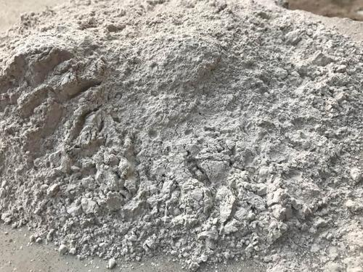

Figure 2 – Fly Ash (Source Internet)

## Advantages of Fly Ash

* Fly Ash improves concrete workability and reduces water demand
* Fly Ash generally exhibits less bleeding and segregation than plain concretes.
* Sulfate and alkali aggregate resistance.
* Fly Ash has lower heat of hydration.
* Fly Ash generally reduces the permeability and absorption of concrete.

## Objectives

* The objective of this study is “Optimization of fly ash and steel fiber composition in cement”. This requires following specific objectives:
* A study on Utilization of fly ash and steel fiber.
* Fly ash and steel fiber Strength Analysis.
* Characterization of fly ash and steel fiber on their physical and chemical properties.

# METHODOLOGY AND EXPERIMENT ANALYSIS

## **Material Used**

The basic ingredients of concrete block which were used in this research work are OPC (ultra tech cement), fly ash, copper slag and Natural Fine aggregate (sand), Water (fresh drinkable water).

## **Ordinary Portland Cement**

The ordinary Portland cement of 53grade manufactured by the ULTRATECH Cement Company was used in the study, which is in accordance with IS 12269:1987.Having design strength for 28 days being a minimum of 53 MPa or 530 kg/sqcm with baine of fly ash 353.6 m2/Kg.

Table 1 – Chemical Composition of Fly Ash

|  |  |  |  |  |  |  |
| --- | --- | --- | --- | --- | --- | --- |
| **Chemical Composition of Fly Ash** | | | | | | |
| LOI | Silica | CaO | Al2O3 | Fe2O3 | MgO | Chloride |
| 1.34 | 59.67 | 3.21 | 28.08 | 4.68 | 0.98 | 0.018 |

Table 2 – Physical Composition of Fly Ash

|  |  |  |  |  |
| --- | --- | --- | --- | --- |
| **Physical Composition of Fly Ash** | | | | |
|  | Blaine, M2/kg | 353.6 |  |  |
|  | Residue, % |  |  |  |
|  | 45µ | 12.48 |  |  |
|  | 19µ |  |  |  |

Table 3 – Chemical Composition of Steel fiber

|  |  |  |  |  |  |  |  |
| --- | --- | --- | --- | --- | --- | --- | --- |
| **C** | **Fe** | **Mn** | **P** | **S** | **Cr** | **Cu** | **Ni** |
| 0.34 | 0.60 | 0.44 | 0.21 | 0.03 | 4.78 | 0.08 | 0.15 |

Table 4 - Portland Composite Cement

|  |  |  |  |  |  |
| --- | --- | --- | --- | --- | --- |
| **Portland Composite Cement** | | | | | |
|
| **Materials** |  |  | **Fly ash%** | **Steel Fiber %** | **Total %** |
| Standard Composition% |  |  | 15-35 | 35-50 |  |
| Keeping Fly Ash only Variable |  |  | 15 | 45 | 100 |
|  |  |  |  |  |  |
|  |  |  | 20 | 40 | 100 |
|  |  |  |  |  |  |
|  |  |  | 25 | 35 | 100 |

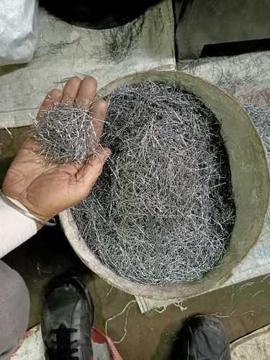

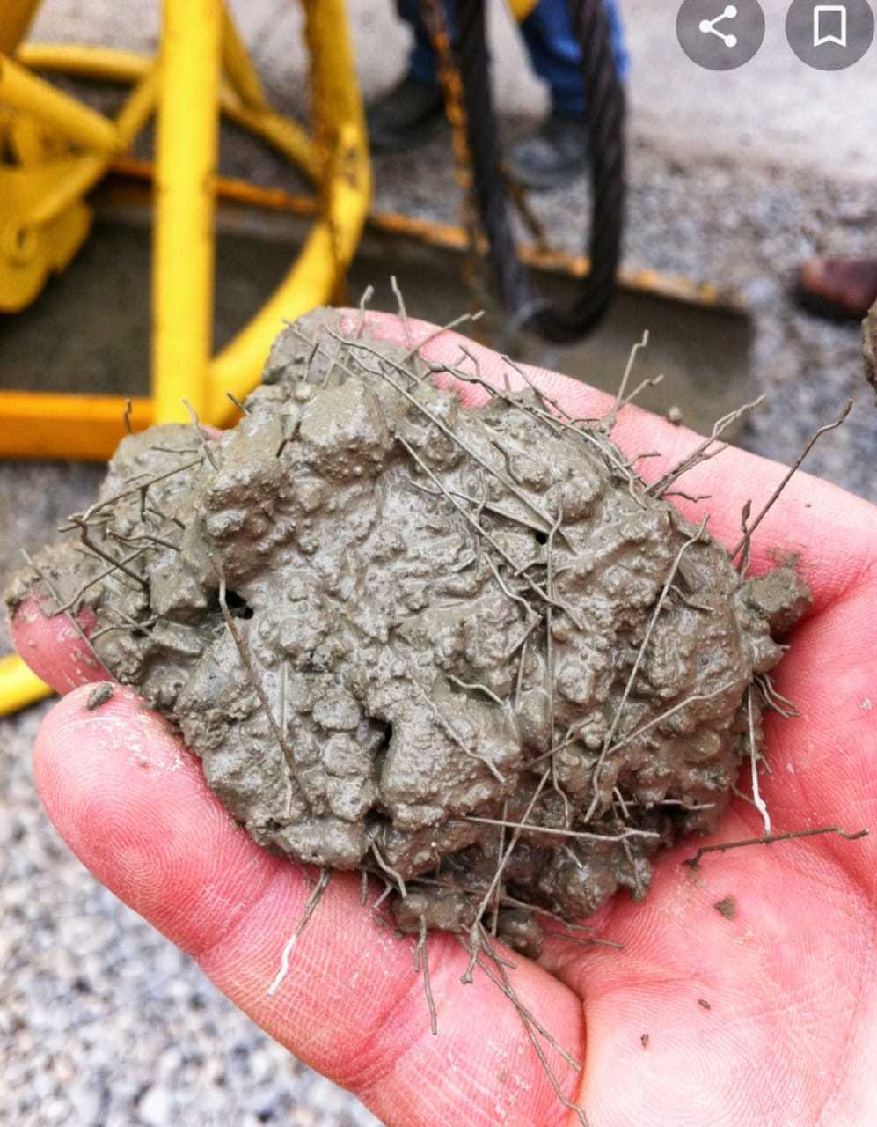

Figure: Batching of materials

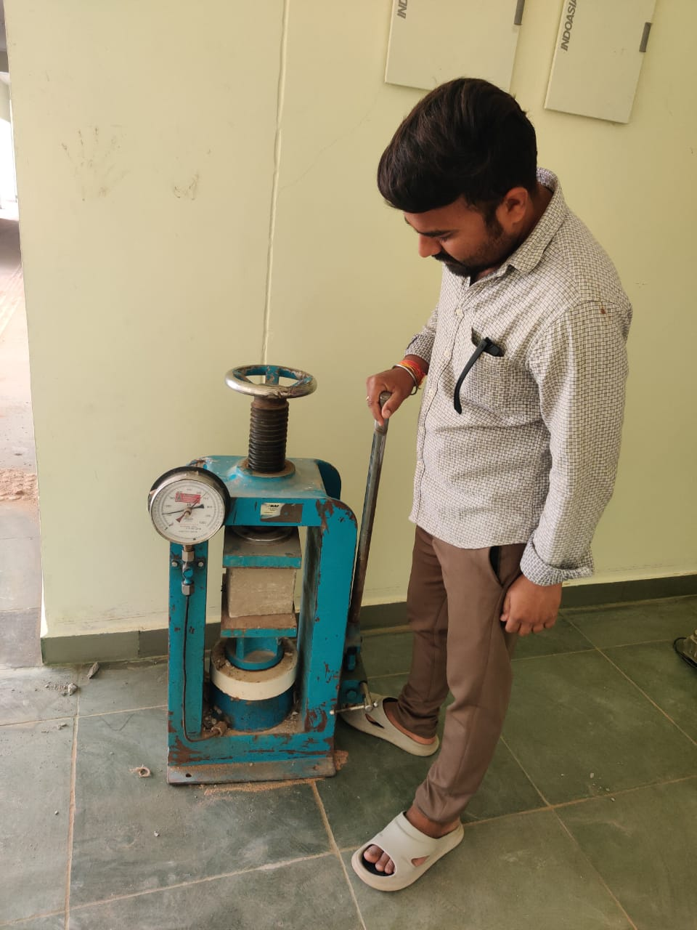

Figure: 4 Breaking of cube sample during compression test.

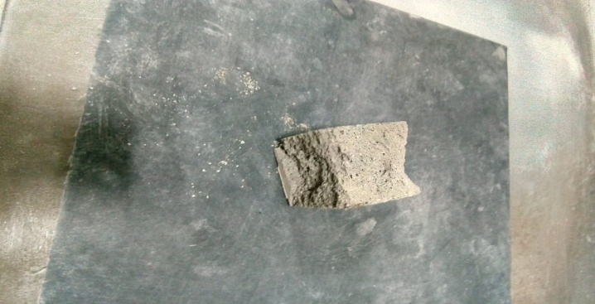

Figure: 5 Breaked cube after experimentation.

# RESULT ANALYSIS AND DISCUSSION

## Experimental Investigation Results for compressive strength test of cement cube with different percentage of admixture

|  |  |  |  |  |  |  |  |
| --- | --- | --- | --- | --- | --- | --- | --- |
| **No. of Experiment** | **Blaine of Flyash** | **Input Parameters** | | **Results O/P** | | | |
| **Fly Ash %** | **Steel fiber (Dia)** | **Compressive Strength (Mpa)** | | | |
| **1 day** | **3 days** | **7 days** | **28days** |
| 1 | 353.6 M2/Kg | 15 | 1 | 10 | 19 | 28 | 38 |
| 2 | 15 | 2 | 11 | 22 | 31 | 43 |
| 3 | 15 | 3 | 13 | 26 | 35 | 46 |
| 4 | 20 | 1 | 6 | 16 | 24 | 31 |
| 5 | 20 | 2 | 7 | 17 | 26 | 35 |
| 6 | 20 | 3 | 10 | 21 | 31.5 | 42 |
| 7 | 25 | 1 | 6 | 14 | 21 | 30 |
| 8 | 25 | 2 | 7 | 16 | 22 | 28 |
| 9 | 25 | 3 | 9 | 18 | 26 | 33 |

Figure: Graph shows Results of compressive strength test of cement cube of no. of day cured sample with different percentage of fly ash and steel fiber.

Figure: Graph shows of Result of Compressive Strength of cement cube with 3 days cured sample.

Figure No.: Graph shows of Result of Compressive Strength of cement cube with 7 days cured sample.

Figure No.:Results of compressive strength test of overall comparison for different admixture.

CONCLUSIONS

* According to interaction plot of mean (Taguchi) it can be seen that graph are nearby parallel which means that is not much interaction between steel fiber and fly ash.
* The compressive strength also depends upon the type of coal used in power plant if the class C and F type of fly ash shows different impact on strength.
* Total no. of trails can be upto 27 but with the help of Taguchi design of experiment method. The optimum results are achieved in trails.

The compressive strength in composition where fly ash is 15% and steel fiber of diameter 3mm is best in comparison with other trails. This composition shows better strength between 1 to 28 no. of days.

##### References

1. [PriyeshJani](https://www.sciencedirect.com/science/article/abs/pii/S092041052100067X#!) et al., “Class C fly ash-based alkali activated cement as a potential alternative cement for CO2 storage applications”, [Journal of Petroleum Science and Engineering](https://www.sciencedirect.com/science/journal/09204105) [Volume 201](https://www.sciencedirect.com/science/journal/09204105/201/supp/C), June 2021, 108408.
2. [ChengLiu](https://www.sciencedirect.com/science/article/abs/pii/S0950061821015944#!) et al., “Effect of curing temperature on hydration, microstructure and ionic diffusivity of fly ash blended cement paste: A modelling study”, [Construction and Building Materials](https://www.sciencedirect.com/science/journal/09500618) [Volume 297](https://www.sciencedirect.com/science/journal/09500618/297/supp/C), 23 August 2021, 123834.
3. [N.Vanitha](https://www.sciencedirect.com/science/article/pii/S2214785321029448#!) et al., “Effect of TiO2, Al2O3 and CaCO3 nano-additives in singular, binary and ternary forms on the mechanical, thermal and microstructural propertites of fly ash supplemented cement matrix”, <https://doi.org/10.1016/j.matpr.2021.04.088>.
4. [ZhiqiangWei](https://www.sciencedirect.com/science/article/abs/pii/S0950061821012678#!) et al., “The role of sucrose on enhancing properties of graphene oxide reinforced cement composites containing fly ash”, [Construction and Building Materials](https://www.sciencedirect.com/science/journal/09500618) [Volume 293](https://www.sciencedirect.com/science/journal/09500618/293/supp/C), 26 July 2021, 123507.
5. [Jin-huaHuo](https://www.sciencedirect.com/science/article/abs/pii/S1875510021001748#!) et al., “Thermal control effects and mechanism of slag and fly ash on heat development of cement slurry used in hydrate formation”, [Journal of Natural Gas Science and Engineering](https://www.sciencedirect.com/science/journal/18755100) [Volume 91](https://www.sciencedirect.com/science/journal/18755100/91/supp/C), July 2021, 103967
6. [JinYang](https://www.sciencedirect.com/science/article/abs/pii/S095006182100917X#!) et al., “Improving durability of heat-cured high volume fly ash cement mortar by wet-grinding activation”, [Construction and Building Materials](https://www.sciencedirect.com/science/journal/09500618) [Volume 289](https://www.sciencedirect.com/science/journal/09500618/289/supp/C), 28 June 2021, 123157
7. [JingMeng](https://www.sciencedirect.com/science/article/abs/pii/S0950061820334747#!) et al., “Interfacial design of nano-TiO2 modified fly ash-cement based low carbon composites”, [Construction and Building Materials](https://www.sciencedirect.com/science/journal/09500618) [Volume 270](https://www.sciencedirect.com/science/journal/09500618/270/supp/C), 8 February 2021, 121470
8. [Lori E.Tunstall](https://www.sciencedirect.com/science/article/abs/pii/S0008884621000016#!) et al., “A new hypothesis for air loss in cement systems containing fly ash”, [Cement and Concrete Research](https://www.sciencedirect.com/science/journal/00088846) [Volume 142](https://www.sciencedirect.com/science/journal/00088846/142/supp/C), April 2021, 106352.
9. [BaixingSong](https://www.sciencedirect.com/science/article/abs/pii/S0950061821008734#!) et al., “Effect of early CO2 curing on the chloride transport and binding behaviors of fly ash-blended Portland cement”, [Construction and Building Materials](https://www.sciencedirect.com/science/journal/09500618) [Volume 288](https://www.sciencedirect.com/science/journal/09500618/288/supp/C), 21 June 2021, 123113
10. [JayanthMahadevan](https://www.sciencedirect.com/science/article/pii/S2214785320379268#!) et al., “Rheological and strength properties of fly ash incorporated rapid hardening cement mix”, <https://doi.org/10.1016/j.matpr.2020.10.315>
11. [Y.Sun](https://www.sciencedirect.com/science/article/abs/pii/S0950061820335364#!) et al., “Prediction of compressive strength development for blended cement mortar considering fly ash fineness and replacement ratio”, [Construction and Building Materials](https://www.sciencedirect.com/science/journal/09500618) [Volume 271](https://www.sciencedirect.com/science/journal/09500618/271/supp/C), 15 February 2021, 121532
12. [SalmanSiddique](https://www.sciencedirect.com/science/article/abs/pii/S0950061821009107#!) et al., “Properties of high-volume slag cement mortar incorporating circulating fluidized bed combustion fly ash and bottom ash”, [Construction and Building Materials](https://www.sciencedirect.com/science/journal/09500618) [Volume 289](https://www.sciencedirect.com/science/journal/09500618/289/supp/C), 28 June 2021, 123150
13. [ChaoZhang](https://www.sciencedirect.com/science/article/abs/pii/S0950061821001100#!) et al., “High-volume ultrafine fly ash-cement slurry mechanical properties and strength development model establishment”, [Construction and Building Materials](https://www.sciencedirect.com/science/journal/09500618) [Volume 277](https://www.sciencedirect.com/science/journal/09500618/277/supp/C), 29 March 2021, 122350
14. [YangSun](https://www.sciencedirect.com/science/article/abs/pii/S0950061820319401#!) et al., “Research on properties evolution of ultrafine fly ash and cement composite”, [Construction and Building Materials](https://www.sciencedirect.com/science/journal/09500618) [Volume 261](https://www.sciencedirect.com/science/journal/09500618/261/supp/C), 20 November 2020, 119935
15. [Khairunisa Muthusamy](https://www.sciencedirect.com/science/article/pii/S2214785320390738#!)et al., “Durability properties of oil palm shell lightweight aggregate concrete containing fly ash as partial cement replacement”, <https://doi.org/10.1016/j.matpr.2020.10.1003> [Volume 41, Part 1](https://www.sciencedirect.com/science/journal/22147853/41/part/P1), 2021, Pages 56-60
16. [ChengLiu](https://www.sciencedirect.com/science/article/abs/pii/S0958946520300780#!)et al., “Modelling of 3D microstructure and effective diffusivity of fly ash blended cement paste”, [Cement and Concrete Composites](https://www.sciencedirect.com/science/journal/09589465) [Volume 110](https://www.sciencedirect.com/science/journal/09589465/110/supp/C), July 2020, 103586
17. [JanFořt](https://www.sciencedirect.com/science/article/abs/pii/S0950061820335480#!)et al., “Biomass fly ash as an alternative to coal fly ash in blended cements: Functional aspects”, [Construction and Building Materials](https://www.sciencedirect.com/science/journal/09500618) [Volume 271](https://www.sciencedirect.com/science/journal/09500618/271/supp/C), 15 February 2021, 121544
18. [IvanMironyuk](https://www.sciencedirect.com/science/article/pii/S2214785319335163#!)et al., “Effect of surface-modified fly ash on compressive strength of cement mortar”, <https://doi.org/10.1016/j.matpr.2019.10.016>, [Volume 35, Part 4](https://www.sciencedirect.com/science/journal/22147853/35/part/P4), 2021, Pages 534-537
19. [JinYang](https://www.sciencedirect.com/science/article/pii/S0950061820328993#!)et al., “Effect of steam curing on compressive strength and microstructure of high volume ultrafine fly ash cement mortar”, [Construction and Building Materials](https://www.sciencedirect.com/science/journal/09500618) [Volume 266, Part A](https://www.sciencedirect.com/science/journal/09500618/266/part/PA), 10 January 2021, 120894
20. [Tausif EElahi](https://www.sciencedirect.com/science/article/abs/pii/S0950061821001276#!)et al., “Engineering characteristics of compressed earth blocks stabilized with cement and fly ash”, [Construction and Building Materials](https://www.sciencedirect.com/science/journal/09500618) [Volume 277](https://www.sciencedirect.com/science/journal/09500618/277/supp/C), 29 March 2021, 122367