**ABSTRACT**

Business expansion through data analysis in Power BI focuses on gaining a comprehensive understanding of sales performance by leveraging its powerful analytics and visualization capabilities. A structured methodology is followed, ensuring a systematic approach to data collection, exploration, cleaning, transformation, and visualization to derive meaningful business indicators. Understanding sales performance is essential for business growth, and Power BI provides robust analytics and visualization tools to facilitate data-driven decision-making. This project focuses on analyzing key sales metrics and trends to gain valuable insights that support strategic business expansion. A structured methodology is implemented, involving data collection, exploration, cleaning, transformation, and visualization to extract meaningful business indicators. As the marketing landscape evolves, businesses often struggle to track sales performance effectively. This study aims to create a comprehensive report for the store, offering a detailed analysis of sales trends, customer behavior, and market demand. By leveraging Power BI’s advanced analytics capabilities, the report will highlight areas for improvement, identify opportunities, and help the store make well-informed decisions to enhance overall performance and profitability. This study highlights Power BI’s role in enabling businesses to leverage data for expansion, optimize their strategies, and improve overall decision-making processes.

**INTRODCTION**

In today’s fast-paced business world, companies must rely on data-driven insights to make informed expansion decisions. Identifying the top-performing cities and understanding regional sales trends are crucial for business growth. This project leverages Power BI, SQL, PostgreSQL, and MySQL to analyze sales data, offering a comprehensive approach to strategic decision-making. By integrating these technologies, businesses can efficiently extract, clean, transform, and visualize sales data to uncover key performance metrics. SQL and PostgreSQL enable effective management of large datasets, ensuring accurate data organization and retrieval. MySQL facilitates structured storage and seamless handling of transactional records. Power BI, serving as the primary analytics tool, transforms raw data into interactive dashboards and detailed reports, making complex insights easily accessible. Power BI’s advanced features, including Power Query for data integration, DAX for complex calculations, and Quick Insights powered by machine learning, enhance the depth of analysis. These tools help businesses detect hidden patterns, correlations, and customer behavior trends, enabling them to refine marketing strategies and optimize expansion efforts. This study demonstrates how real-time data analytics can empower organizations to analyze sales fluctuations, assess regional demand, and drive business growth. By integrating SQL-based databases with Power BI, companies can generate actionable intelligence that enhances decision-making, operational efficiency, and overall market performance.

**Aim:**

The Morning Coffee Store sales analysis project leverages data analytics to address key business questions related to coffee sales, customer behavior, and potential market growth across various cities in India. The goal of this paper is to provide actionable insights into the store's sales performance and customer behavior, facilitating strategic decisions for business expansion. Coffee Consumers Count: We estimated the number of people consuming coffee in each city, assuming that 25% of the population consumes coffee. This calculation helps determine the potential customer base in each region, giving us insight into market demand. Total Revenue from Coffee Sales: We calculated the total revenue generated from coffee sales across all cities during the last quarter of 2023. This allowed us to understand the store's overall sales performance and pinpoint areas for improvement in revenue generation. Sales Count for Each Product: By analyzing the data, we determined the total number of units sold for each coffee product, helping us understand which products are popular and which ones need more attention in terms of marketing or inventory adjustments. Average Sales Amount per City: We calculated the average sales per customer in each city, giving us a deeper understanding of customer purchasing behavior. This information is vital for evaluating the effectiveness of our pricing strategy in different regions. City Population and Coffee Consumers: We compiled a list of cities along with their populations and estimated coffee consumers, which helped identify regions with high coffee demand and potential for future business growth. Top Selling Products by City: We analyzed which coffee products were the top 3 sellers in each city based on sales volume. This helped us better understand regional preferences and adapt product offerings accordingly.

Customer Segmentation by City: We identified the number of unique customers in each city who purchased coffee products. This segmentation allowed us to understand customer loyalty and determine the effectiveness of promotions targeting distinct customer groups. Impact of Estimated Rent on Sales: We analyzed the average sale per customer and average rent per customer across different cities, helping us understand the relationship between rent and sales performance. This insight is useful for optimizing store locations and determining which regions offer the best return on investment. Monthly Sales Growth: We measured the percentage growth or decline in sales on a monthly basis, tracking sales fluctuations. This analysis helped us identify seasonal patterns and assess the effectiveness of sales strategies over time. Market Potential Analysis: We identified the top 3 cities with the highest sales by analyzing total sales, rent, total customers, and estimated coffee consumers. This information allowed us to focus expansion efforts in cities with the highest market potential.

By addressing these questions, this project provides a comprehensive understanding of the Morning Coffee Store's sales trends, customer behavior, and market potential. The insights gained from this analysis will enable the store to make informed decisions for business expansion and optimize sales strategies to maximize profitability across different cities in India.

The most important steps include: **1. Data Collection:** Describe how sales data was collected, including data sources and initial challenges. **2. Data Cleansing:** Explain the steps to clean the data, including handling missing values and ensuring data integrity. **3. Data Transformation:** Explain how the data was transformed to obtain appropriate metrics and indicators for sales analysis. This can include aggregating or creating calculated fields. **4. Creating Power BI Dashboards:** Describe the design and development of Power BI dashboards, highlighting the selection of visualizations and interactions to convey meaningful information. **5.** Analysis and Insights: Present the results of data analysis, including key performance indicators (KPIs) and actionable insights. **6. Limitations and Future Work:** Recognize any limitations of the analysis and suggest areas for future research or improvements. **7. ETL (Extract, Transform, Load):** Once we know the basic functions of the data we have to work with, I import the MySQL database into Power BI to perform the necessary transformations and get a reliable and useful framework table.

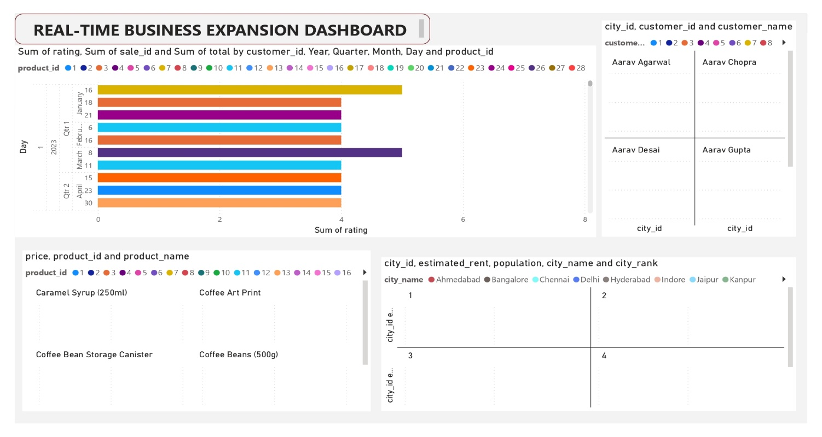

**2. CONCLUSION**

SQL and Power BI are two powerful tools that work together to help businesses make data-driven decisions. SQL is used to manage and organize large amounts of data stored in databases. It allows users to query, clean, and structure data, making sure it's accurate and ready for analysis. SQL is like the backbone for handling all the raw information, ensuring that it’s well-organized before analysis.

Power BI, on the other hand, takes that organized data and turns it into visual reports and dashboards that are easy to understand. It connects to various data sources, including SQL, and allows users to create interactive charts, graphs, and insights. Power BI helps turn complex data into clear visualizations, making it easier for businesses to spot trends and make informed decisions. Together, SQL handles the data, while Power BI makes it easy to interpret and act on it.

**City 1: Pune**

• Average rent per customer is very low.

• Highest total revenue.

• Average sales per customer is also high.

**City 2: Delhi**

• Highest estimated coffee consumers at 7.7 million.

• Highest total number of customers, which is 68.

• Average rent per customer is 330 (still under 500).

**City 3: Jaipur**

• Highest number of customers, which is 69.

• Average rent per customer is very low at 156.

• Average sales per customer is better at 11.6k.

3. REFERENCES

[1] Adamala, S. & Cidrin, L. (2011). Key Success Factors in Business Intelligence. Journal of Intelligence Studies in Business, Vol. 1(1).

[2] Alaskar, T., & Efthimios, P. (2015). Business Intelligence Capabilities and Implementation Strategies. International Journal of Global Business, Vol. 8 (1), pp. 34- 45.

[4] https://www.ijraset.com/research-paper/data-analysis-and-visualization-of-sales-dataset-usingpower-bi

[8] https://journalofbigdata.springeropen.com/articles/10.1186/s40537-015-0030-3

[9] https://hevodata.com/learn/10-best-power-bi-reports-examples/

[10] https://powerbi.microsoft.com/en-us/

[11] https://rigorousthemes.com/blog/best-power-bi-dashboard-examples/ [12] https://inblog.in/Power-BI-Projects-HdlkEZeaXK