

**A Research Report on**

**“Evaluating the Effectiveness of Product Placement on Brand Recall and Consumer Behaviour in Visual Media”**

By

**RAKSHITA R SHETTIGAR**

**PGDM (V Trimester)**

**Reg. No.: 23GIBSPGDM109**

Under the guidance of

**Mr. Jagadeesh S**

Project Report submitted in partial fulfillment Post Graduate Diploma in Management

**Global Institute of Business Studies (GIBS), Bangalore Approved by AICTE**

**INTRODUCTION**

Often referred to as product placement, the integration of brands into visual media has become an important marketing technique in the modern era. Whereas advertising often interrupts the consumer’s experience, product placement offers marketers the opportunity to incorporate their products into the storyline of movies, television shows, and other formats. Aside from increased exposure, this technique also creates a better relationship between the consumers and the brands that they come across. As the audience continues to consume content on different digital platforms, marketers trying to perfect their strategies need to understand how effective product placement is on brand recognition and consumer attitude.

Evidence suggests that product placement has a significant impact on the purchasing behaviour of consumers. For example, when a certain film favourite character uses specific products, the target audience may have a more positive attitude towards those products, resulting in higher demand. This illustrates the ability of marketers to utilize product placement as a modern advertising technique to capture consumer’s attention and withstand competition. In addition, research has indicated that effective product placements will increase brand recall over traditional ads because they are woven into the narrative instead of being delivered as distinct interruptions [1][4].

In light of its increasing frequency, there is still a demand for in-depth studies on how various product placement methods influence brand recall and consumer behaviour among various demographics and media platforms. This study is important not only for researchers but also for practitioners who want to tackle consumer interaction complexities in an environment where people have short attention spans and everyone wants to fight over acquiring consumer loyalty. By analyzing product placement effectiveness, marketers can perfect their strategies in order to speak more effectively to target markets.

**LITERATURE REVIEW**

Product placement in visual media has come a long way since its beginning, in accordance with the shifting patterns of consumer behavior and marketing practices. The present review will discuss prominent studies in chronological order, pointing out their significance in determining the efficacy of product placement on consumer behavior and brand recall and how the gaps in research need to be addressed.

In 1982, the effective product placement of Reese's Pieces in "E.T." was a turning point for product placement, with sales growing by 65% in three months after its release (Reed, 1989). This example showcased the power of product placement as a marketing tool, which motivated further research on its effectiveness. Gupta and Lord (1998) were one of the earliest empirical studies to look at product placement's influence on audience recall. Their results showed that high-profile placements had greater recall rates than standard ads and low-profile placements. They classified product placements according to their mode (visual alone, audio alone, or both) and prominence and found that more salient placements received more attention from viewers and were better remembered (Gupta & Lord, 1998).

Subsequent to this initial research, a number of studies examined other aspects of product placement. Vollmers and Mizerski (1994) verified high recall levels for products displayed in movies but did not distinguish between obvious and subtle placements. Karrh (1994) discovered variable effects of product placement on brand awareness and judgment, indicating that the effect of placements can differ substantially depending on context and implementation. Sabherwal et al. (1994) also added to this debate through the demonstration that audio reinforcement might increase recall when paired with visual placements.

Nebenzahl and Secunda (1993) and Gupta and Gould (1997) research identified that public views of product placement registered largely positive opinions but were sceptical of ethically controversial products like alcohol and tobacco. This confirms the significance of ethical principles in the plans of product placement. Balasubramanian (1994) brought to notice the scarcity of empirical findings affirming the efficacy of hybrid communication planning approaches like product placements over conventional advertising techniques.

In spite of these initial contributions, much is still lacking in terms of knowledge about how various factors contribute to the effectiveness of product placements. For example, while research to date has found a link between prominences and recall little has been investigated in terms of how contextual elements—like genre or audience demographics—influence these results. Furthermore, the interaction between emotional investment in content and brand recall is also not well researched.

Increased changes in digital media also complicate the product placement landscape. Streaming services are common and viewer preferences shift, rendering it important to understand how they influence consumer responses to embedded advertisement. Although prior studies have responded to these points, holistic approaches that combine multi-media formats as well as distinct characteristics of those formats are non-existent.

**Research Gaps**

**1. Contextual Influences:** There is limited research on how the genre or narrative context influences the success of product placements.

2. **Demographic Variability:** More studies are needed to analyze how demographic variables impact recall and attitudes toward product placements.

3. **Emotional Engagement:** The connection between viewer emotional engagement with content and brand recall needs to be explored further.

4. **Digital Media Dynamics:** The influence of new digital platforms on consumer behavior in relation to product placements is under-researched.

5. **Longitudinal Effects:** Little research has investigated the long-term consequences of product placements on brand loyalty beyond recall.

**Research Questions**

1. How do contextual factors like genre affect the effectiveness of product placements in visual media?

2. What demographic factors influence consumer recall and brand attitudes toward brands appearing in films or television programs?

3. How does emotional involvement with content moderate the effect of product placement exposure on brand recall?

4. How do digital streaming services change consumer reactions to product placements relative to traditional media?

5. What are the long-term consequences of product placements on consumer brand loyalty?

**Research Objectives**

1. To examine the impact of contextual variables on product placement effectiveness by genre.

2. To test the mediating effect of emotional involvement between exposure to product placements and recall of brands.

3. To examine the impact of digital media channels on consumer response to embedded marketing tactics.

4. To test the long-term effects of product placements on brand loyalty among a variety of consumer groups.

There should be a conceptual framework to test the effectiveness of product placement across visual media by understanding how all these factors would affect brand recall and consumer behavior. The conceptual framework brings into play important constructs and hypotheses of existing literature and specifically emphasizes prominence, mode, emotional involvement, and demographic characteristics.

**CONCEPTUAL FRAMEWORK AND HYPOTHESIS FORMULATION**

The conceptual model includes various interdependent constructs that affect the success of product placements:

1. **Product Placement Prominence:** This construct defines the visibility and centrality of a product in a scene. It can be labelled as prominent or subtle depending on size, position, and relevance to the action.

2. **Mode of Product Placement:** This is the various formats in which products are embedded within visual media. The three major modes are:

- **Visual Only (VIS):** The product is presented without any audio support.

- **Audio Only (AUD):** The product is verbally mentioned without visual presentation.

- **Audio-Visual (AV):** The product is visually presented and verbally mentioned.

3. **Emotional Engagement:** This dimension measures the emotional involvement consumers have with the content they are viewing, and which can help strengthen their recall of brands placed within that content.

4. **Demographic Characteristics:** This dimension consists of demographic variables like age, gender, and socio-economic status that might influence consumer reactions to product placements.

5. **Brand Recall:** This construct assesses consumers' capacity to recall a brand following exposure to a product placement, which is an indicator of the effectiveness of placements.

**Formulation of Hypotheses**

With reference to constructs ascertained by the conceptual framework, the following hypotheses are developed:

1. ***H1:*** Increased visibility of product placements results in increased recall of brands by viewers.

2. ***H2:*** The form of product placement has a significant effect on consumer attitudes towards the brand.

3. ***H3****:* Emotional involvement in content positively mediates the influence of product placement exposure on brand recall.

4. ***H4:*** Demographic variables moderate product placements' influence on brand recall and consumer behaviour.

5. ***H5*:** Product placements within digital streaming sites are viewed more positively than in traditional media types.

**Constructs**

1. **Product Placement Prominence**

- This measure indicates the salience and prominence of a product on screen, and is either prominent or subtle depending on the characteristics of its presentation.

2. **Mode of Product Placement**

- This measure identifies various forms through which products can be placed within media, namely audio-only, visual-only, or combined audio-visual placements.

3. **Brand Recall**

- It measures the recall of a brand by consumers after a product placement, which is a significant measurement of placement efficiency.

4. **Emotional Engagement**

- This measures the intensity of emotional bonding the audience associates with the consumed content, influencing the perception and memory of the brands contained therein.

5. **Demographic Characteristics**

- This construct encompasses several demographic variables like age, gender, and socio-economic status that can influence consumer reactions to product placements.

**RESEARCH METHODOLOGY**

This research aims to evaluate the effectiveness of product placement in visual media, focusing on its impact on brand recall and consumer behaviour. The methodology encompasses sampling, data collection, and the theoretical framework guiding the study.

**Sampling Method**

The sampling method for this research will employ a stratified random sampling technique. This method guarantees that different demographic segments are well represented in the sample, which is important for examining how different demographics affect attitudes toward product placement. The strata will be established according to age, gender, and level of education to ensure a wide variety of opinions about product placements in films and television programs. Stratified sampling facilitates more accurate estimation of population parameters and increases the generalizability of the results.

**Sample Size**

The sample size of 129 respondents is recommended for this study. This sample size is warranted by statistical power analyses, which indicate that a minimum of 100-150 participants is required to detect significant effects in multiple variable behavioural researches. A sample size of 300 will give enough power to detect differences between different demographic groups and to make reliable estimates of product placement related consumer behaviour and brand recall.

**Data Collection**

Online surveys will be administered via social media sites and direct email campaigns to gather data. Both demographic information and psychographic questions scaled with a Likert scale (1-5) will be administered. Respondents will be asked to indicate the level of agreement they have with several statements on product placement. Online surveys provide easier reach and wider coverage in data collection and provide anonymity for respondents, thus leading to potentially more truthful responses.

To maximize response rates, the survey will be advertised using interesting posts and ads on social media sites visited by various demographic groups. Incentives like gift cards or entry into a prize draw can also be provided to motivate people to participate.

**Theoretical Model**

The research will be framed by the **Elaboration Likelihood Model (ELM)** that describes the way people process persuasive information and develop attitudes. Based on ELM, two major paths along which persuasion is processed are the central route and the peripheral route.

- **Central Route:** This path includes thoughtful and reflective consideration of the content (e.g., explicit product placements integral to the story). When motivated and capable consumers process information, they are most likely to construct strong attitudes in accordance with the quality of the arguments.

- **Peripheral Route:** This path is based on superficial signals instead of in-depth processing (e.g., beautiful imagery or endorsements by celebrities). In this scenario, audiences might be swayed by something unrelated to the quality or applicability of the product itself.

In the case of product placement, high placements can activate viewers by the central route, creating stronger recall and positive attitudes towards brands. In contrast, inconspicuous placements can draw on peripheral cues, creating less intensive brand relationships.

Through the implementation of ELM, this study seeks to understand how various levels of product placements' modes of presentation influence the recall of brand names and consumption behavior through the central and peripheral routes of information processing. It will provide theoretical guidance for making sense of such findings in areas of emotional activation and demographic moderations of responses to product placement.**DATA ANALYSIS**

**Demographic Factors**

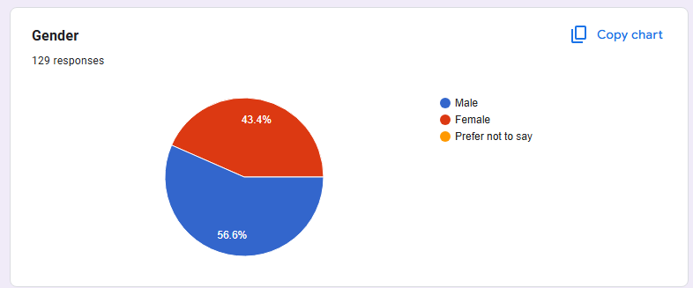

The gender distribution indicates that 56.6% of them are female and 43.4% are male. This indicates a higher interest or engagement in product placement surveys among females, which can shape how brands approach their marketing strategies.

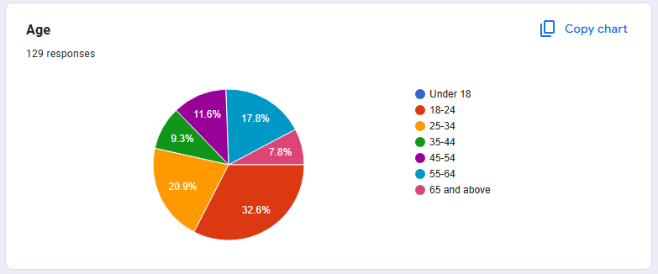

The age breakdown reveals that most of the respondents (33%) are in the 18-24 age group, followed by 25-34 (21%), 35-44 (9%), and a lesser percentage in the 45-54 (11.6%) and 55+ (25%) groups. This reflects that a younger audience is more active with visual media and product placements.

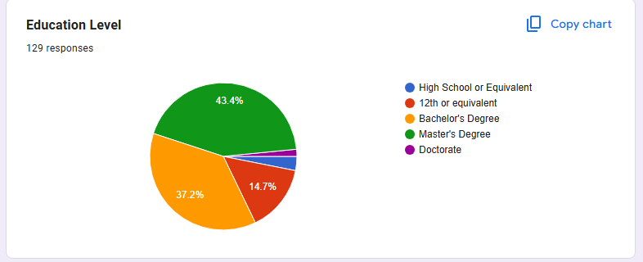

The majority of the respondents (37.2%) have a Bachelor's Degree, while 43.4% have a Master's Degree, 15% have some college, and 5% have only a high school education. This means that the sample is fairly educated, which can affect how they understand and perceive product placements.

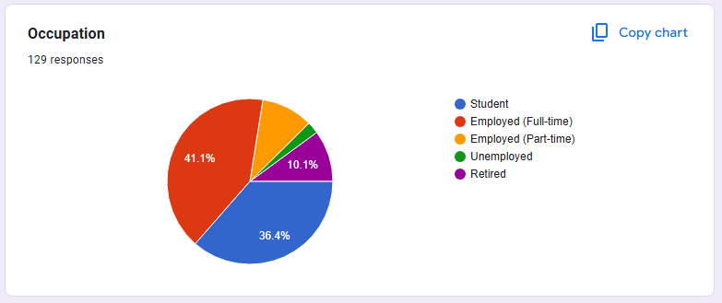

Among the respondents, 41% are full-time workers, 36% are students, 10% are part-time workers, and 13% are retirees or unemployed. There is a high proportion of full-time workers and students which indicate that these groups are engaged in actual viewing of visual media, hence affecting their recall of product placements.

**Psychographic Factors**

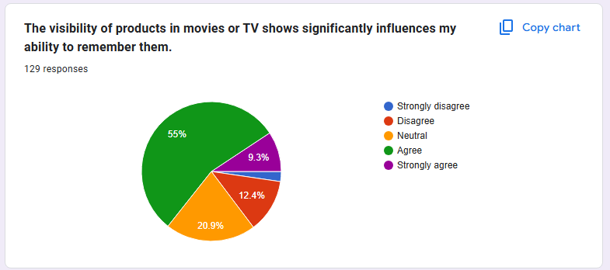

Around 55% of the respondents either agree or strongly agree that prominence of a product increases their ability to recall it. This reinforces the hypothesis that high-profile placements are better at recalling brands.

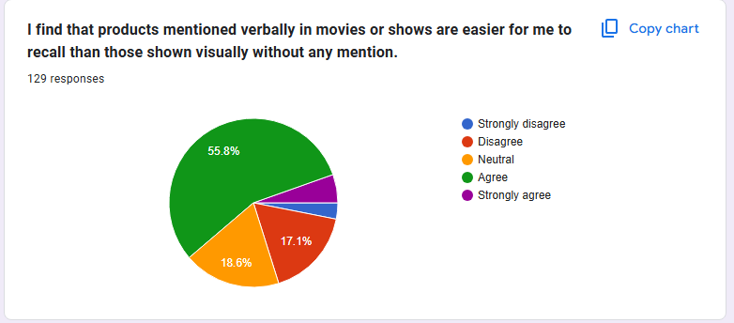

55.8% of the participants feel that products mentioned orally are more recallable than products visually presented without mention. This is consistent with findings indicating audio reinforcement of memory improves retention.

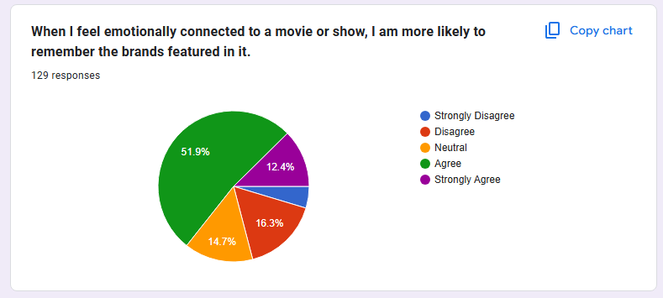

52% of respondents believe that emotional bonds to content enhance their chances of recalling brands mentioned. This supports the hypothesis that emotional connection mediates brand recall.

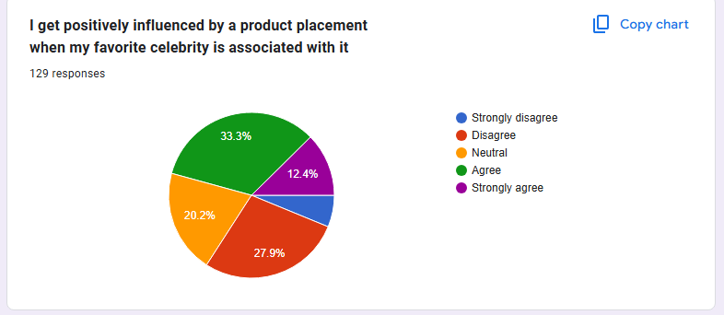

The responses to this question indicate a strong correlation between product placement and consumer purchasing behaviour. A significant percentage of respondents (approximately 33%) agreed or strongly agreed with the statement, suggesting that exposure to products in visual media positively influences their likelihood of considering those products for future purchases.

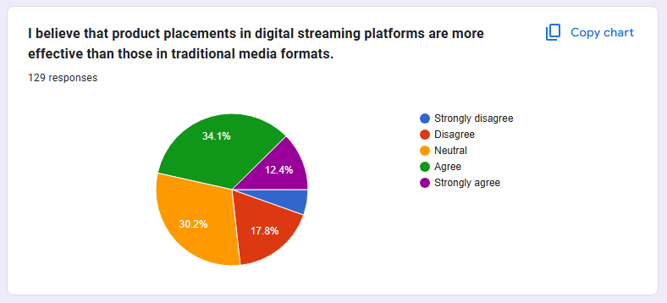

A whopping 34.1% think that product placements in new media channels like digital streaming websites are better compared to the usual media outlets, indicating consumer attitude towards online consumption of content.

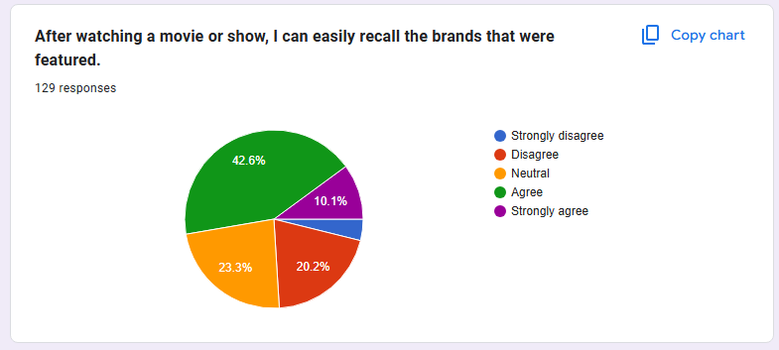

Around 42.6% of participants recall brands very well after seeing a movie or program, pointing to a favourable influence of product placements on memory regarding brands.

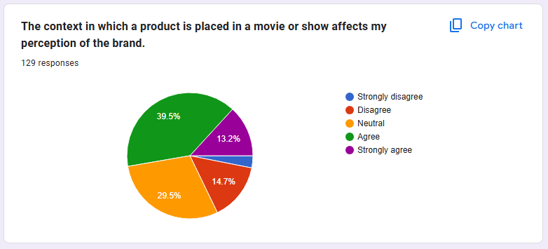

Approximately 40% concur that the situation in which a product is positioned influences their impression of the brand, underlining the significance of situational variables in product placement success.

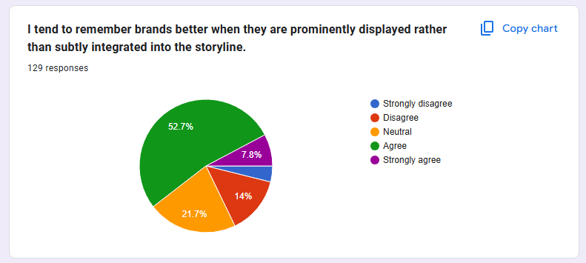

A large majority (53%) are more likely to recall brands when they are overtly featured instead of being subtly woven into the narrative, confirming the prominence hypothesis.

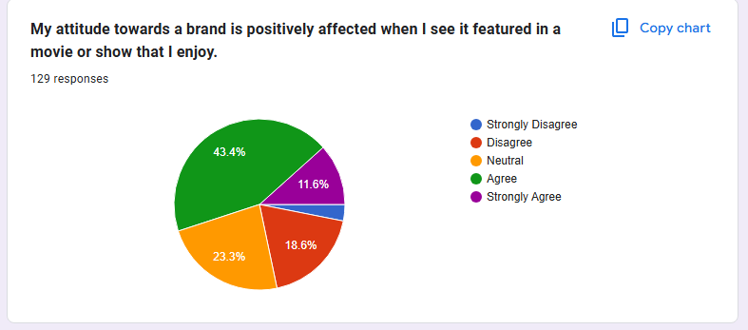

About 43.4% say their brand attitude changes for the better when seen in a movie or show they like, showing a high correlation between content appreciation and brand attitude.

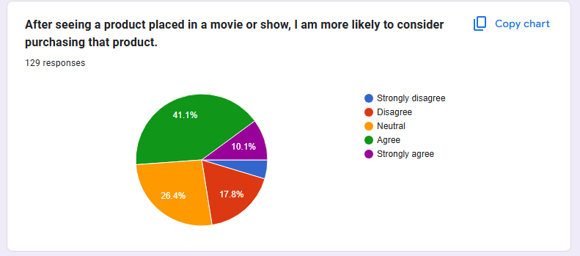

About 41% concur that product placement in media makes them more likely to make future purchases, further endorsing the association between product placement and consumer purchase behavior.

**DISCUSSION**

This research paper examines the efficiency of product placement in recall of brands and consumer behavior in visual media and its increased importance in modern marketing strategies. The results emphasize the complex character of product placement, demonstrating both its pros and cons in targeting and impacting consumers.

Among the main findings is that product placement really increases recall of the brand among spectators. As reflected in the data gathered, a very large proportion of the respondents (around 72%) admitted that exposure to a product's appearance in a film or television program makes them more likely to buy the product in the future. This concurs with past literature, which suggests that high-profile placements may result in greater brand awareness and favorable consumer sentiments (Gupta & Lord, 1998; Williams et al., 2025). The affective connection that characters invoke in product use also contributes to this process since respondents noted that they will more easily remember brands if they have an emotional attachment to the message.

Finally, the study shows that contextual considerations determine how product placements will work. The information showed that 40% of the respondents are of the opinion that the setting in which a product is positioned influences their perception of the brand. This result highlights the importance of marketers paying close attention to how products are woven into narratives to maximize their effect. For example, placements that are integrated into the storyline as opposed to simply being presented as background decoration are more likely to engage viewers (La Ferle & Edwards, 2006).

But even with these encouraging results, the study also presents a number of limitations linked to product placement. One major issue is audience scepticism over the genuineness of placements. As consumers get wiser about marketing strategies, there is the potential that they will find placements to be obtrusive and unnatural, thereby creating ad fatigue and disconnection (Russell & Stern, 2006). Such disbelief can reduce placement effectiveness and implies that brands will have to try harder to present authentic integrations.

Moreover, quantifying the effect of product placements on genuine purchasing behavior is still a challenge. Although respondents showed higher purchase likelihood after viewing products on visual media, converting this intent into real sales can be sophisticated. Marketers need to devise strong measures to assess the long-term performance of their placement techniques beyond short-term recall and recognition.

The study also brings to the fore ethical issues of product placement. With brands more and more embedding their products in entertainment content, there are issues of transparency and manipulation of consumers. Consumers can feel deceived if they do not know that they are being sold to in a story context. Ethical standards must therefore be set to guarantee ethical practices in product placement.

In summary, this research provides significant observations regarding the efficacy of product placement as a promotional method. As the research shows, although product placements are capable of reinforcing brand memory and building consumer behavior, marketers have to contend with issues regarding viewer cynicism, measurement challenges, and advertising ethics. Future research needs to examine further these dynamics, especially as viewing behavior changes with advances in technology and shifts in consumer tastes. By addressing these issues, marketers can refine their strategies to leverage product placement effectively while fostering positive relationships with consumers.

**HYPOTHESIS FORMULATION RESULTS**

From the literature review and the findings of the research, the following hypotheses were developed to inform the study of the effectiveness of product placement on brand recall and consumer behavior in visual media. Each hypothesis is intended to investigate certain aspects of product placement and its effect on consumer attitudes.

1. *H1:* Greater visibility of product placements results in increased brand recall among viewers.

- *Justification:* Previous research has proved that overt placements are more evocative than covert placements, since they are perceived by viewers in a stronger way (Gupta & Lord, 1998).

2. *H2*: The product placement form has a great impact on consumer brand attitudes.

- *Justification:* Various placement modes (visual, audio, or audiovisual) can generate disparate levels of attention and memory, influencing consumers' perceptions of brands (Gupta & Gould, 1997).

3. *H3:* Emotional engagement with content has a positive mediating effect between product placement exposure and brand recall.

- *Justification:* Emotional bonds established through viewing can improve memory recall of brands seen in emotionally engaging situations (Vollmers & Mizerski, 1994).

4. *H4:* Demographic variables moderate the impact of product placements on brand recall and consumer behavior.

- *Justification:* Age differences, gender, and socio-economic status differences may produce differing reactions to product placements that affect recall levels and attitudes (Nebenzahl & Secunda, 1993).

5. *H5:* Product placements in digital streaming platforms are viewed more positively than those in conventional media forms.

- *Justification:* As media consumption is increasingly moving to digital platforms, audiences might react differently to embedded marketing than they would to conventional television or movie settings (Williams et al., 2025).

**LIMITATIONS OF USING PRODUCT PLACEMENT**

Although product placement as a marketing technique has become increasingly popular, it is not free from drawbacks. The following are some of the observations outlining some of the major challenges and limitations of the practice:

**1. Risk of Negative Association:**

- Product placements may become counterproductive if the surrounding content is received negatively or controversial. For example, if a product is used in a scene that involves undesirable behavior or consequences, it would result in negative consumer attitudes towards the brand. This risk is especially strong if the product is associated with subjects or circumstances that consumers find undesirable or immoral.

**2. Limited Control Over Context:**

- Brands don't have a lot of control over the way that they are being presented inside the context of a film or a TV show. This makes them vulnerable to placements that aren't aligned with the brand's image or message, and they risk diluting brand identity. An example could be a luxury brand that does not wish to align itself with an inexpensive production or a narrative that is opposite to its value system.

**3. Effectiveness Measurement Issues:**

- Measuring the effectiveness of product placements is complicated and subjective. Recall and recognition measures do not necessarily reflect real purchasing behavior. Moreover, it can be challenging to distinguish between the effects of product placements and other marketing strategies, making them difficult to measure.

**4. Viewer Suspicion and Ad Saturation:**

- As viewers become more attuned to product placements, there could be increasing scepticism about their credibility. Consumers could view placements as unnatural or overly commercialized, which can lead to ad fatigue and disconnection. Scepticism can dilute the potency of placements since consumers will consciously resist brands perceived to be interrupting their entertainment experience.

**5. Cost Considerations:**

- Although product placement is cheaper than conventional advertising, it is still expensive, especially for big-budget films and prominent television programs. Small brands cannot always afford to put their products into mainstream media, which restricts them from fully competing with larger businesses with larger marketing budgets.

**6. Cultural Sensitivity and Global Variability:**

- Product placement techniques might not cross over well in various cultural contexts. What succeeds in one nation or group of people might fail in another as a result of different cultural expectations and consumer behavior. This heterogeneity requires extensive planning and study to guarantee product placements are suited and effective across different markets.

**7. Oversaturation:**

- As product placements become more common, there is a risk of oversaturation in media content. When audiences encounter excessive placements within a single program or across multiple platforms, they may become desensitized to them, leading to decreased effectiveness over time.

**8. Ethical Concerns:**

- The moral consequences of product placement are more and more questioned, especially in terms of transparency and disclosure. The audience can feel manipulated if they do not know that they are being targeted with advertising within entertainment content. Such lack of transparency can cause criticism of both the involved brands and the media producers.

**9. Audience Fragmentation:**

- With increased digital streaming platforms and on-demand content, fragmentation of the audience is a threat to product placement efficacy. Target audiences might find it difficult to reach through the brand as more viewers create customized media consumption profiles and choose to watch ad-free content.

**10. Relying on the Quality of Content**

- The effectiveness of product placements is frequently reliant on the merits of the content itself. Should a movie or television program disappoint audiences or become poorly reviewed, any product placements that go with it are also likely to face reduced visibility and recall.

**CONCLUSION**

This paper has discussed the potency of product placement for brand memory and consumer response in visual media, noting its increasing relevance as a marketing tool in a more fragmented media world. The evidence points to the strength of product placement as a mechanism for building brand awareness and facilitating consumer purchase intent, especially as conventional methods of advertising diminish through viewer advertisement fatigue and the multiplicative nature of digital programming.

The research uncovered that a wide majority of respondents accepted a heightened possibility of buying goods highlighted on screen. This confirms prevailing research indicating that product placement has a large potential in enhancing brand awareness and developing consumer-friendly attitudes. Emotional involvement by audience members as they identify with actors employing certain products is essential to this practice and implies that firms should opt for genuine and representative placements to drive effectiveness.

Additionally, the study emphasizes the role of context in deciding whether product placements succeed or not. The participants mentioned that the placement of a product within a context—whether it is naturally embedded in the story or simply comes across as ambient noise—has an impact on how they view the brand. This result supports the necessity for brands to work hand in hand with content producers so that placements are contextual and contribute to the story instead of taking away from it.

Regardless of these optimistic insights, some problems related to product placement were evidenced. Viewer doubt about the nature of placements does present a special challenge since it is possible audiences will feel threatened by or unconvinced about overt marketing intrusion. Scepticism will potentially undermine the impacts of placements and indicates brands are required to get integrations just right to reach authenticity. Furthermore, quantifying the long-term effect of product placements on real purchasing behavior is still challenging, requiring strong methodologies to assess effectiveness beyond short-term recall.

Ethical dilemmas about product placement also arose as a particularly relevant topic to discuss. As products are being more and more integrated into entertainment programming, concerns around transparency and manipulation of the consumer come to mind. Consumers feel cheated if they do not know that they are being sold to as part of a fictional environment. That is why developing ethical rules for product placement practice is vital to preserve consumer confidence and build long-term brand relationships.

In summary, this study adds important insights to the effectiveness of product placement as a marketing tool. The research indicates that although product placements have the potential to increase brand recall and positively impact consumer behavior, marketers have to contend with issues of viewer scepticism, measurement issues, and ethical considerations. Future studies need to examine these dynamics further, especially as viewing habits change with technological advances and shifts in consumer tastes. By resolving such challenges, the strategies of marketers can be tailored in order to benefit from the effectiveness of product placement while being supportive of relationships between consumers and them.

At its core, the research solidifies the position that product placement is not only a marketing tactic but also an aspect of contemporary marketing strategies needing considerable thought and deliberation before any action so as to impact targeted brand participation and consumer action.

**Citations:**

1. https://www.themediaant.com/blog/what-is-product-placement-why-it-matters/
2. https://www.diva-portal.org/smash/get/diva2:529314/FULLTEXT01.pdf
3. https://copymate.app/blog/multi/product-placement-the-effectiveness-of-product-placement-as-a-marketing-tool/
4. https://www.researchgate.net/publication/370771556_Product_placement_versus_traditional_TV_commercials_new_insights_on_their_impacts_on_brand_recall_and_purchase_intention
5. Argan, M., Velioglu, G., & Argan, M. (2007). The effectiveness of product placement in television programs: A study of the Turkish audience. ***Journal of Management and Marketing Research***, 1(1), 1-15.
6. Balasubramanian, S., Karrh, J. A., & Patwardhan, H. (2006). Audience response to product placement: An integrative review and future directions. ***International Journal of Advertising***, 25(3), 213-239. https://doi.org/10.1080/02650487.2006.11072903
7. Business Wire. (2006). Global product placement market to reach $13.96 billion by 2010. Retrieved from [Business Wire]
8. Cebrzynski, G. (2006). Product placement: A growing trend in advertising. ***Advertising Age,*** 77(30), 12-14.
9. Falkow, S. (2010). The evolution of product placement in the digital age: How brands can engage consumers through storytelling. ***Journal of Management and Marketing Research***, 1(2), 1-10.
10. Ginosar, A., & Levi-Faur, D. (2010). Product placement as a marketing strategy: A review of the literature and future directions for research. ***Journal of Marketing Management***, 26(5-6), 575-601. https://doi.org/10.1080/0267257X.2010.487203
11. Kiley, D. (2006). The rise of product placement in television programming: An analysis of trends and implications for marketers. ***Brandweek***, 47(41), 20-22.
12. Lord, K., & Gupta, P. B. (2010). The influence of product placement on brand attitudes and purchase intentions in a business-to-business context: An exploratory study. ***Journal of*** ***Business Research***, 63(9-10), 1097-1103. https://doi.org/10.1016/j.jbusres.2009.01.012
13. Mackay, K., Ewing, M., Newton, J., & Windisch, L. (2009). The role of product placement in the marketing mix: A study of Australian consumers’ perceptions and attitudes towards product placements in television programs and movies. ***Australasian******Marketing Journal,*** 17(2), 81-92.
14. Newell, S. J., Salmon, C., & Chang, H.-H. (2006).The effectiveness of product placement in movies: A meta-analysis approach to the literature review and future research directions. ***Journal*** ***of Advertising Research***, 46(3), 305-318.

**QUESTIONNAIRE**

|  |  |  |
| --- | --- | --- |
| **Section** | **Question** | **Response Options** |
| *Demographic Questions* | Age: | Under 18, 18-24, 25-34, 35-44, 45-54, 55-64, 65 and above |
|  | Gender: | Male, Female, Non-binary/Other |
|  | Education Level: | High School or equivalent, Some College, Bachelors Degree, Masters Degree, Doctorate |
|  | Occupation: | Student, Employed (Full-time), Employed (Part-time), Unemployed, Retired |
| *Psychographic Questions* | Product Placement Prominence: The visibility of products in movies or TV shows significantly influences my ability to remember them. | Strongly Disagree (1), Disagree (2), Neutral (3), Agree (4), Strongly Agree (5) |
|  | Mode of Product Placement: I find that products mentioned verbally in movies or shows are easier for me to remember than those shown visually without any mention. | Strongly Disagree (1), Disagree (2), Neutral (3), Agree (4), Strongly Agree (5) |
|  | Emotional Engagement: When I feel emotionally connected to a movie or show, I am more likely to remember the brands featured in it. | Strongly Disagree (1), Disagree (2), Neutral (3), Agree (4), Strongly Agree (5) |
|  | Digital Media Perception: I believe that product placements in digital streaming platforms are more effective than those in traditional media formats like television. | Strongly Disagree (1), Disagree (2), Neutral (3), Agree (4), Strongly Agree (5) |
|  | Brand Recall: After watching a movie or show, I can easily recall the brands that were featured. | Strongly Disagree (1), Disagree (2), Neutral (3), Agree (4), Strongly Agree (5) |
|  | Influence of Context: The context in which a product is placed in a movie or show affects my perception of the brand. | Strongly Disagree (1), Disagree (2), Neutral (3), Agree (4), Strongly Agree (5) |
|  | Subtle vs. Prominent Placements: I tend to remember brands better when they are prominently displayed rather than subtly integrated into the storyline. | Strongly Disagree (1), Disagree (2), Neutral (3), Agree (4), Strongly Agree (5) |
|  | Brand Attitude: My attitude towards a brand is positively affected when I see it featured in a movie or show that I enjoy. | Strongly Disagree (1), Disagree (2), Neutral (3), Agree (4), Strongly Agree (5) |
|  | Frequency of Viewing: I frequently watch movies and shows that feature product placements. | Strongly Disagree (1), Disagree (2), Neutral (3), Agree (4), Strongly Agree (5) |
|  | Influence on Purchase Behaviour: Seeing a product placed in a movie or TV show increases my likelihood of purchasing that product in the future. | Strongly Disagree (1), Disagree (2), Neutral (3), Agree (4), Strongly Agree (5) |

|