**Comprehensive Phytochemical Analysis of *Croton Macrostachyus* Leaves: A Preliminary Study.**

Gemechu Duguma Argessa 1

Email: [gemechudug@gmail.com](mailto:gemechudug@gmail.com),

1\*Department of Industrial Chemistry, College of Natural & Computational Sciences, Bule Hora University, Hagere Mariyam, Ethiopia

Gemechu Duguma Argessa: [**https://orcid.org/0009-0009-2371-9783**](https://orcid.org/0009-0009-2371-9783)

**Highlights**

Here are the highlightsof this research article.

* Comprehensive phytochemical screening of *Croton macrostachyus* leaf extract to identify bioactive compounds.
* Qualitative analysis confirmed the presence of alkaloids, flavonoids, saponins, terpenoids, glycosides, and phenols, while tannins were absent.
* Phytochemicals detected are known for their pharmacological properties, including antimicrobial, antioxidant, and anti-inflammatory effects.
* Experimental methods included standard biochemical tests such as Shinoda’s, Hager’s, Froth, and Salkowski’s tests for compound identification.
* Findings support the traditional medicinal use of *C. macrostachyus* and highlight its potential for drug discovery.

# **ABSTRACT**

*Medicinal plants have long been a valuable source of bioactive compounds with diverse pharmacological applications. Croton macrostachyus, a species from the Euphorbiaceae family, has been traditionally used in African medicine to manage ailments such as malaria, bacterial infections, gastrointestinal disorders, and inflammation. However, limited research has been conducted on the phytochemical composition of its leaves. This study aimed to perform a qualitative phytochemical screening of C. macrostachyus leaf extracts to identify key secondary metabolites. Standard biochemical assays were conducted to detect the presence of alkaloids, flavonoids, tannins, saponins, terpenoids, glycosides, and phenolic compounds. The results confirmed the presence of alkaloids, flavonoids, saponins, terpenoids, glycosides, and phenolic compounds, while tannins were absent. These findings align with previous reports on Croton species and suggest that C. macrostachyus leaves contain bioactive compounds with potential medicinal applications, including antimicrobial, antioxidant, and anti-inflammatory properties. Further studies are recommended to isolate, characterize, and evaluate the pharmacological potential of these compounds to support the development of plant-based therapeutic agents.*

**Key words:** bioactive compounds, potential, qualitative and valuable.

1. **INTRODUCTION**

Medicinal plants have played a crucial role in traditional and modern medicine, serving as a rich source of bioactive compounds with potential pharmacological applications. These plants contain secondary metabolites that contribute to their therapeutic properties, making them essential in drug discovery and development. One such medicinal plant is *Croton macrostachyus,* a species belonging to the Euphorbiaceae family, which is widely distributed across tropical Africa. Traditionally, various parts of this plant, including its leaves, bark, and roots, have been used to manage ailments such as malaria, bacterial infections, gastrointestinal disorders, and inflammatory conditions (1,2).

Phytochemical screening is a fundamental process in identifying the bioactive compounds present in plants. This analysis helps in understanding the medicinal potential of plants by detecting secondary metabolites such as alkaloids, flavonoids, tannins, saponins, and terpenoids. These compounds exhibit diverse biological activities, including antimicrobial, antioxidant, anti-inflammatory, and anticancer properties (3,4). Several studies have documented the presence of bioactive constituents in different Croton species, highlighting their pharmacological significance. However, despite its extensive traditional use, limited research has been conducted on the phytochemical composition of *C. macrostachyus* leaves, leaving a knowledge gap regarding its full therapeutic potential (5,6).

This study aims to conduct a qualitative and quantitative phytochemical screening of *C. macrostachyus* leaf extracts. By identifying and analyzing the secondary metabolites present in this plant, the research seeks to provide scientific validation for its traditional medicinal applications. The findings from this study could contribute to the discovery of novel bioactive compounds and support the development of plant-based pharmaceuticals.

## **2. QUALITATIVE PHYTOCHEMICAL SCREENING ANALYSIS**

### **2.1 Preparation of Stock Solution for phytochemical Screening.**

Phytochemical screenings are preliminary tests used to detect the presence of primary and secondary metabolites in an extract. This study focuses on qualitative phytochemical screening of *C. macrostachyus* leaves extract to identify secondary metabolite compounds. Standard procedures were used for each test to confirm the presence or absence of secondary metabolites (7, 8).

During preliminary screening the sample was tested for the presence or absence of secondary metabolites such as alkaloids, steroidal compounds, phenolic compound, flavonoids, saponins, tannins and cardiac glycosides. The following bioactive tests has been performed to confirm the presence or absence of the secondary metabolites in the leave extracts.

A stock solution of 5g/ l00ml was prepared by mixing 5gm of milled *Croton macrostachoiu*s with 100 ml of distilled water and it was filtered by using Whatman No.1 filter paper. All three-stock solutions were made by this way.

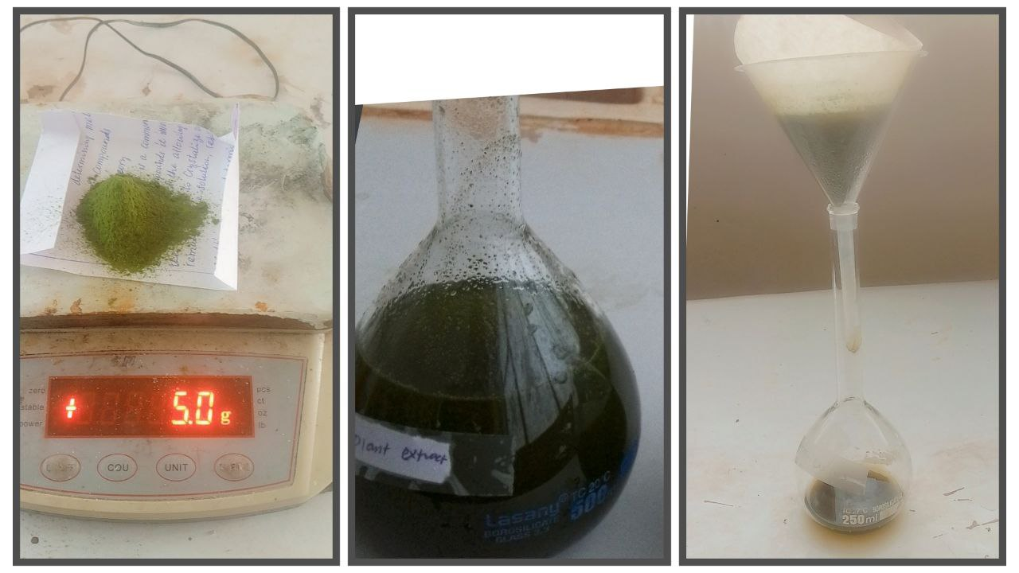  
Figure 1 Plant extract stock solution preparation and filtration for phytochemical Screening.

#### Test for flavonoids

**Shinoda’s test. : -** About 1mL of *Croton macrostachoius* aqueous leaves extract were taken into a test tube. Then, few drops of concentrated hydrochloric acid was added followed by boiling chips and shaken. Emergence of pink coloration showed the presence of flavonoids (9, 10, and 11).

#### Test for Tannins

**Gelatin’s test: -** 1mL of *C. macrostachyus* aqueous leaves extract were taken and placed in a test tube. Then 1% gelatin solution containing sodium chloride was added and shaken. Absence of white precipitate indicates the disappearance of tannins in the extract (9, 10, and 11).

#### Test for Alkaloids

**Hager’s test: -** 2mL of solution of an extract were taken into a test tube. After that a few drops of saturated ferric solution (Hager’s reagent) were added and it was shaken immediately. Formation of yellow-colored precipitate indicates the existence of alkaloids (9, 10, and 11).

#### Test for Saponins

2 ml of distilled water were added to 2 ml of plant extract sample and shaken vigorously lengthwise for 15 min in a graduated cylinder. A layer of foam 1 cm or more thick confirmed the existence of saponins in the test extract (9, 10, and 11).

#### Test for phenol

**Ferric chloride test: -** 1mL solution of an extract were taken and placed into a test tube. Then 1% gelatin solution containing sodium chloride was added and shaken. Formation of bluish-black color confirmed the presence of phenol (9, 10, and 11).

#### Test for Glycosides

**Ferric chloride Test:** 2mL of the aqueous leaves extract were mixed in to 5 ml of conc. H2SO4 and it was boiled for 15 min. Then it was cooled and neutralized with 20% KOH. Then the solution was divided into two portions. Three drops of ferric chloride solution was added to one of the portions, and a green to black precipitate indicated phenolic glycone as a result of hydrolysis of glycoside (9, 10, and 11).

#### Test for Steroids

**Salkowski’s test: -** About 5 mL *C. macrostachyus* aqueous leaves extract was taken in to a test tube and concentrated sulphuric acid was added by drop wise. The formation of red colour confirmed the presence of steroids (9, 10, and 11).

## **3. RESULTS AND DISCUSSION**

## **3.1. Phytochemical Analysis of *Croton macrostachyus* leaf extract.**

The biochemical assays were done to check the secondary metabolites present in the sample of *C. macrostachyus* aqueous leaf extract that was collected. After performing several tests, the secondary metabolites and its phytochemicalconstituents present in it were identified. A total of seven phytochemical tests were performed to see the presence of alkaloids, steroids, flavonoids, phenols, saponins, tannins and cardiac glycosides.

### **Test results for phenolic compounds**

**Ferric chloride test :** Test for phenols showed strong positive results which were formation of bluish-black color shows a positive result. (Fig 2).

|  |  |
| --- | --- |
| **C:\Users\THIS PC\Downloads\Telegram Desktop\IMG_20240716_125817_288.jpg** | Test for **phenol** were showed a strong Positive result. |

Figure 2 Results for Ferric chloride test for phenolic compounds.

### **Test results for flavonoids**

**Shinoda’s test :-** This test was done to find out the presence of flavonoids in *Croton macrostachoius* leaves by adding a few drops of concentrated hydrochloric acid and boiling chips then shaken. Emergence of pink coloration indicates for positive result [47 -49]. The result was showed in Figure 3 below.

|  |  |
| --- | --- |
| C:\Users\user\Desktop\Project photo\Research (1)\111\2021-09-05_17.24.58.jpg | Test for in **flavonoids** were showed a positive result. |

Figure 3 Results for Shinoda’s test for flavanoid compounds.

Test results for alkaloids

For testing alkaloids 3 different types of tests were carried out.

(a) **Hager’s Test:** This test involving the addition of 2ml of extract to 3 drops of Hager‟s reagent shows yellow precipitation in presence of alkaloids. Fig 4 below shows the test results for alkaloids in *C. macrostachyus*. The yellow precipitate in the three extracts showed a positive result (9, 10 and 11).

|  |  |
| --- | --- |
| C:\Users\user\Desktop\Project photo\Research (1)\111\2021-09-05_17.23.43.jpg | Test for **alkaloids** were showed a positive result. |

Figure 4 Results for Hager’s Test for alkaloid compounds

#### Test results for tannins

For testing the presence of tannin, 1% gelatin solution containing sodium chloride added and shaken. A yellow precipitate shows a positive result (10).(fig 5).

|  |  |
| --- | --- |
| C:\Users\THIS PC\Downloads\Telegram Desktop\IMG_20240715_182334_208.jpg | Test for **tannin** were showed a Negative result. |

Figure 5 Results for tannin test.

**Test results for Saponins**

For testing the presence of saponin froth test was performed. 2 ml of distilled water was added to 2 ml of plant extract sample and shaken vigorously lengthwise for 15 min. A layer of foam 1 cm or more thick confirmed the existence of saponins in the test samples implies positive result (9). In this experiment a strong positive result was seen (fig 6).

|  |  |
| --- | --- |
| C:\Users\THIS PC\Downloads\Telegram Desktop\IMG_20240715_183317_548.jpg | Test for Saponins were showed a Positive result. |

Figure 6 Results for saponin test

**Test results for glycosides**

The presence of glycosides was tested using the **Ferric chloride Test**. This required 2mL of the aqueous leaves extract were mixed in to 5 ml of conc. H2SO4 and was boiled for 15 min. Then it was cooled and neutralized with 20% KOH and adding a drops of ferric chloride solution (11). A positive result is supposed to show a black precipitate. According to the results in this experiment a strong positive result was found (fig 7).

|  |  |
| --- | --- |
| **C:\Users\user\Desktop\Project photo\Research (1)\IMG_20210828_131218.jpg** | Test for **glycosides** were showed a strong Positive result. |

Figure 7 Results for Ferric chloride test for glycosides.

### **Test for Terpenoids**

**Salkowski test:** 2 ml of crude extract was mixed with 2ml of chloroform and 3Ml of concentrated H2SO4 was added carefully to form a layer. Reddish-brown coloration of the interface indicates the presence of terpenes (8).

|  |  |
| --- | --- |
|  | Test for Terpenoids were showed a Positive result. |

Figure8 Results for Salkowski test for terpenoid test

Table 1: The result of qualitative phytochemical analysised of the aqueous leaf extract of *Croto macrostachyus*

|  |  |  |  |
| --- | --- | --- | --- |
| **Chemical components** | **Methods** | **Colour interference** | **Result** |
| Phenols | Ferric chloride Test | reddish-brown precipitate | **+** |
| Alkaloids | Hager’s Test | white precipitate | **+** |
| Flavonoids | Shinoda’s Test. | pink coloration | **+** |
| Glycosides | Ferric chloride Test | yellow to colorless | **+** |
| Saponins | Froth Test | Brick red precipitate | **+** |
| Tannins | Gelatin Test | white precipitate | **-** |
| Terpenoids | Salkowski’s Test | Reddish-brown coloration | **+** |

Key: + present, - absent

Interesting similarities exist between this result and the previously reported findings which show that in addition to alkaloids and phenol, the aqueous extract of *C. macrostachyus* leaves contains chemical components such as phenols, alkaloids, flavonoids, glycosides, saponins, and terpenoids. The existence of this biomolecule suggests that a functional group necessary for the reduction of metal ions to metal nanoparticles may be present in the leaf extract (12).

# **CONCLUSION**

This study provides a comprehensive phytochemical analysis of *Croton macrostachyus*, highlighting its potential as a source of bioactive compounds with medicinal value. The qualitative screening study confirmed the presence of alkaloids, flavonoids, saponins, terpenoids, and phenolic compounds, which are known to exhibit antimicrobial, antioxidant, and anti-inflammatory properties. The existence of secondary metabolites observed in the leaves, in this study suggests its potential for developing natural antimicrobial agents.

Despite these promising findings, further research is required to elucidate the specific mechanisms of action of these bioactive compounds, assess their toxicity profiles, and conduct in vivo studies to validate their therapeutic potential. Future studies should also explore the synergistic effects of different phytochemicals present in the plant. Overall, this research contributes to the growing body of knowledge on medicinal plants and supports the scientific validation of *C. macrostachyus* as a potential source of novel pharmacological agents.

# **REFERENCES**

1. Balunas, M. J., & Kinghorn, A. D. (2005). Drug discovery from medicinal plants. Life Sciences, 78(5), 431–441.
2. Abebe, D. (1986). Traditional medicine in Ethiopia: The attempt being made to promote it for effective and better utilization. SINET: Ethiopian Journal of Science, 9(1), 61–69.
3. Wube, A. A., Bucar, F., & Asres, K. (2011). Antimalarial compounds from Croton macrostachyus. Phytotherapy Research, 25(1), 1756–1760.
4. Kuete, V. (2010). Potential of Cameroonian plants and derived products against microbial infections: A review. Planta Medica, 76(14), 1479–1491.
5. Akinmoladun, F. O., Akinrinlola, B. L., & Komolafe, O. T. (2019). Phytochemical constituents and medicinal potentials of Croton species: A review. Journal of Medicinal Plants Research, 13(18), 454–469.
6. Giday, M., Asfaw, Z., Woldu, Z., & Teklehaymanot, T. (2009). Medicinal plant knowledge of the Bench ethnic group of Ethiopia: An ethnobotanical investigation. Journal of Ethnobiology and Ethnomedicine, 5(1), 34.
7. Dubale, S., Kebebe, D., Zeynudin, A., Abdissa, N., & Suleman, S. (2023). Phytochemical screening and antimicrobial activity evaluation of selected medicinal plants in Ethiopia. *Journal of experimental pharmacology*, 51-62.
8. Oncho, D. A., Ejigu, M. C., & Urgessa, O. E. (2021). Phytochemical constituent and antimicrobial properties of guava extracts of east Hararghe of Oromia, Ethiopia. *Clinical Phytoscience*, *7*, 1-10.
9. Abubakar, A. R., & Haque, M. (2020). Preparation of medicinal plants: Basic extraction and fractionation procedures for experimental purposes. *Journal of Pharmacy and Bioallied Sciences*, *12*(1), 1-10.
10. Panchal, P., & Parvez, N. (2019). Phytochemical analysis of medicinal herb (Ocimum sanctum). *International Journal of Nanomaterials, Nanotechnology and Nanomedicine*, *5*(2), 008-011.
11. Ali, S., Khan, M. R., Irfanullah, Sajid, M., & Zahra, Z. (2018). Phytochemical investigation and antimicrobial appraisal of Parrotiopsis jacquemontiana (Decne) Rehder. *BMC complementary and alternative medicine*, *18*, 1-15.
12. Kibret, B., Israel, A., Milkyas, E., & Demiss, A. (2018). Comparative Study of the Antibacterial Activity of Leaves of Croton macrostachyus and Aloe vera. *Advances in Life Science and Technology*, *54*(1), 22-28.

# **CONFLICT OF INTEREST DECLARATION**

Me the author of the research paper titled **" Comprehensive phytochemical analysis of *Croton macrostachyus* leaves: A preliminary study"** hereby declare that:

1. The has no financial, professional, or personal conflicts of interest that could inappropriately influence or bias the publication of this research.
2. No competing interests exist on the paper and any individuals, institutions, or organizations that could affect the integrity of the research findings.
3. This work is an original research study, and no external entity has influenced the design, execution, analysis, or interpretation of the results.
4. If any potential conflicts of interest arise in the future, I will promptly disclose them to the appropriate authorities.
5. I affirm that the research has been conducted ethically and transparently, in accordance with applicable guidelines and standards.

**Author**

* **Gemechu Duguma Argessa** (Author)

No one is the potential competing interest!!!