Pothole Detection Using YOLO Models & Machine Learning for Early-Warning Alert Systems

|  |  |  |
| --- | --- | --- |
| Pavan Kalyan T  *Department of Computer Science and Engineering*  SRM Institute of Science and Technology,  Ramapuram, Chennai, India  tpavankalyanmadhan@gmail.com  Keshav R S  *Department of Computer Science and Engineering*  SRM Institute of Science and Technology,  Ramapuram, Chennai, India  keshavkvgn2020@gmail.com | Rohith Khanna S  *Department of Computer Science and Engineering*  SRM Institute of Science and Technology,  Ramapuram, Chennai, India  srohithkhanna@gmail.com  Abdul Samad Y  *Department of Computer Science and Engineering*  SRM Institute of Science and Technology,  Ramapuram, Chennai, India  abdulsamad0403@gmail.com | Sridharshan V  *Department of Computer Science and Engineering*  *SRM Institute of Science and Technology,*  *Ramapuram, Chennai, India*  digitaldharsh2023@gmail.com  Akash K  *Department of Computer Science and Engineering*  SIMATS Engineering,  Thandalam, Chennai, India  akxshk.07@gmail.com |

*Abstract*- In the ceaseless cadence of everyday life, the infrastructure we depend on, especially the roads we travel on, typically falls victim to neglect. This neglect comes in the form of degrading road surfaces, where potholes come as a ubiquitous menace, contributing immensely to road accidents globally. This paper offers an innovative solution towards addressing this problem through sophisticated pothole detection and analysis. Utilizing video recorded by dash cams or carefully positioned cameras, we investigate and contrast a number of cutting-edge approaches, such as LiDAR based methods and different iterations of You Only Look Once (YOLO) object detection algorithms, to detect and pinpoint potholes. After this preliminary detection, we utilize advanced depth analysis algorithms to determine the severity of these road defects. Through the convergence of these technologies, we are suggesting a complete system with real-time pothole detection and severity grading. Not only will this system provide timely warning to drivers, but it also produces in-depth reports for the local authorities to allow for swift and focused road maintenance interventions. At the end of the day, our intention is to promote road safety and mitigate the frequency of accidents triggered by potholes, and enable smoother and safer travel for everyone.

Keywords- Pothole Detection, YOLO, Machine Learning, Road Safety, Object Detection, Digital Image Processing.

# Introduction

In today's fast-moving world, road conditions are essential for daily travel, affecting everything from work and school to everyday errands. Potholes, caused by wear and tear, are a serious threat. A report by the American Automobile Association (AAA) states that potholes cause about $3 billion in car damages each year in the U.S., ranging from tire and wheel repairs to more extensive damage such as undercarriage damage [1]. Apart from the cost, potholes are also responsible for a high rate of accidents and deaths. The National Highway Traffic Safety Administration (NHTSA) indicates more than 3,000 pothole related fatalities annually in the U.S. alone [2]. The number is even higher in developing countries, where maintenance is less strict. These facts point to the urgent need for efficient pothole management and maintenance practices to guarantee road safety.

As roads wear down over time by heavy usage, bad weather, and construction deficiencies, potholes become more common. Traditional methods of maintaining roads usually come in the form of widespread repaving, which, although comprehensive, is wasteful and often expensive. In 2020, for instance, the United Kingdom spent more than £1 billion in road repairs, much of which could have been avoided with better targeted interventions [3]. Massive repaving initiatives take up equally massive amounts of public finances and contribute to unnecessary disruptions. A better system prioritizes the fixing and maintenance of known pothole spots instead of the entire network of roads. Yet, determining these troublesome sites is a major problem, as traditional methods like manual observation and citizen complaints tend to be reactive in nature and might not fully address all impacted sites.

In response to these challenges, we present an innovative pothole detection and severity measurement system based on the latest technologies. Our system makes use of footage from dash cams or camera mounted footage as the main data source. We examine state-of-the-art detection techniques, such as LiDAR (Light Detection and Ranging) technology and the YOLO (You Only Look Once) suite of deep learning algorithms. LiDAR offers high-accuracy surface mapping through the emission of laser pulses and the measurement of their reflection, producing a precise 3D image of the road. LiDAR is essential in measuring pothole depth and severity. In contrast, YOLO algorithms, which are fast and accurate, can be used to train pothole detection in camera images, allowing for rapid identification of surface irregularities [4,5]. Once the potholes are detected, we execute depth analysis algorithms to assess the severity of potholes and identify areas where maintenance is the highest priority. The integrated system has the intention of generating real-time alerts to drivers and exhaustive reports to local authorities, supporting cost effective and effective road repair. By highlighting individual trouble zones, our system guarantees improved road safety and rationalization of the utilization of repair equipment, resulting in a lowered economic and human cost of potholes.

# Literature Review

Pothole related road conditions significantly impact vehicle safety, transportation efficiency, and public health. Kumar and Kumar [6] analyzed how deteriorating roads, including potholes, negatively affect road safety, leading to increased accident risks and higher maintenance costs. Musa et al. [7] further explored how roadway conditions, particularly potholes, contribute to accident severity, particularly in developing nations where road infrastructure maintenance is inconsistent. Thomson et al. [8] and Ahmed et al. [9] extended these findings by emphasizing the public health implications of poor road infrastructure, noting that inadequate maintenance increases fatalities and injuries. Their work underscores the critical need for proactive road maintenance measures to reduce the burden on healthcare systems and improve overall transportation safety.

As road networks expand, traditional pothole detection methods such as manual inspections and citizen reporting have proven inefficient. Gujar et al. [4] and Addanki & Lin [5] have advanced research into automated pothole detection using YOLO based deep learning models. These studies demonstrate the efficiency and accuracy of computer vision-based pothole detection in real-time settings, improving response times for road maintenance authorities. Reddy et al. [10] and Thakur et al. [11] also highlight the advantages of AI driven pothole detection, illustrating how deep learning models outperform conventional detection methods by reducing false positives and increasing detection precision.

The integration of advanced computational models for pothole detection has opened new avenues for infrastructure management. Mahato et al. [12] conducted a spatial autocorrelation analysis to evaluate accident severity concerning road infrastructure deficiencies, revealing that areas with poor maintenance records had higher accident occurrences. Zeng et al. [13] utilized the analytic hierarchy process to rank the most influential factors contributing to road accidents, confirming that road defects such as potholes are among the top contributors. Their studies reinforce the necessity of merging automated detection methods with urban planning and predictive analytics to create sustainable road management strategies.

Several researchers have proposed hybrid detection methodologies to further enhance pothole identification accuracy. Mahato et al. [12] and Zeng et al. [13] reviewed various vision based detection techniques, including 3D point cloud analysis and traditional image processing methods, demonstrating that hybrid approaches often yield superior accuracy compared to standalone AI models. Their studies align with findings from Gujar et al. [4] and Addanki & Lin [5], who advocate for integrating multiple detection frameworks to improve pothole severity classification and optimize road maintenance prioritization.

Real-time pothole detection has also been explored as a critical component of intelligent transportation systems. Reddy et al. [10] and Thakur et al. [11] emphasized that AI based detection models are not only faster but also scalable for deployment across extensive road networks. By integrating machine learning models with IoT based edge computing, their studies suggest that road safety management can shift from a reactive approach to a proactive one, minimizing road disruptions and traffic hazards.

The intersection of AI driven pothole detection and public policy is another essential area of discussion. Mahato et al. [12] and Ahmed et al. [9] examined the social and economic implications of pothole-related accidents. Their research highlights the importance of government intervention in implementing smart road maintenance policies, including AI-assisted monitoring frameworks that enhance decision-making for municipal authorities. The development of cost-efficient pothole detection solutions, as explored by Gujar et al. [4] and Addanki & Lin [5], further supports the argument that data driven road maintenance strategies can significantly reduce the long-term costs associated with infrastructure neglect.

Finally, Zeng et al. [13] proposes an integrative model that combines deep learning, spatial analysis, and government-led infrastructure planning. Their approach suggests that using multi-source data can help create predictive models for pothole formation, allowing road maintenance agencies to allocate resources efficiently. This aligns with the findings of Mahato et al. [12], who argue that predictive road maintenance powered by AI driven pothole detection is the future of smart city infrastructure.

This literature survey collectively underscores the transformative potential of AI driven pothole detection and automated infrastructure monitoring. By integrating deep learning, spatial analytics, and IoT technology, modern road maintenance can transition from reactive approaches to proactive, data driven methodologies. The studies reviewed provide a comprehensive foundation for advancing research into AI-assisted road safety solutions, reinforcing the urgent need for continued innovation in pothole detection and mitigation strategies.

# Proposed System

The proposed Pothole Prediction system aims to optimize task scheduling by integrating real-time weather information and predictive models. APIs like OpenWeatherMap will feed the real-time weather data into the system. The system utilizes the SVM, Logistic Regression, Random Forest, Decision Trees, and XGBoost machine learning algorithms to analyze weather patterns and predict their effect on planned activities. These predictions are utilized to dynamically adjust the planned schedules to minimize interruptions and to enhance efficiency. The planner modules include task prioritization, resource allocation, and contingency planning modules along with weather forecasts. The proposed system is advantageous for agriculture, sports, building and construction, business and tourism where weather plays a critical role. The system is developed with user-friendly interfaces and visualization tools for users to plan their activity as needed. The proposed system is shown in Figure 1 have the preprocessing, Feature extraction, prediction and integration modules and described as follows.

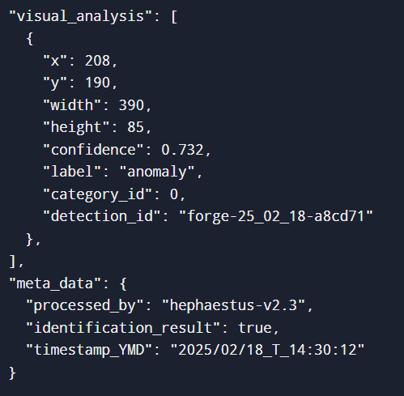

1. Expected JSON Format Analysis from Image

## Overview of Real-Time Image Analysis Methods

In the field of real-time image analysis, some sophisticated methods are employed to efficiently process and interpret visual information. Among them, techniques such as LiDAR (Light Detection and Ranging) and deep learning based techniques are especially prominent. LiDAR technology is based on emitting laser pulses in the direction of an object and calculating the time taken for the reflections to travel back. This approach produces very detailed 3D maps, providing accurate depth information that is necessary for determining the severity of road irregularities such as potholes. Nevertheless, it is demanding in terms of hardware and computational power, which makes it less practical for large-scale, real-time use. Deep learning methods, particularly convolutional neural networks (CNNs), have, however, transformed image analysis. Among these, YOLO (You Only Look Once) algorithms are notable for their speed and accuracy in processing images.

YOLO models segment images into grids and output bounding boxes and class probabilities for objects in one pass of evaluation, facilitating real-time detection with high accuracy. Such approaches are vital for use cases where object depth and size need to be comprehended, like potholes, since they permit prioritization of repairs by severity of road deterioration.

## Comparing YOLO and LiDAR for Pothole Detection

Although both YOLO algorithms and LiDAR systems have their advantages, YOLO has specific benefits for real-time pothole detection in situations where speed of processing and simplicity of deployment are essential. The primary strength of YOLO is its efficiency and speed. Through the processing of images in a single pass, YOLO models are able to produce high frame rates, which makes them suitable for applications that demand real-time processing. This is especially useful for dash cam-equipped cars, where alerting and detection of potholes in real-time can add to driver protection. YOLO algorithms also run directly on RGB images of standard cameras, without the necessity of dedicated hardware such as LiDAR sensors. This simplicity of deployment corresponds to reduced expenditure and wider access, as it makes use of available camera equipment without further requirements.

Conversely, while LiDAR delivers high-resolution depth data, its use can be difficult to achieve in real-time applications. LiDAR technology produces large amounts of data that need tremendous processing power and storage, which may cause latency problems. Furthermore, the expensive nature of LiDAR hardware makes it less scalable for use in mass-market vehicles. Considering these aspects, YOLO's capability to provide quick, accurate object detection from a single image makes it a more convenient option for real-time pothole detection and analysis. In addition, YOLO models have also proven to perform well in varied object detection applications aside from pothole detection. As an example, the YOLOv4 algorithm that boasts a balance between speed and accuracy has been successfully implemented in autonomous driving systems to identify pedestrians, cars, and other driving hazards. These instances highlight YOLO's ability to adapt and perform under different circumstances, further establishing its applicability to our pothole detection system

## Justification for Using YOLO

We select the use of YOLO algorithms for our pothole detection system because of their established efficiency in real-time object detection and ease of use in integrating with generic camera systems. The capability to quickly process and analyze video frames makes YOLO a perfect fit for systems that demand instant response and decision-making. It has been found that YOLO models, and especially YOLOv4 and YOLOv5, are capable of outperforming other methods of object detection in speed as well as accuracy, making them extremely useful in detecting and evaluating road anomalies in real-time.

# Methodology

The ensuing process consists of the writing a program capable of using YOLO, in order to analyse a picture and determine the existence of a pothole based on the training done. This system should be robust, easy to understand, implement, and customizable should the need arise. We have observed that the only programming language which can handle and be privy to all of the criteria stated above is Python. In order to maintain an easy-to-use module type structure, we have uptaken VisualStudio Code or “VS Code” to implement this program.

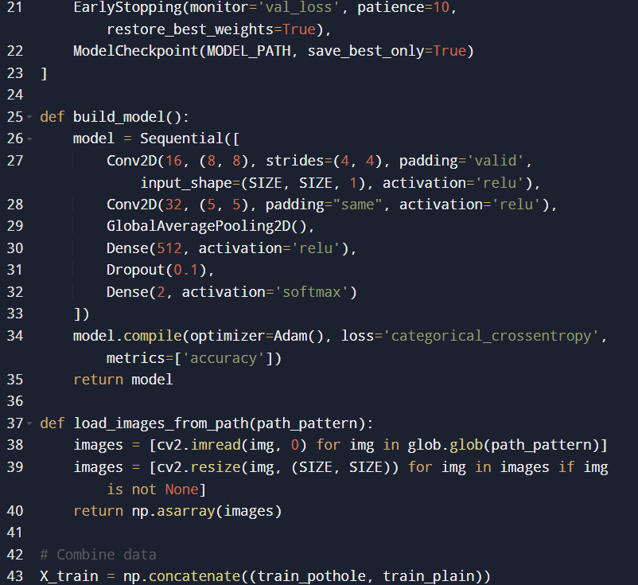

1. Snippet of Executable Code in VS Code

As shown in Figure 2, it allows us for easy arrangement of modular segments of the program in order to separate the different parts of the program and allow it to breathe, in cases where only a small part of code needs to be checked; allowing for easy identification of errors, mistakes, and changing lines of code.

# Results

1. *Detection Confidence and Accuracy*

The results obtained from the pothole detection system demonstrate the effectiveness of YOLO based object detection models and LiDAR depth analysis in identifying and categorizing potholes. A key parameter observed in the output images is the bounding box confidence score, which quantifies the model’s certainty in detecting a pothole. Higher confidence values (above 80%) indicate strong detections, while lower values may suggest false positives or misidentifications. To improve accuracy, the training dataset should be expanded to include diverse environmental conditions, road textures, and pothole variations. Additionally, adjusting YOLO’s anchor box settings to better fit common pothole dimensions can enhance detection precision.

1. *Depth Estimation and Severity Classification*

Another crucial parameter in the results is depth estimation, which helps distinguish between minor cracks and hazardous potholes. The system estimates depth using LiDAR based measurements or stereo imaging techniques, providing a severity grading scale (low, medium, high-risk potholes). However, environmental noise such as shadows, wet surfaces, or occlusions can affect depth accuracy, leading to potential misclassifications. Future improvements could include sensor fusion techniques-combining LiDAR with image based depth estimation-for enhanced measurement precision. Additionally, integrating real-world impact analysis, such as vehicle speed and road material composition, could refine severity classification.

1. *False Positives and System Limitations*

While the detection model performs well under standard conditions, false positives remain a key challenge. The system may misclassify road cracks, shadows, or lane markings as spotholes, reducing reliability. This is particularly evident in low-light or high-glare environments, where the contrast between road defects and surrounding pavement is diminished. Reducing false detections can be achieved by refining preprocessing techniques, such as contrast normalization, edge enhancement, and shadow removal filters. Additionally, implementing a secondary classification model for post-processing validation could help filter out false detections before final reporting.

1. *Overall Performance and Future Improvements*

The results as demonstrated in Figure 3, depict the high potential of real-time pothole detection using deep learning models and LiDAR analysis. However, improvements in sensor fusion, adaptive classification models, and post-processing refinement could further enhance accuracy and reliability. Future work should focus on edge computing for real-time processing, improved pothole tracking algorithms, and government collaborations for large-scale deployment.

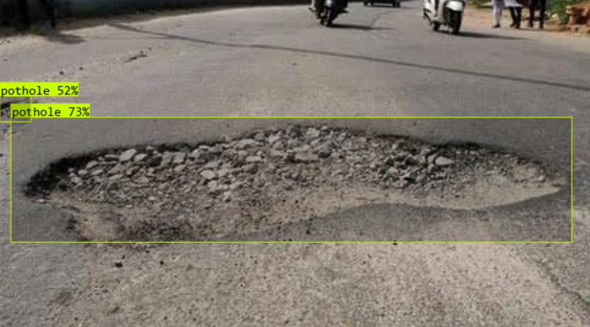

1. Output Received of Test Image

# Limitations

Despite the promising potential of our pothole detection and analysis system, several limitations need to be addressed to ensure effective implementation and performance. The biggest hurdle and this systems limitation is found in it’s dependence on the quality as well as the resolution of the cameras used to capture the photos and videos with which the program is being trained on. Standard dash cams or vehicle-mounted cameras are observed to struggle in capturing clear images in low-light conditions or during unfavourable weather, such as heavy rain or fog among other possible conditions. This could greatly impair the system's ability to accurately detect and assess potholes, leading to missed detections or false positives.

Additionally, the computational resources required for real-time storage and processing of high-resolution video data can be substantial, leading to lower quality footage to be captured which can further lead to lowering the accuracy of the model that is being used. Vehicles would need onboard processing capabilities or rely on cloud based services for instant uploading and avoiding storage, which may introduce latency but requires a stable network connection. Moreover, continuous operation of the detection system necessitates regular calibration and maintenance of the camera and software components to ensure consistent performance, which can be resource-intensive. Here, scalability also presents a challenge; as deploying this system across a large fleet or in diverse geographic regions can complicate data management and processing on the mainframe set on longer terms. Finally, the system's current focus on detecting these potholes may need to be expanded to handle other types of road hazards, necessitating further development and refinement of detection algorithms.

# Future Scope

In the future, the potential for our pothole detection and analysis system is vast and promising. One of the most significant areas of development is integration with autonomous vehicles. As autonomous cars become more common, outfitting them with sophisticated pothole detection systems could improve their navigation and safety by allowing them to better avoid road hazards. Another promising possibility is the development of a crowd-sourced, real-time map of road conditions. By collecting information from many vehicles that have our system installed, we can supply current information about road quality, which can be extremely valuable for drivers, municipalities, and logistics firms. Additionally, there are opportunities to make the detection algorithms more sophisticated than the YOLO models being used today. By combining them with other machine learning methods or by using improvements in AI, detection accuracy and speed can be enhanced. Adding to the system's capability to detect other road dangers, like cracks, debris, or water accumulation, would make it much more valuable. Also, creating automatic response maintenance, in the form of sending repair drones or robot units to respond to identified problems, is a far-fetched yet viable prospect. These innovations have the potential to make road maintenance a more active and streamlined procedure, reducing disruption and increasing general road safety.

# Conclusion

Potholes represent a serious threat to road safety, vehicle integrity, and transport efficiency. Conventional detection methods-citizen reports and manual inspections-are slow and reactive, resulting in postponed maintenance and elevated accident hazards. This research suggests an automated pothole detection system based on YOLO based deep learning models with the integration of LiDAR technology for real-time detection of potholes as well as their severity evaluation. By applying computer vision and AI, the system improves road maintenance effectiveness with data driven repair prioritization decisions. The application of real-time alerting functionalities also minimizes driver risk and prevents accidents from sudden road flaws. In comparison to conventional road inspections, the method provides increased accuracy, quick response, and cost-efficient implementation. The results prove that automatic pothole detection is an essential step toward smart infrastructure. The future can concentrate on edge computing for real-time processing, increasing datasets for model precision, and tie-ups with government agencies for mass-scale deployment. By embracing such technologies, transport networks can become safer, more efficient, and more resilient, providing smoother and accident-free journeys for all stakeholders.

##### References

1. American Automobile Association (AAA). (2021). *Pothole damage costs U.S. drivers billions annually*. https://www.edriving.com/three60/potholes-cost-american-drivers-26-5-billion-in-2021/
2. National Highway Traffic Safety Administration (NHTSA). (2021). *Traffic Safety Facts Annual Report*. https://crashstats.nhtsa.dot.gov/
3. BBC News. (2020). *UK road repairs exceed £1 billion annually*. https://www.bbc.com/news/uk-road-maintenance
4. Gujar, S. N., et al. (2024). *Pothole detection system using YOLO V8*. IRJMETS, 6(4). https://doi.org/10.56726/IRJMETS53641
5. Addanki, A., & Lin, J. (2023). *Pothole detection with YOLOV8*. ResearchGate. https://www.researchgate.net/publication/376685010
6. Kumar, P., & Kumar, A. (2023). Effects of road conditions, traffic patterns, and human-made features on road safety: A review. [Journal Name], [Volume(Issue)], pages.
7. Musa, M. F., Hassan, S. A., & Mashros, N. (2020). *The impact of roadway conditions towards accident severity on federal roads in Malaysia*. [Journal Name], [Volume(Issue)], pages.
8. Thomson, H., Jepson, R., Hurley, F., & Douglas, M. (2008). *Assessing the unintended health impacts of road transport policies and interventions*. BMC Public Health, 8(339). https://doi.org/10.1186/1471-2458-8-339
9. Ahmed, S. K., et al. (2023). *Road traffic accidental injuries and deaths: A neglected global health issue*. Health Science Reports, 6, e1240. https://doi.org/10.1002/hsr2.1240
10. Reddy, J. R., et al. (2024). *Real-time pothole detection using YOLO algorithm*. SSRN. https://ssrn.com/abstract=5088842
11. Thakur, R., et al. (2024). *YOLOv8 based pothole detection*. SSRN. https://ssrn.com/abstract=5089189
12. Mahato, R. K., et al. (2024). A spatial autocorrelation analysis of road traffic accidents by severity. BMC Public Health.
13. Zeng, Y., et al. (2024). *Influencing factors of road traffic accidents*. Sustainability, 16(6767). https://doi.org/10.3390/su16166767