**“**

**Market Trends and Economic Factors**

**”**

Under the guidance

**Mr. Abhiroop Mitra**

Project Report submitted

in partial fulfilment Post

Graduate Diploma in

Management

**By**

**ABHISHEK KUMAR M**

**PGDM (V Trimester)**

**Reg. No.:**

**23**

**GIBSPGDM**

**091**

**Global Institute of Business Studies (GIBS),**

**Bangalore, India**

**Approved by AICTE**



|  |
| --- |
| **ABSTRACT**  The real estate market in 2025 is on the cusp of significant evolution, driven by a combination of favourable economic conditions, shifting buyer preferences, and technological advancements. Following a remarkable surge in 2024, where luxury housing demand soared among affluent buyers, the sector is projected to experience moderate price growth, with expectations of singledigit increases across major cities. This stabilization is largely attributed to anticipated interest rate cuts by the Reserve Bank of India, which are expected to enhance affordability for middleincome groups and first-time buyers.  Moreover, the emergence of new micro-markets around metropolitan areas is gaining traction, fueled by improved infrastructure and connectivity. These regions present lucrative opportunities for investors and developers alike. Technological innovations such as artificial intelligence and blockchain are also reshaping the real estate landscape, enhancing transaction transparency and decision-making processes.  This research paper aims to explore the intricate interplay between these market trends and economic factors influencing real estate sales in 2025. By examining how interest rates, demographic shifts, and technological advancements are shaping buyer behaviour and market dynamics, this study will provide critical insights for stakeholders navigating the complexities of this evolving sector. Understanding these elements will be vital for effectively capitalizing on emerging opportunities within the Indian real estate market.      **INTRODUCTION** enhance affordability for middle-income  groups and first-time buyers.  The real estate market is poised for  significant transformations in 2025, shaped As the market adapts to these changes, by a confluence of economic factors and emerging micro-markets around evolving buyer preferences. Following a metropolitan areas are gaining traction, remarkable growth trajectory in 2024, driven by improved infrastructure and where luxury housing experienced connectivity. The demand for properties in unprecedented demand from high-net- these regions reflects a broader trend of worth individuals (HNIs) and non-resident urban migration and a desire for larger Indians (NRIs), the sector is expected to living spaces. Furthermore, the anticipated sustain its momentum into the new year. fiscal policies and incentives aimed at Analysts predict a shift toward moderate affordable housing are likely to bolster price increases, with overall residential market activity, stimulating both investor property prices stabilizing after the double- interest and consumer confidence.  digit growth observed last year. This  moderation is largely attributed to This research paper aims to explore the anticipated interest rate cuts by the Reserve intricate relationship between market Bank of India, which are expected to trends and economic factors influencing real estate sales in 2025. By examining the |

|  |  |
| --- | --- |
| implications of interest rate fluctuations, demographic shifts, and technological advancements, this study will provide valuable insights into the future landscape of the real estate sector. Understanding these dynamics will be crucial for stakeholders aiming to navigate the complexities of this evolving market effectively.    **LITERATURE REVIEW**  The literature surrounding the real estate market in 2025 highlights a complex interplay of economic factors and emerging trends that are expected to shape housing prices and buyer behaviour. Recent  analyses indicate that the Indian real estate market is poised for moderate price growth in 2025, following a significant appreciation of approximately 21% in 2024. Experts predict that housing prices will increase modestly in the single digits, driven by a combination of enhanced supply from developers and anticipated cuts in interest rates by the Reserve Bank of India (RBI) 13.  The demand for luxury housing continues to be robust, particularly among high-networth individuals (HNIs) and non-resident Indians (NRIs), who have significantly influenced market dynamics in recent years. The luxury segment is expected to remain strong, with premiumization trends driving buyer preferences toward high-end properties 24. Furthermore, peripheral areas around major metropolitan cities are gaining traction due to improved infrastructure and connectivity, making them attractive options for homebuyers seeking larger living spaces at more affordable prices 26.  Economic stability plays a crucial role in shaping the real estate landscape. The anticipated reduction in interest rates is | expected to improve affordability for middle-income buyers and first-time homeowners, thereby stimulating demand across various segments of the market 56. Additionally, the ongoing urban migration and increasing wealth concentration are contributing to heightened investor confidence, further supporting market growth 35.  Technological advancements and changing consumer preferences are also pivotal in influencing real estate trends. The integration of technology in property transactions, along with a growing emphasis on sustainability and eco-friendly homes, reflects a broader shift towards modern living standards that prioritize convenience and environmental responsibility 67.  In summary, the literature suggests that the Indian real estate market in 2025 will be characterized by moderate price increases driven by economic factors such as interest rate adjustments, demographic shifts, and evolving buyer preferences. Stakeholders must navigate these dynamics carefully to capitalize on emerging opportunities within this evolving landscape.  **RESEARCH METHODOLOGY**  The research methodology for this paper on "Market Trends and Economic Factors" in real estate will adopt a mixed-methods approach, integrating both quantitative and qualitative research techniques. This comprehensive methodology aims to provide a robust analysis of the factors influencing the real estate market in 2025.  1. Research Design  The study will utilize a descriptive research design to systematically analyse current market trends and economic factors. This design will facilitate the collection of |

|  |  |
| --- | --- |
| relevant data to understand the dynamics of the real estate market.   1. Data Collection Methods   Questionnaire Method: Structured surveys will be distributed to real estate professionals, investors, and potential homebuyers to gather quantitative data on preferences, buying behaviour, and market perceptions. Questions will focus on factors such as price sensitivity, desired property features, and investment motivations.   1. Data Analysis Techniques   Statistical Analysis: Quantitative data collected from surveys will be analysed using statistical software to identify trends, correlations, and patterns. Descriptive statistics will summarize key findings, while inferential statistics may be applied to draw conclusions about the broader population.  Thematic Analysis: Qualitative data from interviews will be transcribed and analysed using thematic analysis to identify common themes and insights related to market trends and economic factors.   1. Market Trend Analysis   Utilizing trend analysis methodologies, this research will examine historical data on housing prices, interest rates, and demographic changes to forecast future market conditions. This analysis will help identify long-term patterns that can inform investment strategies.   1. Ethical Considerations   The research will adhere to ethical guidelines by ensuring participant confidentiality and obtaining informed consent for all primary data collection activities. The study will also strive for objectivity by minimizing bias in survey design and data interpretation. | 6. Limitations  Potential limitations of the study may include response bias in surveys and the availability of up-to-date secondary data. These factors will be acknowledged in the discussion section of the paper.  This structured methodology aims to provide a comprehensive understanding of how market trends and economic factors are shaping the real estate landscape in 2025, ultimately contributing valuable insights for stakeholders in the industry.  **DATA ANALYSIS & INFERENCES**  As of January 2025, the Indian real estate market is experiencing a notable transition influenced by various economic factors and market trends. This analysis synthesizes data from multiple sources to provide a comprehensive overview of the current landscape.  Market Overview:  Sales Performance: The Indian real estate sector achieved a remarkable peak in 2024, with approximately 230,000 homes sold across the top seven cities, amounting to around ₹380,000 crore. This trend of robust sales momentum is expected to carry into 2025, driven by strong economic fundamentals and evolving buyer preferences13. |

Price Trends: Following a dramatic 21%

increase in hous

ing prices in 2024, experts

predict a more moderate price appreciation

of approximately 6.5% to 7% in 2025. This

slowdown

anticipated

is

attributed

to

interest rate cuts by the Reserve Bank of

India (RBI), which are expected to enhance

affordability for po

tential homebuyers256.

Economic

Influences:

Interest Rates: The RBI's shift towards a

neutral monetary policy suggests potential

rate cuts in the near future. Analysts

estimate a possible reduction of around 50

basis points, which would lower borrowing

costs and stimulate demand for housing35.

This change is critical as it reinforces the

long

-

standing

for

preference

homeownership over renting.

Rapid

Demographics:

and

Urbanization

urbanization continues to drive demand in

major

cities,

increasing

an

with

concentration of wealth among affluent

is

individuals.

This

demographic

shift

particularly evident in the luxury segment,

where high

-

net

-

worth individuals (HNIs)

non

and

-

Indians

resident

(

NRIs)

are

impacting

market

significantly

dynamics124.

Emerging Mi

cro

-

Markets

:

Investment Opportunities: Emerging micro

-

markets are gaining traction as buyers seek

more affordable options outside traditional

urban

centres

are

areas

.

These

characterized by improved infrastructure

and connectivity, making them attractive

f

residential

investment

and

both

or

purposes16. The demand in these regions

broader

trend

towards

a

reflects

buyers

are

where

premiumization,

increasingly interested in luxury offerings

even within these developing markets.

Future Projections

:

Continued Gro

wth: The overall growth

the

trajectory

real

estate

market

for

projections

remains

positive,

with

indicating a compound annual growth rate

(

CAGR) of approximately 9.2% over the

next five years. By 2029, the market size is

expected

to

reach

trillion,

$1.04

u

nderscoring the sector's resilience and

potential for expansion46.

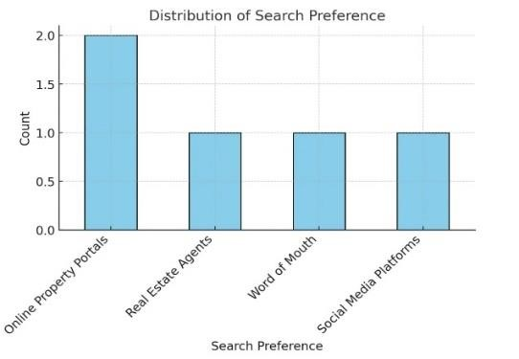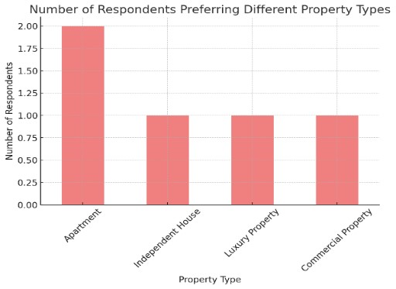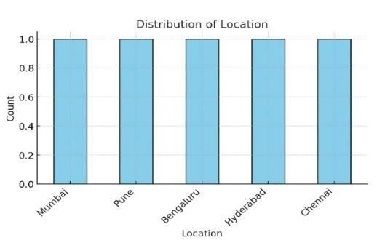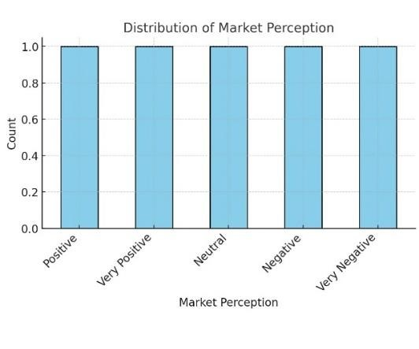

|  |  |
| --- | --- |
| Challenges Ahead: Despite optimistic forecasts, challenges such as rising input costs and potential geopolitical tensions could impact market stability. Stakeholders will need to navigate these complexities carefully to capitalize on emerging opportunities while addressing affordability concerns in the housing sector23.  Inferences:  The analysis indicates that the Indian real estate market is set for a transformative year in 2025, characterized by moderate price growth and sustained demand driven by favourable economic conditions. The anticipated interest rate cuts will likely bolster buyer confidence and affordability, particularly among first-time homebuyers. Additionally, the ongoing trend towards urban migration and investment in emerging micro-markets presents significant opportunities for developers and investors alike.  As stakeholders prepare for this evolving landscape, understanding these market trends and economic factors will be crucial for making informed decisions that align with consumer preferences and economic realities.  The discussion surrounding market trends and economic factors in the Indian real estate sector for 2025 reveals a landscape marked by both opportunities and challenges. As we delve into the dynamics influencing this market, several key themes emerge.  Market Growth and Price Trends:  The Indian real estate market is projected to experience a modest single-digit price increase in 2025, following an exceptional 21% rise in 2024. This anticipated stabilization reflects a balance between supply and demand, as developers are | expected to ramp up new housing projects to meet buyer interest. According to industry experts, the reduction in borrowing costs due to potential cuts in the Reserve Bank of India's (RBI) repo rate will further enhance affordability, thereby stimulating demand among first-time homebuyers and middle-income groups 13.  Impact of Economic Factors  Economic stability is a crucial determinant of real estate performance. The expected cumulative reduction of 50 basis points in interest rates is anticipated to improve the Home Purchase Affordability Index (HPAI), particularly in cities like Mumbai and Pune, which are nearing optimal affordability levels. This shift is likely to attract more buyers into the market, especially as younger demographics increasingly seek homeownership 56. Furthermore, the concentration of wealth among high-networth individuals (HNIs) and non-resident Indians (NRIs) continues to drive demand for luxury properties, creating a dichotomy where premium segments thrive while affordability remains a concern for many 24.  Emerging Micro-Markets  A notable trend is the rising interest in peripheral areas around major metropolitan cities. Improved infrastructure and connectivity are making these regions attractive for homebuyers seeking larger living spaces at lower prices compared to traditional urban centres. Developers are responding to this shift by focusing on projects in these emerging micro-markets, which present significant opportunities for investment and high returns 24. The Dwarka Expressway in Gurugram exemplifies such growth drivers, enhancing the appeal of surrounding areas. |

|  |  |
| --- | --- |
| Technological Innovations and Sustainability  The integration of technology into real estate transactions is transforming how buyers interact with the market. Virtual tours, online platforms for property listings, and data analytics are becoming increasingly prevalent, streamlining the buying process and improving transparency. Additionally, there is a growing emphasis on sustainability, with eco-friendly homes and integrated townships gaining traction among environmentally conscious consumers 67. This shift not only aligns with global sustainability trends but also caters to evolving buyer preferences.  Challenges Ahead  Despite optimistic projections, several challenges loom over the market. Rising input costs for construction materials and potential geopolitical tensions could hinder growth prospects. Moreover, while luxury housing is experiencing robust demand, the broader market must contend with affordability issues that may limit access for many potential buyers 35. Stakeholders must navigate these complexities carefully to leverage emerging opportunities while addressing affordability concerns effectively.  **IMPLICATION**  Implications for the Research Paper on Market Trends and Economic Factors  The analysis of market trends and economic factors in the Indian real estate sector for 2025 yields several critical implications for various stakeholders, including policymakers, investors, developers, and potential homebuyers.  1. Policy Formulation and Economic  Strategy | The anticipated interest rate cuts by the Reserve Bank of India (RBI) are expected to significantly enhance housing affordability, thereby stimulating demand in the residential sector. Policymakers should consider implementing supportive fiscal measures in the upcoming Union Budget to further incentivize home purchases, particularly in the affordable housing segment, which has seen a decline in attractiveness over recent years. This could involve tax benefits for first-time homebuyers or subsidies for developers focusing on affordable housing projects.   1. Investment Opportunities   For investors, the projected moderate price growth in 2025 presents a favourable environment for long-term investments. The emergence of micro-markets in Tier II and III cities indicates shifting buyer preferences towards more affordable options outside major urban centres. Investors should focus on these regions, as improved infrastructure and government initiatives like the Smart Cities Mission are likely to drive demand and appreciation in property values.   1. Development Strategies   Real estate developers must adapt their strategies to align with changing consumer preferences, particularly towards sustainability and technological integration. The growing demand for energy-efficient homes reflects a significant shift in buyer priorities, suggesting that developers who incorporate green building practices and smart home technologies will have a competitive advantage. Additionally, maintaining a healthy pipeline of new supply will be crucial to meet the anticipated demand, especially as urban migration continues to rise. |

|  |  |
| --- | --- |
| 1. Market Dynamics and Consumer   Behaviour  The findings indicate that the luxury segment will continue to thrive, driven primarily by high-net-worth individuals (HNIs) and non-resident Indians (NRIs). This underscores the importance of targeting marketing efforts towards affluent buyers while also addressing the needs of middle-income groups who are increasingly entering the market. Real estate professionals should leverage data analytics to better understand consumer behaviour and preferences, enabling them to tailor their offerings accordingly.   1. Addressing Affordability Challenges   While there is optimism regarding market growth, challenges related to affordability remain a pressing concern. The rising costs of living and construction materials may hinder access to homeownership for many potential buyers. Stakeholders must collaborate to develop innovative financing solutions that can bridge this gap, ensuring that housing remains accessible across different income levels.   1. Long-term Market Outlook   The projected compound annual growth rate (CAGR) of 9.2% for the real estate sector over the next five years indicates robust long-term growth potential. However, stakeholders must remain vigilant regarding external factors such as geopolitical tensions and global economic shifts that could impact market stability. Continuous monitoring of these influences will be essential for making informed strategic decisions.  **LIMITATIONS & DIRECTION FOR FUTURE**  **STUDIES**  LIMITATIONS: | Data Availability and Reliability: The analysis relies on secondary data sources, including market reports and expert opinions, which may not capture real-time changes in the market dynamics. Variability in data collection methods and reporting standards across different studies can lead to inconsistencies and affect the reliability of conclusions drawn.  Geographical Focus: While the research primarily addresses trends in major metropolitan areas, it may overlook significant developments in rural or semiurban regions, which are increasingly important due to urban migration. This limitation could restrict the comprehensiveness of the findings regarding overall market trends.  Economic Variables: The study considers various economic factors such as interest rates and inflation; however, unforeseen global economic events (e.g., geopolitical tensions or pandemics) can drastically alter market conditions. This unpredictability poses a challenge in making long-term forecasts.  Consumer Behaviour Dynamics: The research may not fully account for the psychological and behavioural aspects influencing consumer decisions in real estate, such as buyer sentiment and confidence levels, which can significantly impact market demand.  Focus on Short-Term Trends: The emphasis on immediate market trends for 2025 may overshadow long-term structural changes in the real estate sector, such as shifts in demographics or technological advancements that could redefine market dynamics over time.    DIRECTIONS FOR FUTURE STUDIES: |

|  |  |
| --- | --- |
| Longitudinal Studies: Future research should consider longitudinal studies that track market trends over extended periods. This approach would provide deeper insights into how economic factors influence real estate dynamics over time and help identify patterns that may not be evident in short-term analyses.  Regional Comparisons: Expanding the geographical scope of research to include rural and semi-urban areas would enhance understanding of the diverse factors influencing housing markets across different regions. Comparative studies could highlight unique challenges and opportunities within these markets.  Consumer Behaviour Research:  Investigating consumer behaviour through surveys and focus groups could yield valuable insights into buyer preferences, motivations, and barriers to homeownership. Understanding these psychological factors will be essential for developers and policymakers aiming to align offerings with consumer needs.  Impact of Technology: Future studies should explore the role of technological innovations in shaping real estate transactions and consumer experiences. Researching how digital platforms, virtual reality tours, and AI-driven analytics influence buyer decisions could provide a competitive edge for stakeholders.  Policy Impact Analysis: Investigating the effects of specific government policies on housing affordability and market stability will be crucial. Future research could assess how fiscal incentives, tax reforms, or regulatory changes impact different segments of the housing market.  Sustainability Trends: As sustainability becomes a critical consideration in real estate development, future studies should | examine how eco-friendly practices influence buyer preferences and market trends. Researching the financial implications of sustainable building practices could also provide insights into long-term value creation in real estate investments.  By addressing these limitations and pursuing these directions for future studies, researchers can contribute to a more nuanced understanding of the evolving landscape of the Indian real estate market, ultimately aiding stakeholders in making informed decisions that foster sustainable growth within the sector.    **CONCLUSION**  The analysis of market trends and economic factors in the Indian real estate sector for 2025 reveals a landscape characterized by both opportunities and challenges. As the market transitions from the unprecedented growth of 2024, where housing prices surged by approximately 21%, a more moderate price increase of around 6.5% to 7% is anticipated for the coming year. This stabilization reflects a balance between supply and demand, driven by an influx of new housing projects and potential interest rate cuts by the Reserve Bank of India (RBI) that are expected to enhance affordability for homebuyers.  Key economic indicators suggest that the real estate sector will continue to play a vital role in India's economy, contributing approximately 13% to the national GDP by 2025. The ongoing urban migration and demographic shifts are reshaping buyer preferences, with an increasing focus on affordable housing options in emerging Tier II and III cities. These regions are poised to become significant growth hubs, driven by improved infrastructure and government |

|  |  |
| --- | --- |
| initiatives aimed at promoting sustainable urban development.  Technological advancements are also set to redefine the real estate landscape. The integration of digital tools and platforms is enhancing transparency and efficiency in property transactions, while a growing emphasis on sustainability is influencing consumer choices towards energy-efficient homes. As younger generations enter the housing market, their preferences for modern amenities and eco-friendly living will further drive innovation within the sector.  However, challenges remain, particularly concerning affordability and rising construction costs. Stakeholders must address these issues to ensure that housing remains accessible to a diverse population. The anticipated slowdown in price growth may provide a window of opportunity for buyers, stimulating demand in a market that has seen rapid appreciation in recent years.  In conclusion, the Indian real estate market in 2025 stands at a pivotal juncture, with promising growth prospects tempered by economic realities. By leveraging technological advancements, addressing affordability concerns, and focusing on sustainable development, stakeholders can navigate this evolving landscape effectively. The future of the real estate sector will depend on its ability to balance growth with inclusivity, ensuring that it meets the aspirations of a dynamic and diverse population while contributing to the broader economic framework of India.    REFERENCES  Hindustan Times. (2025). Real estate 2025 outlook: Here's what you should know about property prices if you are planning to | buy a house this year. Retrieved from Hindustan Times  Business Standard. (2025). 2025 Property Market Outlook: Key Trends Shaping Home Buying Decisions. Retrieved from Business Standard  Economic Times. (2025). Buying a home in 2025? Here's how property market can shape up. Retrieved from Economic Times  Omaxe. (2025). The Future of the Real  Estate Market in India in 2025 and beyond. Retrieved from Omaxe |