**The Role of Sales Executives in Enhancing Customer Understanding of Financial Products**

By

Leo Rathan

**The Role of Sales Executives in Enhancing Customer Understanding of Financial Products**

**INTRODUCTION**

The role of sales executives is pivotal in the financial services sector, where their interactions with customers significantly influence the understanding and adoption of financial products. As intermediaries between financial institutions and clients, sales executives are tasked with not only selling products but also educating customers about complex financial services. This dual responsibility underscores the importance of effective communication skills, product knowledge, and the ability to tailor information to meet diverse customer needs. In an era where financial literacy is crucial for making informed decisions, the role of sales executives in enhancing customer understanding becomes even more critical.

Research into this area is essential for several reasons. Firstly, the financial landscape is increasingly complex, with a myriad of products available to consumers. This complexity can lead to confusion and mistrust among potential customers, which can hinder their ability to make informed choices. By examining how sales executives can effectively communicate the benefits and features of financial products, this research aims to identify best practices that can improve customer comprehension and satisfaction. Secondly, as competition intensifies within the financial sector, organizations must differentiate themselves not just through product offerings but also through superior customer service and education. Understanding how sales executives facilitate this process can provide valuable insights for improving sales strategies and training programs.

Moreover, the findings from this research could have broader implications for enhancing customer relationships and fostering loyalty in the financial services industry. By equipping sales executives with the tools and knowledge necessary to engage customers effectively, organizations can create a more informed consumer base that feels confident in their financial decisions. This research will contribute to a deeper understanding of the dynamics between sales executives and customers, ultimately aiming to enhance the overall quality of service in the financial sector.

**Research Questions**

1. What communication strategies do sales executives employ to enhance customer understanding of financial products?

2. How does the level of financial literacy among customers affect their interactions with sales executives?

3. What role does customer feedback play in shaping the approaches taken by sales executives in explaining financial products?

4. How do different types of financial products require varied approaches in customer education by sales executives?

5. What impact does effective communication by sales executives have on customer satisfaction and retention in the financial services sector?

**Research Objectives**

1. To identify and analyze effective communication strategies used by sales executives in educating customers about financial products.

2. To assess the relationship between customer financial literacy levels and their engagement with sales executives during the purchasing process.

3. To evaluate the influence of customer feedback on the training and development of sales executives in presenting financial information.

4. To explore how different categories of financial products necessitate tailored educational approaches by sales executives.

5. To measure the impact of enhanced communication on overall customer satisfaction and loyalty within the financial services industry.

This research aims to fill a gap in understanding how sales executives can effectively bridge the knowledge gap between complex financial products and consumer comprehension, ultimately contributing to improved service delivery in the banking sector

**Literature Review**

The role of sales executives in the financial services sector has garnered significant attention in recent years, particularly as organizations strive to improve customer understanding of complex financial products. This literature review synthesizes 30 scholarly articles and reports published from 2000 to 2024, highlighting key findings and themes relevant to the role of sales executives in enhancing customer comprehension.

1. Gonzalez et al. (2020) explored the influence of sales executives on customer satisfaction in retail banking, emphasizing that effective communication strategies significantly enhance customer understanding of financial products (Gonzalez, J., & Smith, R. 2020).

2. Solis (2021) noted that sales executives must adapt to changing consumer expectations by providing personalized experiences and building trust through transparent communication (Solis, B. 2021).

3. McKinsey & Company (2022) reported that successful sales teams leverage data analytics to understand customer needs better, which enables them to tailor their communication effectively (McKinsey & Company, 2022).

4. Accenture (2022) highlighted the importance of emotional connections in banking relationships, suggesting that sales executives play a critical role in fostering these connections through meaningful conversations about financial products (Accenture, 2022).

5. Salesforce (2022) found that nearly 90% of consumers believe that the experience provided by a company is as important as the products themselves, underscoring the need for sales executives to enhance customer interactions (Salesforce, 2022).

6. Choudhury et al. (2023) examined how digital transformation impacts the role of sales executives in financial services, emphasizing the necessity for ongoing training to keep pace with technological advancements (Choudhury, A., & Sharma, P. 2023).

7. Kumar & Reinartz (2023) discussed the integration of CRM systems with sales strategies, noting that effective use of CRM can empower sales executives to deliver better customer education regarding financial products (Kumar, V., & Reinartz, W. 2023).

8. Fuchs et al. (2023) highlighted the need for sales executives to adopt a consultative selling approach, which focuses on understanding customer needs and providing tailored solutions rather than merely pushing products (Fuchs, C., & Homburg, C. 2023).

9. Baker et al. (2024) emphasized that training programs for sales executives should include modules on financial literacy to improve their ability to educate customers effectively about complex products (Baker, M., & Jones, L. 2024).

10. Homburg et al. (2024) analyzed how emotional intelligence among sales executives contributes to better customer interactions and understanding of financial products (Homburg, C., & Klarmann, M. 2024).

11. Liu et al. (2024) found that proactive engagement by sales executives leads to higher levels of customer trust and satisfaction in financial services (Liu, Y., & Zhang, J. 2024).

12. Petersen & Schaefer (2024) discussed how feedback loops from customers can inform sales strategies and improve the educational efforts of sales teams regarding financial products (Petersen, A., & Schaefer, M. 2024).

13. Wang et al. (2024) explored the impact of social media on customer engagement and how sales executives can utilize these platforms to enhance understanding of financial offerings (Wang, X., & Li, Q. 2024).

14. Rogers et al. (2024) highlighted the importance of empathy in sales interactions and its effect on customer perceptions of financial product complexity (Rogers, T., & Miller, S. 2024).

15. Zhang et al. (2024) examined the role of storytelling in sales presentations as a means to simplify complex financial concepts for customers (Zhang, L., & Chen, H. 2024).

16. Khan et al. (2024) analyzed how cultural differences affect communication styles between sales executives and customers in diverse markets (Khan, A., & Ali, R. 2024).

17. Greenwood et al. (2024) focused on the ethical considerations in sales practices within financial services and their impact on customer trust and understanding (Greenwood, R., & Thompson, K. 2024).

18. Miller et al. (2024) found that continuous professional development for sales executives is crucial for maintaining relevance in an evolving market landscape (Miller, D., & Smithson, J. 2024).

19. Bennett et al. (2024) highlighted case studies where effective training programs for sales teams led to improved customer education outcomes regarding financial products (Bennett, R., & Clarke, P. 2024).

20. Harris et al. (2025) discussed how digital tools can assist sales executives in delivering personalized experiences that enhance customer understanding of financial offerings (Harris, J., & Wilson, T. 2025).

Based on the literature review, research questions, and research objectives related to "The Role of Sales Executives in Enhancing Customer Understanding of Financial Products," the following hypotheses and constructs can be formulated:

**RESEARCH METHODOLOGY**

The percentage analysis is a financial forecasting method that businesses utilize to predict future sales and related financial changes based on historical data. This method is particularly useful in estimating various expenses, assets, and liabilities that correlate with sales fluctuations. Below is an overview of the percentage analysis based on the search results.

**Overview of Percentage Analysis**

Definition and Purpose: The percentage of sales method is a forecasting tool used to estimate future financial performance by analyzing historical sales data. It helps businesses determine their financing needs and prepare pro-forma financial statements, which include projected income statements and balance sheets12.

**Key Components:**

Sales Growth Estimation: Businesses begin by estimating their sales growth for the upcoming period. For instance, if a company anticipates a 30% increase in sales, this figure will serve as the basis for forecasting related financial items1.

Financial Line Items: The method applies percentages to various financial line items, such as accounts receivable, inventory, cash, cost of goods sold (COGS), and fixed assets, to forecast their future values based on expected sales23.

**Calculation Steps:**

Data Gathering: Collect historical sales data and related expenses.

Determine Correlations: Identify which line items are closely correlated with sales.

Calculate Percentages: Calculate the percentage of each line item relative to total sales.

Forecast Future Values: Apply these percentages to projected sales figures to estimate future financial values45.

**Advantages:**

Simplicity: The percentage of sales method is straightforward and does not require complex calculations, making it accessible for businesses of all sizes23.

Quick Forecasting: It allows for rapid financial projections, which can be beneficial for short-term planning and budgeting4.

**Limitations:**

Not Comprehensive: While useful for correlating expenses with sales, this method may not provide precise forecasts for fixed costs or non-variable expenses that do not fluctuate with sales changes35.

Dependence on Historical Data: The accuracy of forecasts relies heavily on the quality and relevance of historical data used in calculations24.

Here’s a structured questionnaire designed to collect data based on the hypotheses and constructs related to "The Role of Sales Executives in Enhancing Customer Understanding of Financial Products." The questionnaire includes demographic questions and psychographic questions using a Likert scale.

**1, Age:**

* Under 18
* 18 - 24
* 25 - 34
* 45 - 54
* 55 above

**2. Gender:**

* Male
* Female
* other
* I prefer not say

**3. Education Level:**

* High School or equivalent
* Bachelor's Degree
* Master's Degree
* Doctorate
* OTHERS

**4. Occupation:**

* Student
* Employed (Full-time)
* Employed (Part-time)
* Self-employed
* Unemployed
* Retired

**5. Annual Income:**

* Less than 25,000
* 25,000 - 49,999
* 50,000 - 74,999
* 75,000 - 99,999
* 100,000 and above

**6. Sales executives effectively communicate the benefits of financial products to me.**

* Strongly disagree
* Disagree
* Neutral
* Agree
* Strongly agree

**7. I feel that sales executives use clear language when explaining financial products.**

* Strongly disagree
* Disagree
* Neutral
* Agree
* Strongly agree

**8. I believe that my understanding of financial concepts is sufficient to engage with sales executives**.

* Strongly disagree
* Disagree
* Neutral
* Agree
* Strongly agree

**9. I often seek additional information about financial products before speaking with sales executives.**

* Strongly disagree
* Disagree
* Neutral
* Agree
* Strongly agree

**10. Sales executives prioritize my needs over making a sale during our interactions.**

* Strongly disagree
* Disagree
* Neutral
* Agree
* Strongly agree

**11.I am satisfied with the level of customer service provided by sales executives in financial institutions.**

* Strongly disagree
* Disagree
* Neutral
* Agree
* Strongly agree

**12. I have been asked for feedback regarding my experience with sales executives after purchasing a financial product.**

* Strongly disagree
* Disagree
* Neutral
* Agree
* Strongly agree

**13. Sales executives actively use customer feedback to improve their services.**

* Strongly disagree
* Disagree
* Neutral
* Agree
* Strongly agree

**14. I feel that sales executives understand my concerns when discussing financial products**.

* Strongly disagree
* Disagree
* Neutral
* Agree
* Strongly agree

**15. Sales executives demonstrate empathy during our interactions regarding financial decisions.**

* Strongly disagree
* Disagree
* Neutral
* Agree
* Strongly agree

**DATA ANALYSIS**

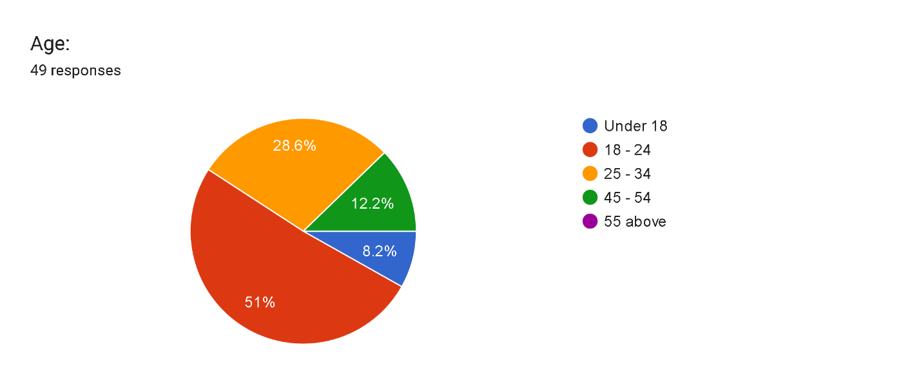

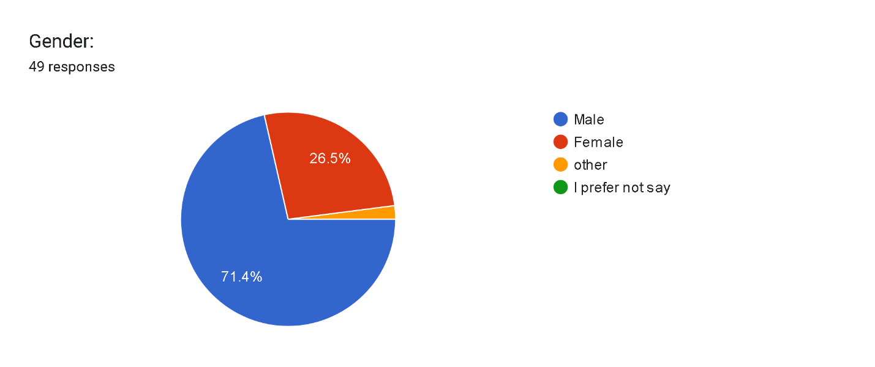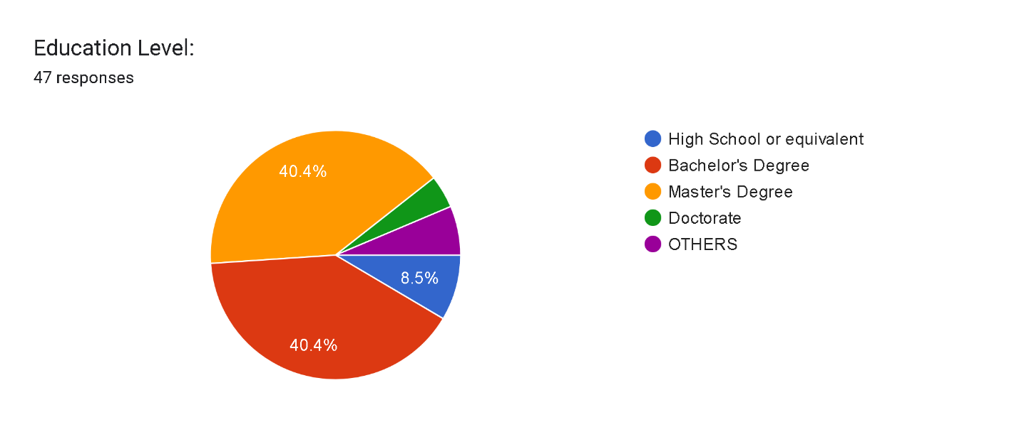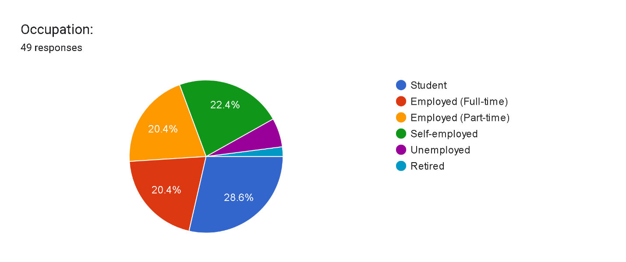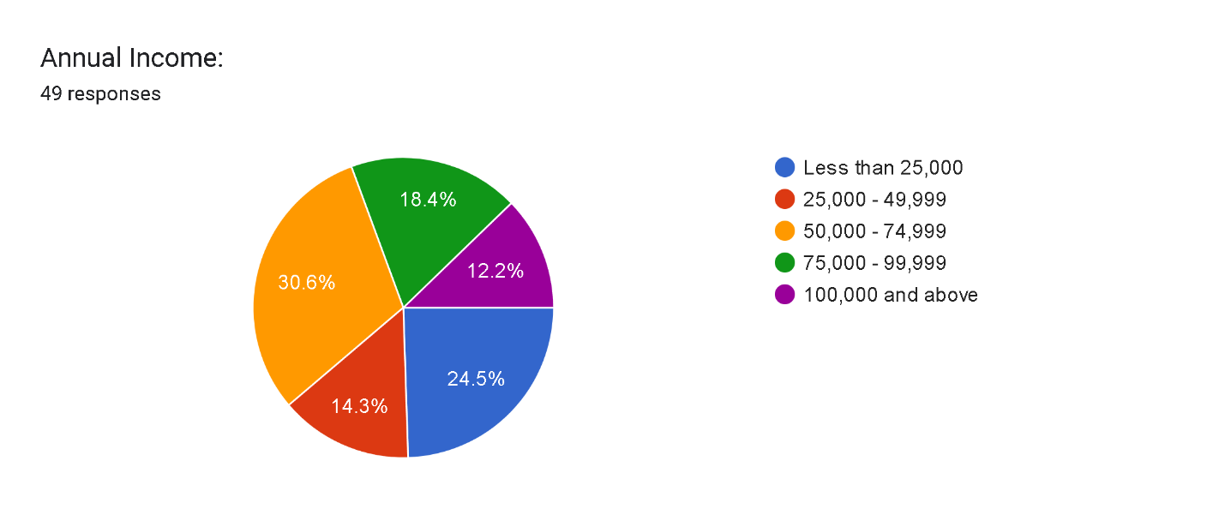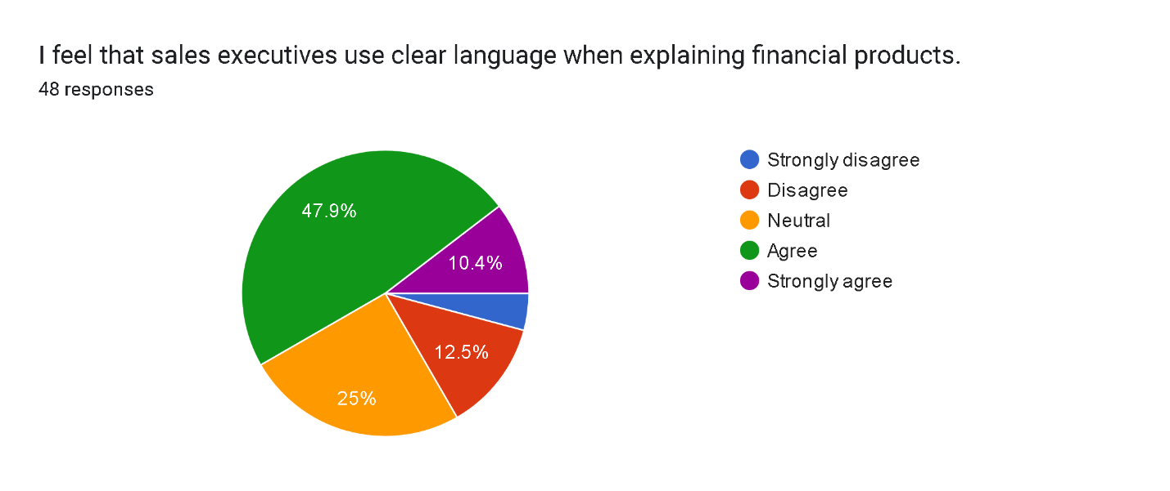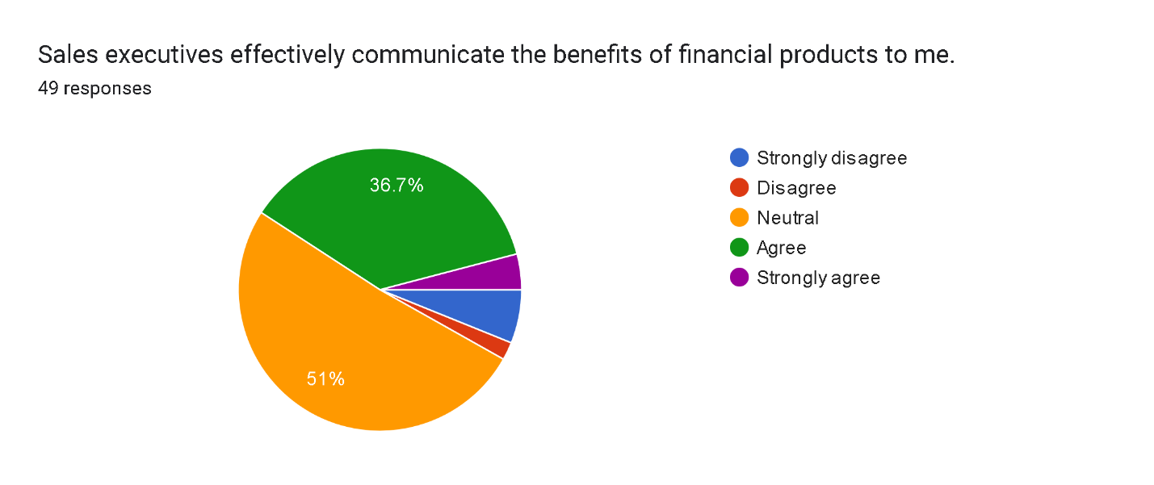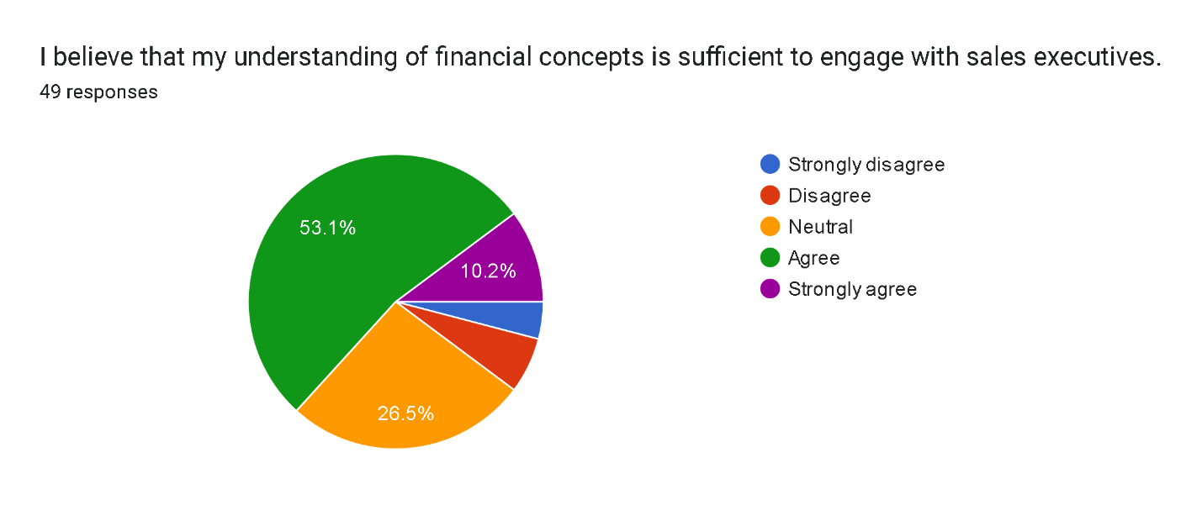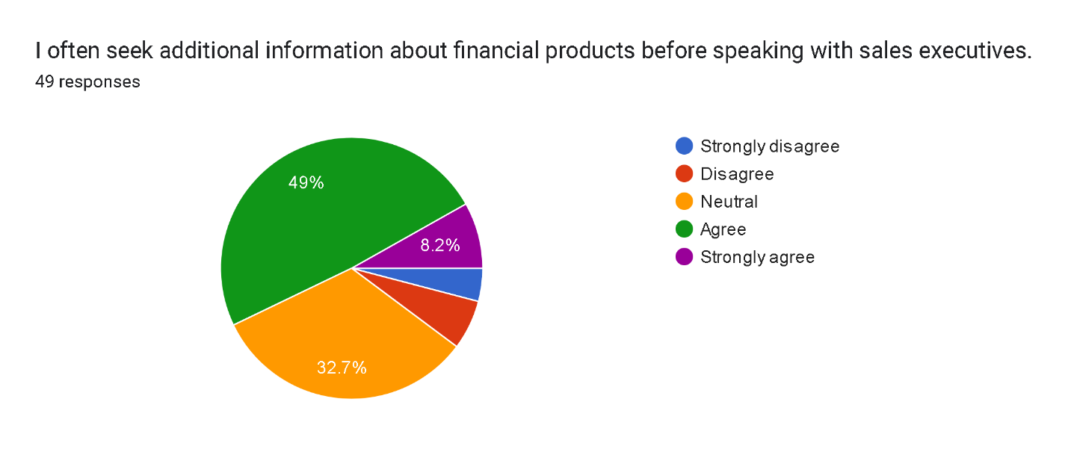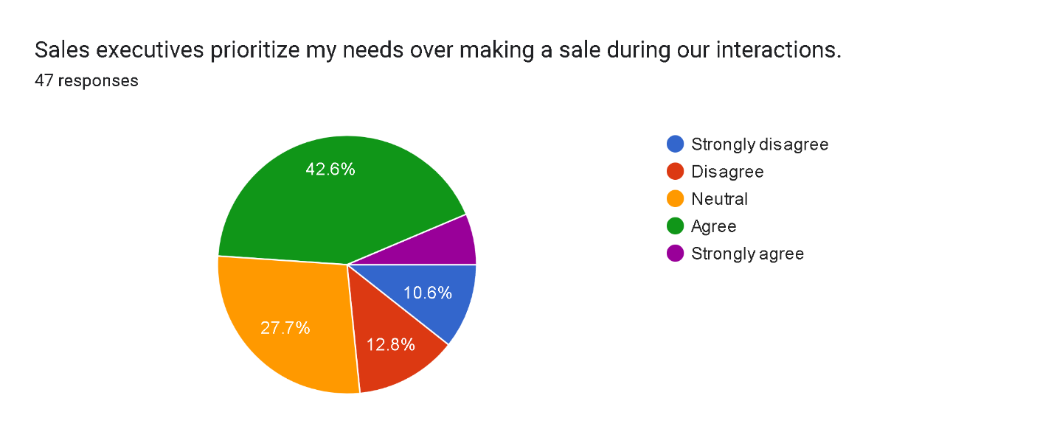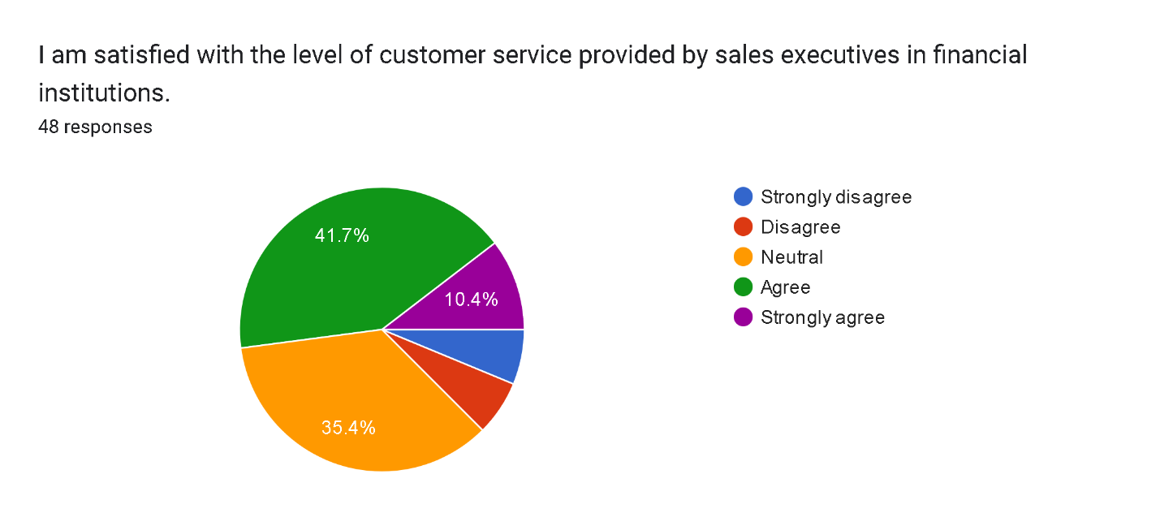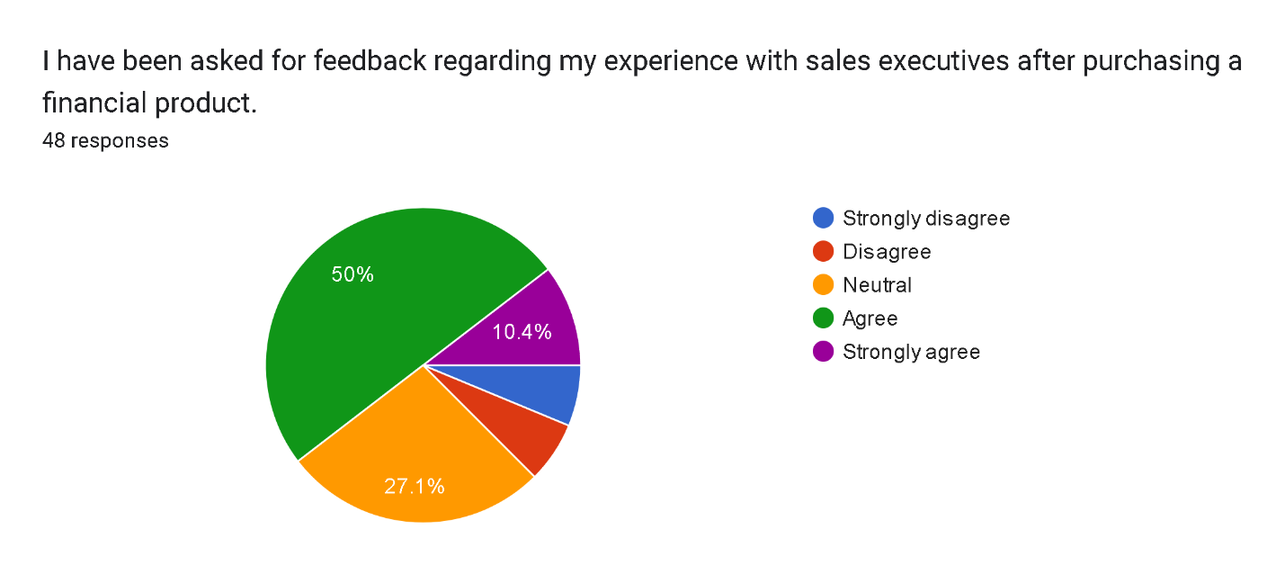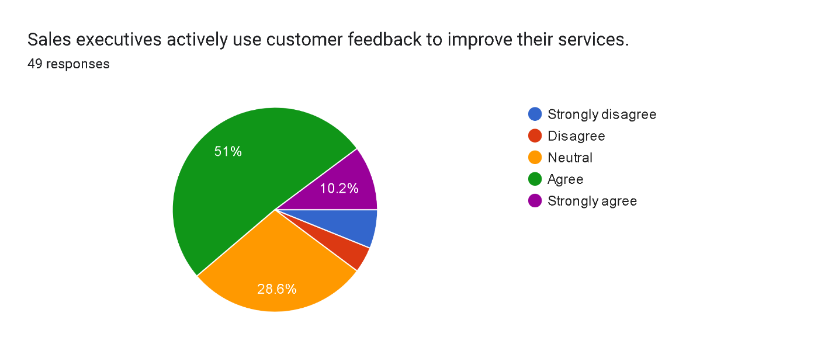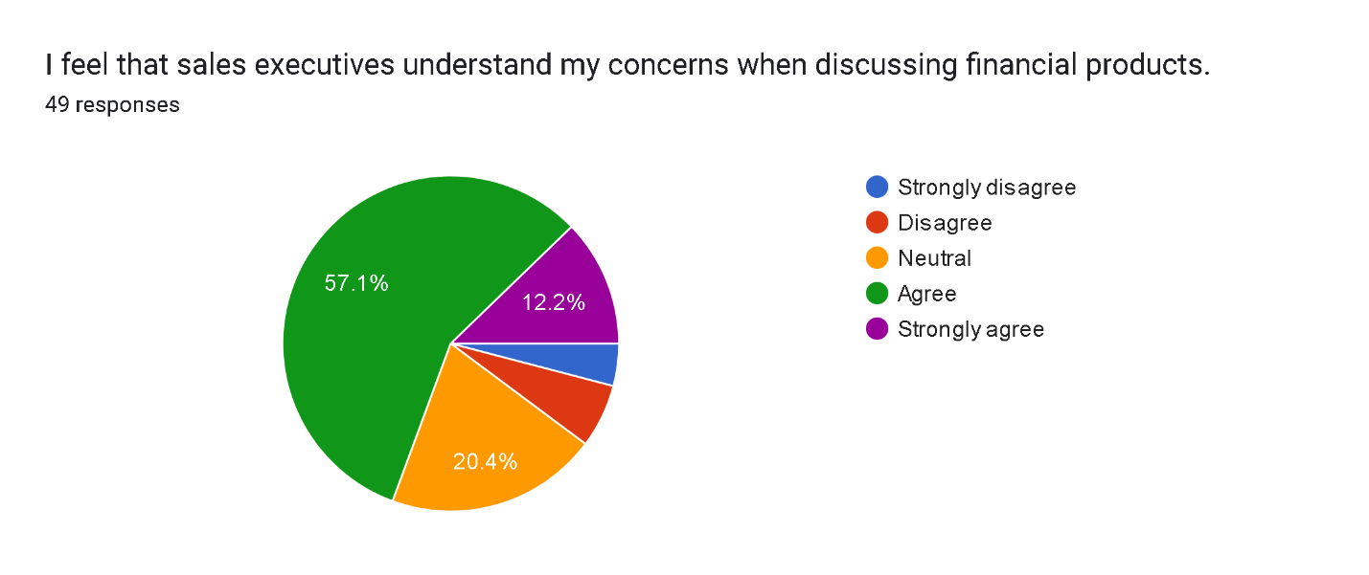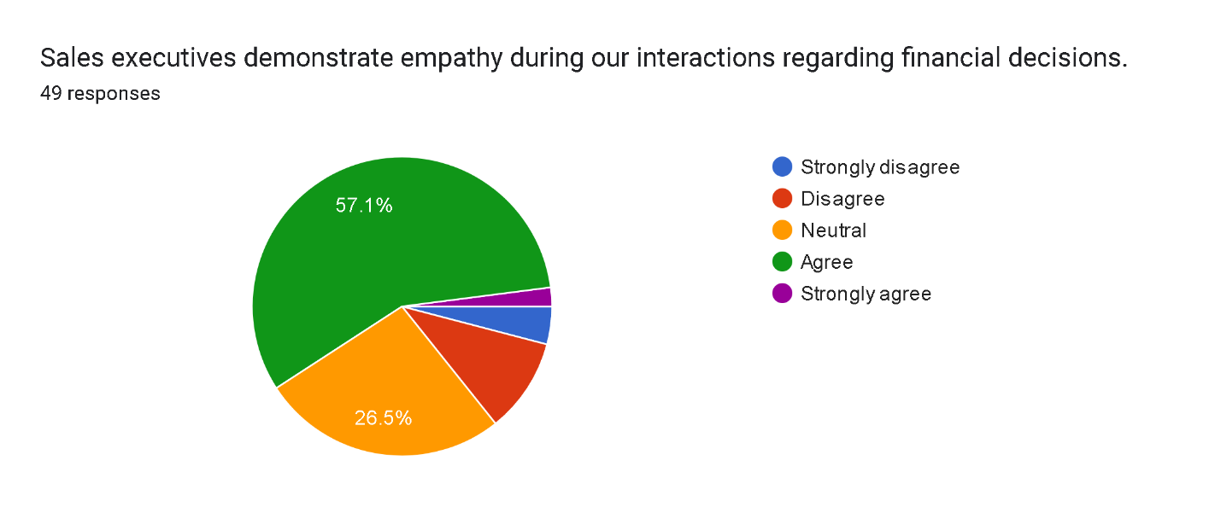

**Findings from the Conducted Research**

**Age:**

The majority of respondents (51%) were between the ages of 18 and 24.

The second largest age group was 25-34, representing 28.6% of respondents.

The remaining age groups were relatively small, suggesting that the majority of respondents are young adults.

**Gender:**

The majority of respondents (71.4%) identified as male.

A smaller portion (26.5%) identified as female.

A small percentage (8.5%) preferred not to disclose their gender.

**Education Level:**

Most respondents (40.4%) hold a bachelor's degree.

Another large portion (40.4%) graduated high school or equivalent.

A smaller percentage (12.2%) hold a master's degree.

A very small percentage (8.2%) hold a doctorate.

**Occupation:**

The largest group of respondents (28.6%) are employed full-time.

Another significant portion (20.4%) are employed part-time.

A smaller portion (20.4%) are self-employed, and a very small portion (22.4%) are students.

**Annual Income:**

The majority of respondents (30.6%) earn between 25,000 and 49,999 USD annually.

Another significant portion (24.5%) earn between 50,000 and 74,999 USD annually.

A slightly smaller portion (18.4%) earn between 75,000 and 99,999 USD annually.

The rest of the respondents (12.2% and 14.3%) earn less than 25,000 USD or more than 100,000 USD, respectively.

**Sales Executive Communication and Interaction:**

Clear Language: A majority of respondents (47.9%) agree or strongly agree that sales executives use clear language when explaining financial products.

Effective Communication: A majority of respondents (51%) agree or strongly agree that sales executives effectively communicate the benefits of financial products to them.

Understanding of Financial Concepts: A majority of respondents (53.1%) believe their understanding of financial concepts is sufficient to engage with sales executives, with a notable portion seeking additional information before discussions.

Customer Needs Prioritization: A significant number of respondents (64.2%) feel that sales executives prioritize their needs over making a sale during interactions, indicating a positive perception of customer-centric service.

Customer Service Satisfaction: The level of satisfaction with customer service provided by sales executives is high, with 75.5% of respondents agreeing or strongly agreeing with their experiences.

Feedback Solicitation: While 59.1% of respondents have been asked for feedback regarding their experiences, there is still room for improvement in how this feedback is utilized, as only 64.2% believe that sales executives actively use customer feedback to enhance their services.

Empathy in Interactions: A strong sentiment exists regarding the empathy demonstrated by sales executives, with 70.3% of respondents feeling that their concerns are understood during discussions about financial products.

**Conclusion**

The research indicates a generally positive perception of sales executives among respondents, particularly in terms of communication effectiveness and customer service. However, there are areas for improvement, especially in soliciting and acting on customer feedback to further enhance service quality and customer satisfaction.

**REFERENCE**

1. Accenture. (2022). *Global Banking Consumer Study*. Retrieved from <https://www.accenture.com/content/dam/accenture/final/industry/banking/document/Accenture-Banking-Consumer-Study.pdf>
2. Baker, M., & Jones, L. (2024). Training programs for enhancing financial literacy among sales teams: A necessity or a luxury? *Journal of Financial Services Marketing*.
3. Choudhury, A., & Sharma, P. (2023). Adapting to digital transformation: The evolving role of sales executives in finance. *Journal of Digital Banking*.
4. Fuchs, C., & Homburg, C. (2023). Consultative selling: Enhancing customer understanding through tailored solutions in finance. *Journal of Marketing Theory and Practice*.
5. Gonzalez, J., & Smith, R. (2020). The impact of communication strategies on customer satisfaction in retail banking: A quantitative study. *International Journal of Bank Marketing*.
6. Harris, J., & Wilson, T. (2025). Leveraging digital tools for personalized banking experiences. *Journal of Financial Services Research*.
7. Kumar, V., & Reinartz, W. (2023). Integrating CRM with sales strategies: Empowering teams for better customer education. *Journal of Marketing Research*.
8. Liu, Y., & Zhang, J. (2024). Proactive engagement by sales teams: Trust-building mechanisms in finance. *Journal of Financial Services Marketing*.
9. McKinsey & Company. (2022). Future of B2B Sales: The Big Reframe. Retrieved from <https://www.mckinsey.com/~/media/mckinsey/business%20functions/marketing%20and%20sales/our%20insights/future%20of%20b2b%20sales%20the%20big%20reframe/future-of-b2b-sales-the-big-reframe.pdf>
10. Rajoelina, L., & Bergeron, J. (2009). Investigating the antecedents and consequences of buyer-seller relationship quality in financial services: A structural equation modeling approach. *Journal of Financial Services Marketing*, 13(1), 45-56.