MODELLING AND SIMULATION OF POWER CONSUMPTION AND LOAD TRAFFIC DEMAND OF A TYPICAL MTN GSM 6/6/6 MICRO BASE TRANSCEIVER STATION IN NIGERIA

Engr. Anih Samuel Chinonyerem1, Prof. J. Eke2, 1Department of Electrical and Electronic Engineering, Enugu State University of Science and Technology, ESUT, Enugu 2Department of Electrical and Electronic Engineering, Enugu State University of Science and Technology, ESUT, Enugu

Corresponding author: (anih_samuel@yahoo.com).

ABSTRACT

The primary source of a mobile cellular network's energy consumption is its base stations. It's critical to measure how much weekend or workday fluctuations in traffic load affect base station power consumption because these variations occur often in mobile networks. Therefore, this paper investigates changes in the instantaneous power consumption, Load Traffic Demand as well as the Interference power of a typical MTN GSM 6/6/6 macro base transceiver station (BTS) in Nigeria. The actual traffic load and power consumption data came from measurements taken at a base station location that was operational. Data demonstrates that base station traffic load and power usage are directly correlated. A linear power consumption model for both technologies' base stations based on this relationship was created. Simulation results show that a zero-deviation occurred between the experimental and simulated power consumption, whereas a 3.61% deviation occurred between the experimental and simulated SNIR.

***Keywords:*** *energy; power; measurement; base station; traffic; modelling; mobile; wireless; consumption; network, SNIR.*

1. INTRODUCTION

The ICT (Information and Communication Technology) industry consumes about 600 TWh, or 3%, of the electrical energy produced worldwide, according to Burgio et al. (2007). By 2030, it is predicted that ICT would require 1,702 TWh of energy. Thus, to make telecommunication systems more environmentally friendly, it is imperative to develop innovative ways to lower the energy consumption of the ICT sector. Reducing the usage of cellular access networks can help the ICT sector cut down on energy consumption because cellular networks make up a sizable portion of the industry. Worldwide installed base station (BS) count has increased due to increased demand for new and dependable mobile telecommunication services. Furthermore, the conventional idea of deploying business systems (BSs) presumes constant operation to always ensure the quality of service and location. Over the past ten years, the combined effect of these two factors has resulted in a notable increase in the overall energy usage of cellular network operators' base stations. It is commonly recognized that the BS accounts for more than 52% of the overall network consumption in cellular mobile networks, making it the primary source of energy consumption (Albaghdadi and Razvi, 2005; Adhikari, 2015; Onoriode and William, 2018). As a result, it has lately become crucial to conduct research on how to lower the energy consumption of BSs, which are the primary energy consumers in cellular networks. The impact of traffic load on the instantaneous base station power consumption and accurate information of the base station energy consumption might be crucial in reducing the energy consumption of cellular networks. It is commonly believed that fluctuations in traffic load have minimal impact on base station power consumption (Patil et al., 2013; Jamal, Mendes, and Zúquete, 2012). Consequently, the purpose of this work is to examine the impact of traffic load fluctuations on the instantaneous power consumption of individual BSs or entire BS sites. To address the aforementioned problems, this study presents the power consumption, load traffic demand, and SNIR data from a genuine, fully operational BSs facility. Furthermore, a power consumption model for base stations (BSs) of various access technologies based on the collected results was created. The instantaneous power consumption of the base station and the present traffic load are linearly dependent on each other in the developed model. The remainder of the paper is structured as follows: An overview of the most promising methods for raising the mobile access networks' energy efficiency is provided in Section 2. The process for implementing the base station power consumption model, its load traffic demand, and the measurement of its signal to noise and interference ratio (SNIR) are all covered in Section 3. Section 4 displays the findings from Section 3, whereas Section 5 provides a concluding statement.

1. **REVIEW OF TECHNIQUES FOR ENERGY SAVING in BSs.**

The components that contribute most to the overall energy consumption of cellular networks must be identified, as BSs account for most of this consumption. The components of a battery backup system (BS) can be categorized into two groups based on how much power they consume: the radiofrequency equipment, which consists of transceivers and power amplifiers and is used to supply power to one or more cells or sectors; and the support system, which includes air conditioning components, DC/AC power conversion modules, battery backup, analogue and digital signal processors, etc. With a share of about 66% of the entire energy usage in the BS, the power amplifier is the biggest energy consumer. It is possible to reduce power usage by as much as 55% by combining these two renewable energy sources (Snow, Varshney, and Malloy, 2000; Margot et al., 2011). The transmission methods used on the air interface can save energy at the link level. As a result, the link level considers the potential sleep modes (macro and micro sleep) of specific BS components, some of which may be turned off for a predetermined period. Then, by arranging traffic load in the downlink and uplink, the BS must provide a specific difference between transmissions (Wu et al., 2015; Mazen and Zarka, 2016). Low transmit power cells such as femto, pico, and micro cells are used in conjunction with macro cells in this kind of cellular network (Haider, Saleem, and Jamal, 2018). While macro cells guarantee continuous coverage, smaller cells switch on and off based on the volume of traffic at that moment. (Li et al., 2013; Adhikari, 2015) also explores the prospect of implementing techniques like cell zooming, where the cell can vary its size according to traffic load condition. Cellular networks can use less power when they are planned and operated. One of the models that has been suggested is the Green Operation (TANGO) and Traffic-Aware Network Planning framework. By using these models in the future, cellular networks can become more energy-efficient while maintaining a good quality of service. Additionally, some programs are predicated on the potential for energy savings through collaboration amongst rival service providers that offer their services within the same coverage area (often cities). The key aspect is that, when traffic is light, one operator can entirely shut down its BS, while the second operator's BS welcomes subscribers from both carriers. As per Mitratel's (2021) writers, implementing this strategy can result in a 25% decrease in energy use. Maruyama et al. (2002) to increase the energy efficiency of 4G base stations put out several proposals. These solutions may be noticed in the temporal, frequency, and spatial domains. The hybrid methods—, which integrate solutions from several domains to adjust the BS site's power consumption to varying traffic conditions—look the most promising. In fact, utilizing most of the aforementioned strategies together will have a synergistic impact that results in fully energy-efficient mobile networks in the future.

1. METHODOLOGY

The Transceiver base station used as the test bed for carrying out this research is an MTN GSM 6/6/6 macro transceiver base station with its power consumption data available.

***3.1. Total Output Power of the Base Station***

The total output power of the BTS, $w_{B}$, can be expressed by its mean value, $w_{Bm}$, by its PDF, $f_{wB}(w)$, and by CDF, $F_{wB}(x)$.

The mean value of the BTS output power can be calculated as the sum of mean values of powers, $ω_{m}$ caused by each active channel:

$w_{Bm}=\sum_{k=1}^{N_{t}}{kω_{m}P(k,A,N_{t})}$ (1)

In equation 1, the variable $P(k, A,N_{t})$ is the probability that K channels are busy in the group of $N_{t}$ channels with the offered traffic A.

According to the assumptions about the number of traffic sources and about the number of channels, $N_{ms} >> N_{t},$ we can use Erlang model, i.e. truncated Poisson distribution,

$$P\left(k,A,N_{t}\right)=ERL\left(k,A,N_{t}\right)$$

$=\frac{\frac{A^{k}}{k!}}{\sum_{i=0}^{N_{t}}{\frac{A^{i}}{i!}}}, k=0, 1, 2, …N_{t}.$ (2)

As it is

$\sum_{k=1}^{N_{t}}{K.}ERL\left(k,A,N_{t}\right)=Y=\left(1-B\right)A$ (3)

***3.2. Signal Power of the Base Station***

The total power of a signal can be computed using the following equation

$P_{x}=\lim_{N→∝}{\sum_{n=0}^{N-1}{{\left|x\left(n\right)\right|}^{2}}}$ (4)

Let $x(t)$ be a sine wave of amplitude ***A*** and frequency ***fc*** represented by the following equation.

$x\left(t\right)=Asin(2πf_{c}t$) (5)

When represented in frequency domain, it will look like the one on the right-side plot in wave form. This is evident from the fact that the sine wave can be mathematically represented by applying Euler’s formula.

$Asin\left(2πf_{c}t\right)=A\frac{e^{j2πf_{c}t}-e^{-j2πf_{c}t} }{2j}$ (6)

Taking the Fourier transform of $x(t)$ to represent it in frequency domain,

$$x\left(f\right)=F[Asin\left(2πf_{c}t\right)]$$

$$=\int_{-∝}^{∝}{\left[\frac{e^{j2πf_{c}t}-e^{-j2πf_{c}t} }{2j}\right]e^{-j2πf_{c}t}}$$

$=\frac{A}{2j}\left[δ\left(f-f_{c}\right)-δ\left(f+f_{c}\right)\right]$ (7)

When considering the amplitude part, the above decomposition gives two spikes of amplitude A/2 on either side of the frequency domain at***-fc*** and ***fc***.

Squaring the amplitudes gives the magnitude of power of the individual spikes/frequency components. The power spectrum was plotted.

Thus, if the pure sine wave is of amplitude A = 230V and frequency=100Hz, the power spectrum will have two spikes of value ${{{ A^{2}}/{4=}230}^{2}}/{4=13225 W}$ at 100 Hz and -100 Hz frequencies. The total power will be ${ A^{2}}/{4+{ A^{2}}/{4=}13225+13225=26450 W}$

Therefore,

$$S_{dBm}=10×log_{10}\left(\frac{26450}{1}\right)+30=74.224 dBm$$

***3.3. Noise Power of the Base Station Receiver***

To obtain the noise power of the base station receiver, the following formula is used.

$Noise power \left(dBm\right)=10×\log_{10}{(Noise Temperature \left(K\right)×Bandwidth\left(Hz\right))}$ (8)

Where the noise temperature can be calculated using the formula:

$Noise Temperature \left(K\right)=290×(frequency {\left(GHZ\right)}^{-2.55})$ (9)

With the frequency for E-GSM being 900 MHZ operating at a bandwidth of 100 HZ

Therefore,

$$Noise Temperature \left(K\right)=290×\left( {0.9}^{-2.55}\right)=379.384K$$

$$Noise power \left(dBm\right)=10×\log_{10}\left(379.384×100\right)=45.791 dBm$$

If the interference power at the input of the receiver in the base station suddenly increases gradually from 1 dBm through 50 dBm, then the value of the Signal to Noise and Interference Ratio (SNIR) in each case was presented in a table.

* 1. ***Development of a Matlab/ Simulink Model for the Base Station***

The model of the characterized MTN GSM 6/6/6 macro base transceiver station was developed in this step using the Matlab/Simulink environment. The model was realized in two stages. The first stage (figure 1) involved the modelling of the power consumption of the different components of the base station as well as the mean output power of the base station. The first stage also contains the model of the load traffic demand leading to the daily power consumption of the different components of the base station.

The stage A model was realized in accordance with the derived formula. The power amplifiers and transceivers were modeled to consume 65% of the total base station power. The AC/DC power consumption modules were modeled to consume about 7.5% of the total base station power. The air conditioning elements were modeled to consume 17.5% of the total base station power whereas the Analog and digital signal processors were modeled to consume around 10% of the total base station power.



**Figure 1: Matlab/Simulink Model of the GSM 6/6/6 base Transceiver Station**

1. **RESULTS**

Figure 2 shows the simulated values of power consumption and load traffic demand for the MTN GSM 6/6/6 macro base transceiver station model. Figure 2 shows a 31-day power consumption pattern for the base station whereas figure 3 shows the power consumption of the base station alongside its corresponding load traffic demand. From figure 2, and figure 3, it is evident that the highest power consumption in a particular day is 3466.3 Watts, and its corresponding load traffic demand is 39.7816 ERL. Similarly, the lowest power consumption in a particular day is 366 Watts with a corresponding load traffic demand of 4.2005 ERL.

A table was used to present the simulated power consumption of the base station components. For power amplifiers and transceivers, the maximum and minimum power consumption is 2262.4 W and 237.9 W. For the AC/DC power consumption modules, the minimum and maximum power consumption is 27.45 W and 261.045 W. For the Air conditioning systems, the minimum and maximum power consumption is respectively 64.05 W and 609.105 W while for the analog and digital signal processors, the minimum and maximum power consumption is respectively 36.6 W and 348.06 W.

Figure 4 shows the power consumption pattern of the different base station components whereas figure 5 shows the total power consumption of the different base station components for the period considered.

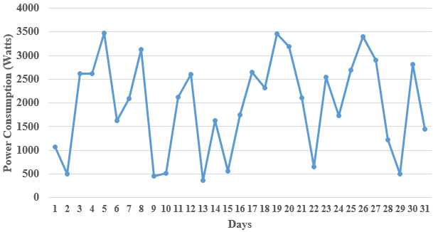

**Figure 2: 31 days power consumption pattern for the base station**

**Figure 3: Power consumption and corresponding traffic of the base station**

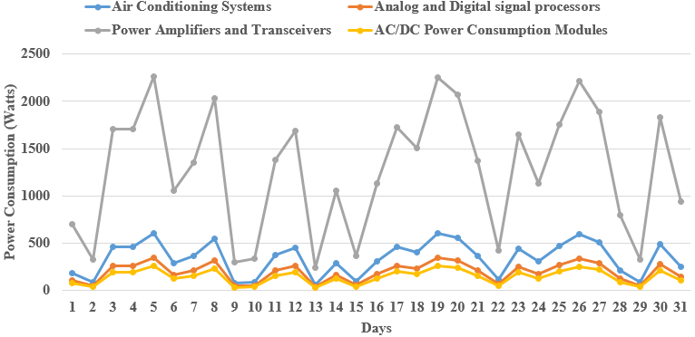

**Figure 4: 31 days power consumption pattern for different base station components**

**Figure 5: Total Power consumption of base station components**

From both figures, it can be observed that the total power consumption by the power amplifiers and transceivers is 39495.5 W whereas it is 4557.15 W for the AC/DC power consumption modules. Similarly, the total power consumption by air conditioning systems is 10633.35 W whereas it is 6076.2 for the analog and digital signal processors.

Figure 6 and figure 7 show the simulated signal to noise and interference ratio (SNIR). A close look at figure 6 and figure 7 shows that the SNIR reduces as the interference power increases.

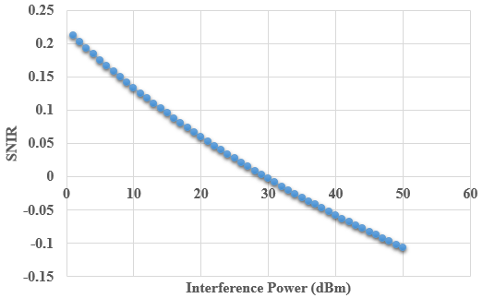

**Figure 6: Curve of interference power against SNIR of the base station**

Figure 6 shows that the SNIR is positive when the interference power ranges from 1 dBm to 29 dBm and negative when the interference power ranges from 30 dBm to 50 dBm.

***4.1. Comparison of experimental and simulated values***

In order to validate the developed Matlab/Simulink model of the MTN GSM 6/6/6 macro base transceiver station, a comparison of the results obtained by experiment is made against the results obtained by simulation. Figure 7 shows the experimental and simulated power consumption pattern of the MTN GSM 6/6/6 base transceiver station.

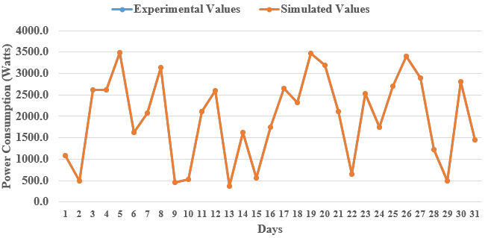

**Figure 7: Experimental vs. simulated power consumption of the base station**

Similarly, Figure 8 shows the comparison of the experimental and simulated SNIR values of the base station.

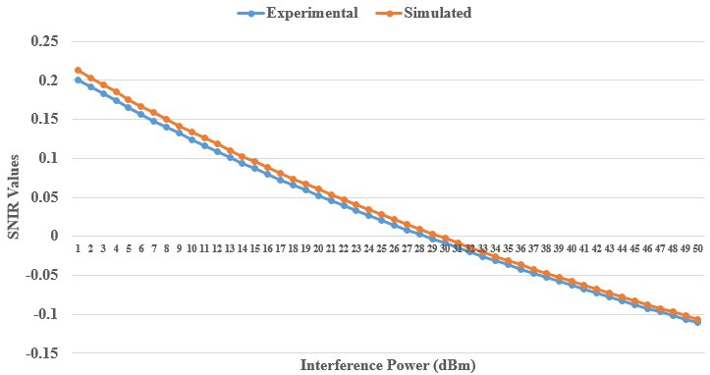

**Figure 8: Comparison of the experimental and simulated SNIR values of the base station**

The deviation in both cases was calculated using the formula:

$$Average \% deviation=ABS\left(\sum_{i=1}^{N}{\frac{E_{i}-S_{i}}{NE_{i}}×100) }\right)$$

Where,

$$E_{i}=the experimental value of the result$$

$$S_{i}=Simulated value of the result$$

$$i=the considered day or interference power$$

$$N=total number of considered days or$$

$$interference power levels$$

From the calculated deviation values, it can be observed that no deviation occurred between the experimental values and simulated values of power consumption whereas a 3.61% deviation occurred between the experimental and simulated SNIR values of the base station. This deviation is, however, acceptable in practice since it is not more than 5% and thus validating the developed base station model.

1. CONCLUSION

This study presents the modeling and simulation of the load traffic demand, the SNIR, and the power consumption pattern. An average MTN GSM 6/6/6 macro base transceiver station has been the subject of analyses. Results showing that the instantaneous power consumption of BSs fluctuates with the traffic load were obtained after 31 days of continuous measurements. This results from the direct correlation between the BS electric current draw and the traffic load pattern. The active power usage in each phase of the three-phase system that supplies the entire macro-BS site with electricity reflects this correlation. As a result, variations in traffic intensity also affect the power consumption of active sites AC. Furthermore, we create a linear power consumption model for every studied BS. The suggested model with a significant percentage of confidence follows the outcomes of accurate on-site measurements. As a result, the interdependence between traffic load and instantaneous BS power consumption may be precisely expressed using the linear power consumption model. We will need to include this interconnection in our future research aimed at enhancing the energy efficiency of BSs that have already been installed.

REFERENCES

Alenoghena C. O.; Emagbetere, J.O. (2012). Base Station Placement Challenges in Cellular Networks: The Nigerian Experience. Conference Paper • October 2012 DOI: 10.1109/ICASTech.2012.6381057

Albaghdadi M, Razvi K. (2005). Efficient transmission of period data follows a consistent daily pattern. 9th IFIP/IEEE International Symposium on Integrated Network Management, IEEE Operation Center, Piscataway, NY. 2005;511-526.

Anand Raghavan, Emmanouil M., Edward Gebara, Joy Laskar (2005). Analysis and Design of an Interference Canceller for Collocated Radios. IEEE Transactions on Microwave Theory and Techniques, Vol. 53, No. 11, November 2005 DOI: 10.1109/TMTT.2005.859042

Albaghdadi M, Razvi K. (2005). Efficient transmission of period data follows a consistent daily pattern. 9th IFIP/IEEE International Symposium on Integrated Network Management, IEEE Operation Center, Piscataway, NY. 2005;511-526.

Ayestaron, R. G. (2006). “Fast near-field multifocusing of antenna arrays including element coupling using neural networks,” IEEE Antennas Wirel. Propag. Lett, vol. 17, no. 7, pp. 1233– 1237, 2018. D. K. Cheng, Field and Wave Electromagnetics, pp. 600–664, Pearson, London, UK, 2nd ed. edition, 2006.

Base Chetan Patil, Channabasappa Baligar (2013). Transceiver Station (BTS) Safety and Fault Management https://www.semanticscholar.org/

Burgio A, Menniti D, Pinnarelli A, Sorrentino N. (2007). The reliability evaluation of a power system in presence of photovoltaic and wind power generation plants and UPS. Paper presented at the 9th International Conference, Electrical Power Quality and Utilization, Barcelona; 2007.

Burgio A, Menniti D, Pinnarelli A, Sorrentino N. (2007) The reliability evaluation of a power system in presence of photovoltaic and wind power generation plants and UPS. Paper presented at the 9th International Conference, Electrical Power Quality and Utilization, Barcelona; 2007.

Chen Y. (2003). Episode perspective of wireless network dependability. MSc Thesis. Ohio University, Ohio; 2006.

David Wake (2003). A survey of current and emerging radio-over-fibre technologies for wireless communications applications. www.microwavephotonics.com

Chowdhury AA, Glover BP, Herbert S, Stadley K, Turanli H. (2004). Bulk transmission equipment outage performance reporting at mid-continent area power pool, Power Engineering Society General Meeting, London.

Domine Leenaerts, Johan van derTang, Cicero S. Vaucher (2001). Circuit design for RF transceivers. Published by Kluwer Academic Publishers, P.O. Box 1 7, 3300 AA Dordrecht, The Netherlands

Fawaz W, Martignon F, Chen K, Pujolle G. (2005). A novel protection scheme for quality-of -service awareness WDM Networks; 2005. IEEE, 0-7803-8939-5/2005.

Federal Siting Legislation Guidance, (2012). Wireless Facilities Deployment: Federal Regulation in the Middle-Class Tax Relief and Job Creation Act of 2012, PCIA, 2012.

Journal of Sustainability Volume 2, Number 1, June 2013 doi : 10.4156/ijs.vol2.issue1.1

Goel L, Gupta R. A (2007). Windows based simulation tool for reliability evaluation of electricity generating capacity. Int. J. Engng Ed. 2007;13(5):347-357.

Hanif D. S, Chandra M. P, and Theodore S. R., (1996). “Optimal location of transmitters for micro-cellular radio communication system design IEEE Journal on selected areas in communications, vol. 14, no 4, pp 662-673.

Jamal, T. Amaral, P. Khan, A. SAB, and Kiramat, (2018). "Denial of Service Attack in Wireless LAN", in Proc. of 12th ICDS 2018, Rome Italy.

Jamal, T. Mendes, P. and Zúquete, A. (2012). “Opportunistic Relay Selection for Wireless Cooperative Network”, in Proc. of IEEE IFIP NTMS, Istanbul, Turkey, May 2012.

Jamal, T. Mendes, P. and Zúquete, A. “Interference-aware opportunistic relay selection”, In Proceedings of The ACM CoNEXT Student Workshop, Tokyo, Japan, 2011.

Jamal, T. and Mendes, P. (2010). “Relay Selection Approaches for Wireless Cooperative Networks”, in Proc. of IEEE WiMob, Niagara Falls, Canada, Oct. 2010.

Jamal, T. and Mendes, P. (2014). “Cooperative relaying in user-centric networking under interference conditions”, in Proc. of IEEE Communications Magazine, vol. 52, no. 12, pp. 18–24, dec 2014

Margot. D., Emmeric, T., Wout, J., Luc, M.,“Modelling and optimization of power consumption in wireless

access network”, Computer Communications, Elsevier, Vol. 34, Issue 17, Pages 2036–2046, 2011.

Mazen Alkhalil and Nizar Zarka (2016). GSM Interfaces Um, A-bis, A DOI: 10.13140/RG.2.1.1895.4000

Jingjin Wu, Yujing Zhang, Moshe Zukerman, Fellow, IEEE, and Edward Kai-Ning Yung (2015) Energy-Efficient Base-Stations Sleep-Mode Techniques in Green Cellular Networks: A survey ieee communication surveys & tutorials, vol. 17, no. 2, second quarter 2015

Kari Heiska (2003). Interference between GSM/EDGE and Other Cellular Radio Technologies. John Wiley & Sons, Ltd. ISBN: 0-470-86694-2 USA.

Luna, F. Durillo, J.J Nebro, A. J. and Alba, E. (2010). “Evolutionary algorithms for solving the automatic cell planning problem: a survey,” Engineering Optimization, vol. 42, no. 7, pp. 671–690, 2010.

Luna, F. Durillo, J.J Nebro, A. J. and Alba, E. (2010). “Evolutionary algorithms for solving the automatic cell planning problem: a survey,” Engineering Optimization, vol. 42, no. 7, pp. 671–690, 2010.

Margot. D., Emmeric, T., Wout, J., Luc, M.,“Modelling and optimization of power consumption in wireless

Mas’ud A. (2006). Fault management in communication networks (A Case Study of the CDMA Intercullar network at Kaduna). MSc Thesis Ahmadu Bello University, Zaria.

Manjish Adhikari (2015). A Survey and Review of GSM Base Transceiver System Installation, Architecture and Uplink/Downlink. Journal of the International Association of Advanced Technology and Science Vol. 16 | July 2015

Mitratel (2021) BTS Hotel https://mitratel.co.id/portfolio/bts-hotel/

Onoriode K. I and William E. O (2018). Reliability Assessment of a Base Transceiver Station Using 2-Parameter Weibull Distribution Method Journal of Engineering Research and Reports 2(4): 1-15, 2018; Article no. JERR.44330 DOI: 10.9734/JERR/2018/v2i416705

Snow A, Varshney U, Malloy A (2000). Reliability and survivability of wireless and mobile networks IEEE Computer Magazine. 2000;49-55.

Shurdi O., Ruci L., Biberaj A. & Mesi G. (2021). 5G Energy Efficiency Overview. European Scientific Journal, ESJ, 17(3), 315. https://doi.org/10.19044/esj.2021.v17n3p315

Satoshi Maruyama; Katsuhiko Tanahashi; Takehiko Higuchi (2002). Base Transceiver Station for W-CDMA System FUJITSU Sci. Tech. J. p. 7.

Sandeep Grewal, and Pooja Sahni (2016). A Review on Base Transceiver Station and Swarm Intelligent Techniques. International Journal of Innovations in Engineering and Technology (IJIET)

Satoshi Maruyama, Katsuhiko Tanahashi, Takehiko Higuchi (2002). Base Transceiver Station for W-CDMA System. August 8, 2002.

Snow A, Varshney U, Malloy A. (2000). Reliability and survivability of wireless and mobile networks IEEE Computer Magazine. 2000;49-55.

Shurdi O., Ruci L., Biberaj A. & Mesi G. (2021). 5G Energy Efficiency Overview. European Scientific Journal, ESJ, 17(3), 315. https://doi.org/10.19044/esj.2021.v17n3p315

Sergios, 2015). https://www.sciencedirect.com/science/article/pii/B9780128188033000131

Tutschku, K. (1998). “Demand-based radio network planning of cellular mobile communication system”, In INFOCOM’ 98 Seventeenth Annual Joint Conference of the IEEE computer and Communications Socities. Proceedings, IEEE,volume 3,pages 1045- 1061,IEEE,1998.

Wenlu Li; Zhihua Zhao; Jian Tang; Fangmin He; Yi Li; Huan Xiao (2013). IEEE Transactions on Electromagnetic Compatibility (Volume: 55, Issue: 6, Dec. 2013) DOI: 10.1109/TEMC.2013.2265803

Zeeshan Haider, Muhammad Saleem and T. Jamal (2018). Analysis of interference in wireless networks.: https://www.researchgate.net/publication/328651455