**Impact of Social Media on College Students: With Special reference to the Students of Yamuna Nagar District of Haryana**

**¹Mr. Gourav Kamboj, ²Ms. Taranjeet Kaur, ³Ms. Gunjan**

**¹Postgraduate Independent Researcher, Guru Nagar Khalsa College, Yamuna Nagar**

**²Assistant Professor, Department of Commerce,Mukand Lal National College, Yamuna Nagar**

**³Assistant Professor, Department of Commerce,Mukand Lal National College, Yamuna Nagar**

**Abstract**: *Social media is playing an important role in every sphere of life now days. Computers and internet has contributed a lot in this field. Smart phones have put the entire world on a common platform. We can connect with anybody throughout the world with the help of social media. There are many social media networks to choose for the people. In this study I have selected Facebook, WhatsApp, Instagram, Snapchat and other platforms as the popularity of these social media networks is more among Indian youth. Other social media networks were also taken in this study. To find out the impact of media on students we have look in to both negative and positive impacts, because everything have positive and negative aspects. This empirical paper aims to investigate the impact of social media on college students in Yamuna Nagar district of Haryana. A sample of more than 100 respondents was selected having smartphone with them. To conduct this study a well-structured google form was developed. The collected data was analyzed on percentage and average bases. The study found that there was both positive and negative impact of social media on social life of Students.*

**Keywords**: Social Media, Yamuna Nagar, College Students, Positive Effects, Negative Effects, Haryana

**Introduction**: The major goal of this research is to see how social media affects college students’ academic performances. Students frequently use social media networking sites and applications. They spend a significant amount of time on these sites on a daily basis. According to studies, university and college students are the most active users of social networking sites among students of various ages. In education, social networking sites are extremely significant. students in fact have a variety of options to better their learning and have access to the most up to date knowledge by interacting with learning groups and other educational systems. Students can also share information by forming connections with diverse people. This has the potential to improve student learning results. Students mental Health, which refers to their emotional, psychological and social well being is also affected by university and college social media. Students at universities and colleges spend a significant amount of time on social media throughout the day and at night and it can be argued that technology plays a significant role in their everyday life. Despite their enormous contribution to knowledge acquisition, it is necessary to identify whether such technologies are being used to gain knowledge or for other reasons that may result in adverse technology abuse affects. Many students spend numerous hours on social media sites such as Facebook, WhatsApp, Instagram and Snapchat everyday. This may appear to be a waste of time at first look, but it also assists kids in developing important knowledge and becoming engaged citizens who create and share content. We believe that technology is an important aspect of students Success as social media sites rise in popularity.

The district of Yamuna Nagar in Haryana, India, serves as an interesting case study for examining the impact of social media among college students. With a diverse population comprising students from various educational institutions, Yamuna Nagar presents a microcosm of the broader trends in social media usage and its impact among young adults in India.

**Objectives of the Study:**

1. To identify the influence of social media on the academic performance of the students life.
2. To know the awareness of social media.
3. To understand the pros and cons of social media on the students.
4. To find the purpose for which social media platforms are used and the percentage of students who use social media.
5. To examine college students’ attitudes towards social media in Yamuna Nagar District of Haryana.
6. To analyze the ways in which social media usage can influence the mental wellbeing of students.

**Review of Literature:**

1. **Elantheraiyan.P & S.Shankarkumar (2019)**

This study investigates the impact of social media on college students in Chennai district, India. The study uses a survey to collect data from 200 college Students and identifies four main themes: social media usage patterns, impact on academic performance, impact on mental health, and impact on Interpersonal relationships. The findings suggest that social media use is prevalent among college students in Chennai and can have both positive and negative impacts on their academic performance, mental health, and interpersonal relationships. The study provides valuable insights into the impact of social media on college students in Chennai and highlights the need for further research and interventions to promote healthy social media use.

1. **S.Vanithamani et al. (2021)**

This study examines the impact of social media among college students in Sulur, Coimbatore, India. The study uses a survey to collect data from 100 college students and identifies four main themes: social media usage patterns, impact on academic performance, impact on mental health, and impact on Interpersonal relationships. The study reveals that social media use is prevalent among college students in Sulur, Coimbatore, and can have both positive and negative impacts on their academic performance, mental health, and interpersonal relationships. The study provides valuable insights into the impact of social media on college students in this region of India and highlights the need for further research and interventions to promote healthy social media use.

1. **Qingya Wang et al. (2011)**

This paper discusses the impact of social media on college students’ academic performance. The study aims to explore the relationship between social media use and study efficiency. Results show that social media is popular among college students, with facebook being the most used platform. The majority of participants spent 6-8 hours per day on social media, with 68% using laptops to access the sites. While 20% used their cell phones, only 12% preferred desktop computers. In terms of social media use during school hours, 64% of participants reported using social media during school hours, with 80% using it while completing homework. The study found that social media use is affecting college students’ academic performance, as 45% of participants admitted to spending too much time on social media. The authors recommend that college students should strive for a better balance between social media use and academics.

1. **Agwi Uche Celestine and Ogwueleka Francisca Nonyelum (2018)**

The study gives us insight into how the internet has allowed for information sharing and collaborative interaction across borders, and social media has become an omnipresent platform for creating and sharing content, networking, and entertainment. Social media’s ease of use, speed, and global reach has led to its widespread use by young people. However, the increased use of social media sites by undergraduate students has raised concerns about its impact on their academic performance. The use of social media has become so prevalent that students spend a significant amount of time engaging in social media activities, which could negatively affect their academic activities. This study was conducted at Samuel Adegboyega University. The results showed that spending too much time on social media can have a detrimental effect on academic activities. Therefore, the study suggests that students should minimize the time spent on social media activities to improve their academic performance.

1. **Kaushik Bhakta (2017)**

The study aimed to determine the nature of social media use among college students, its impact on their academic performance, and its overall effect on them. The survey research method was used, and a self-made questionnaire was administered to 100 second-year undergraduate students pursuing a BA Degree in English in Howrah and Kolkata districts. The results indicated that students primarily used WhatsApp for entertainment purposes and that a negative relationship existed between social media usage duration and academic achievement. Social media had both positive and negative impacts on

college students. While it allowed them to participate in different groups and social activities, overuse of social media could also hinder their academic performance. Therefore, it is crucial for parents, teachers, and the government to create guidelines to monitor social media use among students.

1. **Anup Adhikari (2020)**

This study discusses the impact of social media on Navodit college students. While social media is a modern communication tool, it can have both positive and negative effects on students. The excessive use of social media can have long-lasting effects on students’ mental and physical health and negatively impact their academic performance. The study reports that students use social media mainly to remain updated on trends and make learning technology easier. However, the research also highlights concerns such as privacy issues, parental control, and peer pressure to join social media. Therefore, the study suggests that students have their own perception of the impact of social media, and it is important to be aware of both the positive and negative effects it can have.

**Research Methodology:**

The data was collected from primary as well as secondary resources. The primary data was collected with the help of well-structured questionnaire. This study employs a mixed-methods approach to investigate the impact of social media on college students in Yamuna Nagar district of Haryana. The secondary data was collected from the previous studies, internet, different libraries, etc. A questionnaire was designed and data was collected from sample size of more than 100 Students.

**How Social Media has affected Students?**

Social media has profoundly impacted students’ lives, influencing their academic performance, mental health, and social interactions. On the one hand, social media has enabled students to connect with peers, access educational resources, and express themselves creatively. Platforms like Instagram, WhatsApp, and Facebook have become essential tools for learning, self-expression, and community-building. However, excessive social media use has led to significant concerns. Students’ constant exposure to curated and manipulated content has fostered unhealthy comparisons, lowered self-esteem, and increased anxiety. Cyber bullying, online harassment and fear of missing out (FOMO) have become pervasive issues, affecting students’ emotional well-being and academic focus. Moreover, social media’s constant distractions have decreased attention spans, reduced face-to-face interaction skills, and compromised critical thinking abilities. The blurring of boundaries between personal and online lives has also led to sleep deprivation, decreased physical activity, and compromised mental health. Furthermore, social media’s algorithms and echo chambers have contributed to the spread of misinformation, biased perspectives, and decreased empathy. Educators and parents must recognize these challenges and promote responsible social media use, digital literacy, and media literacy to ensure students navigate the online world effectively and maintain a healthy balance between their online and offline lives.

**How Social Media is Changing Education?**

Social media permeates today’s society with millions of us engrossed, some would argue to the point of unhealthy addiction, in the latest happenings via apps such as Facebook , Instagram and WhatsApp. According to the previous survey conducted, 85% of all adults aged 16+ have a profile on at least one social networking site, and though the report doesn’t break down these figures by age group, it’s reasonable to assume that among those of university age, that percentage could potentially be much higher.

Education is very essential part of any individual’s life. For every teenager, education is more important than anything. Today teenager shows very much interest for using social networks but unfortunately social networks affect education badly. Previous research done has already calculated that more than 90% of college students use social networks. Technology Has shown a fast development by producing small communication devices but these small communication devices can be used for accessing social networks any time anywhere, these devices include pocket computers, laptops, ipads and even simple mobile phones (which support internet) etc. Technology is step towards betterment, no doubt but any technology which can provide ease of social networks can be dangerous for social network addicts.

**Data Analysis :** Social media helps students in many ways. This study collects the data for analyzing the impact of social media on the life of students and their academic performance. For this study, students of different colleges have been chosen for the collection of data. These data were collected from different colleges of Yamuna Nagar district of Haryana.

* **What Social Networking Sites do you use?**

This bar chart reveals that highest number of students will use Instagram and after that Snapchat, Facebook, Twitter, WhatsApp and Others.

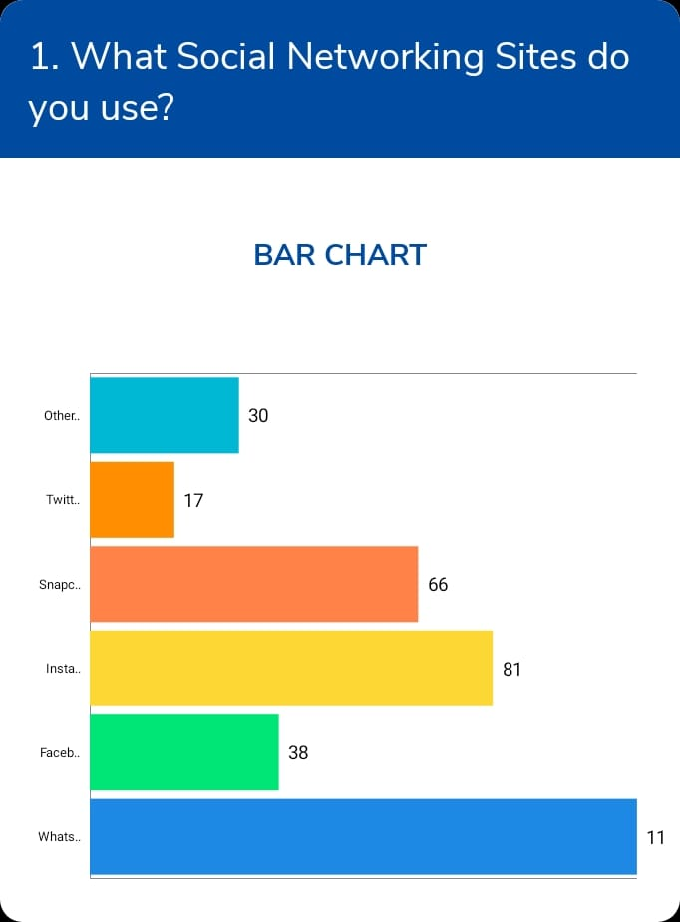

* + **How many hours a day you spend on these sites?**

This pie chart reveals that 74 students spent 1-2 hours in social media platforms and 42 students spent 3-4 hours , 11 students spent 4-5 hours, 4 students spent 5& above hours on social media platforms.

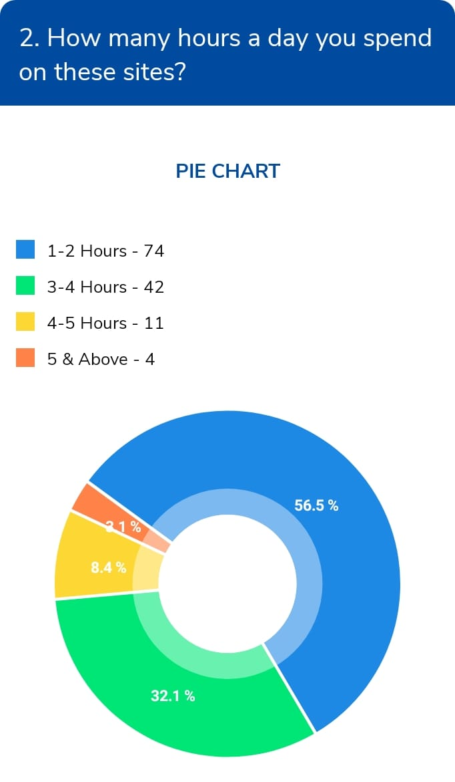

* + **What is the purpose of using social media sites?**

This pie chart reveals that 87 students will use Social Media platforms for the purpose of education and research and 70 students will use for sharing information, 53 students will use for the purpose of keeping in touch with friends and 52 students for recreation and relaxation and 38 students for meeting new people can help you socialize.

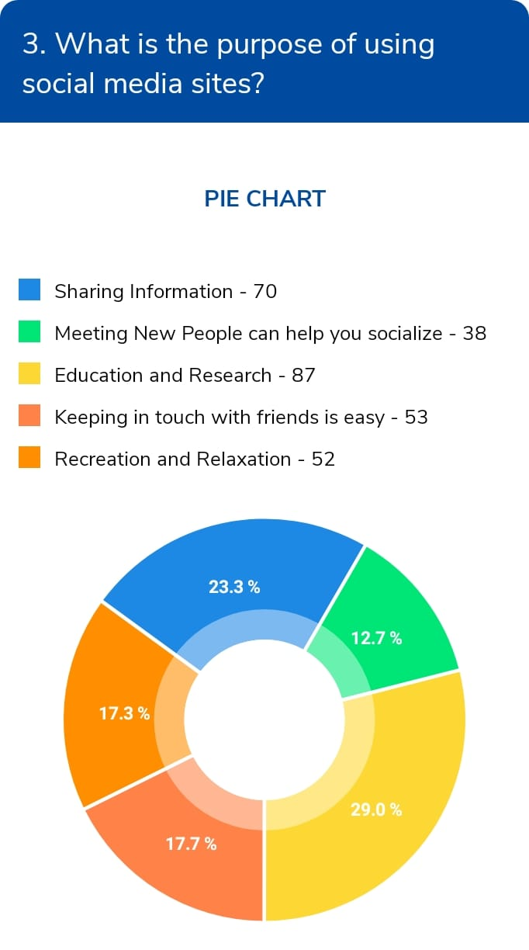

* + **What is the impact of Social media?**

This pie chart reveals that 43 students believed that social media impacts us positively. 11 students believed that it will impacts us negatively. 77 students believed that it will impact us neutral.

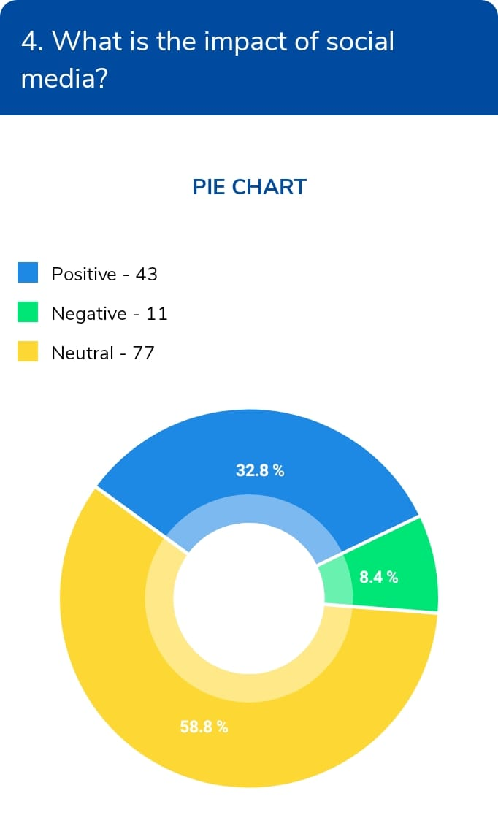

* + **What do you believe are the disadvantages of using social networking sites?**

The pie chart reveals that 75 students believed that hacking is the biggest disadvantage of using social media platforms. 64 students believed that headache and eye problems, 63 students believed that misinformation and fake news, 56 students believed that it reduces family closeness, 54 students believed that social media addiction, 43 students believed that cyber bullying and 31 students believed that it diminishes understanding and thoughtfulness.

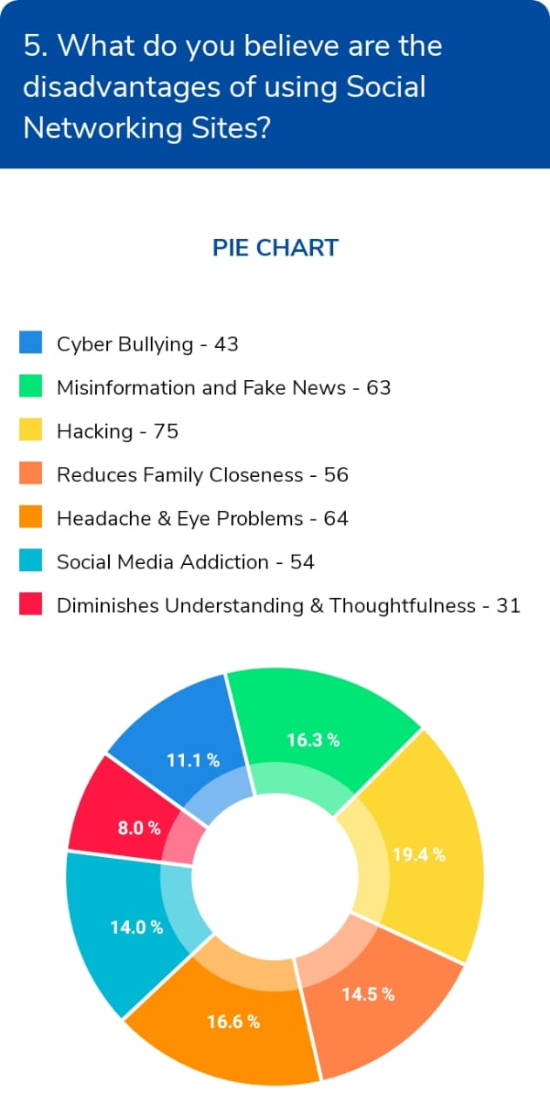

* + **Do you thinking privacy policies are effective in social networking sites?**

31 students Strongly agree to this point, 77 students agree and 23 students will disagree to this point.

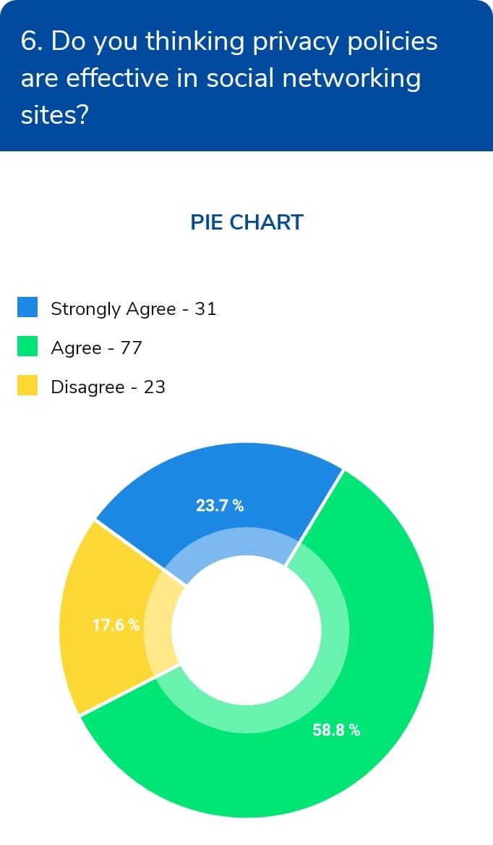

* + **To What extent, do you think social networking sites are impacting your overall well being?**

88 students said that it will bring both positive and negative impact on our overall well being and 21 students said that it only bring positive impact and 14 students said that it will bring No impact and 8 students said that it will bring negative impact.

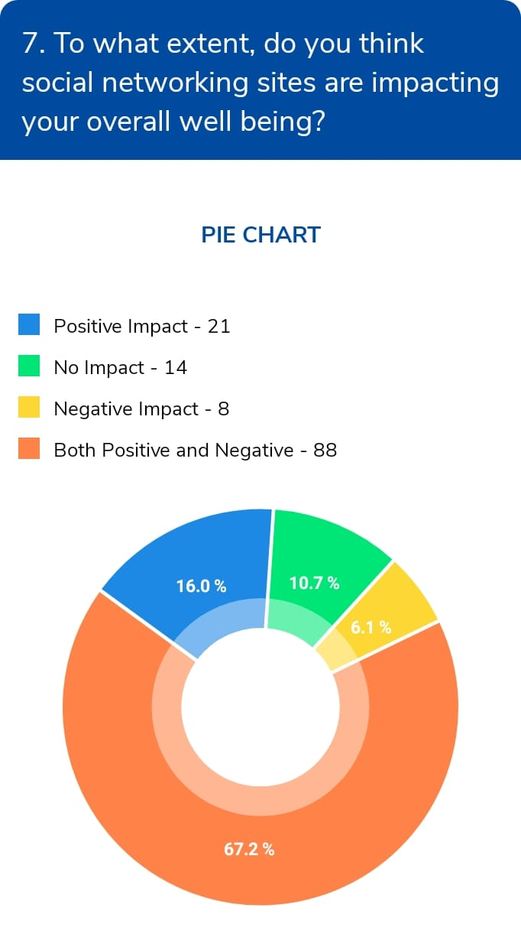

* + **Do you think social media has an effect on your academics performance? If yes, is it a Negative Impact or a Positive Impact?**

57 students said yes it has positive impact on our academic performance. 32 students said yes it has negative impact on our academic performance. 42 students said no impact.

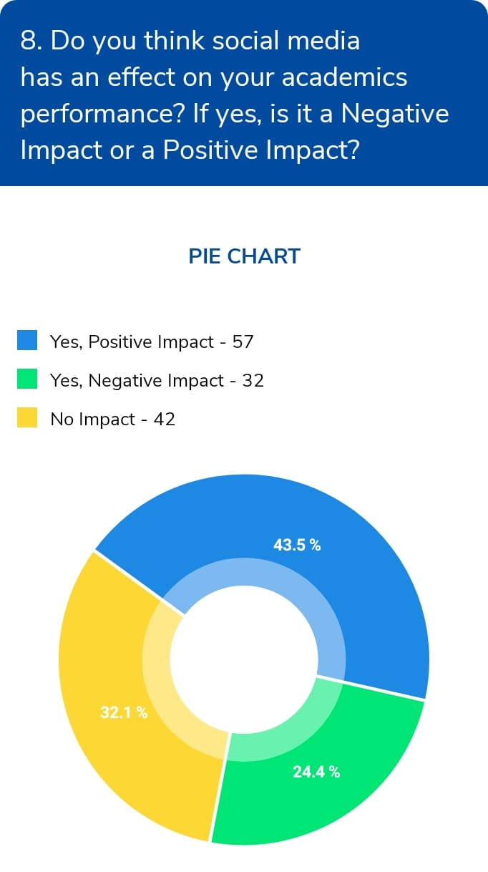

**Findings of the Study:**

* Most of the teenagers spend more time on social networking site.
* Results show that the respondents use social media networks less for educational purpose.
* Majority of respondents said that it will bring both positive and negative impact on our overall well being.
* Majority of respondents believed that it will impact us neutral.
* Majority of respondents said that they will use Social Media platforms for the purpose of education and research.

**Limitations of the Study:**

The present study is a case study of a particular city therefore the results of this study cannot be applicable on throughout the country or state. The number of samples was also small. This is mere a research paper and the time spent in this research was also not long. It is difficult to made deep generalisation within a short period of time.

**Implications for Future Study:**

Further research could look at why WhatsApp and Facebook have become so popular in comparison to other social media platforms. Because both social networking sites have large utilisation rates, it would be interesting to earn why people use them so frequently. It would be a worthwhile issue to investigate as these websites become more popular. Finally, additional study on gender and social networking websites usage is needed to better understand the effects of males and females using these sites.

**Conclusion and Suggestions:**

Social media has now become an important part of life for the people. People are assessing social media for number of reasons. Students specially use social media for number of purpose. This study shows that majority of students using social media platforms and they spent their 2 to 3 hours each day on social media. In this study, most of the students were under graduate students who are using social media most of the time. Most of the students are using social media for more than 3 years. They mostly use social media for sharing information and learning technology. Most of the students take help of social media during completion of assignments because it aware about innovations previously done researches which help students complete their assignments more accurately. As per this research, most of the students were agreed that social media is useful in studies because it provide most of the information on a single click without any delay. Social media poses positive effect on studies because it is helpful in providing many information and previously done researches and about upcoming technology and with social media it is very easy to share any information to anyone who connected to the person through social media. Everyone started sharing their personal information and various data on social media, these information‟s are used by hackers and unwanted persons for their personal benefits and their personal benefit causes big harm to the authentic users so there is privacy issues related to social media. There are many drawbacks of social media but in many ways social media is useful for students because it provide education, connectivity with others, provide many information‟s and aware with various updates, innovations and other things In present world social media poses positive effect on life therefore social media is essential for modern world.

**References**:

1. De Andrea, D. C. et al., Serious Social media ; On the use of Social media for improving students’ adjustment to college, Internet And Higher Education ( 2011) , doi: 10.1016/j.iheduc.2011.05.009.
2. Abbasi, M. A., & Liu, H. (2013). Measuring user credibility in social media. Social Computing, Behavioral-Cultural Modeling, and Prediction. Springer Berlin Heidelberg. Pp. 441-448.
3. Ahmad, A. (2011). Rising of Social Network Websites in India Overview. IJCSNS International Journal of Computer Science and Network Security, 11, 155-158.
4. Swati Mishra, Abhishek Mishra and Rishabhrawat. (2015). A study of impact of social Media on college students. CLEAR International Journal of Research in Commerce &Management, 6(12), 27-34.
5. Wang, Q., Chen, W., and Liang, Y. (2011). The Effects of Social Media on College Students. Johnson & Wales University, Providence, RI.
6. Shabir, hammeed, safdar and gilani (2014). The impact of social media on youth; a case study of Bahawalpur city. C Asian journal of social science and humanities, vol,3(4), ISSN:2186-8492
7. Arora (2014). Social networking -A study of Indian youth. Gian Jyothi E-journal, vol, -5Nno-1&2, ISSN:22500-348X, PP 1-9.
8. Abaleta, A. B, Centaza, S.M, & Calimlim, M. E. (2004). Impact of Social Networking on the Academic Performance of College Students in Anellano University-(Unpublished Dissertation) pp. 1-19
9. Malik, D., Singh, P., & Dhiman, D. (2022). Science Communication in India: Current Trends and Future Vision. Science Communication in India: Current Trends and Future Vision (June 10, 2022).
10. Dhiman, B., & Malik, P. S. (2021). Psychosocial Impact of Web Series and Streaming Content: A Study on Indian Youth. Global Media Journal, 19(46), 1-7.
11. Fraenkel, J. R. & Wallen, N. E. (2003) How to Design and Evaluate Research in Education, 5th ed. Boston: McGraw Hill, pp 96-97,118-119
12. Akram, W. and Kumar, R., (2017), A Study on Positive and Negative Effects of Social Media on Society, International Journal of Computer Science and Engineering (open access), Vol.5, Issue 10, October, 2017, ISSN €: 2247-2693, pp. 347-354.
13. Bhardwaj, Akashdeep, Avasthi, Vinay and Groundar, Sam, (2017), Impact of Social Networking On Indian Youth-A Survey, International Journal of Electronics and Information Engineering, Vol. 7, No. 1, September, 2017, (DOI: 10.6636/IJEIE.201709.7(1).05), pp. 41-51.
14. Duffett, R. G. (2015). Facebook advertising’s influence on intention-to-purchase and purchase Amongst Millennials. Internet Research, 25(4), 498-526.
15. Ajzen, I. (1991). The theory of planned behavior. Organizational Behavior and Human Decision Processes, 50(2), 179-211.
16. Lee, J., Hong, I., & Kim, M. (2020). The impact of social media influencers on purchase Intention and the mediation effect of customer attitude. Journal of Retailing and Consumer Services, 53, 101742.
17. Berger, J., & Milkman, K. L. (2012). What makes online content viral? Journal of Marketing Research, 49(2), 192-205.
18. Hair Jr, J. F., Hult, G. T. M., Ringle, C. M., & Sarstedt, M. (2016). A primer on partial least Squares structural equation modeling (PLS-SEM). Sage Publications.
19. Kaplan, A. M., & Haenlein, M. (2010). Users of the world, unite! The challenges and Opportunities of Social Media. Business Horizons, 53(1), 59-68.
20. Zarrella, D. (2009). The social media marketing book. O’Reilly Media, Inc.