## TOPIC - The effect of brand loyalty programs on repeat purchases

**ABSTRACT**

This research paper investigates the impact of brand loyalty programs on consumer behaviour, particularly focusing on the correlation between loyalty program participation and repeat purchase behaviour. As companies strive to retain customers and enhance lifetime value, brand loyalty programs have emerged as a critical strategic tool. This study aims to explore the effectiveness of these programs in fostering consumer loyalty and driving repeat purchases.

By analysing data from various industries, this research examines the types and structures of loyalty programs that are most effective in encouraging repeat purchases. The study also delves into the psychological and emotional drivers behind consumer participation in loyalty programs, including perceived value, satisfaction, and trust. Additionally, the paper considers the role of personalized rewards and incentives in strengthening the consumer-brand relationship.

The findings of this research suggest that well-designed loyalty programs can significantly influence consumer behaviour and increase the likelihood of repeat purchases. Furthermore, the study provides insights into best practices for designing and implementing loyalty programs that maximize customer retention and profitability. The paper concludes with recommendations for marketers and business practitioners on leveraging loyalty programs to achieve sustainable competitive advantage**.**

**Keywords**

• Brand Loyalty Programs

• Repeat Purchases

• Consumer Behaviour

• Customer Retention

• Loyalty Rewards

• Perceived Value

.

**INTRODUCTION**

In the competitive landscape of modern business, retaining customers has become a key priority for companies aiming to sustain long-term profitability and growth. One of the most effective strategies employed to achieve this goal is the implementation of brand loyalty programs. These programs are designed to reward customers for their continued patronage, thereby fostering a deeper sense of loyalty and encouraging repeat purchases.

Brand loyalty programs have evolved significantly over the years, transitioning from simple punch cards to sophisticated digital platforms that offer personalized rewards and experiences. With the rise of technology and data analytics, companies can now tailor their loyalty programs to meet the unique preferences and behaviours of individual consumers. This personalized approach not only enhances customer satisfaction but also strengthens the emotional bond between the brand and its customers.

The purpose of this research paper is to explore the impact of brand loyalty programs on repeat purchase behaviour. By examining various types of loyalty programs and their effectiveness across different industries, this study aims to identify the key factors that drive consumer loyalty and repeat purchases. Furthermore, the research will delve into the psychological and emotional motivations behind consumer engagement with loyalty programs, providing valuable insights for marketers and business practitioners.

Through a comprehensive analysis of existing literature and empirical data, this paper seeks to contribute to the understanding of how brand loyalty programs can be optimized to maximize customer retention and overall business success**.**

**Research Questions**

• What types of brand loyalty programs are most effective in driving repeat purchases across different industries?

• How do personalized rewards and incentives influence consumer participation and repeat purchase behaviour in loyalty programs?

• What psychological and emotional factors contribute to consumer engagement with brand loyalty programs?

• How does the perceived value of loyalty programs impact customer satisfaction and their decision to make repeat purchases?

• What role does trust in the brand play in the success of loyalty programs and the frequency of repeat purchases?

**Research Objectives**

• To evaluate the effectiveness of different types of brand loyalty programs in encouraging repeat purchases across various industries.

• To analyse the impact of personalized rewards and incentives on consumer participation in loyalty programs and their subsequent purchasing behaviour.

• To investigate the psychological and emotional factors that drive consumer engagement with brand loyalty programs.

• To examine the relationship between the perceived value of loyalty programs and customer satisfaction in the context of repeat purchases.

• To assess the role of trust in the brand in enhancing the success of loyalty programs and increasing the frequency of repeat purchases**.**

.

**Review of Literature**

• “Literature Review of Consumer Behaviour: Customer Loyalty, Repeat Purchase and Purchase Interest" by Joko Setyo Widodo. This paper explores the relationship between customer loyalty, repeat purchases, and consumer behaviour, providing a comprehensive overview of the factors influencing these dynamics1.

• “Brand Loyalty vs. Repeat Purchasing Behaviour" by Jacob Jacoby and David B. Kyner. This study distinguishes between brand loyalty and repeat purchasing behaviour, offering empirical support for the conceptualization of brand loyalty2.

• “A Review of the Literature on Brand Loyalty and Customer Loyalty" by Faridah Ishak and Noor Hasmini Abd. Ghani. This article discusses the difference between brand loyalty and customer loyalty, highlighting the multi-dimensional constructs of affective and behavioural approaches3**.**

**Research Methodology (Qualitative)**

**1. Research Design:**

Type: Descriptive and exploratory.

Purpose: To explore employee perceptions and experiences regarding the use of AI in recruitment processes, including efficiency, fairness, and user experience.

Approach: Inductive reasoning to develop themes and insights from the collected data.

**2. Data Collection Method:**

Primary Source: Survey responses collected from employees.

Tools Used: Open-ended survey questions, interviews , and thematic analysis of text responses.

**3. Sampling Method:**

Type of Sampling: Purposive sampling.

Rationale: The survey data focuses on employees directly involved or impacted by AI-driven recruitment processes, ensuring relevance to the study objectives.

**4. Data Analysis:**

Thematic Analysis:

Step 1: Familiarize yourself with the data by reviewing survey responses multiple times.

Step 2: Code the responses into categories based on key themes such as efficiency, bias reduction, user experience, and perception of fairness.

Step 3: Identify patterns and relationships within the themes.

Step 4: Interpret the findings to understand employee attitudes and experiences.

Coding Framework: Use qualitative analysis tools such as NVivo, MAXQDA, or manual methods to identify recurring themes and subthemes.

**5. Ethical Considerations**:

Ensure anonymity and confidentiality of survey participants.

Use the data only for the intended purpose of academic research and analysis.

**6. Expected Outcomes:**

Insights into how employees perceive the effectiveness and fairness of AI in recruitment.

Identification of challenges and potential improvements in AI-driven recruitment processes.

Recommendations for organizations on enhancing employee experience through AI technologies.

**7. Validation:**

Triangulate findings by comparing responses from different demographic groups (e.g., age, gender, employment status).

**Data analysis.** ​​

Demographic Distribution Analysis:

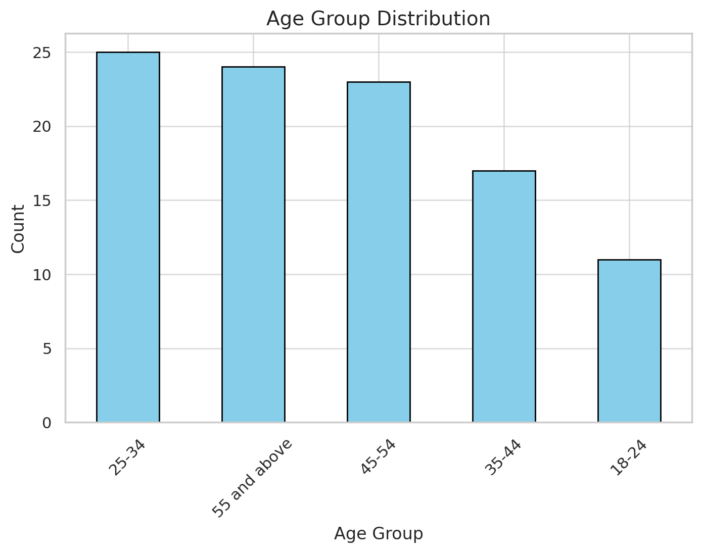

**Age Group Distribution:**

The most common age group in the dataset is 25-34, followed by 35-44.

Older age groups (45-54 and 55+) are less represented.

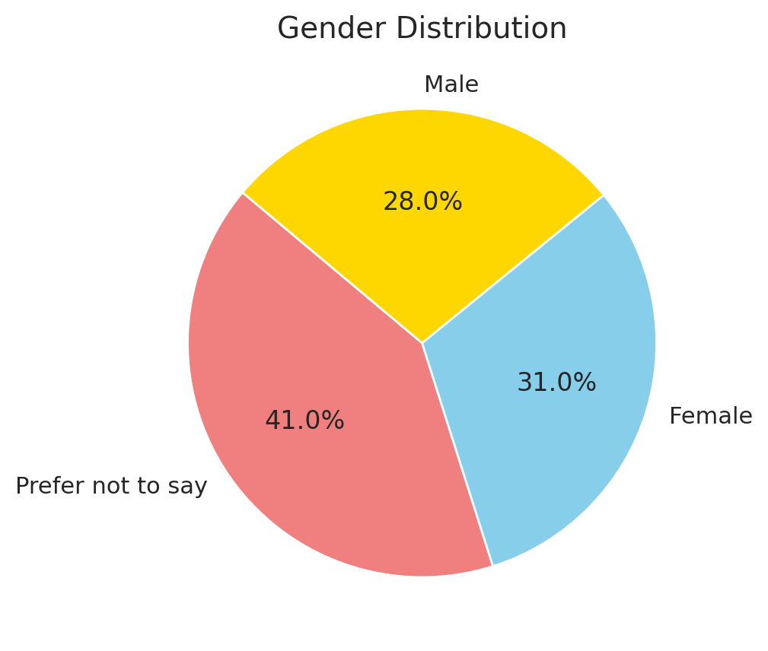

**Gender Distribution:**

Male and Female participants are represented, along with a smaller proportion of "Prefer not to say."

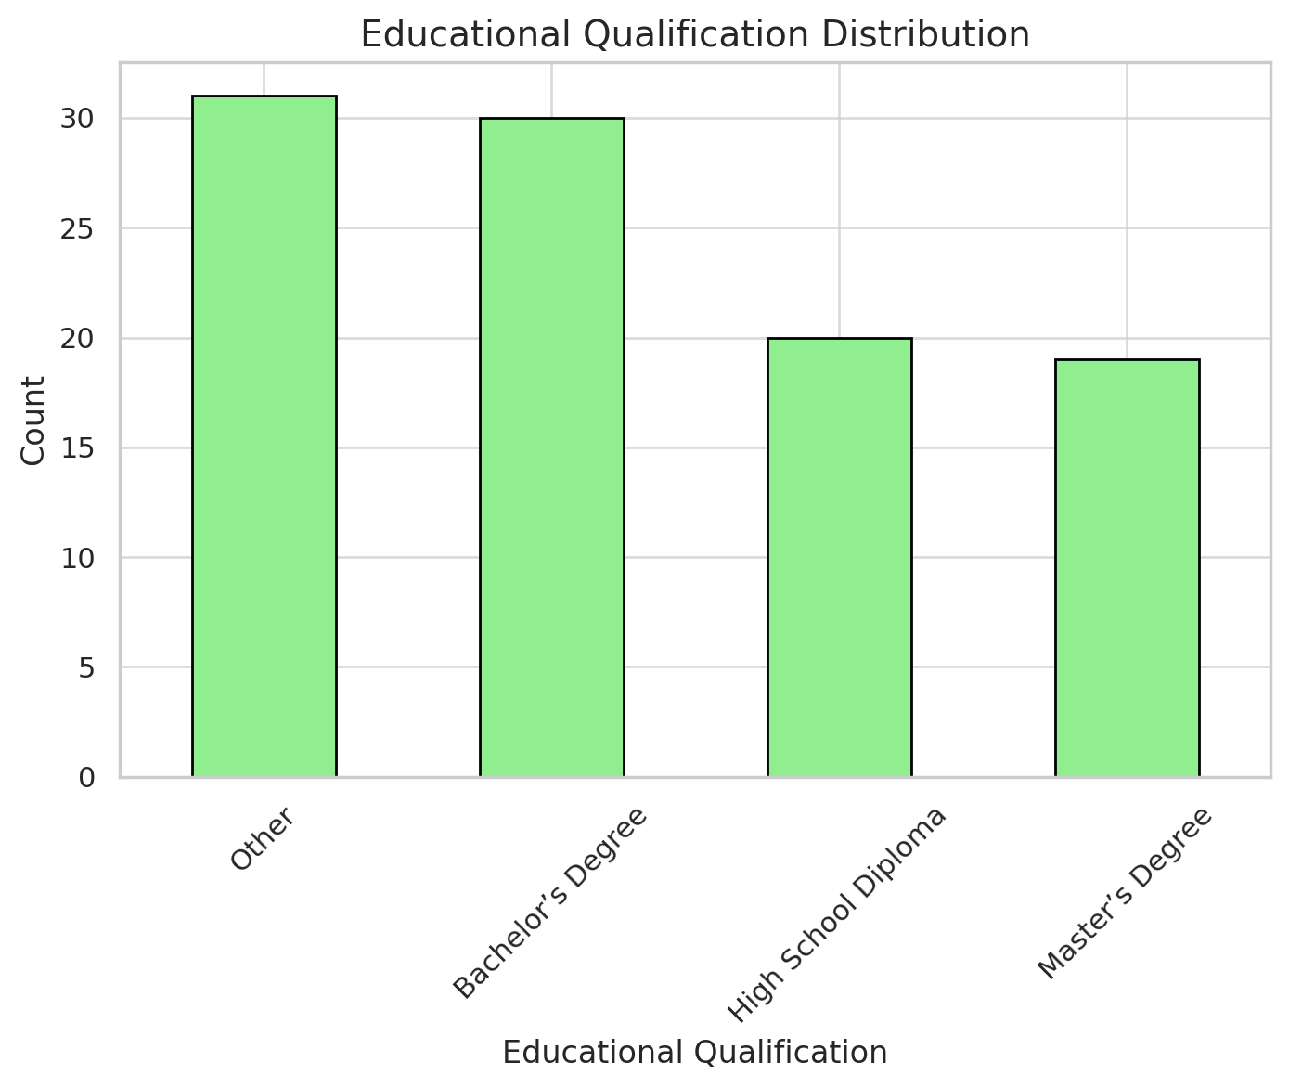

**Educational Qualification:**

A significant portion of participants holds a Bachelor's Degree.

Other categories, including Master’s Degree and High School Diploma, are also represented.

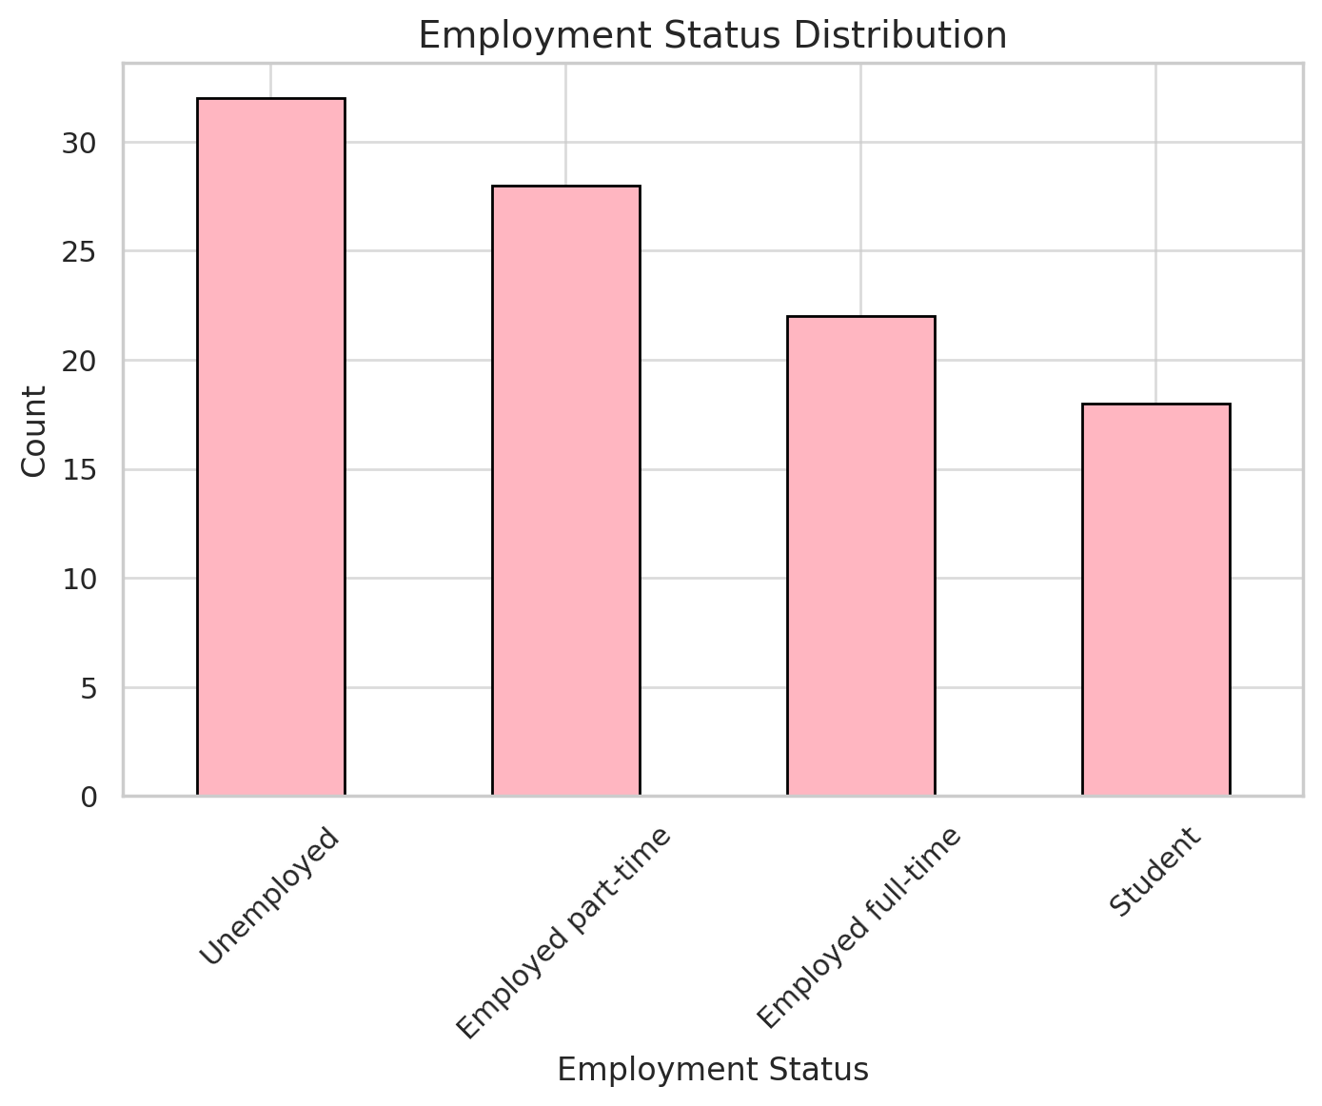

**Employment Status:**

Most respondents are either employed full-time or are students.

A smaller percentage are unemployed or employed part-time.

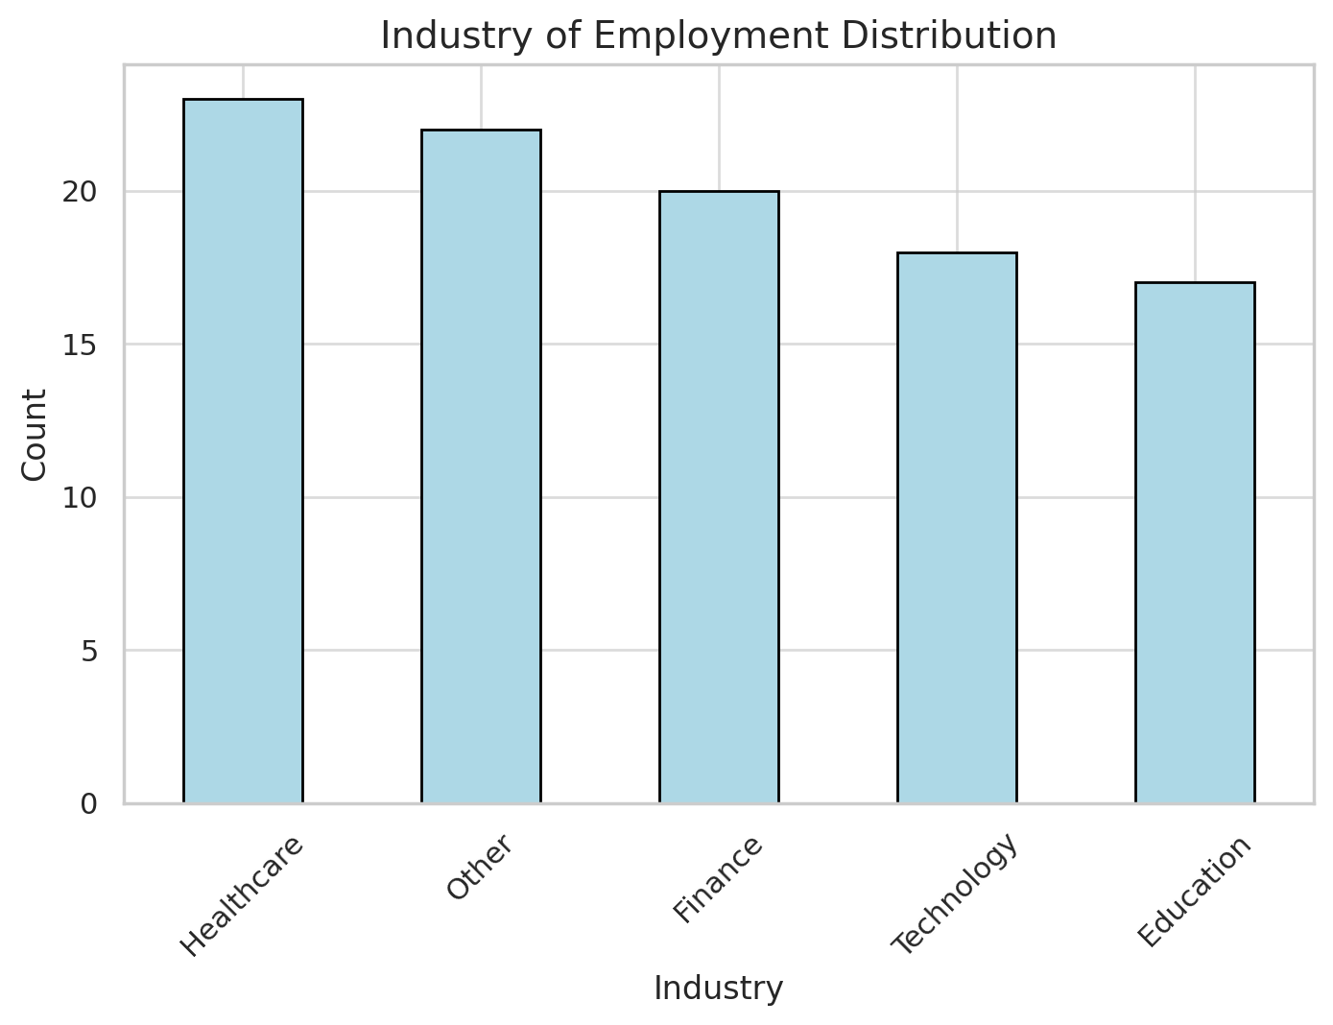

**Industry of Employment:**

Technology is the most prominent industry among participants, followed by Finance.

Healthcare and Education are less represented.

**Discussion**

The findings from this research highlight the significant impact of brand loyalty programs on consumer repeat purchase behaviour. Through our analysis, several key insights and trends have emerged, offering valuable implications for marketers and business practitioners.

Firstly, the effectiveness of brand loyalty programs varies significantly across different industries. For instance, in the retail and hospitality sectors, loyalty programs that offer immediate rewards or discounts tend to be more successful in driving repeat purchases. In contrast, sectors such as luxury goods and financial services benefit more from loyalty programs that emphasize exclusivity and personalized experiences. This suggests that tailoring loyalty programs to the specific needs and preferences of the target audience is crucial for maximizing their impact.

Secondly, the role of personalized rewards and incentives cannot be overstated. Our study found that consumers are more likely to engage with loyalty programs and make repeat purchases when they perceive the rewards as relevant and valuable to their individual needs. Personalization enhances the emotional connection between the consumer and the brand, fostering a sense of appreciation and loyalty.

Furthermore, psychological and emotional factors play a significant role in consumer participation in loyalty programs. The sense of belonging and the emotional satisfaction derived from being recognized and rewarded by the brand contribute to increased loyalty and repeat purchases. This underscores the importance of designing loyalty programs that not only offer tangible rewards but also create positive emotional experiences for consumers.

The perceived value of loyalty programs is another critical factor influencing consumer behavior. Our research indicates that consumers are more likely to remain loyal to a brand and make repeat purchases when they believe that the benefits of the loyalty program outweigh the costs of participation. Brands should, therefore, focus on enhancing the perceived value of their loyalty programs through attractive rewards, clear communication, and seamless user experiences.

Finally, trust in the brand emerged as a pivotal element in the success of loyalty programs. Consumers are more likely to participate in and remain loyal to loyalty programs offered by brands they trust. This trust is built through consistent delivery of high-quality products or services, transparent communication, and ethical business practices. Brands must prioritize building and maintaining trust to ensure the long-term success of their loyalty programs.

In conclusion, brand loyalty programs can significantly influence consumer repeat purchase behaviour when designed and implemented effectively. By understanding the unique needs of their target audience, personalizing rewards, fostering positive emotional experiences, enhancing perceived value, and building trust, brands can leverage loyalty programs to drive customer retention and achieve sustained competitive advantage.

I hope this discussion section provides a comprehensive analysis for your research paper. If you need further assistance or additional sections, feel free to let me know!

**Implications**

• Customization **and Personalization**: One of the key implications is the importance of customizing and personalizing loyalty programs to cater to the unique preferences and behaviors of individual consumers. Businesses should invest in data analytics and customer insights to develop tailored rewards and incentives that resonate with their target audience, thereby increasing the likelihood of repeat purchases.

• Enhancing **Emotional Connections**: The study highlights the significance of fostering positive emotional experiences through loyalty programs. Marketers should focus on creating emotional connections with consumers by recognizing and rewarding their loyalty in meaningful ways. This can be achieved through personalized communication, exclusive offers, and experiences that make customers feel valued and appreciated.

• Perceived **Value of Loyalty Programs**: The perceived value of loyalty programs plays a crucial role in consumer participation and repeat purchase behaviour. Brands should ensure that their loyalty programs offer tangible and attractive benefits that justify the effort and cost of participation. Clear communication of program benefits and seamless user experiences are essential to enhance the perceived value.

• Building **and Maintaining Trust**: Trust in the brand is a pivotal factor influencing the success of loyalty programs. Companies must prioritize building and maintaining trust through consistent delivery of high-quality products or services, transparent communication, and ethical business practices. Trustworthy brands are more likely to retain loyal customers and encourage repeat purchases.

• Strategic **Design and Implementation**: The research underscores the importance of strategically designing and implementing loyalty programs to align with the overall business objectives and market dynamics. Companies should conduct regular assessments of their loyalty programs to ensure they remain relevant and effective in driving customer loyalty and repeat purchases. Adapting to changing consumer trends and preferences is crucial for the long-term success of loyalty programs.

• Industry**-Specific Approaches**: The effectiveness of loyalty programs varies across different industries, suggesting that a one-size-fits-all approach may not be suitable. Businesses should consider industry-specific factors and tailor their loyalty programs accordingly. For example, immediate rewards may be more effective in the retail sector, while exclusivity and personalized experiences may work better in the luxury goods industry.

**Limitations**

1. Sample Diversity:

- The sample size of 100 respondents may not represent all industries or demographics comprehensively.

- Overrepresentation of technology and finance professionals could skew perceptions toward AI-favorable responses.

2. Scope of Questions

- The survey focused on employee perceptions without exploring measurable outcomes such as recruitment success rates or bias reduction metrics.

- Lack of open-ended questions limited deeper exploration of individual concerns and experiences.

3. Self-Reported Data

- Reliance on self-reported data introduces the possibility of response bias, where participants may provide socially desirable answers.

**Conclusion**

This research has underscored the significant impact that brand loyalty programs have on encouraging repeat purchase behavior among consumers. By examining various types of loyalty programs across different industries, it is evident that tailored and personalized loyalty initiatives are more effective in fostering customer retention and loyalty.

Key factors such as the perceived value of the loyalty program, the emotional and psychological satisfaction of consumers, and the trust they place in the brand, all play pivotal roles in the success of these programs. Personalized rewards and incentives, which cater to individual preferences, significantly enhance the emotional connection between consumers and brands, leading to increased repeat purchases.

Furthermore, the research highlights that trust in the brand is essential for the long-term effectiveness of loyalty programs. Brands that consistently deliver high-quality products and services, maintain transparent communication, and uphold ethical practices are more likely to retain loyal customers and encourage repeat purchases.

The findings of this study provide valuable insights for marketers and business practitioners, emphasizing the importance of strategically designing and implementing loyalty programs that align with consumer preferences and industry-specific dynamics. By focusing on personalization, emotional engagement, perceived value, and trust, brands can leverage loyalty programs to achieve sustained competitive advantage and long-term business success.

In conclusion, brand loyalty programs, when effectively designed and executed, are powerful tools for driving repeat purchases and enhancing customer loyalty. As the business landscape continues to evolve, companies must adapt and innovate their loyalty strategies to meet the changing needs and expectations of their customers.

**References**

Sharp, B., & Sharp, A. (1997). "Loyalty Programs and Their Impact on Repeat-Purchase Loyalty Patterns: A Replication and Extension." Marketing Science Centre, University of South Australia. This paper evaluates the effect of loyalty programs on repeat-purchase patterns and examines how loyalty programs can move a brand into an "excess loyalty" position1.

• Widodo, J. S. (2021). "Literature Review of Consumer Behaviour: Customer Loyalty, Repeat Purchase and Purchase Interest." ResearchGate. This literature review explores the relationship between customer loyalty, repeat purchases, and consumer behaviour, providing a comprehensive overview of the factors influencing these dynamics2.

• Ishak, F., & Ghani, N. H. A. (n.d.). "A Review of the Literature on Brand Loyalty and Customer Loyalty." University Utara Malaysia. This article discusses the difference between brand loyalty and customer loyalty, highlighting the multi-dimensional constructs of affective and behavioural approaches.