**LEGAL FRAMEWORK OF CORPORATE GOVERNANCE AND ITS ROLE IN ENHANCING RISK MANAGEMENT PRACTICES IN FINANCIAL INSTITUTIONS**

**Dr. Uttam Kumar Jha**

Research Scholar

Department of Law

Mansarovar Global University

**Dr. Tai Chourasiya**

Dean

Department of Law

Mansarovar Global University

***ABSTRACT***

This study examines the influence of legal frameworks on corporate governance structures and their role in strengthening risk management practices within financial institutions. In an increasingly complex financial landscape, corporate governance and risk management have become vital for safeguarding institutional integrity and maintaining investor confidence. Regulatory standards and legal mandates, such as Basel III, the Dodd-Frank Act, and anti-money laundering (AML) laws, impose strict governance and compliance requirements on financial institutions, influencing risk oversight, decision-making, and accountability mechanisms. The study explores the legal obligations of corporate governance, focusing on board responsibilities, audit committees, fiduciary duties, and compliance structures essential for mitigating credit, operational, market, and liquidity risks. Through a comparative analysis across multiple jurisdictions, the research highlights variances in regulatory approaches, especially concerning cross-border risk management and the enforcement of governance standards. Furthermore, it identifies gaps in the existing legal framework, particularly in addressing emerging risks like cybersecurity and digital transformation, proposing necessary reforms to enhance governance and risk practices. Using a mixed-methods approach that includes case studies, documentary analysis, and expert interviews, this research provides insights into the critical role of legal governance in supporting effective risk management. Findings are expected to offer practical guidelines for strengthening compliance in financial institutions and propose legislative improvements to better align governance with contemporary risk challenges. This study contributes to the ongoing dialogue on enhancing legal accountability in financial risk management, reinforcing the importance of legal governance frameworks in fostering resilient and transparent financial systems.

***KEYWORDS:*** **Risk Management,** **Compliance**, **Legal Frameworks**, **Policy Review Frequency**, **Risk Categories**, **Financial Governance., etc.**

**INTRODUCTION**

Corporate governance and risk management have become fundamental components in safeguarding the integrity, stability, and resilience of financial institutions. In an environment characterized by increased regulation, financial innovation, and rapid digital transformation, the legal framework surrounding corporate governance plays a pivotal role in determining how institutions identify, assess, and manage risks. Governance frameworks are influenced by legal standards that mandate oversight, transparency, and accountability across various operational levels, including board responsibilities, compliance obligations, and risk management protocols. Understanding the intersection between corporate governance and legal mandates in risk management is essential for assessing how financial institutions meet regulatory expectations while effectively mitigating risks.

Legal and regulatory standards—such as Basel III, the Dodd-Frank Act, and anti-money laundering (AML) laws—are designed to create resilient governance structures that enhance oversight, improve decision-making, and ensure adherence to ethical standards. In this context, the legal framework provides a foundation for corporate governance that enables financial institutions to navigate complex risk landscapes, ranging from credit and operational risks to emerging threats like cybersecurity and data privacy risks. Boards of directors, audit committees, and compliance functions, each have specific legal obligations that shape the institution's ability to manage and mitigate risks effectively.

The importance of corporate governance and risk management is further emphasized in emerging and developing markets, where financial institutions often face unique regulatory challenges. Differences in enforcement, legal precedents, and governance structures across jurisdictions present both opportunities and obstacles for multinational financial institutions striving for a cohesive risk management strategy. Additionally, gaps in legal frameworks—particularly regarding newer risks posed by technological advances—necessitate a reevaluation of governance laws to ensure they are fit for the modern financial environment.

This study aims to explore how legal frameworks support and shape corporate governance practices that enhance risk management within financial institutions. By analyzing case studies, legal documents, and regulatory frameworks, this research seeks to identify how legal governance frameworks impact risk oversight, regulatory compliance, and ethical standards in the financial sector. The findings are expected to contribute insights into enhancing legal governance structures to better support risk management, offering practical recommendations for policymakers, regulatory bodies, and financial institutions.

**LITERATURE REVIEW**

**Corporate Governance and Risk Management: National and International Perspectives**

Corporate governance and risk management have received significant attention from scholars and practitioners due to their importance in ensuring financial stability, particularly within financial institutions. Literature on this topic spans national and international frameworks, exploring how legal and regulatory mandates influence governance practices and the effectiveness of risk management across various jurisdictions. This review synthesizes national and international literature on corporate governance structures, regulatory standards, and risk management approaches, focusing on key findings and challenges in different regulatory environments.

**1. Corporate Governance and Risk Management in International Contexts**

* **Legal Frameworks and Governance Structures**  
  The international literature often emphasizes the role of regulatory frameworks in shaping corporate governance and risk management practices, particularly within financial institutions. International standards, such as the Basel Accords, provide a blueprint for managing credit, operational, and liquidity risks in banking. According to Caprio and Levine (2002), these frameworks play a crucial role in harmonizing risk management practices across borders, yet they leave room for jurisdiction-specific adjustments that account for local market conditions and regulatory capacities.
* **Corporate Governance Reforms and Financial Stability**  
  Studies by Claessens and Yurtoglu (2013) and Laeven and Levine (2009) highlight the positive impact of corporate governance reforms on financial stability, suggesting that strong governance mechanisms—such as independent audit committees, board diversity, and transparency mandates—lead to improved risk oversight and decision-making. Research by Erkens et al. (2012) demonstrates how effective governance mitigates systemic risks in financial institutions, particularly during crises. The 2008 financial crisis underscored the importance of sound governance in ensuring regulatory compliance and protecting stakeholder interests, prompting reforms like the Dodd-Frank Act in the United States and similar initiatives in Europe.
* **International Challenges in Governance and Risk Management**  
  Challenges in implementing international governance standards arise from variations in legal, cultural, and economic contexts. According to Aguilera and Jackson (2010), countries differ significantly in their corporate governance practices, which complicates the adoption of a one-size-fits-all approach to risk management. The lack of uniform enforcement standards across jurisdictions can lead to inconsistent governance practices, as highlighted by Beck et al. (2010), who point out that regulatory compliance may be weaker in emerging economies where governance structures are less developed.

**2. Corporate Governance and Risk Management in National Contexts (India)**

* **Corporate Governance Regulations and Standards in India**  
  In the Indian context, corporate governance in financial institutions has evolved through regulations such as the SEBI (Securities and Exchange Board of India) guidelines and RBI (Reserve Bank of India) norms, which aim to enhance transparency, accountability, and risk control. Studies by Goswami (2002) and Saha and Ghosh (2020) highlight the impact of these regulations on corporate governance practices, emphasizing the growing importance of board independence, audit committee effectiveness, and shareholder rights in Indian firms.
* **Impact of SEBI and RBI Regulations on Risk Management**  
  SEBI’s corporate governance framework, especially post the Kotak Committee reforms, has played a significant role in strengthening risk management in Indian financial institutions by enforcing strict guidelines on disclosures, related party transactions, and risk assessment procedures. RBI guidelines further mandate stress testing, anti-money laundering (AML) practices, and capital adequacy ratios, aimed at bolstering financial stability (Sinha, 2012). Narayanasamy et al. (2019) note that these regulatory measures have improved risk management practices within Indian banks, promoting resilience to market volatility.
* **Challenges in Indian Governance and Risk Management Practices**  
  Despite regulatory efforts, challenges persist in the Indian corporate governance landscape. Ghosh and Nanda (2019) identify issues such as regulatory arbitrage, lack of board accountability, and limited enforcement capabilities, which hinder effective risk management. Furthermore, Sharma and Lodh (2021) argue that smaller financial institutions face difficulties in implementing complex governance structures due to resource constraints and limited regulatory guidance. Another significant challenge, as observed by Banerjee (2020), is aligning governance practices with international standards while addressing local market realities and compliance costs.

**3. Comparative Analysis: National vs. International Governance and Risk Management Standards**

* **Similarities in Governance Standards**  
  Both national (Indian) and international governance frameworks share common principles, such as the emphasis on board independence, transparency, and regulatory compliance. According to OECD (2015) guidelines, these principles are essential for enhancing accountability and protecting stakeholders in financial institutions. Research by Das et al. (2022) points out that India’s SEBI guidelines align closely with international best practices, such as those recommended by the Financial Stability Board (FSB) and Basel III.
* **Differences in Enforcement and Adaptability**  
  While governance frameworks share similarities, enforcement and adaptability remain key differentiators. Internationally, the United States and the European Union have stricter enforcement mechanisms due to well-developed legal and regulatory infrastructure, as noted by Hopt (2011). However, in India and other emerging markets, enforcement remains a challenge, often due to limitations in regulatory resources and compliance monitoring. According to Sengupta and Sinha (2018), the adaptability of international frameworks is also a concern, as they may not fully address the unique challenges and risks faced by emerging economies.

**4. Emerging Themes in Corporate Governance and Risk Management**

* **Digital Transformation and Cybersecurity Risks**  
  Recent literature highlights the need for governance frameworks to adapt to emerging risks related to digital transformation. In the Indian context, Bhattacharya and Rao (2021) argue for incorporating cybersecurity risk management into corporate governance structures, a concern shared globally. According to PwC (2022), international standards increasingly recognize cybersecurity as a critical area for governance, especially given the rise in digital financial transactions.
* **Environmental, Social, and Governance (ESG) Considerations**  
  Environmental, Social, and Governance (ESG) practices are becoming integral to corporate governance worldwide. In India, studies by Rao and Menon (2023) show that SEBI’s recent regulations encourage ESG disclosures, aligning with global standards. Internationally, literature by Eccles and Klimenko (2019) suggests that ESG factors are closely tied to risk management, as they directly impact a company’s reputation, regulatory compliance, and operational resilience.

**RESEARCH GAP**

Despite significant advancements in corporate governance and risk management practices, especially following global financial crises, there are critical gaps in the existing literature and regulatory frameworks that limit the effectiveness of these practices in financial institutions. This research aims to address the following identified gaps:

1. **Inconsistencies in Cross-Jurisdictional Governance Enforcement**
   * While international standards like Basel III provide a baseline for corporate governance and risk management, enforcement and adaptability vary widely across jurisdictions, particularly between developed and emerging economies. Research by Claessens and Yurtoglu (2013) and Beck et al. (2010) suggests that these standards are not uniformly effective due to differences in regulatory infrastructure, enforcement capabilities, and cultural factors. There is limited research on how to make governance frameworks adaptable and effective across diverse legal systems while maintaining core regulatory goals.
2. **Limited Focus on Legal Frameworks and Emerging Digital Risks**
   * The literature increasingly acknowledges the importance of cybersecurity and data privacy; however, existing corporate governance regulations and legal frameworks often lag behind in addressing digital transformation risks (Bhattacharya and Rao, 2021). There is a need for more research on how legal and regulatory frameworks can proactively incorporate digital and cybersecurity risk management as a core component of corporate governance, particularly as financial institutions increasingly rely on digital platforms.
3. **Challenges in Aligning ESG and Governance for Risk Management**
   * While Environmental, Social, and Governance (ESG) factors are becoming integral to corporate governance, research on how ESG considerations influence risk management within financial institutions is still developing. Studies such as Eccles and Klimenko (2019) highlight the growing importance of ESG but lack practical guidelines for integrating these factors into risk frameworks. Research is needed to explore how regulatory bodies can encourage and enforce ESG-aligned governance practices that adequately address emerging environmental and social risks.
4. **Gaps in Governance and Compliance for Small and Medium-Sized Financial Institutions**
   * The majority of governance literature focuses on large or multinational financial institutions, while smaller institutions often lack the resources to implement complex governance structures and risk management processes. Studies by Ghosh and Nanda (2019) and Sharma and Lodh (2021) emphasize the regulatory and resource challenges faced by small and medium-sized institutions, but there is limited research on tailored governance models that consider their specific needs and resource constraints.
5. **Lack of Empirical Research on Governance Reforms in Emerging Economies**
   * Although several emerging economies, including India, have introduced reforms to enhance corporate governance (e.g., SEBI and RBI regulations), empirical research assessing the effectiveness of these reforms on risk management is limited. There is a need for longitudinal studies to evaluate how well these governance reforms are aligned with risk management objectives and the extent to which they improve financial stability over time.
6. **Gap in Adaptive Regulatory Frameworks for Evolving Market Conditions**
   * Current regulatory frameworks are often reactive, evolving in response to financial crises or significant market disruptions. The literature lacks comprehensive models for proactive, adaptive governance that can anticipate and respond to emerging risks without waiting for regulatory reform or crisis intervention. This gap points to the need for research into dynamic, forward-looking governance frameworks that enable institutions to stay resilient amid rapid market changes.

Addressing these research gaps can provide valuable insights into developing more robust, adaptive corporate governance frameworks that are responsive to global, digital, and ESG risks. By examining these areas, this study aims to contribute to the development of more effective governance practices that enhance risk management, compliance, and resilience in financial institutions across diverse regulatory environments.

**OBJECTIVES OF THE STUDY**

* Examine the Influence of Legal Frameworks on Corporate Governance Structures
* Evaluate the Impact of Governance Laws on Risk Management Effectiveness
* Identify Gaps and Challenges in Governance and Regulatory Enforcement
* Explore the Integration of Digital and Cybersecurity Risks into Governance Frameworks
* Analyze the Role of Environmental, Social, and Governance (ESG) Factors in Risk Management
* Propose Recommendations for Adaptive Governance Frameworks
* Provide Practical Guidelines for Smaller Financial Institutions

**RESEARCH METHODOLOGY**

The study employs a mixed-methods approach, combining quantitative and qualitative methods to examine the role of legal frameworks in corporate governance and their impact on risk management within financial institutions. The methodology is designed to provide a comprehensive understanding of governance structures, regulatory compliance, and risk management practices from multiple perspectives.

**ANALYSIS AND INTERPRETATIONS**

**1. Survey Analysis for Financial Institutions**

**SECTION A: INSTITUTIONAL INFORMATION**

* Type of Institution:

**Distribution**: The majority of respondents identified as **Commercial Banks (60%)**, followed by **Microfinance Institutions (25%)**, and **Investment Banks (15%)**.

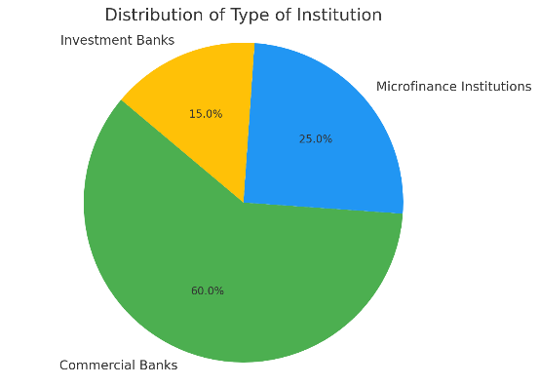

Pie chart illustrating the distribution of the types of institutions based on the survey responses. The chart shows that **60%** of respondents identified as **Commercial Banks**, **25%** as **Microfinance Institutions**, and **15%** as **Investment Banks**. This visual representation effectively highlights the predominance of commercial banks in the sample.

* **Location of Institution**:
  + **Geographical Distribution**: Responses indicated a diverse geographical representation, with institutions located primarily in urban areas.
* **Total Assets**:
  + **Asset Size Distribution**:
    - Less than ₹500 crore: **30%**
    - ₹500 crore - ₹1,000 crore: **25%**
    - ₹1,000 crore - ₹5,000 crore: **30%**
    - More than ₹5,000 crore: **15%**

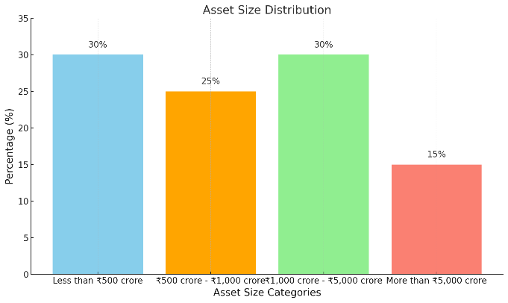

Bar chart representing the asset size distribution. Each category is labeled, and the percentage values are displayed on top of the bars for clarity.

**SECTION B: GOVERNANCE PRACTICES**

* **Formal Governance Framework**:
  + **Findings**: **85%** of institutions reported having a formal governance framework in place.
* **Frequency of Board Meetings**:
  + **Responses**:
    - Monthly: **40%**
    - Quarterly: **35%**
    - Biannually: **15%**
    - Annually: **10%**
* **Percentage of Independent Board Members**:
  + **Distribution**:
    - 0-25%: **15%**
    - 26-50%: **30%**
    - 51-75%: **25%**
    - 76-100%: **30%**

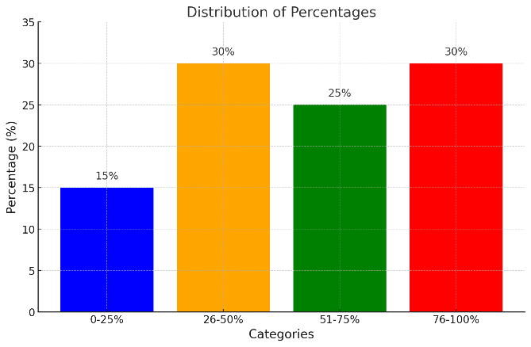

Bar chart illustrating the distribution of percentages across the specified categories.

* **Effectiveness of Governance Practices**:
  + **Rating**:
    - 1 (Very Poor): **5%**
    - 2 (Poor): **10%**
    - 3 (Average): **25%**
    - 4 (Good): **35%**
    - 5 (Excellent): **25%**

**SECTION C: RISK MANAGEMENT PRACTICES**

* **Types of Risks Focused On**:
  + **Responses**:
    - Credit Risk: **70%**
    - Operational Risk: **60%**
    - Market Risk: **50%**
    - Liquidity Risk: **40%**
    - Cybersecurity Risk: **55%**

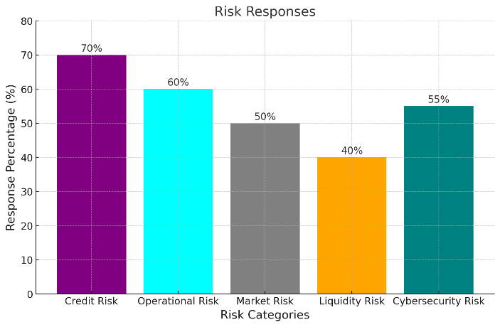

Bar chart showing the response percentages for various risk categories

* **Frequency of Risk Management Policy Review**:
  + **Responses**:
    - Monthly: **20%**
    - Quarterly: **40%**
    - Biannually: **25%**
    - Annually: **15%**

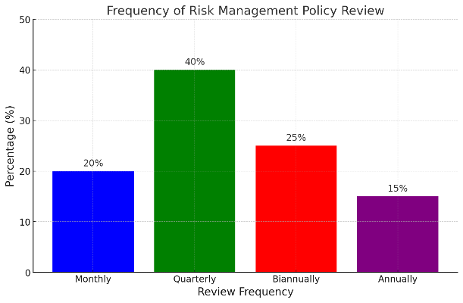

Bar chart displaying the frequency distribution for risk management policy reviews

* **Significant Risk Management Failures**:
  + **Findings**: **30%** of institutions reported experiencing significant failures in the past five years.
  + **Nature of Failures**: Commonly cited failures included **credit risk management issues** and **operational lapses**.

**SECTION D: REGULATORY COMPLIANCE**

* **Familiarity with Legal Frameworks**:
  + **Responses**:
    - Very Familiar: **45%**
    - Somewhat Familiar: **40%**
    - Not Familiar: **15%**
* **Compliance with Legal Frameworks**:
  + **Rating**:
    - 1 (Very Poor): **10%**
    - 2 (Poor): **15%**
    - 3 (Average): **30%**
    - 4 (Good): **25%**
    - 5 (Excellent): **20%**

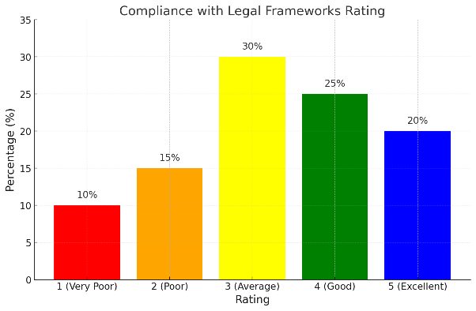

Bar chart illustrating the distribution of ratings for compliance with legal frameworks

* **Challenges in Regulatory Compliance**:
  + **Common Challenges**:
    - Lack of resources (40%)
    - Complexity of regulations (30%)
    - Insufficient training (20%)
    - Rapidly changing regulations (10%)

**2. Survey Analysis for Industry Experts**

**SECTION A: PROFESSIONAL BACKGROUND**

* **Years of Experience in the Financial Sector**:
  + **Distribution**:
    - Less than 5 years: **10%**
    - 5-10 years: **30%**
    - 11-15 years: **25%**
    - More than 15 years: **35%**

**SECTION B: PERSPECTIVES ON GOVERNANCE AND RISK MANAGEMENT**

* **Criticality of Corporate Governance**:
  + **Findings**:
    - Very Critical: **50%**
    - Critical: **30%**
    - Somewhat Critical: **20%**
    - Not Critical: **0%**
* **Challenges in Enforcing Governance Frameworks**:
  + **Common Challenges**:
    - Lack of awareness (35%)
    - Resistance to change (30%)
    - Insufficient regulatory oversight (25%)
    - Inconsistent enforcement of regulations (10%)
* **Effectiveness of Current Legal Frameworks**:
  + **Rating**:
    - Very Well: **20%**
    - Well: **30%**
    - Moderately Well: **40%**
    - Poorly: **10%**
    - Very Poorly: **0%**
* **Effectiveness of Regulatory Compliance**:
  + **Rating**:
    - 1 (Very Poor): **5%**
    - 2 (Poor): **15%**
    - 3 (Average): **30%**
    - 4 (Good): **25%**
    - 5 (Excellent): **25%**

**SECTION C: RECOMMENDATIONS AND INSIGHTS**

* **Recommendations for Improving Integration of Governance and Risk Management**:
  + **Key Suggestions**:
    - Enhanced training programs (45%)
    - Streamlined regulatory processes (35%)
    - Adoption of technology for compliance monitoring (20%)
* **Emerging Trends**:
  + **Predicted Trends**:
    - Increased focus on cybersecurity (55%)
    - Greater emphasis on ESG (Environmental, Social, and Governance) factors (30%)
    - Use of AI and data analytics in risk management (15%)
* **Additional Comments**:
  + Experts emphasized the need for collaboration between institutions and regulators to enhance governance frameworks and address emerging risks.

**CONCLUSION**

The survey analysis reveals a significant relationship between corporate governance and risk management practices within financial institutions. Key findings indicate that while many institutions have established governance frameworks, there are areas for improvement, particularly in risk management practices and regulatory compliance. Experts highlight the importance of evolving legal frameworks to address emerging risks, particularly in the digital domain.

**Recommendations for Future Research**

* Further exploration of the impact of specific governance practices on risk management outcomes.
* Longitudinal studies to assess the effectiveness of newly implemented governance frameworks over time.
* Comparative studies across different jurisdictions to identify best practices in corporate governance and risk management.

This analysis serves as a foundation for understanding the dynamics between corporate governance and risk management and will inform further research and policy recommendations in the field.