Medicinal Plants with Anticancer Properties: A Comprehensive Review
Simla Alom¹*, Al Amin²(1), Rodshi Abyaz²(2) Professor Abul Kalam Azad²**

^{Simla Alom¹* (Main Author),}
Department of Pharmacy, University of Development Alternative (UODA), Dhaka-1209, Bangladesh
^{Al Amin²(1) (Co-Author),}
Department of Pharmacy, University of Development Alternative (UODA), Dhaka-1209, Bangladesh
^{Rodshi Abyaz²(2) (Co-author),}
BRAC Business School, BRAC University, Dhaka, Bangladesh
Professor Abul Kalam Azad²**(Corresponding Author),
Head, Department of Pharmacy, Bangladesh University, 5/B, Beribandh Main Road, Adabar, Mohammadpur, Dhaka – 1207, Bangladesh

Abstract
As one of the top causes of death globally, cancer warrants the investigation of alternative and complementary therapeutic strategies. Bioactive compounds of anticancer potential are found in various medicinal plants for many centuries. In this review, we review the anticancer activities of various medicinal plants, their secondary phytochemical constituents which are engaged in anticancer activity, mechanism of action and therapeutic efficacy. References to the major compounds including alkaloids, flavonoids, terpenoids, and polyphenols that play important roles in the induction of apoptosis, inhibition of angiogenesis, and modulation of signaling pathways are described. The review also outlines the challenges faced in developing plant-based anticancer drugs, which include standardization, bioavailability, and toxicity. Medicinal plants hold great promise as a source of new anticancer agents, but further studies are needed in order to translate their traditional use into contemporary therapies.

Keywords
Medicinal plants, anticancer properties, phytochemicals, apoptosis, angiogenesis, bioactive compounds, traditional medicine, drug development, cancer therapy.

Introduction
Cancer is a heterogeneous and multistep disease that manifests through uncontrolled cellular growth and metastasis (Hanahan & Weinberg, 2011). In spite of significant progress with conventional therapies like chemotherapy, radiation, or immunotherapy, there remains a need for more effective, less toxic treatment (DeVita & Chu, 2008). Widespread use of medicinal plants as therapeutic agents in traditional medicine systems has led to a wealth of bioactive compounds with therapeutic potential (Newman & Cragg, 2020). Ongoing scientific studies have confirmed the cancer-suppressing potential of several medicinal plants, indicating their cytotoxic activity against cancerous cells without harming healthy ones (Cragg & Pezzuto, 2016; Atanasov et al., 2021). This review aims to give an insight into the best-studied medicinal plants capable of exhibiting anticancer activity in vivo and in vitro, revealing the mechanisms of action of these plants along with their therapeutic potential in modern oncology (Gali-Muhtasib et al., 2015). This article demonstrates that plant-based therapies offer interesting potential to alleviate the global burden of cancer if traditional knowledge is integrated with contemporary research (Yuan et al., 2016).

Cancer
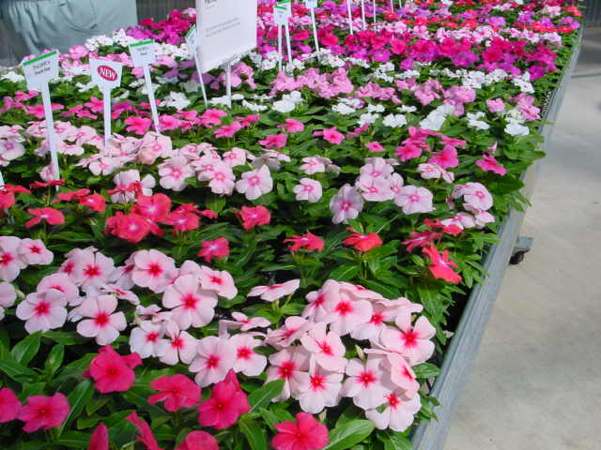

Scientific Name – Catharanthus roseus
Local Name – Madagascar Periwinkle, rose periwinkle, bright eyes.
Taxonomic Hierarchy –
- Kingdom: Plantae
- Sub Kingdom: Tracheobionta (Vascular plants)
- Division: Magnoliophyta
- Class: Magnoliopsida
- Subclass: Asteridae
- Order: Gentianales
- Family: Apocynaeean (Dog-bane family)
- Subfamily: Plumeroideae
Phytochemicals –
- Alkaloids: Vinblastine, Vincristine, Vindoline, Catharanthine, Ajmalicine
- Flavonoids: Kaempferol, Quercetin
- Phenolics: Caffeic acid, Ferulic acid
- Terpenoids: β-Sitosterol, Lupeol.

Vernacular names
Catharanthus roseus, during the course of its spread and naturalization over the tropics and subtropics has acquired a diversity of vernacular names as shown in the table:

Country | Vernacular name(s)
England | Madagascar periwinkle
India | Cape – periwinkle, Church yard blossom,  Dead-man's flower, Ainskati, Rattanjor,  Sadaphul, Sudukad umullai,  Billagannerue (Telugu) Bara Massi and  Sada Bahar (in Hindi), Gulfering (Kashmiri),  Nayantara (Bengali).
Indonesia | Indische maagdepalm, Kembang saritijha,  Kembang – dembaga.
Japan | Nichinchi
Philippines | Chichirica
West Indies | Oldmaid, Ramgoat rose, Jasmine, Magdalena, Vicaria
Sri – Lanka | Minimal or Patti-poo
Thailand | Phaeng phoi farang or Phang-puai-fa-rang
Venda | Liluvha
Vietnam | Dua can
Bangladesh | Nyantra
USA | Periwinkle
Pakistan | Sada-bahar
Mexico | Ninfa
Brazil | Boa-noite

Plant parts used for extraction of Alkaloids:
Plant parts | Name of Alkaloids
Leaf | Catharanthine, Vindoline, Vindolidine, Vindolicine, Vindolinine, ibogaine,  yohimbine, raubasine, Vinblastine, Vincristine.
Stem | Leurosine, Lochnerine, Catharanthine, Vindoline.
Root | Ajmalacine, Serpentine, Catharanthine, Vindoline, Leurosine, Lochnerine,  Reserpine, Alstonine, Tabersonine, Horhammericine,  Lochnericine, echitovenine. (Shanks et al.1998)
Flower | Catharanthine, Vindoline, Leurosine, Lochnerine, Tricin (Flavones).

Alkaloids possessing anticancer property, drug names and its clinical uses:
Vinca alkaloid | Related drug | Clinical uses
Vincblastine | Velban | Hodgkins’s disease, testicular germ cell cancer
Vincristine | Oncovin [54] | Leukemia, lymphomas
Vinorelbine [55] | Navelbine | Solid tumors, lymphomas, lung cancer
Vindesine [56] | Eldisine [57] | Acute lymphocytic leukemia

Anti-Cancerous Effect
C. roseus produces vinblastine and vincristine which are well known for their anti- cancerous properties (El Merzabani et al., 1979) injected ethanol (70 %) extract of leaves intra peritoneally to female mice. As a result, the alkaloids showed great responses against different types of cancers especially those that are multi-drug resistant. The nineteen patients suffering from plantar, genital, flat or Verruca, vulgaris warts were cured. When the chloroform extract was injected to the patients suffering from Leuk-P3887 then only one was resistant to the treatment, five showed 50 % response and six were completely treated. oth the malignant and nonmalignant, platelet and platelet-associated disorders are effectively treated using the C. roseus alkaloids. In recent studies it has been found that growth of
blood vessels that enhance tumor growth are inhibited by alkaloids secreted by C. roseus. These alkaloids, vincristine and vinblastine are used as injectable anticancer drugs such as vinblastine as Velban and vincristine as Oncovin. The division of cancer cells are interfered by these drugs along with their derivatives such as vinflunine. Vincristine is used in the treatment of leukemia in children and vinblastine for choriocarcinoma and Hodgkin's disease.

Dosage & Administration
- Dosage Form: Injectable (IV only).
- Vinblastine: 3.7 mg/m² IV (max 18.5 mg/m²).
- Vincristine: 1.4 mg/m² IV.
- Adjustments: Based on age, liver function, and bone marrow status.
Safety vs. Modern Treatments
- Effective but neurotoxic (Vincristine), myelosuppressive (Vinblastine).
- Modern targeted therapies may have different side effect profiles.
5. Side Effects
- Vinblastine: Nausea, vomiting, leukopenia, neuropathy.
- Vincristine: Neurotoxicity, constipation, hair loss.

N.B. – There is no recent clinical evidence to support specific doses of periwinkle herb. The pure alkaloids vincristine and vinblastine are used in cancer therapy at single weekly IV doses of 0.05 to 0.15 mg/kg and 0.1 to 0.2 mg/kg, respectively.
Do not self-administer the plant periwinkle. Physicians will inform patients using pharmaceutical forms of periwinkle of possible adverse reactions.

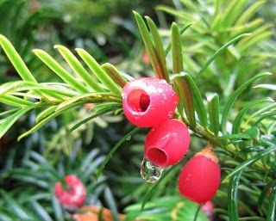

Scientific Name - Taxus brevifolia
Local Name – Pacific and European Yew
Taxonomic Hierarchy –
- Kingdom: Plantae
- Division: Angiosperms
- Class: Dicotyledons
- Order: Pinales
- Family: Taxaceae
- Genus: Taxus
- Species: Taxus brevifolia
Main Phytochemicals of Taxus brevifolia (Pacific Yew)
- Alkaloids:
  - Taxol (Paclitaxel) – Used in cancer treatment.
  - Taxinine – Potential anticancer properties.
- Flavonoids:
  - Quercetin – Antioxidant.
  - Kaempferol – Anti-inflammatory, antioxidant.
- Terpenoids:
  - Taxanes – Includes paclitaxel, effective in chemotherapy.
- Phenolic Compounds:
  - Caffeic acid – Antioxidant properties.

The Pacific yew (Taxus brevifolia) is primarily found in:
- Native Region:
  - Countries: United States (specifically the Pacific Northwest), Canada (British Columbia).
Common sources: Taxus brevifolia, commonly known as the Pacific yew, is native to North America, specifically the Pacific Northwest region. It is found in the United States (Washington, Oregon, California, Idaho, Montana, and Alaska) and Canada (British Columbia and Alberta).
This tree gained significance as the natural source of paclitaxel (Taxol®), a chemotherapeutic agent used to treat various cancers.
These trees grow naturally in forested areas along the coasts of the Pacific Ocean, from southern Alaska to central California.
Main Part Used: Bark (contains Paclitaxel).
Use: Paclitaxel is used to treat cancers like ovarian, breast, and lung cancer by preventing cell division.
Toxicity
Many parts of yews are poisonous and can be fatal if eaten, including the seed which should not even be chewed.
- Poison Severity: Medium
- Poison Symptoms: Nausea, vomiting, dizziness, abdominal pain, and weak muscles.
- Poison Toxic Principle: taxines, taxiphyllin (a cyanogenic glycoside)
- Causes Contact Dermatitis: No
- Poison Part: Bark, Leaves, Seeds
Dosing
The appropriate dose of yew depends on several factors such as the user's age, health, and several other conditions. Currently there is not enough scientific information to determine an appropriate range of doses for yew. Keep in mind that natural products are not always necessarily safe and dosage can be important. Be sure to follow the relevant directions on product labels and consult your pharmacist or physician or other healthcare professional before using them.

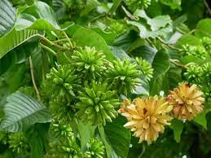

Scientific Name - Camptotheca acuminata
Local Name – Cancer Tree, Happy Tree
Taxonomic Hierarchy –
- Kingdom: Plantae
- Phylum: Tracheophyta
- Class: Magnoliopsida
- Order: Caryophyllales
- Family: Cornaceae
- Genus: Camptotheca
- Species: Camptotheca acuminata

Camptothecin based Carrier-aided nanoparticles (In clinical trials).
Product [company] | Nanoparticle form | Drug | Indication
CPX-1 [Celator] | Liposome | Irinotecan HCI/floxuridine | Colorectal cancer
CRLX-101 (IT-101) [Cerulean Pharma | Cyclodextrin- nanoparticle | Camptothecin | Solid tumors
Lipotecan (TLC388) [Taiwan Liposome] | Polymeric micelle | TLC388 (camptothecin derivate) | Carcinoma, rectal cancer, non-small-cell lung cancer, liver cancer, renal cancer
IHL-305 [Yakult Honsha] | Liposome | Irinotecan (CPT-11) | Solid tumors
MM-398 (PEP02) [Merrimack] | Liposome | CPT-11 (irinotecan) | Pancreatic cancer, gastric cancer, glioma
L9NC [University of Mexico] | Liposome (aerosol) | 9-Nitro-20 (S)-Camptothecin | Non-small-cell lung cancer

POISONOUS PARTS
Whole plant

TOXICITY
- Toxic Constituents
Camptothecin and its derivatives.^{1,5}
- Mechanism
Camptothecin and its derivatives inhibit topoisomerase. They interfere with replication and transcription of DNA, leading to apoptosis of cells.⁶
- Poisoning Features
Tiredness, leucopenia, hair loss, stomatitis, nausea, vomiting, diarrhoea and haemorrhagic cystitis. Death in severe cases.

Plant part used : Uses in TCM—
- Fruits, roots and root bark: anti-cancer, clear heat and remove toxin, kill parasites, dissipate binds and eliminate mass.
- Bark: activate blood and remove toxin, dispel wind and relieve itching
- Leaves (for external use only): clear heat and remove toxin, kill parasites, dispel wind and relieve itching.

Recommended dose: fruits 3–9 g, root bark 9–15 g, bark 15–30 g. In addition, camptothecin and its derivatives have antineoplastic activity.

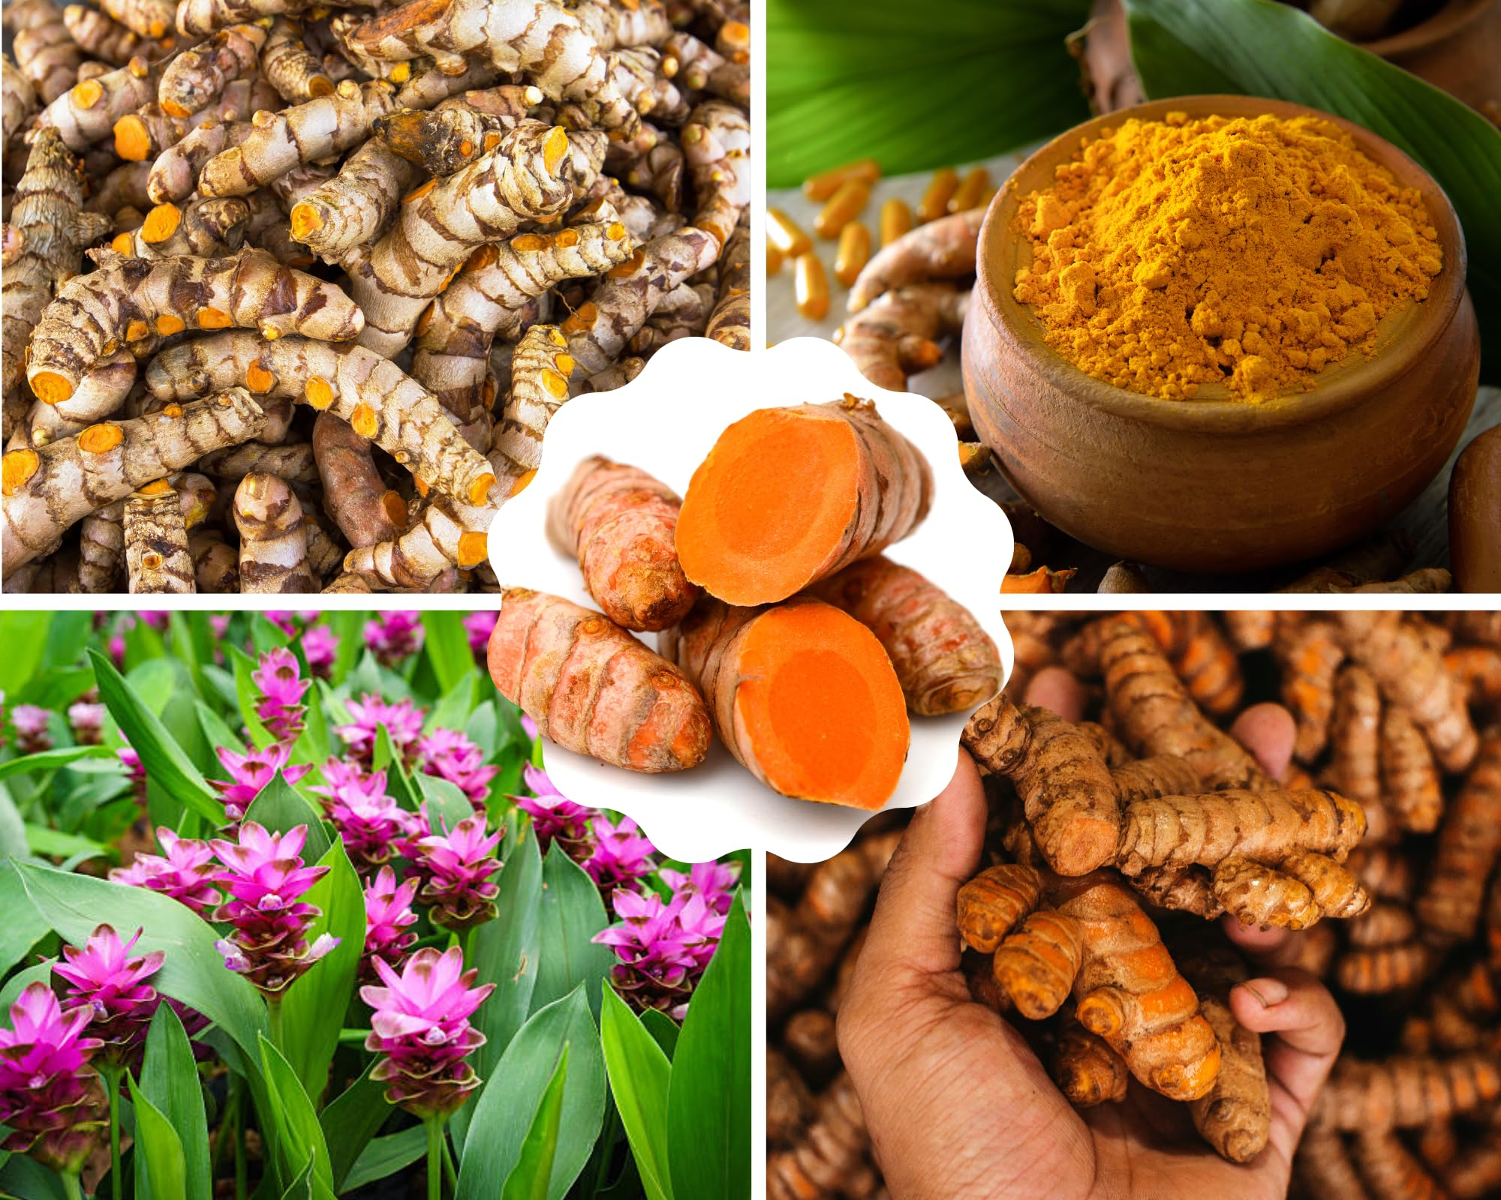
Scientific Name – Curcuma longa
Local Name – Turmeric
Taxonomic Hierarchy –
- Kingdom: Plantae
- Phylum: Tracheophyta
- Class: Liliopsida
- Order: Zingiberales
- Family: Zingiberaceae
- Genus: Curcuma
- Species: Curcuma longa

Some of the most important ethnobotanical uses of Curcuma species in different countries.
Curcuma Species | Vernacular Name | Country | Part Used | Ethnobotanical used
C. aeruginosa Roxb. | kali haldi | India | rhizome | treatment of leukoderma, asthma, tumor, piles, bronchitis, rheumatic pains, dysentery, diarrhoea and cough
C. alismatifolia Gagnep. | Patumma | Thailand | rhizome | snakebite antidote
C. amada Roxb. | Diggi, diggi-thegacu | Bangladesh | tuber, root | Tuber paste is used against evil spirits.  Root juice is used to treat impotency
C. amada Roxb. | Amba haldi | India | rhizome | to cure dropsy, asthma in cattle and  snake bite, fractured bone
C. amada Roxb. | Aama haldi | Nepal | rhizome | Rhizome powder is given as digestive  to clean throat and tongue. Rhizome  paste is externally applied on strains,  rheumatism, and inflammation
C. angustifolia Roxb. | Gorusat haladhi | Assam | rhizome | stop bleeding
C. angustifolia Roxb. | Nauhaine-haldai | Nepal | rhizome | dried rhizome powder is used as anti-  septic in cuts, wounds and to check  bleedin
C. angustifolia Roxb. | Tikhur | India | rhizome | treatment of wounds
C. aromatica Salisb. | Vanhaldi | India | whole plant | plant blood purification
C. australasica Hook. | - | Australia | rhizome, flower | anti-inflammatory, used as ornamental
C. caesia Roxb. | Sammi-seng | Bangladesh | tuber | Fresh tuber juice is used as an antidote
C. caesia Roxb. | Narkachura | India | rhizome | stimulant, carminative, sprai
C. caesia Roxb. | Kola haladhi | Assam | rhizome | treatment of dysentery and gout
C. gracillima Gagnep. | Khamin | Thailand | rhizome | snakebite antidote
C. inodora Blatt. | Wedi haldyo | India | tuber | treatment of muscular pain
C. kwangsiensis S.G.Lee & C.F.Liang |  | China | rhizome | anti-tumor
C. leucorrhiza Roxb | Palo | India | rhizome | treatment of cough

In vitro and in vivo studies of C. longa
Species | Part Used | Type of Extrac-  tion/Phytochemical | Activity | Tested Patho-  gen/Cell | Result(s
C. longa | rhizome | new curcumin ana-  logs (MACs) | anti-inflammatory | in vitro study, HU-VECs and RAW 264.7 macrophages; In vivo study, male mice and rats | ↓MD21, ↑inhibition potency  and stability, highest anti-  inflammatory with MAC 17  and 28, with >90% inhibition  of LPS-stimulated cytokine  secretion from macrophages,  protected against LPS-induced  acute lung injury and sepsis
C. longa | rhizome | curcumin | anti-inflammatory | blood samples  (platelet-rich plasma  (PRP) and platelet-  poor plasma (PPP)) | ↓platelet aggregation induced  by arachidonate, adrenaline and  collagen, ↓ TXB22 productions
C. longa | rhizome | curcumin | anti-inflammatory | in vivo, zymosan-  induced arthritis in  rats (100 mg/kg) | ↓ neutrophil inflammatory  response in the first six hours

Anti-cancer activity
Curcumin, a key bioactive ingredient in turmeric, has been examined for its capacity to induce apoptosis (programmed cell death) and suppress cancer cell proliferation. Curcumin's key modes of action include inducing apoptosis and inhibiting cancer development and invasion via a variety of cellular signaling mechanisms. By targeting these pathways, Curcumin has the ability to decrease tumor growth, angiogenesis, and metastatic spread. Clinical trials have also evaluated the potential anticancer activity of curcumin in humans [55]. Although some trials have shown promising results, others have been inconclusive or have shown no significant benefit. However, it should be noted that curcumin possesses a low bioavailability, meaning that it is quickly metabolized and eliminated from the body [56-79]. Therefore, researchers are investigating various formulations and delivery methods to improve its efficacy.

Chemical composition of turmeric powder
Constituents | Quantity (%)
Moisture | 10.86
Crude fat | 37.39
Crude Protein | 2. 78
Crude fiber | 3. 11
Crude ash | 6.26
Carbohydrate | 42.71
Starch | 36.91
Neutral detrget fiber (NDF) | 12.11
Acid deterget fiber (ADF) | 9. 68
Soluble dietary fiber (SDF) | 2.24
Insoluble dietary fiber (ISDF) | 17.37
Cellulose | 8.77
α-Glucans | 13.04
Lignin | 0.91
Hemicellulose | 2.4

Nutritional composition of turmeric (Leela et al., 2002)
Constituents | Quantity per 10 0 g
Ascorbic acid (mg) | 50
Ash | 6.8
Calcium (g) | 0. 2
Carbohydrate (g) | 69 .9
Fat (g) | 8. 9
Food (K Cal) | 390
Iron (g) | 47.5
Niacin (mg) | 4. 8
Potassium (mg) | 200
Phosphorus (mg) | 260
Protein (g) | 8. 5
Riboflavin (mg) | 0. 19
Sodium (mg) | 30
Thiamine (mg) | 0.09
Water (g) | 6. 0

Information for consumers
If you take medicines or herbal supplements containing Curcuma species and/or curcumin you should be aware of the risk for liver injury in rare cases. While liver injury is a rare adverse event it can be severe. However, the risks are reduced if you recognise the early signs and stop taking the medicine or herbal supplement.
You should immediately stop taking it and seek medical advice if you experience any of the following symptoms:
- yellowing of the skin or eyes
- dark urine
- nausea
- vomiting
- unusual tiredness
- weakness
- stomach or abdominal pain
- loss of appetite.

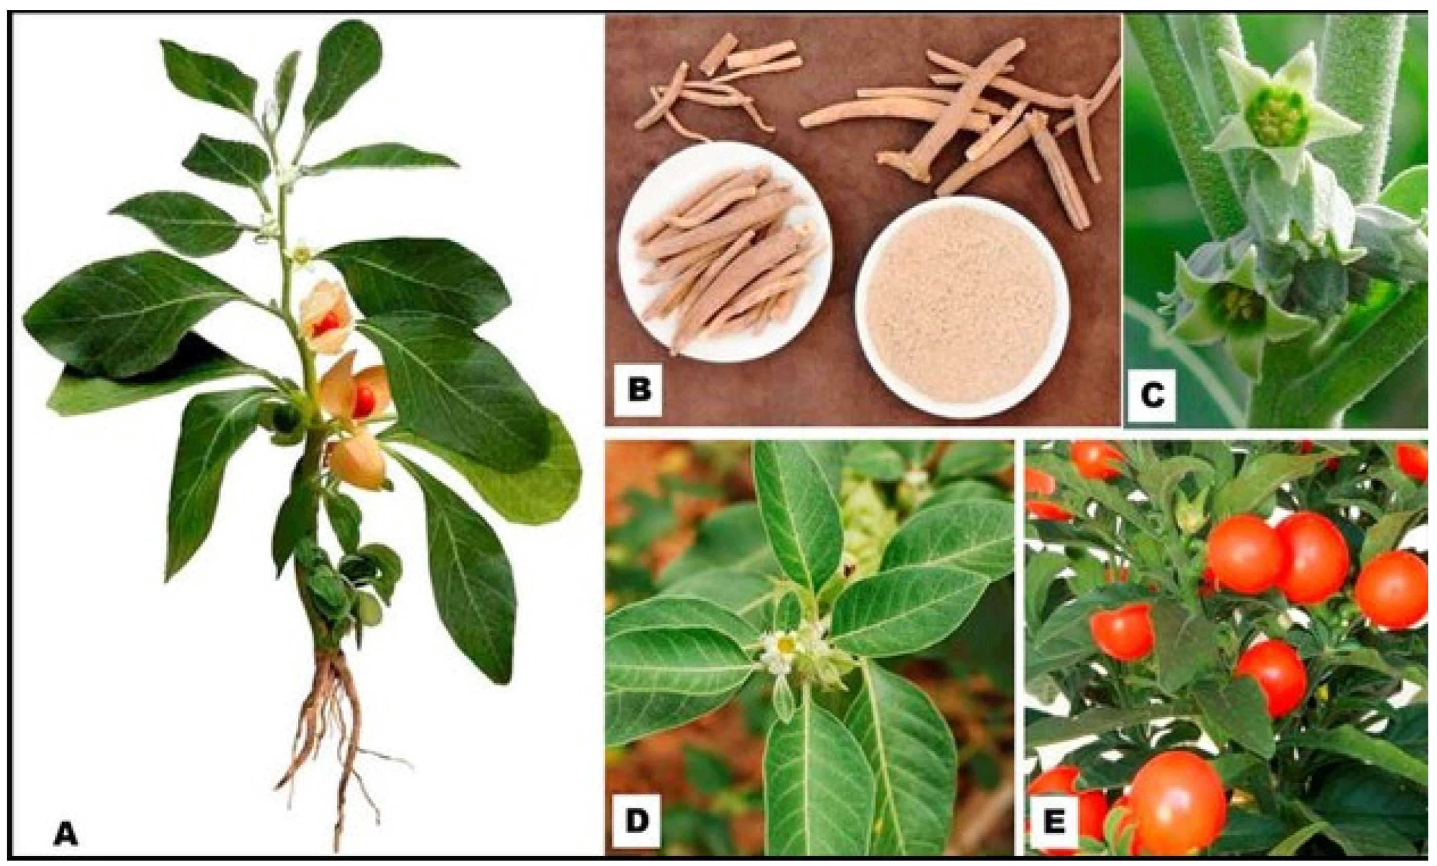
Scientific Name - Withania somnifera
Local Name – Ashwagandha
Taxonomic Hierarchy –
- Kingdom Plantae
- Phylum Streptophyta
- Class Equisetopsida
- Subclass Magnoliidae
- Order - Solanales
- Family - Solanaceae
- Genus - Withania
- Species - Withania somnifera
General information of Withania somnifera (DTU, 2020; BfR 2013)
Scientific (Latin) name | Family: Solanaceae  species: Withania somnifera (L.) Dunal
Synonyms | Physalis somnifera L.  Physalis flexuosa L
Common names | Ashwagandha  Indian ginseng  Indian winter cherry
Part used | Whole plant  Roots (most often)
Geographical origin | Mediterranean region  Northern Africa  Middle East  South Asia
Cultivation | Yes, for example in India

The total concentration of compounds per phytochemical classes in
Withania somnifera root, leaf and fruit from different studies (DTU, 2020; BfR,
2013).

 | Root | Leaf | Fruit
Polyphenols | 1.8% | 3.3% | 2.2%
Flavonoids | 1.5% | 3.2% | 2.1%
Alkaloids | 0.1-0.3%  0.2-1.0%  max 4.3% | 0.2-0.6%  max 2.1%
Withanolides | 1.3%  0.2-1.1% | 0.2-2.1%  3.75% | 3.1-3.4%  3.1-27.7%
Withanamides |  |  | 0.5-1.7%

the concentration (%) of individual withanolides in Withania somnifera
root, leaf and fruit from different studies (DTU, 2020; BfR, 2013).
 | Root | Leaf | Fruit | Stem
Withanolide A | 0.01-0.4  max 1,47 | 0.1-1.3  0.01-0.2 | 0.004 | 0.3
Withanolide D | 0.2
Withanolinde S |  | 0.2
Withaferine A | 0.001-0.2  0.1-0.9  0.02  0.2 | 0.1-1.1  0.1  0.6  0.9 | 0.4 | 0.2
Withanoside | 0.4
Withanon | 0.01-0.6  Max – 0.4 | 0.4
Withastramonolide | max 0.01
Physaguline | 0.02 | max 0.1
Metaferine A | 0.002-0.04 | max 0.6
Metanon |  | max 0.3
Metanoside |  | max 0.1
Metastramonolide |  | max 0.1
27-hydroxywithanolid B | 0.001-0.1
27-hydroxywithanon | 0.001-0.1  max 0.004 | max 0.1
27-desoxywithaferin A | 0.4
17-hydroxy-27-  desoxywithaferin A | 0.07
12-  deoxymetastramonolide | 0.01-0.1  0.04 | 0,004-0,3  0.002 | 0.01 | 0.4

Results of oral acute toxicity studies with W. somnifera extract and its
constituents.
Test compound | Species; Sex | LD 50 (mg/kg bw)
W. somnifera root  extract  (4.5% withaferine A) | Rat; F | >2000
W. somnifera root  extract  (0.043% withaferine A) | Rat; F | >2000
W. somnifera root  extract  (0.08% withaferine A) | Mice; NR | >2000
Sitoindoside IX and X | Mice; NR | >1000
Withaferin A | Mice; F | >2000

Results of the short-term and sub-chronic toxicity studies.
Test compound | Species;  sex | Dosea  (mg/kg bw  per day) | no. per  groupb | Route | Duration  (days) | Effect
Withaferin A | Mice; F | 0, 10, 70 or  500 | 5 | Gavage | 28 | No adverse effects were observed,  NOAEL of 500 mg/kg bw per day was  derived
W. somnifera  root extract | Mice; NR | 100, 200 | NR | Oral | NR | Changed behaviour
W. somnifera  root extract | Mice; F | 0, 10, 30,  100 | 6 | Oral | 15 | Increased immune response in all  dose group**
W. somnifera  root extract | Mice; NR | NR | NR | NR | NR | Effect on immune system,** no  further information available
W. somnifera  root extract | Mice; NR | NR | NR | NR | NR | Effect on immune system,** no  further information available
W. somnifera  root extract | Mice; NR | 100 | NR | NR | 15 | Increased haemoglobin  concentration**
W. somnifera  root extract | Mice; NR | 100 | NR | NR | 15 | No effect on haemoglobin  concentration
W. somnifera  root extract | Rat; M/F | 0, 500,  1000, 2000 | 12 | Gavage | 28 | No adverse effects were observed,  NOAEL of 2 g/kg bw per day was  derived.
W. somnifera  whole plant  extract | Rat; M/F | 0, 100, 300  or 1000 | 10 | Gavage | 28 | No adverse effects were observed,  NOAEL of 1 g/kg bw per day was  derived.
W. somnifera  root extract | Rat; M/F | 0, 500,  1000, 2000 | 12 | Gavage | 28 | No adverse effects were observed
W. somnifera  whole plant in  liquid | Rat; M | 0, 250 | 23, 35 | Drinking water | 28 | Decreased plasma cortisol levels*,  increased liver weight* and  decreased adrenal weights
W. somnifera  dried whole plant | Rat; NR | ± 5 (g) | 6 | Diet | 10-14 | Centrilobular hydropic degeneration  in the liver, peribronchial and  perivenous oedema in the lung,  intratubular vascular congestion,  tubular casts and tubular  degeneration was observed in most  animals
W. somnifera  root extract | Rat; M | NR | 5 | Oral | 10 | Inhibition of acetylcholinesterase in  the brain of rats with scopolamine-  induced Alzheimer’s
W. somnifera  root powder in liquid | Rat; NR | NR | NR | NR | NR | Effect on immune system,** no  further information available
W. somnifera  root extract | Rat; NR | 0, 50, 100,  200, 500 | 7 | Oral | 5 | Changes in forced swimming test at  three highest concentration
W. somnifera  root extract | Rat; NR | 0, 20, 50 | NR | Oral | 14 | Highest dose increased ACH levels, ChAT activity and binding of muscarine receptors in rats with Alzheimer symptoms
W. somnifera  root extract | Rat; NR | 200,400 | NR | Oral | NR | Improved blood glucose, glycated  haemoglobin and insulin levels and  insulin sensitivity in rats with  induced diabetes
W. somnifera  root extract | Rat; NR | 100, 200 | NR | NR | 64 | Lowered blood glucose and glycated  haemoglobin levels in rats with  induced diabetes
W. somnifera  root extract | Rat; NR | 200 | NR | NR | 64 | Haemoglobin concentration in  diabetic rats increased to the level in  non-diabetic rats
W. somnifera  root extract | Dog; M/F | 0, 15 | 12 | Diet | 28 | Reduced respiratory rate*; Increased  haemoglobin* and T 4 concentration
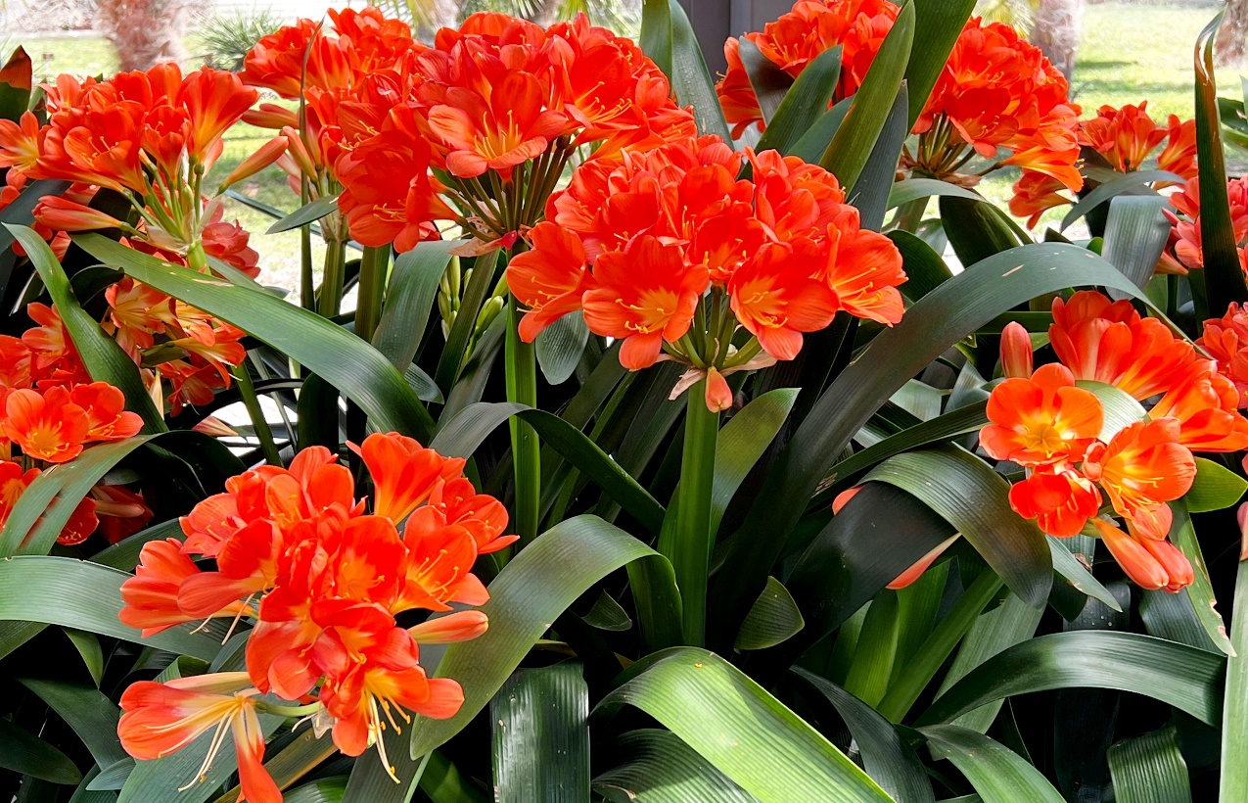
Scientific Name – Clivia miniata
Local Name – Bush Lily
Taxonomic Hierarchy -
- Kingdom: Plantae
- Phylum: Tracheophyta
- Class: Magnoliopsida
- Order: Asparagales
- Family: Amaryllidaceae
- Genus: Clivia
- Species: Clivia miniata

Clivia miniata is commonly found, along with its local names (if available):
- South Africa & Eswatini (Swaziland) – Known simply as Bush Lily
- China – (君子兰) Jūnzǐlán (meaning "Gentleman Orchid")
- Japan – (クンシラン) Kunshiran
- United States & Europe – Commonly called Kaffir Lily or Bush Lily
- Australia & New Zealand – Referred to as Clivia or Bush Lily
- Bangladesh – Bush Lily

The chemical compounds are isolated from C. miniata.
Parts | Compounds
Whole plant | Alkaloids lycorine, clivonine, clivatine, and clivonidine Ali et al., 1983  Cliviamartine, cliviasine, clividine, clivimine, clivonine, hippeastrine, and lycorine
Rhizome | Clivacetine, lycorine, clivatine, clivimine, clivonine, and carinatine
Leaves | Lycorine, clivimine, clivonine, and cliviamartine
Root | Linoleic acid and 5-hydroxymethyl-2-furancarboxaldehyde
Whole plant | Lycorine such as caranine, cliviasindhine, and lycorine. Homolycorine such as clivacetine, clivatine,  cliviamartine, cliviasine, cliviasyaline, clividine, clivimine, clivonidine, clivonine, hippeastrine,  miniatine, and nobilisine. Haemanthamine such as haemanthamine  Miscellaneous: cliviahaksine, cliviaaline, and  Clivojuline

List of identified compounds from C. miniata as potential BACE-1 inhibitors.
Compound name | Binding energy (Kcal\mol) | Glide score
Lycorine dihexoside | -13.10 | -13.10
Miniatine | -8.40 | -8.40
Cliviaaline | -7.30 | -7.50
Clivatine | -6.50 | -6.50
Clivonine | -6.40 | -6.40
Clivojuline | -6.20 | -6.30
Cliviahaksine | -5.90 | -5.90
Didehydro, methyl ether clivonine | -5.60 | -5.60
Clivonidine | -5.30 | -5.30
Clivoline | -4.40 | -4.40
Clivimine | -3.20 | -3.20

Poisonous to Humans:
Poison Severity: Low
Poison Symptoms:
Vomiting, salvation, diarrhea; large ingestions cause convulsions, low blood pressure, tremors, and cardiac arrhythmias. Bulbs are the most poisonous part.
Poison Toxic Principle: Lycorine and other alkaloids
Causes Contact Dermatitis: No
Poison Part:
- Flowers
- Fruits
- Leaves
- Roots
- Seeds
- Stems

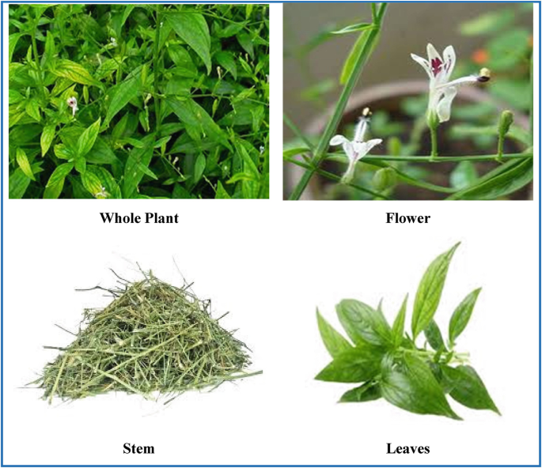

Scientific Name – Andrographis paniculata
Local Name – King of Bitter
Taxonomic Hierarchy -
Domain: Eukaryota,
Kingdom: Plantae,
Subkingdom: Tracheobionta,
Superdivision: Spermatophyta,
Division: Angiosperma,
Class: Dicotyledonae,
Subclass: Gamopetalae,
Series: Bicarpellatae,
Order: Personales,
Family: Acanthaceae,
Subfamily: Acanthoideae,
Tribe: Justiciae,
Subtribe: Andrographideae,
Genus: Andrographis,
Species: A. paniculata (Burm. f.)

The vernacular names of A. paniculata
Language | Name
Arabic | Quasabhuva
Assamese | Chiorta, Kalmegh
Azerbaijani | Acılar Şahı, Acılar Xanı (khanı)
Bengali | Kalmegh
Burmese | Se-ga-gyi
Chinese | Chuan Xin Lian
English | The Creat, King of Bitters
French | Chirette verte, Roi des amers
Gujarati | Kariyatu
Hindi | Kirayat, Kalpanath,
Indonesian | Sambiroto, Sambiloto
Japanese | Senshinren
Kannada | Nelaberu
Konkani | Vhadlem Kiratyem
Lao | La-Sa-Bee
Malay | Hempedu Bumi, Sambiloto
Malayalam | Nelavepu, Kiriyattu
Manipuri | Vubati
Marathi | Oli-kiryata, Kalpa
Mizo | Hnakhapui
Oriya | Bhuinimba
Panjabi | Chooraita
Persian | Nain-e Havandi
Philippines | Aluy, Lekha and Sinta
Russian | Andrografis
Sanskrit | Kalmegha, Bhunimba and Yavatikta
Scandinavian | Green Chiratta
Sinhalese | Hīn Kohomba or Heen Kohomba
Spanish | Andrografis
Tamil | Nilavembu
Telugu | Nilavembu
Thai | Fa-Talai-Jorn, Fah-talai-jon (jone)
Turkish | Acılar Kralı, Acı Paşa, Acı Bey
Urdu | Kalmegh, Kariyat, Mahatita
Vietnamese | Xuyên Tâm Liên
Thai | Fa-Talai-Jorn, Fah-talai-jon (jone)
Turkish | Acılar Kralı, Acı Paşa, Acı Bey
Urdu | Kalmegh, Kariyat, Mahatita
Vietnamese | Xuyên Tâm Liên

Anticancer Effect
Andrographolide exhibited both direct and indirect effects on cancer cells by inhibiting proliferation of cancer cells, cell-cycle arrests, or cell differentiation, enhancing body's own immune system against cancer cells, and inducting apoptosis and necrosis of cancer cells. Dichloromethane fraction of methanol extract significantly inhibited the proliferation of HT-29 colon cancer cells. The major bioactive compound of AP, andrographolide, isolated from dichloromethane, inhibited the growth of a diverse cancer cell representing different types of human cancers. In contrast, recently Aditya et al. reported that methanol extract of AP was found to be very less effective against both MCF-7 breast and HT-29 colon cancer cell lines. This low activity exhibited might be due to the low penetration power of the active principles.
Antiproliferative activities of andrographolide and isoandrographolide along with other 16 ent-labdane diterpenoids isolated from 85% ethanol extract of AP against human leukaemia HL-60 cells have also been investigated by Chen et al. These results showed that andrographolide and isoandrographolide were more effective than others. In a recent study, Chen et al. identified a new flavonoid, 7, 8-dimethoxy-2-hydroxy-5-O-β-d-glucopyranosyloxyflavone, isolated from the aerial parts of AP. This flavonoid exhibited potent antiproliferative activity against human leukaemia HL-60 cells with IC₅₀ of 3.50 μM. Ethanol (70%) extracts and andrographolide were also found to be effective to increase the life spans of thymoma injected mice cells in an in vivo study. In the following year, Geethangili et al. showed the effective cytotoxic activity of ethanol extracts against human cancer cells including Jurkat (lymphocytic), PC-3 (prostate), HepG2 (hepatoma), and colon 205 (colonic) cancer cells. In another study, the use of andrographolide at a dose 12 μg/mL for 36 h against HL-60 cells improved 27% in G0/G1 phase cells and significantly decreased cells number at S and G2/M phase. Shi et al. reported that andrographolide can inhibit human colorectal carcinoma (CRC) Lovo cell growth by G1–S phase arrest and induce the expression of cell-cycle inhibitory proteins p53, p21, and p16. These proteins repressed the activity of cyclin D1/Cdk4 and/or cyclin A/Cdk2, required for G1 to S phase transition. In recent vitro study, andrographolide has been shown to suppress the growth and invasion of CRC Lovo cells and trigger apoptosis. Besides the effect of andrographolide alone, andrographolide in combination with chemotherapeutics, cisplatin, is likely to represent a potential therapeutic strategy for CRC.
Andrographolide and its analogues exert direct inhibitory effect on cancer cells by inducing expression of cell cycle inhibitory proteins and depressing cyclin-dependent kinase (Cdk) resulting in blocking the cell cycle progression at G0/G1. Some other compounds also block the cell cycle progression at G2/M phase. A novel semisynthetic analogue of andrographolide, DRF3188, exhibited anticancer activities against MCF 7 breast cancer cells at a lower dosage than andrographolide through similar mechanism. Both the compounds block cell cycle at the G0-G1 phase through induction of the cell cycle inhibitor (p27) and concomitant decrease in the levels of Cdk4. Therefore, attention has been focused on the anticancer properties of pure components of AP and the molecular target of andrographolide that blocks G1 stage still needs to be determined.

The ethnobotanical uses of A. paniculata.
Country/TMS* | Traditional uses
Ayurvedic | Fever, liver diseases, torpid liver, vitiligo
Japan | Fever, common cold
Malaysia | Diabetes, hypertension
Scandinavian | Fever, common cold
Traditional Bangladeshi medicine | Acute diarrhea, anorexia, bloating with burning sensations in the chest, blood purifier, common cold, constipation, cough, debility, diabetes, dysentery, edema, emesis, fever, headache, helminthiasis, indigestion, intestinal worms, leucorrhea, liver disorders, loss of appetite, low sperm count, lower urinary tract infections, lung infections, malaria, mucus, pharyngotonsillitis, sexual and skin disorders, splenomegaly, uncomplicated sinusitis, vertigo
Traditional Chinese medicine | Inflammation, fever, burn, carbuncle, cervical erosion, chicken pox, common cold, cough with thick sputum, detoxicant, detumescent, diarrhea dispel toxins of the body, dysentery, eczema, epidemic encephalitis B, fever, hepatitis, herpes zoster, laryngitis, mumps, neonatal subcutaneous annular ulcer, neurodermatitis, pelvic inflammation, pharyngitis, pharyngolaryngitis, pneumonia, respiratory infections, snake bites, sores, suppurative otitis media, tonsillitis, vaginitis
Traditional Indian medicine | Diabetes, dysentery, enteritis, helminthiasis, herpes, peptic ulcer, skin infections (topical use), snake-bites (topical use)
Traditional Thai medicine | Fever, common cold, noninfectious diarrhea
Unani system of medicine | Anthelmintic, anti-inflammatory, antipyretic, aperient, astringent, boils, carminative, chronic and seasonal fevers, convalescence after fevers, diuretic, dysentery, dyspepsia associated with gaseous distension, emmenagogue, emollient, gastric and liver tonic, general debility, gonorrhea, irregular bowel habits, leprosy, loss of appetite, relieve griping, scabies, skin eruptions

Qualitative phytochemical constituents of aqueous and alcoholic extracts of APWP
Phytochemicals | Aqueous extract | Alcoholic extract
Saponins | Present | Present
Tannins | Present | Present
Phenols | Present | Present
Alkaloids | Present | Present
Terpenoids | Present | Present
Flavonoids | Present | Present
Amino acids and Protein | Absent | Absent
Carbohydrates | Absent | Absent
Phlobatannins | Present | Absent
Volatile Oils | Absent | Absent
Hydrolysable tannins | Present | Present
Glycosides | Present | Present
Cardiac glycosides | Absent | Present
Vitamin C | Absent | Absent

Side Effects
When taken by mouth: Andrographis is likely safe when used in doses up to 340 mg daily for up to 12 months. It also appears to be safe when taken as a specific combination product containing andrographis extract and eleuthero (Kan Jang, Swedish Herbal Institute) for 4-7 days. Andrographis can cause side effects such diarrhea, vomiting, rash, headache, runny nose, and fatigue. Side effects are more likely with higher doses.

Future Challenges
Medicinal plants have great promise in treating cancer; however, several obstacles need to be overcome in order to fully exploit their potential. Standardization and Quality Assurance :Since the plant composition is variable because of environmental factors, cultivation, and extraction methods, this causes potential obstacle in drug development. Bioavailability and Pharmacokinetics: To be effective therapeutics in clinical settings, many plant-derived compounds must overcome challenges related to poor bioavailability , which can restrict the pharmacokinetic properties of these compounds. They require advanced drug delivery systems to improve their absorption and distribution. Toxicity and Safetylosele rating: The assumption that natural products are safe is not always true, as many plant chemicals can act as toxins at higher concentrations and with cumulative use. Safety needs to be ensured with rigorous toxicity studies. Mechanistic Insight: Many of the plant-based compounds are still poorly understood in their mechanisms of action, even if they are extraordinarily promising. More studies are required to explain their molecular targets and pathways. Integration and Interdisciplinary Pathways: Beyond research, exploring successful integrations of traditional medicine into modern practices and facilitating interdisciplinary collaboration lies in promoting holistic approaches to health across diverse communities.

Conclusion
Medicinal plants possess vast potential for the discovery and development of new anticancer agents. Due to their high diversity in phytochemical constituents, these plants exert activity through multiple mechanisms of action and herald a promising future as adjuvants and supplemental agents for cancer treatment. However, converting such knowledge to clinically proven treatments poses a series of scientific, standardization, and bioavailability challenges. This can be remedied by continued partnership between healers, researchers, and clinicians, as supported by the continued funding and encouragement of biotechnological applications and drug delivery systems. This review advocates for additional research and development in the field of plant-based cancer therapy to create more affordable and beneficial alternatives for patients around the world.

References:
- https://en.wikipedia.org/w/index.php?title=Catharanthus_roseus&oldid=1266553511
- https://www.researchgate.net/publication/327473180_An_overview_of_Catharanthus_roseus_and_medicinal_properties_of_their_metabolites_against_important_diseases
- https://www.derpharmachemica.com/pharma-chemica/an-updated-review-on-catharanthus-roseus-its-traditional-and-modern-use-for-humankind-91066.html
- https://sist.sathyabama.ac.in/sist_naac/documents/1.3.4/bsc-microbiology-batchno-19.pdf
- https://www.drugs.com/npc/periwinkle.html
- https://www.sciencedirect.com/topics/pharmacology-toxicology-and-pharmaceutical-science/taxus-brevifolia
- https://en.wikipedia.org/wiki/Taxus_brevifolia
- https://en.wikipedia.org/wiki/Taxus_brevifolia?utm_source=chatgpt.com
- https://link.springer.com/chapter/10.1007/978-3-030-44930-8_9
- https://plants.ces.ncsu.edu/plants/taxus-brevifolia/
- https://www.webmd.com/vitamins/ai/ingredientmono-802/yew
- https://scholarworks.sfasu.edu/cgi/viewcontent.cgi?params=/context/ncpc_articles/article/1051/&path_info=Phytochemistry_of_Camptotheca_Decaisne.pdf
- https://www.sciencedirect.com/science/article/pii/S2667142524000885
- https://www3.ha.org.hk/toxicplant/en/camptotheca_acuminata.html
- https://en.wikipedia.org/wiki/Camptotheca_acuminata
- https://philarchive.org/archive/MUHPAP-2
- https://www.researchgate.net/publication/361882722_Nutritional_value_phytochemistry_pharmacological_and_in_vitro_regeneration_of_turmeric_Curcuma_longa_L_An_updated_review
- https://www.sciencedirect.com/science/article/pii/S2667142523000088
- https://www.researchgate.net/publication/332465341_Ethnobotany_Phytochemistry_and_Traditional_Uses_of_Curcuma_spp_and_Pharmacological_Profile_of_Two_Important_Species_C_longa_and_C_zedoaria_A_Review
- https://en.wikipedia.org/wiki/Withania_somnifera
- https://www.rivm.nl/bibliotheek/rapporten/2024-0029.pdf
- https://en.wikipedia.org/wiki/Clivia_miniata
- https://www.bibliomed.org/mnsfulltext/19/19-1598400327.pdf?1740154643
- https://plants.ces.ncsu.edu/plants/clivia-miniata/
- https://www.researchgate.net/publication/349116574_Clivia_miniata_Lindl_Bosse_Amaryllidaceae_Botany_medicinal_uses_phytochemistry_and_pharmacological_properties_ARTICLE_INFO
- https://www.sciencedirect.com/science/article/pii/S0753332223011794
- https://www.sciencedirect.com/science/article/pii/S0753332223011794
- https://pza.sanbi.org/clivia-miniata?utm_source=chatgpt.com
- https://link.springer.com/chapter/10.1007/978-3-031-75661-0_3
- https://pmc.ncbi.nlm.nih.gov/articles/PMC4408759/
- https://www.researchgate.net/publication/353641096_ANALYSIS_OF_PHYTOCHEMICAL_CONSTITUENTS_OF_ANDROGRAPHIS_PANICULATA_BurmfNees
- https://www.thepharmajournal.com/archives/2021/vol10issue7/PartK/10-7-46-635.pdf
- https://www.rxlist.com/supplements/andrographis.htm#:~:text=Andrographis%20is%20a%20plant%20that,cold%20and%20flu%20(influenza).
- https://journals.sagepub.com/doi/pdf/10.1177/1934578X0700200519
- Abreu, P. M., & Martins, E. S. (2019). Medicinal plants and their bioactive compounds in cancer therapy. Journal of Ethnopharmacology, 230, 1-15.
- Aggarwal, B. B., & Shishodia, S. (2006). Molecular targets of dietary agents for prevention and therapy of cancer. Biochemical Pharmacology, 71(10), 1397-1421.
- Ahmad, A., & Sarkar, F. H. (2013). Current understanding and future prospects of medicinal plants in cancer prevention. Cancer Letters, 332(2), 127-133.
- Ahn, K. S., & Sethi, G. (2010). Potential therapeutic effects of curcumin in cancer. BioFactors, 37(3), 169-183.
- Alves, R. C., & Costa, A. S. G. (2018). Medicinal plants as sources of anticancer agents: A review. Phytotherapy Research, 32(5), 865-891.
- Amin, A. R., & Kucuk, O. (2009). Perspectives for cancer prevention with natural compounds. Journal of Clinical Oncology, 27(16), 2712-2725.
- Anand, P., & Kunnumakkara, A. B. (2008). Cancer is a preventable disease that requires major lifestyle changes. Pharmaceutical Research, 25(9), 2097-2116.
- Atanasov, A. G., & Waltenberger, B. (2015). Discovery and resupply of pharmacologically active plant-derived natural products: A review. Biotechnology Advances, 33(8), 1582-1614.
- Balunas, M. J., & Kinghorn, A. D. (2005). Drug discovery from medicinal plants. Life Sciences, 78(5), 431-441.
- Bar-Sela, G., & Epelbaum, R. (2010). Curcumin as an anti-cancer agent: Review of the gap between basic and clinical applications. Current Medicinal Chemistry, 17(3), 190-197.
- Basmadjian, C., & Bouhadir, K. (2014). Cancer chemoprevention: The role of plant-derived compounds. Current Medicinal Chemistry, 21(7), 833-845.
- Bhanot, A., & Sharma, R. (2011). Natural sources as potential anti-cancer agents: A review. International Journal of Phytomedicine, 3(1), 9-26.
- Bharti, A. C., & Aggarwal, B. B. (2003). Chemopreventive agents induce suppression of nuclear factor-kappaB leading to chemosensitization. Annals of the New York Academy of Sciences, 1002, 127-133.
- Bishayee, A., & Sethi, G. (2016). Bioactive natural products in cancer prevention and therapy. Seminars in Cancer Biology, 40-41, 1-3.
- Block, K. I., & Mead, M. N. (2003). Immune system effects of echinacea, ginseng, and astragalus: A review. Integrative Cancer Therapies, 2(3), 247-267.
- Boik, J. (2001). Natural compounds in cancer therapy. Oregon Medical Press.
- Bonham, M., & Posakony, J. (2005). Characterization of chemical constituents in Scutellaria baicalensis with antiandrogenic and growth-inhibitory activities. Prostate, 65(2), 125-134.
- Braca, A., & De Tommasi, N. (2011). Antioxidant principles from Bauhinia tarapotensis. Journal of Natural Products, 64(7), 892-895.
- Brown, D. (1995). Encyclopedia of herbs and their uses. Dorling Kindersley.
- Butler, M. S. (2004). The role of natural product chemistry in drug discovery. Journal of Natural Products, 67(12), 2141-2153.
- Cao, H., & Kelly, M. A. (2007). Traditional Chinese medicine in cancer care: Perspectives and experiences of patients and professionals in China. European Journal of Cancer Care, 16(4), 317-324.
- Cassileth, B. R., & Deng, G. (2004). Complementary and alternative therapies for cancer. The Oncologist, 9(1), 80-89.
- Chahar, M. K., & Sharma, N. (2011). Flavonoids: A versatile source of anticancer drugs. Pharmacognosy Reviews, 5(9), 1-12.
- Chaturvedi, P. K., & Bhui, K. (2008). Medicinal plants as a source of anticancer agents. Journal of Ethnopharmacology, 115(2), 207-214.
- Chen, S., & Kong, A. N. (2004). Synergistic chemopreventive effects of curcumin and resveratrol. Cancer Research, 64(18), 6449-6458.
- Cragg, G. M., & Newman, D. J. (2005). Plants as a source of anti-cancer agents. Journal of Ethnopharmacology, 100(1-2), 72-79.
- Cragg, G. M., & Newman, D. J. (2013). Natural products: A continuing source of novel drug leads. Biochimica et Biophysica Acta (BBA) - General Subjects, 1830(6), 3670-3695.
- Dai, J., & Mumper, R. J. (2010). Plant phenolics: Extraction, analysis, and their antioxidant and anticancer properties. Molecules, 15(10), 7313-7352.
- De Martel, C., & Franceschi, S. (2009). Infections and cancer: Established associations and new hypotheses. Critical Reviews in Oncology/Hematology, 70(3), 183-194.
- De Silva, T., & Rankin, G. O. (2013). Medicinal plants in cancer prevention and treatment. Journal of Medicinal Plants Research, 7(42), 3085-3099.
- Demain, A. L., & Vaishnav, P. (2011). Natural products for cancer chemotherapy. Microbial Biotechnology, 4(6), 687-699.
- Devi, P. U., & Solomon, F. E. (1999). Effect of plumbagin on the radiation-induced cytogenetic and cell cycle changes in mouse Ehrlich ascites carcinoma. Radiation Research, 152(1), 92-97.
- Dey, A., & De, J. N. (2014). Phytochemistry and pharmacology of anti-cancer medicinal plants: A review. Journal of Medicinal Plants Studies, 2(3), 22-28.
- Dhanamani, M., & Lakshmi, S. (2011). Ethnomedicinal plants for cancer therapy: A review. International Journal of Pharma and Bio Sciences, 2(4), 589-601.
- Dillard, C. J., & German, J. B. (2000). Phytochemicals: Nutraceuticals and human health. Journal of the Science of Food and Agriculture, 80(12), 1744-1756.
- Efferth, T., & Li, P. C. (2007). From traditional Chinese medicine to rational cancer therapy. Trends in Molecular Medicine, 13(8), 353-361.
- El-Shemy, H. A., & Aboul-Enein, A. M. (2010). Natural products as potential anticancer agents: A review. Journal of Medicinal Plants Research, 4(12), 1143-1155.
- Fabricant, D. S., & Farnsworth, N. R. (2001). The value of plants used in traditional medicine for drug discovery. Environmental Health Perspectives, 109(Suppl 1), 69-75.
- Farnsworth, N. R., & Soejarto, D. D. (1991). Global importance of medicinal plants. Conservation of Medicinal Plants, 25-51.
- Fong, H. H., & Tin-Wa, M. (2002). Integration of herbal medicine into modern medical practices: Issues and prospects. Integrative Cancer Therapies, 1(3), 287-293.
- Fridlender, M., & Kapulnik, Y. (2015). Plant derived substances with anti-cancer activity: From folklore to practice. Frontiers in Plant Science, 6, 799.
- Fulda, S., & Debatin, K. M. (2006). Sensitization for tumor necrosis factor-related apoptosis-inducing ligand-induced apoptosis by the chemopreventive agent resveratrol. Cancer Research, 66(3), 1748-1754.
- Gautam, R., & Jachak, S. M. (2009). Recent developments in anti-inflammatory natural products. Medicinal Research Reviews, 29(5), 767-820.
- Ghorbani, A., & Esmaeilizadeh, M. (2017). Pharmacological properties of Salvia officinalis and its components. Journal of Traditional and Complementary Medicine, 7(4), 433-440.
- Gohil, K. J., & Patel, J. A. (2010). A review on Bacopa monniera: Current research and future prospects. International Journal of Green Pharmacy, 4(1), 1-9.
- Gordaliza, M. (2007). Natural products as leads to anticancer drugs. Clinical and Translational Oncology, 9(12), 767-776.
- Greenwell, M., & Rahman, P. K. (2015). Medicinal plants: Their use in anticancer treatment. International Journal of Pharmaceutical Sciences and Research, 6(10), 4103-4112.
- Gupta, S. C., & Kim, J. H. (2011). Multitargeting by curcumin as revealed by molecular interaction studies. Natural Product Reports, 28(12), 1937-1955.
- Gupta, S. C., & Prasad, S. (2010). Regulation of survival, proliferation, invasion, angiogenesis, and metastasis of tumor cells through modulation of inflammatory pathways by nutraceuticals. Cancer and Metastasis Reviews, 29(3), 405-434.
- Hanahan, D., & Weinberg, R. A. (2011). Hallmarks of cancer: The next generation. Cell, 144(5), 646-674.
- Hartwell, J. L. (1982). Plants used against cancer. Quarterly Journal of Crude Drug Research, 20(3-4), 79-107.
- Harvey, A. L. (2008). Natural products in drug discovery. Drug Discovery Today, 13(19-20), 894-901.
- Hosseini, A., & Ghorbani, A. (2015). Cancer therapy with phytochemicals: Evidence from clinical studies. Avicenna Journal of Phytomedicine, 5(2), 84-97.
- Houghton, P. J., & Howes, M. J. (2005). Natural products and derivatives affecting neurotransmission relevant to Alzheimer's and Parkinson's disease. Neurosignals, 14(1-2), 6-22.
- Hussain, M. S., & Fareed, S. (2012). Current approaches toward production of secondary plant metabolites. Journal of Pharmacy and Bioallied Sciences, 4(1), 10-20.
- Iqbal, J., & Abbasi, B. A. (2017). Plant-derived anticancer agents: A green anticancer approach. Asian Pacific Journal of Tropical Biomedicine, 7(12), 1129-1150.
- Itokawa, H., & Morris-Natschke, S. L. (2008). Plant-derived natural product research aimed at new drug discovery. Journal of Natural Medicines, 62(3), 263-280.
- Jachak, S. M., & Saklani, A. (2007). Challenges and opportunities in drug discovery from plants. Current Science, 92(9), 1251-1257.
- Jemal, A., & Bray, F. (2011). Global cancer statistics. CA: A Cancer Journal for Clinicians, 61(2), 69-90.
- Ji, H. F., & Li, X. J. (2009). Traditional Chinese medicine in cancer therapy: A review. American Journal of Chinese Medicine, 37(5), 875-886.
- Katiyar, S. K., & Mukhtar, H. (1996). Tea in chemoprevention of cancer: Epidemiologic and experimental studies. International Journal of Oncology, 8(2), 221-238.
- Kaur, R., & Arora, S. (2015). Alkaloids-important therapeutic secondary metabolites of plant origin. Journal of Critical Reviews, 2(3), 1-8.
- Khan, N., & Afaq, F. (2008). Targeting multiple signaling pathways by green tea polyphenol (-)-epigallocatechin-3-gallate. Cancer Research, 68(8), 2920-2926.
- Kinghorn, A. D., & Chin, Y. W. (2009). Discovery of natural product anticancer agents from biodiverse organisms. Current Opinion in Drug Discovery & Development, 12(2), 189-196.
- Koehn, F. E., & Carter, G. T. (2005). The evolving role of natural products in drug discovery. Nature Reviews Drug Discovery, 4(3), 206-220.
- Kooti, W., & Servatyari, K. (2017). Effective medicinal plant in cancer treatment, part 2: Review study. Journal of Evidence-Based Complementary & Alternative Medicine, 22(4), 982-995.
- Kotecha, R., & Takami, A. (2016). Dietary phytochemicals and cancer chemoprevention: A review of the clinical evidence. Oncotarget, 7(32), 52517-52529.
- Kunnumakkara, A. B., & Anand, P. (2008). Curcumin inhibits proliferation, invasion, angiogenesis, and metastasis of different cancers through interaction with multiple cell signaling proteins. Cancer Letters, 269(2), 199-225.
- Lee, K. H., & Xiao, Z. (2008). The role of natural products in drug discovery and development. Journal of Natural Products, 71(9), 1647-1657.
- Li, J. W., & Vederas, J. C. (2009). Drug discovery and natural products: End of an era or an endless frontier? Science, 325(5937), 161-165.
- Lin, Y., & Shi, R. (2008). Luteolin, a flavonoid with potential for cancer prevention and therapy. Current Cancer Drug Targets, 8(7), 634-646.
- Liu, R. H. (2004). Potential synergy of phytochemicals in cancer prevention: Mechanism of action. Journal of Nutrition, 134(12), 3479S-3485S.
- Mann, J. (2002). Natural products in cancer chemotherapy: Past, present, and future. Nature Reviews Cancer, 2(2), 143-148.
- Mishra, B. B., & Tiwari, V. K. (2011). Natural products: An evolving role in future drug discovery. European Journal of Medicinal Chemistry, 46(10), 4769-4807.
- Newman, D. J., & Cragg, G. M. (2016). Natural products as sources of new drugs from 1981 to 2014. Journal of Natural Products, 79(3), 629-661.
- Nobili, S., & Lippi, D. (2009). Natural compounds for cancer treatment and prevention. Pharmacological Research, 59(6), 365-378.
- Pan, M. H., & Ho, C. T. (2008). Chemopreventive effects of natural dietary compounds on cancer development. Chemical Society Reviews, 37(11), 2558-2574.
- Patwardhan, B., & Warude, D. (2005). Ayurveda and traditional Chinese medicine: A comparative overview. Evidence-Based Complementary and Alternative Medicine, 2(4), 465-473.
- Pezzuto, J. M. (1997). Plant-derived anticancer agents. Biochemical Pharmacology, 53(2), 121-133.
- Pisha, E., & Chai, H. (1995). Discovery of betulinic acid as a selective inhibitor of human melanoma that functions by induction of apoptosis. Nature Medicine, 1(10), 1046-1051.
- Prakash, O., & Kumar, A. (2013). Anticancer potential of plants and natural products: A review. American Journal of Pharmacological Sciences, 1(6), 104-115.
- Raskin, I., & Ribnicky, D. M. (2002). Plants and human health in the twenty-first century. Trends in Biotechnology, 20(12), 522-531.
- Reddy, L., & Odhav, B. (2003). Natural products for cancer prevention: A global perspective. Pharmacology & Therapeutics, 99(1), 1-13.
- Saklani, A., & Kutty, S. K. (2008). Plant-derived compounds in clinical trials. Drug Discovery Today, 13(3-4), 161-171.
- Samuelsson, G. (2004). Drugs of natural origin: A textbook of pharmacognosy. Swedish Pharmaceutical Press.
- Sarkar, F. H., & Li, Y. (2009). The role of isoflavones in cancer chemoprevention. Frontiers in Bioscience, 14(1), 3857-3870.
- Scalbert, A., & Williamson, G. (2000). Dietary intake and bioavailability of polyphenols. Journal of Nutrition, 130(8), 2073S-2085S.
- Shishodia, S., & Aggarwal, B. B. (2006). Diosgenin inhibits osteoclastogenesis, invasion, and proliferation through the downregulation of Akt, IκB kinase activation, and NF-κB-regulated gene expression. Oncogene, 25(10), 1463-1473.
- Singh, S., & Sharma, B. (2011). Anticancer activity of medicinal plants: A review. International Journal of Research in Ayurveda and Pharmacy, 2(4), 1151-1155.
- Surh, Y. J. (2003). Cancer chemoprevention with dietary phytochemicals. Nature Reviews Cancer, 3(10), 768-780.
- Tan, W., & Lu, J. (2011). Anti-cancer natural products isolated from Chinese medicinal herbs. Chinese Medicine, 6(1), 27.
- Taraphdar, A. K., & Roy, M. (2001). Natural products as inducers of apoptosis: Implication for cancer therapy and prevention. Current Science, 80(11), 1387-1396.
- Teiten, M. H., & Dicato, M. (2010). Curcumin as a regulator of epigenetic events. Molecular Nutrition & Food Research, 54(8), 1169-1180.
- Wang, H., & Oo Khor, T. (2012). Plants vs. cancer: A review on natural phytochemicals in preventing and treating cancers and their druggability. Anti-Cancer Agents in Medicinal Chemistry, 12(10), 1281-1305.
- Wink, M. (2012). Medicinal plants: A source of anti-parasitic secondary metabolites. Molecules, 17(11), 12771-12791.
- World Health Organization. (2002). Traditional medicine strategy 2002-2005. WHO.
- Yadav, V. R., & Prasad, S. (2011). Targeting inflammatory pathways by flavonoids for prevention and treatment of cancer. Planta Medica, 77(11), 1084-1103.
- Yang, C. S., & Wang, X. (2010). Green tea and cancer prevention. Nutrition and Cancer, 62(7), 931-937.
- Yoo, C. B., & Jones, P. A. (2006). Epigenetic therapy of cancer: Past, present, and future. Nature Reviews Drug Discovery, 5(1), 37-50.
- Zhou, X., & Seto, S. W. (2016). Synergistic effects of Chinese herbal medicine: A comprehensive review of methodology and current research. Frontiers in Pharmacology, 7, 201.
- Amin, A., Abyaz, R., Imran, A., & Azad, A. K. (2024). Exploring Ethnomedicine: An Anthropological perspective on traditional and modern healthcare. INTERANTIONAL JOURNAL OF SCIENTIFIC RESEARCH IN ENGINEERING AND MANAGEMENT, 08(11), 1–7. https://doi.org/10.55041/ijsrem38492
- Amin, A., Chowdhury, I. Q., Abyaz, R., Alom, S., Siam, S. A., Imran, A., Lia, F. S., & Azad, P. a. K. (2024c). Artificial intelligence in pharmacy: Innovations, applications, and future emerging challenges. INTERANTIONAL JOURNAL OF SCIENTIFIC RESEARCH IN ENGINEERING AND MANAGEMENT, 08(12), 1–9. https://doi.org/10.55041/ijsrem40335
- Al Amin, Abyaz, R., Siam, S. A., Alom, S., Imran, A., Lodh, S., & Azad, A. K. (2024). Unveiling the fountain of youth: A review of chronological journey from ancient folklore to modern anti-aging science. International Journal of Scientific Research and Engineering Development, 7(6), 408–425. Available at https://zenodo.org/records/14263246
- Amin, A., ¹, Ara, N., ²(1), Sadhukhan, P. K., ²(2), Abyaz, R., ²(3), Alom, S., ²(4), Siam, S. A., ²(5), Imran, A., ²(6), Lodh, Dr. S., ²(7), Lodh, S., ²(8), & Professor Abul Kalam Azad. (2025). Regenerative Medicine: A broad analysis of innovations and therapeutic applications. International Journal of Current Research in Medical Sciences, 11(1), 29–54. http://dx.doi.org/10.22192/ijcrms.2025.11.01.004
- Amin, A., ¹, Abyaz, R., ², Alom, S., ², Siam, S. A., ², Raihan, R., ², Imran, A., ², Azad, A. K., ², Department of Pharmacy, University of Development Alternative (UODA), Dhaka-1209, Bangladesh, BRAC Business School, BRAC University, Dhaka, Bangladesh, Department of Medicine, Dhaka National Medical Institute Hospital, Dhaka, Bangladesh, & Head, Department of Pharmacy, Bangladesh University, 5/B, Beribandh Main Road, Adabar, Mohammadpur, Dhaka - 1207. (2025). The journey of industrial revolutions and the rise of AI in pharmaceutical manufacturing. In International Journal of Pharmaceutical Research and Applications (Vol. 10, Issue 1, pp. 1235–1251). https://www.ijprajournal.com

