**AUTOMATED EVIDENCE RECOGNITION FROM FORENSIC DIGITAL IMAGE**

**Jayaresmi J**

Assistant Professor ,Dept of Electronics & Communication Engineering, LBS Institute of Technology for

Women,Trivandrum

Keywords: Video surveillance, Object detection, Video forensics, Anomaly detection, Video synopsis

Correspondence to: jayaresmi@lbsitw.ac.in

----------------------------------------------------------------------------------------------------------------------------------------------------------------------------------------------------------------------------------------------------------------------------------------------

Abstract : Video surveillance systems acquire a top notch activity as application-oriented studies that are developing swiftly within the past decade. The foremost recent studies try to integrate computer vision, image processing, and AI capabilities into video surveillance applications. As a results of the recognition of smart mobile devices and also the low cost of surveillance systems, visual data are increasingly being employed in digital forensic investigation. Digital videos are widely used as key evidence sources obvious identification, analysis, presentation, and report. The most goal of this paper is to develop a comparative study on moving object detection in video forensic.

*----------------------------------------------------------------------------------------------------------------------------------------------------------------------------------------------------------------------------------------------------------------------------------------------*

1. INTRODUCTION

Forensic video analysis and multimedia evidence processing are still relatively new compare to tradition photography-based analysis. In recent, the new technologies make it much easier to make, collect, and analyze these image materials. The advances of emerging strategies like mobile devices, low cost image/video taking pictures devices along with informatics (such as AI, machine learning, etc.) have appreciably extended the forensic analysis level. As a result, there has been a good deal of research work on image and video validation of image and video integrity. The footage in digital forensics is frequently used for comparative analysis, together with forensic analysis, comparison of images of questioned about recognize objects like subjects, vehicles, clothing, and weapons. In many modern CCTV systems, biometric authentication services are embedded to spot online criminals or suspects. Other services like motion detection, body and face recognition. cross-pose recognition, gait recognition, are widely researched within the past few years. In some hard cases (poor viewing conditions), it's very difficult to spot humans benefit of face, body, still, etc. Although many image processing techniques are developed within the past few decades, most of them don't benefit of face, body, etc.

## 2.BACKGROUND

Modelling human blobs in crowd for analysing the behaviour is a crucial issue for video surveillance and may be a challenging task thanks to the unpredictability. Huge video dataset is captured by using various resources like surveillance cameras in many places including the general public environment like depot, airport etc. it's very time ingesting to observe the whole video manually for forensic purposes of study.

3.METHODOLOGY

3.1CONVOLUTIONALNEURAL NETWORK

In neural networks, Convolutional neural network (ConvNets or CNNs) is one of the main categories to do images recognition, images classifications. Detections of objects, facial recognition, etc., are some of the fields in which CNNs are commonly used. CNN image processing takes, processes, and classifies an input image in those categories. They make changes to the architecture so that the connections between layers are sparse. Weights are shared between the layers. They are superior to regular artificial neural networks since ANN takes a vector of inputs and products as outputs another hidden layer vector fully connected to the input. For large image sizes the number of weights/parameters to be estimated is too large. A volume image input like RGB image will lead to an explosion in the no of weights, henceforth requires more memory, computations and data. CNNs can exploit the structure of images. Sparse connections exists between input and output neurons. Parameter sharing occurs between output neurons.

3.2CONTRAST LIMITED ADAPTIVE HISTOGRAM EQUALISATION (CLAHE)

Histogram Equalization (HE) is one of the well-known method for enhancing the contrast of given images, making the result image have a uniform distribution of the gray levels. It flattens and stretches the dynamic range of the image’s histogram and results in overall contrast improvement. HE has been widely applied when the image needs enhancement however, it may significantly change the brightness of an input image and cause problem in some applications where brightness preservation is necessary. Since the HE is based on the whole information of input image to implement, the local details with smaller probability would not be enhanced

CLAHE is an adaptive contrast enhancement method. It is based on AHE, where the histogram is calculated for the contextual region of a pixel. The pixel's intensity is thus transformed to a value within the display range proportional to the pixel intensity's rank in the local intensity histogram. CLAHE operates on small regions in the image, called tiles, rather than the entire image. Calculates the contrast transform function for each tile individually. Each tile's contrast is enhanced, so that the histogram of the output region approximately matches the histogram specified by the distribution value. The neighboring tiles are then combined using bilinear interpolation to eliminate artificially induced boundaries. The contrast, especially in homogeneous areas, can be limited to avoid amplifying any noise that might be present in the image.

**CLAHE Algorithm**

1.Acquisition process of input image

2.Count the number of pixels in each contextual area and set the clip limit to 0.3.

4.For each pixel (x,y), compare with the clip limit and accordingly do the clipping.

5.Calculate the partial correlation between pixels.

6.Newly distributed pixel values can be found from redistributed pixel and will be incremented by partial correlation or partial rank

7.Enhance the contrast of grayscale output by transforming the value.

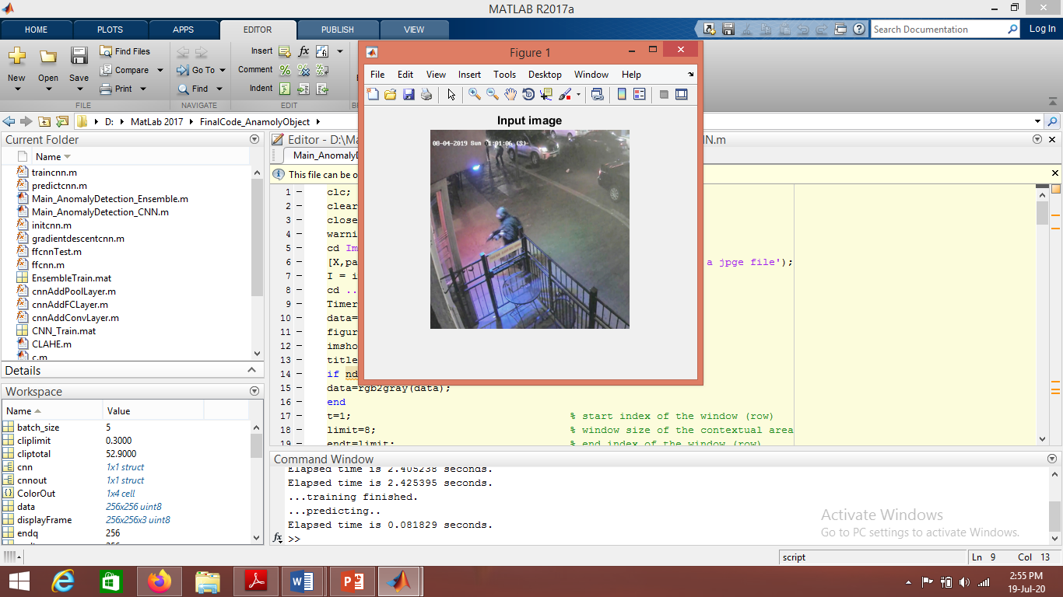

***Figure 4.1*** *Original input image*

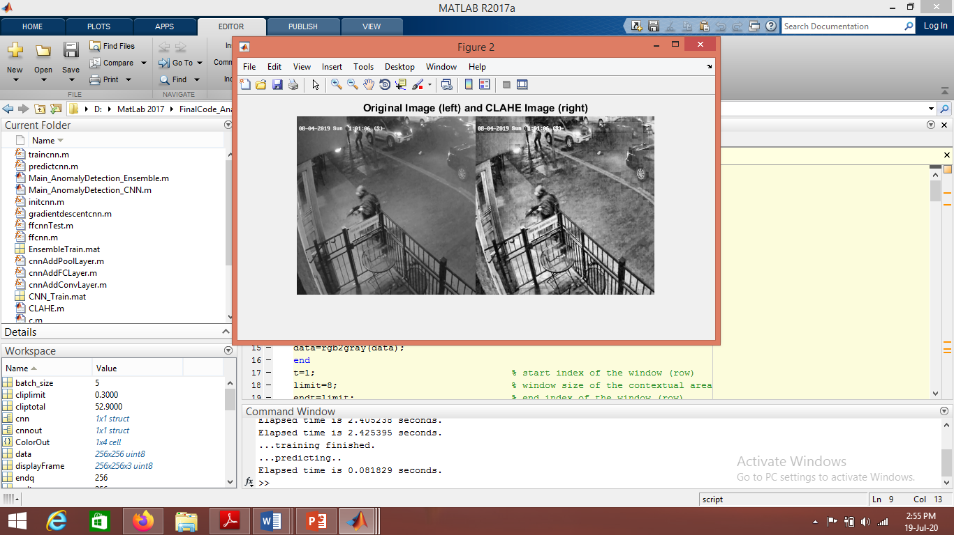

***Figure*** *CLAHE output image*

It helps to prevent the over amplification of noise that the Adaptive Histogram Equalization can give rise to. CLAHE, though able to increase the contrast more than the other techniques. This method solves edge shadowing effect of AHE and reduce the problem of over enhancement.

3.3 ENSEMBLE LEARNING

random subspaces are an attractive choice for problems where the number of features is much larger than the number of training points. The random subspace method has been used for [decision trees](https://en.wikipedia.org/wiki/Decision_tree_learning); when combined with "ordinary" bagging of decision trees, the resulting models are called [random forests](https://en.wikipedia.org/wiki/Random_forest).It has also been applied to [linear classifiers](https://en.wikipedia.org/wiki/Linear_classifier),[support vector machines](https://en.wikipedia.org/wiki/Support_vector_machine),[nearest neighbors](https://en.wikipedia.org/wiki/Nearest_neighbors_classifier) and other types of classifiers. There are several types of ensemble methods. In this study, Random Subspace and k-Nearest Neighborhood (kNN) methods are used

The basic random subspace algorithm uses these parameters.

* m is the number of dimensions (variables) to sample in each learner.
* d is the number of dimensions in the data, which is the number of columns (predictors) in the data matrix X.
* n is the number of learners in the ensemble.

The basic random subspace algorithm performs the following steps:

1. Choose without replacement a random set of m predictors from the d possible values.
2. Train a weak learner using just the m chosen predictors.
3. Repeat steps 1 and 2 until there are n weak learners.
4. Predict by taking an average of the score prediction of the weak learners, and classify the category with the highest average score.

3.3 EVIDENCE DETECTION USING ENSEMBLE LEARNING

In this method for feature extraction is based on DWT and Gray Level Co-occurrence Matrix (GLCM) and for classification, Random subspace ensembles of kNN is used. The block diagram for this method is given below. The initial steps are same as that of previous method. Image acquisition, pre-processing and image enhancement using CLAHE are initial steps.

4.RESULTS

This section of the paper focuses entirely upon the practical results of proposed evidence detection model. A set of images are used to test the proposed system. Two input images are shown and the corresponding outputs. CLAHE method reduces the over enhancement produced by HE and improve the image quality which will results in the improved detection rate. Training error probabilities graph shows the error values and number of iteration. As number of iteration increases, error occurred reduced. Table 8.1 shows the total elapsed time for testing of different images using CNN and ensemble learning technique. From these outputs it is clear that the time taken for execution by using ensemble method is low when compared to detection using CNN technique. 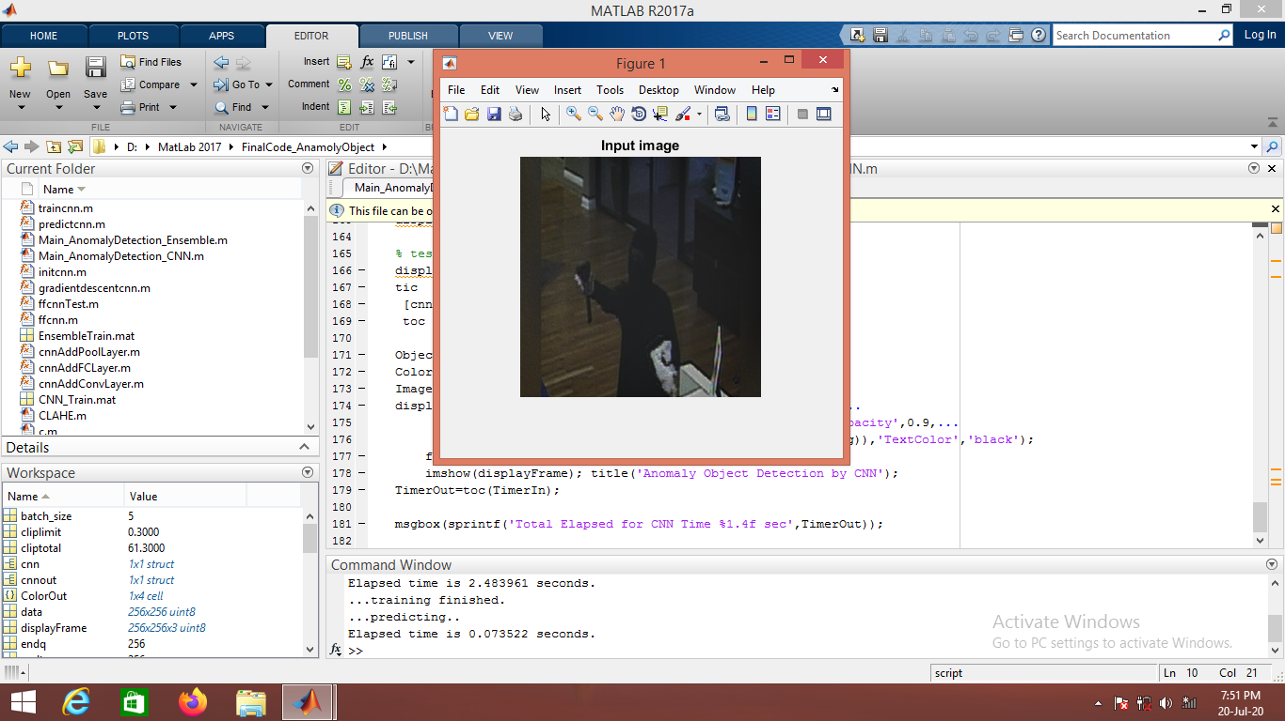

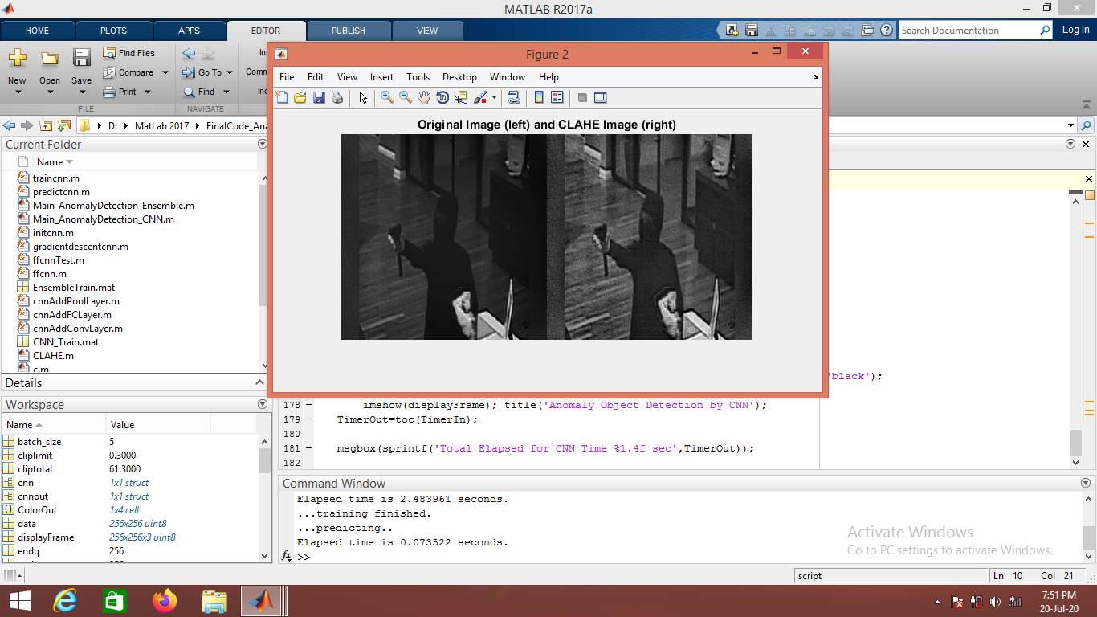

***Figure 4.1:****(a) Input selected image, (b) Original image in gray scale (left) and CLAHE image (right)*

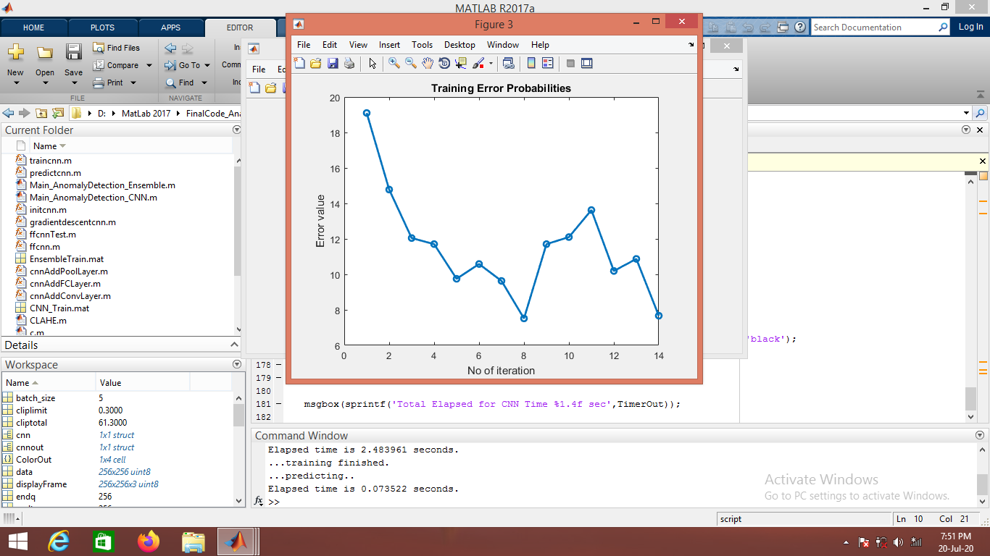

(c )

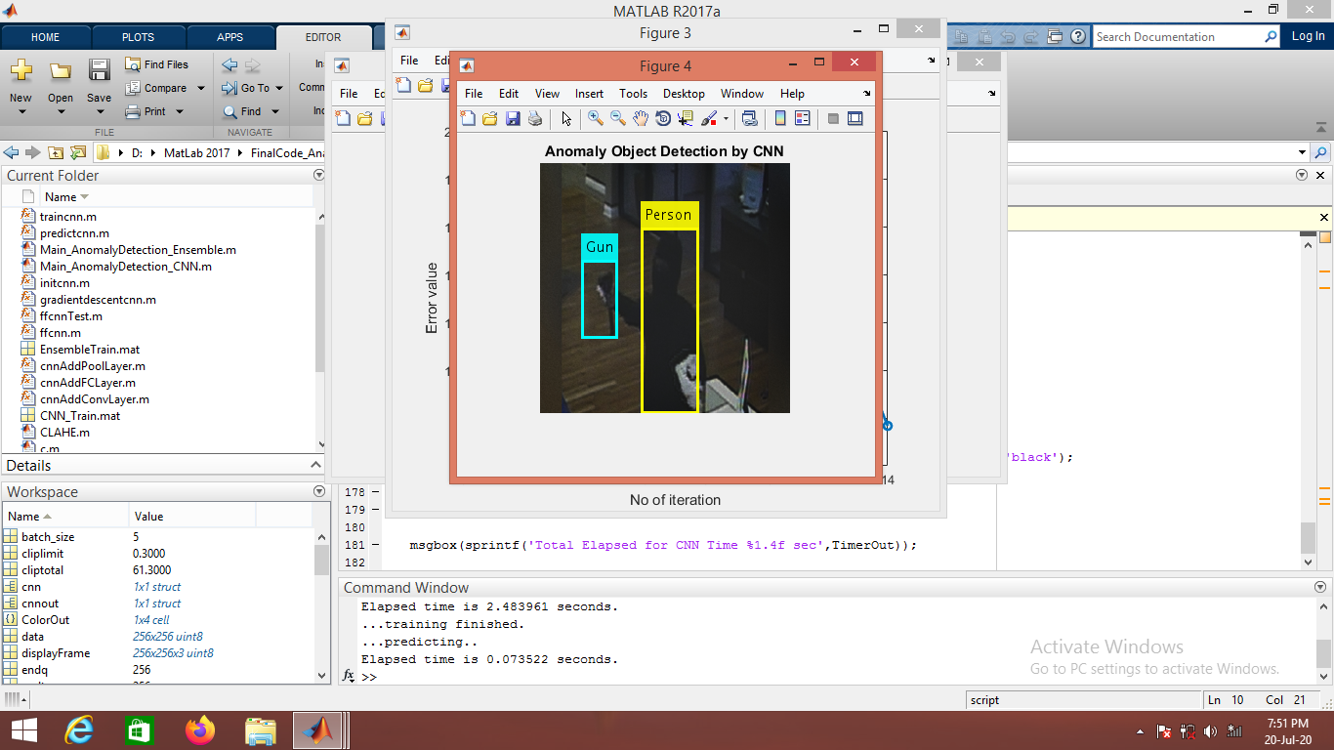

(d) 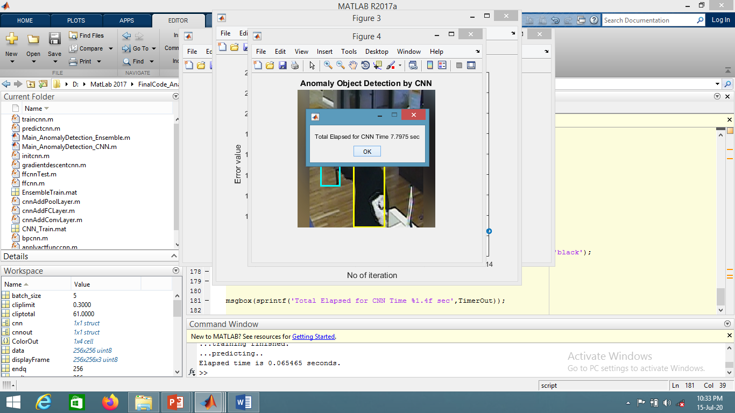

(e) 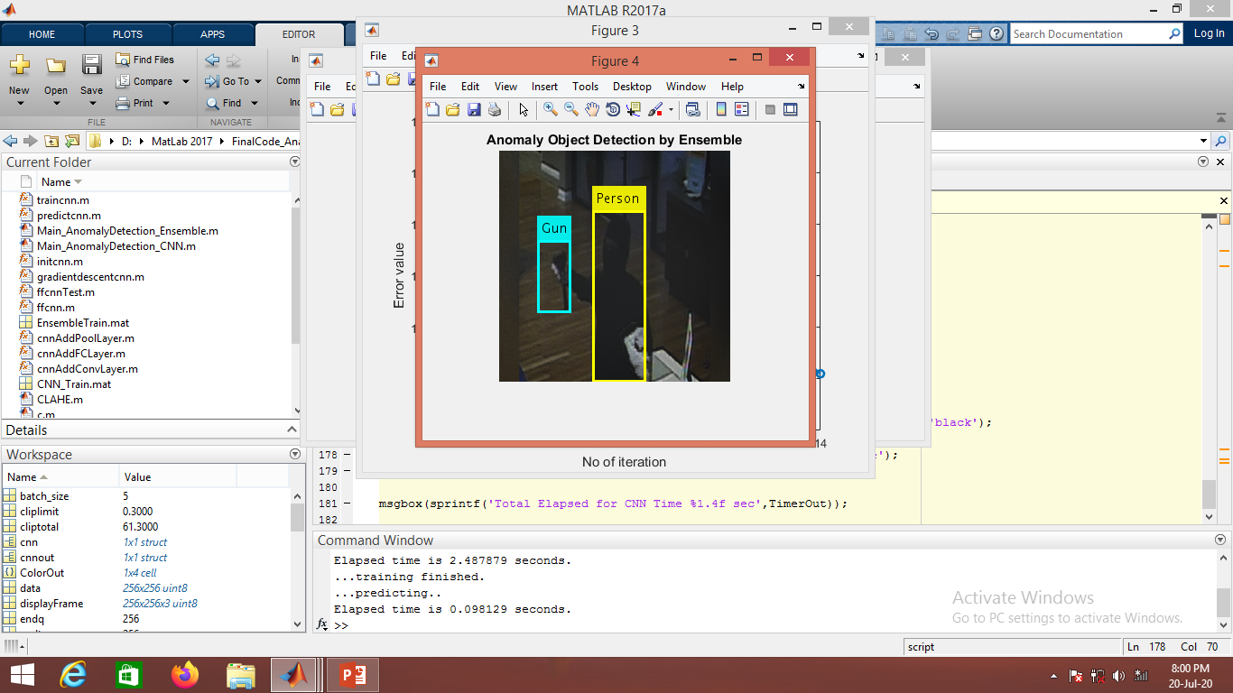

(f)

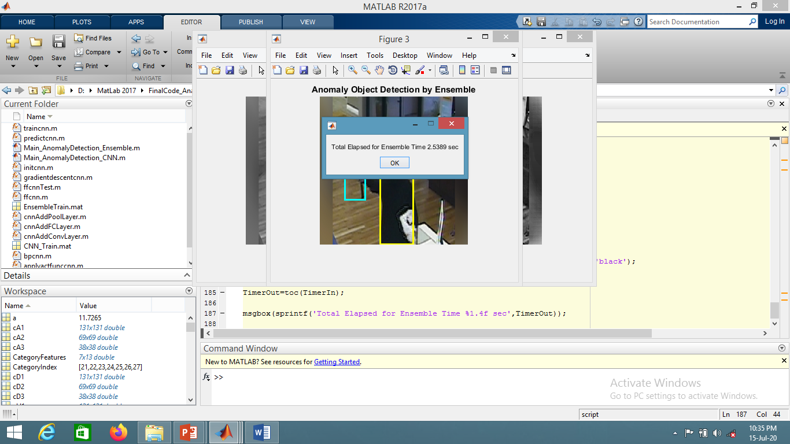

(g)

***Figure 4****.****2****: (c) Training error probabilities, (d) Anomaly object detection of gun using CNN, (e) Total time elapsed for detection by CNN, (f) Anomaly object detection of gun using ensemble technique (g) Total time elapsed for detection by ensemble technique*

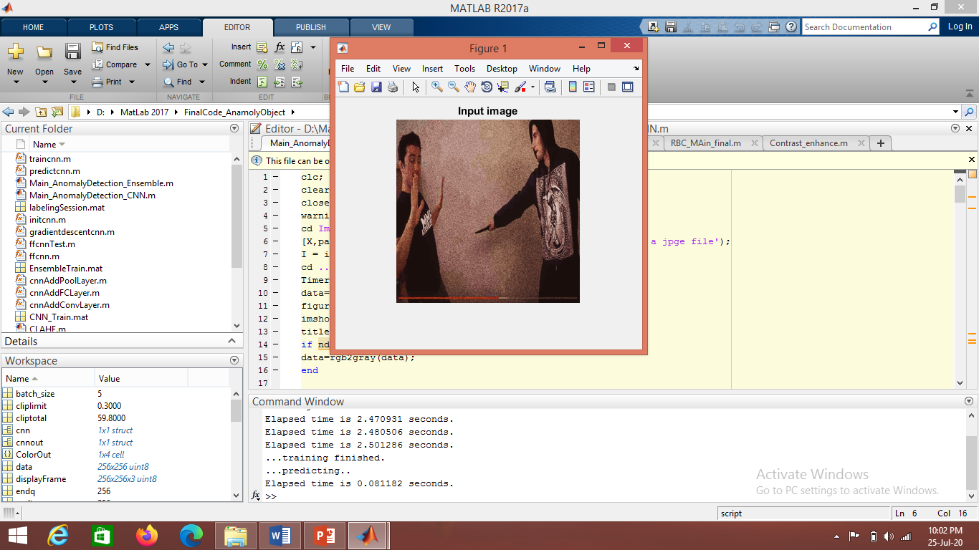

(a)

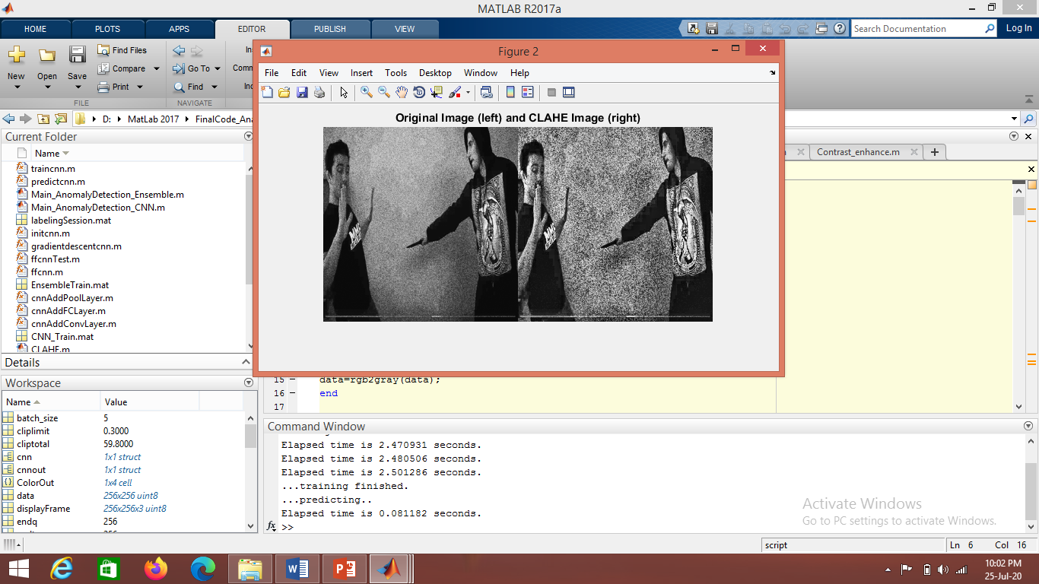

b)

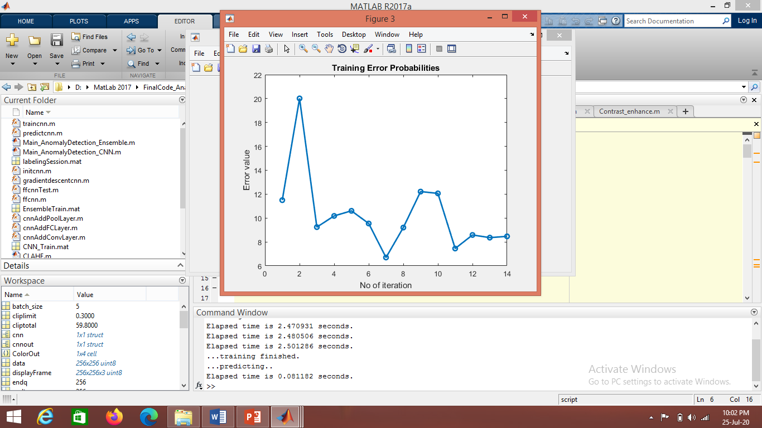

(c)

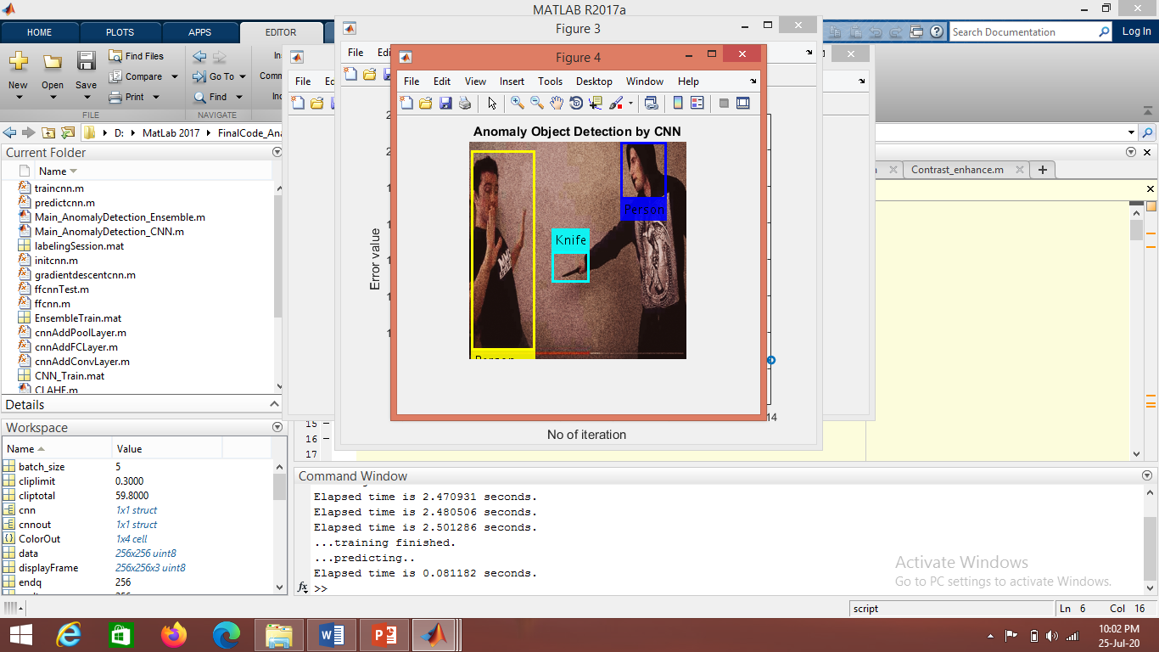

(d)

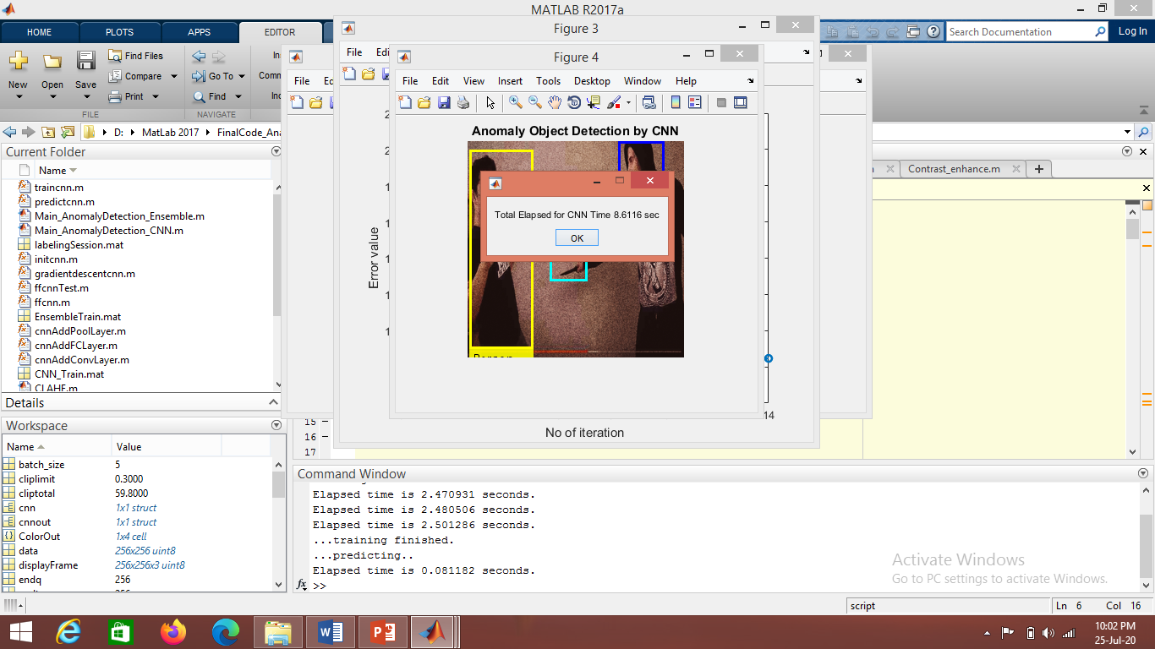

(e)

***Figure 4.3****: (a) Input image, (b) Original image in gray scale (left) and CLAHE image (right), (c) Training error probabilities, (d) Anomaly object detection of knife using CNN, (e) Total time elapsed for detection by CNN.*

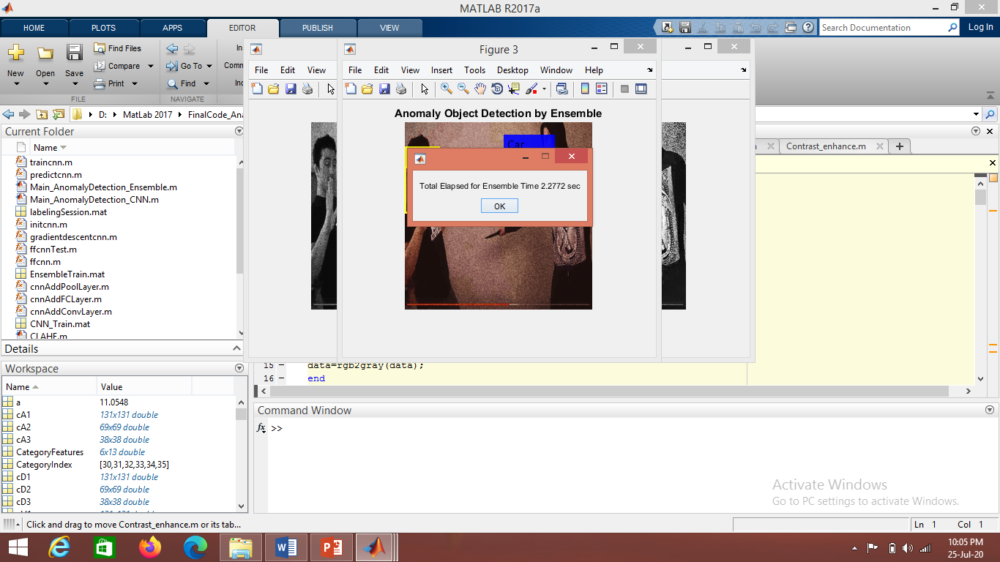

(f)

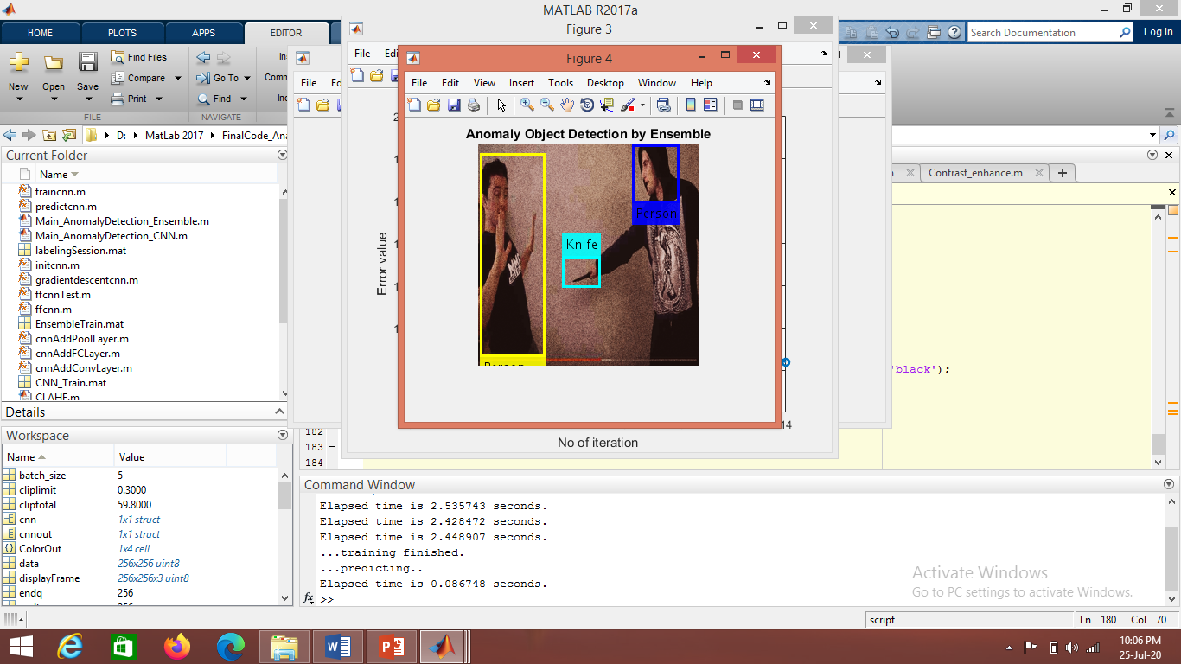

(g)

***Figure 8.2:*** *(f) Total time elapsed for detection by ensemble technique, (g) Anomaly object detection of gun using ensemble technique.*

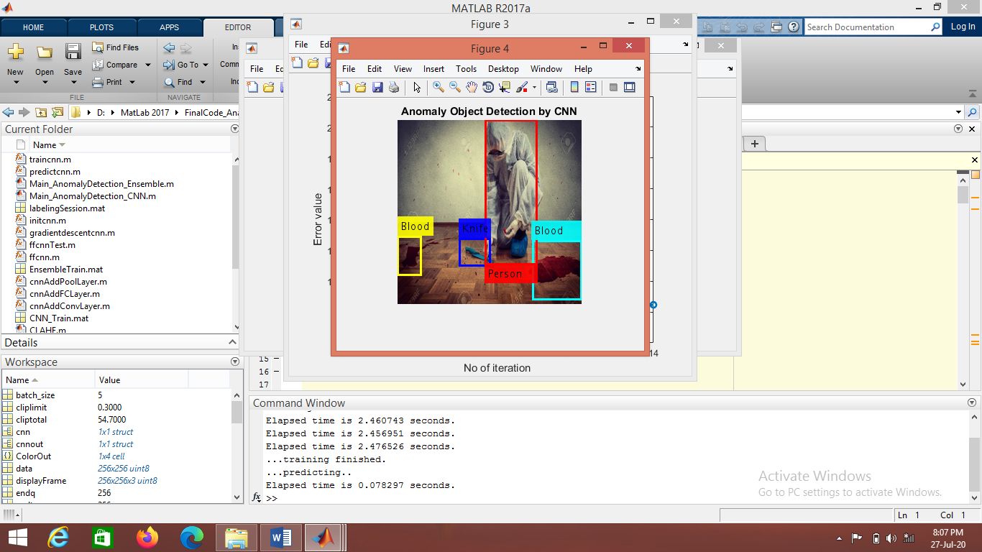 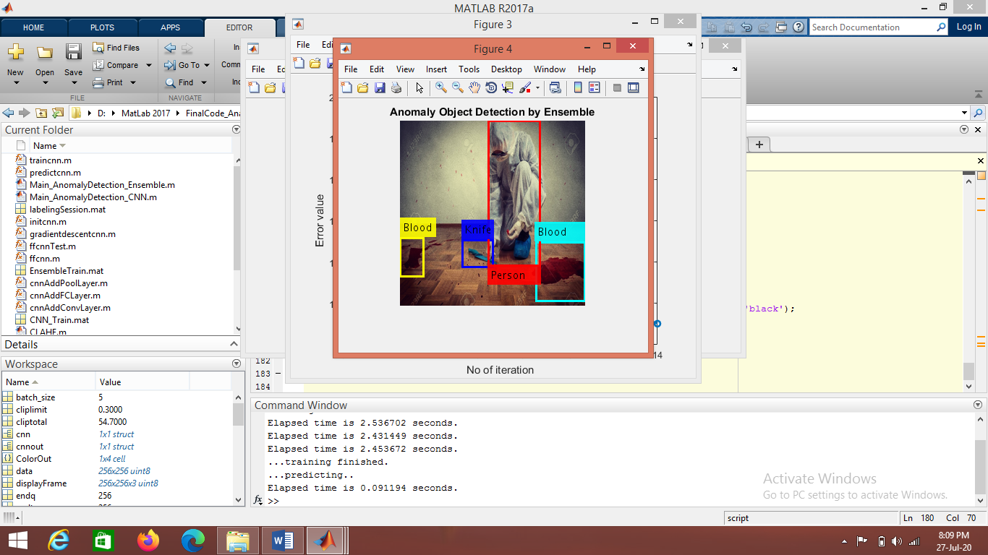

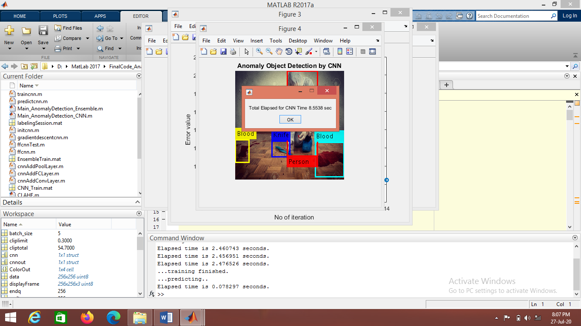 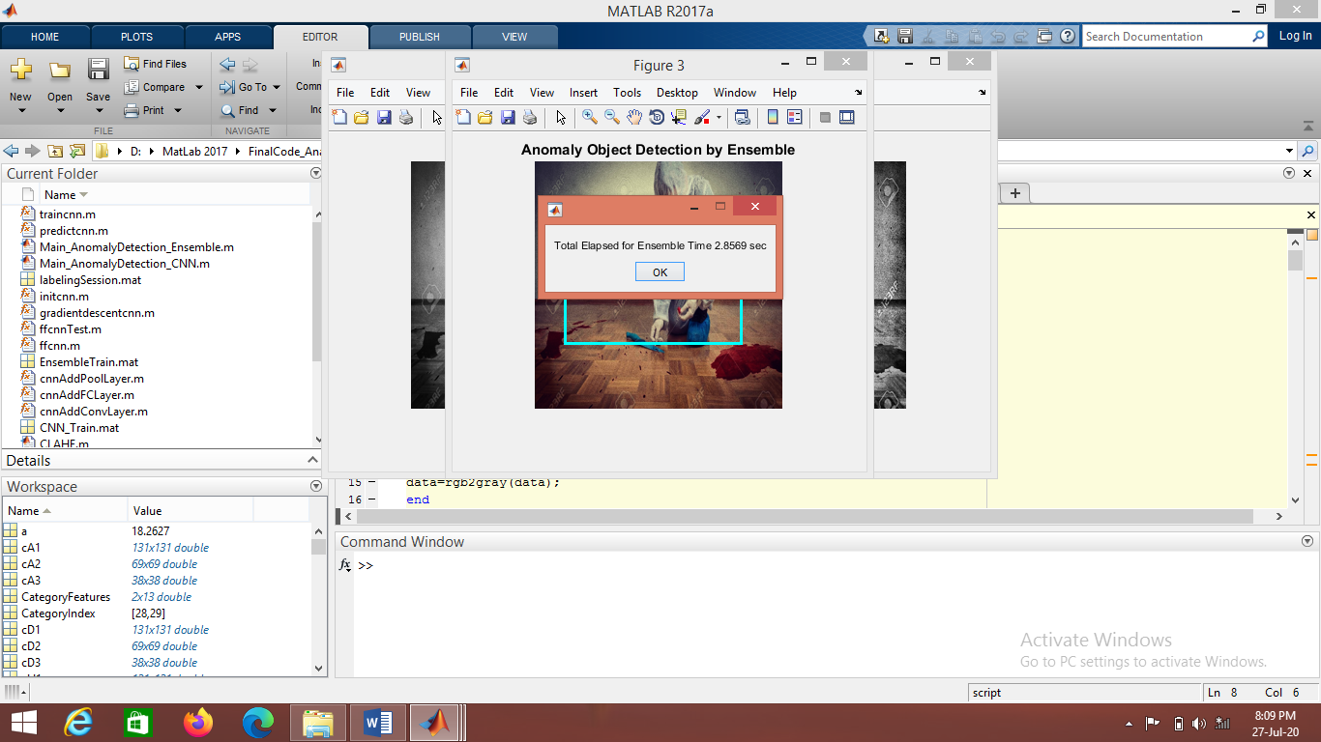

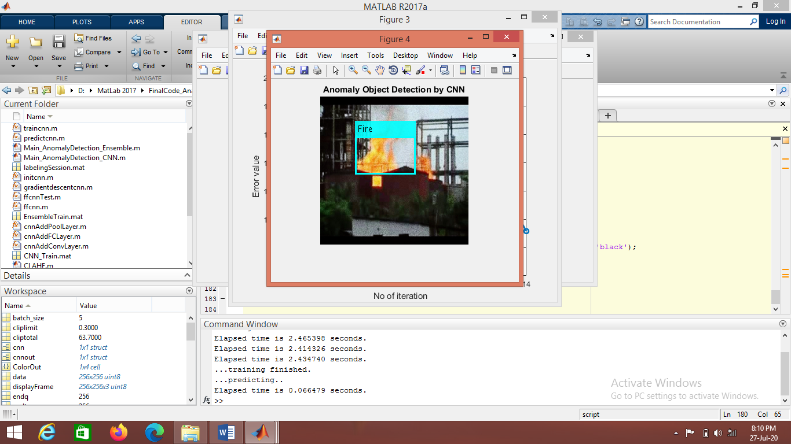

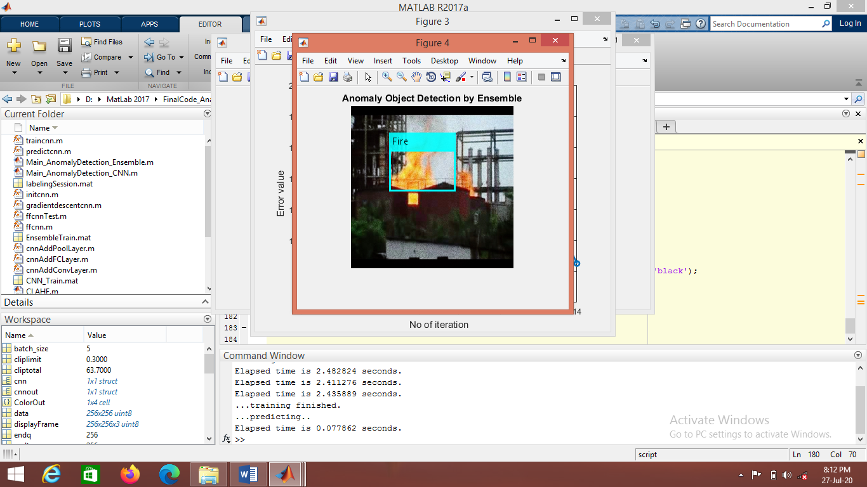

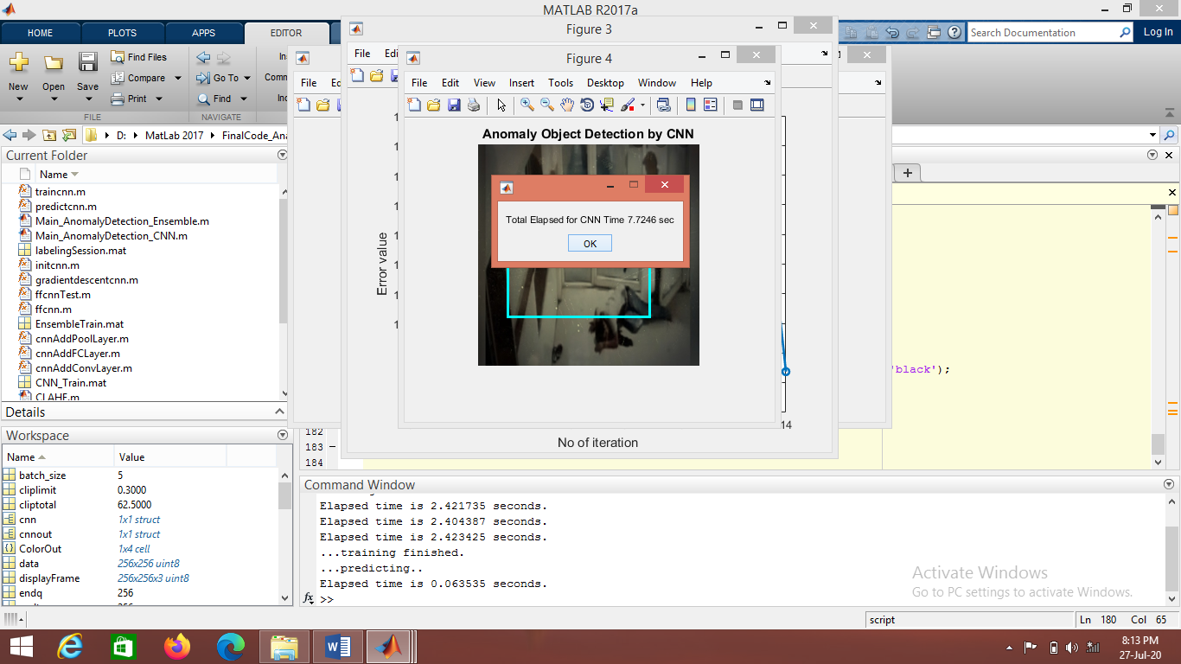 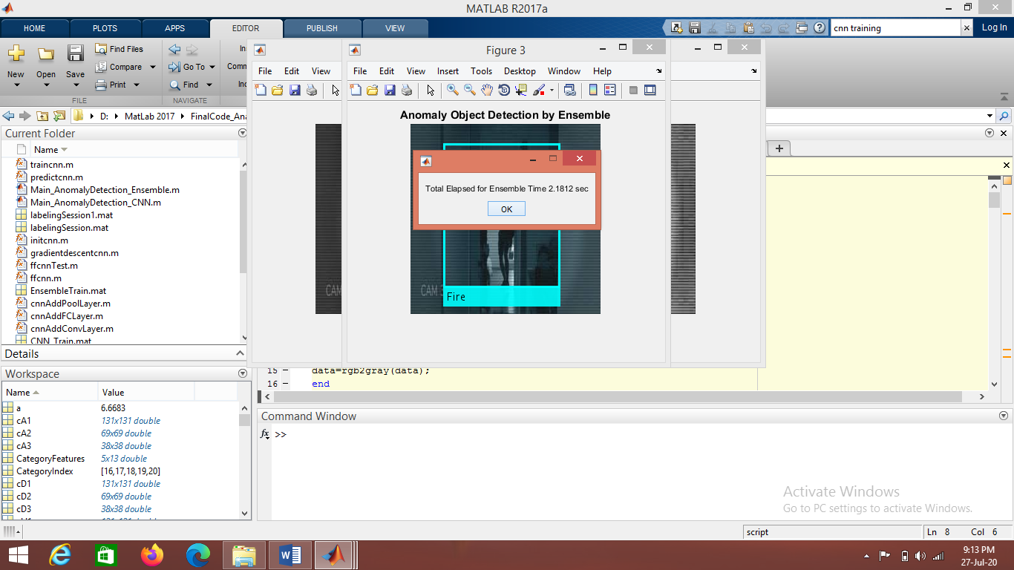

***Figure 4.4:*** *Anomaly object detection using CNN and ensemble learning technique*

|  |  |  |
| --- | --- | --- |
| Input | Time elapsed for evidence detection (in sec) | |
| Using CNN | Using Ensemble learning |
| Image 1 | 7.84 | 2.44 |
| Image 2 | 8.55 | 2.79 |
| Image 3 | 14.14 | 6.52 |
| Image 4 | 7.93 | 3.54 |
| Image 5 | 8.28 | 3.68 |
| Image 6 | 7.87 | 3.02 |
| Image 7 | 10.75 | 5.38 |
| Image 8 | 7.70 | 2.83 |
| Image 9 | 7.69 | 2.59 |
| Image 10 | 8.73 | 3.94 |

***Table 4.1:*** *Comparison between total time elapsed for evidence detection using CNN and Ensemble learning method (in sec)*

Conclusion

This proposed method successfully detect suspicious objects on which we can predict the crime scene occurred or not. The wrong alert is reduced that makes us our model very efficient for this task compare to other models. In this paper we uses two methods for suspicious object detection: detection using CNN and detection using ensemble learning technique. When compared to evidence detection using CNN, faster response is given by ensemble learning method. Developed a way to enhance the quality of image to extract as much as evidence items. Specifically, proposed a method to extract more evidence items. CLAHE method improved the quality of input image effectively. Predicting crime scene by detecting threatening objects can have far reach impact on computer vision field

References

[1] R. Mahajan and D. Padha, “Detection of concealed weapons using image processing techniques: A review,” in 2018 First International Conference on Secure Cyber Computing and Communication (ICSCCC), Dec 2018, pp. 375–378.

[2] F. Gelana and A. Yadav, “Firearm detection from surveillance cameras using image processing and machine learning techniques,” in Smart Innovations in Communication and Computational Sciences. Singapore: Springer Singapore, 2019, pp. 25–34.

[3] S. Nevhal and D. A. Ghotkar, “A Survey on Object Detection and Tracking Algorithm,” International Journal of Innovative Research in Computer and Communication Engineering, vol. 5, no. 5, pp. 1302–1309, 2017.

[4] Z.-Q. Zhao, P. Zheng, S.-T. Xu, and X. Wu, “Object detection with deep learning: A review,” IEEE Transactions on Neural Networks and Learning Systems, p. 1–21, 2019. [Online]. Available: <http://dx:doi:org/10:1109/tnnls:2018:2876865>

[5] Ma, Jinxiang, et al. "Contrast limited adaptive histogram equalization based fusion forunderwater image enhancement." Preprints 127 (2017).

[6] T. Ayyavoo and J. J. Suseela, ``Illumination pre-processing method for face recognition using 2D DWT and CLAHE,'' IET Biometrics, vol. 7, no. 4, pp. 380_390, Jul. 2018.

[7] L. G. Moré, M. A. Brizuela, H. L. Ayala, D. P. Pinto-Roa, and J. L. V. Noguera, “Parameter tuning of CLAHE based on multiobjective optimization to achieve different contrast levels in medical images,'' in Proc. IEEE Int. Conf. Image Process. (ICIP), Sep. 2015, pp. 4644_4648.

[8] R. Olmos, S. Tabik, and F. Herrera, “Automatic handgun detection alarm in videos using deep learning,” Neurocomputing, vol. 275, pp. 66–72, 2018.

[9] Chang, Yakun, et al. "Automatic contrast-limited adaptive histogram equalization with dual gamma correction." IEEE Access 6 (2018): 11782-11792.

[10] Li, Liangliang, Yujuan Si, and Zhenhong Jia. "Medical image enhancement based on CLAHE and unsharp masking in NSCT domain." Journal of Medical Imaging and Health Informatics 8.3 (2018): 431-438.

[11] Grega, Michael, Andrzej Matiolanski, Piotr Guzik, and Mikolaj Leszczuk. "Automated Detection of Firearms and Knives in a CCTV Image." Sensors 16.1 (2016): 47

[12] W. Saunders, G. Sastry, A. Stuhlmuller, and O. Evans, “Trial with- ¨ out error: Towards safe reinforcement learning via human intervention,” in Proceedings of the 17th International Conference on Autonomous Agents and MultiAgent Systems, AAMAS ’18, (Richland, SC), pp. 2067–2069, International Foundation for Autonomous Agents and Multiagent Systems, 2018.

[13] Öztürk, Şaban, and Bayram Akdemir. "Application of feature extraction and classification methods for histopathological image using GLCM, LBP, LBGLCM, GLRLM and SFTA." *Procedia computer science* 132 (2018): 40-46.

[14] Petty, Mark, Shyh Wei Teng, and Manzur Murshed. "Improved Image Analysis Methodology for Detecting Changes in Evidence Positioning at Crime Scenes." 2019 Digital Image Computing: Techniques and Applications (DICTA). IEEE, 2019.

[15] Gu, Jing, et al. "Random subspace based ensemble sparse representation." *Pattern Recognition* 74 (2018): 544-555.

[16] Zhang, Boyu, A. Kai Qin, and Timos Sellis. "Evolutionary feature subspaces generation for ensemble classification." *Proceedings of the Genetic and Evolutionary Computation Conference*. 2018.

[17] Savakar, Dayanand G., and Anil Kannur. "Ensemble Learning Approach for Weapon Recognition Using Images of Wound Patterns: A Forensic Perspective." *International Journal of Image, Graphics & Signal Processing* 10.11 (2018).

Author Information

JAYARESMI.J

Assistant Professor

ECE Department

LBSITW (APJAKTU), Thiruvanathapuram, Kerala, India.