KEY METRICS IN TALENT ACQUISITION REPORTING & HOW THEY INFLUENCE STRATEGIES

**Marthala Chetana Reddy**

PGDM-HR & Marketing

GIBS Business School, Bangalore

**ABSTRACT**

The paper probes the subject matter on key performance indicators in reporting on talent acquisition, further demonstrating that data analytics and machine learning greatly influence recruitment and hiring procedures. It establishes the presence of various performance parameters; notably these are time-to-hire, quality of hire, cost to hire, and acceptance rate. Such key performance measures reveal insights toward an efficient recruitment practice and process completion. These metrics allow companies to make informed decisions about enhancing their hiring procedures and eventually aligning them with their overall business objectives. Data-driven approaches in talent acquisition are important in effectively competing within the competitive job market and to attract top talent.

**KEYWORDS**

Talent Acquisition, Data Analytics, Artificial Intelligence, Recruitment Metrics, Key Performance Indicators (KPIs), Hiring Efficiency, Organizational Performance, Strategic Decision-Making.

**INTRODUCTION**

This environment is rapidly transforming with the infusion of data analytics and artificial intelligence (AI) into talent acquisition. For any organisation to effectively attract and retain the best talents, it has to understand some of the metrics that are associated with the recruitment process. Metrics will provide some essential information on how efficient or effective the recruitment processes are; hence, such information is essential for strategic decisions that can highly influence organisational performance. The current research study attempts to examine key metrics related to talent acquisition reporting, thereby highlighting how these have an effect on recruitment approaches and their wider implications for organisational success. In recent years, it has been evident that the growing complexity of the job market has prompted a more data-driven approach in hiring procedures. Employers are currently using many metrics such as time to hire, cost per hire, quality of hire, and offer acceptance rates to gauge their recruitment processes. These metrics become benchmarks for the HR professional in identifying areas for improvement, aligning recruitment strategies with company goals, and improving the candidate experience. By grasping the quality of hire, which includes both performance evaluations and employee retention rates, organisations can refine their hiring standards and recruitment procedures.

The advent of AI technologies has substantially impacted how organisations manage the process of recruiting talent. AI systems can process vast amounts of data to uncover trends and patterns that human hiring teams may overlook. This capability streamlines the hiring process and enhances decision-making capabilities by providing valuable data points. For AI to be integrated into the talent acquisition process to be effective, proper knowledge of key metrics must be established to ensure that these tools are properly calibrated to meet the needs of the organization. Researching this area becomes important for many reasons. As the competition for the best talent has surged, businesses need to devise fresh strategies not only to gain but also to retain the most talented professionals. Recruitment strategies that integrate multiple metrics can be a way of streamlining hiring processes, thus contributing to higher organisational effectiveness. This study will significantly contribute to the existing dialogue on talent management by providing empirical evidence on the relationship between the implementation of metrics and attainment of strategic objectives.

**Research Objectives**

This research aims to identify and categorize the key performance indicators used in talent acquisition reporting, analysing their impact on recruitment strategies across various industries. This research investigation explores the potential of artificial intelligence to enhance specific performance indicators and streamline decision-making protocols, while also analysing the challenges organisations face when adopting data-driven hiring strategies.

**Literature Review**

The time frame in question lasted from 2015 to 2019.

 By the mid-2010s, talent acquisition started to gain considerable momentum, with initial research highlighting the need for aligning recruitment tactics with a company's goals. Lopamudra (2015) indicates that successful talent acquisition is vital for organisational success, recommending that human resource management be incorporated into overall business strategies. Research by Stoyanova in 2019 underscored this alignment, suggesting that companies need to adapt their recruitment processes to stay in line with evolving market requirements.

Integration of Technology took place over the period from 2020 to 2021.

As technology has become more advanced, researchers have begun to examine its impact on the process of drawing in and employing highly skilled people. The advent of digital platforms and social media has transformed recruitment methods, enabling businesses to connect with a wider range of people (Kaplan et al., 2020). Studies conducted by Martin et al. in 2019 discovered that HR professionals require proficiency in data analytics and digital marketing to utilise these tools efficiently. Research indicated that incorporating artificial intelligence into recruitment procedures was another point of discussion, with studies suggesting its potential to enhance efficiency while also raising concerns about algorithmic bias and data security (Dineen et al., 2020).

Inclusion and Diversity Programs for the period spanning 2021 through 2022.

Throughout this time, a heightened focus on integrating diversity, equity, and inclusion (DEI) principles into recruitment policies was evident. Research by Kalev et al. (2021) found that business diversity leads to improved economic benefits, including increased innovation and financial success. Businesses are revising their recruitment processes to incorporate diversity, equity, and inclusion criteria, such as eliminating biased language from job advertisements and implementing structured interview protocols (Holmes et al., 2020). This shift signifies a broader societal trend towards greater diversity and inclusivity in corporate policies.

The Current Era of Organizational Achievement spans from 2022 to the present.

Research findings have reinforced the significance of implementing efficient talent acquisition methods in evaluating a company's overall success. Researchers Wang and Chen conducted a 2021 study, examining the link between organisations' use of agile approaches to hiring and their capacity to adapt, finding that companies capable of responding to market shifts are more likely to achieve success. Research conducted by Liu et al. in 2022 established a clear link between well-structured hiring procedures and improved staff morale, along with extended job tenure, demonstrating the direct correlation between efficient recruitment methods and a productive workplace environment.

**Research Methodology**

**Research Design**

This study utilises a descriptive research methodology to examine the role of key metrics in talent acquisition reporting and their influence on recruitment strategies. The research seeks to reveal important insights and relationships by integrating qualitative and quantitative data, thereby improving decision-making processes in talent acquisition procedures.

**Data Collection Methods**

**Primary Data Collection**

Data was initially gathered through surveys and interviews designed to capture the perspectives of HR professionals, recruitment specialists, and hiring managers. The methods used for collecting the data included a range of strategies.

Surveys were conducted using Google Forms in a structured format to achieve their goals.

Recruitment specialists and HR professionals need to understand the specific application and implications of certain metrics.

Top-level managers should use data-driven insights to evaluate the effectiveness of their organisation's talent recruitment strategies.

Key Considerations in Survey Methodology

Four key performance indicators used in the recruitment process are time-to-hire, cost-per-hire, quality-of-hire, and candidate satisfaction ratings.

Metrics play a key role in identifying constraints within recruitment processes.

The importance of analytics in synchronizing recruitment approaches with a firm's goals is recognised.

Qualitative insights were gathered through in-depth interviews with senior HR leaders on.

To maximise the use of talent acquisition data, it is essential to adhere to established best practices.

Utilizing and interpreting metrics can be challenging.

Strategic decision-making is influenced by a range of key performance indicators.

**Collection of Data from External Sources**

A comprehensive review of over 25 peer-reviewed articles, industry reports, and credible online sources offered the secondary data. Understanding the evolution of talent acquisition metrics and analytics.

Studies on improving recruitment methods identify areas that require additional research.

Reviewing successful talent acquisition strategies employed by leading companies based on measurable performance metrics.

Reviewing case studies from prominent companies on effective metric-based talent acquisition approaches.

**Sampling Methodology and Intended Study Group**

**The primary area of research concentration was on:**

Recruitment specialists must have access to data on operational metrics and analytics software.

Senior executives and human resources directors must understand the lasting consequences and strategic implications of implementing metrics.

Senior leaders and HR managers must comprehend the long-term effects and strategic outcomes associated with the application of metrics.

**A specific sampling technique was employed to ensure participation from individuals with significant experience in talent acquisition and metrics analysis.**

The final example consisted of. Junior recruitment staff will discuss challenges they face in their day-to-day work.

HR professionals and hiring managers are required to evaluate the practical application of metrics in real-world scenarios.

Senior HR executives should provide strategic insights.

Senior human resources executives should offer strategic perspectives.

**Data Analysis**

**Quantitative Data Analysis**

The survey responses were analyzed using statistical procedures to establish.

The way people use the metric system is evolving.

The link between primary performance metrics and recruitment outcomes.

Performance metrics, including time-to-hire, cost-per-hire, and candidate satisfaction ratings, were utilized to assess their impact on corporate objectives.

The metrics of time-to-hire, cost-per-hire, and candidate satisfaction were quantified in order to assess their influence on an organisation's objectives.

**Visualization:**

Dashboards and charts were designed to visualise the connection between recruitment metrics and their strategic consequences.

**Qualitative Data Analysis**

Analysis of the open-ended survey responses and interview transcripts was conducted to identify the major recurring themes.

The discussion will focus on difficulties associated with implementing the metric system, strategies to mitigate data isolation, and innovative uses of analytics.

The topics covered included difficulties in implementing metric standards, methods for addressing data fragmentation, and creative applications of analytics.

**Case Study Synthesis:**

Strategies from prominent firms that focused on metrics were analyzed to identify successful practices.

**Demographic Details**

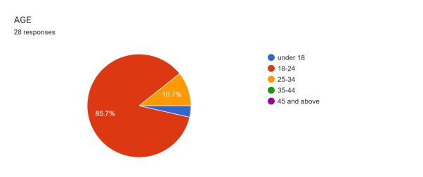

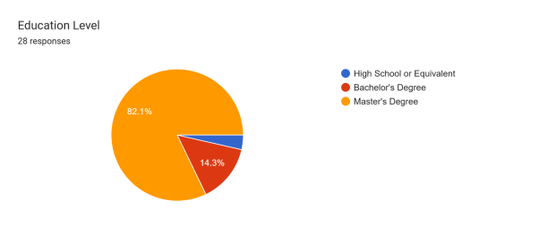

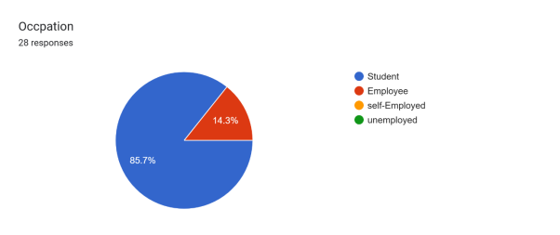

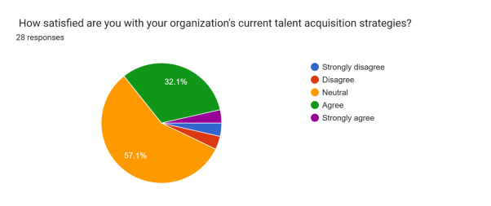

The data indicates that a substantial portion of the participants held neutral views, suggesting either a blend of opinions or a deficiency in intense emotions towards the efficacy of the current methods. This implies that companies have openings to improve their communication and talent recruitment procedures.

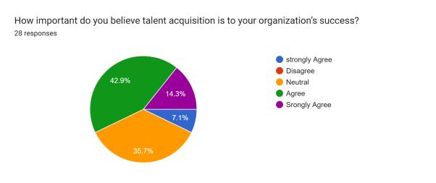

Many respondents recognised the value of talent acquisition, indicating that they see it as a crucial component in helping their organisation achieve its goals. A company's business plan should centre around effectively implementing a rigorous talent acquisition strategy to ensure optimal recruitment processes.

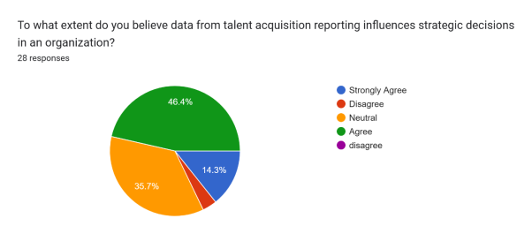

Firms may not be fully leveraging data analytics in their decision-making processes. This presents an opportunity for companies to enhance their data usage in order to attain more effective long-term strategic outcomes.

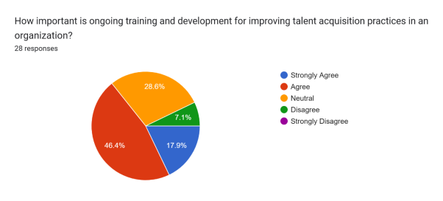

There is a widespread consensus regarding the importance of continuous learning. Businesses are urged to invest in training programs by respondents, who believe it is essential for developing effective talent acquisition strategies.

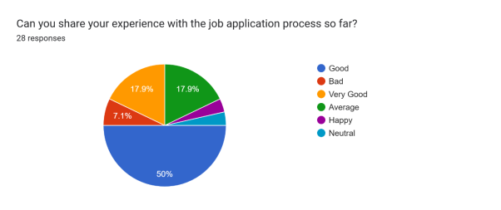

It was observed that clear communication and open procedures were notable positives, whereas some individuals pointed out areas that required enhancement, specifically in terms of response periods and feedback mechanisms. Companies are recommended to prioritize enhancing the candidate experience in order to attract high-calibre candidates.

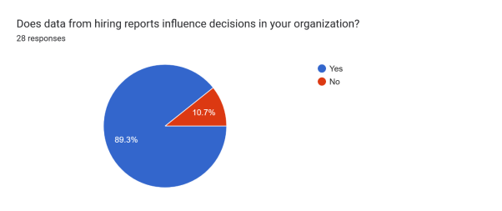

The trend seems to be moving towards making informed decisions with the help of data, taking into account the impact of hiring analytics on company policies and procedures.

What ideas do you have for keeping employees longer?

* A supportive workplace environment and guidance are provided, along with equal opportunities for learning and growth. Job security, employee benefits, and incentives are also offered to help the company's revenue. Furthermore, the company considers work-life balance through various initiatives, such as a Mentorship Program, outings, and tours. Additionally, employees are compensated fairly, recognised, and appraised based on their performance, resulting in high job satisfaction and a healthy work culture.

**Demograghic Analysis**

**Age Groups**

The majority of the survey participants were predominantly young professionals and students.

The majority of participants, 88%, were aged 18-24 years, totaling 22 individuals.

25-34 years: 3 participants (12%)

The participant involved was under the age of 18, accounting for 4% of the total.

The survey reveals a significant bias towards young adults, with a notable concentration of individuals aged 18 to 24, suggesting the sample predominantly comprises people who have recently graduated or are in the initial phases of their professional lives.

**Education Qualification**

Twenty out of 20 participants (80%) held a Master's degree.

Four percent of participants, or 16% when including those who hold a bachelor's degree, have this degree.

Four percent of the participants came from a high school background.

The majority of participants hold Master's degrees, indicating that they are part of a highly educated group with advanced academic qualifications.

**Gender Representation**

Females comprised 60% of the 15 participants.

Male: 10 participants (40%)

The survey's findings indicate a balanced gender distribution, with women comprising a slight majority of respondents, which provides a diverse perspective on recruitment strategies.

**The survey results indicate a crucial juncture for businesses in evaluating their talent acquisition strategies.**

The data suggests that although some participants see benefits in current processes, there is still a need for improvement. As organisations face intensifying competition for top talent, this challenge becomes increasingly pressing. Recognising the importance of talent acquisition marks a strategic shift in viewing recruitment as a vital component of an organisation's overall success, rather than merely a required obligation.

This perspective aligns with the growing dependence on data-driven decision-making, with analytics playing a crucial role in formulating effective recruitment strategies. Furthermore, placing a high value on ongoing training shows a recognition of the value of ongoing improvement in meeting the changing needs of the market and enhancing overall performance in attracting top talent.

**Suggestions and Recommendations**

**Enhancing Communication within the Recruitment Process for High-Quality Job Applicants.**

Companies need to focus on improving communication about their hiring processes, given the mixed reactions from employees to current talent acquisition strategies. Clearer communication about job responsibilities, expected results, and project timelines can alleviate uncertainty and differing viewpoints among job seekers and those involved in the hiring process.

**Decisions should be grounded in thorough data analysis.**

The differing views on the effects of data highlight the need for organisations to incorporate data analysis more effectively into their hiring strategies. Organisations can make well-informed decisions that align with their strategic goals by leveraging data from hiring reports and candidate feedback.

**Pledge to investing in training and professional development programmes for employees.**

There is a widespread agreement on the importance of continuous employee training, recommending that businesses invest in development programs intended to enhance their methods for recruiting skilled staff. Continuous learning opportunities can further develop skills and improve employment outcomes.

**Improving the experience for job applicants.**

Employers should pinpoint the specific areas of dissatisfaction in their job application process and implement changes to enhance applicant satisfaction. Simplifying application procedures, reducing turnaround times, and providing timely feedback to applicants could be involved in this.

**Establish and Put into Practice Successful Strategies to Boost Employee Retention.**

A supportive organisational culture is essential for reducing employee turnover. Companies should consider introducing initiatives such as mentorship schemes, flexible working arrangements, and reward systems to foster employee satisfaction and loyalty.

**Utilize the hiring manager's comments.**

Ongoing feedback from hiring managers can be instrumental in identifying areas for improvement in the recruitment process. Businesses can tailor their hiring processes to fit their organisational goals by considering the needs and expected results of job candidates.

**Conclusion**

Organisations must take proactive steps to address the key issues uncovered by the survey data analysis. Companies can greatly enhance their ability to attract and hire the best talent by concentrating on more effective communication, prioritising the examination of data, investing in staff development, streamlining interactions with job applicants, creating schemes to keep employees, and considering the advice of those responsible for hiring.

Boosting job seeker and hiring staff satisfaction will have a dual benefit: it will boost overall satisfaction and also be crucial in creating a robust company culture that attracts and retains top-performing employees. To attain long-term success in drawing top-notch applicants, it is crucial to embrace the dynamic landscape of talent recruitment by putting these pivotal suggestions into action.

**References**

Visier. (2023). *The Top 10 Strategic Talent Acquisition Metrics*. Retrieved from [Visier](https://www.visier.com/blog/strategic-talent-acquisition-metrics/" \t "_blank) - This article discusses essential metrics such as revenue per employee and quality of hire improvement that organizations should track to enhance their talent acquisition strategies.

Symphony Talent. (n.d.). Measuring Success in Talent Acquisition: Key Metrics and KPIs. Retrieved from Symphony Talent - This blog outlines the importance of talent acquisition metrics and KPIs, emphasizing how data-driven insights can improve recruitment effectiveness and align with organizational goals.

Leoforce. (2024). Top Talent Acquisition Metrics to Measure Success in 2025. Retrieved from Leoforce - This resource highlights critical metrics such as time to hire and time to productivity, providing insights into their significance in optimizing recruitment strategies.

Lever. (n.d.). 12 Important Talent Acquisition Metrics You Need to Measure. Retrieved from Lever - This guide breaks down essential recruiting metrics that can help organizations measure hiring effectiveness and improve outcomes.

iMocha. (2024). Top 8 Talent Acquisition Metrics to Track in 2024. Retrieved from iMocha - This article discusses key metrics that enhance decision-making and align recruitment strategies with organizational priorities.

AIHR. (2024). *23 Recruiting Metrics You Should Know*. Retrieved from [AIHR](https://www.aihr.com/blog/recruiting-metrics/) - This comprehensive overview provides a list of common recruiting metrics that can be tracked to measure the effectiveness of recruitment efforts.

Jobylon. (n.d.). *8 Talent Acquisition Metrics Every Organization Needs to Know*. Retrieved from [Jobylon](https://www.jobylon.com/blog/talent-acquisition-metrics/" \t "_blank) - This blog emphasizes the importance of various metrics, including offer acceptance rate and candidate experience, in shaping effective talent acquisition strategies.

Recruise India. (2024). *10 Important Talent Acquisition Metrics You Need to Measure*. Retrieved from [Recruise India](https://recruiseindia.com/ten-important-talent-acquisition-metrics-you-need-to-measure" \t "_blank) - This guide discusses essential metrics such as time to fill, quality of hire, and candidate experience, highlighting their importance in optimizing recruitment strategies.

Ceipal. (n.d.). *Talent Acquisition Metrics: Data-Driven Insights for Effective Hiring*. Retrieved from [Ceipal](https://www.ceipal.com/resources/insights/articles/talent-acquisition-metrics-data-driven-insights-for-effective-hiring/" \t "_blank) - This article emphasizes the significance of various talent acquisition metrics and how they empower HR professionals to make strategic decisions based on data.

Deloitte. (n.d.). *Talent Acquisition Analytics*. Retrieved from [Deloitte](https://www2.deloitte.com/us/en/pages/human-capital/articles/talent-acquisition-analytics.html) - This resource explores the systematic use of analytics in talent acquisition, highlighting how data can inform recruitment processes and improve hiring outcomes.

ResearchGate. (2023). *Human Resource Analytics on Talent Acquisition: A Systematic Review*. Retrieved from [ResearchGate](https://www.researchgate.net/publication/374838125_Human_Resource_Analytics_on_Talent_Acquisition_A_Systematic_Review) - This systematic review examines various studies related to HR analytics and talent acquisition, providing insights into effective practices and methodologies.

R Erickson, ―The evolution of Talent Acquisition‖, Newsletter, Bersin by Delloitte Research, 2012.

B Caulfield "Recruit or Die: How Growing Firms Are Waging the War to Fill Empty Seats", June, 2000.

N Chanda, ―The Tug of War for Asia's Best Brains‖,Far Eastern Economic Review, August , 2002.

M C Heid, ―Its 2012, Do you know where the talent is?”, Financial Executive, December 2007.

P Srivastava and J Bhatnagar, ―Talent acquisition due diligence leading to high employee engagement: case of Motorola India MDB‖, APROS 12 Conference, December, 2007.

M.A.Armatys, ―The state of Talent Management: Today’s challenges and tomorrow’s opportunities‖, Human Capital Institute, 2008.

Taleo Research White paper, ―Hidden ROI of Talent Acquisition and Mobility‖, 2005.

D.K.R.Jain, ―Recent trends in Talent Acquisition and Retention‖, Management Trends, Vol: 4 No.2, April – September 2007.

C Phillips, ―Tapping into the next talent generation‖, Strategic HR Review, Vol: 7, No.3, 2008 Pg: 31. ―The Talent Acquisition Challenge 2009 - Recruitment trends and issues impacting today’s leading organizations‖, www.pinstriptalent.com, 2009.

Webster Buchanan Research, ―The changing dynamics of Talent Acquisition‖, December 2009.