**Role of Financial Analytics in Enhancing Sports Team Performance**

**Dr. P. Ranjith1, Dr. K. Baranidharan2 ,**

**R. Sathya Narayanan3, R.Shrivatshan4, B.Rahul5, P.Badrinathan6**,

Director, Physical Education (DPE)1

Professor, Master of Business Administration2

First Year MBA3,4,5,6

Sri Sai Ram Institute of Technology, West Tambaram, Chennai, India

# Abstract

In the competitive realm of professional sports, financial analytics has emerged as a pivotal tool for enhancing team performance and operational efficiency. This document outlines the objectives, scope, and necessity of studying financial analytics within sports management. It delves into the significance of data-driven decision-making, the tools and methodologies employed, and the impact of financial analytics on strategic planning and resource allocation. By examining the intersection of financial data and sports performance, this study aims to provide insights that can lead to improved competitiveness and sustainability in the sports industry.

**Key Words**: Financial Analytics, Sports, Performance, Income, Cost effective.

**Introduction**

Financial analytics are becoming an essential tool for professional sports teams to improve their performance in all aspects of the game, not just on the field. Discover how data-driven decision-making may enhance team performance, resource allocation, and strategy planning as this document delves into the convergence of financial analytics and sports management. Sports teams may improve operational efficiency, optimize pay cap management, and obtain insights into player performance by employing financial analytics. Teams can make better decisions in a highly competitive environment when financial data and performance indicators are integrated. When it comes to analyzing financial data for the purpose of informing strategic decisions, financial analytics covers a wide range of strategies and procedures. In the realm of sports, this can involve examining player contracts, determining the monetary effects of moves, and figuring out how much money is coming in from things like tickets, merchandising, and sponsorships. Having a good grasp of the financial picture allows teams to spot areas for growth and ways to save costs, which in turn leads to a more sustainable business model.

A holistic approach to comprehending the dynamics of team performance is integral to financial analytics, which goes beyond simple figure crunching. Teams can utilize predictive analytics to make informed decisions about player recruiting and training by predicting their performance based on past data. In addition, teams can use financial analytics to determine the ROI of different activities, like marketing campaigns or facility enhancements, which helps with resource allocation. The value of financial analytics is growing in an ever-changing sports business. When it comes to the complex sports business landscape, teams that use data-driven strategies have a leg up on the competition and may improve their performance as a result. The purpose of this paper is to explore financial analytics in sports from a more comprehensive angle, illuminating its uses, advantages, and potential developments in the field.

**Objectives of the Study**

* Determine the impact of financial analytics on decision-making procedures within sports organizations.
* To look into ways that sports clubs might use financial analytics to boost their income sources.
* Find out how financial analytics helps in allocating resources and managing costs effectively.

**Scope of the Study**

Analysis of operational expenses, revenue sources, and player contracts, among other financial factors. Analyzing financial analytics software like Excel and Tableau as well as predictive modeling methods financial analytics can help sports organizations with their long-term strategy planning and decision-making. An examination of the ways in which performance measures and financial metrics can work together to boost team output.

**Research is Necessary**

Teams in today's more cutthroat sports market need to use financial analytics to stay ahead of the competition. A thorough grasp of financial analytics is essential for informing strategic decisions in light of the trend towards data-driven initiatives. To ensure long-term viability, it is essential to allocate resources wisely. Financial analytics can shed light on how teams may make the most of their allocated funds. Gaining a grasp of financial analytics can help you find more ways to make money and increase your profits. Strategies to engage fans, which are crucial to success and loyalty in the long run, can be enhanced with the use of financial analytics.

**Review of Literature**

**Kahn, L. M., & Sherer, D.(2018),** This study explores the impact of financial analytics on team performance and operational efficiency. The authors argue that teams leveraging financial data can make better decisions regarding player acquisitions and resource allocation, ultimately leading to improved performance on the field.

**Franck, E., & Nüesch, S. (2019)**, the authors investigate the relationship between financial analytics and player performance evaluation. They conclude that integrating financial metrics with performance data allows sports organizations to assess player contributions more accurately, thereby optimizing team composition and strategy.

**Szymanski, S. (2020),** this article discusses the evolving role of financial analytics in the sports industry. Szymanski emphasizes that as the market becomes more complex, teams that adopt financial analytics will be better equipped to forecast financial outcomes and navigate challenges, ensuring long-term viability and success.

**Berri, D. J., & Schmidt, M. B. (2021),** the authors provide a comprehensive analysis of how financial analytics can drive strategic decision-making in sports organizations. They highlight case studies where teams successfully utilized financial data to enhance performance and operational efficiency, reinforcing the necessity of financial analytics in modern sports management.

**Financial analytics in sports**

Financial analytics in sports is the process of analyzing financial data from the sports industry using statistical and quantitative methods. Countless tasks fall under this umbrella, such as cost analysis, revenue management, budgeting, and forecasting. Gaining insights that can maximize resource allocation, decision-making, and financial performance is the main objective of financial analytics. Collecting and analyzing data pertaining to several financial aspects of sports organizations, including player salaries, ticket sales, sponsorship deals, and operating expenditures, is the essence of financial analytics. Teams and organizations may use this data to track performance, spot patterns, and make data-driven decisions that help them reach their financial objectives.

**Importance of Financial Analytics in Sports**

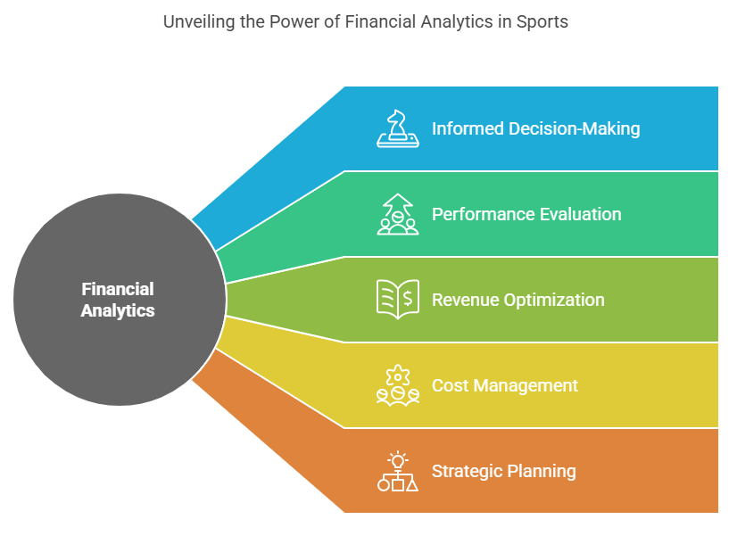

The importance of financial analytics in sports cannot be overstated. Here are several key reasons why it is vital for sports organizations:

1. **Informed Decision-Making:** Financial analytics provides teams with the necessary insights to make informed decisions regarding player acquisitions, contract negotiations, and budget allocations.

2. **Performance Evaluation:** By analyzing financial data, organizations can evaluate the performance of players, coaches, and overall team operations, leading to better management and investment strategies.

3. **Revenue Optimization**: Financial analytics helps teams identify new revenue streams, such as merchandising, ticket sales, and sponsorship opportunities, ultimately enhancing profitability.

4. **Cost Management:** Understanding the financial implications of various operational decisions allows teams to manage costs effectively and allocate resources efficiently.

5. **Strategic Planning:** Financial analytics supports long-term strategic planning by providing forecasts and projections that help organizations prepare for future challenges and opportunities.

**Tools for Financial Analytics in Sports**

This document explores various tools and software solutions that assist sports organizations in conducting financial analytics. In the ever-evolving landscape of sports finance, the ability to analyze and interpret financial data is crucial for making informed decisions. The following sections detail some of the most commonly used tools, highlighting their features and benefits for financial analysis in the sports industry.

# 1. Excel

Microsoft Excel remains one of the most widely used tools for financial analysis due to its flexibility and powerful data manipulation capabilities. Excel allows users to create complex financial models, perform calculations, and visualize data through charts and graphs. Its extensive range of functions and formulas makes it an essential tool for budgeting, forecasting, and analyzing financial performance in sports organizations.

# 2. Tableau

Tableau is a leading data visualization tool that enables sports organizations to create interactive dashboards and visual representations of financial data. With its user-friendly interface, Tableau allows users to easily connect to various data sources and generate insightful visualizations. This capability makes it easier to identify trends, patterns, and insights that can inform financial decision-making and strategy development.

# 3. SAS

SAS (Statistical Analysis System) provides advanced analytics capabilities, including predictive modeling and statistical analysis, which can be applied to financial data in sports. With its robust suite of tools, SAS allows analysts to perform in-depth analyses, uncovering valuable insights that can drive financial performance. Its ability to handle large datasets and complex calculations makes it a preferred choice for organizations looking to leverage data for strategic advantage.

# 4. R and Python

R and Python are popular programming languages among data analysts for performing complex financial analyses and developing custom models tailored to specific needs. Both languages offer extensive libraries and packages designed for statistical analysis, data manipulation, and visualization. Their versatility allows sports organizations to conduct sophisticated financial modeling, enabling them to make data-driven decisions based on comprehensive analyses.

# 5. Business Intelligence (BI) Tools

Business Intelligence tools like Power BI and ClickView enable organizations to aggregate data from various sources and generate comprehensive reports that inform financial decision-making. These tools provide intuitive interfaces for data exploration and visualization, allowing users to create interactive reports that highlight key financial metrics. By consolidating data from different departments, BI tools help sports organizations gain a holistic view of their financial performance and identify areas for improvement.

**Features of Financial Analytics in Sports**

Financial analytics in sports is a crucial aspect that helps organizations manage their financial health and make informed decisions. This document delves into the key features of financial analytics in the sports industry, highlighting how these features contribute to better financial management and strategic planning.

# Data Integration

One of the primary features of financial analytics in sports is **data integration**. This capability allows organizations to consolidate data from various sources, including ticket sales, merchandise revenue, sponsorship deals, and broadcasting rights. By integrating these diverse data streams, sports organizations can gain a comprehensive view of their financial health. This holistic perspective enables decision-makers to identify trends, assess performance across different revenue streams, and make informed strategic choices.

# Real-Time Analysis

Another significant feature is **real-time analysis**. Financial analytics tools are designed to provide immediate insights into financial data, allowing organizations to respond swiftly to changing financial conditions and market dynamics. For instance, if ticket sales are lower than expected, teams can quickly adjust their marketing strategies or pricing models to address the issue. This agility is essential in the fast-paced sports environment, where timely decisions can significantly impact revenue and overall success.

# Predictive Analytics

**Predictive analytics** is a powerful feature that employs advanced techniques such as machine learning and statistical modeling to forecast future financial performance. By analyzing historical data, organizations can identify patterns and trends that inform their financial projections. This capability allows sports teams and organizations to anticipate changes in revenue, expenses, and overall financial health, enabling them to plan effectively for the future and allocate resources more efficiently.

# Scenario Planning

Financial analytics also facilitates **scenario planning**, which is vital for assessing the potential impact of various decisions and market conditions on financial outcomes. Organizations can create different financial scenarios based on factors such as changes in player contracts, shifts in fan engagement, or fluctuations in sponsorship revenue. By evaluating these scenarios, teams can better understand the risks and opportunities associated with different strategic choices, ultimately leading to more informed decision-making.

# Reporting and Visualization

Lastly, effective **reporting and visualization** features are essential for communicating complex financial data to stakeholders. Financial analytics tools often include dashboards and visual representations of data that make it easier for decision-makers to grasp key insights at a glance. This clarity enhances communication among team members, sponsors, and other stakeholders, fostering collaboration and ensuring that everyone is aligned with the organization's financial goals.

**Understanding Financial Analytics**

Financial analytics is a critical aspect of modern sports management, focusing on the analysis of financial data through statistical methods and data visualization tools. This document delves into the intricacies of financial analytics, emphasizing its importance in evaluating the financial health of sports organizations. By examining revenue streams, cost management, player valuation, and financial forecasting, we aim to provide a comprehensive understanding of how financial analytics can enhance strategic planning and decision-making in the sports industry.

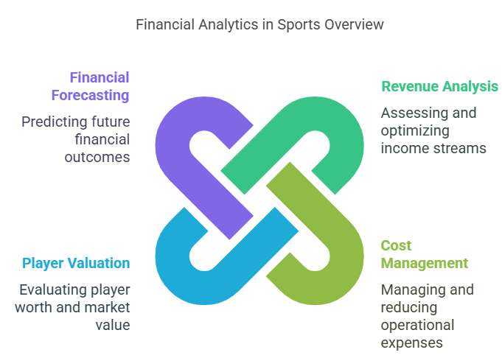

# Key Components of Financial Analytics in Sports

## 1. Revenue Analysis

Sports teams generate income from a variety of sources, including ticket sales, merchandise, sponsorships, and broadcasting rights. Financial analytics plays a pivotal role in assessing the performance of these revenue streams. By analyzing data related to sales trends, fan engagement, and market demand, teams can identify opportunities for growth and optimize their revenue-generating strategies. This analysis not only helps in maximizing current income but also in forecasting future revenue potential.

## 2. Cost Management

Understanding and managing costs is crucial for any sports organization. Financial analytics enables teams to conduct a thorough analysis of operational expenses, player salaries, and other financial commitments. By utilizing data-driven insights, organizations can identify areas where costs can be reduced without compromising performance. Effective cost management ensures that teams maintain a balanced budget, which is essential for long-term sustainability and success.

## 3. Player Valuation

One of the most significant aspects of financial analytics in sports is player valuation. Teams leverage data analytics to evaluate player performance, potential, and market value. This comprehensive analysis aids in making informed decisions regarding trades, contracts, and acquisitions. By understanding a player's worth in the market, teams can negotiate better contracts and make strategic investments that align with their financial goals.

## 4. Financial Forecasting

Predictive analytics is a powerful tool that allows teams to forecast future revenues and expenses based on historical data and market trends. This foresight is essential for long-term planning and sustainability. By anticipating financial outcomes, sports organizations can make proactive decisions that enhance their competitive edge. Financial forecasting also helps in budgeting and resource allocation, ensuring that teams are prepared for both opportunities and challenges.

**The Role of Financial Analytics in Enhancing Team Performance**

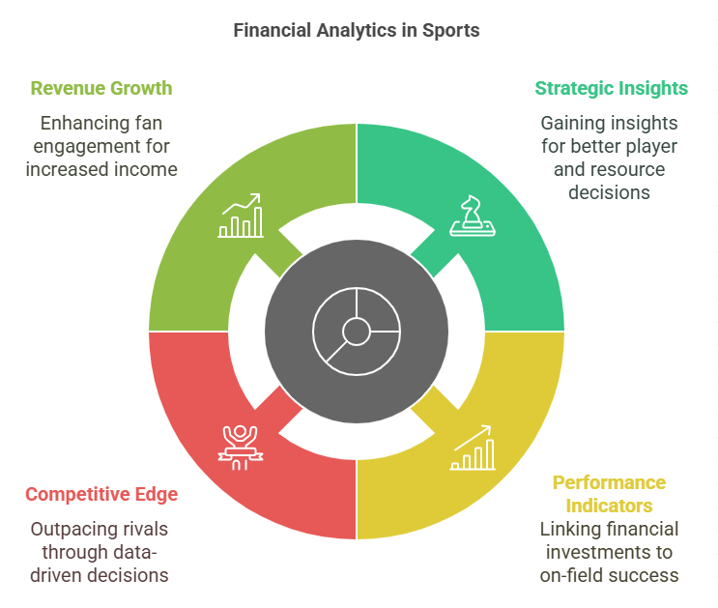

**Developing Long-Term Plans**

Sports organizations can gain valuable strategic insights from financial analytics. Teams can find the best players to invest in, the best ways to distribute resources, and places to save money without sacrificing performance by examining financial data. With this plan in place, the team's on-field performance can improve.

**Measures of Performance**

Through the use of financial analytics, teams can establish performance indicators that link monetary investments to success in the game. Teams can learn a lot about what investments pay off, like when they look at the return on investment (ROI) for player signings. Allotting funds to individuals and techniques that perform to their full potential is the goal of this data-driven strategy.

**Gain an Edge over the Competition**

Financial analytics can give you a huge leg up in the cutthroat world of sports. Teams who are good at using financial data can out-decide their rivals in terms of speed and quality of decision-making. Particularly in high-stakes contexts like talks and deals, this nimbleness can spell victory or defeat.

**The Role of Fans and the Growth of Revenue**

Improving fan engagement—which is critical for revenue growth—also plays a role in financial analytics. Team marketing, ticket and item pricing, and promotion targeting may all be fine-tuned by studying fan spending habits and preferences. To succeed in the long run, it's crucial to have a dedicated fan base, and this does double duty by increasing both revenue and fan loyalty.

**Theoretical Models and Frameworks for Analyzing Financial Data in Sports**

The purpose of this paper is to examine the several theoretical models and frameworks used to analyze sports sector financial data. All parties involved—teams, leagues, sponsors, and investors—must have a firm grasp of these models as the sports industry's complexity and monetary importance only increase. Decisions, strategy, and performance evaluation can all be aided by analyzing financial data in sports.

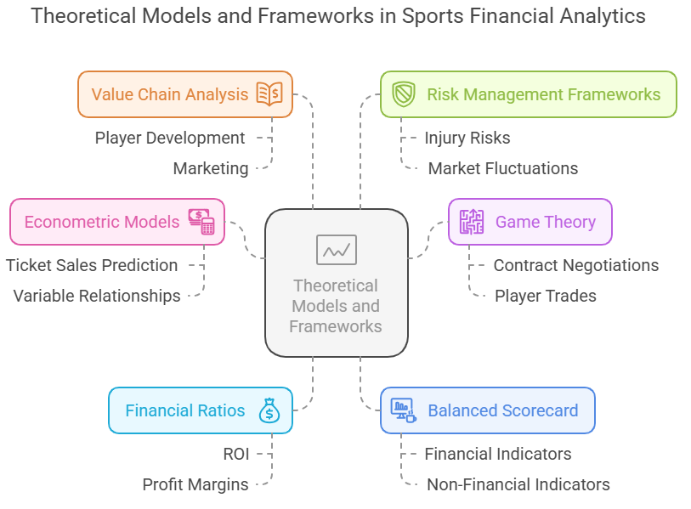

1. **Introduction to Financial Data in Sports**

The sports industry generates substantial financial data, ranging from ticket sales and merchandise revenue to broadcasting rights and sponsorship deals. Analyzing this data requires robust theoretical models that can accommodate the unique characteristics of the sports market, including seasonality, player performance metrics, and fan engagement levels.

2**. Key Theoretical Models**

**Econometric Models**

Econometric models are widely used in sports finance to analyze relationships between variables. These models often employ regression analysis to predict outcomes based on historical data. For example, teams may use econometric models to forecast ticket sales based on factors such as team performance, opponent strength, and historical attendance figures.

**Game Theory**

Game theory provides a framework for understanding competitive interactions in sports. It can be applied to analyze strategies employed by teams and players, particularly in contract negotiations and player trades. By modeling the decisions of various stakeholders as a game, analysts can predict outcomes based on the strategies adopted by each party.

**Financial Ratios and Performance Metrics**

Financial ratios, such as return on investment (ROI) and profit margins, are essential for evaluating the financial health of sports organizations. Performance metrics, including player efficiency ratings and team win-loss records, can also be integrated into financial analysis to provide a comprehensive view of a team's profitability relative to its on-field success.

3. **Frameworks for Analysis**

**The Balanced Scorecard**

The Balanced Scorecard is a strategic planning and management framework that can be adapted for sports organizations. It incorporates financial and non-financial performance indicators, allowing teams to assess their performance from multiple perspectives, including financial, customer, internal processes, and learning and growth. This holistic approach enables organizations to align their financial goals with broader strategic objectives.

**Value Chain Analysis**

Value chain analysis helps sports organizations identify the key activities that contribute to their financial performance. By examining each segment of the value chain—from player development and marketing to ticket sales and merchandise distribution—teams can pinpoint areas for improvement and optimize their operations for better financial outcomes.

**Risk Management Frameworks**

Given the inherent uncertainties in sports, risk management frameworks are crucial for financial analysis. These frameworks help organizations identify, assess, and mitigate financial risks associated with player injuries, market fluctuations, and changes in fan engagement. By employing risk management strategies, teams can safeguard their financial health and ensure long-term sustainability.

**Challenges and Opportunities**

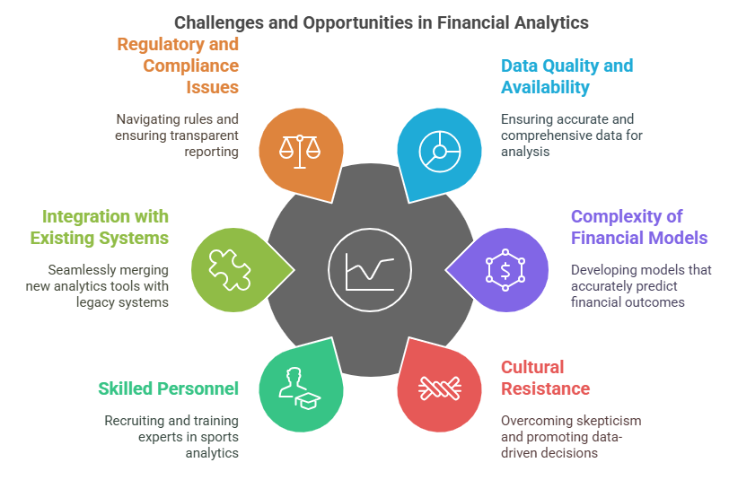

1. **Data Quality and Availability**

One of the foremost challenges in implementing financial analytics in sports is the quality and availability of data. Sports organizations often deal with disparate data sources, including ticket sales, merchandise sales, sponsorship deals, and player contracts. The lack of standardized data formats can lead to inconsistencies and inaccuracies, making it difficult to derive meaningful insights. Furthermore, many organizations may not have access to comprehensive historical data, which is essential for accurate forecasting and trend analysis. Ensuring data integrity and establishing a centralized data repository are critical steps that organizations must take to overcome this challenge.

2. **Complexity of Financial Models**

Financial analytics in sports often involves complex modeling techniques that require a deep understanding of both finance and sports operations. Developing accurate financial models that can predict revenue streams, assess player value, and evaluate the financial impact of various decisions is no small feat. Many organizations may struggle with the intricacies of these models, leading to potential misinterpretations of data and misguided strategies. Simplifying these models without losing their analytical power is a significant challenge that organizations must navigate.

3. **Cultural Resistance**

Cultural resistance within sports organizations can also pose a significant barrier to the successful implementation of financial analytics. Traditional decision-making processes in sports often rely on intuition and experience rather than data-driven insights. This can lead to skepticism among stakeholders who may be hesitant to embrace analytics as a legitimate tool for decision-making. Overcoming this resistance requires a cultural shift that emphasizes the value of data and analytics, along with training and education to help stakeholders understand and trust the insights generated.

4. **Need for Skilled Personnel**

The successful implementation of financial analytics requires skilled personnel who can interpret data and translate it into actionable insights. However, there is often a shortage of professionals with the necessary expertise in both finance and sports analytics. Organizations may find it challenging to recruit and retain talent capable of navigating the complexities of financial data in a sports context. Investing in training programs and partnerships with educational institutions can help bridge this skills gap and ensure that organizations have the expertise needed to leverage financial analytics effectively.

5. **Integration with Existing Systems**

Integrating financial analytics into existing systems and processes can be another significant challenge. Many sports organizations rely on legacy systems that may not be compatible with modern analytics tools. This can lead to inefficiencies and increased costs as organizations attempt to retrofit their systems to accommodate new analytics capabilities. A strategic approach to technology integration, including the adoption of cloud-based solutions and data management platforms, can help streamline this process and enhance the overall effectiveness of financial analytics.

6. **Regulatory and Compliance Issues**

Sports organizations must also navigate a complex landscape of regulatory and compliance issues when implementing financial analytics. Different leagues and governing bodies have specific rules regarding financial reporting, salary caps, and player contracts. Ensuring compliance with these regulations while leveraging analytics can be challenging, as organizations must balance the need for transparency with the desire for competitive advantage. Developing robust compliance frameworks and staying informed about regulatory changes are essential for organizations looking to implement financial analytics successfully.

**Possibilities for Improving Sports Teams' Results with the Use of Financial Analytics**

Financial analytics has become an essential tool for modern sports teams to improve their performance. Sports businesses may maximize operational efficiency, audience engagement, and on-field performance by analyzing financial data and making informed decisions. This document delves into many ways teams can use data to their advantage by utilizing financial analytics in sports.

**Understanding Financial Analytics in Sports**

Financial analytics involves the systematic analysis of financial data to inform strategic decision-making. In the context of sports teams, this can include revenue management, cost analysis, and investment strategies. By employing financial analytics, teams can assess their financial health, identify areas for improvement, and allocate resources more effectively. This data-driven approach can lead to better performance both on and off the field.

**Enhancing Player Recruitment and Retention**

When it comes to financial analytics, one of the biggest potential is in the realm of player recruiting and retention. Teams might find undervalued athletes with strong potential returns on investment by comparing player performance indicators with financial data. To make sure they invest in talent that fits within their budget and meets their performance goals, clubs can use financial analytics to determine how cost-effective player contracts are.

Assessing the worth of holding on to key players over the long run is another area where financial analytics can be useful. When clubs look at things like injury trends, market demand, and player performance trends, they can make better decisions on contract extensions and trades. By keeping the roster competitive while staying within budget, this strategic approach to player management can improve team performance.

**Optimizing Game-Day Revenue**

Game-day revenue is a crucial component of a sports team's financial success. Financial analytics can be utilized to optimize ticket pricing, concessions, and merchandise sales. By analyzing historical sales data, teams can identify pricing strategies that maximize revenue while maintaining fan engagement. Dynamic pricing models, for instance, can adjust ticket prices based on demand, ensuring that teams capitalize on high-demand games. Moreover, financial analytics can help teams understand fan behavior and preferences. By analyzing spending patterns, teams can tailor their offerings to enhance the game-day experience, ultimately driving higher revenue. This could include targeted promotions, improved concession options, and enhanced merchandise strategies that resonate with fans.

**Enhancing Sponsorship and Partnership Opportunities**

Sponsorship deals are a significant revenue stream for sports teams. Financial analytics can provide insights into the effectiveness of existing sponsorships and identify potential new partners. By analyzing data on fan demographics, engagement levels, and brand alignment, teams can create compelling proposals for sponsors, demonstrating the value of their partnership. Furthermore, financial analytics can help teams evaluate the return on investment (ROI) of sponsorship deals. By measuring the impact of sponsorships on brand visibility, fan engagement, and revenue generation, teams can make data-driven decisions about which partnerships to pursue or renew. This strategic approach ensures that teams maximize their financial resources while enhancing their brand presence.

**Improving Operational Efficiency**

Beyond enhancing performance on the field, financial analytics can drive operational efficiency within sports organizations. By analyzing operational costs, teams can identify areas for cost reduction without compromising quality. This could involve optimizing staffing levels, streamlining processes, or renegotiating supplier contracts. Additionally, financial analytics can aid in budgeting and forecasting. By leveraging historical data and predictive analytics, teams can create more accurate budgets that align with their strategic goals. This proactive approach to financial management allows teams to allocate resources effectively, ensuring that they remain competitive in a rapidly evolving sports landscape.

**Solutions to Difficulties and Ways to Make the Most of Opportunities**

A great deal of opportunity and a great deal of difficulty await people and businesses in today's dynamic and rapid world. In this document, we will look at several proven methods for getting beyond challenges and making the most of favorable situations. One can overcome obstacles and make the most of opportunities for professional and personal development by learning and applying these tactics.

**Understanding Challenges and Opportunities**

Challenges can arise from various sources, including economic fluctuations, technological advancements, competition, and internal organizational issues. Conversely, opportunities may present themselves through market trends, innovations, networking, and shifts in consumer behavior. Recognizing the dual nature of challenges and opportunities is crucial for developing effective strategies.

**Strategies for Overcoming Challenges**



1. **Embrace a Growth Mindset**

Adopting a growth mindset is fundamental in overcoming challenges. This involves viewing difficulties as opportunities for learning and development rather than insurmountable obstacles. By fostering resilience and adaptability, individuals can approach challenges with a positive attitude, which can lead to innovative solutions.

2. **Set Clear Goals**

Establishing clear, achievable goals provides direction and focus when facing challenges. By breaking down larger objectives into smaller, manageable tasks, individuals can create a roadmap for success. This structured approach helps in maintaining motivation and tracking progress.

3. **Develop Problem-Solving Skills**

Enhancing problem-solving skills is essential for overcoming challenges. This can be achieved through critical thinking exercises, brainstorming sessions, and collaborative discussions. By encouraging diverse perspectives, teams can generate creative solutions to complex problems.

4. **Build a Support Network**

Having a strong support network can significantly aid in overcoming challenges. This network may include mentors, colleagues, friends, and family who can provide guidance, encouragement, and resources. Engaging with others can also foster a sense of community and shared purpose.

5. **Stay Informed and Adaptable**

In a rapidly changing environment, staying informed about industry trends and emerging technologies is vital. Being adaptable allows individuals and organizations to pivot when necessary, ensuring they remain competitive and capable of addressing challenges effectively.

**Strategies for Maximizing Opportunities**

1. **Identify and Analyze Opportunities**

To maximize opportunities, it is essential to identify and analyze them thoroughly. This involves conducting market research, understanding consumer needs, and recognizing emerging trends. By staying attuned to the environment, individuals can position themselves to seize opportunities as they arise.

2. **Leverage Strengths and Resources**

Understanding and leveraging one’s strengths and available resources is crucial for capitalizing on opportunities. This may involve utilizing unique skills, knowledge, or connections that can provide a competitive advantage. By aligning strengths with opportunities, individuals can enhance their chances of success.

3. **Foster Innovation and Creativity**

Encouraging a culture of innovation and creativity can lead to the discovery of new opportunities. This can be achieved by promoting brainstorming sessions, allowing for experimentation, and rewarding innovative thinking. Organizations that embrace creativity are often better positioned to identify and exploit new opportunities.

4. **Network and Collaborate**

Building relationships and collaborating with others can open doors to new opportunities. Networking allows individuals to connect with like-minded professionals, share ideas, and explore potential partnerships. Collaboration can lead to innovative projects that may not have been possible individually.

5. **Take Calculated Risks**

Maximizing opportunities often requires taking calculated risks. This involves assessing potential rewards against possible downsides and making informed decisions. By being willing to step outside of their comfort zone, individuals can unlock new avenues for growth and success.

**Findings**

1. **Decision-making impact:** Financial statistics substantially affect sports organization decisions. Teams use financial data to negotiate contracts, buy players, and set budgets.

2. **Revenue Increase:** Financial analytics boosts sports club ticket, retail, and sponsorship sales. Financial health and profitability improve.

3. **Cost control:** Financial analytics aids teams in understanding operational decisions' financial effects, enabling cost control. This knowledge optimizes resource allocation and reduces waste.

4. **Performance Assessment:** Financial analytics evaluates player and team performance. Companies can better evaluate contributions and optimize team composition by integrating financial indicators with performance data.

5. **Planning Strategically:** Financial analytics forecasts and projections enhance strategy. Companies can anticipate problems and grab opportunities with this capacity.

6. **Tool Use:** Sports organizations analyses finances with Excel, Tableau, SAS, R, and Python. They provide data integration, real-time analysis, and prediction.

7. **Data Integration, Real-Time Analysis**: A firm's financial picture is complete with multi-source data. Teams can respond swiftly to market and financial shifts using real-time analysis.

Performance"

**Suggestions**

1. To improve staff awareness and implementation of financial analytics tools and processes, sports companies should invest in training programs. This will help teams make data-driven decisions.

2. **Use advanced analytics techniques:** Teams should use machine learning and predictive modeling to improve forecasting and strategic planning.

3. **Improve data collection methods:** Sports organizations will have high-quality, complete data via improving data gathering. This may involve using technology to collect data from fan interaction measures and other sources.

4. **Encourage Department Collaboration:** Encourage financial analysts, coaches, and managers to collaborate for better integrated decision-making. This collaboration can improve sports finance analytics.

5. **Review Financial Strategies regularly**: Sports organizations should examine their financial strategy regularly to stay current with market conditions and aims. This aids performance optimization and change adaptation.

6. **Utilize Visualization Tools:** Finance stakeholders can better understand financial insights with data visualization tools. Clear data visualizations aid comprehension and decision-making.

7. **Prioritize long-term sustainability:** Financial analytics should be used to find new revenue streams and boost profits for long-term sustainability. This focus will help clubs compete in a fast-changing sports landscape.

**Conclusion**

Finally, in today's sports world, financial analytics are vital because they help teams make smart decisions that boost efficiency and performance. Optimal resource allocation, player performance evaluation, and financial outcome forecasting are all possible when financial data and performance measurements are integrated. Financial analytics will become more important for teams in the sports business as they try to adapt to the changing market and remain successful in the long run. In order to better understand the financial dynamics at play in the sports industry and to drive performance, this study stresses the significance of financial analytics as a strategic tool.

**Reference:**

*1.Kahn, L. M., & Sherer, D, 2018, Journal of Sports Economics  
2.Franck, E., & Nüesch, S, 2019, International Journal of Sport Finance  
3.Szymanski, S, 2020, Journal of Sports Management  
4.Berri, D. J., & Schmidt, M. B, 2021, Journal of Quantitative Analysis in Sports*

*5.Investigating the Relationship between Financial Outcomes and Sports Performance Measures, Dr. K. Baranidharan Dr. P. Ranjith, 2025/2. International Journal of Advanced Research in Science, Communication and Technology, (IJARSCT). Volume:5, Issue:1, Pages:353-365, Publisher: www.ijarsct.co.in.DOI: 10.48175/IJARSCT-23249.*

*6.An Investigation in to Sports Analytics and Related Tools. V. Deepika Dr. K. Baranidharan , K. Sabitha, 2024/7, International Journal of Advanced Research in Science, Communication and Technology (IJARSCT), Volume:4, Issue:1, Pages:262-272, Publisher: www.ijarsct.co.in.DOI: 10.48175/IJARSCT-19132.*

*7.An Examination of the Utilization of Sports in the Realm of Financial Analytics, V. Deepika, Dr. K. Baranidharan , K. Sabitha, 2024/7, International Journal of Research Publication and Reviews, Volume:5, Issue:7, Pages:1661-1669.*

*8.Business Sports Marketing Opportunities : A Study, J. Ravivarman Dr. P. Ranjith, Dr. K. Baranidharan, Dr. T. Suganya, Dr. N. Selvakumar, T. Sujathabaranidharan, J. Rokesh Kanna, 2023/3, International Journal of Advanced Research in Science, Communication and Technology (IJARSCT), Volume:3, Issue:2, Pages: 456-465.*

*9.Sports Business Opportunities in Entrepreneurship: A Study, Janarthanan Dr. P. Ranjith, Dr. K. Baranidharan, Dr. T. Suganya, Dr. N. Selvakumar, T. Sujathabaranidharan, I. Jonath Christopher, 2023/3, International Journal of Research Publication and Reviews, Volume:4, Issue:3, Pages: 2440-2445.*

10.[Sports management](https://www.ijprems.com/uploadedfiles/paper/issue_3_march_2023/30719/final/fin_ijprems1679307962.pdf), *P Ranjith, K Baranidharan, G Balakrishnan, T Suganya, N Selvakumar, V Nithesh Kumar, International Journal Of Progressive Research In Engineering Management And Science (IJPREMS), Vol. 03, Issue 03, March 2023, pp : 181-187, DOI: https://www.doi.org/10.58257/IJPREMS30719 .*

*11.A Study that Looks into Financial Analytics for Statistical Tools, Dr. N. Selvakumar, Dr. K. Baranidharan, K. Sevanthi, Dr. T. Suganya, 2024/6, International Journal of Advanced Research in Science, Communication and Technology (IJARSCT), Volume:4, Issue:1, Pages: 520-532..*

*12.A Study on the Application of Financial Analytics in the Field of Blockchain Technology, V. Deepika Professor Dr.K.Baranidharan, Research Scholar K. Sabitha. 2024, International Journal of Science, Engineering and Technology, Volume:12, Issue:3, Pages: 1-15.DOI: /10.61463/ijset.vol.12.issue3.190.*

*13.A Study On The Utilization Of Predictive Analytics In The Finance, V. Deepika Dr. K. Baranidharan , Dr. N. Selvakumar , K. Sabitha, 2024/6, International Journal Of Progressive Research In Engineering Management And Science (IJPREMS), Volume:4, Issue:6, Pages: 2095-2107,* [*www.doi.org/10.58257/IJPREMS35210*](http://www.doi.org/10.58257/IJPREMS35210)*.*

*14.A Study that Looks into Financial Analytics for Statistical Tools, Dr. N. Selvakumar Dr. K. Baranidharan , K. Sevanthi , Dr. T. Suganya, 2024/6, International Journal of Advanced Research in Science, Communication and Technology (IJARSCT), Volume:4, Issue:1, Pages: 520-532, DOI: 10.48175/IJARSCT-18771*