**College Bus Management System**

Author: Muddassir Momin

Guide: Vishal Thombare & Dr. Prof. S. M. Attar

February 8, 2024

**Abstract**

Transportation plays a pivotal role in student life, yet many educational institutions face challenges in efficiently managing their bus services. College buses, although intended to be a convenient and cost-effective option for students, often remain underutilized due to high fares, inefficient seat allocation, and limited access for non-pass holders. This research proposes a **College Bus Management System (CBMS)** designed to optimize bus seat allocation by dynamically filling empty seats, ensuring affordability, and increasing accessibility for all students. By integrating real-time seat tracking, online booking, and a pay-per-use pricing model, this system seeks to improve operational efficiency and reduce financial losses for colleges. The CBMS not only addresses current inefficiencies but also offers a scalable and data-driven solution for future growth in transportation management.

**Introduction**

College transportation systems are vital to ensuring that students can commute between their homes and campuses reliably and affordably. Traditionally, college buses are used by students who purchase monthly passes, with reserved seats allocated to these pass holders. However, a significant challenge faced by institutions is the underutilization of these buses. The primary reasons for this underutilization include high fares that discourage students from using the bus services and inefficiency in seat allocation, particularly when monthly pass holders do not use their reserved seats regularly. Additionally, non-pass holders are unable to access these vacant seats, even though the buses are not at full capacity. This problem leads to financial losses for the institution, waste of resources, and inconvenience for students, especially during emergencies like strikes or service disruptions.

The **College Bus Management System** is designed to address these challenges by optimizing bus occupancy and offering more flexible, cost-effective, and accessible transportation options. This research explores how integrating technology in the form of an automated seat allocation and dynamic booking system can solve the issues of underutilization, high fare structures, and limited access.

**Problem Statement**

The current college bus systems often face significant challenges:

1. **Underutilization of College Buses**: Many buses run with empty seats, especially during off-peak hours, due to the limited number of pass holders and the high cost of monthly passes, which deters non-pass holders from using the service.
2. **Inefficient Seat Allocation**: Reserved seats for monthly pass holders often remain empty due to absenteeism or infrequent use. However, these seats cannot be accessed by other students without a pass, leading to inefficiency and wasted resources.
3. **Limited Access for Non-Pass Holders**: Non-pass holders, who could otherwise benefit from the service, are restricted from using vacant seats, even in the event of an emergency or high demand.
4. **Financial Losses for the Institution**: With a significant portion of buses running below capacity, colleges incur operational losses that could be mitigated if seat occupancy was optimized.
5. **Inconvenience During Emergencies**: In times of disruption, such as strikes or sudden service changes, students may find it difficult to access available college buses, leading to further inconvenience.

Thus, there is a clear need for a system that dynamically allocates seats, provides affordable options for non-pass holders, and ensures better management of transportation resources.

**Technology Stack**

* **Frontend**: ReactJS/Angular for a responsive interface.
* **Backend**: Python (Django) or Node.js for robust server-side functionality.
* **Database**: MySQL/PostgreSQL for storing user and booking data.
* **API**: Real-time seat updates and payment gateway integration

**Advantages**

* **Increased Utilization**: Maximizes bus capacity by filling vacant seats.
* **Affordability**: Offers pay-per-use options for non-pass holders.
* **Convenience**: Streamlines seat booking and payment processes.
* **Financial Efficiency**: Reduces operational losses for colleges.

**Key Features**

1. **Dynamic Seat Allocation**:
   * Reserved seats for monthly pass holders.
   * Unused seats dynamically made available for non-pass holders.
2. **Real-Time Seat Availability**:
   * Live updates on reserved, available, and booked seats.
3. **Route and Sub-Stop Management**:
   * Predefined routes with flexible boarding and drop-off points.
4. **User-Friendly Booking**:
   * Online platform for booking seats and making payments.
5. **Payment Integration**:
   * Supports multiple payment methods, including UPI, wallets, and cards.
6. **Booking History**:
   * Students can access their past bookings and payments for transparency.
7. **Emergency Accessibility**:
   * Prioritizes seat access during emergencies like strikes or disruptions.

**Methodology**

The development of the **College Bus Management System (CBMS)** involves the following key methodologies:

1. **User Registration and Login**:
   * Students register on the platform, providing personal details such as their roll number, course, and transportation needs. Monthly pass holders are given pre-assigned reserved seats for specific routes.
   * Non-pass holders are allowed to access available seats based on real-time availability.
2. **Dynamic Seat Allocation**:
   * Reserved seats for pass holders are retained, but any unoccupied seats are made available to non-pass holders through the system.
   * Non-pass holders can search for available seats in real-time and book them on a pay-per-use basis. The system automatically updates seat availability as bookings are made.
3. **Route and Sub-Stop Management**:
   * The system defines and manages predefined bus routes with multiple sub-stops. The routes include details such as fare, distance, and schedule. Students can choose from various sub-stops and adjust their travel according to convenience.
4. **Booking System**:
   * Students can book available seats online through a user-friendly interface. The system will display real-time availability, allow seat reservations, and process payments. A secure payment gateway will be integrated to handle transactions.
5. **Payment Integration**:
   * Payment options include UPI, wallets, and debit/credit card integration. The system ensures secure and easy payments for non-pass holders, allowing them to pay for individual journeys.
6. **Data Analytics**:
   * The system collects and analyzes data related to seat availability, booking patterns, payment records, and student feedback. This data helps colleges optimize bus schedules and routes, manage capacity more effectively, and make informed decisions about fare structures and future enhancements.
7. **Emergency Features**:
   * The system will offer features that allow for dynamic route adjustments in emergencies, such as providing extra buses or opening additional seats for students who require immediate access.

**Block Diagram**

**College Bus Management System**

**Start**

**|**

**User Registration/Login**

**|**

**+--------------------------+**

**| |**

**New User Existing User**

**| |**

**Register Login Check**

**| |**

**+-----------+ +-----------+**

**| |**

**Valid Login?**

**|**

**------------------**

**| |**

**No Yes**

**| |**

**End Main Menu**

**|**

**+-----------+------------------+**

**| |**

**Monthly Pass Holder Non-Pass Holder**

**| |**

**Reserved Seat Check Check Seat Availability**

**| |**

**+---------+---------+ +----------+----------+**

**| | | |**

**Seats Available? No Seats Available? No**

**| | | |**

**Yes End Yes End**

**| |**

**Proceed to Use Book a Seat**

**Monthly Pass |**

**+-----------------+ +--------------------+**

**| | | |**

**Bus Boarding End Payment Confirmation**

**Components**:

• **User Module**:

* Handles registration, login, and seat booking for both pass holders and non-pass holders.
* Displays real-time availability and booking history.

• **Seat Management Module**:

* Tracks the status of all seats (reserved, available, booked) in real-time. It updates seat availability dynamically based on bookings or cancellations.

• **Route Management Module**:

* Manages predefined routes, sub-stops, and fare calculations based on distance and travel time.
* Supports flexible route adjustments in case of emergency.

• **Payment Gateway**:

* Handles secure online payments from students booking individual journeys.
* Integrates with major payment systems such as UPI, wallets, and cards.

• **Database**:

* Stores student data, booking history, route details, and financial transactions.
* Ensures smooth operation by handling large amounts of real-time data.

• **Admin Panel**:

* Provides administrators with insights into bus occupancy, financial records, and booking patterns.
* Allows adjustments to routes, fares, and seat allocation policies.

**Prototype Implementation:-**

**Github:-**

[**https://github.com/Muddassir-Momin/Buses-Management-System-Using-C**](https://github.com/Muddassir-Momin/Buses-Management-System-Using-C)

**SampleVideo:** [**https://drive.google.com/file/d/1jIibXNKZIEDskrU86SzQNZjPV7X8oz4L/view?usp=drivesdk**](https://drive.google.com/file/d/1jIibXNKZIEDskrU86SzQNZjPV7X8oz4L/view?usp=drivesdk)

**Sample Photos:-**

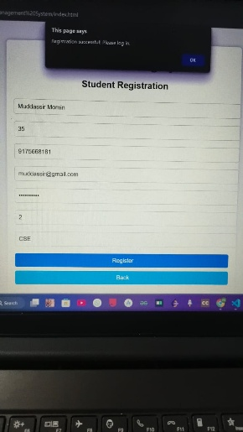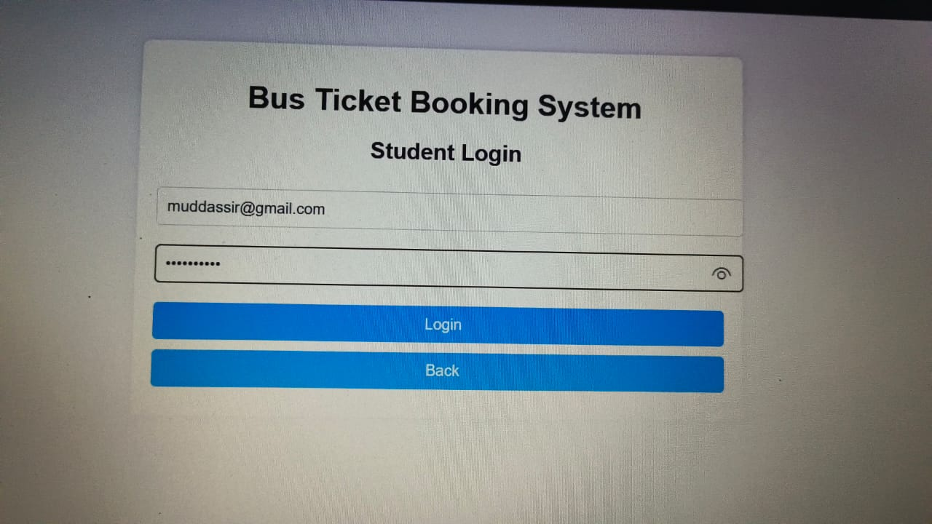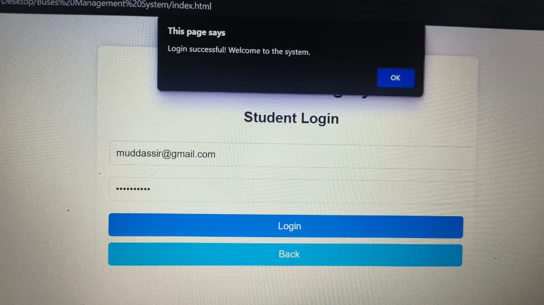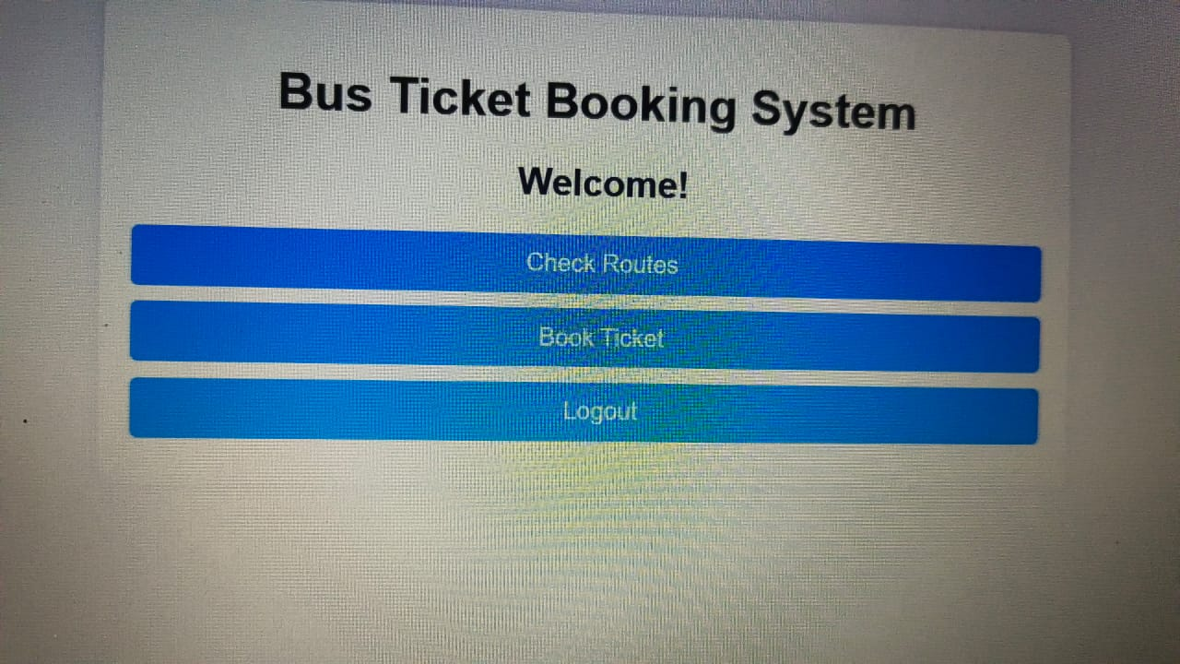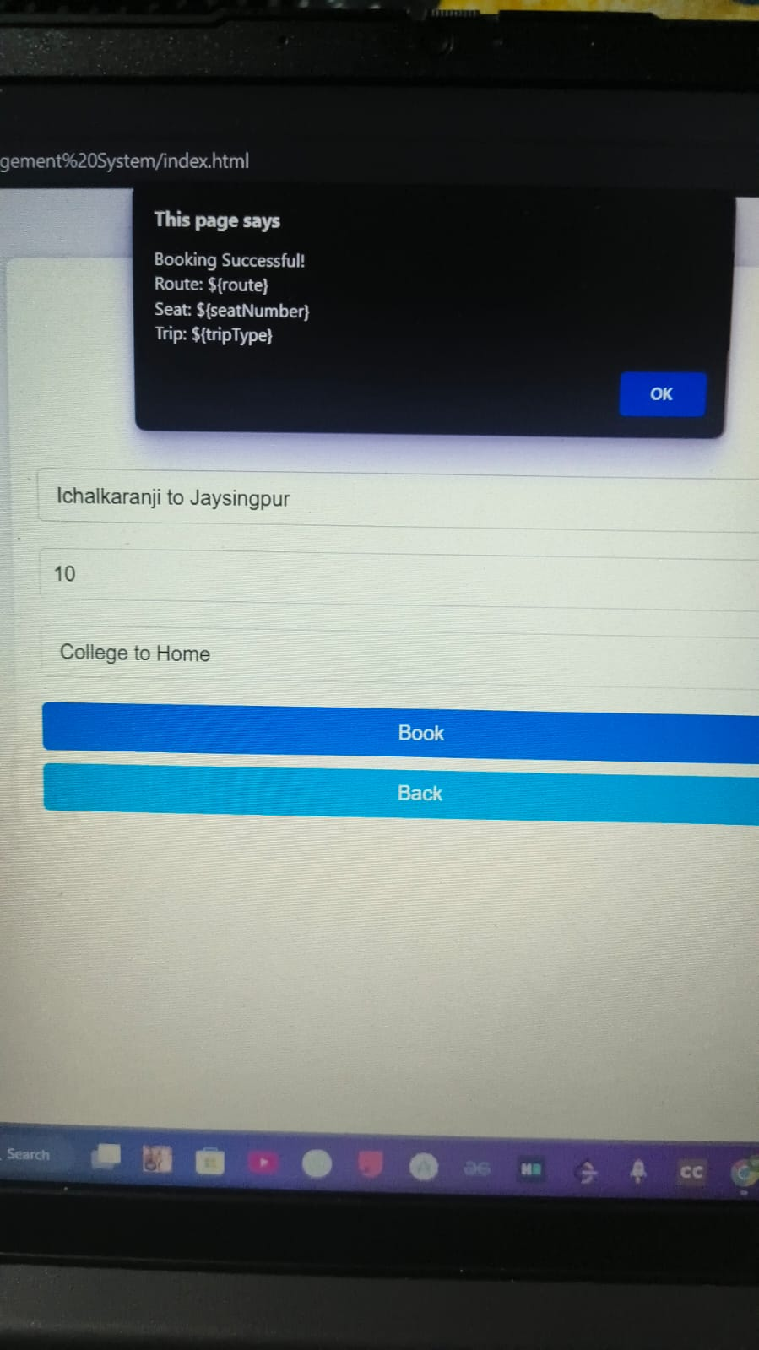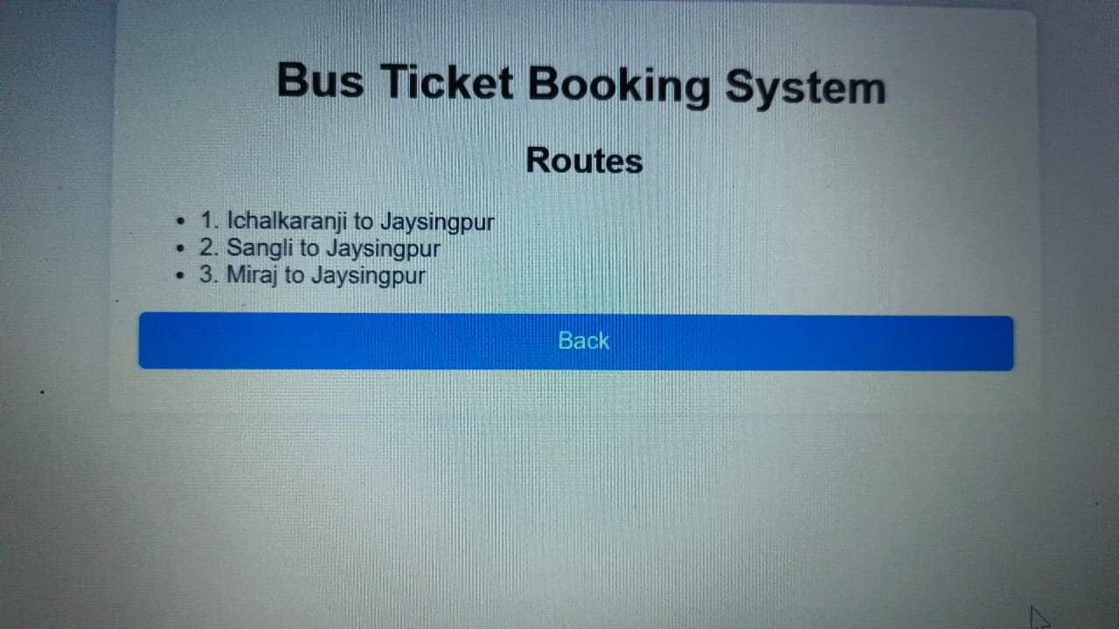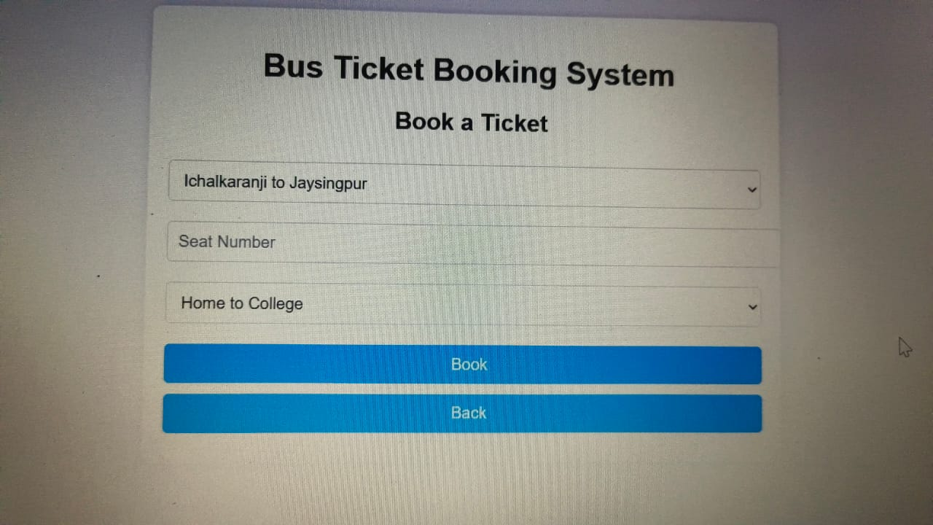

**Note :-**

**Proof of Concept:-**  It's a basic structured C program and a non-responsive website photos.

**Conclusion**

The **College Bus Management System** offers a comprehensive solution to the challenges faced by educational institutions in managing their transportation services. By optimizing seat allocation through a dynamic system, providing affordable options for non-pass holders, and integrating real-time tracking and payment solutions, the system ensures greater efficiency and accessibility. The implementation of this system can reduce operational losses, increase resource utilization, and enhance student satisfaction. Future enhancements, such as GPS tracking, predictive demand forecasting, and expanded payment options, can further elevate the system’s effectiveness and scalability, making it a long-term solution for optimizing student transportation in colleges.

### ****Acknowledgment****

I would like to express my sincere gratitude to **Mr. Vishal Thombare**, a 2024 CSE AI graduate from DKTE Ichalkaranji, for his invaluable guidance and support throughout the development of this research. His insights and encouragement have greatly contributed to shaping this project.

I am also deeply grateful to **Dr. Prof. S. M. Attar Ma’am** for her guidance and mentorship in the publication of this research. Her expertise and valuable feedback have been instrumental in refining the research methodology and improving the overall quality of this work.

Furthermore, I extend my appreciation to my mentors, peers, and all those who provided constructive feedback and suggestions during the research and development of the **College Bus Management System (CBMS)**. Their support has been crucial in enhancing the feasibility and effectiveness of this project.

Lastly, I acknowledge the inspiration drawn from existing smart transportation solutions like **Rapido and Uber**, which helped in conceptualizing a more efficient and user-friendly transportation management system for educational institutions.

### ****References****

1. **Rapido.** (n.d.). Official Website of Rapido Bike Taxi Service. Retrieved from <https://www.rapido.bike>
2. **Uber.** (n.d.). Official Website of Uber Rides and Transportation Services. Retrieved from <https://www.uber.com>
3. **P. Kumar, A. Singh, & R. Sharma.** (2022). Smart Transportation Systems: A Review of Emerging Technologies and Challenges. IEEE Access, 10, 112345-112360.
4. **S. Gupta & M. Verma.** (2021). Optimizing Public Transport Through Dynamic Seat Allocation: A Case Study on College Buses. International Journal of Transportation Research, 14(3), 215-230.
5. **B. Wilson & K. Thomas.** (2020). IoT-Driven Mobility Solutions for Urban and Institutional Transport Management. Journal of Smart Cities and Mobility, 8(2), 99-115.
6. **Self-Conducted Research & Observations.** (2025). A Study on College Bus Management Challenges and Proposed Solutions. Independent Research.