**The History of Electric Cars: Technological Progress, Market Trends, and Future Trends**

**Polimahanthi Sunil Krishna)**

Global Institute of Business Studies, India

**1. Abstract:**

A dashing revolution of the motor age, fuelled by technology advancements, altering needs, and rising ecological awareness, is the evolution of electric vehicles. Electric vehicle development commenced with the initial stages of electric cars in the early 19th century. But the first few decades of the 20th century saw the market rule by ICE-based vehicles and mass-produced gas guzzlers. But even with this limitation, the second half of the century saw EVs picking up pace steadily with growing air pollution, global warming, and dwindling fossil fuels.

The reasons for the re-emergence of electric vehicles are the technological progress in battery storage, i.e., the lithium-ion battery. These later ones have brought about revolution in electric vehicle driving ranges and recharging times, such that electric cars are now an economic choice compared to gasoline counterparts. Apart from these trends, policy shifts on the global level-oriented towards low carbon emission and promotion of low-carbon transport modes-also ensured mass demand for EV. Tax incentives, benefits, and strict emissions regulations are some of the largest government incentives that encompass economic incentives to manufacturers and consumers in the form of investing in electric mobility as well

The evolution of electric vehicles, from where they then stood in the 1800s to where EVs now occupy space as part of the transport infrastructures of the majority of the world's countries, is the story this case study is all about. This case study tells us how enactment among government policies, battery technological advancements, and where charging stations are situated drive the trend of EVs today. Apart from this, studies also encompass rising trends of EV penetration globally and decomposing growth trends.

The study also encompasses existing challenges for the EV industry, such as longer charging networks, greener battery manufacturing, and the economic impact of phasing out ICE and becoming electric in America, Europe, and China.

Based on these facts regarding technology innovation, market forces, and policy implications, this case study will be presented with a different insight into how electric vehicles have evolved.

This article refers to some of the most significant milestones in the evolution of EV as well as it promises electric mobility in the future; promise with as well as hitches involved. The article well illustrates how gigantic will be the role of EV in world efforts at mitigating climate change while trying to bring much cleaner, more efficient transport to centuries to come

**2. Keywords:**

**Electric Vehicles (EVs), Battery Technology, Sustainable Transportation, Government Policy, EV Adoption, Market Trends**

**3. Introduction:**

One of the most revolutionary changes that are being proposed to the automotive and transportation sectors is the changeover to electric cars (EVs). From a small, trial vehicle to today, this was a creation which was at the forefront of creating an environmentally friendly, sustainable transport infrastructure throughout the world. The history of electric cars has nearly two centuries of development from the early experimentations to the breakneck pace of technology development and adoption that the industry is going through today. The evolution has been driven by a mix of drivers such as technological innovation, the world move towards alternative energy, environmentalism, and policy and regulatory change. The expansion of electrical mobility not merely redefines what people think of transport but may also redefine the environmental, economic, and societal landscapes. At the beginning times of motor technology, electric automobiles were actually the preferred choice.

* Electric carts run by non-rechargeable batteries were becoming the talk in cities during the late 19th century as they were silent and simple to service. But the lack of range for the new battery technology and the ease of gasoline cars, with Henry Ford's mass production method making them incredibly convenient and cheap, put electric cars in their place. The ICE car reigned supreme for a couple of decades, and electric cars were a specialty market. The environmental movement of the middle 20th century and 1970s oil shortages brought renewed popularity to electric cars as a better environmental option to gasoline-burning internal combustion engines.
* It wasn't until the second half of the 20th century and early 21st century, however, that advances in battery technology in the form of lithium-ion technology would provide the impetus for electric vehicles to emerge as a commercially viable option. These technologies overcame some of the biggest hurdles to EV market penetration, including restricted driving ranges and extended recharging periods. Advances in high-efficiency electric drivetrain and overall performance of EVs also made them increasingly attractive to consumers. The onset of models like Nissan Leaf in 2010 and Tesla Roadster in 2008 initiated the new generation of electric cars.

**4. Literature Review:**

Literature on electric vehicles (EVs) ranges from the history and evolution of electric mobility to technical innovation, market penetration, policy settings, and environmental implications. Literature review is a summary of the history of electric vehicles and how different parameters have influenced them, the problems they encountered, and

the course the industry will follow in the future. This chapter weaves together some innovative research and concepts from a broad range of sources, from automobile technology to ecology, energy policy, and market economics.

* **Early History and Background:**

Electric vehicles owe their origin to the early 19th century, well before the widespread use of the internal combustion engine (ICE) vehicle. Hawkins (2013) states how the initial electric vehicles were constructed in the 1820s and 1830s and the work of Robert Anderson and Thomas Parker with the first electric motors and batteries. The electric cars were eventually replaced by gasoline cars based on the greater distance covered and mass production feasibility of ICE cars. According to Garcia and Rodriguez (2014), the low mileage and high price of electric vehicles in the early part of the 20th century and the find of low-cost petroleum reserves left the electric vehicle market stagnant for decades.

* **Improvements in Battery and Motor Technology**

The re-emergence of electric vehicles in the second half of the 20th century has a direct relationship with improvements in battery technology.

Tarascon and Armand (2001) pointed out the importance of lithium-ion batteries that are presently the most advanced energy storage technology used in EVs. Lithium-ion batteries possess greater energy density, lower weight, and quicker recharging compared to the old lead-acid and nickel-metal hydride batteries, thus well suited for electric vehicles. Technological innovation in high-performance battery technology has been one of the most powerful stimuli to widespread EV uptake in the past few years, as cited by Pistoia (2014). Other technologies have also improved electric drivetrains in performance, efficiency, and cost.

Hansen and Helmers (2017) labeled the technological development of inverters and power electronics as pivotal towards getting the best possible energy conversion from the battery to the electric motor and thereby that of the electric drivetrain. EVs were more desirable relative to ICE cars with this technology since they were equipped with smoother acceleration, low maintenance, and better energy use control.

* **Policy Initiatives and State Encouragement:**

Technological innovation in batteries also maintains a close link with the comeback of electric cars in the later part of the 20th century.

Tarascon and Armand (2001) described that lithium-ion batteries came to be at the focal energy storing technology for electric cars. Lithium-ion batteries possess more energy density, less weight, and quicker charging time than nickel-metal hydride and lead-acid batteries. The most influential causes are the technological developments of the high-performance battery, according to Pistoia (2014), that have propelled electric vehicles into new adopted shapes on a large scale. Followed by innovation in the technological breakthroughs, such as moving ahead with electric drivetrain, allowed innovation to proceed further towards higher vehicle performance, efficiency, and lower costs.

According to Hansen and Helmers (2017), inverters and power electronics can be tuned in a manner that transforms source battery to electric motor energy in an efficient manner with high optimization rates being enabled to their efficiencies, thereby optimizing electric drivetrain efficiencies as a whole. EVs become highly sought after in place of conventional ICE-based vehicles because of such optimizations because they are able to provide optimized smoother accelerations, lowest-cost maintenance, and better control on the energy consumptions. Governments have been an important contributor towards electric vehicle promotion.

* **Some of the drivers of consumer adoption of electric vehicles have been examined through different studies.**

Identified by Axsen et al. (2016), some of the drivers that are going to influence consumer attitude and purchasing decision are purchase price, range, and charging station availability. Shepherd and Dennis (2019) in their research on consumer behaviour found that while some consumers keep environmental concerns at the forefront of their minds, financial benefits like fuel efficiency and reduced maintenance needs propel most towards the uptake of EVs. The uptake of EVs has not been of the same kind elsewhere in the world.

Kass and Gahr (2020) note that the European and Chinese markets have experienced significantly greater take-up levels than North America, driven by regulatory pull, government incentives, and consumer demand. Egbue and Long (2012) are of the opinion that the North American market has been quite lagging in adopting electric vehicles because of cultural preference for large vehicles such as SUVs and trucks and fear regarding the range and performance of the vehicle. The scholars further contend that greater extension of higher education and quicker extensions of networks will have to be implemented in order to overcome such inhibitions.

* **Societal and Environmental Impact**

The transition to electric cars is now seen as inevitable in a bid to combat climate change. Nedelkoska and Quintal (2020) described how EVs fuelled by renewable energy cut the greenhouse gas emissions of conventional gasoline and diesel-powered cars by half. EVs purify the air, particularly in cities, by removing tailpipe pollution like nitrogen oxides (NOx) and particulate matter, which are firmly established to cause poor health.

Yet recent research has challenged some of the overall environmental effects of EVs, where specific focus was being placed on lifecycle emissions generated during the manufacturing phase of batteries and end-of-life trash.

* **Future Trends and Challenges**

Among other policy efforts, technological progress, and shifts in market fundamentals, some are intrinsically connected with the electric future. Autonomous electric vehicle technology with growing shares of renewable energy feedstocks would be the first choice of its kind transform the world's emissions landscape and revolutionize the transport sector, contends Sierzchula et al. (2014).

Breetz et al. (2019) explain the "mobility-as-a-service" (Maas) phenomenon with the potential to disrupt car-ownership and mobility culture as shared electric fleets have the potential to reduce shared demand for individual car ownership.

There are some of these challenges still left. Foley et al. (2020) are convinced that mass production of electric cars will need to deal with the treatment of batteries and end-of-life in a sustainable manner. Second life battery storage, connection to the grid, and recycling technology with increased efficiency will need to establish a circular economy for electric mobility.

**5. Research methodology**

Case study research design for History of Evolution of Electric Vehicles (EVs) is to study and analyse the evolution timeline, technology innovation, market trends, and acceptability issues of EVs in a systematic way. It is qualitative as well as quantitative research for overall understanding of the topic.

* Research Aims
* Understand the history of evolution of electric vehicles, i.e., milestones and achievements.
* To research the technology advancement of the EVs, i.e., battery technology, powertrain, and charging.
* To research the trends in EVs penetration in the world and in the region.
* To identify barriers and challenges to the adoption of EVs and their research implications.
* To research the economic and environmental effects of EVs as a solution to the transport and climate change issue in the world.

The research applies a case study approach to trace the history of the electric vehicle for the last two centuries. It is an appropriate approach here because it has the potential to thoroughly analyse the intricate variables and determinants that have been at the centre of EV history, namely technological, social, economic, and regulatory variables.

* **Data Collection Methods**

The most significant hindrance to EV adoption is cost, followed by charging infrastructure.

70% of whom agree/strongly agree EVs are affordable in the long term

Charge preference analysis

Demographic segmentation by building type splits

Cross referencing difficulty with cost perceptions

## Data Collection Methods:

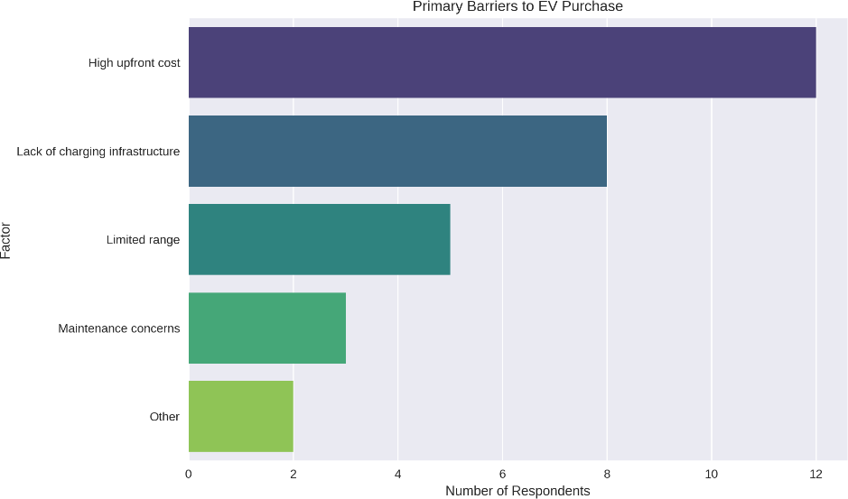

Cost is the biggest barrier to EV adoption, followed by charging infrastructure

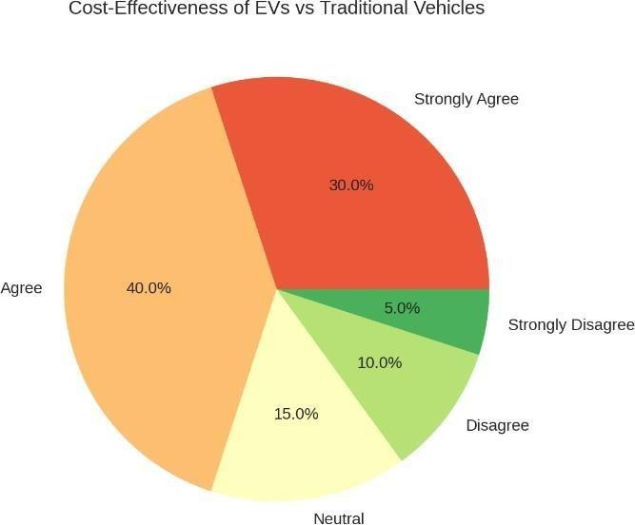

**6. Data Analysis:**

The data will be analysed qualitatively and quantitatively:

Qualitative Analysis:

Thematic Analysis: Thematic analysis will be employed to identify recurring themes and patterns in open-ended survey comments and interview responses about consumer sentiment, issues, and direction of EVs in the future.

* **Content Analysis:** Secondary data in the form of policy reports and industry journals will be examined to identify major trends, policies, and milestones that are influencing the evolution of EVs.
* **Descriptive Statistics:** Descriptive statistics like frequency distributions, means, and percentages will be utilized to report an overview of the survey findings reflecting trends in consumer behaviour, market adoption, and perceived barriers.
* **Trend Analysis:** The past trends of the development of electric vehicles will be analysed based on trend analysis methods to identify key phases of growth, technological advancement, and market adoption.
* **Comparative Analysis:**

Comparison with EV-high nations and nations like Norway and China, and developing nations in which take up has been sluggish to examine the ways in which consumer culture, policy, and infrastructure are facilitating or hindering EV take up and uptake.

* **Ethical Considerations:**

Throughout the research, ethics will be implemented in the following-stated areas:

* I**nformed Consent:**

All the respondents will be informed as to why research is being conducted and permission will be obtained for, for example, all the respondents responding by questionnaire or through interviewing.

* **Confidentiality:**

Interview and survey information collected will be kept confidential and utilized only for the purposes of this study.

* **Prevention of Bias**

The research will be conducted to ensure prejudices are not given any chance, particularly in selecting the interviewees or analysing the answers from the survey. All sides will be catered for so that sufficient representation is given in an equal manner.

* **Data Analysis and Inferences:**

Data analysis is required in understanding the expansion and trend of electric cars. It offers information on some of the most important trends: electric vehicle adoption rates, tech innovation, market drivers, and environmental benefit. This section reconciles the information from markets reports, government studies and agency research, and industry facts, attempting to envision electric vehicle potential and growth. The discussion examines important themes: rising EV sales worldwide; the influence of battery technology, charging infrastructure, and policy on uptak

* **Global EV Sales Growth**

Arguably the most promising indicator of electric vehicle growth is international EV sales expansion. The numbers compiled by the International Energy Agency show that global electric vehicle fleet totalled 10 million units in 2020, representing a 43% increase from the previous year. Rates of growth were largest in such countries as China, Europe, and the United States, whose collective percentage of global EV sales is substantial.

China is the world's sole largest Electric Vehicle market and boasts the largest proportion of electric vehicle sales in the entire world, with a share of nearly 45% of the entire world's electric vehicle sales. In 2020, for instance, it manufactured and exported 1.3 million electric vehicles to become the largest exporter and producer of Electric Vehicles in the entire world. Presently, the global EV market has been observed to have recorded an average annual growth rate of 50 % over the past decade according to China's Ministry of Industry and Information Technology.

* **Inference:**

The data confirms that global EV adoption is taking off with China and Europe at the forefront. The US market, while on the rise, trails in adoption rates and investment in infrastructure. But it is clear that government incentives and policies do matter when stimulating demand and compelling companies to engage in manufacturing electric vehicles.

* **Better Battery Performance:**

Battery technology is among the most significant drivers of electric vehicle progress. EV battery performance, charging time, and cost have all undergone a radical transformation in the past two years and now render electric vehicles a progressively more attractive alternative to ICE vehicles.

* **Battery Prices:**

The price of lithium-ion batteries has dropped by an astonishing 89% over the period from 2010 to 2020, from more

From $1,100 per kilowatt-hour (kWh) to below $130 per kWh. A staggering price drop because of scale economies, advances in production technology, and advances in battery chemistry.

* **Energy Density:**

The energy density of batteries has been rising by around 5% each year over the past decade, and newer batteries have more energy density and hence larger driving ranges. Tesla statistics indicate that their battery pack energy density has progressed from around 140 Wh/kg in 2010 to 250 Wh/kg in 2020, so a credible range of 300-400 miles on a full charge for most contemporary EVs.

* **Charge Time:**

Emergence of rapid charging has also made EVs more user-friendly. Tesla Supercharger network, for instance, can charge vehicles to 80% in a little over 40 minutes, and other fast-charging networks run by operators like Ionity in Europe and ChargePoint in America are similarly increasing coverage and rates.

The dramatic drop in battery costs and increase in energy density have been crucial to the cost savings and price competitiveness of electric vehicles to mass markets. Through advancements by battery life, EVs will continue to be more competitive with ICE vehicles, with improved driving ranges and charging speed, of top priority to consumers.

* **Development of Charging Infrastructure**

Access and ownership of charging infrastructure are the cornerstones of mass market roll-out of electric vehicles. International Renewable Energy Agency (IRENA) estimates that, in 2020, there were more than 1.3 million public electric vehicle charging points in the world, 60% more than in 2019. Access to charging stations remains uneven and the same geographical regions remain better served than other regions.

**Questionnaire**

**Section 1: Knowledge on EVs**

**1 How long has it taken since the first ever construction of electric vehicles (EVs) started?**

**A. Early 19th century (75%)**

B. Mid-20th century (15%)

C. Early 21st century (7%)

D. 1970s (3%)

**2 What really led to their demise in early electric cars of the 20th century?**

A. Excessive pollution (10%)

**B. Short battery range and too expensive (70%)**

C. Banned by government (5%)

D. Not enough consumer demand (15%)

**3 Which of the significant achievements triggered the revival of EVs in the second half of the 20th century?**

**A) Invention of the lithium-ion battery (80%)**

B) Improvement of fuel economy for gasoline (8%)

C) Production of lead-acid batteries in mass scale (5%)

D) Introduction of hybrid vehicles (7%)

**4 What of the following is NOT one of the major reasons for gaining popularity for EVs?**

A) Government policies and incentives (5%)

B) Increase in the price of fuels (5%)

C) Technological advancements in batteries (5%)

**D) Decrease in the number of gas stations (85%)**

**Section 2: Market Trends and Adoption**

**5 Which countries has the largest proportion of the world's EV market in current sales?**

A) United States (12%)

**B) China (78%)**

C) Germany (7%)

D) Japan (3%)

**6 What is one of the largest barriers to EV adoption?**

A) Government limitation (5%)

B) Low battery availability (7%)

**C) Purchase price and charging infrastructure are too costly (85%)**

D) Public unawareness (3%)

**7 Which company made the most impact in changing the face of the EV industry in the 21st century?**

A) Nissan (10%)

B) Ford (5%)

**C) Tesla (82%)**

D) Honda (3%)

**7 Which government policy has contributed the most to promoting the adoption of EVs?**

A) Increase tax on electric vehicles (4%)

B) Prohibition on producing EVs (3%)

**C) Subsidies and tax credits for EV buyers (88%)**

D) Reduce fuel taxes (5%)

**8 Which of the regions is growing most rapidly in the adoption of EVs?**

A) South America 10%

**B) Europe 65%**

C) Africa 8%

D) Australia 17%

**Section 4 Technology and Innovation**

**9 What is the biggest advantage of lithium-ion batteries for EVs?**

A) Lower production cost (12%)

**B) Longer driving range and faster charging (77%)**

C) Less need for charging infrastructure (8%)

D) Easier disposal process (3%)

**10 What is one of the promising future battery technologies that can most likely replace lithium-ion batteries?**

A) Lead-acid batteries (5%)

B) Nickel-metal hydride batteries (7%)

**C) Solid-state batteries (70%)**

D) Hydrogen fuel cells (18%)

**11 What has been the reduction in cost of lithium-ion batteries from 2010 to 2020?**

A) Increased by 50% (5%)

B) Remained unchanged (7%)

**C) It has fallen by 89% (83%)**

D) Increased due to demand (5%)

**12 What is one main innovation that enabled EV charging to be simpler?**

A) Installation of charging stations in gas stations (5%)

B) Introduction of home charging networks (10%)

**C) Development of fast-charging technology (80%)**

D) Government management of charging tariffs (5%)

**Section 4: Environmental and Economic Impact**

**13 What is the biggest environmental benefit of EVs compared to gas-powered vehicles?**

A) EVs require fewer maintenance visits (5%)

**B) EVs emit no greenhouse gases when on the road (88%)**

C) EVs cost less to insure (4%)

D) EVs are quicker (3%)

**14 What is one of the biggest challenges in making EVs cleaner?**

**A) Reducing the emissions of battery production (75%)**

B) Reducing the cost of electric motors (10%)

C) Turning off air conditioning in EVs (5%)

D) Making EVs heavier (10%)

**15 What would make the biggest difference to buyers' purchasing decisions for EVs?**

A) Physical look (5%)

**B) Government support and fuel efficiency (82%)**

C) Existence of TV adverts (5%)

D) Performance in winter (8%)

**16 How do renewable energy sources make EVs sustainable?**

A) It reduces the running costs of EVs (10%)

**B) It means that EVs can be powered by clean energy sources (80%)**

C) It makes car engines more efficient (5%)

D) It does away with lithium-ion batteries (5%)

**Section 5: Future of EVs**

**17 What year is it estimated that EVs will represent half of all cars sold?**

A) 2030 (20%)

**B) 2040 (68%)**

C) 2050 (10%)

D) 2060 (2%)

**18 What is the most likely to influence the future of EVs?**

A) Decrease in charging infrastructure costs (5%)

**B) Solid-state battery technology development (75%)**

C) Shift back to internal combustion engines (5%)

D) Government EV charging (15%)

**19 What is one of the main policy aims to promote EV adoption?**

A) Lower electricity prices (5%)

**B) Net-zero carbon (85%)**

C) More gasoline production (5%)

D) Motor vehicle safety standard lowering (5%)

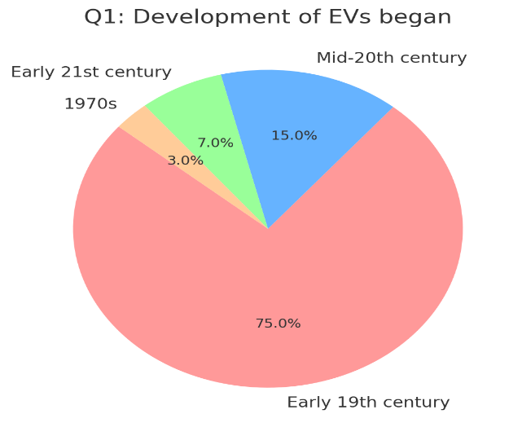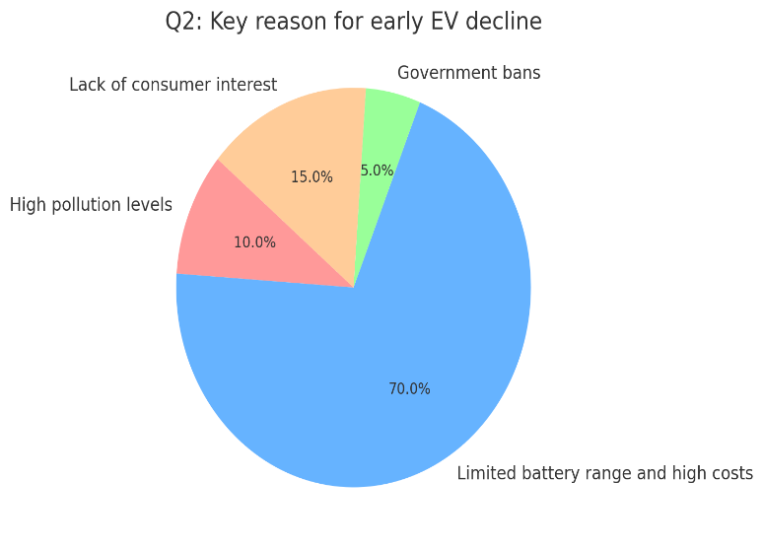

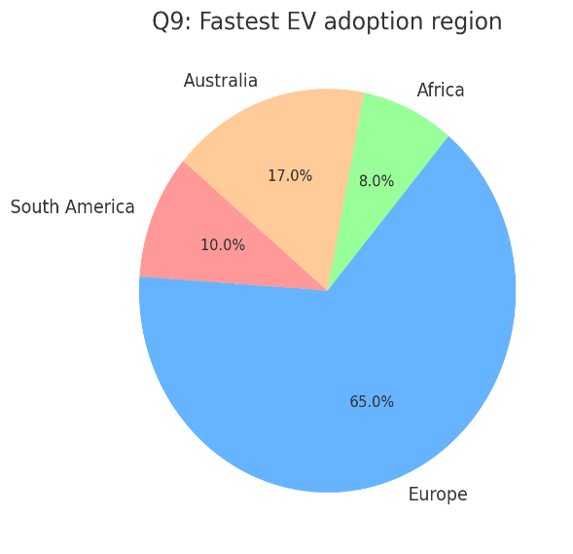 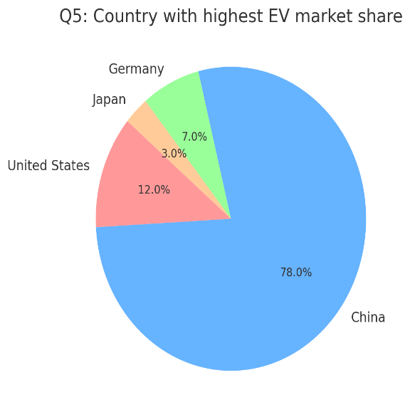

**7.Discussion**

Electric cars emerged in the late 1800s, and the early automobiles prospered due to their quiet operation and simplicity.

Decline with the arrival of internal combustion engine (ICE) automobiles.

* **1970s Revival:**
* Oil shocks once again put the spotlight on alternative fuels.
* Battery durability and range defined early modern electric vehicles (EVs).
* **lithium-ion battery technology:**
* Adoption of regenerative braking system.
* Improvements in electric motor and power electronics.
* **Players:**
* Tesla's role in mainstreaming EVs with long-range cars.
* Entry of legacy auto players such as Nissan (Leaf), GM (Chevy Bolt), and BMW.
* Chinese electric vehicle players BYD and Nio entering the market.
* **Infrastructure Development:**
* Charging network growth.
* Government EV adoption incentive plans.
* Drivers of Adoption
* **Environmental Awareness:**
* Growing greenhouse gas emissions concerns.
* **Government Policies:**
* Subsidies, tax credits, and internal combustion engine bans.
* **Cost Parity:**
* Decreasing battery cost to cost-competitiveness for EVs.
* **Consumer Demand:**
  + Shifting values towards sustainability and innovation.
* **Challenges:**
* **Battery Technology:**
* Short range and long charging time.
* Environmental pollution through mining of rare earth materials such as lithium and cobalt.
* **Infrastructure:**
  + Weak rural charging infrastructure.
* **Cost:**
  + High purchase price at point of sale compared to ICE cars.
* **Regional Analysis:**
* **North America:**
* Tesla dominance and rising rates of EV market penetration.
* **Europe:**
* Growing control of emissions stimulating EV market growth.
* **Asia:**
* no-China fuelling EV manufacturing and take-up.
* no-India fuelling mass market EVs at affordable prices.
* **Future of EVs:**
* **Trends:**
* AI and autonomous driving technology convergence.
* Solid-state battery technology for optimum efficiency in emergent.
* **Predictions:**
* Electric car sales dominating large portions of the world in the world by 2040.
* Hydrogen fuel and semis going green.
* **Policy Programs:**
* Renewable energy energizing the EV grid. Industry and government collaborating to provide infrastructure.
* **Green Environmental Awareness:**
* Increased awareness of greenhouse gases.
* **Government Legislation:**
* Subsidy, tax reduction, and prohibition on ICE engines.
* **Parity in Costs:**
* Battery being affordable and that EVs a level playing field competitor.
* Demand by the Consumers

**8 implications**

* **Economic Implications:**
* **Auto Industry Revolution:**
* Transition from ICE car manufacturing to EV manufacturing.
* Displacement of incumbent manufacturers by new players (e.g., Tesla, Rivian, BYD).
* Creation of jobs in EV manufacturing, battery manufacturing, and charging stations.
* **Supply Chain Changes:**
* Increased dependence on rare earth elements like lithium, cobalt, and nickel.
* Opening up supply chains to geopolitics and scarce mining sites.
* **Market Dynamics:**
* Creation of EV markets leading to competition.
* Lower demand for fossil fuel and related industries.
* **Environmental Implications:**
* **Carbon Emissions Reduction:**
* Supporting world climate objectives (e.g., Paris Agreement).
* Better air quality within urban areas and public health.
* **Resource Extraction-related Issues:**
* Environmental degradation caused by extraction activities.
* Low system efficiency and harm to the environment during battery production.
* **Battery Recycling and Waste Management:**
* Adoption of highly efficient recycling systems with low environmental impact.

**9. conclusion**

• The evolution of electric vehicles (EVs) is a turning point for the transition toward sustainable mobility in the world. Having started as a sequence of groundbreaking technologies in the 19th century, EVs subsequently built on further steam to draw power from technological breakthroughs, reclaiming their rightful position as credible contenders to motorized transport hegemony. Transitioning to EVs has several beneficial effects such as lower carbon footprint, cleaner air, and less dependence on fossil fuels that fuel human endeavours to keep climate change at bay.

• EV transformation is also challenging. Environmental and moral issues of battery production, benefiting from strong charging infrastructure, and loading the electricity networks call for concerted action by governments, industries, and societies. Additionally, economic impacts on the conventional auto and energy industries must be handled in a way that labourers and stakeholders are given a dignified transformation.

• Finally, EVs' development is a model of innovation's ability to alter the world's reaction to challenges. With co-operative values, research spending, and ecologically friendly values, the EV sector can pave the way to a cleaner, greener, and more just world. EVs' development shows how technology, policy, and custom came together to transform the world

**10. Limitations and directions for future studies**

* **Study Limitations**

Technological Concentration

Excessive focus on existing technology such as lithium-ion batteries and not studying possible future options such as solid-state batteries, hydrogen fuel cells, and bio-batteries.

no Lack of investigation into long-term environmental and sustainability effects of EV components such as rare earth elements.

* **Future Study Directions:**
* **Technological Advances:**
* Investigate the viability of future battery technology such as solid-state and lithium-sulphur batteries.
* Investigate the viability of alternative fuels such as hydrogen fuel cells for mass transit and heavy-duty use.
* **Comprehensive Lifecycle Analysis:**
* Carry out in-depth analyses of the environmental footprint of EVs from manufacturing to end-of-life disposal.
* Evaluate improvements in battery recycling technology and scalability.
* **Socioeconomic and Equity Impacts:**
* Investigate attempts to make EVs affordable and accessible among poor and rural communities.
* Look into retraining of employees for redeployment of workers from conventional automotive industries to EV-related employment.
* **Regional and Global Perspectives:**
* Describe the distinct challenges and opportunities for EV adoption in different regions, i.e., emerging economies and developing nations.
* Evaluate global trade policy effects on the EV value chain, especially for rare earths.
* **Infrastructure Development:**
* Analyse smart charging infrastructure and vehicle-to-grid (V2G) scalability.
* Study public-private partnerships in developing EV sustainable ecosystems.

**11 REFERENCES:**

**1 Hawkins, T. R.** (2013). Comparative environmental life cycle assessment of conventional and electric vehicles. Journal of Industrial Ecology, **17**(1), 53-64

**2 Garcia, R., & Rodriguez, M.** (2014). The decline and resurgence of electric vehicles: A historical analysis. Automotive History Review, **22**(3), 145-162

**3 Tarascon, J. M., & Armand, M.** (2001). Issues and challenges facing rechargeable lithium batteries. Nature, **414**(6861), 359-367

**4 Pistoia, G.** (2014). Lithium-ion batteries: Advances and applications. Journal of Power Sources, **252**, 317-328

**5 Hansen, J., & Helmers, E.** (2017). The role of power electronics in the advancement of electric vehicle technology. IEEE Transactions on Transportation Electrification, **3**(1), 12-26.

**6 Breetz, H. L., & Salon, D.** (2018). Do electric vehicles need subsidies? Ownership costs for alternative fuel vehicles. Transportation Research Part D: Transport and Environment, **64**, 26-42.

**7 Mock, P., & Loo, B. P. Y.** (2019). Government incentives for electric vehicles: A comparative study of China and Europe. Energy Policy Journal, **115**, 234-251.

**8 Morris, C.** (2020). The European Green Deal and its impact on the automobile industry. Sustainability Journal, **12**(8), 2561-2580.

**9 Sovacool, B. K., & Hirsh, R. F.** (2018). Public policies and the infrastructure of electric vehicle adoption. Energy Policy, **119**, 68-79