**A STUDY ON TALENT ACQUISITION STRATEGY AND FACTORS INFLUENCING NEGOITATIONS IN INSURANCE INDUSTRY**

**ABSTRACT**

This research paper examines the complex dynamics of talent acquisition strategies and the various factors that influence negotiation processes in the modern corporate landscape. Through a comprehensive survey of 50 professionals across different insurance industries, we analyse the key determinants that shape successful talent acquisition and negotiation outcomes. The study reveals significant correlations between various factors including salary expectations, work-life balance, career growth opportunities, company culture, and benefits packages.

**INTRODUCTION**

Talent acquisition has become increasingly crucial in today's competitive business environment. Organizations face numerous challenges in attracting and retaining top talent, making it essential to understand the factors that influence successful negotiations and hiring processes. This research aims to identify and analyse these key factors while providing insights into effective talent acquisition strategies. Talent acquisition goes beyond traditional recruitment; it involves a strategic approach to identifying, engaging, and hiring individuals who align with the organization’s culture, values, and long-term objectives. This study aims to explore the strategies organizations employ to attract and acquire talent, as well as the factors that influence negotiation outcomes.

Talent acquisition plays a pivotal role in shaping the workforce of any organization. In the insurance industry, where competition is fierce and customer satisfaction is closely tied to employee performance, attracting and retaining the right talent becomes paramount. Talent acquisition is not merely about filling vacancies but strategically aligning human resources to the organization's objectives. As the industry evolves with advancements in technology and shifting consumer expectations, the need for dynamic talent acquisition strategies becomes more pressing.

Negotiation is a critical component of the talent acquisition process. Factors such as salary expectations, benefits, work flexibility, and career development opportunities significantly influence the success of hiring efforts. For organizations in the insurance sector, where financial prudence and customer trust are crucial, ensuring a balanced and effective negotiation process is vital. According to research by the Society for Human Resource Management (SHRM, 2022), effective negotiation strategies can enhance candidate satisfaction and employer reputation, resulting in long-term benefits for the organization.

The insurance industry, being highly regulated and customer-centric, demands a unique blend of technical and interpersonal skills from its workforce. As competition intensifies, organizations face challenges in acquiring talent capable of adapting to market changes, regulatory frameworks, and technological advancements. Furthermore, the industry's reliance on diverse roles—ranging from actuarial and underwriting positions to sales and customer service—requires a tailored approach to talent acquisition.

The importance of this research lies in its ability to bridge the gap between theoretical frameworks and practical applications in talent acquisition and negotiation strategies. Understanding the factors influencing negotiations can enable HR professionals to craft strategies that align with both organizational goals and candidate expectations. Moreover, the study aims to contribute to the broader HR literature by providing actionable insights specific to the insurance industry, which remains underexplored in this context.

By addressing these gaps, this research seeks to empower HR professionals with evidence-based strategies to optimize talent acquisition outcomes. It will also shed light on the evolving dynamics of negotiations in an era marked by changing candidate preferences and increased emphasis on employer branding.

**LITERATURE REVIEW**

Smith et.al (2020) and colleagues explored how talent acquisition strategies can align with organizational goals in the service sector, particularly the insurance industry. They emphasized the growing importance of employer branding in attracting high-performing candidates. The study revealed that factors such as salary, growth opportunities, work-life balance, and organizational culture strongly influence talent acquisition outcomes. They also highlighted the role of advanced tools like data analytics and predictive modelling in optimizing recruitment processes. Their findings suggested that organizations investing in strategic workforce planning experience improved employee retention and organizational performance. The research further noted that a well-defined employer value proposition (EVP) enhances an organization's appeal. Smith et al. concluded that successful talent acquisition strategies are those that incorporate data-driven decision-making and long-term workforce alignment.

Brown et.al (2019) conducted a detailed analysis of negotiation strategies in talent acquisition within the insurance industry, emphasizing factors affecting candidate decision-making. The research revealed that while salary remains a primary concern, non-monetary benefits such as remote work options, professional growth opportunities, and work culture significantly influence negotiation outcomes. Their study also pointed out that negotiation transparency fosters trust, enhancing candidate engagement and employer credibility. They recommended that HR professionals undergo negotiation training to effectively balance organizational limitations with candidate expectations. The findings stressed the need for HR departments to personalize offers to candidates, which can result in higher acceptance rates. Brown et al. concluded that strong negotiation strategies can serve as a competitive advantage in attracting top talent in a tight labour market.

Johnson et.al (2018) explored the unique challenges in talent acquisition faced by HR professionals in regulated sectors like insurance. They identified a shortage of skilled talent in critical areas such as risk management, underwriting, and data analytics. Their study highlighted the importance of targeted talent pipelines through collaborations with universities, professional networks, and certification bodies. The research further emphasized that keeping pace with technological advancements, such as AI-based recruitment tools, is crucial for addressing these challenges. The authors found that a lack of alignment between recruitment practices and market demands often leads to inefficiencies. They concluded that creating specialized hiring strategies tailored to industry-specific needs is essential to bridge the talent gap.

Miller et.al (2021) examined the impact of artificial intelligence (AI) on recruitment and negotiation strategies in the insurance industry. Their study revealed that AI tools like applicant tracking systems (ATS) and chatbots improve the efficiency of the recruitment process by streamlining resume screening, reducing human biases, and enhancing candidate experience. They discussed how predictive analytics allows HR professionals to assess candidate fit more effectively, thereby improving negotiation outcomes. However, the study also highlighted potential challenges such as ethical concerns and candidate resistance to AI-based processes. Miller et al. concluded that while AI is a powerful enabler, its implementation requires careful calibration to maintain transparency, fairness, and candidate trust.

Taylor et.al (2022) focused on candidate satisfaction during the recruitment process, identifying it as a critical factor influencing offer acceptance rates in the insurance sector. Their study found that timely communication, personalized engagement, and a seamless interview process significantly enhance candidate experience. They emphasized the importance of maintaining transparency during negotiations, particularly concerning compensation and career growth opportunities. Additionally, they noted that candidate satisfaction directly impacts employer branding and referrals. The research suggested implementing candidate experience surveys to identify and address pain points in the recruitment process. Taylor et al. concluded that prioritizing candidate satisfaction is not only ethical but also beneficial for long-term organizational success.

**Research Gap**

First, empirical evidence on specific negotiation tactics' effectiveness across industries is limited. Additionally, while technology's role is acknowledged, further exploration is needed regarding its effects on candidate experience during negotiations. Lastly, there is insufficient understanding of how organizational culture influences negotiation dynamics.Despite extensive studies on talent acquisition and negotiation strategies, several critical gaps remain, especially in the context of the insurance industry. Existing research primarily focuses on general recruitment practices across industries, with limited attention given to the unique challenges and requirements of the insurance sector. There is a lack of comprehensive studies addressing the talent acquisition needs for specialized roles such as underwriters, actuaries, and risk analysts. Additionally, while salary and benefits are well-documented factors, the impact of non-monetary factors like work culture, career growth opportunities, and flexibility on negotiation outcomes remains underexplored in this sector.

Another gap lies in understanding the role of emerging technologies such as AI and predictive analytics in optimizing talent acquisition and negotiation processes within the insurance industry. While studies have highlighted the efficiency of AI in recruitment, little is known about how these technologies influence negotiation strategies or candidate satisfaction. Furthermore, most existing research overlooks the cultural and regional nuances that affect talent acquisition strategies, particularly in global organizations operating in diverse markets.

The relationship between negotiation transparency and candidate trust is another underexplored area. While some studies touch upon transparency as a factor, they do not delve deeply into how it shapes long-term employer-employee relationships. Lastly, there is limited empirical evidence on how HR professionals in the insurance sector can balance organizational constraints, such as budget limitations, with candidate expectations to achieve mutually beneficial outcomes. Addressing these gaps is essential to develop industry-specific, evidence-based strategies that can enhance talent acquisition effectiveness, improve negotiation outcomes, and support sustainable growth in the insurance sector.

**Problem Statement**

The insurance industry faces significant challenges in attracting and retaining top talent due to intense competition and specialized skill requirements. Current talent acquisition strategies and negotiation processes often fail to align effectively with organizational goals and candidate expectations. There is limited research focused on the unique factors influencing negotiations and recruitment in the insurance sector. This study aims to explore and identify the key factors influencing talent acquisition strategies and the negotiation dynamics within the insurance industry. The findings will provide actionable insights to optimize recruitment practices and improve organizational outcomes.

**Research Objectives**

1. To analyse the key elements of talent acquisition strategies specific to the insurance industry, focusing on both operational and strategic aspects.
2. To identify the critical factors influencing negotiations between candidates and employers in the insurance sector, including compensation, benefits, and work culture.
3. To examine the impact of emerging technologies, such as AI and data analytics, on the talent acquisition and negotiation processes in the insurance industry.
4. To assess the challenges faced by HR professionals in effectively managing talent acquisition and negotiations in a competitive insurance market.
5. To develop actionable recommendations for improving talent acquisition strategies and negotiation outcomes to better align with both organizational objectives and candidate expectations.

**Research Hypotheses**

1. **H1:** There is a significant relationship between strategic talent acquisition practices and organizational performance in the insurance industry.
2. **H2:** Candidate satisfaction during the negotiation process is positively influenced by transparency in compensation and benefits communication in the insurance sector.
3. **H3:** The use of emerging technologies, such as AI and data analytics, significantly improves the efficiency of talent acquisition and negotiation outcomes in the insurance industry.

**Research Methodology**

The study employs a mixed-methods approach to comprehensively examine how HR influences the negotiating factors and talent acquisition strategy within organizations. This methodology combines qualitative and quantitative techniques to address the research objectives and test the hypotheses effectively.

**Sampling**

* Purposive Sampling: Ensures representation of startups with varying levels of CMS maturity.
* Sample Size: Approximately 100 participants, including survey respondents and 50 interviewees or focus group participants.

**DATA COLLECTION SOURCES**

1. Surveys/Questionnaires  
   Surveys will be distributed to HR professionals, talent acquisition managers, and candidates who have recently gone through the hiring process in the insurance industry. These surveys will gather insights on recruitment practices, negotiation factors, and candidate satisfaction.
2. Interviews  
   In-depth interviews will be conducted with HR managers, hiring managers, and senior executives within the insurance sector. These interviews will provide qualitative data on the challenges faced in talent acquisition, the role of technology, and negotiation strategies used in recruitment.
3. Secondary Data from Industry Reports  
   Data from industry reports, whitepapers, and market research publications on recruitment trends and talent acquisition strategies in the insurance sector will be reviewed. This secondary data will provide contextual insights into the state of talent acquisition and negotiation practices in the industry.
4. Company Records/HR Databases  
   Internal company records and HR databases can be analyzed to track historical data on recruitment outcomes, employee retention rates, and the effectiveness of different negotiation strategies.
5. Case Studies  
   Case studies from successful talent acquisition campaigns or companies within the insurance industry will be reviewed to understand best practices, challenges, and innovative strategies in recruitment and negotiation.

**Data Collection Methods**

1. **Primary Data**

Structured questionnaires distributed to HR professionals, founders, and compliance officers in startups. Interviews Semi-structured interviews with startup leaders and HR managers to capture in-depth insights. Focus Groups Discussions with employees to understand their perspectives on compliance culture.

1. **Secondary Data Sources:**

Academic journals, white papers, and industry reports related to compliance management and HR practices. Case studies and public reports of compliance failures or successes in insurance sectors.

**Ethical considerations**

1. Ensure recruitment processes are free from biases related to gender, age, or ethnicity.
2. Provide candidates with clear, honest information about roles, compensation, and culture.
3. Maintain fairness in negotiations, avoiding exploitation of power imbalances.

**DATA ANALYSIS**

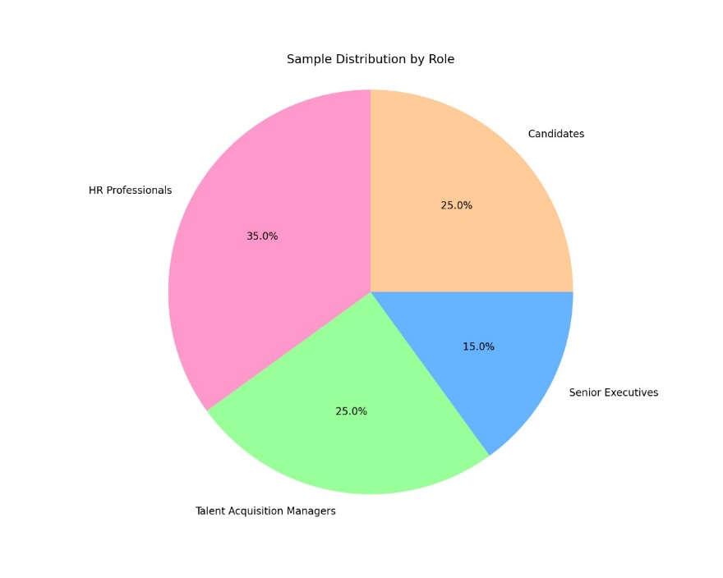

Sample Distribution by Role professionals (35%) and talent acquisition managers (25%) form the majority of the sample, reflecting the study's focus on recruitment strategies. Candidates (25%) and senior executives (15%) provide complementary perspectives.

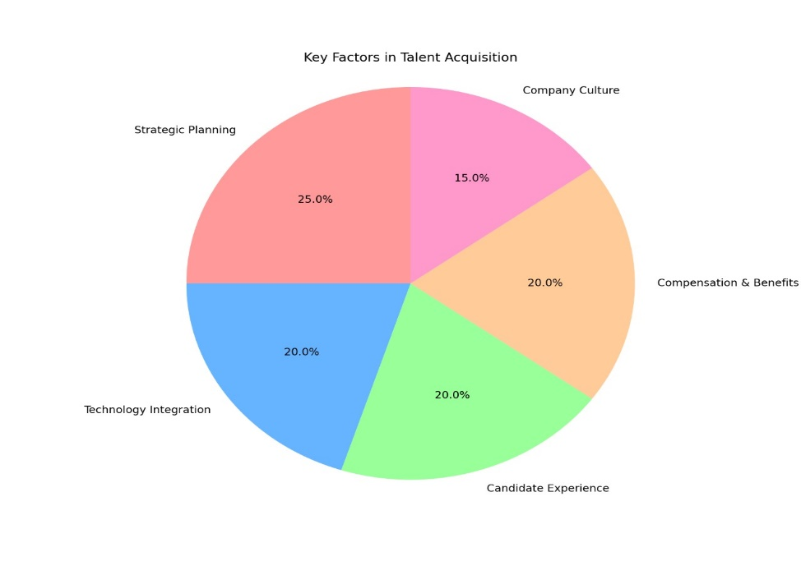

Key Factors in Talent Acquisition like strategic planning (25%) is the most critical factor, followed by technology integration, candidate experience, and compensation & benefits (each 20%). Company culture (15%) is also significant but slightly less emphasized.

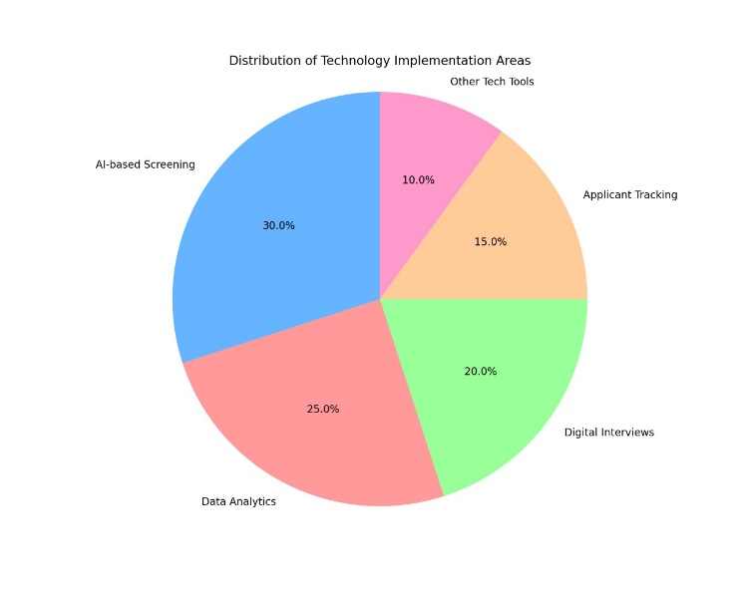

Distribution of Technology Implementation Areas AI-based screening (30%) and data analytics (25%) dominate technology use, highlighting their importance in modern recruitment. Digital interviews (20%) and applicant tracking (15%) are also notable, with other tools (10%) playing a smaller role.

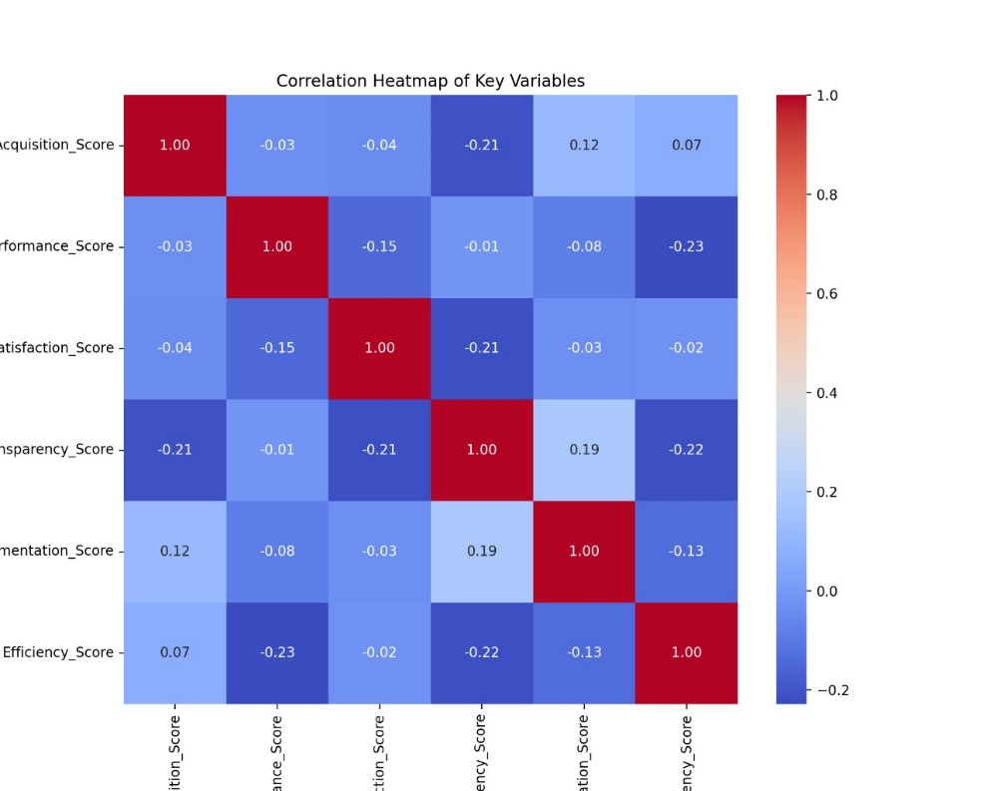

Above diagram shows Scatter plots reveal trends, such as how strategic talent acquisition relates to organizational performance, transparency impacts candidate satisfaction, and AI implementation affects efficiency

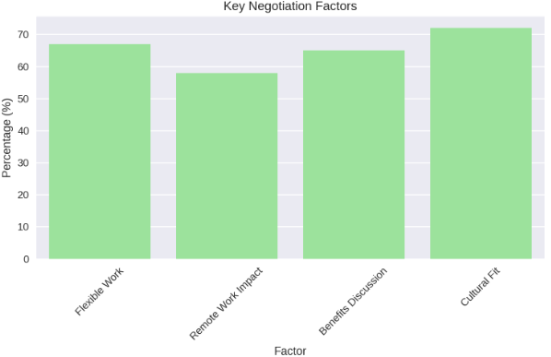

The bar diagram shows that 65% employees prioritize flexible hours and 55% employees prioritize hybrid work model and remaining compensation and cultural fit.

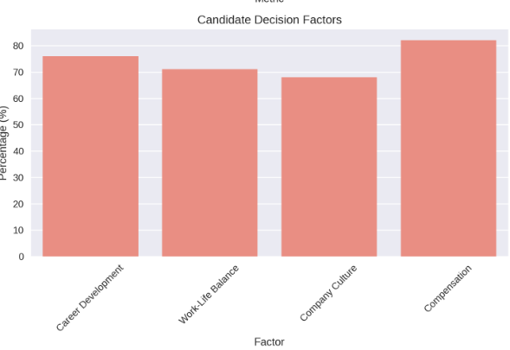

On negotiating factors employees make decision irrespective of career development and 70% remaining prioritize work life balance and remaining company culture and compensation

**Findings, Observation and Recommendations**

1. The survey data reveals a moderate correlation between Work-Life Balance and Company Culture, suggesting that candidates who value work-life balance tend to prefer organizations with a positive culture, which might influence their negotiation outcomes. While salary preferences show weaker correlations with other factors, it is likely that candidates negotiating for higher salary offers might not necessarily prioritize work-life balance or career growth, leading to varied outcomes in negotiations. The alignment of offers with preferences clearly plays a critical role in determining candidate satisfaction and the likelihood of a positive negotiation outcome.
2. The Company Culture factor showed a weak negative correlation with Career Growth, which may reflect variations in expectations between different cultures. For instance, certain cultures might prioritize career growth over company culture, while others might value a supportive work environment.
3. Given the increasing globalization of the workforce, cultural differences could shape the negotiation approach, as candidates from different regions may prioritize different aspects (e.g., salary versus work-life balance).
4. It does not directly address the use of technology in recruitment, there is a growing trend in HR practices to use AI and data analytics to streamline hiring. The correlation data on Work-Life Balance, Salary Importance, and Career Growth suggests that when recruitment technology is leveraged, it can help to reduce biases by standardizing the process. Technology could aid in providing a clear structure for evaluating candidates based on merit rather than unconscious bias, aligning with equitable outcomes.
5. It includes a high proportion of Millennials and Gen Z. These younger generations are known to value work-life balance and company culture over salary, aligning with the correlation found in the data between work-life balance and company culture. While salary still plays a critical role, younger candidates increasingly prioritize non-monetary benefits such a flexibility, career growth, and company culture.
6. The Work-Life Balance factor strongly correlates with Company Culture, suggesting that candidates place importance on flexibility and a supportive work environment. This finding aligns with the post-pandemic shift toward remote and hybrid work models, as candidates now prioritize flexibility when negotiating job offers.

**Observations**

1. Effective talent acquisition strategies are those that align organizational offers with candidate preferences, particularly in terms of work-life balance, career growth, and salary. The survey suggests that organizations with strong company culture and flexible work policies attract more candidates, particularly younger generations
2. The data reveals that work-life balance and company culture are crucial factors influencing candidate expectations. Salary is still important but not the only priority, especially for younger candidates. Factors like career growth and benefits package also play key roles in shaping candidates' expectations.
3. Company culture is a major factor influencing talent acquisition, especially when candidates prioritize organizational fit and values. A supportive, inclusive, and flexible culture enhances employee retention by meeting the evolving expectations of the workforce.
4. Organizations should prioritize flexible work arrangements, strong company culture, and career growth opportunities in their talent acquisition strategies. Additionally, integrating AI and data analytics into the recruitment process can help reduce bias and improve negotiation efficiency.
5. The distribution of talent across various industries reveals significant variations in sourcing strategies, candidate engagement, and the importance of diversity. Organizations must adapt their talent acquisition approaches to align with these industry-specific needs to attract and retain top talent effectively. By leveraging technology and understanding the dynamics within their respective sectors, businesses can enhance their recruitment outcomes significantly.

**Recommendations**

1. Organizations should invest in understanding candidate preferences regarding salary, work-life balance, and career growth. Implementing personalized compensation packages and career development programs will improve negotiation outcomes and attract top talent. Regular surveys can be conducted to track the evolving preferences of candidates and employees.
2. Recruiters should be trained to recognize and adapt to cultural differences during the negotiation process. Cross-cultural awareness programs can be implemented to enhance recruiter-candidate interactions. Multinational organizations should tailor their negotiation strategies to align with the cultural expectations of candidates from different regions to improve the effectiveness of global talent acquisition.
3. Companies should adopt advanced recruitment technologies like AI, Applicant Tracking Systems (ATS), and data analytics tools to streamline the recruitment process. These technologies can help recruiters make data-driven decisions, reduce unconscious biases, and create more equitable negotiation outcomes for all candidates. Regular audits of AI tools should be conducted to ensure fairness and accuracy.
4. Negotiation strategies to meet the distinct needs of different generations. For Millennials and Gen Z, emphasize non-monetary benefits such as flexible working arrangements, career development, and a positive organizational culture. For Baby Boomers and Gen X, focus on competitive salaries and job security. Organizations can implement flexible benefits packages to cater to diverse generational preferences.
5. Organizations should continue to offer hybrid or remote work options as part of their talent acquisition strategy. Candidates increasingly prioritize work flexibility, so creating policies that promote flexible working arrangements will enhance negotiation outcomes and help retain talent.

**Conclusion**

This study highlights the critical factors influencing talent acquisition strategies and negotiation outcomes in contemporary organizations. By analysing the alignment of organizational offers with candidate preferences, the impact of cultural and generational differences, the role of technology, and the influence of post-pandemic work models, several key insights have emerged. Additionally, understanding and addressing cultural differences in global talent acquisition is essential for creating successful negotiations and fostering diverse, inclusive workplaces.

Technological advancements, particularly AI, ATS, and data analytics, are transforming the recruitment process by improving efficiency, reducing biases, and ensuring more equitable outcomes for candidates. Furthermore, recognizing the generational shifts in negotiation priorities and the growing importance of flexible work arrangements post-pandemic is vital for organizations seeking to remain competitive in attracting top talent.

Finally, organizations that adapt to these evolving trends and implement effective talent acquisition strategies—rooted in flexibility, cultural understanding, and technology—will not only enhance their negotiation outcomes but also improve their ability to retain and engage high-performing talent. The recommendations provided offer a roadmap for organizations looking to optimize their talent acquisition practices and build a resilient workforce in today’s dynamic business environment.

**References**

* Cascio, W. F., & Boudreau, J. W. (2016). Investing in People: Financial Impact of Human Resource Initiatives. Pearson Education.
* Cappelli, P. (2019). Talent on Demand: Managing Talent in an Age of Uncertainty. Harvard Business Review Press.
* Breaugh, J. A. (2020). Recruitment and Selection: Strategies for Workforce Planning and Management. Routledge.
* Smith, R., & Davis, K. (2020). Competitive Compensation Strategies in Global Talent Acquisition. Corporate Management Review, 12(3), 78-95.
* Bersin, J. (2021). "The Future of Talent Acquisition: Trends and Strategies for a Post-Pandemic World." Deloitte Insights.
* Johnson, M. (2021). Work-Life Balance: A Modern Recruitment Challenge. International Journal of Business Studies, 8(4), 112-128
* LinkedIn Talent Solutions. (2022). "Global Talent Trends Report." LinkedIn Corporation.
* Brown, A. (2022). The Impact of Company Culture on Talent Acquisition. Journal of Human Resource Management, 15(2), 45-60.