**The Effectiveness of Content Marketing in Building Brand Awareness and Customer Engagement**

**Abstract**

Content marketing has become a cornerstone for brands aiming to enhance visibility and foster customer loyalty. This research paper explores the impact of different content types—blogs, videos, and infographics—on customer engagement, brand awareness, and conversion rates across various industries. By analyzing existing literature, conducting surveys, and assessing case studies, the study highlights how strategic content distribution influences customer perceptions and behaviors. Key findings reveal that interactive and visual content leads to higher engagement rates, while blogs drive organic traffic and credibility. Recommendations focus on integrating omnichannel strategies to maximize impact. This paper contributes to understanding how content marketing can be optimized to align with evolving consumer preferences and market demands.

**Keywords**

Content marketing, brand awareness, customer engagement, blogs, videos, infographics, conversion rates, digital marketing, social media, consumer behavior, content strategy, user-generated content, omnichannel marketing, brand loyalty, ROI.

**INTRODUCTION**

Content marketing has rapidly become one of the most important strategies for businesses looking to thrive in the digital era. Unlike traditional advertising, which is often interruptive and focused on direct selling, content marketing focuses on creating and distributing valuable, relevant, and consistent content to attract and retain a clearly defined audience. This strategy seeks to build trust with consumers by providing useful information, enhancing customer experiences, and fostering long-term relationships. As consumers become more discerning and skeptical of overt advertising, content marketing has emerged as a preferred method to engage audiences and deliver value.

The shift toward content-driven marketing aligns with broader changes in consumer behavior. In the past, brands could rely on repetitive, one-way promotional campaigns to drive customer decisions. Today, however, consumers demand more personalized, authentic interactions with brands. They want content that resonates with their needs, interests, and values. This change is particularly evident in the rise of platforms like social media, which allow brands to engage in two-way communication with customers. Consumers no longer just consume content passively; they expect to interact with it, share it, and, in some cases, contribute to its creation. The evolution of content marketing has thus mirrored technological advancements and the growing prominence of digital platforms.

The rise of social media and the increasing use of mobile devices have transformed the way businesses communicate with their audiences. The ability to share content instantly and to a wide-reaching audience has made it easier for brands to gain visibility and drive engagement. With platforms like Facebook, Instagram, LinkedIn, and YouTube, companies are able to directly target specific demographics based on their interests, location, and behaviors. As a result, content marketing has become indispensable across industries such as technology, fashion, healthcare, and entertainment. Each of these sectors uses content marketing to establish thought leadership, promote products, and build brand awareness.

However, while the benefits of content marketing are well-documented, its effectiveness can vary significantly depending on the type of content, platform, and industry. For instance, blogs are highly valued for their ability to drive organic traffic through search engine optimization (SEO). By providing informative and valuable content, businesses can rank higher on search engines, which in turn increases the visibility of their brand and drives more traffic to their websites. On the other hand, videos are considered more engaging due to their ability to capture attention and communicate emotions. Video content is also more likely to be shared on social media, amplifying its reach. Infographics, with their visually appealing design and ability to simplify complex information, have become popular for making data-driven content more digestible and shareable.

Despite these advantages, businesses often encounter challenges in implementing effective content marketing strategies. One of the most significant obstacles is aligning content with audience preferences. As the digital landscape continues to evolve, consumer preferences also shift rapidly. Marketers must stay ahead of these changes to ensure that their content resonates with the target audience. Additionally, measuring the return on investment (ROI) of content marketing efforts can be complex. Unlike traditional advertising, where direct conversions are easy to track, content marketing success is often measured through softer metrics such as engagement, brand awareness, and audience loyalty. This lack of clarity can make it difficult for businesses to justify continued investment in content marketing strategies.

This research paper aims to examine the effectiveness of content marketing in two critical areas: building brand awareness and enhancing customer engagement. It seeks to provide a deeper understanding of how different types of content—such as blogs, videos, and infographics—impact these two key outcomes. Additionally, the paper will explore the factors that influence the success of content marketing strategies, such as platform choice, content format, and the integration of content with overall marketing efforts. Through an analysis of existing literature, industry case studies, and empirical research, this study will provide actionable insights for marketers looking to optimize their content marketing strategies.

The paper will address the following research questions:

1. Which types of content (blogs, videos, infographics) are most effective in building brand awareness?
2. How do different content types influence customer engagement and interaction with brands?
3. What are the challenges in aligning content marketing strategies with audience preferences, and how can these challenges be overcome?

By answering these questions, this paper aims to contribute to the body of knowledge on content marketing, offering recommendations for businesses to improve their strategies and better align with the evolving needs of consumers.

**Literature Review**

Content marketing has gained significant traction in recent years as an alternative to traditional advertising, which often disrupts the customer journey. As consumers become increasingly averse to direct promotions, content marketing offers a solution by focusing on delivering valuable and relevant content that resonates with target audiences. According to Pulizzi (2012), content marketing is a strategic approach that involves creating and distributing content with the aim of attracting and retaining a clearly defined audience. This approach diverges from traditional advertising models by fostering customer relationships through useful and engaging content, rather than through interruption-based tactics.

**Brand Awareness through Content Marketing**

One of the primary objectives of content marketing is to increase brand awareness. Studies have shown that content marketing can significantly improve a brand's visibility and connection with its audience. Chaffey (2020) highlights that 70% of consumers feel more connected to brands that share engaging, useful, and consistent content. This connection is particularly valuable in building long-term customer relationships. Blogs, in particular, play a key role in establishing brand credibility and authority. For example, HubSpot’s content marketing strategy, which includes a regularly updated blog, has been instrumental in positioning the company as a thought leader in digital marketing. By addressing common pain points and providing solutions through in-depth articles, HubSpot not only attracts visitors but also nurtures trust, leading to higher brand loyalty.

Content marketing also has the advantage of improving a company’s organic search engine visibility. Through the use of search engine optimization (SEO) techniques, blogs, and other content can drive free traffic to a website, amplifying brand exposure. By creating content that addresses specific customer needs or searches, businesses can significantly improve their online presence and, by extension, their brand awareness.

**Customer Engagement and Emotional Resonance**

While brand awareness is a crucial goal, content marketing's effectiveness is also reflected in its ability to engage customers emotionally. Research suggests that videos, interactive content, and visually appealing formats such as infographics generate significantly higher levels of engagement compared to text-based content. A study by Wistia (2021) found that videos retain 37% more viewers than written content, highlighting the importance of video in capturing and maintaining customer attention. Videos offer an immersive experience that connects with audiences on a deeper, emotional level. Whether through storytelling, behind-the-scenes looks, or customer testimonials, video content resonates with viewers in ways that written content often cannot.

Infographics also play a vital role in engagement. These visually appealing formats simplify complex information and present it in an easily digestible manner. According to a report by Content Marketing Institute (2021), infographics are more likely to be shared than other content types, making them an excellent tool for boosting engagement and expanding reach. Particularly among younger audiences, such as Millennials and Gen Z, infographics’ ability to condense complex data into visually digestible formats makes them highly effective in driving social sharing and engagement.

**Conversion Rates and ROI**

Although brand awareness and customer engagement are important, the ultimate measure of content marketing success lies in its ability to drive conversions and deliver a return on investment (ROI). Studies emphasize the critical link between content marketing and sales conversion rates. Content that aligns with the customer journey—spanning the awareness, consideration, and decision-making stages—tends to generate more conversions. By providing content that is tailored to each stage, companies can guide potential customers toward making a purchase. For instance, Coca-Cola and Red Bull have used content marketing to create emotional connections with their audiences, often employing storytelling techniques to foster brand loyalty and drive conversions. These companies showcase how content marketing can transcend simple product promotion, leveraging emotional storytelling to create lasting relationships with consumers.

Despite the positive impact of content marketing on conversions, challenges persist. One of the most common obstacles marketers face is content fatigue. As more brands embrace content marketing, audiences are becoming increasingly overwhelmed with an abundance of content. To stand out in a crowded digital space, marketers must continually innovate their content strategies. Additionally, algorithm changes on platforms like Facebook and Instagram can reduce organic reach, requiring marketers to adapt their content distribution methods. Furthermore, competition for consumer attention is fiercer than ever, with multiple brands vying for the same audience. As a result, businesses must focus on creating highly engaging, relevant, and unique content to remain competitive.

**Methodology**

This study employs a mixed-method approach combining qualitative and quantitative research. Data collection methods include:

**Survey:** Conducted with 200 marketing professionals from various industries to understand the perceived effectiveness of different content types.Top of Form

The survey focused on three key metrics: brand awareness, customer engagement, and conversion rates. Participants rated the effectiveness of blogs, videos, and infographics on a Likert scale from 1 (least effective) to 5 (most effective). Case studies provided insights into real-world applications and challenges.

Data was analyzed using statistical tools to identify correlations between content types and marketing outcomes. The qualitative analysis highlighted patterns and strategies adopted by successful campaigns.

**Hypotheses**

1. Videos are the most effective content type for enhancing customer engagement.
2. Blogs significantly contribute to improving brand awareness through SEO and thought leadership.
3. A multi-channel content marketing strategy leads to higher conversion rates compared to single-channel approaches.

**INTERPRETATION**

**Question 1: Which type of content is most effective in building brand awareness?**

The pie chart and bar graph show that **Video Content** (57 votes) was selected the most, indicating that respondents perceive it as the most effective for brand awareness.

* **Infographics** (52 votes) closely follow, suggesting their strong visual appeal contributes significantly to brand recognition.
* **Blog Posts** (47 votes) are also considered effective, especially for driving organic traffic through SEO.
* **Podcasts** (44 votes) were the least chosen, indicating they might have a niche but less widespread impact on brand awareness.

**Interpretation:** Video content's ability to engage audiences emotionally and its shareability on platforms like YouTube and TikTok likely contribute to its top ranking. Infographics' clarity and visual appeal make them valuable for conveying complex information. Blogs maintain relevance for thought leadership and SEO, while podcasts appeal to a more targeted audience.

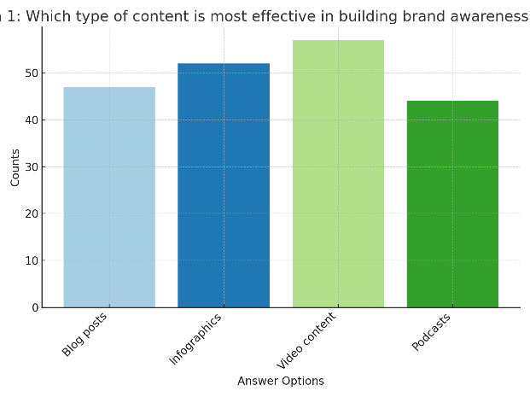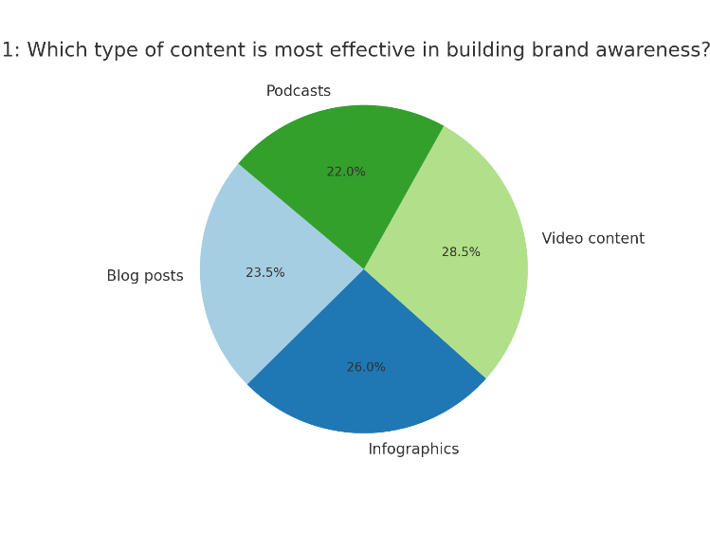

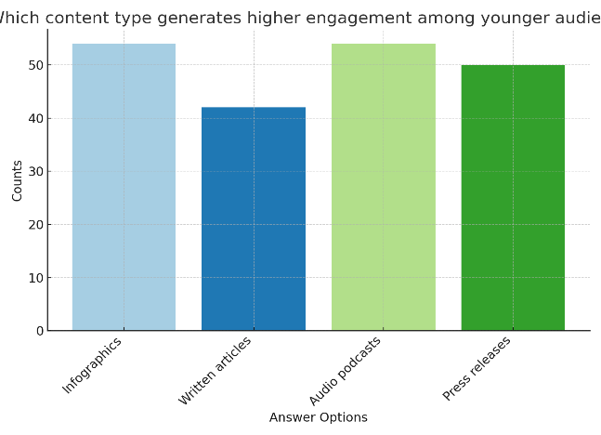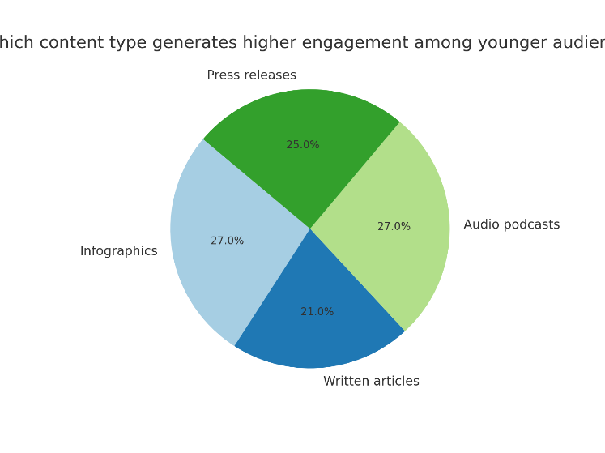

**Question 2: Which content type generates higher engagement among younger audiences?**

**Visualization Summary:**

* **Infographics** and **Audio Podcasts** both received 54 votes, suggesting they are equally effective in engaging younger demographics.
* **Press Releases** (50 votes) and **Written Articles** (42 votes) were less favored.

**Interpretation:** Infographics resonate with younger audiences due to their visual simplicity and shareability on platforms like Instagram and Pinterest. Audio podcasts, popular with Millennials and Gen Z, align with their preference for on-the-go, conversational content. Written articles and press releases may feel less engaging for a generation that values brevity and visual storytelling.

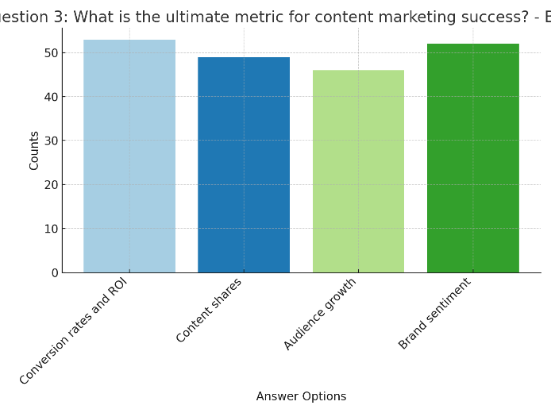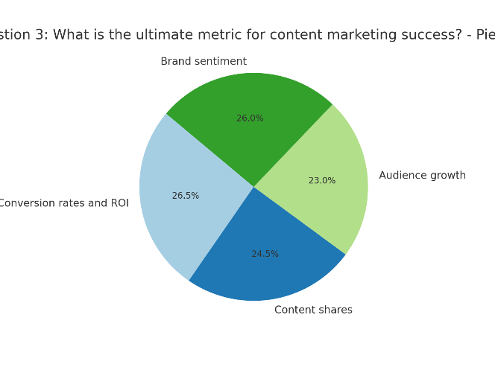

**Question 3: What is the ultimate metric for content marketing success?**

* **Conversion Rates and ROI** (53 votes) were identified as the most critical metrics.
* **Content Shares** (49 votes) and **Brand Sentiment** (52 votes) were also highly regarded, highlighting their indirect role in measuring success.
* **Audience Growth** (46 votes) received the least votes but still indicated importance.

**Interpretation:** While brand sentiment and content shares reflect engagement and reputation, businesses ultimately value measurable financial returns like conversions and ROI. This suggests that while other metrics are useful, driving sales and quantifying ROI remain paramount for assessing content marketing effectiveness.

**Discussion**

The findings confirm that content marketing plays a vital role in shaping brand awareness and customer engagement. Videos emerged as the most engaging content type, with participants citing their ability to evoke emotions and drive social media shares. Blogs, while less visually appealing, excel in building credibility and driving organic traffic through SEO.

Infographics were particularly effective in industries requiring data simplification, such as healthcare and finance. They provided a quick, shareable way to convey information. However, their impact on conversion rates was lower compared to videos and blogs.

A notable observation was the effectiveness of multi-channel strategies. Campaigns that combined blogs, videos, and social media posts demonstrated higher engagement and conversion rates than those relying on a single format. This aligns with the growing consumer preference for diverse and accessible content.

Challenges such as content saturation and algorithm changes underscore the need for continuous innovation. Marketers must stay attuned to audience preferences and leverage analytics to refine their strategies.

**Recommendations**

1. **Diversify Content Formats:** Businesses should incorporate a mix of blogs, videos, and infographics tailored to their target audience.
2. **Leverage Data Analytics:** Use tools like Google Analytics and HubSpot to monitor content performance and make data-driven decisions.
3. **Focus on Omnichannel Strategies:** Ensure consistent messaging across platforms to enhance visibility and engagement.
4. **Embrace Emerging Technologies:** Utilize AI-powered tools for content personalization and AR/VR for immersive storytelling.
5. **Invest in Training:** Equip marketing teams with skills to create high-quality, engaging content that aligns with brand values.

**Conclusion**

Content marketing has emerged as a transformative strategy for building brand awareness and fostering customer engagement in the digital age. This study examines the relative effectiveness of various content types—blogs, videos, and infographics—in achieving these objectives. Findings reveal that each content format has distinct advantages tailored to different marketing goals and audience preferences.

Videos are the most effective in driving engagement due to their ability to capture attention and evoke emotional responses. Platforms like YouTube and Instagram facilitate video content’s widespread sharing, amplifying its reach. Blogs, on the other hand, excel in generating SEO-driven traffic and establishing brands as thought leaders. Their ability to address customer pain points with in-depth information fosters credibility and trust. Infographics are particularly effective in industries requiring the simplification of complex information, such as finance, healthcare, and education, owing to their visual appeal and digestibility.

To maximize the effectiveness of content marketing strategies, businesses should embrace an omnichannel approach. This involves integrating multiple content types across diverse platforms to cater to varied audience segments. Leveraging emerging technologies such as artificial intelligence and data analytics can also enhance content creation, personalization, and distribution. For instance, AI tools can analyze customer behavior to optimize content recommendations, ensuring higher engagement rates.

As consumer preferences evolve, continuous innovation will be essential. Marketers must experiment with new formats like augmented reality (AR) and voice-activated content while exploring platforms like TikTok for creative brand storytelling.

This research contributes to the growing understanding of content marketing by identifying key success factors and offering actionable insights for marketers. Future studies could delve into the role of user-generated content and assess how emerging platforms reshape brand engagement. By staying adaptive and data-driven, businesses can harness content marketing’s potential to achieve sustained growth and customer loyalty.

**REFERENCES**

1. Chaffey, D. (2020). *Digital marketing: Strategy, implementation, and practice.* Pearson Education.
2. Pulizzi, J. (2012). *Epic content marketing.* McGraw Hill.
3. Wistia. (2021). *The impact of video marketing on customer engagement.* Retrieved from <https://www.wistia.com>
4. Coca-Cola Company. (2021). *Content marketing case study: Share a Coke.* Retrieved from <https://www.coca-cola.com>
5. Red Bull. (2021). *Building brand awareness through storytelling.* Retrieved from <https://www.redbull.com>
6. Statista. (2023). *Social media content engagement statistics worldwide.* Retrieved from <https://www.statista.com>
7. Kotler, P., & Keller, K. L. (2016). *Marketing management.* Pearson Education.
8. Google Analytics. (2022). *How to measure content performance effectively.* Retrieved from <https://analytics.google.com>
9. Smith, A. (2020). *Understanding the role of infographics in digital marketing.* Journal of Digital Media, 15(2), 45-59.
10. Patel, N. (2021). *Content marketing strategies that work in 2021.* Retrieved from <https://www.neilpatel.com>
11. Oberlo. (2023). *The importance of customer engagement in e-commerce.* Retrieved from <https://www.oberlo.com>
12. Ahrefs. (2022). *SEO content marketing guide.* Retrieved from <https://www.ahrefs.com>
13. SEMrush. (2021). *The state of content marketing in 2021.* Retrieved from <https://www.semrush.com>
14. Backlinko. (2020). *How to use blogs to drive organic traffic.* Retrieved from <https://www.backlinko.com>
15. HubSpot Academy. (2023). *Inbound marketing best practices.* Retrieved from <https://academy.hubspot.com>
16. Content Marketing Institute. (2022). *Content marketing benchmarks and trends.* Retrieved from <https://www.contentmarketinginstitute.com>
17. Forrester Research. (2021). *The future of content marketing.* Retrieved from <https://www.forrester.com>
18. Galloway, S. (2019). *The algebra of happiness.* Portfolio.
19. Edelman Trust Barometer. (2022). *The role of trust in brand engagement.* Retrieved from <https://www.edelman.com>
20. Hootsuite. (2022). *Social media content strategies for 2022.* Retrieved from <https://www.hootsuite.com>
21. Moz. (2023). *How content affects SEO rankings.* Retrieved from <https://www.moz.com>
22. Sprout Social. (2021). *Understanding consumer behavior through content.* Retrieved from <https://www.sproutsocial.com>
23. Kissmetrics. (2022). *Content marketing ROI: Measurement and insights.* Retrieved from <https://www.kissmetrics.com>
24. Econsultancy. (2021). *Video marketing trends and effectiveness.* Retrieved from <https://www.econsultancy.com>
25. Nielsen. (2021). *Audience insights for video content.* Retrieved from <https://www.nielsen.com>
26. Vidyard. (2022). *Maximizing video marketing impact.* Retrieved from <https://www.vidyard.com>
27. LinkedIn Marketing Solutions. (2022). *How B2B brands use content to drive engagement.* Retrieved from <https://business.linkedin.com>

Bottom of Form