**A STUDY THE TRANSFORMATION AND EVOLUTION FROM TRADITIONAL TO DIGITAL MARKETING**

**(Dr. G. MANJU, ASSOCIATE PROFESSOR, DEPARTMENT OF MANAGEMENT, KONGU ARTS**

**AND SCIENCE COLLEGE(AUTONOMOUS), ERODE 638 107 Email id:** [**manjukongu@gmail.com**](mailto:manjukongu@gmail.com)

**Phone. No.9842115112 )**

**ABSTRACT**

The transformation from traditional to digital marketing has brought about a wealth of data that can

help businesses evaluate the success of their campaigns. By analyzing website traffic, social media

engagement, conversion rates, cost per acquisition, and customer lifetime value, businesses can gain a

deeper understanding of their marketing efforts and make data-driven decisions. The transformation

from traditional to digital marketing has been significant in the last few years. By incorporating digital

platforms, businesses can now reach a much larger audience quickly and efficiently. The availability of

data analytics and tracking tools helps businesses to understand and evaluate the performance of their

marketing campaigns in real-time. This ensures that they can optimize their approach, deliver targeted

messages, build customer relationships efficiently and drive engagement for better results. The digital

marketing revolution has transformed the way companies do business, providing many new opportunities

for growth and profitability. As a result, businesses that are embracing digital marketing strategies are growing

and becoming more successful today.

Overall, digital marketing is a dynamic and challenging field that requires businesses to stay up to date

with the latest trends and technologies. By implementing effective digital marketing strategies and leveraging

the power of AI, businesses can gain a competitive advantage and achieve long-term success.

**Keywords: (Traditional marketing and digital marketing such as Content marketing, Display**

**marketing, Affiliate marketing, Social media marketing and SWOT Analysis etc.,)**

**A STUDY THE TRANSFORMATION AND EVOLUTION FROM TRADITIONAL TO DIGITAL MARKETING**

**(Dr. G. MANJU, ASSOCIATE PROFESSOR, DEPARTMENT OF MANAGEMENT, KONGU ARTS**

**AND SCIENCE COLLEGE(AUTONOMOUS), ERODE 638 107 Email id:** [**manjukongu@gmail.com**](mailto:manjukongu@gmail.com)

**Phone. No.9842115112 )**

**INTRODUCTION**

In the past century, companies have made a great effort to leave their rivals behind throughout the process of globalization and branding. Companies follow various strategies in order to adopt to the competition and make a difference. Additionally, meeting and satisfying customer needs have become much more difficult since customer demands have increased. Moreover, since the beginning of the 21st century, technology have been improving drastically, causing changes in each and every part of our lives. Companies have inevitably been affected by these changes and have started to use information and communication technologies more and more in the market.

One of the advantages the Internet provides is that daily problems can be solved easily and quickly. In addition to this, consumer awareness takes a different shape with the advances in technology. Consumers now can find various products and services and make a comparison between them, especially with the help of social media. Furthermore, companies are able to analyze the behaviors and habits of consumers better with the help of social media. Companies which are properly and constantly making editions and optimizations on their web pages are one step ahead in digital marketing. It has become crucial to know the type of search engines consumers use and whether they are able to find certain companies on search engine maps. Advertisements, which were once famous on newspapers, have been replaced with the ones on the web.

In this study, you will be given conceptual information about the stages of digital marketing in the beginning. Then the digital marketing advertisements and the traditional ads will be compared in terms of measurability. Finally, advantages of interactive media will be evaluated.

**WHAT IS MARKETING?**

Marketing refers to any actions a company takes to attract an audience to the company's product or services through high-quality messaging. Marketing aims to deliver standalone value for prospects and consumers through content, with the long-term goal of demonstrating product value, strengthening brand loyalty, and ultimately increasing sales.

**WHAT IS TRADITIONAL MARKETING?**

Traditional marketing refers to any form of advertising or promotional activity that has been used before the rise of digital media. This can include a wide range of activities, such as print advertising (e.g. newspapers, magazines), broadcast advertising (e.g. television, radio), direct mail marketing, telemarketing, billboards, and in-person events and activations.

**WHAT IS DIGITTAL MARKETING?**

Digital marketing (also known as data-driven marketing) is an umbrella term for the marketing of products or services using digital technologies, mainly on the Internet, but also including mobile phones, display advertising, and any other digital medium. Digital marketing's development since the 1990s and 2000s has changed the way brands and businesses utilize technology for marketing. As digital platforms are increasingly incorporated into marketing plans and everyday life, and as people use digital devices instead of visiting physical shops, digital marketing campaigns are becoming more prevalent and efficient.

**TRADITIONAL MARKETING**

##### Techniques of Traditional Marketing:-

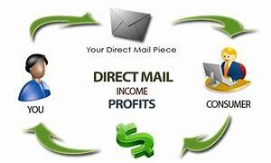Direct Mail

Direct-mail marketing creates awareness of a product through postcards, brochures, letters and fliers sent through mail. Direct mail is called a targeted type of marketing strategy because information is sent to a specific target market. However, direct-mail marketing can be expensive as a business incurs design and printing costs as well as postage expenses to reach its target.

Print

Print marketing includes advertising products and services through newspapers and magazines. Print marketing is both a mass-marketing and niche-marketing strategy. As a mass-marketing strategy, printed advertisements reach different classes of people, who might or might not have an interest in the product. In magazines, print marketing reaches out to the niche market that reads the magazine, such as women, fathers, teens or car lovers.

Broadcast

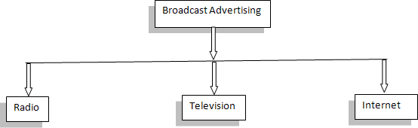

Television and radio are traditional avenues still widely used. Broadcast marketing reaches a large audience within a limited period of time. Television advertisements also bring authenticity and realism to a product as people can see how the product works. However, broadcast messages have a shorter lifespan compared with printed messages.

Referral

Referral marketing, also known as word of mouth, relies on customers to spread information about products or services. Referral is not a strategic or planned marketing activity, but it might help a business build a loyal client base. It also costs close to nothing for the business.

Billboards

Billboards are some of the largest forms of traditional advertising. Many exist on the interstate to entice travelers to stop along their journeys. These advertisements must be short and very visible to have an impact. It is also important for the billboards to be placed in an area that receives a lot of traffic, as well as in a reasonable proximity to the business.

Newspapers

Newspapers are one of the oldest areas in which to place advertisements. With new editions daily, in most cases, this makes it also the most disposable type of advertising. The effect must be gathered before the consumer turns the page or the usefulness of the advertisement is gone forever. Most newspapers have a readership that consists mostly of local people to your area. however, there are a few national newspapers. Consider your target market and which newspaper they are most likely to read prior to purchasing newspaper advertisements.

Magazines

Magazines are more long-term versions of advertising medium, as opposed to newspapers. While the magazine is most likely published monthly, many keep their magazines for several months and read them more than once. Additionally, magazines are more typically passed off to others than newspapers, so there is a much higher chance that your advertisement will be seen. The high gloss and color content of a magazine, versus a newspaper, makes it a desirable form of advertising**.**

##### Advantages and Disadvantages of Traditional Marketing

Advantages:- Reach

You can reach a group of specific consumers that do not necessarily utilize internet browsing.

Face to Face Contact

Personalized marketing is considered to be one of the best strategies and the most efficient method to gain recognition as a brand and product.

Tangible Offers

Traditional Marketing offers tangibility- this refers to ads or products that clients contact in during their free time, like a newspaper ad for example.

##### Disadvantages:-

Expensive

Purchasing television, radio, or printed ads tends to be pricey for both small and mid-sized businesses.

Inefficiency

Unlike Online Marketing, it is quite difficult to measure the conversion rate of your ads through traditional marketing, which makes it difficult to have a good understanding of the efficiency of your ads and the results they offer.

Forced Strategy

This type of marketing strategy is known to be a forced method of selling a product, since the consumer is not necessarily seeking your product in the first place.

### DIGITAL MARKETING

#### Digital Marketing Tactics:-

Content Marketing

Content marketing is a strategic marketing approach focused on creating and distributing valuable, relevant, and consistent content to attract and retain a clearly defined audience and, ultimately, to drive profitable customer action**.**

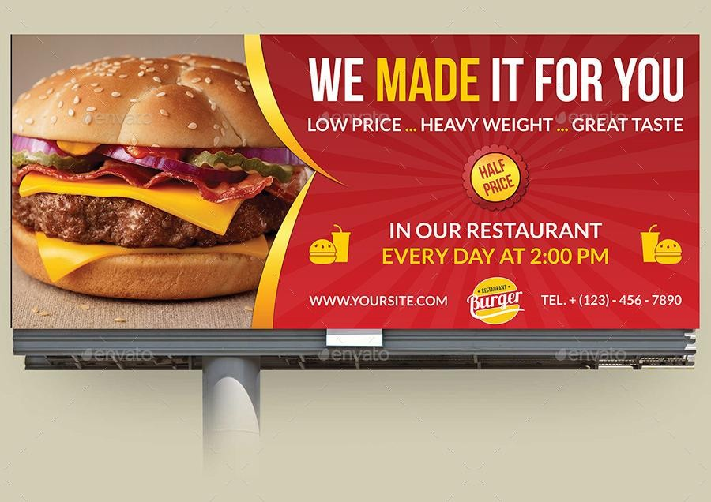Display Advertising

Based on your audience profile and your products, select ad space in specific websites from where you can get good traffic. Display ads can be anything from the banner ads to videos. In the online world, it is considered as one of the most effective ways of digital branding. Instead of developing text-based communication, create interesting videos or images that will speak on behalf of your brand. Also, take time to follow your targets and wisely choose the websites, which in turn are followed by your audience group.

Mobile Marketing

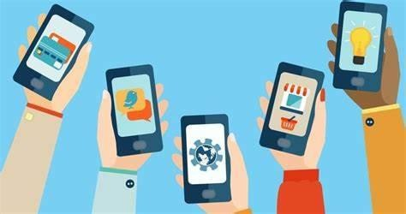

Mobile-centric ads are the current trend. From the in-app messages to the videos, mobile advertising is the most effective way to promote your brand. With the entire world going mobile, developing short and crisp communication targeting the mobile users is the best practice. As people carry their mobiles your brand communication stays in their mind, for a longer time. While developing mobile ads, ensure that it fits the screen sizes of all hand-held devices. In this way, your message will be clear and you shall successfully position your brand name in the minds of your targets.

Marketing Skills

Digital marketers support the wider marketing team and the strategic goals of the whole company by rolling out marketing strategies in the online environment, Hobson said. Digital marketers strive to be a voice for the customer and how they want to interact with a brand digitally, Rogers said.

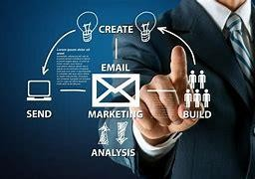Email Marketing

Even with the emergence of social media, mobile applications and other channels, email is still one of the most effective marketing techniques, Rogers said. It can be part of a content marketing strategy, providing value to consumers and over time convert an audience into customers.

Affiliate Marketing

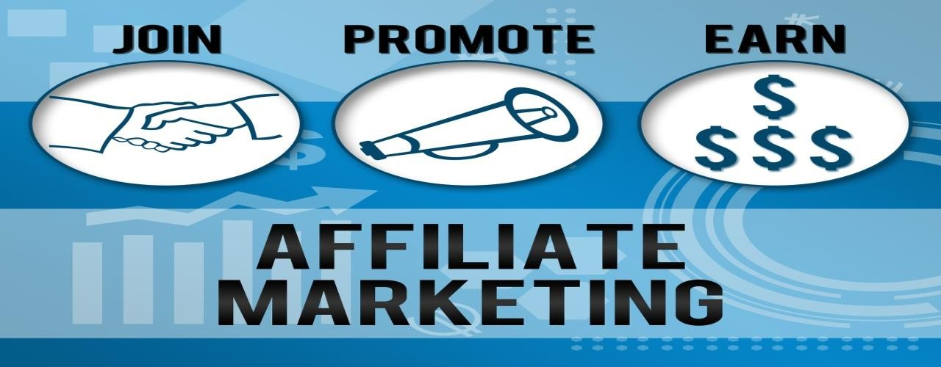

With the increased prominence of online marketing, affiliate marketing—also known as influencer marketing has become popular among many organizations in bridging the gap between consumers and organizations.

Search Engine Optimization (SEO)

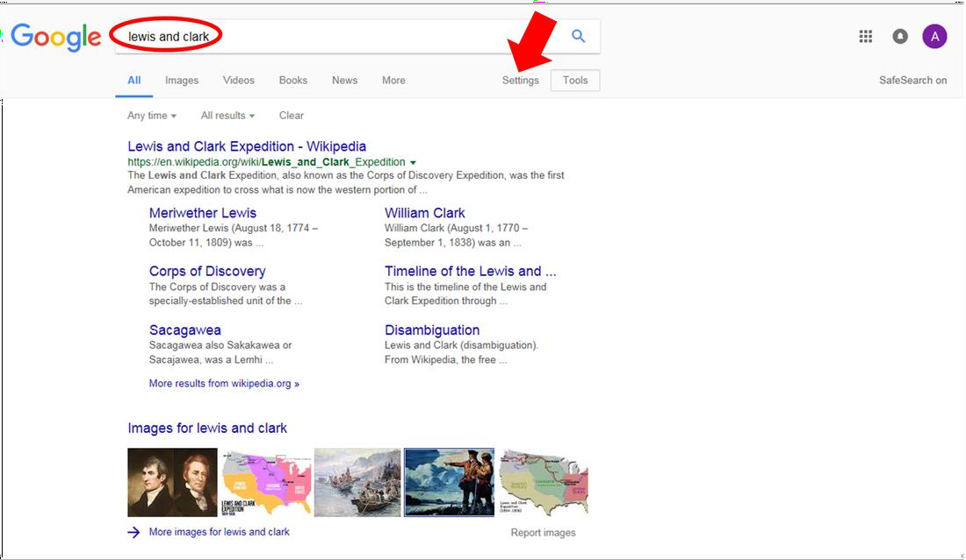

Search engine optimization (SEO) is a technique that seeks to improve the ranking of online material on search engines, such as Google or Bing. If you have ever searched for something on Google, you’ve likely noticed that even the simplest search can yield millions of results. Yet, you probably rarely go past the first few suggestions, let alone the next page.

Social Media Marketing

Social media marketing is a form of digital marketing that uses social networks, such as Twitter, Instagram, and Facebook, to reach customers. A core feature of modern digital marketing, social media marketing leverages the reach of social network platforms with data-driven efforts to reach targeted consumers. The active user size of social media platforms makes them particularly enticing to marketers. One study published in January 2022 quantified the number of active social network users in the billions

##### Advantages of digital marketing;-

**Global reach -** a website allows you to find new markets and trade globally for only a small investment.

**Lower cost -** a properly planned and well targeted digital marketing campaign can reach the right customers at a much lower cost than traditional marketing methods**.**

**Trackable, measurable results -** measuring your online marketing with web analytics and other online metric tools makes it easier to establish how effective your campaign has been. You can obtain detailed information about how customers use your website or respond to your advertising.

##### Disadvantages of digital marketing:-

**Skills and training** - You will need to ensure that your staff have the right knowledge and expertise to carry out digital marketing with success. Tools, platforms and trends change rapidly and it's vital that you keep up-to-date.

**Time consuming** - Tasks such as optimizing online advertising campaigns and creating marketing content can take up a lot of time. It's important to measure your results to ensure a return-on-investment.

**High competition -** While you can reach a global audience with digital marketing, you are also up against global competition. It can be a challenge to stand out against competitors and to grab attention among the many messages aimed at consumers online.

###### IS, DIGITAL MARKETING EFFECTIVE?

Digital marketing can be very effective, especially when implemented correctly. Digital marketing offers a wide range of tactics and channels that can be tailored to reach specific target audiences, engage them in two-way conversations, and build strong relationships with customers over time.

How and Why Digital Marketing Is Growing?

A business owner wants to go to the customer. Customers spend more time and resources on online channels than ever before. They are consuming ads on websites, apps, or social media. Businesses have to personalize their content per their audience. Since this audience hangs out online, digital marketing is growing. It’s also increasing because the digital marketing industry is thriving. Here’s a digital marketing salaries guide showing the growth of digital marketing from an employment perspective.

How Do Businesses Monitor the Success of Digital Marketing?

The impact of your digital marketing strategies depends on the KPIs that are relevant to the branch of digital marketing and the tools you are using. You use analytics tools like Google Analytics and Heap to track these KPIs and get actionable insights. Website metrics—such as overall traffic, bounce rates, and average time per visit—are all important to look at. A company with more robust a social media strategy might use different metrics, such as reach and impressions, engagement rate, and click-through rate.

What Is the Heart of Digital Marketing?

The heart of digital marketing is knowing your audience. It doesn’t matter how much you spend on digital marketing strategies, or what your digital marketing efforts include. If your business is unclear about the audience and their pain points, there’s no point. Empathetic connection through consumer-focused content is vital. This is true regardless of formats, platforms, and Google trends.

###### ENHANCE DIGITAL MARKETING CAMPAIGN:-

**Define your target audience:** Clearly define your target audience and tailor your messaging and content to their needs and interests. Use demographic data, customer feedback, and analytics to better understand your audience and create more personalized and relevant content.

**Set clear goals and KPIs:** Define specific, measurable goals and key performance indicators (KPIs) to track your progress and determine the success of your campaigns. Use analytics tools to monitor your metrics in real-time and make data-driven decisions to optimize your campaigns.

**Optimize your website:** Ensure that your website is user-friendly, mobile-responsive, and optimized for search engines. Use keywords, meta tags, and internal linking to improve your website's visibility and ranking in search engine results pages (SERPs).

**Leverage social media:** Use social media platforms to engage with your audience, build relationships, and drive traffic to your website. Use paid advertising and social media influencers to expand your reach and increase engagement.

**Invest in content marketing:** Create high-quality, informative, and engaging content that resonates with your target audience. Use blog posts, info graphics, videos, and other forms of content to attract and engage your audience.

###### THE 4 PS OF MARKETING AND THEIR IMPLICATIONS FOR DIGITAL MARKETING

* Product
* Price
* Place
* Promotion

Product

This may be a physical product or a service proposition. The key here is that something is developed that people actually want to buy. Some businesses begin with a product and then try to force that on an audience. If there is no demand for your product and no one is interested then you will not be able to create demand.

Price

Pricing is the second P and one that can be more of a science than an art. Understanding price elasticity and competitive positioning are angles to consider but the key factor is whether the price reflects the amount that people are willing to pay. The ‘willing to pay’ element depends on many factors such as brand value, online reviews, product quality and others but there are also numerous pricing tactics and strategies that can be employed during the different phases of the product life cycle.

Place

Location, location, location. In the marketing mix, the process of moving products from the producer to the intended user is called place. In other words, it is how your product is bought and where it is bought. This movement could be through a combination of intermediaries such as distributors, wholesalers and retailers. Building your shop in the wrong place decreases footfall and ultimately means fewer sales. Having your shop in the right place but not having the stock in the shop is even worse.

Promotion

Promotion is what most people think of when they hear the word marketing and consists of TV campaign, press advertising and display banners. This is often the first time that people will have any relationship with the company’s brand and in below-the-line marketing; this can be a personal relationship. To be successful in digital marketing, first impressions about the company are very important and hence so getting the company’s promotion strategy right is vital.

## INDUSTRY PROFILE

|  |  |
| --- | --- |
| Industry name | Digital Marketing |
| Sub types | Affiliate marketing, SEO,SMM |
| Sector | Marketing |
| Audience | Start-up, business and company |
| Content | Analytics, Survey, video’s and feed's |
| Revenue method | Promotions, marketing, traffic generation |
| Market size | $321 B (Till January 2023) |
| USP | Technology, easy access |
| Growth rate | 13.1% |
| Competitive advantage | Targeted audience, cost effective |

**THE NATURE OF BUSINESS**

**SECTOR:** TRADITIONAL/DIGITAL MARKETING

**INDUSTRY:** MARKETING

Traditional Marketing:

Traditional marketing refers to the conventional methods of advertising and marketing that have been in use for a long time. These include advertising in print media such as newspapers, magazines, brochures, etc., outdoor advertising like billboards and banners, and broadcast advertising such as TV and radio commercials. These methods rely on broad targeting and reach, and are relatively expensive compared to digital marketing.

Digital Marketing:

Digital marketing refers to the use of digital channels to promote products or services. Social media platforms, email campaigns, content marketing, search engines, and mobile apps are some of the channels used in digital marketing. It is comparatively less expensive than traditional marketing because digital marketing strategies focus on specific target audience and demographics, and are measurable in terms of return on investment (ROI).

Industry Trends:

The marketing industry has undergone significant changes in recent years, driven mainly by the shift towards digital marketing. While a significant proportion of businesses still rely on traditional marketing methods, more and more companies are shifting towards digital marketing due to its cost-effectiveness and target specificity.

Some of the key trends in digital marketing include the use of social media influencers, personalized marketing, and artificial intelligence and automation in marketing campaigns. Social media influencers, who have a large and loyal following on social media platforms, have become a key component of many digital marketing campaigns.

Personalized marketing is also increasingly being used, wherein marketing efforts are tailored to a specific audience based on their interests and behaviours. Artificial intelligence and automation are being used to optimize marketing campaigns and improve the customer experience.

In conclusion, both traditional and digital marketing strategies have their benefits, and companies must choose the best one based on their target audience, objectives, and budget. However, the growth of digital marketing is inevitable, and businesses must be willing to adapt to the changing landscape to remain competitive.

### SWOT ANALYSIS OF TRADITIONAL AND DIGITAL MARKETING

##### Strengths of Traditional Marketing:

**Reaches a wide audience:** Traditional marketing has been around for decades and has become a tried and tested method for reaching a wide audience, through modes like television, radio, and print advertisements.

**Tangibility:** Tangibility of traditional marketing materials such as flyers, brochures, billboards, etc., makes them easier to remember and hold on to, thereby enhancing the brand recall value.

**Familiarity for older audiences:** People from older generations might find traditional marketing methods more accessible, as they are more familiar with them.

**Selective targeting:** Traditional marketing offers easy targeting, as it is possible to segment the audience based on geographical and demographic factors and cater to specific audiences.

##### Strengths of Digital Marketing:

**Access to a global audience**: Digital marketing reaches a vast number of people worldwide via the internet.

**Cost-effective:** Digital marketing is much cheaper than traditional marketing, making it suitable for small businesses and start-ups, which may have a limited marketing budget.

**Real-time analytics:** Online marketing metrics, or analytics, can be monitored in real-time, allowing businesses to evaluate the impact of their marketing strategies quickly.

**Personalization:** Digital marketing provides marketers with the potential to personalize their approach since it can track a user's browsing habits, social media behavior, search history, etc.

##### Weaknesses of Traditional Marketing:

**Limited analytics:** It is difficult to measure the performance of traditional marketing accurately. It’s hard to know the number of people who saw the advertisement or the number of conversions achieved.

**Expensive:** Traditional marketing activities such as creating TV commercials, newspaper ads, flyers, or billboards are usually costly, making them harder for small businesses to execute.

**Scope for errors**: Traditional methods provide limited testing opportunities, making it more costly and time-consuming to correct errors or to change the strategies once implemented.

**Limited personalization:** Due to the limited targeting capabilities and inability to provide targeting beyond demographics and specific locations, traditional marketing lacks personalization.

##### Weaknesses of Digital Marketing:

**Requires internet access:** Digital marketing depends on users having access to the internet; it may not be cost-effective if a business wants to target users without access to the internet.

**Overwhelming competition:** The number of digital marketing strategies and competitors involved in the online market can make it hard for a business to stand out from the crowd.

**Potential for errors:** Although digital marketing offers real-time analysis, the data collected can be overwhelming, resulting in errors or an insufficient understanding of the data's real implications.

**Dependence on technology:** If the internet or the power supply goes down, then digital marketing strategies may become ineffective and unavailable, making the brand invisible.

Opportunities of Traditional Marketing:

**Reach a wide audience:** Traditional marketing methods allow businesses to reach a large number of

people at once regardless of the demographics.

**Tangibility:** Products and services could be presented to customers physically in traditional marketing

methods, creating lasting impressions.

**Personal touch:** Traditional marketing methods like handouts and direct mails offer a personal touch that

digital marketing can’t replicate.

##### Threats of Traditional Marketing:

**Cost:** Traditional marketing methods like print ads, billboards, and brochures can be quite

expensive, especially for small businesses.

**Limited interactive capabilities:** Traditional marketing doesn’t allow for two-way communication between businesses and customers.

**Difficulty in tracking results:** Traditional marketing methods do not offer good tracking options, so it

is difficult to understand their impact.

##### Opportunities of Digital Marketing:

**Targeted audience:** Digital Marketing allows businesses to target a specific audience more effectively.

**Cost-effective:** Digital marketing methods like social media advertising and email marketing are relatively cheap, making it a more cost-effective option for small businesses.

**Interactive:** Digital marketing channels like social media and web-based channels allow businesses

to connect and interact with customers in real-time.

##### Threats of Digital Marketing:

**Over reliance on technology:** Digital marketing relies heavily on technology which can be unreliable at times.

**High competition:** Digital marketing is highly competitive and requires consistent monitoring and adjustment to be successful.

**Potential for fraud:** Digital marketing can be prone to click fraud, where businesses pay for clicks that do not lead to actual sales.

### LITERATURE REVIEW

**According to Neelika Arora** Has published research article entitled "Trends in Online Advertising" in advertising Express, Dec 2013. The global online advertising revenues are expected to touch US $10bn by 2015. In India, the revenues at present are estimated to be Rs 80 cr. and are expected to increase six times more within the next five years. In India, Internet as a medium is accepted by a wider industrial segment that includes automobiles, telecom, education, banking, insurance, credit cards. FMCG (Fast Moving Consumer Goods), apparel clothing, durables, media, business services and tourism. Out of these, it is estimated that the banking, FMCG and insurance sectors together account for 45% of the total advertising spend. In comparison to this, automotive, travel and retail spend 37% of the total advertising revenue and financial service companies spend 12% only. Some of the top spenders in India are automobiles, followed by brands like Pepsodent, Kelloggs, Cadbury, HDFC(Housing Development Finance Corporation Ltd.) loans and Sunsilk. In addition to these the early adopters in the field of finance and IT are also increasing their spending. Globally, the trend is that almost 60% of the revenue goes to five firms- Goggle, Yahoo, Microsoft, AOL(America Online Launchers), and Overture Approximately. 90% of the Goggle revenues come from advertising In India, portals like indiatimes.com, exchange4media.com, rediffmail.com, agencyfaqs.com etc are attracting major online spender. This article explains demographic profile of Indian users.

**According to Sumanjeet** Has published article on "On Line Banner Advertising" in Indian Journal of Marketing Online banner advertising has great potential as an advertising medium. It is easy to create, place and use. It offers companies targeting well educated. Innovative, affluent males/females or students with great potential for success as their segments are highly represented.

**According to Avinash kaushik** He is an Indian entrepreneur published an article in dec 2014 titled digital marketing and analytics are two ladders of magnificent success Jaffrey Graham45 has published his article entitled "Web advertising's future e- Marketing strategy Morgan Stanley Dean Witter published an equity research report analysing the Internet marketing and advertising industry. The report studies research from dozens of companies and calculates the cost and effectiveness of advertising across various media. Branding on the Internet works. For existing brands, the Internet is more effective in driving recall than television, magazines, and newspapers and at least as good in generating product interest Advertising in social media: How consumers act after seeing social ads. Adapted from Nielsen (2012: 10). Social media has not only changed how people communicate online, but it has also changed the consumption of other media too. Online social connections are used to filter, discuss, disseminate, and validate news entertainment, and products for consumption (Ryan 2011: 15) The next chapters will explain more about each of the world's current most widely used social medias. There are, of course, many other social networks and applications (apps) available but considering the study, the focus is on the main Medias.

**According to Vikas Bondar** He has published his article on "sales and marketing strategies" Internet is a really good thing. The Internet gives people a greater amount of information as we need. It is the best way to get a comparison of the products that we need. If we are interested in buying. it is best for us to check the Web sites. Also if we would like to make our own Web page we can do this, without paying a lot of money. From where do we set all this information? The answer is from advertising, which we see. everywhere on TV on the Internet, in the newspapers and more. Year after year we get more and more new, interesting information and in the future the Internet use will increase more than now. This article explains how internet is useful tool for advertisement

**According to Garder's survey** The top priority in digital marketing investment will be to improve commerce experiences through social marketing, content creation and management and mobile marketing. Key findings also revealed that a company' marketing success relies mostly on their website, social marketing, and digital advertising, which are all parts of digital marketing. In addition, savings made by using digital marketing can be reinvested elsewhere. Normally, companies spend 10 percent of their revenue on marketing and 2.4 percent on digital marketing, which will increase to 9 percent in the future.

**According to Taylor** He had predict that by 2020 that all traditional outdoor advertising space in major cities will be replaced by digital displays. It is worth nothing that a lot of DOOH (traditional and non-traditional media interlink) can be used in tandem with programmatic, to create an immersive experience that changes based on real time variables.

**According to Freitas** He has discussed how linked in is the main social platform for B2B sales and how events are intertwined. this linking of traditional and non-traditional in this sense is very measurable as there will be a clear indicate of the number of consumers who have received the message and the end result being a led conversion.

### PROBLEM DEFINITION

Traditional Marketing:

**Decreased sales or revenue**: This problem might arise due to changes in the market,

decreased demand for the product, or increased competition**.**

**Lack of brand awareness:** Customers might not know about the company's products or services,

which makes it difficult to attract new customers and increase sales.

**Limited reach:** Traditional marketing tactics like flyers and billboards have a limited reach and might not reach the desired target audience.

**Poor customer retention:** Customers might switch to competitors due to dissatisfaction with the product or service.

Digital Marketing:

**Low online visibility:** A website might not rank high on search engine results pages, reducing its visibility and reach.

**Low website traffic:** A website might not attract many visitors, reducing its chances of generating

leads and revenue.

**High bounce rate:** Visitors might leave the website quickly, indicating that the website failed to meet their expectations or provide useful information.

**Poor lead generation:** Visitors might not convert into leads due to a lack of trust, poor user experience,

or inadequate lead generation tactics.

### OBJECTIVES OF STUDY

* To study the effect of Digital marketing on brand awareness and overall perception of the company.
* To know whether online marketing is better than offline marketing in today’s scenario.
* To gather knowledge about the various modes of marketing.
* To evaluate the mode of marketing gives better results in terms of sale, profit etc.
* To identify the satisfaction level of customers about online and traditional marketing.

### SCOPE OF STUDY

* Conducting market research to identify the target audience and their digital behaviours and preferences.
* Evaluating and optimizing email marketing campaigns to improve open rates, click- through rates, and conversion rates.
* Analyzing website traffic and user behaviour through web analytics tools to identify areas for improvement.
* Developing a content marketing strategy that aligns with the brand's messaging and business objectives.
* Creating and executing a social media marketing campaign to increase brand awareness and engagement.

### LIMITATION OF STUDY

* **Sample bias:** Research conducted solely through online surveys or social media may only capture the perspectives of individuals who are active online, leading to a biased sample that may not accurately represent the larger population.
* **Limited data access:** Due to privacy concerns, researchers may have limited access to data that digital marketing platforms collect, making it difficult to accurately measure the effectiveness of certain digital marketing strategies.
* **Rapidly evolving technology:** The digital marketing landscape is constantly evolving, making it challenging for researchers to keep up with the latest trends and best practices.
* **Difficulty measuring impact:** Measuring the impact of digital marketing strategies can be difficult, particularly when it comes to assessing long-term effects or determining causality.
* **Limited generalizability:** Results from digital marketing studies may not be easily generalized to other industries or regions, as different factors may come into play in different contexts.
* **Lack of standardization:** There is a lack of standardization in the way that digital marketing metrics are defined and measured, making it difficult to compare results across studies or platforms.

**HYPOTHESIS**

This study is conducted to assess the hypothesis that if company is marketed through social media platforms, then what will be the effects of this type of marketing on its image or awareness.

**NULL HYPOTHESIS [H0]-** There is no significant relationship between marketing the products on web through social media channels.

**ALTERNATIVE HYPOTHESIS [H1]-** There is a significant relationship between the marketing on social media channels and its effects on the company’s brand.

38

### HYPOTHESIS TESTING

**NULL HYPOTHESIS (HO):** There is no significant relationship between marketing the products on web through social media channels.

**ALTERNATIVE HYPOTHESIS (H1):** There is a significant relationship between the marketing on social media channels and its effects on the company’s brand.

**Results:** Based on the results of our hypothesis testing, we reject the null hypothesis and accept the alternative hypothesis. This means that there is a statistically significant relationship between marketing products on the web through social media channels. We can conclude that social media marketing is an effective strategy for promoting products on the web.

### RESEARCH METHODOLOGY

Steps or techniques used to identify, select, process, and analyze information so as to clearly understanding the research problem with the help of data or information. In this study both primary and secondary data has been used for carrying out the result.

###### MODE OF DATA COLLECTION:

There are two types of data:

**Primary Data:** Primary research is data which is obtained firsthand. This means that the researcher conducts the research. Primary research means going directly to the source, rather than relying on pre-existing data samples.

**Secondary Data**: Secondary research is also known as desk research. This type of research relies on pre-existing data sources such as company websites, articles and market research reports. It is generally carried out at a desk, either offline (via books, research documents, etc.) or online (via websites, pdf reports, etc.).

This study is based on secondary data which collected using different websites available on the internet. We also collected data from various websites available on the internet including the official website of the company and other survey conducting websites

## DATA ANALYSIS & INTERPRETATION

* **Showing which method of marketing you prefer**

|  |  |  |
| --- | --- | --- |
| Particulars | No. of respondents | Percentage |
| Online marketing | 32 | 64 |
| Traditional Marketing | 18 | 36 |
| Total | 50 | 100 |

* **Showing which method of marketing mostly preferred bypeople**

70

60

50

40

30

Percentage

20

10

0

Traditional

Marketing

Digital

Marketing

**preference**

**Percentage**

**Interpretation**

It shows the preference of marketing. 64% of respondents prefer online marketing and 36% of respondents prefer traditional marketing.

* **Showing that getting a new product launching info via online marketing than a traditional marketing is more informative**

|  |  |  |
| --- | --- | --- |
| Particulars | No. of respondents | Percentage |
| Strongly agree | 13 | 26 |
| Agree | 26 | 52 |
| Neutral | 9 | 18 |
| Disagree | 1 | 2 |
| Strongly disagree | 1 | 2 |
| Total | 50 | 100 |

* **Showing opinion regarding the statement that getting a new product launching info via online marketing than a traditional marketing is more informative**

60

50

40

30

20

Percentage

10

0

Strongly agree Agree

Neutral

Disagree

Strongly

disagree

**more informative**

**Percentage**

**Interpretation**

52% of respondents agree that getting a new product launching info via digital marketing is more informative than traditional marketing, 26% of respondents strongly agree that getting a new product launching info via digital marketing is more informative than traditional marketing,18% of them have neutral opinion, 2% of them disagree that getting a new product launching info via digital marketing is more informative than traditional marketing, 2% of respondents strongly disagree that getting a new product launching info via digital marketing is more informative than traditional marketing.

* **Showing attentiveness in online marketing**

|  |  |  |
| --- | --- | --- |
| Particulars | No. of respondents | Percentage |
| Strongly agree | 4 | 8 |
| Agree | 25 | 50 |
| Neutral | 15 | 30 |
| Disagree | 4 | 8 |
| Strongly disagree | 2 | 4 |
| Total | 50 | 100 |

* **Showing attentiveness in online marketing**

60

50

40

30

20

Percentage

10

0

Strongly agree Agree

Neutral

Disagree

Strongly

disagree

**attentiveness**

**percentage**

**Interpretation**

It shows attentiveness in online marketing. 50% of respondents agree that they are attentive in online marketing, 30% of respondents have neutral opinion that they are attentive in online marketing, 8% of respondents strongly agree that they are attentive in online marketing and 8% of respondents disagree that they are attentive in online marketing, 4% of respondents strongly disagree that they are attentive in online marketing.

* **Showing how much people are satisfied with online marketing**

|  |  |  |
| --- | --- | --- |
| Particulars | No. of respondents | Percentage |
| Highly satisfied | 6 | 12 |
| Satisfied | 23 | 46 |
| Neutral | 18 | 36 |
| Dissatisfied | 3 | 6 |
| Highly dissatisfied | 0 | 0 |
| Total | 50 | 100 |

* **Showing how much people are satisfied with online marketing**

50

45

40

35

30

25

20

Percentage

15

10

5

0

Highly

satisfied

Satisfied

Neutral

Dissatisfied Highly

dissatisfied

**satisfaction**

**Percentage**

**Interpretation**

It shows the satisfaction in online marketing by the respondents. 46% of them are satisfied with online marketing, 36% of respondents have neutral opinion about the satisfaction of online marketing, 12% of respondents highly satisfied with online marketing, 6% of respondents dissatisfied with online marketing .No one were highly dissatisfied with online marketing**.**

* **Showing what are the benefits does traditional marketing offer over the online marketing**

|  |  |  |
| --- | --- | --- |
| Particulars | No. of respondents | Percentage |
| Wide range of  information | 5 | 10 |
| Low cost | 6 | 12 |
| Time saving | 13 | 26 |
| Ease of shopping | 19 | 38 |
| Interactive medium | 7 | 14 |
| Total | 50 | 100 |

* **Showing the benefits does traditional marketing offer over the online marketing**

40

35

30

25

20

15

Percentage

10

5

0

Wide range of Low cost

information

Time saving Ease of Interactive

shopping medium

**benefits**

**Percentage**

**Interpretation**

It shows the benefits does traditional marketing offer over the online marketing. 58% of respondents opinion that traditional marketing offer easy of shopping over than online marketing, 26% of respondents opinion that time saving is provided by traditional marketing, 14% of respondents opinion that traditional marketing as a interactive medium and 12% respondents opinion that traditional marketing offer low cost.10% of respondents opinion that traditional marketing offer wide range of information.

* **Showing how would you rate traditional marketing**

|  |  |  |
| --- | --- | --- |
| Particulars | No. of respondents | Percentage |
| Excellent | 8 | 16 |
| Satisfied | 23 | 46 |
| Good | 18 | 36 |
| Fair | 1 | 2 |
| Bad | 0 | 0 |
| Total | 50 | 100 |

* **Showing rating of traditional marketing by people**

50

45

40

35

30

25

20

Percentage

15

10

5

0

Excellent

Satisfied

Good

**rating**

Fair

Bad

**Percentage**

**Interpretation**

It shows the rating given to traditional marketing by the respondents. 46% of respondents are satisfied with traditional marketing, 36% of respondents have good opinion about traditional marketing, 16% of respondents have excellent opinion about traditional marketing, 2% of respondents have fair opinion about traditional marketing, No one have bad opinion about traditional marketing.

### FINDING'S

* **Social media is a powerful tool for reaching customers:** Social media platforms such as Facebook, Instagram, Twitter, and LinkedIn continue to be important for reaching customers and building brand awareness.
* **Video marketing is on the rise:** Video content is becoming increasingly popular as consumers prefer more engaging and interactive forms of marketing.
* **Mobile optimization is essential:** With more than half of all web traffic now coming from mobile devices, it's essential for businesses to optimize their websites and marketing campaigns for mobile.
* **Personalization is key:** Consumers expect personalized experiences, and businesses that use data to provide personalized marketing messages and recommendations are more likely to succeed.
* **Voice search is growing:** With the increasing popularity of smart speakers and virtual assistants, voice search is becoming an important consideration for businesses in their digital marketing strategies.
* **AI and machine learning are transforming marketing:** AI and machine learning technologies are being used to optimize digital marketing campaigns, personalize customer experiences, and provide valuable insights into consumer behaviour.

### SUGGESTION

* **Know your audience:** Understanding your target audience is essential for creating effective digital marketing campaigns. Research your audience's demographics, interests, and behaviours to tailor your messaging and targeting.
* **Use social media effectively:** Social media platforms are an essential part of any digital marketing strategy. Identify the platforms your audience uses most and create a presence there. Engage with your followers, share valuable content, and use social media advertising to reach new audiences.
* **Optimize for mobile:** With more than half of all web traffic coming from mobile devices, it's essential to optimize your website and marketing campaigns for mobile. Make sure your website is mobile-friendly and create mobile-specific content and ads.
* **Leverage SEO:** Search engine optimization (SEO) is a powerful tool for driving organic traffic to your website. Use keyword research to optimize your website's content and structure, and focus on creating valuable and relevant content that will rank well in search engines.
* **Use data to inform your strategy:** Digital marketing generates a wealth of data, from website analytics to social media engagement metrics. Use this data to track the performance of your campaigns and make data-driven decisions about where to invest your marketing resources.
* **Stay up to date with the latest trends:** Digital marketing is a fast-paced and constantly evolving field. Stay up to date with the latest trends and technologies, such as AI, voice search, and personalization, to stay ahead of the competition.

### CONCLUSION

In conclusion, the transformation from traditional to digital marketing has brought about a wealth of data that can help businesses evaluate the success of their campaigns. By analyzing website traffic, social media engagement, conversion rates, cost per acquisition, and customer lifetime value, businesses can gain a deeper understanding of their marketing efforts and make data-driven decisions.

The transformation from traditional to digital marketing has been significant in the last few years. By incorporating digital platforms, businesses can now reach a much larger audience quickly and efficiently. The availability of data analytics and tracking tools helps businesses to understand and evaluate the performance of their marketing campaigns in real-time. This ensures that they can optimize their approach, deliver targeted messages, build customer relationships efficiently and drive engagement for better results. The digital marketing revolution has transformed the way companies do business, providing many new opportunities for growth and profitability. As a result, businesses that are embracing digital marketing strategies are growing and becoming more successful today.

Overall, digital marketing is a dynamic and challenging field that requires businesses to stay up to date with the latest trends and technologies. By implementing effective digital marketing strategies and leveraging the power of AI, businesses can gain a competitive advantage and achieve long-term success.

### BIBLIOGRAPHY

**LINKS:-**

* <https://www.mygreatlearning.com/blog/introduction-to-digital-marketing/>
* <https://www.simplilearn.com/traditional-marketing-vs-digital-marketing-article>
* <https://www.simplilearn.com/history-and-evolution-of-digital-marketing-article>
* <https://www.perceptive.co.nz/blog/from-traditional-to-digital-the-evolution-of-digital-marketing-strategy>
* <https://www.journalbusinesses.com/index.php/revista/article/view/295/661>
* <https://www.researchgate.net/publication/303163963_Digital_Marketing_in_Indian_Context>
* <https://www.customermonitor.com/blog/from-traditional-to-digital-the-evolution-of-digital-marketing-strategy>
* [https://www.studocu.com/in/document/itm-group-of-institutions/management-of-new-ventures/299399529-final-](https://www.studocu.com/in/document/itm-group-of-institutions/management-of-new-ventures/299399529-final-project-report-on-digital-marketing/16260347)

[project-report-on-digital-marketing/16260347](https://www.studocu.com/in/document/itm-group-of-institutions/management-of-new-ventures/299399529-final-project-report-on-digital-marketing/16260347)

**REFERENCE**

**Digital Transformation** [|Digital Transformation: Survive and Thrive in an Era of Mass](https://books.google.co.in/books/about/Digital_Transformation.html?id=Ip-RDwAAQBAJ&redir_esc=y) [Extinction - Thomas M. Siebel - Google Books](https://books.google.co.in/books/about/Digital_Transformation.html?id=Ip-RDwAAQBAJ&redir_esc=y)

**Principles of Marketing** | basic concepts of marketing | By Pearson by Neelika Arora (Author), Gary Armstrong (Author), Prafulla Agnihotri (Author)

Paperback : <https://amzn.to/3AyKn9P>

**Marketing Management** | marketing cases in the Indian context | Fifteenth Edition | By Pearson by Avinash kaushik (Author), Keven Lane Keller (Author), Others (Author)

Paperback : <https://amzn.to/3IGDJkt> Kindle Edition : <https://amzn.to/34fDlL3>

**Marketing 4.0: Moving from Traditional to Digital** by Philip Freitas (Author), Hermawan Kartajaya (Author), Iwan Setiawan (Author)

Kindle Edition : <https://amzn.to/3r3hmzK>