**A**

**Project report**

**On**

**To study of Marketing mix strategy in NorthStar Academy**

**Submitted in**

**Partial fulfilment for the award of the**

**Degree on**

**PGDM**

**Submitted by** **Submitted to**

N jannes prof. Jagadeesh s

Reg No: 23GIBSPGDM127.

PGDM

**GIBS BUSINESS SCHOOL**

**DECLARATION**

by the candidate is true to the best of my knowledge.

I, Mr. N JANNES student of PGDM, belong into GIBS Business School, declare that this Project Report / Dissertation entitled “TO STUDY OF MARKETING MIX STRATEGY IN NORTHSTAR ACADEMY” is the result the of project / dissertation work done by me under the supervision of Prof.Jagadeesh s and at GIBS BUSINESS SCHOOL

I am submitting this Project Report / Dissertation in partial fulfilment of the requirements for the award of the degree of Post Graduate Diploma in Management in Marketing by the GIBS BUSINESS SCHOOL, Bangalore during the academic year 2023-25.

I declare that this project report has been tested for plagiarism and has passed the plagiarism test with the similarity score less than 25% and it satisfies the academic requirements in respect of Project work prescribed for the said Degree.

I further declare that this project / dissertation report or any part of it has not been submitted for award of any other Degree / Diploma of this University or any other University/ Institution.

(Signature of the candidate)

Signed by me on 09/01/2025.

Certified that this project work submitted by N JANNES has been carried out under my / our guidance and the declaration made.

Signature of Guide

Date ……...

Signature of Director of School

|  |  |  |
| --- | --- | --- |
| **SL.NO** | **LIST OF CONTENTS** | **PAGE.NO** |
| **1** | **COMPANY PROFILE**  2.1Introduction  2.2 mission  2.3 vision  2.4 Selling platform: NORTHSTAR digital platform.  2.7 MAJOR PLAYERS IN EDTECH INDUSTRY |  |
| **2** | **RESEARCH METHODOLOGY**  3.1 Title of the study  3.2 Literature review  3.3 Scope of the study  3.4 Statement of the problem  3.5 Objectives of the Study  3.6 Research design  3.7 Sampling  3.8 Data collection  3.9 Tools Used for data analysis.  3.10 Limitations of the study |  |
| **3** | **DATA ANALYSIS AND INTERPRETATION** |  |
| **4** | **FINDINGS, SUGGESTIONS AND CONCLUSION** 5.1 FINDINGS 5.2 SUGGESTIONS 5.3 CONCLUSION |  |

**executive summary**

The purpose of this executive summary is to provide an overview of the study conducted on marketing mix strategy. The marketing mix refers to a set of controllable variables that a company can use to influence consumer behaviour and achieve its marketing objectives. This study aimed to analyse the significance of the marketing mix in contemporary business environments and explore its impact on consumer decision-making and overall business performance.

Product: The product is a vital element of the marketing mix strategy. This study emphasized the importance of understanding customer needs and developing products that align with those needs. Successful product strategies involve continuous innovation, quality improvement, and effective branding to create a unique value proposition for customers.

Price: Price is a critical factor that influences customer perception and purchase decisions. The study revealed that pricing strategies should consider factors such as market demand, competition, and value perception. Effective pricing strategies can optimize revenue, profitability, and market penetration.

Place: The study highlighted the significance of distribution channels and the accessibility of products or services to target customers. Choosing the right distribution channels, managing inventory, and ensuring a seamless purchasing experience are crucial for reaching and serving customers effectively.

Promotion: Promotion plays a vital role in creating awareness, generating interest, and influencing customer behaviour. The study emphasized the need for a well-defined promotional mix that includes advertising, sales promotions, public relations, direct marketing, and digital marketing. Integration and consistency across various promotional channels are essential for maximizing impact.

The study of marketing mix strategy demonstrates that a well-designed and integrated approach to product, price, place, promotion, people, process, and physical evidence is essential for achieving marketing objectives and driving business success. By understanding customer needs, optimizing the marketing mix elements, and adapting to dynamic market conditions, organizations can create a competitive edge and establish long-term customer relationships. Continuous monitoring and adaptation of the marketing mix strategy are crucial to remain relevant and responsive to evolving customer preferences and market trends.

**2.COMPANY PROFILE**

**2.1 Introduction**

NorthStar Academy is a premier institution for Finance and Accounting with presence across india. NSA was awarded as the 'Best Emerging Educational Institute" by the Indo-Global Foundation. Awarded as Best training institute by Indian Education Award in the year 2020.

Over a period, a of 5 years NSA has trained 20000+ students and continue to deliver the successful journey. Our vision is to become a Unicorn: By providing the right quality education and investing in the right technology and team.

Currently NSA is working with more than 100+ corporates and early-stage startups to ensure that its successful students are placed and fulfilling skilled resources requirement of corporates and providing customised training to meet their needs.

NorthStar Academy is Official Gold Partner of IMA and an exclusive official partner of Becker. Becker study material is comprehensively created by industry leaders & educators to help aspirants in their endeavour to pass CMA USA. It also brings an online test-bank. NorthStar Academy is IMA's official training provider in India for Certified Management Accounting.

**2.2 Mission:**

* Provide personalized and dedicated mentorship as well as learning experience with the objective of enabling students realize their skills and abilities for a successful career in finance and accounting.
* Offering result oriented, systematic and cohesive learning environment that is aimed at creating synergies between complete online education as well as offline tools, hence delivering greater flexibility in the pursuit of professional excellence.

Create an institution of learning, skill development, goal oriented and professional education that serves as the foundation upon which we shape the lives of our students and build a sustainable future.

**2.3 vision:**

To provide excellence in education that is relevant while enhancing lateral thinking abilities and creating meritorious professionals who confidently meet the corporate challenges of the modern era.

**2.5 Selling platform: NorthStar academy digital platform**

NorthStar Academy is an online learning platform that provides personalized, flexible, and certified education to students worldwide. Below is a brief overview of the sales platform focusing on its main features and products.

**Marketing mix of NorthStar academy**

Increasing effort to deliver best value to customers, through a better product quality.

**Product:**

**List Of Products-:​**

* ACCA
* CMA
* CPA
* CFA
* CA
* EA

**Price:**

NORTHSTAR uses skimming pricing strategy in which goods and services are priced slightly below market price, making them cheaper for consumers. Therefore, customers will not be put off by the high prices. The skimming strategy adopted by NorthStar management is a unique business strategy.

**Promotion strategy of NorthStar academy**

Another reason why NorthStar 's marketing strategy is so unique is that it doesn't spend a lot on advertising. Competing brands spend millions of dollars on various advertising programs, and NorthStar doesn't even have TV advertising. NorthStar uses a very cheap but very effective social media advertising strategy.

**2.8 MAJOR PLAYERS IN EDTECH INDUSTRY:**

Some key players in the EdTech market include:

* 2U Inc.
* BYJU'S
* Chegg Inc.
* Class Technologies Inc.
* Coursera Inc.
* Edutech
* Google LLC (Alphabet Inc.)
* Instructure Inc.
* Vedantu

**3.RESEARCH METHODOLOGY**

**Title of the study: marketing mix in NorthStar academy**

**3.1 Literature review**

* (Sashi, 2012) The formulation of the business mix depends on the nature of the organization's activities and the nature of the target market. Organizations should be brought together to meet the needs and wants of their customers (Sashi, 2012).
* (Owomoyela, Oyeniyi, & Ola, 2013) Marketing Mix Concepts is used as a tool for organizations to survive in a competitive environment. The strategy is managed by organizations and includes four elements: product, price, location and promotion.
* (Ho & Hung, 2008) For organizations to make the best business decisions, including the macro and microenvironment, a customer database should be the 4Ps are considered the main concept for building a business model in an organization by offering high quality products at an affordable price (Ho & Hung, 2008).
* (Mathieu, 2001) the product forms the first element of the commercial mix and, by its nature and properties, affects the other three elements of the mix. The features of the product and the features of the differ depending on the difference between the target market and the according to the needs. needs the differences that make up the market composition and market environment.
* (Kotler & Armstrong, 2012) Kotler and Armstrong, things"... The duties or benefits that the parties may provide to each other are essentially incompetent and do not lead to the ownership of anything”.
* (Singh, 2012) Price is the second element in marketing.is influenced by the strength of the customer and is considered an important factor in the purchasing decision. Article can easily be interpreted as the customer must trade to get the product.
* (Davenport & Harris, 2007) There are many factors that affect an organization's pricing strategy, such as the cost of materials, different products, level of competition, market share, and the user value found of items.
* (Goi, 2009) Al Brahimi’s SME segment products are priced at and include total cost, revenue, product lifecycle, regulations, financial management, etc. is affected by many factors. Location can be defined as the process by which goods and services are delivered to customers from suppliers or manufacturers.
* Szopa and Pękała (2012) The implementation of marketing strategies does not depend on the achievement of production targets, prices or just promotion.is also associated with a successful delivery process that enables the organization to achieve its goal of having the product on-site and on time. Companies in Al Buraimi's SME sector use distribution as a way to communicate with customers through content delivery, reaching them at the right time and place at. According to Szopa and Pękała (2012), There are many advantages associated with distribution, such as moving products from required areas, providing information to customers about products and services, and support products and services.
* (Sidhanta & Chakrabarty, 2010). Advertising is one of the most important elements of the marketing mix. This means contacting and persuading the target market - by identifying the target's needs - to buy the company's products. The concept of promotion is to inform, persuade and remind the target market about the company and its products or services, etc. It includes all marketing activities used to create a quality image in the minds of consumers.

**3.2 Scope of study**

The scope of examining the marketing mix in the fashion industry is broad because the fashion industry is a competitive and competitive market. The fashion industry includes many products, from clothing and shoes to accessories, beauty products and more. The following are some types of marketing mix specific to the fashion industry:

Products: The product mix in the fashion industry includes products ranging from casual modern to high-end luxury fashion. It also covers the design, performance and marketing of these products, which play an important role in creating and maintaining customer loyalty.

Price: Because different customers have different prices, pricing strategies in the fashion industry are often complex and varied.

Factors that affect price include production costs, image type, and perceived value.

Source: The fashion industry uses a variety of distribution channels such as stores, online stores, and direct-to-consumer models. Location, logistics and channel selection are important aspects of location in the fashion industry.

Advertising: Advertising strategies in the fashion industry are often broad and creative and can include fashion, marketing, social media, and more. Creating brand awareness, buzz, and engaging with customers are key elements of fashion marketing campaigns.

As a result, the study of the marketing mix in the fashion industry requires a deep understanding of the unique characteristics of the industry, including consumer preferences, trends and the competitive landscape, mountain landscape. By identifying and optimizing the four elements of the marketing mix, fashion brands can achieve their marketing goals and be successful in a competitive market.

**3.4 Statement of problem for marketing mix in Edtech industry:**

The Edtech industry is competitive and Edtech companies face many challenges in developing and implementing their marketing strategies. One of the main problems retailers face when developing a marketing mix is ​​how to balance the various elements of the mix to achieve their marketing goals.

Another problem is the rapid change in consumer preferences and market trends necessitates avoiding brand changes in response to market changes. This makes it difficult to build and maintain a consistent brand and message across all industries.

Price is also a challenge, as customers are often price sensitive and always looking for value for money.

Edtech companies must find a balance between competitive pricing and product management and perceived value.

Distribution is also a challenge for the Edtech industry as e-commerce disrupts traditional stores. Edtechbrands must find a combination of stores, online stores, and direct-to-consumer models to reach their customers.

Finally, advertising strategies are important in the Edtech industry and brands need to create new campaigns and partnerships to grab the attention of their target audience. However, with the proliferation of social media and influencer marketing, it can be difficult to cut through the noise and create a message that resonates with consumers.

Overall, the challenge for fashion brands is to create a marketing mix that solves these problems well and allows them to differentiate themselves from their competitors while creating long-term customers.

**Objectives of study**

1.to study the market trends of Edtech industry

2. to find the present status of Edtech industry

3.To study consumer needs

4.to study the importance of marketing mix in an organization.

5.To understand the consumer perception towards fashion

**3.5 RESEARCH DESIGN**

Exploratory research in Marketing mix research involves collecting preliminary data and understanding various aspects of the marketing mix. These studies are designed to develop strategies, identify problems or opportunities, and better understand the market and customer preferences. Research studies can be conducted through various methods such as questionnaire, focus group, interview and secondary data analysis.

The primary purpose of marketing mix research is to understand market and customer preferences. Through research, businesses can gain a better understanding of many aspects of the marketing mix such as product design, pricing, distribution and promotion.

This understanding can help companies identify opportunities and threats in the market and develop strategies to address them.

Some of the benefits of exploratory marketing research are:

Identifying customer needs: Research can help businesses identify their customers' needs and preferences so they can create products and services that meet those needs.

Identify Potential Issues: Research studies can uncover issues or issues in the market, such as changes in customer preferences or new competition.

Generating new ideas: By generating new ideas for research work, product design, pricing, distribution and promotion, it can help businesses differentiate themselves from their competitors and benefit customers.

Insights: Research studies can help businesses test market assumptions and customer preferences to understand the effectiveness of different marketing strategies.

Overall, marketing research is an essential tool for companies to understand the market and customer preferences. Through research, businesses can better understand various aspects of the marketing mix and develop effective marketing strategies to achieve their business goals.

**3.6 SAMPLE DESIGN**

Sample size is 90.

The sample is collected within the Bangalore.

**3.7 Data collection:**

**Primary data**

Questionnaire

**Secondary data**

* Internet
* Company reports and brochures.
* Newspaper articles journals
* magazines

data is also gathered by talking to the respondents (target audience, understanding their beauty needs, what aspires them to go for a brand). Also, ethe level of:

* brand awareness
* price level
* visibility of brand personality
* expectation of communication

All these factors were the prime criterion for selecting (which brand??) shortlisting and ranking (level of worthiness or most favoured) which has helped us to find winner.

**3.8 Tools used for data analysis.**

Surveys: Surveys are a popular way to gather information about customer preferences, opinions, and behaviour. They can be done online, by phone or in person and can be used to gather more and better information. Surveys can target specific customers and can be designed to ask specific questions about elements of the marketing mix.

Focus Group: A focus group is a qualitative data collection method in which a group of people is asked to discuss their thoughts and feelings about a product or service. Focus groups can be used to gather feedback on various aspects of the marketing mix and are particularly useful for gathering ideas about the product, packaging and marketing business.

Interview: An interview is a conversation between the interviewer and the interviewee. Interviews can be conducted face-to-face, over the phone, or online. They are particularly useful for collecting detailed qualitative data on consumer sentiment and behaviour associated with the marketing mix.

Survey Research: Survey research is the observation and recording of real-life behaviour of consumers. This method can be used to gather information about how consumers interact with the products around them and the content of the marketing mix.

For example, a company might analyse how customers interact with its products in a retail setting.

Secondary Data Analysis: Secondary data is data collected from other sources such as government agencies, business organizations, or trade publications. Secondary data can be used to gather information on market trends, competitive strategies and consumer behaviour related to the content of the marketing mix.

Online Analytics: Online analytics involves collecting and analysing information about consumers on websites, social media, and other online resources. Online analytics can be used to gather information about online advertising, pricing strategies, and customer engagement in products.

**3.9 Limitations of the study**

The marketing mix is ​​a framework that includes many elements that a company can use to influence customers and achieve business goals. While it can be a useful tool for developing and implementing a marketing strategy, the marketing mix has some limitations. The following are some limitations of marketing research: products, prices, promotions and locations. It doesn't take into account common business issues such as market segmentation, targeting, and subscriptions.

Inflexible: The marketing mix assumes that the elements of the mix are interchangeable. In practice, however, these elements are often interrelated, and changes in one element can have negative consequences for others.

Ignoring Environmental Factors: The economic mix may ignore the impact of other environmental factors (such as economic, social and technological) on the decisions of business regrets.

Limited Application: The marketing mix is ​​best for consumer businesses focused on generating demand for the product. It will not apply to other types of products such as services or products.

Ignore customer feedback: The marketing mix does not consider customer feedback or preferences. This can cause companies to focus on the wrong elements of the mix, leading to poor marketing strategies.

Chapter 4: Data Analysis and it’s Interpretation.

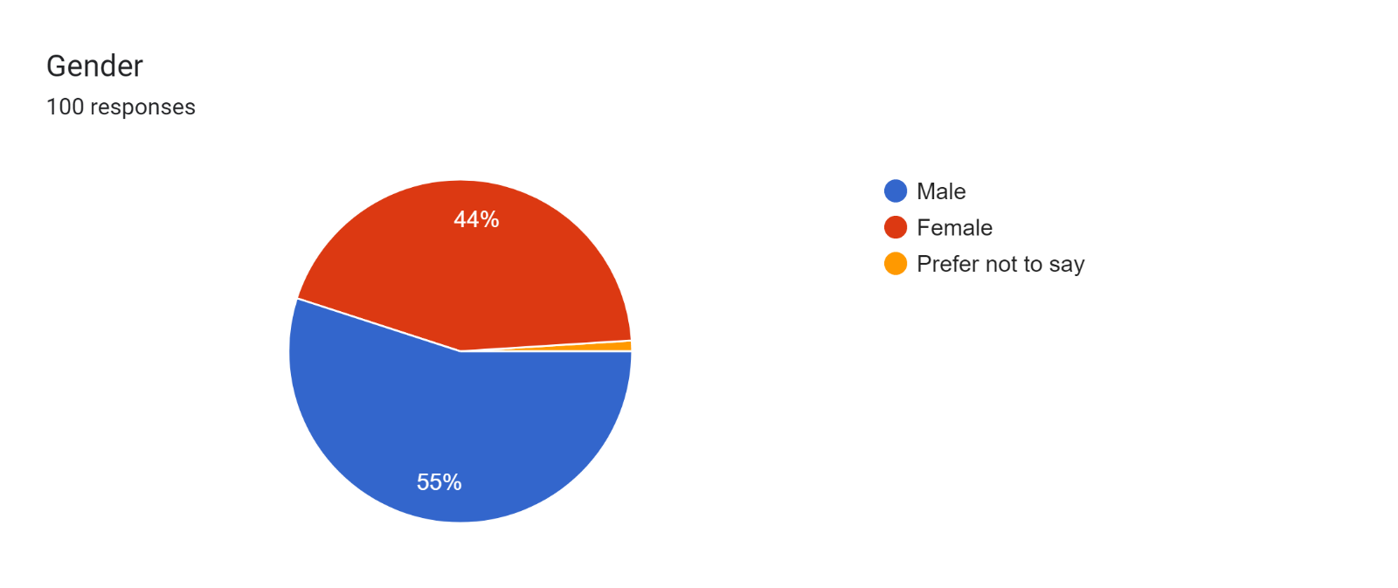

The chart shows 55% of the respondents are of male gender and rest of the respondents are females.

Forms response chart. Question title: How familiar are you with the
(product,price,place,promotion)?. Number of responses: 100 responses.

The pie chart shows that familiarity of the respondents to the marketing mix concept out of 30 respondents 26% are extremely familiar with the concept,40% of them are just familiar with the concept,19% of them are moderately familiar with the concept,11% of them are somewhat familiar with it and rest of the 4% are not at all familiar with the concept of marketing.

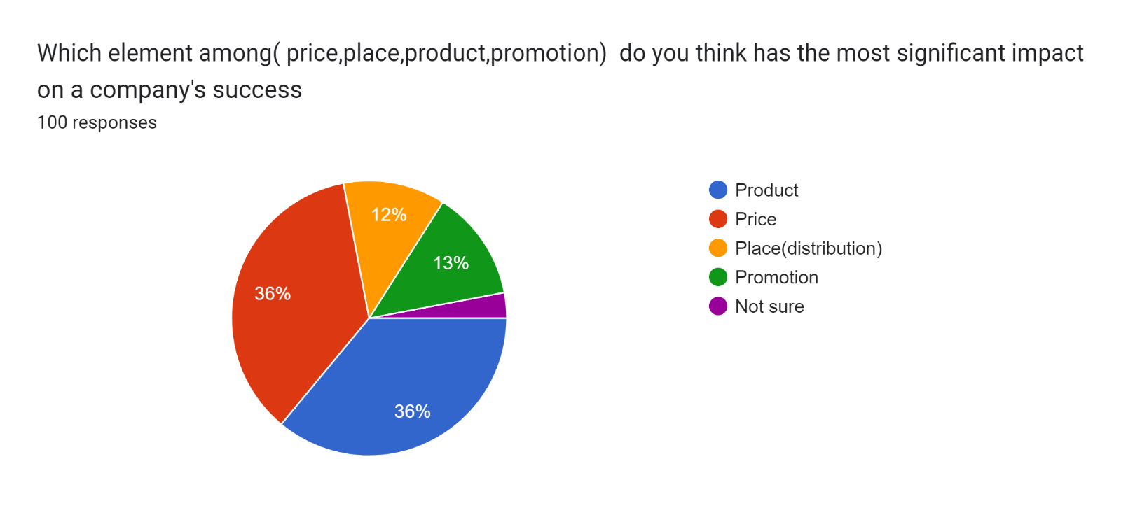

The chart shows element of the marketing which has the most significant impact on a company's success 36% of the respondents think that product is most significant element,36% of the respondents think that price is the most important factor and 13% of the respondents think that promotion is one of the Important factor that impacts on the company’s success, whereas only 12% of respondents feel that place is most significant factor and 3% are not sure.

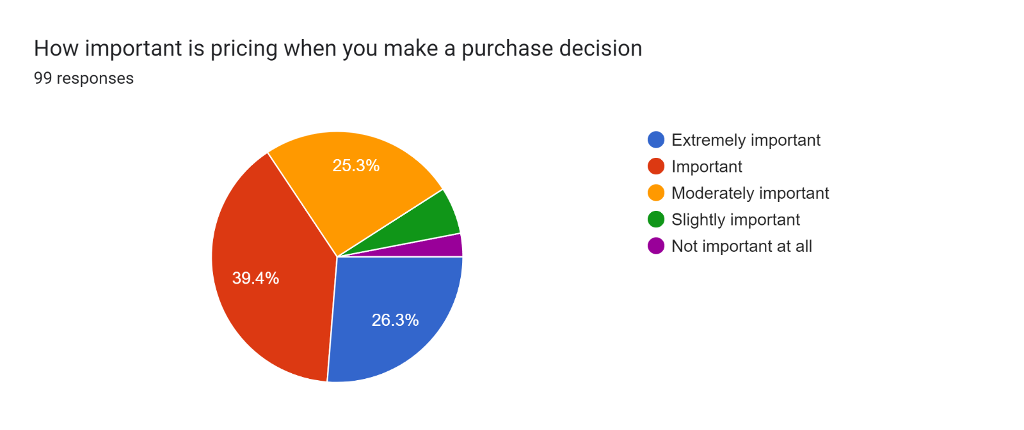

The chart shows the importance of pricing to make a purchase decision 39% of respondents think that it’s just important 26% of them think that it’s extremely important and 25% of the respondents think that it’s just moderately important that the pricing will influence the pricing decision rest all thick either it is slightly important or not at all.

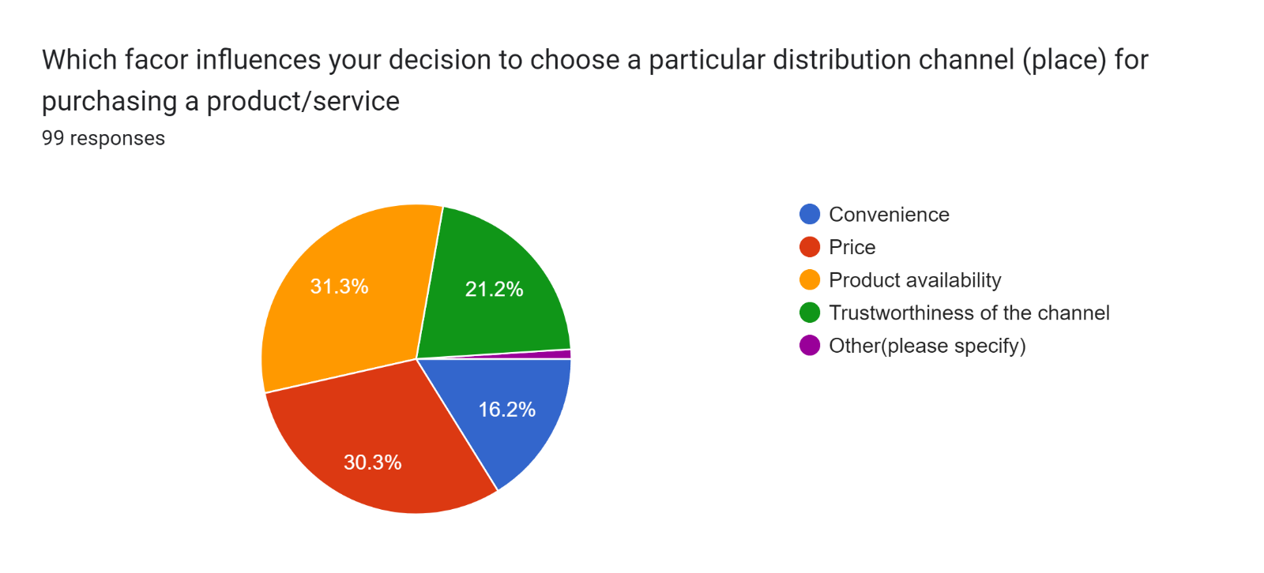

The chart shows factor influences decision to choose a particular distribution channel (place) for purchasing a product/service 30% of respondents think price as influencing factor,31% of respondents think product availability as the influencing factor,21% of them think trustworthiness of the channel as the influencing factor and rest 16% of think that convenience could a factor influencing decision to choose a particular distribution channel for purchasing a product/service.

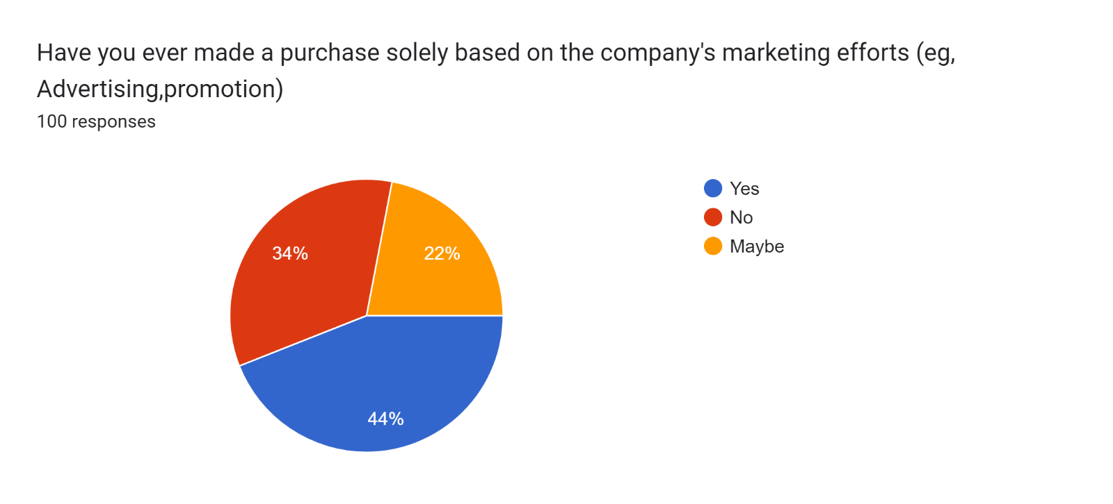

The chart shows purchase solely based on the company's marketing efforts 44% of the respondents agree with it and 34%of the disagree with it rest 22% of them are not sure about it.

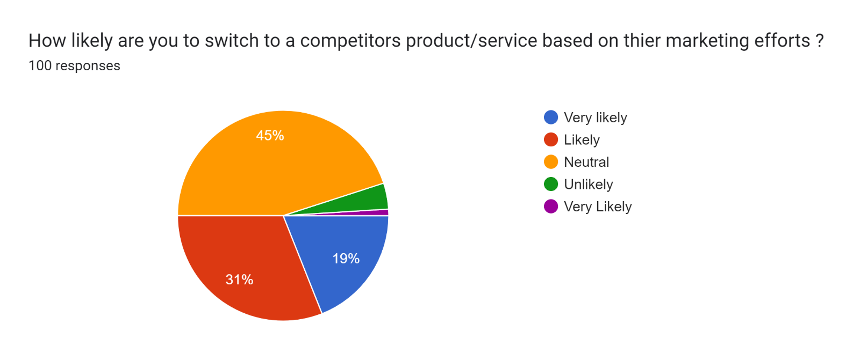

The chart shows that how likely are you to switch to a competitor’s product/service based on their marketing efforts 45% of them have answered as neutral 31% of the respondents are likely to switch

19% of them are very likely to switch based on the marketing efforts whereas remaining are unlikely to switch products or services based on the competitor’s marketing efforts.

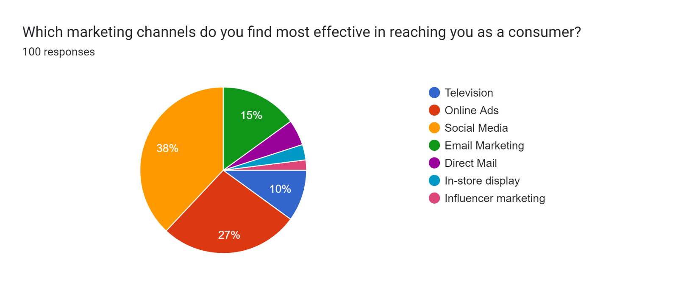

the chart shows that Which marketing channels is most effective in reaching to a consumer 38% of the respondents think that social media is one of the most effective marketing channel to reach a customer,27% of respondents choose online ads,10% of respondents think television if effective channel to reach out a customer and remain of them think that direct mail, in store display and influencer marketing to be effective channels to reaching out a customer.

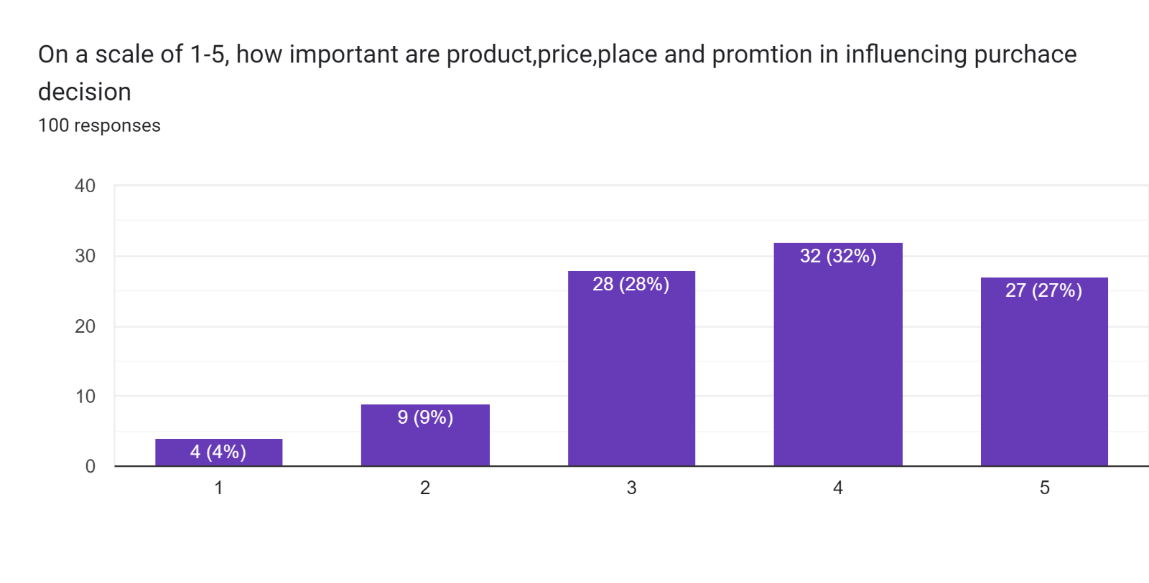

the bar char shows that On a scale of 1-5, how influential is the marketing mix is in shaping a company's overall marketing strategy 28% of them rated as 3,32% of the respondents rated 4,27% of them rated 5 and remaining of them rated 1and 2 on scale of 5

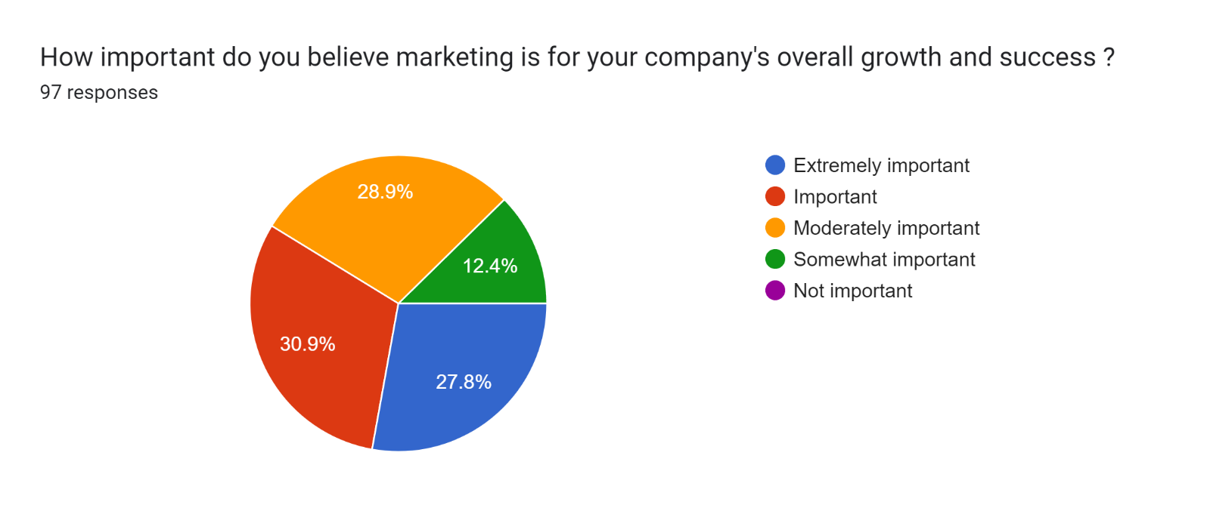

The chart shows the importance of marketing for a company for its overall growth and success 27% of them believe that marketing is extremely important,30% of them believe that its just important,28% of them think its moderately important and remaining 12% of them believe that marketing is somewhat important for company’s overall growth and success.

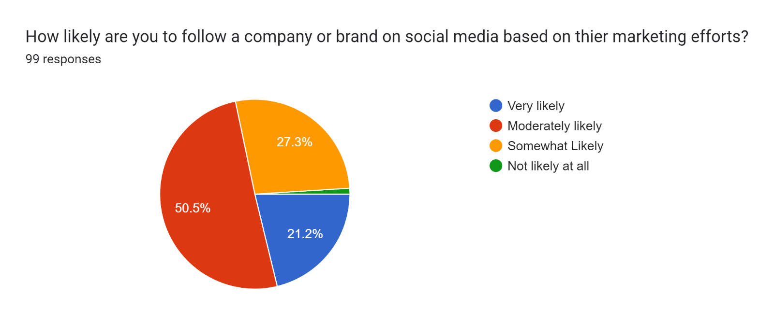

The chart shows that how likely are you to follow a company or brand on social media based on their marketing efforts so 50% of them moderately likely to follow ,27% are somewhat likely to follow and 21% of them are very likely to follow a company on social media based on their marketing efforts rest of them are not likely to follow.

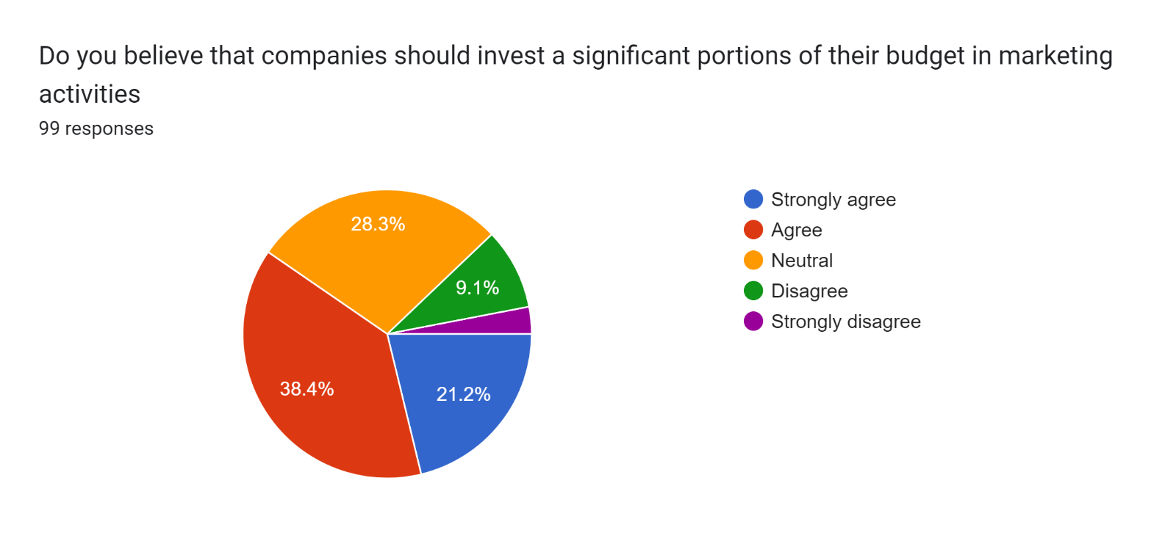

The chart shows that should the companies invest a significant portion of their budget in marketing activities 38% of them agree with the fact that a company should invest,28% of them neither agree or disagree,21% of them strongly agree that the company should invest a significant portion of their budget in marketing and remaining of them disagree.

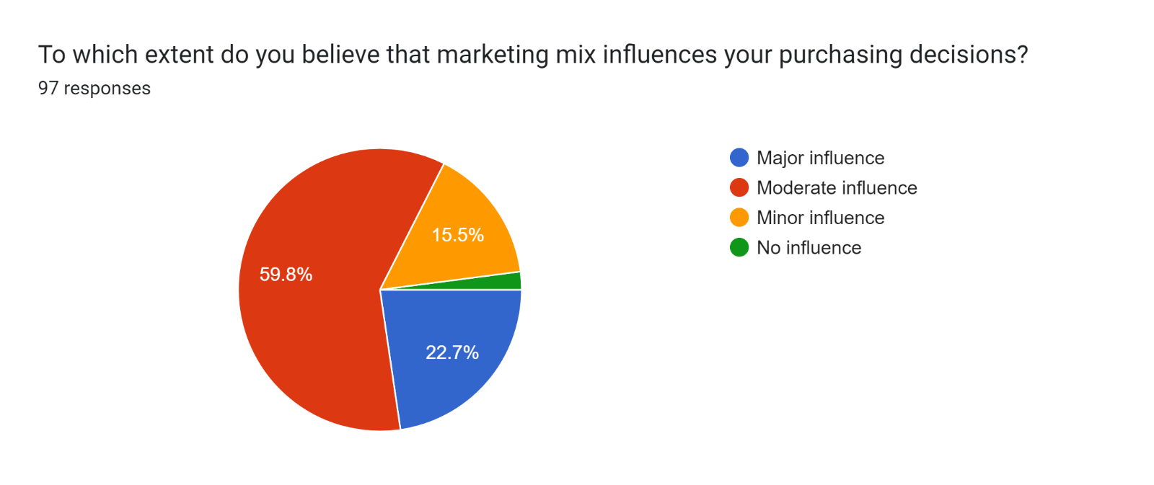

The chart shows the influence of marketing mix on purchasing decision 59% of the respondents think it has a moderate influence on purchase decision,22% of the respondents think it has major influence,15% of them think it has minor influence and rest of them believe that it has no influence and rest of them think it won’t influence.

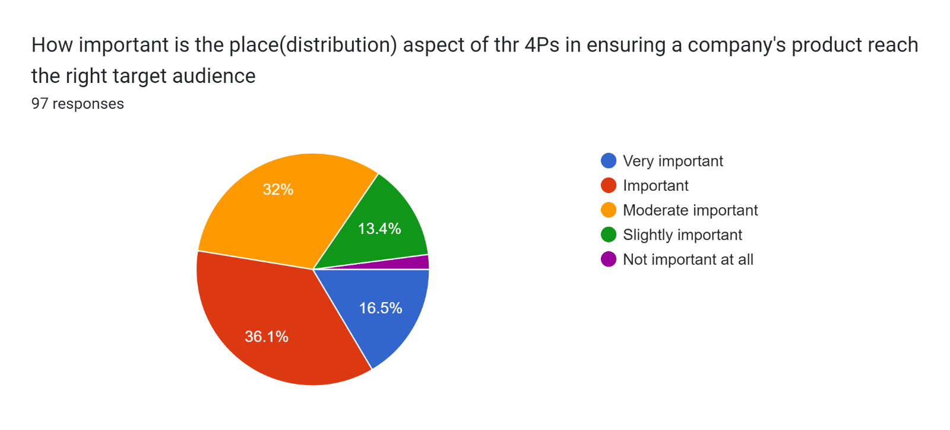

The chart shows the importance of the place(distribution) aspect of the 4Ps in ensuring a company's product reach the right target audience 16% of the respondents think it’s very important and another 36% of them think it’s just important rest of the 32% think that its moderately important and remaining 13% give less importance to it and rest of them think it is not important.

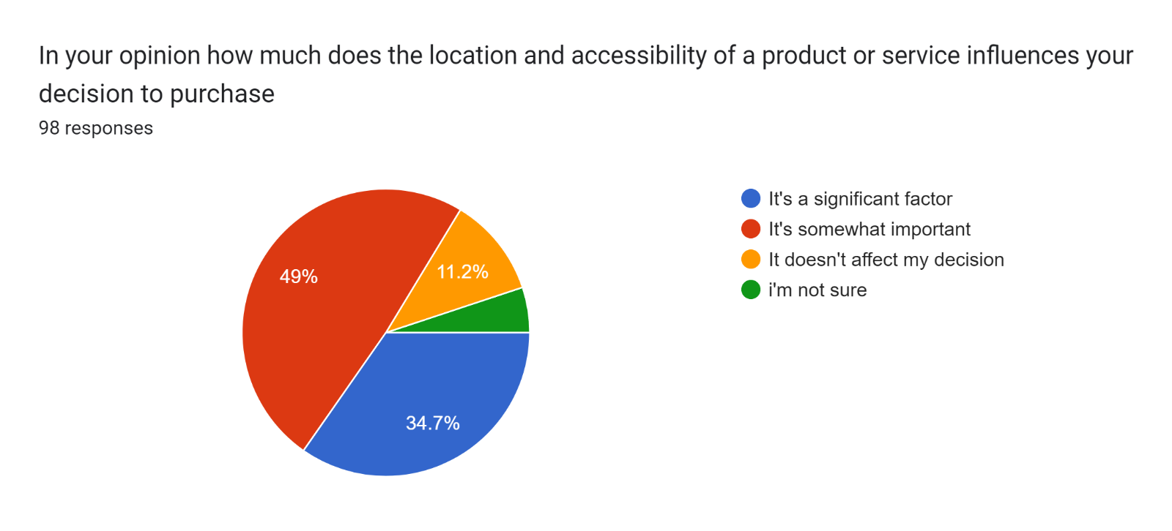

The chart shows how much the location and accessibility of a product or service influences the decision to purchase 49% of them think it’s somewhat important 34% of them think it’s a significant factor ,11% of them are not sure reaming think that it doesn’t affect the decision rest of them are not sure.  
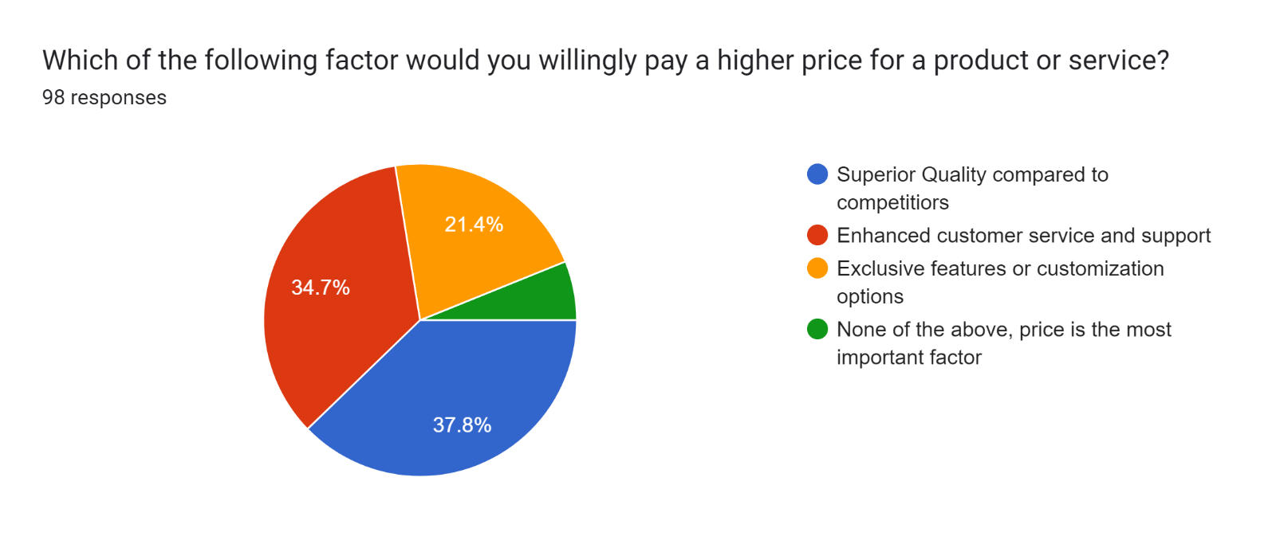

The chart shows the factors for which you would be willingly pay a higher price for a product or service 37% of them choose superior quality compared to competitor ,34% of them choose enhanced customer service and support,21% of them choose exclusive features or customisation options rest of them think price is the most important factor.

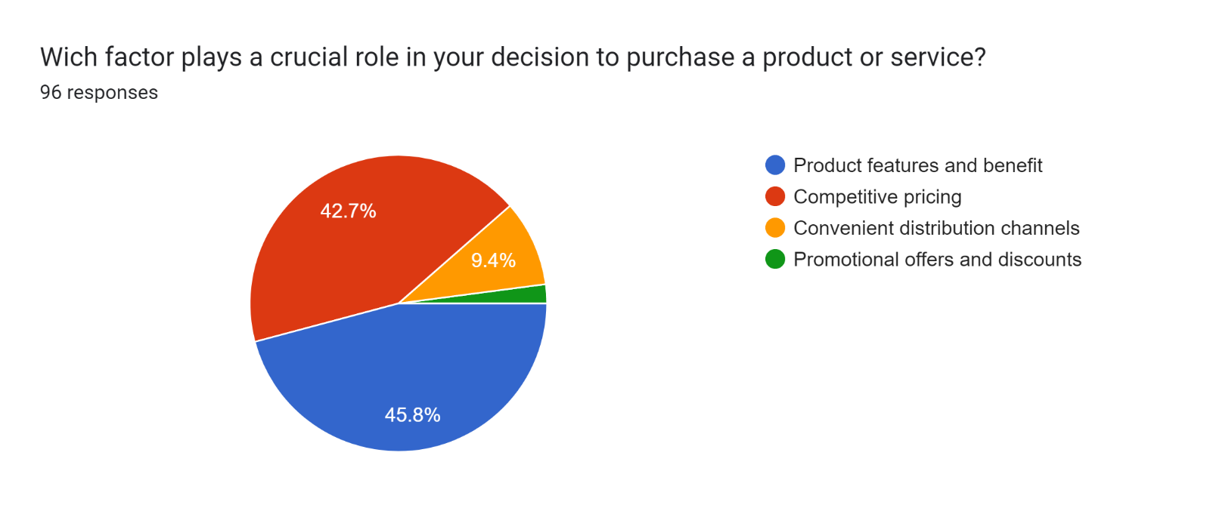

The chart show Which factors plays a crucial role in decision to purchase a product or service according to 45% of them product features and benefits play a crucial role,42% of them believe that competitive pricing play a crucial role in decision of purchasing a product and services,9.4% of them think that convenient distribution channels play a crucial role rest of them think that promotional offers and discounts play an important role in decision of purchasing a product or service.

Chapter 5: **summary of findings:**

According to the survey conducted it comes to an understanding that most of the people are familiar with the 4ps of the marketing only few of them are not familiar with it.

* It also denotes that most of the people think that product and price are one of the most important factors for a company’s success.
* The people think that price is very important factor while making a purchase decision.
* According to the survey, price and product availability are two most influencing factor while choosing a particular place.
* So, based on the data collected it shows that most of the people buy product based on a company’s adverting.
* Survey says that social media and online ads are most effective way to reach a customer.
* Survey shows that location could be an important factor for making a purchase of a product.
* According to most of them product features and their benefits play a crucial role in making a decision to purchase a product and service.

**5.2 Suggestions:**

A company should mostly focus on their product and the pricing of the product because even through the quality is compromised price could play a very crucial role for a company.

Social media and online ads could be one of the effective ways to reach customer, but television ads could be one of the best ways to reach out any age group of customers it is one of the platforms which has huge customer base.

Product features and benefits might play a crucial role in purchase decision but promotional strategy and discounts should also be considered as an important factor for making a purchase decision.

**5.3 Conclusion:**

As a result, it could be said that the study of marketing mix strategy demonstrates that a well-designed and integrated approach to product, price, place and promotion is essential for achieving marketing objectives and driving business success. By understanding customer needs, optimizing the marketing mix elements, and adapting to dynamic market conditions, organizations can create a competitive edge and establish long-term customer relationships. Continuous monitoring and adaptation of the marketing mix strategy are crucial to remain relevant and responsive to evolving customer preferences and market trends.

**Bibliography:**

[**https://www.upet.ro/annals/economics/pdf/2011/part4/Palade.pdf**](https://www.upet.ro/annals/economics/pdf/2011/part4/Palade.pdf)

[**https://www.slideshare.net/athiathi3/vtu-final-year-project-report**](https://www.slideshare.net/athiathi3/vtu-final-year-project-report)

[**https://www.coursehero.com/file/83379872/MKTG-2001-MCQ-quizdocx/**](https://www.coursehero.com/file/83379872/MKTG-2001-MCQ-quizdocx/)

[**https://en.wikipedia.org/wiki/Portal:Clothing**](https://en.wikipedia.org/wiki/Portal:Clothing)

[**https://dbpedia.org/resource/Clothing**](https://dbpedia.org/resource/Clothing)

[**https://canadacommons.ca/topics/clothing/**](https://canadacommons.ca/topics/clothing/)

[**https://www.holoniq.com/notes/global-education-technology-market-to-reach-404b-by-2025/**](https://www.holoniq.com/notes/global-education-technology-market-to-reach-404b-by-2025/)[**https://candra.keystoneuniformcap.com/asia/why-is-it-important-to-wear-our-national-dress-in-bhutan**](https://candra.keystoneuniformcap.com/asia/why-is-it-important-to-wear-our-national-dress-in-bhutan)

[**https://www.definitions.net/definition/clothed**](https://www.definitions.net/definition/clothed)

[**https://fr.linkedin.com/company/aavtrasia**](https://fr.linkedin.com/company/aavtrasia)

[**https://catalog.ucdenver.edu/cu-denver/undergraduate/courses-a-z/entp/entp.pdf**](https://catalog.ucdenver.edu/cu-denver/undergraduate/courses-a-z/entp/entp.pdf)

[**https://universe-theme.myshopify.com/blogs/news/delicious-places-to-eat-in-nyc**](https://universe-theme.myshopify.com/blogs/news/delicious-places-to-eat-in-nyc)

[**https://in.linkedin.com/in/jayvyn-punjabi-282905212**](https://in.linkedin.com/in/jayvyn-punjabi-282905212)