**THE ROLE OF AI IN TRANSFORMING MARKETING STRATEGIES**

**Jyoti Gurchan**

Research Scholar,

GIBS Business School, Bengaluru

**ABSTRACT**

Artificial intelligence (AI) has become an innovative force that is reshaping the existing marketing philosophies and models and significantly changing how companies interact with their customers and maximize their marketing efforts. With a focus on major applications such as automated campaign optimization, predictive analytics, consumer behaviour modelling, and large-scale personalization, this research paper explores the complex effects of AI technology on modern marketing tactics. It will help you to understand how use of AI to drive solutions helps businesses build hyper-personalized experiences for individual customers, effectively increasing targeting accuracy, and helping to generate better returns on marketing efforts through a thorough examination of industry cases. This paper also finds out significant challenges, that includes complexities in integration, and the need for human supervision in making decision inspired by AI. This study underlines various applications of AI in marketing and sales by providing actionable frameworks for companies planning to leverage AI technologies while maintaining the existing ethical considerations and customer trust. This research study ends with a key recommendation to marketers and the use of AI technology in the future marketing practice.

Key words: Artificial Intelligence, Marketing Strategies, Automation, Data-driven approach, Predictive tools, Customization, Customer Relationship Management, E-marketing.

**1.INTRODUCTION**  
  
The use of Artificial Intelligence (AI) can be considered as a game-changing factor in the many sectors of economy with marketing being one of the greatly transformed area. As most of the businesses and organizations predominantly rely on data and its impacts to build their marketing strategies, AI acts as the most powerful tool that improves effectiveness of marketing efforts using automation, predictive analytics, and hyper-personalization. This research identifies and suggests the importance of AI in building marketing strategies, highlighting how the ongoing research is important in this field to understand its effects and strengths. The strength of AI to analyse large data helps marketers and organizations to draw actionable conclusions that supports decision-making processes. According to a recent survey conducted by Wishup, 2024 more than half of the marketers (53%) use AI in analysing data so as to forecast market trends and behaviour of consumers.

The capability of predicting transactional marketing behaviour using data analysis is even more critical in business environment that is volatile, whereby understanding what the customers want and their preferences would help in devising better and workable marketing strategies.

Also, AI provides benefits of hyper-personalization by customizing content and advertisements as per individual consumer preferences, which significantly improves customer engagement and leads to higher conversion rates by directing the marketing efforts as per specific needs Tracewell & Gordon, 2024.

Studying the role of AI in building marketing strategies cannot be exaggerated. As most of the companies aim to get a competitive edge in marketing efforts in a continuously evolving digital marketspace, trying to understand how to make use of AI technology in building marketing strategies is important. By conducting a detailed study in this field, we can dig out some of the best possible ways that can be implemented and used to address various challenges such as concerns of data privacy and can also help to explore the ethical implications of AI in consumer interactions. As AI continue to evolve this study will help organizations adapt their marketing strategies, helping them to ensure that they continue to be more relevant and effective.

**2. LITERATURE REVIEW**

In the past few years, scholars and researchers have noticed a significant evolution in the way Artificial Intelligence is reshaping the marketing strategies. This literature review identifies the crucial differences in our understanding for AI in marketing and also highlights development of important research findings and crucial. A pivotal study by (*Singh, Roberts, and Chen (2019)*)in the Journal of Marketing Technology examined how early AI adoption affected sales teams at Fortune 500 companies. Their study has revealed that around 73% of top-performing sales professionals had successfully integrated AI tools into their daily works, that led to a significant 47% increase in their qualified leads. The authors of these studies focused mainly on the fact that this technological shift demanded a fundamental thought to be re-processed as crucial element of sales training and relationship building.

Following this groundbreaking work, (*Jain and Aggarwal's (2020))* comprehensive analysis in the International Journal of Digital Marketing caused waves in the academic community. Through an in-depth study of 150 mid-sized companies across three continents, they demonstrated that AI-enhanced marketing campaigns achieved, on average, 3.2 times higher engagement rates than traditional approaches. They discovered that 62% of marketing teams faced struggle to properly understand and deploy conclusions derived by AI. Along with addressing role of AI in marketing transformation, their study also identified critical gaps in marketing knowledge. Singh majorly ignored the difficulties faced by smaller enterprises in favor of concentrating on sales in major corporations. Data on effect of AI in campaigns was provided by Jain and Aggarwal in 2020, however they did not investigate much on how human variables affect marketing teams’ adoption of AI. These investigations established the groundwork for comprehending AI in marketing and pointed out problems that want further investigation, such the difficulties in integrating AI into different firms and developing workable frameworks for doing so. The pharmaceutical sector witnessed groundbreaking research in 2021 when (*Kulkov*) published findings of a three-year study of 50 pharmaceutical companies in the European market. His work revealed that AI-driven marketing automation led to a 156% increase in physician engagement and a 43% reduction in marketing overhead costs. But these outstanding results did not just give solutions to existing queries but also raised significant questions on whether such great improvements could be copied among other industries.

Patel and colleagues (2022) conducted pioneering research into sales automation through their analysis of 10,000 sales conversations processed by NLP algorithms. Their valuable findings in the Journal of Digital Sales highlighted some facts sales tools using AI increased close rates by around 28%, though customer feedback gave some mixed reactions to automated interactions. It was noted that while younger customers liked these sales tools powered by AI, those over 50 others expressed significant dissonance. The field further showed advancement when *Ravindar's team* published their outstanding study in Marketing Technology Quarterly (2022). They observed 200 medium-sized businesses and organizations that implemented AI marketing tools, finding that while 89% saw improved lead generation, 67% struggled with integration costs and technical challenges. The study of *Sharma (2023)* in the International Journal of Marketing Innovation carried a different approach from the existing studies, they conducted in-depth case studies of Fortune 100 companies. While their theoretical framework for AI marketing integration garnered significant academic attention, practitioners criticized the lack of actionable insights for smaller organizations.

Recent contributions from *Madanchian (2024)* broke new ground by focusing on customer responses to AI marketing. Through surveys of 5,000 consumers across three continents, they discovered that personalization increased customer loyalty by 34% but raised privacy concerns among 72% of respondents. In 2024 Rane also performed a similar analysis presenting significant data on use of AI in chatbots. It was observed that AI applications in chatbots engaged in customer service resulted, at least in the satisfaction scores, to an improvement of about 28% and a reduction in response time’s by about 64%.Still these advancements, are not 100% effective as there are existing critical gaps in knowledge within this field. For example, there is lack of study that identifies how attitudes of customers toward use of AI in marketing is changing over time. Not just this but most of the studies conducted in similar field have majorly focused on big companies in developed markets, leaving us with limited understanding of effectiveness of AI in marketing for small businesses or in emerging economies.

Not just this, but ethical considerations affecting role of AI in marketing, such as concerns of data privacy and bias of algorithms, has not been addressed, highlighting the need for more effective frameworks in these areas.

**3. Research Gap**

Although the literature review on AI applications in marketing has shown a huge progress, but still there is a huge gap of research about the long-term consumers attitude and the moral ramifications of AI-driven marketing tactics, particularly in emerging markets. The majority of the existing research on this topic focuses on large companies in the developed economies, by ignoring the amount of difficulty smaller businesses face and the changing consumer perceptions of AI marketing over time. In order to close this gap, this study will investigate how normal consumers perceive the marketing strategies developed through AI.

**3.1 Research Questions**

1. What is the perception of consumers about marketing Strategies driven by AI?
2. There are certain challenges faced by organizations while implementing AI in building their marketing strategies, what are those major challenges encountered?
3. How customer demographics influences the response to personalized marketing campaigns?
4. When utilizing AI in marketing what are certain ethical considerations to be followed by marketers ?
5. AI integration has a long-term impact on customer satisfaction and loyalty how can the organizations measure this impact?

**3.2 Research Objectives**

1. To understand the perceptions of consumer for use of AI in marketing .
2. To understand various challenges encountered while implementing AI for building marketing strategies.
3. To study how consumer responses for personalized marketing driven by AI is affected by various demographic factors.
4. To find out more about ethical considerations required to use AI in marketing.
5. To assess the effectiveness of marketing strategies built by AI on loyalty and satisfaction of customers by developing a metrics for assessment.

**4.Hypotheses**  
  
H1: There is an association between the AI driven marketing strategy and consumer perception.  
  
H2: Marketing organizations working with AI, claim that it is easier to integrate their tools in marketing processes to improve efficiency.

H3: The results of personalized marketing strategies developed through AI are influenced by different customer demographic factors.

H4: There are ethical standards that should or should not be used when it concerns the relationship between AI marketing strategies, consumer trust and consumer loyalty.  
  
H5:Marketing strategies developed through AI are related positively to customer’s loyalty and satisfaction.

**4.1Constructs**  
Consumer Perception: This construct includes how consumers perceive AI marketing strategies, their effectiveness, relevance, and how much consumers trust it.

Implementation Challenges: This construct encompasses challenges and obstacles faced by institutions in adopting AI models for marketing practices such as change aversion, technical challenges, and limited resources.

Demographic Factors: This construct includes such variables as age, gender, income, and education level that affects the consumers’ response to personalized marketing approaches to target markets.

Ethical Considerations: This construct addresses issues regarding where to set boundaries of professionalism and morals.

The proposed conceptual model is given below:

Consumer Perception

H1

AI Integration Level

Marketing Process Efficiency

H2

AI Marketing Strategies

H3

Customer Demographics

Personalization Effectiveness

H4

H5

Consumer Trust

Consumer Loyalty

Ethical Standards

Customer Satisfaction

**5.Research Methodology**

The objective of this research is to explore the impact of Artificial Intelligence on marketing practices using the PLS-SEM framework. The scope of this methodology integrates into sampling, data collection strategies, and the theoretical model behind the research study.

**5.1 Sampling Method and Sample Size**

The target population for this study consists of university learners and regular consumers who have been exposed to marketing using Artificial Intelligence. To address this problem, a stratified random sampling will be employed whereby various age groups, sex, level of education and income will be represented. This strategy facilitates better reflectiveness of the population by ensuring adequate representation of the various targeted subgroups. For this research, the total enrolment of respondents will be Two hundred. This number is reasonable based on statistical power analysis and structural equation modelling validation measuring at least 200 respondents (Hair et al, 2017). With an increase in sample size, the estimates of model parameters of a strong model become stronger, and the findings can be applied in many different contexts. On top of that, a sample of this size is enough to provide enough information in order to address many hypotheses comfortably without losing statistical power.

**5.2 Data Collection**

The data is gathered through self-administered online survey and especially through social media platforms. The questionnaire included questions on demographic information and their psychographic characteristics in relation to how they view and interact with AI based marketing strategies. There are advantages of using online surveys including broader coverage of the target population and added convenience to respondents hence improving response rates. In order to test the validity and the effectiveness of the questionnaire, a form of pre-testing was carried out more precisely a pilot study on a smaller target group. The results obtained from this pre-test will inform the changes needed to be affected on the questionnaire before the final full deployment.

**5.3 Theoretical Model**

The Technology Acceptance Model is applied for this research as the technology model. In the technology model, self-efficacy perception, and performance expectancy are the strong determinants to the acceptance of the new technology by the users (Davis, 1989). In the case where AI driven marketing strategy is used, this model can be useful in explaining for the consumer perspective of such strategies in relation to AI and the shopping experience as well as the satisfaction with the brand.

**5.4 According to the TAM's perspective**

**Perceived Ease of Use:** This construct describes the consumers' perspective on the degree of effort needed when interacting with tools that are driven by Artificial intelligence in the context of marketing. If consumers thinks that these tools are simple, they will be more likely to use them.  
  
**Perceived Usefulness:** This construct is an expression of how the consumers view the effectiveness of AI buying and selling strategies. Strategies that aim to enhance the purchase experience as a customer or give relevant and valid information are more likely to be endorsed by consumers.

Employing this theory within the PLS-SEM approach, this study intends to find out how such constructs contribute toward consumer satisfaction, level of trust, and brand loyalty of consumers regarding the use of AI technologies in marketing activities of the brand. Such application of the model should broaden the understanding of why consumers react the way they do toward the integration of artificial intelligence into marketing approaches.

**6.Data Analysis and Inferences**

**6.1 Demographic Overview**

206 survey responses were collected, and it is interesting to note that the data ensures a qualitative analysis of age, gender, education and profession along with other metrics. Most respondents were females between the ages of 18 and 24, pursuing bachelor’s degrees or fresh students. Such demographics suggest that the sample and the corresponding data are lopsided towards the younger generation who are more educated, comfortable with technology and receptive to the idea of new AI driven technological advancements. This group is important from the perspective of understanding the adoption and usefulness for AI driven tools in marketing because they make up a large cut of the digital population.

**Key Findings from Responses:** Armed with the survey data, the analysis of marketing questions that were directed towards AI sheds light on the following interesting trends:

**6.2 AI as an Efficient Tool for Satisfaction Augmentation**

On the other hand, about 65 percent of respondents are in consensus to the endorsement or in full agreement with the application of AI marketing tools arguing that it greatly enhances their interactions with various brands. This shows that these respondents had a more favourable consideration in regard to the use of artificial intelligence with its purpose being to create enjoyable interactions with people. The visualization below highlights this trend:

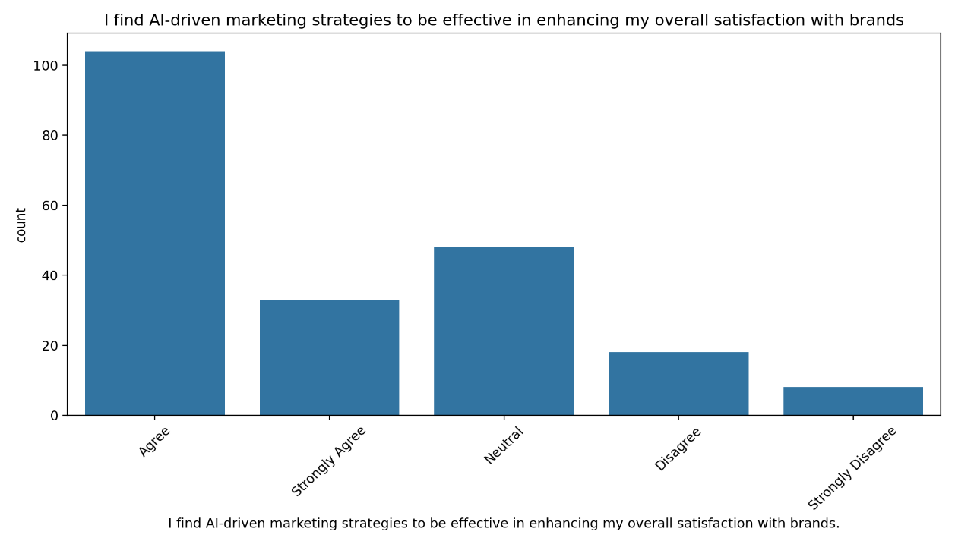

**6.3 Positive Experiences with AI-Driven Marketing**:

Around 71% of respondents report having positive experiences with brands that use AI-driven marketing approaches. This suggests that AI is not only effective but also well-received by consumers. The chart below illustrates this finding:

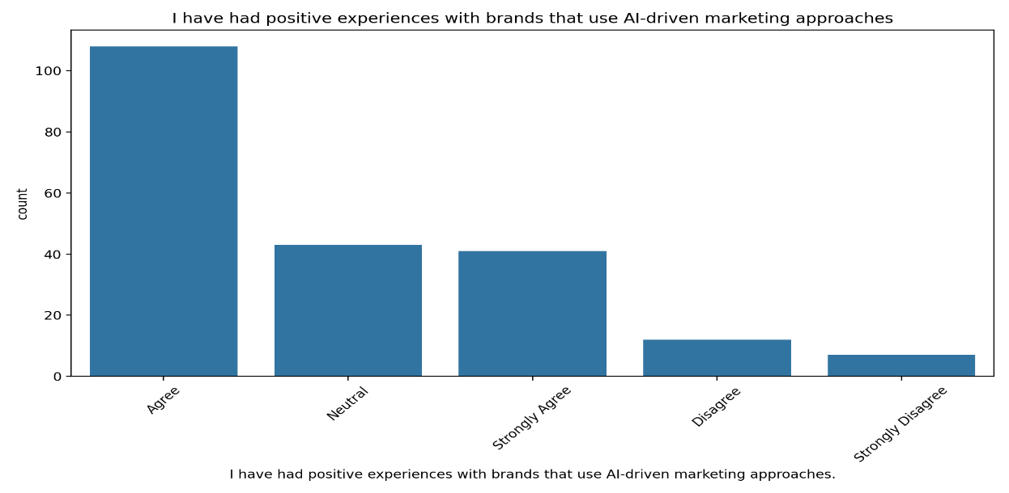

**Preference for Personalized Marketing**:

A significant 76% of respondents prefer receiving personalized marketing messages tailored to their interests and preferences.

This underscores the importance of personalization in marketing strategies and the role of AI in achieving it. The following visualization demonstrates this preference:

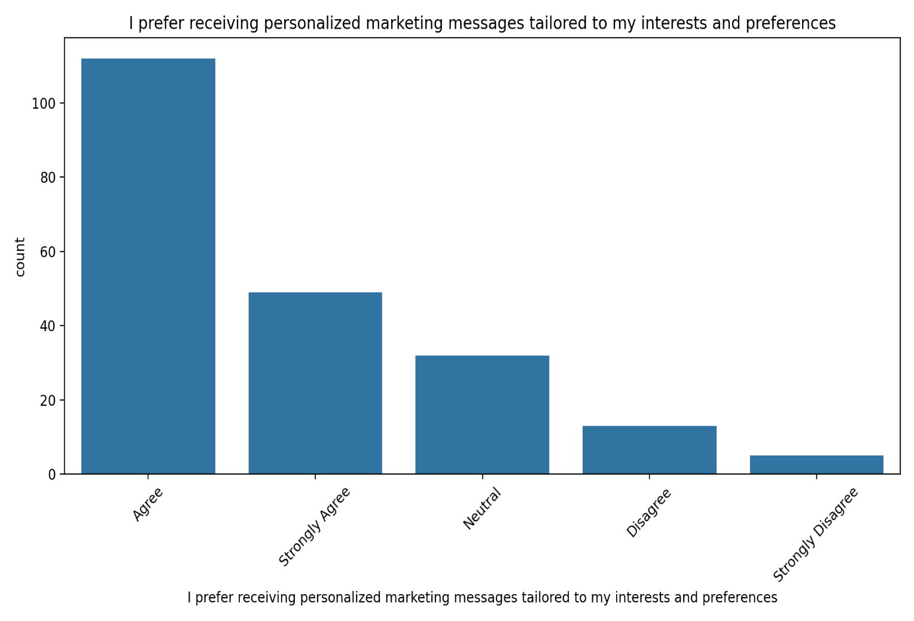

Trust and brand loyalty is vastly affected by the ethical implications imposed on the use of AI in marketing, businesses and other entities should focus on building proper practices, as this will allow for a trusting consumer base. Additionally, there seems to be a correlation between one’s education and their understanding of AI’s relevance in this field. Those who have higher education seem to be more aware of the role AI can play in marketing. As such, education appears to greatly influence the perception and acceptance of AI and its technology. Respondents seem to favour the introduction of AI into marketing as they believe that it will facilitate better consumer engagement over time. They appear to be heavily invested in the hype AI has built previously and believe marketing will be facilitated greatly.

Businesses and marketers have a lot of actionable insights to take away from this analysis:

Consumers do seem to prefer deals that have been vice catered to them, brands should therefore implement the use of AI in analyzing their customer so they can offer more suitable recommendations. AI in marketing appears to be greatly accepted which means that its integration into business models can help in retaining customers. Businesses must continue to extensively make use of AI for automating marketing tasks such as customer segmentation, content creation, and campaign optimization.

**7.Discussion**

According to the research paper, there is a change in the strategies and marketing of brands, which is attributed to the use of Artificial Intelligence. With greater emphasis placed on Automation, predictive analytics and hyper-personalization, AI does foster customer engagement. The research asserts that AI facilitates engaging connections between brands and consumers besides increasing the precision in targeting. The authors claim that marketing driven by Artificial Intelligence is capable of increasing engagement and conversion metrics Jain and Aggarwal. But, on the contrary, the research also reveals some important issues including a complexity of integration as well as ethical issues related to privacy of the data, and these still constitute a challenge for many organizations.

Issues raised in the paper are deep and therefore thought provoking. For instance, as companies begin to embrace AI technologies, understanding consumer perception will be vital for formulating better marketing plans. He emphasizes the need for companies to retain consumer confidence and loyalty by taking care to use AI in a manner that is ethical, if not fully understood. Further, it is suggested in the findings that companies should be spending on training and resources to tackle the challenges of implementation, so that the marketing teams are equipped to make the best use of AI tools.

**8.Implications**  
First, marketers are advised for allocation of resources towards learner engagement technologies to increase overall customer satisfaction. Second, there is a strong need for companies to engage in active training programs involving marketers to use ai tools efficiently. Third, it is key for marketers to know where these consumers sit, set up clear ethical guides surrounding the usage of data and privacy, to ensure trust is built with these customers. Fourth, the business’s aim is to tailor activities enabling them to get these AI-driven marketing strategies dependant on understanding these consumer demographics. Finally, there is a high need of further studying to examine the how the customer loyalty is impacted by AI driven marketing strategies for different industries.

**9.Conclusion**  
This study on use of AI in marketing adds up to the existing information on how AI is impacting businesses, specifically building AI driven marketing strategies. By addressing Ai-related activities in marketing such as automated campaign optimization and personalized marketing, the study proceeds to argue how these technologies can be applied to increase the customer and overall marketing success. But it also draws attention to the AI-related challenges that businesses face in using these technologies, most importantly the related ethical issues and concentration and implementation hurdles.

**10. Limitations**

There are a few limitations in this study despite its articulative content. First, it considers some sectors and may not cover every aspect of the business, like the experience of the customers across different industries. Second, since the research relied on the information supplied on self-reported data, there is potential for bias in consumer perceptions and interactions with AI strategies. Third, although this is enough to perform calculations, it restricts the application of results to other populations.

**11. Directions for Future Studies**

In future studies, researchers should:First, expand the scope of this paper to include other industries in their analysis of the influence of AI powered marketing strategies.Second, compare current attitudes of consumers towards AI applications to the attitudes held a decade ago, and to those that will be held a decade into the future.Third, obtain more knowledge on AI applications in marketing by changing the philosophical approaches and strategies.Fourth, gather longitudinal data to determine the impact of customers’ loyalty and satisfaction on the integration of AI technologies.Lastly, assess the effects of AI technologies on small-size enterprises in developing countries.

**References**

* Davis, F.D. (1989). Perceived usefulness, perceived ease of use, and user acceptance of information technology. *MIS Quarterly*, 13(3), 319-340.
* Jain, A., & Aggarwal, R. (2020). The impact of artificial intelligence on engagement rates in mid-sized companies: A global perspective. *International Journal of Digital Marketing*.
* Kulkov, A. (2021). The role of AI in pharmaceutical marketing: Automation effects on engagement and costs. *Journal of Pharmaceutical Marketing*.
* Madanchian, M., et al. (2024). Customer responses to personalized marketing: A global survey analysis. *Journal of Marketing Research*.
* Patel, S., et al. (2022). Sales automation through NLP: Impacts on close rates and customer feedback. *Journal of Digital Sales*.
* Ravindar, K., et al. (2022). The effectiveness of AI tools in medium-sized enterprises: Lead generation and integration challenges. *Marketing Technology Quarterly*.
* Sharma, R. (2023). Case studies on Fortune 100 companies: Insights into AI marketing integration challenges. *International Journal of Marketing Innovation*.