**Leadership Impact on Team Performance**

**ABHISHEK KUMAR PANDEY**

**PGDM GLOBAL INSTITUTE OF BUSINESS STUDIES**

**Abstract**

Every organization follows the leadership styles to manage its team and bring positive results. On the nature of this work, this research focuses on the correlation between transformational, transactional, and authentic leadership on organizational employee motivation and work productivity.

It shows that transformational behaviour creates commitment and encourages creativity and that transactional behaviour maintains organization performance. It is implicit to mention that when leadership is authentic in a true term, including integrity and trust, the level of satisfaction of the employees is greatly improved. However, practice issues like organizational culture and leading technology present certain influences to the models of leadership. Accordingly, the study suggests targeted development of leadership training programs and the strengthening of supportive organizational climate as the ways for enhancing leadership output and staff involvement.

***Keywords***

*Benevolent management, transformational management, transcendental management, transactional management, team efficiency, staff engagement, corporate personality*

**Introduction**

What make leadership important in organizational frameworks is that it plays a hugely significant role in determining team behaviours, outcomes and actualization of strategies. Leadership behaviours and organisational performance has remained an essential area for scholarly and practitioner research to this day, especially in the dynamic world business environment. Of different leadership styles that are recognized within current literature, there is rather significant focus on authentic leadership as the one that may contribute to and/or enhance staff/co-worker productivity and cohesion. Fundamental to organizational performance is leadership that steers, mobilises and inspires people towards organisational goals. Such steps include; ability to challenge system and resources, promote commitment and collaboration, facilitate the use of the strengths of personnel which leads to increase in competitiveness and organizational sustainability (Northouse, 2021). It is in the midst of global market forces pressure, technological advancements and changing consumer behaviour that leadership is required to guide the teams through the dynamics. Thus, the development of leadership knowledge increased from early trait approaches, which assume that leaders are born with certain inborn abilities, to behavioral approaches that stress the manner in which leaders behave and act (Bass, 1990). Recent leadership theories include; transformation, transactional and servant leadership that have enriched the viewpoints of how leaders influence organizational performance (Avolio et al.; Greenleaf). Among these, authentic leadership gets noticed because it focuses on the ethical behaviour of leaders, self- and other- transparency and the building of positive, strong leader–follower relationships. This paper discusses how genuine leadership enhances organisational values alongside employee trust and organisational self-esteem (Walumbwa et al., 2008). Based on the positive psychological perspective, measure characterized by self-awareness, authenticity, fairness, and having clear and well-developed schema of right and wrong behavior at work (Avolio and Gardner, 2005; Walumbwa et al., 2008). Authentic leadership means that leaders strive to make people accept diversity and treat everyone with courtesy in order to foster highest level of performance among organizational members.

This study investigates the influence of leadership styles, with a focus on authentic leadership, on team productivity and performance within modern organizational settings. By synthesizing insights from existing research and empirical findings, it seeks to uncover how authentic leadership enhances employee engagement, job satisfaction, and overall organizational outcomes. Additionally, the paper examines how external factors, such as organizational culture, technological changes, and economic conditions, shape the connection between authentic leadership practices and team effectiveness.

**Leadership and Organizational Success**

Leadership plays a pivotal role in driving organizational achievement, influencing team interactions, employee engagement, and overall performance outcomes. Over the years, researchers have introduced numerous theories and frameworks to classify leadership styles, offering diverse insights into what constitutes effective leadership in contemporary workplaces.

**Traditional Leadership Theories**

Early explorations into leadership sought to identify innate characteristics that distinguished successful leaders. Pioneers like Stogdill (1948) and Bass (1990) identified attributes such as intelligence, decisiveness, integrity, and sociability as essential traits for leadership effectiveness. Despite their contributions, these trait-centric theories were criticized for oversimplifying leadership by overlooking the importance of situational and contextual factors.

**Behavioral and Situational Approaches**

Behavioral theories shifted the focus from innate traits to observable leader behaviors. Groundbreaking studies from institutions like Ohio State and the University of Michigan introduced two primary leadership behaviors: consideration (emphasizing relationships) and initiating structure (task-oriented actions) (Stogdill, 1948). These frameworks highlighted the balance between interpersonal dynamics and goal achievement, serving as a precursor to situational theories.

Hersey and Blanchard’s (1969) situational leadership model further expanded on this idea, suggesting that effective leaders adapt their approach based on the readiness or maturity of their followers. This theory underscored the importance of flexibility, proposing that leadership effectiveness depends on aligning behaviors with specific situational demands and follower characteristics.

**Transformational and Transactional Leadership**

The transformational leadership model, developed by Burns (1978) and later refined by Bass (1985), brought attention to leaders who inspire and motivate their teams to exceed personal interests for collective goals (Avolio et al., 2004). Transformational leaders leverage vision, charisma, and innovation to drive higher levels of commitment and performance.

On the other hand, transactional leadership emphasizes structured rewards and corrective measures to ensure task completion and organizational order (Bass, 1985). This approach relies on clear expectations, performance monitoring, and a focus on short-term objectives, maintaining efficiency through formalized processes.

**Servant Leadership**

Greenleaf’s (1977) servant leadership model takes a people-centered approach, where the leader prioritizes the needs of others over personal gain. Key principles of servant leadership include empathy, community-building, and a focus on fostering growth among followers (Sendjaya et al., 2008). This leadership style highlights humility and empowerment, cultivating trust and collaboration within teams.

**Authentic Leadership: Foundations and Characteristics**

The concept of authentic leadership has gained traction for its emphasis on ethics, self-awareness, and genuine relationships between leaders and their teams (Avolio & Gardner, 2005). Rooted in positive psychology, this leadership style incorporates transparency, moral integrity, and balanced decision-making (Walumbwa et al., 2008).

Authentic leaders maintain alignment with their core values, openly communicate their thoughts and emotions, and foster trust through honest interactions (Walumbwa et al., 2008). By creating inclusive environments based on mutual respect, authentic leadership encourages employees to feel valued and motivated, driving them to achieve shared organizational goals.

**Impact of Authentic Leadership on Teams**

Empirical studies indicate that authentic leadership positively impacts employee engagement, job satisfaction, and team performance (Gardner & Schermerhorn, 2003). By cultivating trust and loyalty, authentic leaders strengthen commitment and inspire motivation among team members (Walumbwa & Schaubroeck, 2009).

Additionally, authentic leadership promotes an ethical organizational culture that emphasizes shared values, open communication, and collaboration (Walumbwa et al., 2011). When leaders align their personal and organizational values, they foster a cohesive and innovative workplace environment (Gardner et al., 2021).

**Moderating Influences: Culture and Environment**

The effectiveness of authentic leadership is shaped by various environmental and cultural factors. Elements such as organizational culture, technological developments, economic conditions, and workforce diversity play a critical role in determining how authenticity translates into performance outcomes (Zhang et al., 2020).

Demographic diversity, including differences in age, gender, and education, can influence the perception and practice of authentic leadership in multicultural settings (Zhang et al., 2020). Meanwhile, technological advancements and economic changes present both challenges and opportunities for leaders striving to maintain trust and authenticity during times of disruption (Kotzé & Nel, 2017).

**KEY FINDINGS**

This research highlights the profound influence of authentic leadership on organizational dynamics and employee outcomes. A comprehensive review and analysis reveal several key findings that underscore the importance of authentic leadership in today’s workplaces.

One significant finding is that authentic leadership serves as a powerful driver of employee engagement and satisfaction. Leaders who exhibit honesty, transparency, and empathy create environments where employees feel valued and supported. This positive atmosphere not only enhances job satisfaction but also fosters a strong sense of dedication among employees toward achieving organizational objectives.

Teams led by authentic leaders demonstrated substantial improvements in performance. By fostering collaboration, trust, and open communication, these leaders facilitated a unified and effective approach to achieving shared goals. Their emphasis on open dialogue and respect for diverse viewpoints allowed teams to harness their collective strengths, leading to increased productivity and superior performance outcomes.

Authentic leadership also plays a crucial role in shaping and reinforcing organizational culture. Leaders who prioritize ethical behavior and transparency contribute to cultivating a positive culture characterized by integrity and innovation. This strong cultural foundation not only attracts new talent but also helps retain employees who resonate with the organization’s core values, ultimately supporting long-term growth and competitive advantage.

The research highlights the importance of leader-employee relationships as a critical mediator in the impact of authentic leadership. Trust and effective communication were identified as essential components that translate authentic leadership behaviors into measurable improvements in employee performance and organizational outcomes. Leaders who actively build genuine connections with their teams create an empowering environment, enabling employees to thrive and enhancing the organization’s overall resilience.

Additionally, the study underscores the moderating effect of external factors on the relationship between authentic leadership and organizational success. Variables such as economic conditions, organizational culture, and advancements in technology influence how authentic leadership practices are realized within organizations. Leaders who effectively adapt to these external dynamics are better equipped to apply authentic leadership principles, addressing challenges and seizing opportunities in their operating environments

**DATA ANALYSIS**

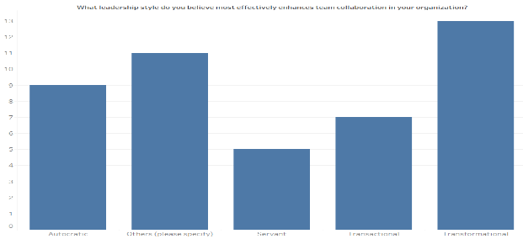

The most preferred leadership style among respondents was Transformational leadership (25.0%), showing that people value leaders who inspire, motivate, and encourage collaboration. Laissez-faire leadership was also popular (21.67%), meaning that some teams appreciate having more autonomy. When it comes to leadership interventions, many people reported seeing positive results "Often" (26.67%) or "Sometimes" (26.67%), suggesting that leadership has an impact, but it may not always be consistent.

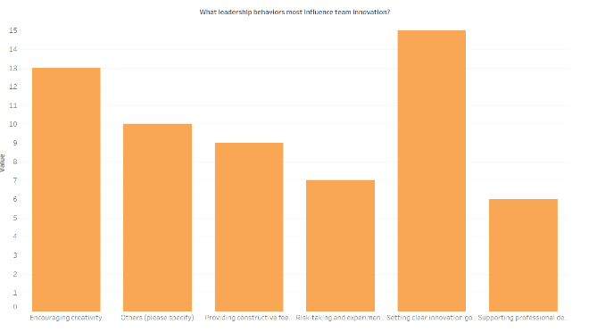

Communication was clearly a key factor in team performance, with 30.0% of respondents saying it is "Very impactful." This shows that clear and effective communication from leaders is essential for a team’s success. On the topic of team morale, the top factor identified was Recognition and rewards (21.67%), meaning employees feel motivated when their efforts are acknowledged. Other important factors include "Empathy and personal support" and "Conflict resolution skills" (both at 18.33%).

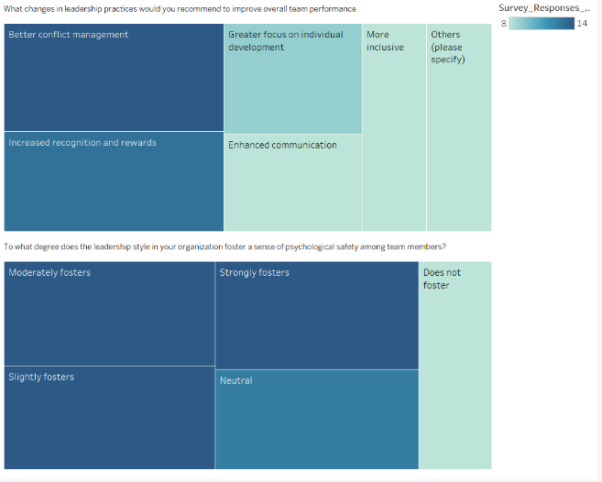

Regarding conflict resolution, while 28.33% said their leaders are "Very effective," a large portion (38.34%) felt that leaders either did not resolve conflicts well or were neutral, indicating room for improvement. The biggest challenge to improving team performance was Resistance to change (23.33%), followed by Communication barriers (18.33%). This highlights that leadership needs to focus on overcoming resistance and improving how they communicate with their teams.

When it comes to balancing task-oriented versus people-oriented leadership, the most common response was Moderately task-oriented (28.33%), but there was a wide range of responses, showing that leaders need to adapt their approach based on the situation. For innovation, leaders who "Set clear innovation goals" (25.0%) and "Encourage creativity" (21.67%) were seen as having the most influence.

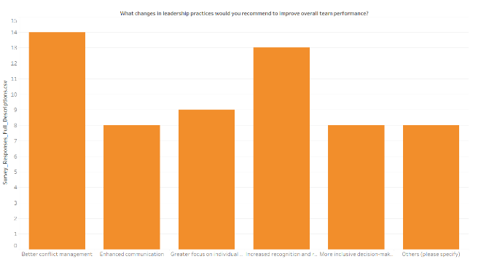

On psychological safety, responses were mixed. While some respondents felt that leadership "Moderately fosters" or "Strongly fosters" safety (21.67%), 15.0% felt it "Does not foster" safety at all, indicating that more work needs to be done to create an open and safe environment. Finally, when asked what changes in leadership practices could improve performance, Better conflict management (23.33%) and Increased recognition and rewards (21.67%) were the most common suggestions.

**INFERENCES**

The data shows that Transformational leadership is highly valued, likely because it promotes motivation, trust, and teamwork. However, there is also a clear need for leaders to communicate more effectively, recognize and reward their teams, and handle conflicts better. The challenges around Resistance to change and Communication barriers suggest that leaders may need more training in adapting to changing circumstances and improving how they interact with their teams. Psychological safety remains a work in progress, with some teams feeling more secure than others, which highlights a gap in creating a truly open and safe environment for all employees.

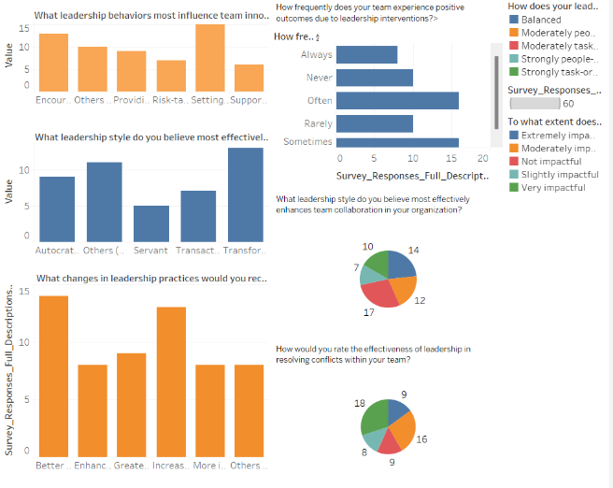

**RECOMMENDATIONS**

To improve leadership effectiveness and To improve leadership effectiveness and ensure long-term organizational success, it is essential to prioritize the development of **Transformational Leadership** skills. By doing so, organizations can cultivate leaders who are better equipped to inspire, motivate, and support their teams. Below are key recommendations:

1. **Invest in Tailored Leadership Development Programs:** Leadership development programs should focus on essential skills such as **emotional intelligence**, **effective communication**, and **ethical decision-making**. These programs will equip leaders to foster trust, inspire innovation, and create a positive and engaging work environment. Leaders should be trained to communicate clearly and consistently, ensuring that their messages resonate with team members and encourage collaboration.
2. **Create Recognition and Rewards Systems:** Implementing a robust recognition and rewards system is crucial for maintaining high employee morale. When employees feel valued, they are more likely to stay engaged, motivated, and aligned with organizational goals. Recognition can be both formal and informal, ensuring that employees' contributions are consistently acknowledged.
3. **Develop Conflict Resolution Skills:** Leaders should be trained to handle conflicts effectively. This includes providing them with tools to resolve disputes in a way that is fair, transparent, and quick. By addressing conflicts efficiently, leaders can help maintain a harmonious and productive team environment, which contributes to overall team morale and performance.
4. **Provide Tools for Managing Change:** Organizations often face resistance to change, whether due to external shifts or internal transitions. Leaders must be equipped with the tools and training to guide their teams through periods of change, ensuring that employees remain adaptable and resilient. Leadership development should include training on managing resistance, fostering a culture of change readiness, and maintaining team motivation during transitions.
5. **Promote Ethical Leadership:** **Ethical leadership** should be a cornerstone of any leadership strategy. Leaders should model integrity and transparency in all their actions, setting a positive example for their teams. By embedding ethical practices at all levels of the organization, businesses can build trust and enhance their reputation with employees, customers, and other stakeholders.
6. **Enhance Employee Engagement:** Strong leadership is key to employee engagement. Leaders should actively engage their teams through open communication, regular feedback, and opportunities for **personal and professional growth**. Empowered employees who feel valued are more motivated to contribute to the organization's success and will exhibit higher levels of job satisfaction and productivity.
7. **Encourage Adaptability:** In today’s fast-paced business environment, leaders must be adaptable in the face of technological advancements and cultural shifts. However, they should maintain authenticity in their approach, ensuring that their leadership style aligns with both the organization’s values and the evolving needs of the workforce. Leaders should be flexible, receptive to new ideas, and committed to continuous learning.
8. **Implement Regular Evaluation and Feedback Mechanisms:** Continuous feedback is essential for leadership development. Organizations should implement regular evaluation systems that allow leaders to assess their performance, identify areas for improvement, and align their practices with organizational values. These assessments will help leaders refine their strategies, stay aligned with the company’s mission, and contribute to a culture of continuous improvement and growth.

**CONCLUSION**

In conclusion, this research highlights the powerful impact of authentic leadership on employee productivity and organizational success. By examining the interplay between leadership behaviors and team dynamics, it becomes clear that authentic leadership—marked by honesty, transparency, and ethical conduct—plays a pivotal role in enhancing employee motivation, engagement, and satisfaction.

Authentic leaders who exhibit self-awareness and empathy foster trust and collaboration, creating a positive work environment that drives both individual and collective performance. The critical role of leader-employee relationships emphasizes the importance of interpersonal connections in translating leadership qualities into measurable outcomes. Additionally, the influence of organizational context, shaped by factors such as demographics, technological shifts, and cultural differences, underscores the need for adaptive leadership strategies.

To leverage the benefits of authentic leadership, organizations should prioritize its cultivation through targeted development programs. These initiatives should emphasize emotional intelligence, ethical decision-making, and fostering trust and transparency, empowering leaders to inspire and support their teams effectively. Ultimately, by aligning leadership practices with employee values and goals, organizations can build a resilient, engaged workforce poised for sustainable growth and innovation in an ever-evolving business environment.Top of FormBottom of Form

**BIBLIOGRAPHY**

1. *Avolio, B. J., & Gardner, W. L. (2005). Authentic leadership development: Getting to the root of positive forms of leadership. The Leadership Quarterly, 16(3), 315-338.*
2. *Avolio, B. J., Bass, B. M., & Jung, D. I. (1999). Re-examining the components of transformational and transactional leadership using the Multifactor Leadership Questionnaire. Journal of Occupational and Organizational Psychology, 72(4), 441-462.*
3. *Bass, B. M. (1985). Leadership and performance beyond expectations. Free Press.*
4. *Bass, B. M. (1990). Bass & Stogdill's handbook of leadership: Theory, research, and managerial applications (3rd ed.). Free Press.*
5. *Burns, J. M. (1978). Leadership. Harper & Row.*
6. *Gardner, W. L., & Schermerhorn, J. R. (2003). Unleashing individual potential: Performance gains through positive organizational behavior and authentic leadership. Organizational Dynamics, 32(3), 270-281.*
7. *Greenleaf, R. K. (1977). Servant leadership: A journey into the nature of legitimate power and greatness. Paulist Press.*
8. *Hersey, P., & Blanchard, K. H. (1969). Management of organizational behavior: Utilizing human resources. Prentice-Hall.*
9. *Kotzé, M., & Nel, P. S. (2017). Authentic leadership and employee well-being in South Africa. SA Journal of Industrial Psychology, 43(1), a1411.*
10. *Northouse, P. G. (2021). Leadership: Theory and practice (9th ed.). Sage Publications.*
11. *Sendjaya, S., Sarros, J. C., & Santora, J. C. (2008). Defining and measuring servant leadership behavior in organizations. Journal of Management Studies, 45(2), 402-424.*
12. *Stogdill, R. M. (1948). Personal factors associated with leadership: A survey of the literature. Journal of Psychology, 25(1), 35-71.*
13. *Walumbwa, F. O., Avolio, B. J., Gardner, W. L., Wernsing, T. S., & Peterson, S. J. (2008). Authentic leadership: Development and validation of a theory-based measure. Journal of Management, 34(1), 89-126.*
14. *Walumbwa, F. O., & Schaubroeck, J. (2009). Leader personality traits and employee voice behavior: Mediating roles of ethical leadership and work group psychological safety. Journal of Applied Psychology, 94(5), 1275-1286.*
15. *Walumbwa, F. O., Wang, P., Wang, H., Schaubroeck, J., & Avolio, B. J. (2010). Psychological processes linking authentic leadership to follower behaviors. Leadership Quarterly, 21(5), 901-914.*
16. *Walumbwa, F. O., Wu, C., & Orwa, B. (2008). Contingent reward transactional leadership, work attitudes, and organizational citizenship behavior: The role of procedural justice climate perceptions and strength. Leadership Quarterly, 19(3), 251-265.*
17. *Zhang, X., & Bartol, K. M. (2010). Linking empowering leadership and employee creativity: The influence of psychological empowerment, intrinsic motivation, and creative process engagement. Academy of Management Journal, 53(1), 107-128.*
18. *Zhang, X., & Waldman, D. A. (2020). A review and synthesis of servant leadership research: Suggestions for future research. Journal of Management, 46(1), 66-94.*