**“**

**RISK**

**-**

**RETURN ANALYSIS WITH RESPECT TO MARKET**

**LINK SECURITIES ESPECIALLY IN THE INTERNATIONAL**

**CURRENCIES AND COMMODITIES MARKET**

**”**

By

**PRASHANT KUMAR**

**PGDM (V**

**Trimester**

**)**

**Reg.**

**No.:**

**23**

**GIBSPGDM**

**136**

Under

the

guidance

of

**P**

**r**

**o**

**f**

**.**

**D**

**HILIPAN**

Project

Report

submitted

in

partial

fulfillment Post Graduate Diploma in

Management

**Global**

**Institute**

**of**

**Business**

**Studies**

**(**

**GIBS),**

**Bangalore Approved by AICTE**



**TABLE OF CONTENTS**

|  |  |  |
| --- | --- | --- |
| **CHAPTER NO** | **INDEX** | **PAGE NO** |
| ***1*** | ***ABSTRACT AND KEYWORDS*** | ***3*** |
| ***2*** | ***INTRODUCTION*** | ***4*** |
| ***3*** | ***FINANCIAL MARKET;FOREX MARKET*** | ***7*** |
| ***4*** | ***LITERATURE REVIEW*** | ***8*** |
| ***5*** | ***RESEARCH METHODOLOGY*** | ***15*** |
| ***6*** | ***DATA ANALYSIS OF QUESTIONNAIRE*** | ***16*** |
| ***7*** | ***KEY FINDING,IMPLICATION AND SUGGESTION*** | ***25*** |
| ***8*** | ***CONCLUSION*** | ***26*** |
| ***9*** | ***REFERENCE*** | ***27*** |
| ***10*** | ***QUESTIONNAIRE*** | ***28*** |

**ABSTRACT**

The dynamic nature of global financial markets has amplified the importance of understanding the intricate relationship between risk and return, especially in market-linked securities (MLSs). These structured financial products provide exposure to diverse asset classes, including international currencies and commodities, offering investors opportunities for enhanced returns. However, such securities also come with unique risks stemming from their inherent complexity and the volatility of the underlying markets. This research paper undertakes a comprehensive analysis of the risk-return profile of MLSs with a focus on forex and commodities markets.

The study begins with a thorough exploration of the structural framework of MLSs, highlighting their characteristics, types, and key features. It then delves into the international currencies market, the largest financial market globally, and the commodities market, which encompasses raw materials and agricultural products. These markets are evaluated in terms of their liquidity, participants, and sensitivity to economic, geopolitical, and market forces.

Quantitative methods such as historical performance analysis, volatility measurement, correlation studies, and scenario-based stress testing are employed to assess the performance and risk factors of MLSs. Particular attention is paid to the influences of exchange rate fluctuations, geopolitical events, and supply-demand imbalances in international currencies and commodities. The findings reveal critical insights into the risk mitigation and return optimization strategies that investors and financial advisors can adopt when incorporating MLSs into their portfolios.

The paper also examines the role of MLSs in portfolio diversification, showing how their inclusion can potentially enhance returns and reduce risks under certain market conditions. This research contributes to the broader understanding of structured financial products and their utility in a rapidly evolving global financial landscape, equipping investors with datadriven insights for informed decision-making.

**Keywords**

Risk-return analysis, market-linked securities (MLSs), forex market, international currencies, commodities market, structured products, portfolio diversification, financial risk management, quantitative analysis, volatility, correlation, economic indicators, geopolitical risk, investment strategies, global financial markets, asset classes, leverage, stress testing.

# INTRODUCTION

In today's dynamic and interconnected financial markets, global financial crisis, international bonds, derivatives, and stock markets have experienced episodes of heightened instability and risk, and investors are constantly seeking opportunities to maximize returns while managing risk. Market-linked securities (MLSs), also known as structured products, especially in Forex trading. Forex Trading is about capturing the changing values of pairs of currencies and has gained popularity as investment vehicles that aim to provide exposure to various asset classes, including international currencies and commodities. These securities offer the potential for higher returns compared to traditional fixed-income instruments, but they also come with unique risks that must be carefully evaluated.

This project report focuses on conducting a comprehensive risk-return analysis of MLSs, with a specific emphasis on those linked to international currencies and commodities markets. The objective is to provide investors and financial professionals with insights into the performance characteristics, risk factors, and potential benefits of these securities.

The report begins by providing an overview of MLSs, including their structure, types, and key features. It then delves into the international currencies and commodities markets, examining their dynamics, trends, and the factors that influence their performance.

International currencies and commodities markets play a vital role in the global financial system, facilitating cross-border trade, investment, and risk management. These markets are characterized by their high liquidity, diverse participants, and sensitivity to economic, political, and market forces.

International Currencies Market: The international currencies market, also known as the foreign exchange (forex) market, is the largest financial market in the world. It involves the buying, selling, and exchanging of currencies from different countries. Key features of the international currencies market include:

* 24/5 trading: The forex market operates 24 hours a day, five days a week, enabling participants to trade currencies across different time zones.
* High liquidity: The forex market is highly liquid, with a large number of participants and a high volume of transactions occurring daily.
* Exchange rate fluctuations: Currency exchange rates are influenced by various factors, such as interest rates, inflation, economic growth, and geopolitical events.
* Majors and exotics: The forex market is divided into major currency pairs (e.g., EUR/USD, GBP/USD) and exotic currency pairs (e.g., USD/ZAR, USD/MXN).

Commodities Market: The commodities market deals with the trading of raw materials and primary agricultural products. It includes a wide range of goods, such as precious metals, energy products, agricultural products, and industrial metals. Key aspects of the commodities market include:

* Standardized contracts: Commodities are traded through standardized contracts, such as futures and options, which specify the quantity, quality, and delivery date of the underlying asset.
* Price discovery: Commodities markets facilitate price discovery, as prices are determined by the interaction of supply and demand forces.
* Hedging and speculation: Commodities markets attract both hedgers, who seek to manage price risk, and speculators, who aim to profit from price movements.
* Economic indicators: Commodity prices often serve as important indicators of global economic health and inflationary pressures.

The core of the report lies in the risk-return analysis, which employs various quantitative methods and tools to assess the historical and expected performance of MLSs. This includes examining return distributions, volatility measures, correlation analysis, and stress testing under different market scenarios. The analysis also takes into account the specific risks associated with international currencies and commodities, such as exchange rate fluctuations, geopolitical events, and supply-demand imbalances.

Risk and Return: Investing in international currencies and commodities markets offers the potential for high returns but also carries significant risks. These include:

* Volatility: Currency exchange rates and commodity prices can be highly volatile, leading to substantial gains or losses.
* Leverage: Many participants in these markets use leverage, amplifying the potential for both profits and losses.
* Geopolitical risks: Political events, such as elections, conflicts, and policy changes, can have a significant impact on currency and commodity prices.
* Market-specific risks: Each currency and commodity has its own set of supply and demand dynamics, which can affect their prices in unique ways.

Furthermore, the report explores the role of MLSs in portfolio diversification and risk management strategies. It examines how these securities can be incorporated into investment portfolios to potentially enhance returns, reduce risk, or achieve specific investment objectives.

The findings of this report aim to provide valuable insights for investors, asset managers, and financial advisors in making informed decisions regarding the inclusion of MLSs in their investment strategies. By understanding the risk-return characteristics of these securities, particularly in the context of international currencies and commodities markets, investors can make more educated choices aligned with their risk tolerance and investment goals.

Overall, this project report contributes to the growing body of knowledge on MLSs and their application in the dynamic landscape of international financial markets. It serves as a comprehensive resource for those seeking to navigate the complexities and opportunities presented by these innovative investment instruments.

# FINANCIAL MARKET: FOREX MARKET

**What Is the Forex Market?**

[The foreig](https://www.investopedia.com/terms/o/otc.asp)n exchange market is where currencies are traded. Its most striking aspect is how it has no central marketplace. Instead, currency trading is done electronically over the counter (OTC). All transactions occur via computer networks among traders worldwide.

The main markets are open 24 hours a day, five days a week. Currencies are traded worldwide, but a lot of the action happens in the major financial centers such as Frankfurt, Hong Kong, London, New York, Paris, Singapore, Sydney, Tokyo, and Zurich. This means the forex market begins in Tokyo and Hong Kong when the U.S. trading day ends. The forex market is highly dynamic at all times, with price quotes changing constantly.

**Key Players in Forex**

* **Banks:** Major players, especially large international banks, facilitate most forex transactions.
* **Commercial Companies:** Businesses involved in international trade use forex to convert currencies for transactions.
* **Central Banks:** Governments use forex markets to influence their exchange rates.
* **Investment Firms & Hedge Funds:** These institutions participate in forex for portfolio diversification and speculation.
* **Retail Investors:** Individuals can also trade forex through brokers, although it carries inherent risks.

**Functions of the Forex Market**

* **Facilitate International Trade:** Businesses can convert their currencies to pay for imports and receive payment for exports.
* **Drive Investment Activities:** Investors can gain exposure to foreign markets by buying or selling currencies.
* **Offer Speculation Opportunities:** Participants can trade currencies based on predictions of future exchange rate movements.

**How Forex Trading Works**

* **Currency Pairs:** Forex trades involve buying one currency and selling another simultaneously. Major pairs like USD/EUR (US Dollar vs. Euro) dominate trading.
* **Exchange Rates:** The value of a currency relative to another is called the exchange rate. It constantly fluctuates based on supply, demand, and various economic factors.
* **Spot vs. Forward Contracts:** Spot transactions involve immediate delivery, while forward contracts lock in an exchange rate for future delivery.

**Factors Affecting Forex Rates**

* **Interest Rates:** Currencies of countries with higher interest rates tend to be stronger.
* **Economic Data:** Economic releases like GDP growth and inflation impact currency valuations.
* **Geopolitical Events:** Political instability or international conflicts can affect currency values.
* **Supply and Demand:** Global economic conditions and investor sentiment influence currency demand.

**Forex Market Risks**

* **Volatility:** Currency values can fluctuate significantly, leading to potential losses.
* **Leverage:** Many forex brokers offer leverage, which can amplify both gains and losses.
* **Counterparty Risk:** There's a risk of default by the other party in an OTC transaction.

# LITERATURE REVIEW

One definition of the commodity future risk premium is the difference between the current futures price and the expected spot price at the time of delivery. Two alternative theories have been developed to explain this form of risk premium. First, according to Keynes (1930), we should anticipate a positive risk premium if investors are providing insurance to producers hedging their physical long positions. For some commodities, this risk premium may be negative if consumers hedging their underlying short positions is more prevalent. Second, there is the theory of storage costs, convenience yield, and the opportunity costs of foregone interest income—see Kaldor (1939), Working (1949), and Brennan (1958). For example, if the commodity is expected to be relatively scarce today compared to the future, the spot price and convenience yield will be high, and the risk premium low.

Martin and Mauer (2003) within the studies paper defined the alternate price threat consequences at the overseas currency which might be precisely identified which has a shorter period. This sort of publicity happens with the relevant changes inside the trade fee all through the time of settlement for a transaction is carried out and with shipping of fee alongside the date of receipt.

Erb and Harvey (2006) showed that individual commodity futures have low correlations with each other, suggesting diversification benefits within the asset class.

Fama and French (1987) find evidence in support of both models, with basis variation in response to storage costs and interest rates; risk premia also varied through time for some agricultural commodities with a range of between 1–2 percent. Kaminsky and Kumar (1990) also find some commodities offering positive risk premia, influenced by macro U.S. variables. Longstaff and Wang (2004) study day-ahead electricity contracts and establish a link between positive risk premia and measures of economic risk faced by market participants. Gorton and Rouwenhorst (2006) use a 45-year sample to show that the collateralized commodity futures risk premium has been equal in size to that of stocks. Kolos and Ronn (2008) find that futures prices are biased predictors of spot energy prices, indicating a non-zero risk price with the sign likely dependent upon the relative balance of hedging investors that are either long or short.

Tang and Xiong (2012) documented increased correlation between commodities and other asset classes since the early 2000s, potentially reducing diversification benefits.

Meese and Rogoff (1983) found that simple random walk models often outperform more complex economic models in predicting exchange rates, highlighting the difficulty in forecasting currency movements.

Kedia and Mozumdar (1999) inspected the part of the traded forex within the publicity of hazard management sports. There was a courting within the publicity of foreign charge exposure with analysis of the denominated debt in foreign forex which became given in a sample of surveys conducted inside the US corporations. Thus the affiliation regarding the forex-denominated debt and the publicity additionally takes location within the character currency level.

Burnside et al. (2011) examined the "forward premium puzzle," showing that high-interest-rate currencies tend to appreciate, contrary to the uncovered interest rate parity theory.

Makar and Huffman (1997) inspected the use of foreign exchange derivatives which have been given significance and being utilized by the corporations within the US to help in handling the currency publicity. The derived outcomes confirmed the foreign exchange derivatives which have been related to overseas forex danger. It had additionally proven that the results have not been a complicated problem for the member states and different industries that turned into associated with specific firms and the recording years. There became evidence where they used different strategies in hedging which had been given.

Menkhoff et al. (2012) demonstrated that currency carry trades deliver significant excess returns, but with substantial crash risk during market turbulence

Far fewer studies have tested the more general ICAPM framework of risk pricing with commodities. Jagannathan (1985) tested the consumption-based ICAPM and the value of the coefficient of relative risk aversion with corn, soybean, and wheat futures. Although the range of estimates was consistent with earlier results using equity returns, they were not statistically significant, even when the sample period or combinations of the dependent variables were changed.

Bessembinder (1992) tests risk pricing integration across asset markets for 22 futures contracts, including six agricultural and five mineral contracts. Risk factors included the U.S. stock market index and six macroeconomic variables similar to those used by Chen, Roll, and Ross (1986), among them unexpected U.S. inflation and the change in real U.S. short-term interest rates. The risk exposure of commodity futures was low and there was very little evidence of non-zero risk pricing, although each commodity’s idiosyncratic risk— conditional on net hedging—had explanatory power for expected returns, consistent with Keynes’ postulation.

Khan, Khoker, and Simin (2008) model the expected return of four commodity futures—oil, natural gas, copper, and gold—as a linear function of systematic risk and two commodity specific factors, hedging pressure and a proxy for the scarcity of the commodity. The betapricing model they estimate suggests that macroeconomic factors have predictive capability for the commodity-specific factors—for example, business conditions may affect inventory holdings (the scarcity proxy). They conclude that the effect of macroeconomic variables on commodities may not only be direct, but indirect through their influence on commodityspecific factors such as hedging pressure.

Ajayi and Mougoue (1996) investigate the short- and long-run relationship between stock prices and exchange rates in eight advanced economies. They find that an increase in stock prices causes the currency to depreciate for both the U.S. and the U.K., Ajayi and Mougoue (1996) explain this as follows: a rising stock market is an indicator of an expanding economy, which goes together with higher inflation expectations. Foreign investors perceive higher inflation negatively. Their demand for the currency drops and it depreciates.

Sjaastad and Scacciavillani (1996) find that when commodities that are traded internationally, a change in any exchange rate will result a change in the prices of those commodities. Solnick (1987) reported a weak positive relationship between changes in the stock returns and changes in the real exchange rates. Giovannini and Jordan (1987) conclude that ex ante returns and exchange rates tend to move together in the U.S.A. Chiang's (1991) study shows evidence that excess returns in the foreign exchange market are correlated with equity market returns. The study conducted by Ong and Izan (1999) shows that there is a weak relationship between exchange rates and stock prices in Australia and the Group of Seven Countries.

Chamberlain, Howe, and Popper (1997) find that the U.S. banking stock returns are very sensitive to exchange rate movements, but not for Japanese banking firms. Ma and Kao (1990) observe that a currency appreciation negatively affects the domestic stock market for an exportdominant country and positively affects the domestic stock market for an import-dominant country, which seems to be consistent with the goods market theory. Granger, Huang and Yang's (2000) work further illustrates that the two markets can jointly affect each other.

Hsing (2004) and Zietz and Pemberton (1990) develop models with monthly data and simultaneously determined macroeconomic variables while Abdalla and Murinde (1997) document that a country's monthly exchange rates tends to lead its stock prices but not the other way around. Pan, Fok&Lui (1999) used daily market data to study the causal relationship between stock prices and exchange rates and found that the exchange rates Granger-cause stock prices with less significant causal relations from stock prices to exchange rate. They also find that the causal relationship have been stronger after the Asian crisis.

Aggarwal (1981) finds that revaluation of the US dollar is positively related to stock market returns. In contrast, when Soenen and Hennigar (1988) considered a different period, they found a significantly negative relationship. Roll (1992), who used daily data over the period 1988e1991, found also a positive relationship between the two markets. On the other hand, Chow et al. (1997) using monthly data for the period 1977-1989 found no relationship for monthly excess stock returns and real exchange rate returns. When repeating the exercise, however, with longer than six months horizons, they found a positive relationship between a strong dollar and stock returns.

Ramasamy and Yeung (2011) shed additional light on the issue of Granger causality between stock prices and exchange rates movement. The aim of this paper is to show the existence of a hit-and-run behaviour in the interaction between SP and EX across 9 selected countries. Bahmani-Oskooee (1992) found bicausality between exchange rates and stock prices for the period July 1973 to December 1988 while Ajayi et al. (1998) reported that stock prices Granger caused exchange rates volatility for the period April 1985 to August 1991. Ma and Kao (1990) attributed the differences in results to the nature of the countries, i.e., whether they were export or import dominant. Morley and Pentecost (2000) argue that the reason for the lack of strong relationship may be due to the exchange controls that were in effect in the 1980s.

Bahmani-Oskooee and Sohrabian (1992) were among the first to use cointegration and Granger causality to explain the direction of movement between exchange rates and stock prices. Rahman and Naziman (2009) investigate the dynamics interactions between exchange rates and stock prices using recent developments in time series modelling. This study investigates whether these national stock markets in the periods are moving in tandem and in equilibrium or they depart permanently from each other in short and long run.

Buchinsky (1998) and Chuang et al. (2009) provide a more complete picture of causal relation between stock returns and exchange rate changes and uncover how this relation varies across different quantiles. Yang (2012) and Hong et al. (2009) and Chuang et al. (2009) extend the test of Koenker and Machado (1999) to evaluate causality in different quantile ranges and to identify the quantile range for which causality is relevant. This approach thus provides a detailed description of the causal relations between exchange rate changes and stock returns.

Griffin et al. (2004) find that equity flows toward a country are mainly driven by the previous day's return in that country's equity market. Thus, it is better to measure interactions between exchange rates and stock prices using high-frequency data, rather than low frequency data. Cumperayot et al. (2006) focus on extreme events, using daily data for 26 developed and emerging markets, including Asian countries such as Japan, India, Indonesia, Korea, Malaysia, Philippines, Taiwan and Thailand. Pan et al. (2007) examine dynamic linkages between exchange rates and stock prices for seven East Asian Countries, excluding China

Different methods of data analysis have been put into use by the researchers in their studies for finding the volatility of stock market and currency market. Granger's causality model, cointegration techniques (particularly Johansen's model) and vector auto regression (VAR) model are the prominent ones that have been used to analyze the data about the stock markets and currency market. However, a number of researchers have used only one or at the most two methods to analyze the data. The studies of Yang et al. (2014), Abdalla and Murinde (1997), Jorion (1990, 1991), Bodnar and Gentry (1993), Bartov and Bodnar (1994), He and Ng (1998), Abdalla and Murinde (1997), Pan, Fok & Lui (1999),Ramasamy and Yeung (2011), Rahman and Naziman (2009), Huang and Yang's (2000), Nath and Samanta (2000) employed Granger Casualty test to explain the direction of movement between exchange rates and stock. Granger's causality model has also been used very extensively by the researchers.

Hsing (2004), Ajayi and Mougoue (1996), Huang and Yang (2000), Chuang et al. (2007) adopt a structural VAR model originally proposed by Sims (1986); using this method allows for the simultaneous determination of several endogenous variables. Bahmani-Oskooee and Sohrabian (1992) were among the first to use cointegration.

Vivek Rajvanshi (2017) in his paper “Commodity Futures Market in India” explained the functioning of futures market and challenges of the futures market. The paper detailed the inception of commodities and their growth to become an alternative class of investment and heading towards financialization. Challenges along with the growth were focused in the study. The study concludes that the Futures market dominates the spot market and the results suggest that inefficiencies in market led to increase in Basis Risk which can be reduced by hedging the commodity futures. The paper also suggests that commodity futures provide transparent price discovery for the traded commodities. Also, the market participants are concerned about the liquidity and higher transaction costs.

BhaskarGoswami, Isita Mukherjee (2015) in the paper “How attractive is the Commodity Futures in India?” compared the return on commodity futures with common stocks, long term government bonds, treasury bills , rate of inflation and detailed that high returns are generally associated with high risk in line with the general theory of risk-return. The standard deviation on real rates of return of commodity futures is same as the standard deviation on nominal rates of return. Results suggest that thought common stocks gave higher return but provided poor hedging during inflation.

Shree Bhagwat, AngadSingh Maravi (2015) in the paper “The Role of Forward Markets

Commission in Indian Commodity Markets” examined the role of Forward Markets Commission. The study included functions, powers and limitations of Forward Markets Commission and the different types of commodities regulated by FMC and the exchanges present are in India are detailed. Results showed important developments of Forward Markets Commission and the need for further improvement is explained. The future plans to be taken by government for improvement in FMC are also mentioned.

M. Venkateswari, G. Ravindran (2014) in the paper “Commodity Derivatives Exchanges in India: A Study of Select Exchanges” analyzed the trend and progress of the commodity national exchanges MCX and NCDEX. The performance of these exchanges is evaluated. The criteria for performance is number of contracts, volume traded and value of the commodities traded and awareness programs conducted. The CAGR of both the exchanges is high and the number of awareness programs conducted for farmers is more than the programs conducted for nonfarmers.

BhaskarGoswami, Isita Mukherjee (2015) in the paper “Risk-Return Analysis of Different

Commodity Futures in Indian Derivative Market” made a comparative analysis of riskreturn on different groups of commodity future and groups of commodity futures. The groups of commodities are agricultural commodity futures, metals, energy and oil and oil related commodity futures. They attempted to study the performance of these futures in the presence of risk-free assets and inflation. Study confirmed the general theory of risk-return. The result suggested that oil & oil related products gave the highest return among all commodity futures but proves to be an ineffective hedge against the inflationary pressure.

E. Kalaivani, Dr. A. Lakshmi (2015) in the paper, “An Overview of the Commodity Risk

Management to the Business Process” studied the impact of commodity risk on business process. It discussed the Commodity Risk Management (CRM), categories of the commodity, and types of commodity risk, commodity and foreign exchange risk. The business‘s financial performance or position will be adversely affected by fluctuations in the prices of commodities. Consumers of commodities such as airlines, transport companies, clothing manufacturers and food manufacturers are primarily exposed to rising prices, which will increase the cost of the commodities they purchase.

Nidhi Aggarwal, Sargam Jain and Susan Thomas (2014) in the paper “Do futures markets help in price discovery and risk management for commodities in India?” examined the price discovery and hedging effectiveness of commodity futures. They concluded that while the commodity future markets were reformed so that futures markets could be substituted for commodity price risk management through price controls by the government, government interventions are the most significant barrier to futures providing good hedging effectiveness against commodity price risk.

S. Selvanathan, Dr. V. Manohar (2013) in the paper “Online Trading- An Insight to Commodities Trade with Special Reference to India” explained the online trading process and the related trends in India. It is concluded that online trading in India has not taken off in spite of the benefits which include low transaction costs, convenience, speed, boundary spanning, improved communication, and risk management. One of the reason quoted for the same was the economic conditions of traders and the study also expects that online trading in commodities will improve with better economic conditions.

# RESEARCH METHODOLOGY

1. **Purpose/Objective of the project:**

Primary Purpose: To analyze the risk-return characteristics of Forex trading among retail investors in India, focusing on identifying key factors influencing trading success and risk management practices.

* + To enhance understanding of the relationship between risk and return in international currencies and commodities markets, to improve investment decision-making, risk management, and market efficiency.
  + To identify and analyze patterns in currency and commodity price movements.
  + To apprehend how volatility occurs in currency derivatives with technical and fundamental analysis assistance.
  + To study forms of currencies traded in the forex market and how they alternate with the help of forex charts, graphs, and other data • To understand the basic fundamentals of the forex market.
  + Learn the trading mechanism of the Forex market.
  + To explore different types of risk (e.g., market risk, liquidity risk, counterparty risk) and their impacts.
  + To develop and evaluate risk management techniques specific to currency and commodity trading.
  + To understand how investor behavior and market sentiment affect risk and return in these markets and the role of psychological factors in trading decisions.
  + Bridge gaps between traditional finance theories and observed market behaviors.

1. **Sampling method, Sample size:**
2. **Geographical coverage (Pune region, Mumbai region, etc)/ Location coverage (Head Office &/or/selected offices, etc): IV. Primary data collection method:**

**1.** Online Survey:

* + - A comprehensive questionnaire distributed via email and Forex trading forums.
    - Will cover aspects such as trading habits, risk perception, strategies used, and demographic information.

**V. Secondary data sources:**

# DATA ANALYSIS

Data Analysis of Questionnaire



29

%

9

%

3

%

27

%

32

%

Education Qualification



Technical analysis



Sentiment analysis



NA



Fundamental analysis



Economic news

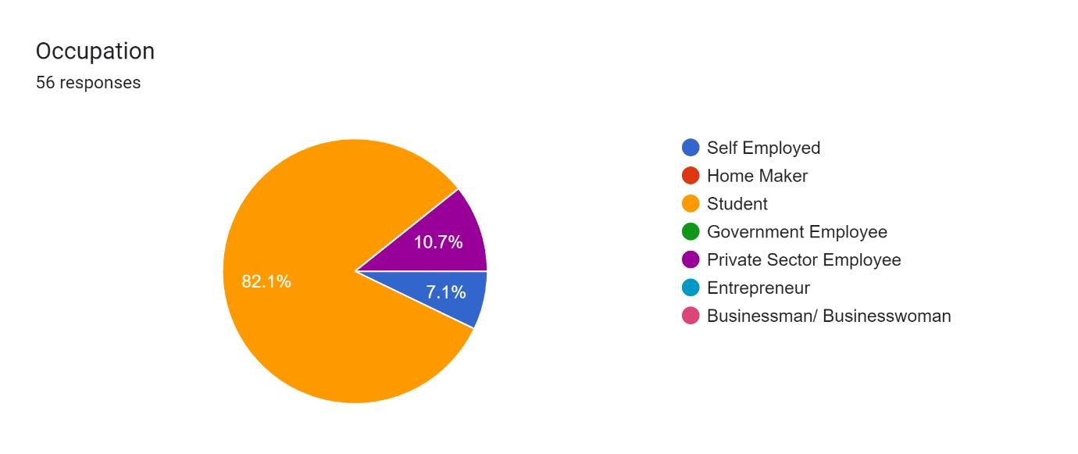

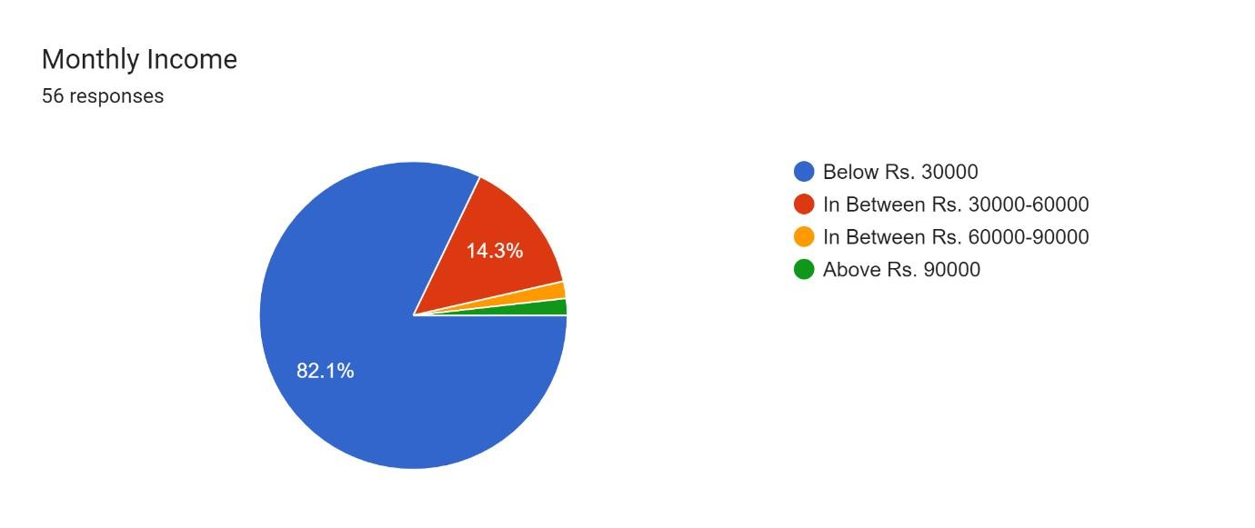

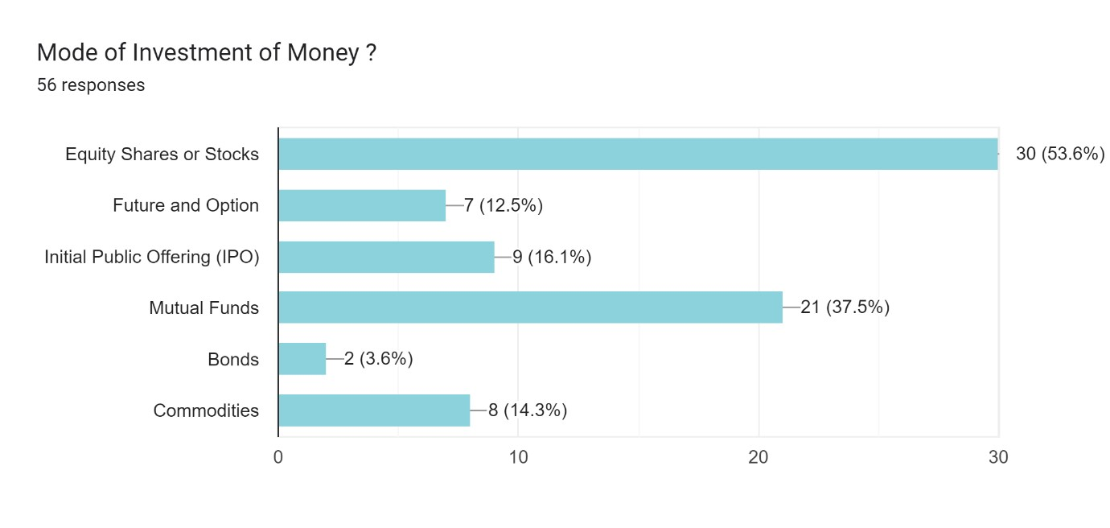

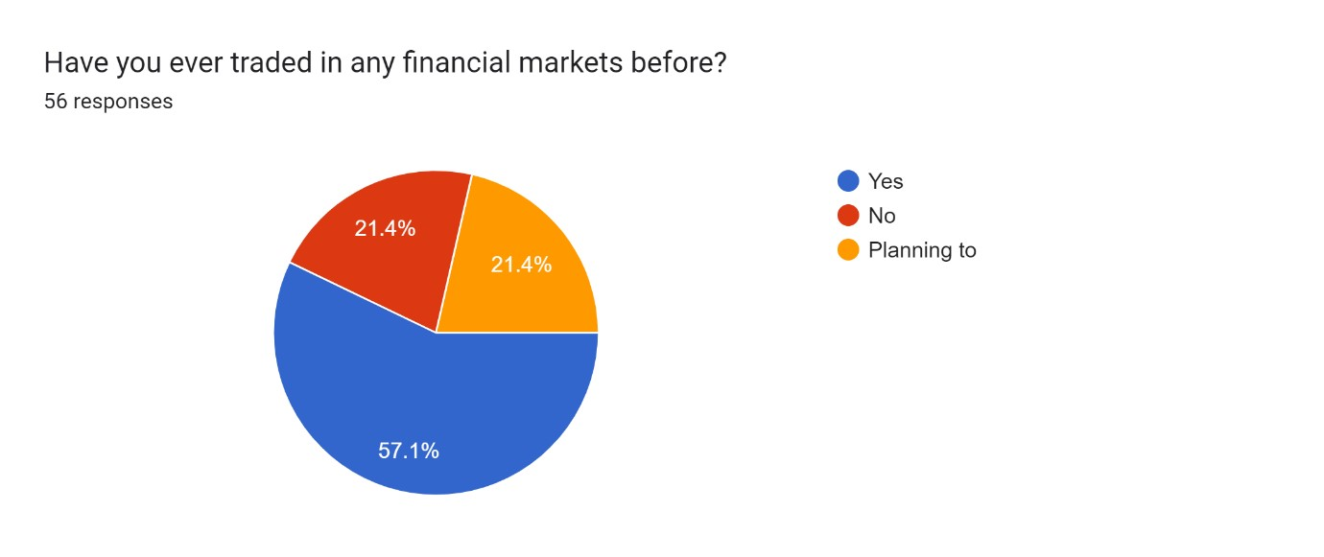

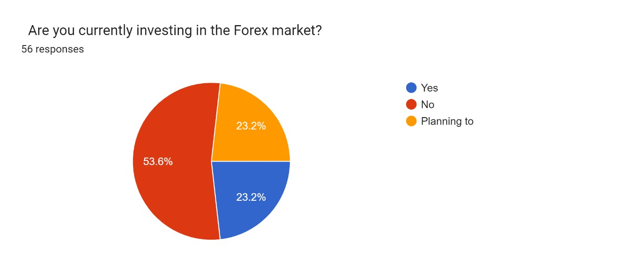

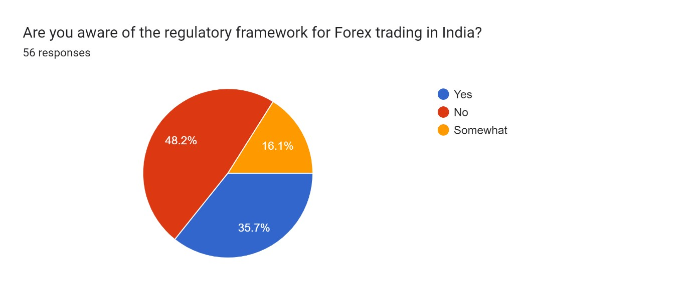

Forms response chart. Question title:   What is your primary goal for investing in forex?  
. Number of responses: 56 responses.

Forms response chart. Question title:   How long have you been investing in Forex?
. Number of responses: 56 responses.

Forms response chart. Question title: How would you rate your current knowledge of forex trading?   
. Number of responses: 56 responses.

Forms response chart. Question title: How much capital are you planning to start with in forex trading?   
. Number of responses: 56 responses.

Forms response chart. Question title: How much of your investment portfolio is allocated to Forex? 
. Number of responses: 56 responses.

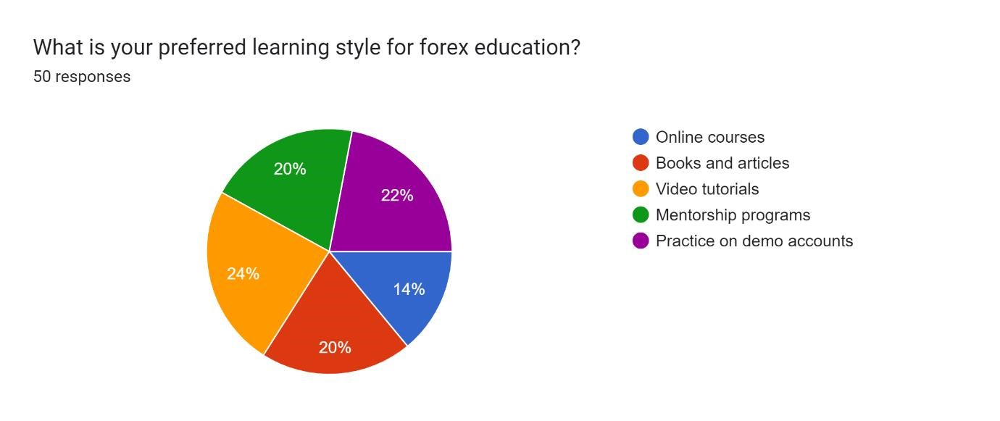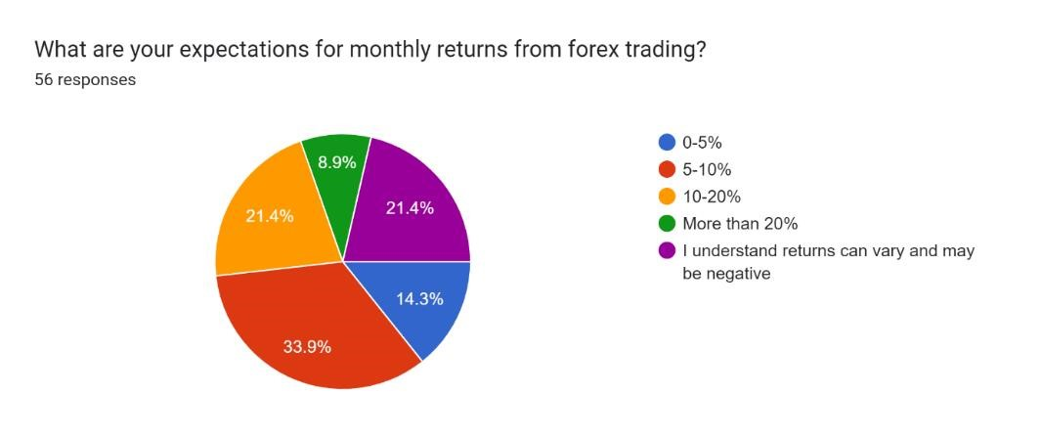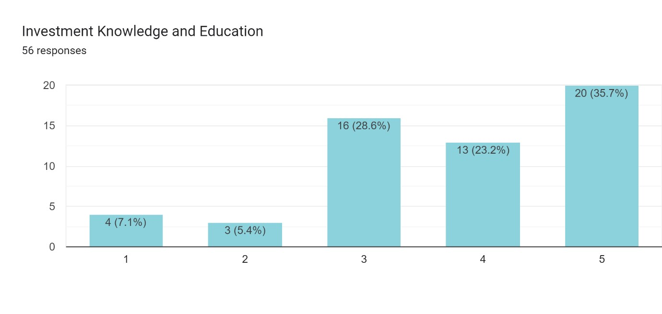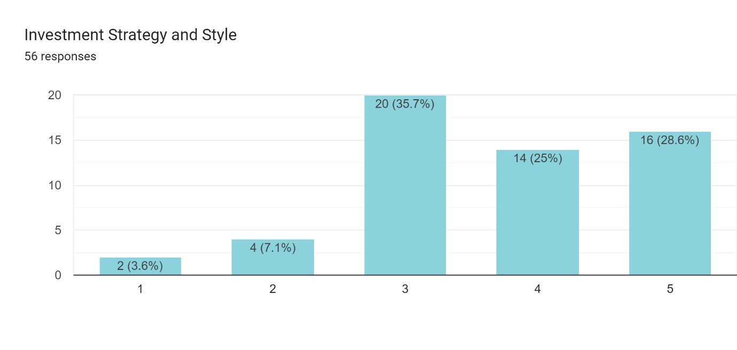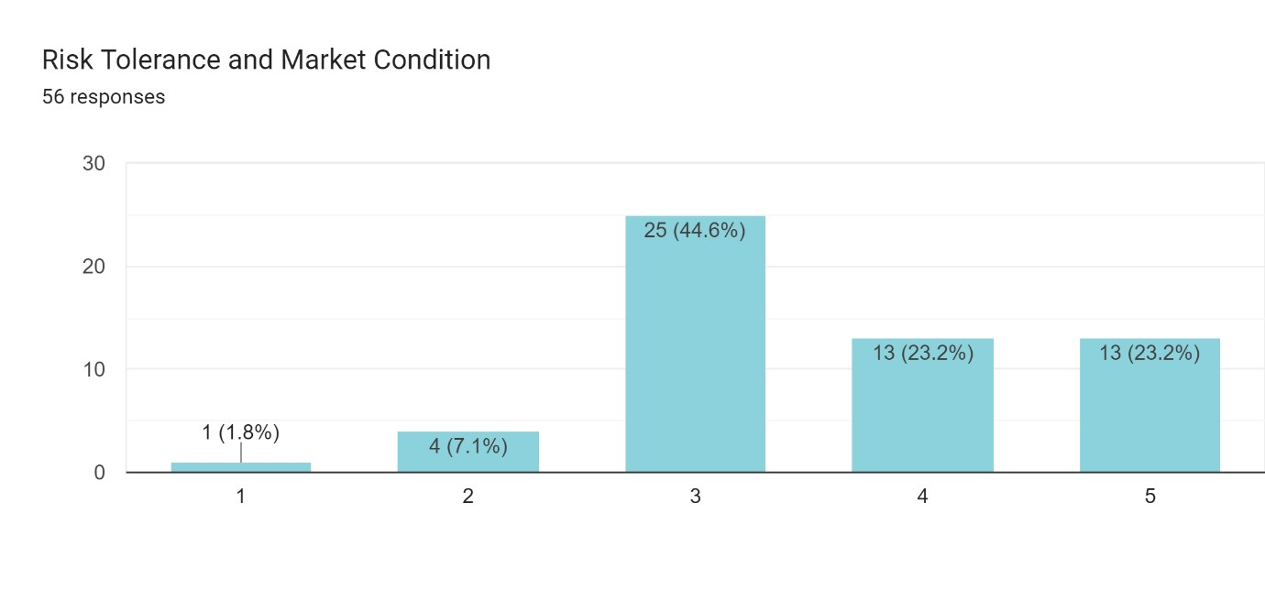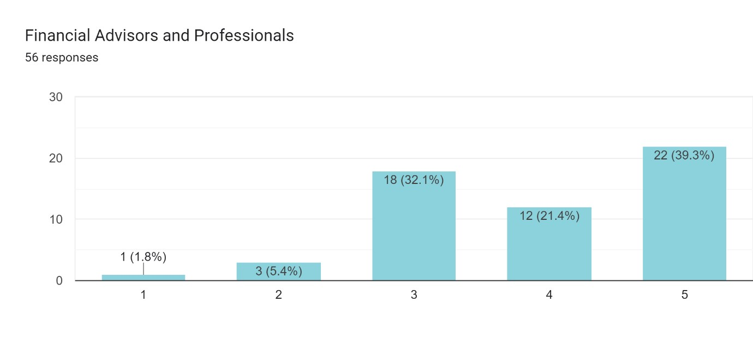

Method of Analysis of Currency and Commodity Pairs

Analysis of Currency Pairs: USDCHF

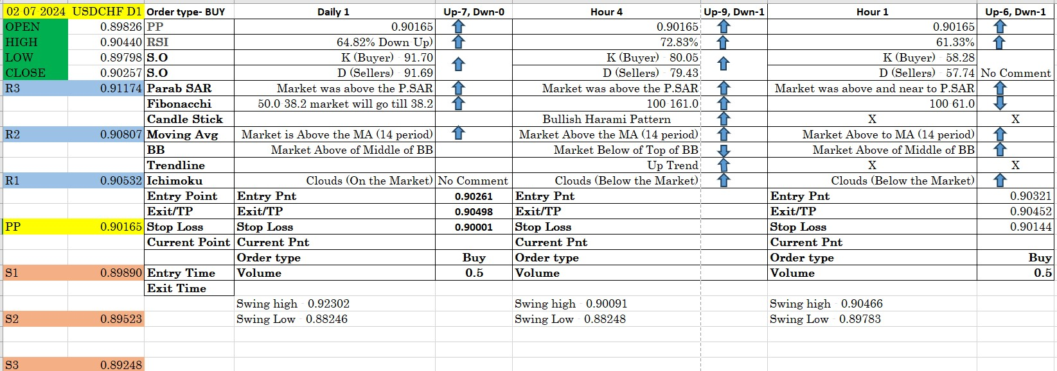

# KEY OBSERVATION,IMPLICATION AND SUGGESTION

**Key Observations** 1. **High Volatility in International Markets**:

o Currency exchange rates and commodity prices demonstrate significant volatility due to macroeconomic variables, geopolitical events, and supplydemand dynamics. This volatility can lead to substantial gains or losses for investors.

1. **Role of Leverage**:
   * The use of leverage in forex and commodity trading magnifies both potential returns and risks. Many traders, especially retail investors, often misuse leverage, resulting in amplified losses.
2. **Diverse Risk Factors**:
   * Risks in these markets include exchange rate fluctuations, counterparty risk, geopolitical instability, and commodity-specific supply-demand imbalances.
3. **Importance of Diversification**:
   * Market-linked securities (MLSs) can serve as effective diversification tools when combined with other asset classes. Their low correlation with traditional equity markets can mitigate overall portfolio risk.
4. **Behavioral Challenges**:
   * Investor behavior, including emotional trading, lack of discipline, and greed, frequently leads to poor trading decisions in volatile markets.
5. **Regulatory Awareness**:
   * Limited awareness of forex trading regulations, particularly in developing countries, increases the likelihood of fraud and misuse.
6. **Technological Tools**:
   * Platforms like MetaTrader5 provide robust tools for technical analysis, facilitating informed decision-making. However, technical proficiency among investors varies widely.
7. **Emerging Market Trends**:
   * Increased interest in forex and commodities trading stems from their potential for high returns. Still, knowledge gaps persist in understanding the fundamental and technical aspects of these markets.

# Implications

1. **For Investors**:
   * The high-risk, high-reward nature of forex and commodities markets necessitates a deep understanding of market dynamics, disciplined trading practices, and effective risk management strategies.
2. **For Financial Institutions**:
   * Institutions offering MLSs must ensure transparent communication of associated risks and provide educational resources to clients.
3. **For Regulators**:
   * Strengthened regulatory frameworks and investor awareness campaigns are crucial to curbing fraudulent activities and ensuring market integrity.
4. **For Market Stability**:
   * Enhanced risk management practices among participants can contribute to reduced volatility and greater market efficiency.

**Suggestions** 1. **Investor Education**:

* + Implement mandatory training programs and workshops for retail investors to improve their understanding of leverage, risk management, and market analysis.

1. **Risk Mitigation Strategies**:
   * Encourage the use of stop-loss orders, diversification, and hedging strategies to minimize potential losses.
2. **Technology Adoption**:
   * Promote the adoption of advanced trading platforms and tools that provide real-time analytics and insights to aid informed decision-making.
3. **Regulatory Frameworks**:
   * Governments and financial authorities should enhance regulatory measures, ensuring compliance and transparency in forex and commodities trading.
4. **Behavioral Insights**:
   * Educate investors on the psychological aspects of trading, emphasizing the importance of emotional discipline and long-term planning over impulsive decision-making.

# Conclusion

The risk-return analysis of market-linked securities (MLSs) with a focus on international currencies and commodities highlights their potential as high-return investment options while underscoring the significant risks involved. These securities provide exposure to dynamic and highly liquid global markets, making them attractive for investors seeking portfolio diversification and alternative asset classes. However, the volatility of forex and commodity markets, influenced by macroeconomic, geopolitical, and market-specific factors, poses substantial challenges.

Key findings from this research indicate that understanding market dynamics, disciplined trading practices, and effective risk management are essential for success in these markets. The use of leverage amplifies both gains and losses, requiring traders to exercise caution and develop a sound strategy. Furthermore, MLSs can serve as effective tools for portfolio diversification, but their utility depends on the investor's ability to navigate the complexities of these markets.

The study emphasizes the importance of investor education, robust regulatory frameworks, and the adoption of advanced technological tools to enhance market efficiency and safeguard investors. Behavioral aspects, including emotional discipline and long-term planning, also play a critical role in trading success.

In conclusion, while MLSs linked to international currencies and commodities offer exciting opportunities, they require a nuanced approach, blending technical expertise, strategic planning, and risk management. Investors and financial professionals must align their investment strategies with their risk tolerance and long-term objectives to harness the potential of these innovative financial instruments effectively.

Reference:

1. [https://www.investopedia.com/terms/fo](https://tradersquote.com/index.php)rex/f/forex-market.asp#toc-advantages-and[disadvantages-of-forex-trading](https://tradersquote.com/index.php)
2. [https://tradersquote.com/index.php](https://www.bbadvisory.co.in/)
3. [https://www.bbadvisory.co.in/](https://byjus.com/commerce/what-is-financial-market/)
4. [https://byjus.com/commerce/what-is-financial-market/](https://papers.ssrn.com/sol3/papers.cfm?abstract_id=1278432)
5. [https://papers.ssrn.com/sol3/papers.cfm?abstract_id=1278432](https://papers.ssrn.com/sol3/papers.cfm?abstract_id=2690672)
6. [https://papers.ssrn.com/sol3/papers.cfm?abstract_id=2690672](https://www.researchgate.net/profile/Amritkant-Mishra/publication/334671059_Foreign_Exchange_Gold_and_Real_Estate_Markets_in_India_An_Analysis_of_Return_Volatility_and_Transmission/links/5f67847a299bf1b53ee508e1/Foreign-Exchange-Gold-and-Real-Estate-Markets-in-India-An-Analysis-of-Return-Volatility-and-Transmission.pdf)
7. [https://www.researchgate.net/profile/Amritkant-](https://www.researchgate.net/profile/Amritkant-Mishra/publication/334671059_Foreign_Exchange_Gold_and_Real_Estate_Markets_in_India_An_Analysis_of_Return_Volatility_and_Transmission/links/5f67847a299bf1b53ee508e1/Foreign-Exchange-Gold-and-Real-Estate-Markets-in-India-An-Analysis-of-Return-Volatility-and-Transmission.pdf)

[Mishra/publication/334671059_Foreign_Exchange_Gold_and_Real_Estate_Markets_ in_India_An_Analysis_of_Return_Volatility_and_Transmission/links/5f67847a299bf](https://www.researchgate.net/profile/Amritkant-Mishra/publication/334671059_Foreign_Exchange_Gold_and_Real_Estate_Markets_in_India_An_Analysis_of_Return_Volatility_and_Transmission/links/5f67847a299bf1b53ee508e1/Foreign-Exchange-Gold-and-Real-Estate-Markets-in-India-An-Analysis-of-Return-Volatility-and-Transmission.pdf)

[1b53ee508e1/Foreign-Exchange-Gold-and-Real-Estate-M](https://www.researchgate.net/profile/Amritkant-Mishra/publication/334671059_Foreign_Exchange_Gold_and_Real_Estate_Markets_in_India_An_Analysis_of_Return_Volatility_and_Transmission/links/5f67847a299bf1b53ee508e1/Foreign-Exchange-Gold-and-Real-Estate-Markets-in-India-An-Analysis-of-Return-Volatility-and-Transmission.pdf)arkets-in-India-An-

[Analysis-of-Return-Volatility-and-Transmission.pdf](https://www.ijresm.com/Vol.2_2019/Vol2_Iss10_October19/IJRESM_V2_I10_134.pdf)

1. [https](https://www.ijresm.com/Vol.2_2019/Vol2_Iss10_October19/IJRESM_V2_I10_134.pdf)://www.ijresm.com/Vol.2_2019/Vol2_Iss10_October19/IJRESM_V2_I10_134.p [df](https://www.ijresm.com/Vol.2_2019/Vol2_Iss10_October19/IJRESM_V2_I10_134.pdf)

# APPENDIX / ANNEXURE

**QUESTIONNAIRE**

1. Have you ever traded in any financial markets before?

a) Yes b) No c) Planning to

1. Are you currently investing in the Forex market?

a) Yes b) No c) Planning to

1. Are you aware of the regulatory framework for Forex trading in India?

a) Yes b) No c) Somewhat

1. What is your primary goal for investing in forex?
   1. Short-term profits
   2. Long-term wealth building
   3. Hedging against currency risk
   4. Learning about global markets
   5. High Return
   6. Portfolio Diversification
2. How would you rate your current knowledge of forex trading?
   1. No knowledge
   2. Basic understanding
   3. Intermediate knowledge
   4. Advanced knowledge
3. How long have you been investing in forex?
   1. Less than 1 year
   2. 1-3 years
   3. 3-5 years
   4. More than 5 years
   5. Not investing yet
4. How much of your investment portfolio is allocated to Forex?
   1. Less than 10%
   2. 10-25%
   3. 25-50%
   4. More than 50%
   5. Not investing in Forex
5. How much capital are you planning to start with in forex trading?
   1. Less than $500
   2. $500 - $1,000
   3. $1,000 - $5,000
   4. More than $5,000
6. Are you familiar with the concept of leverage in forex trading?
   1. Yes, I understand it well
   2. I have a basic understanding
   3. No, I'm not familiar
7. Which of these forex terms are you familiar with? (Select all that apply)
   1. Pip
   2. Lot size
   3. Margin call
   4. Stop-loss
   5. Take profit
   6. None of the above
8. How do you analyze the forex market?
   1. Technical analysis
   2. Fundamental analysis
   3. Sentiment analysis
   4. Economic news
   5. All of the above
   6. Other
9. Are you aware of the potential risks involved in forex trading?
   1. Yes, fully aware
   2. Somewhat aware
   3. Not really aware
10. What is your preferred learning style for forex education?
    1. Online courses
    2. Books and articles
    3. Video tutorials
    4. One-on-one mentoring
    5. Practice on demo accounts
11. How do you plan to manage your emotions during trading?
    1. Strict adherence to a trading plan
    2. Setting clear profit/loss limits
    3. Mindfulness or meditation techniques
    4. Haven't thought about it yet
12. What are your expectations for monthly returns from forex trading?
    1. 0-5%
    2. 5-10%
    3. 10-20%
    4. More than 20%
    5. I understand returns can vary and may be negative
13. Size of Investment Capital (Fund)
    1. Highly Unimportant
    2. Unimportant
    3. Somewhat Important
    4. Very Important
    5. Highly Important
14. Investment Knowledge and Education
    * 1. Highly Unimportant
      2. Unimportant
      3. Somewhat Important
      4. Very Important
      5. Highly Important
15. Risk Tolerance and Market Condition
    * 1. Highly Unimportant
      2. Unimportant
      3. Somewhat Important
      4. Very Important
      5. Highly Important
16. Investment Strategy and Style
    * 1. Highly Unimportant
      2. Unimportant
      3. Somewhat Important
      4. Very Important
      5. Highly Important
17. Financial Advisors and Professionals
    * 1. Highly Unimportant
      2. Unimportant
      3. Somewhat Important
      4. Very Important
      5. Highly Importannt