**Consumer Perspectives on Electric Vehicles: Barriers, Motivations, and Future Trends.**

**Author: (Kothamasu Kanaka Sai CharanKumar.)**

# Abstract

Electric vehicles are on the way to replacing the traditional internal combustion engine vehicles because of multiple advantages that electric vehicles have exuded. This research explores consumer perspectives on EV adoption by addressing three critical dimensions: barriers, motivations, and future trends. Key challenges include high upfront costs, range anxiety, limited charging infrastructure, and concerns about battery performance. Conversely, environmental consciousness, technological advancements, and government incentives drive consumer interest. Emerging trends in the EV market include advancements in battery technology, autonomous driving, and shared mobility services. This study emphasizes that consumer concerns should be addressed by aligning policies, marketing strategies, and technological innovations to boost the adoption of EVs. Findings from this research provide actionable insights for stakeholders to foster a transition to sustainable mobility.

# Keywords

Electric Vehicles, Consumer Behavior, EV Adoption Barriers, Sustainability, Green Technology, Charging Infrastructure, Environmental Awareness, Battery Technology, Autonomous Driving, Shared Mobility, Renewable Energy Integration, Government Policies.

# Introduction

Concern over climate change, energy resources, and the limited fossil fuels has prompted the rise of electric vehicles (EVs) in the automotive industry. Around the world, governments, environmentalists, and car manufacturers promote switching to electric mobility through lessening reliance on fuel emitting GHG as well as on non- renewable sources of energy. Consumers have not accepted EVs as has been anticipated so far. Thus, understanding barriers and motivations towards the adoption and future trends must take focus on the consumer's point of view.

The automotive industry is at a crossroads, where technology meets environmental responsibility. As the damage caused by conventional internal combustion engine (ICE) vehicles becomes more apparent, the EV seems to be an excellent alternative that will help in mitigating the impacts of traditional transportation. It will provide a sustainable solution, as it will fit into the efforts of the world to fight climate change and renewable energy use.

Electric vehicles still have several limitations to overcome. Some of them include high capital costs, driving range anxiety and lack of necessary charging infrastructure; the performance level of the electric battery is among the concerns consumers have about getting an electric car. Lack of knowledge and also misinformation about this type of transport further creates hesitation among them. Thus understanding these barriers plays a crucial role for strategies that make consumers accept, adopt, or use electric vehicle.

On the other hand, several motivations push consumer interest in electric vehicles. It involves environmental concerns, increasing fuel costs, and a government incentive towards the purchase of EVs besides the technological evolution of EV. In fact, these drivers unveil the value proposition that appeals to the potential purchaser; it enables further examination in terms of the demographic, psychographic, as well as geographical factors that point toward the segments of consumers most likely to adopt an EV.

It goes beyond the future of bridging gaps as they exist now. It is being in harmony with what is emerging in terms of trends and the dynamics of markets. Technologies such as these related to advancements in battery technology, autonomous driving, and smart mobility solutions shape the contours of the landscape of EVs. Government policies, corporate commitments toward sustainability, and an emerging sharing economy also contribute their share toward altering the pattern through which consumer behavior is induced and the market is shaped.

This research study attempts to understand consumer perception about electric vehicles based on three important dimensions: barriers, motivations, and future trends. Based on a broad approach, this study attempts to develop a link between what consumers expect in the EV market and the reality around it. These findings will hold several learning moments for policymakers, manufacturers, and marketers to develop the right strategies which can facilitate the accelerated switch to electric mobility.

# Literature Review

The global call to cut down on greenhouse gas emissions and aid in climate change directly ties in with the urgent need to implement EVs. As the automotive industry evolves, understanding consumer perspectives on electric vehicles— specifically the barriers to adoption, motivations for purchase, and anticipated future

trends—has become increasingly important. This literature review synthesizes existing research on these topics, highlighting key findings and identifying gaps in the current understanding.

### Barriers to Electric Vehicle Adoption

* + 1. **High Upfront Costs**: One of the most frequently cited barriers to electric vehicle adoption is the high initial purchase price compared to traditional internal combustion engine vehicles. According to *“Breetz et al. (2018)..”*, the higher upfront costs of EVs deter many consumers, despite the potential for lower total cost of ownership over time due to savings on fuel and maintenance. This financial barrier is particularly pronounced among lower- income consumers who may not have the means to invest in a more expensive vehicle upfront.
    2. **Driving Range and Range Anxiety:** The fear of electric cars going out running out of battery before the reaching a charging point or what is called range anxiety is one huge challenge to the widespread use of electric vehicles. *“Gnann et al. (2018)..”* found that consumers are often concerned about the driving range of electric vehicles, especially for long-distance travel. This concern is exacerbated by the perception that charging infrastructure is insufficient, leading to hesitance in adopting EVs. Research by “*Rezvani et al. (2015)..”* supports this notion, indicating that range anxiety significantly impacts consumers' willingness to consider electric vehicles.
    3. **Insufficient Charging Infrastructure:** The existence and distribution of charging points are essential determinants factors affecting the uptake of electric cars by consumers. “*Kley et al. (2011)..”* highlight that consumers are more likely to consider purchasing an electric vehicle if they have access to a reliable and convenient charging network. The inadequacy of charging infrastructure, especially in rural areas, could make potential owners cautious about switching to electric vehicles. According *to "Hall and Lutsey (2017),"* there is a need for a robust network of EV charging stations with networks able to solve consumer concerns to induce EV purchases
    4. **Concerns About Battery Life and Performance**: Consumers often express concerns about the longevity and performance of electric vehicle batteries. Issues such as battery degradation, replacement costs, and the environmental impact of battery production and disposal can influence consumer perceptions. “*Zhang et al. (2019)..”* indicate that addressing these concerns through education and transparency can enhance consumer confidence in electric vehicles. Furthermore, research by Wang et al. (2020) suggests that

consumers are increasingly aware of the environmental implications of battery production, which can further complicate their decision-making process.

* + 1. **Limited Model Availability and Variety**: The availability of electric vehicle models that meet diverse consumer needs is another barrier to adoption. According to a study by “*Egbue and Long (2012)..”*, consumers often perceive a limited selection of electric vehicles, which may not align with their preferences for size, style, or features. This perception can lead to frustration and reluctance to consider EVs as viable options. As the market for electric vehicles continues to grow, manufacturers must expand their offerings to cater to a broader range of consumer preferences.

### Motivations for Electric Vehicle Adoption

* + 1. **Environmental Concerns**: One of the primary motivations for consumers to adopt electric vehicles is the desire to reduce their environmental impact. “*Lane and Potter (2007)*..” found that environmental consciousness is a significant driver for many consumers considering electric vehicles. As awareness of climate change and air pollution increases, more consumers are motivated to choose sustainable transportation options that align with their values.
    2. **Fuel Savings and Economic Benefits**: The potential for fuel savings is another key motivator for consumers considering electric vehicles. Research by “*Sierzchula et al. (2014)*..” indicates that consumers are increasingly aware of the long-term cost savings associated with electric vehicles, particularly in terms of reduced fuel and maintenance expenses. This economic incentive can be particularly appealing in regions where fuel prices are high.
    3. **Technological Innovation and Performance**: The appeal of advanced technology and performance features in electric vehicles can also motivate consumers to make the switch. According to a study by “*Rezvani et al. (2015)*..”, many consumers are attracted to the innovative features of electric vehicles, such as instant torque, quiet operation, and advanced infotainment systems. As manufacturers continue to enhance the technological capabilities of EVs, consumer interest is likely to grow.
    4. **Government Incentives and Policies**: Government policies and incentives play a crucial role in shaping consumer attitudes towards electric vehicles. Research by “*Breetz et al. (2018)..”* highlights that financial incentives, such as tax credits and rebates, can significantly influence consumer decisions to purchase electric vehicles. Additionally, policies aimed at expanding charging

infrastructure and promoting EV adoption can create a more favorable environment for consumers considering electric vehicles.

# Research Methodology

This research combines the use of qualitative and quantitative methods of inquiry, aiming for a mixed-method approach to their holistic understanding of consumer perspectives. Surveys, interviews, and focus groups will be conducted to gather primary data of any potential or existing consumer of EVs. Secondary data will be gathered from industry reports, academic journals, and government publications as complementing analysis. A cross-regional and cross-demographic study will provide insights into the diverse factors that affect the adoption of EVs.

A Questionnaire was framed and conducted to collect samples for the study. Purposive Random Sampling techniques were applied, and the sample consists of both EV users and Non EV users. Most of the data was collected from students and employees who regularly use vehicles. The data consists of both EV and Non EV users based on which an assumption that users can differentiate and form a rational perception on EVs was made. A total of 331 respondents filled the questionnaire during the survey with varied demographics like age, type of vehicle used, income etc. out of which 7 were rejected due to incomplete data and biased responses.

### Tools Used

* + - * **Data Collection:**

A survey questionnaire was prepared comprising 32 questions which were responsible for identifying various aspects of the research.

### Data Analysis:

* + - * + Various charts like Bar Chart, Pie Chart, Column chart were used for data analysis.
        + For studying relationship between groups, Chi-Square test was used and applied. The Chi-square test of independence **checks whether two variables are likely to be related or not.**

## SURVEY QUESTIONNAIRE:

The following survey questionnaire was designed with an aim of generating data related to Consumer Perception on Electric Vehicles. The respondents were asked to fill the questionnaire. Questions were framed inn logical order and were of different types. Few are a short answer whereas few are rating scales. This diversified

approach while framing the Survey questionnaire helped us in collecting the data in an easier format without much chaos. It must be noted that the responses are entirely based on the perception of the respondents.

### Name :

1. **Gender:** Male Female

Prefer not to say

1. **Occupation** Student Employee Self employee Unemployed

### Age

18-20

20-35

35-55

55-75

### Income Per Annum:

Less than Rs.5,00,000

Rs. 5,00,000 – Rs.10,00,000

Greater than Rs,10,00,000

### Do you own a vehicle

Yes – 2 wheeler Yes – 4 wheeler

Yes – Both 2 and 4 wheeler No, I don’t own a vehicle

1. **You vehicle runs on** Petrol/Diesel Electricity LPG/CNG

### Safety rating:

1 2 3 4 5

### Battery Durability and range covered

1 2 3 4 5

### Pick up rating

1 2 3 4 5

### Model design

1 2 3 4 5

### Service Facilities

1 2 3 4 5

### Smart features

1 2 3 4 5

### Overall Satisfaction

1 2 3 4 5

### Do you think that your EV vehicle is cost efficient

Yes No

### Would you stop using EV if there is an increase in Electricity charges

Yes No

### Will you recommend to your friends/ family to use EV?

Yes No

### What do you expect from an ideal EV?

Safety Range

Cost efficiency

Eco – friendly features Others

### Is there any specific reason for refraining from buying an EV?

Over – priced

Safety and trust issues Limited range

Satisfied with Petrol / Diesel vehicles Not interest in EVs

Others

# Data Analysis & Inferences

## OCCUPATION – VEHICLE ANALYSIS

The following data was generated during the survey. There were a total of 324 respondents who belong to different socio-economic backgrounds and have a varied perception about EVs. From the sample collected, 72% (235) are students, 18% (57)

are employees, 7% (22) are self-employed and 3% (10) are unemployed. The above chart shows the occupations of respondents

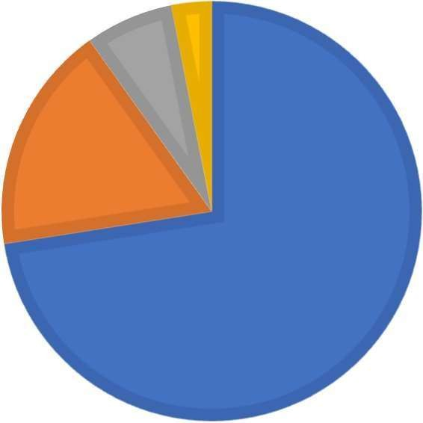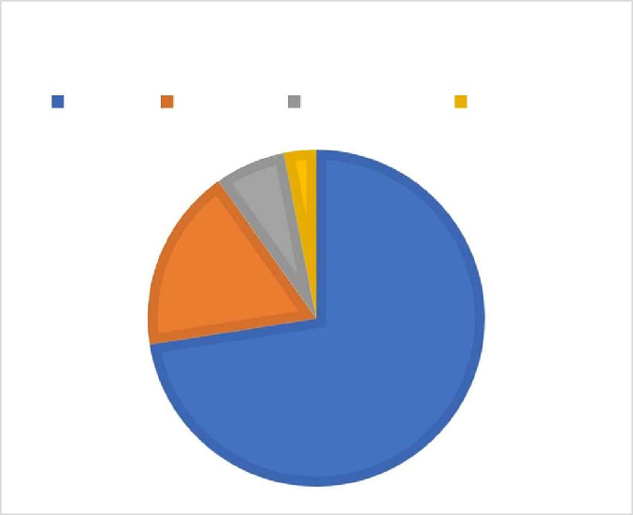

**OCCUPATION**

Student Employee self-employed Unemployed

**7% 3%**

**18%**

**72%**

The following chart explains the fuel mode preferred by various occupations



Occupation Wise Vehicle Owned

160

140

120

100

80

60

40

20

0

Petrol

LPG / CNG

Electricity

Student Employee Self-employed Unemployed

From the above visualisation, it can be clearly understood that most of the students and employees prefer vehicle that runs on Petrol/Diesel rather than those that runs on electricity. Very small proportion of the sample use vehicles that run on LPG/CNG. Out of the 171 students, 148 students use vehicles that run on petrol/diesel whereas 21 of them use vehicles running on electricity and 2 of them use vehicles running on LPG/CNG. Similarly, out of the 56 employed people in the sample, 42 of them use vehicles running on petrol/diesel; 13 of them use vehicles running on electricity and 1 of them use LPG/CNG vehicle. Out of the 22 self- employed people, 20 of them use petrol/diesel vehicles and 2 people use electrical vehicles. All of the 10 unemployed people use vehicles running on petrol/diesel.

## ANALYISIS OF EV SEGMENT

It has been observed that very small proportion of the sample is using Electric Vehicles. Out of those users, most of them own a 2-wheeler electric scooter. There is a lot of variation among company and brand they chose. A significantly lower portion own both 2-Wheeler and 4-Wheeler Electric vehicle.



Users in EV Segment

2W and 4W

6

2W

28

4W

2

0

5

10

15

20

25

30

## DESCRIPTIVE ANALYSIS OF SATISFACTION INDICES OF A VEHICLE:

To study satisfaction of a vehicle and its power source, following indices were established.

For vehicles that run on petrol, diesel and LPG/CNG the following were used as index to measure satisfaction:

* + - Model Design
    - Mileage
    - Pick-up
    - Safety
    - Comfort
    - Smart Features
    - Service Facilities
    - Overall Satisfaction

For vehicles that run on electricity, the following were used as index to measure satisfaction:

* + - Model Design
    - Battery Durability and Range
    - Pick-up
    - Safety
    - Comfort
    - Smart Features
    - Service Facilities
    - Overall Satisfaction.

The respondents were asked to rate the above features on a linear scale of 1 to 5 in the questionnaire, 1 being least satisfaction and 5 being maximum satisfaction. The following table shows averages of the above stated indices.

|  |  |
| --- | --- |
| Average Ratings by users whose vehicle runs on Petrol / Diesel | |
| Index | Average |
| Model Design | 3.875 |
| Mileage | 3.805 |
| Pick | 3.816 |
| Safety | 3.838 |
| Comfort | 3.875 |
| Smart Features | 3.602 |
| Service Facilities | 3.797 |
| OVERALL SATISFACTION | 3.875 |

|  |  |
| --- | --- |
| Average Ratings by users whose vehicle runs on Electricity | |
| Index | Average |
| Model Design | 4.279 |
| Battery Durability and Range | 4 |
| Pick | 4.186 |
| Safety | 4.023 |
| Comfort | 4.069 |
| Smart Features | 4.302 |
| Service Facilities | 3.72 |
| OVERALL SATISFACTION | 4.325 |

From the above table we can observe the following :

* As to the extent of usage and satisfaction, the ratings of all the features of vehicles running on Petrol/Diesel are ranging from **3.5** to **4**
* The ratings of the same kind of features of vehicles running on electricity given by EV users, are ranging from **3.5** to **4.5**.
* Barring Service facilities, every other feature of the EVs has garnered a rating of more than **4** which is tremendous to say the least.
* The rating of even one feature of the Petrol/Diesel vehicles is not more than

**4**.

The Indices are assigned numbers in the order of arrangement of a vehicle in order to plot them on a line chart.

|  |  |
| --- | --- |
| 5  4  3  2  1  0 | Average of Indices |
|  |
|  |
|  |
|  |
| 1 2 3 4 5 6 7 8 |

From the chart, we can clearly observe that:

Others 33

* The orange line that depicts the average indices given by EV users is higher than that of the blue line that indicate the average indices given by non EV users
* We can also state that both EV and non-EV users are satisfied with the service facilities offered by their respective companies.

## EV PURCHASING PLANS:

Out of the total respondents, only 43 use electric vehicle. Remaining ones use vehicles that run on electricity or LPG/CNG. The following section explains the various causes for not purchasing an Electric Vehicle and gives a detailed analysis of related issues as well.

### Reasons for not purchasing an ev :

|  |  |  |  |
| --- | --- | --- | --- |
|  | Reasons for not buying an EV | |  |
| Over-Priced | 102 |
| Safety and trust issues | 123 |
| Limited Range | 111 |
| Satisfied with Petrol/Diesel vehicles | 39 |
| Not interested in EVs | 30 |
| REASONS FOR NOT PURCHASING AN EV  Others Not interested in EVs  Satisfied with Petrol/Diesel vehicles  Limited Range Safety and trust issues  Over-Priced  0 20 40 60 80 100 120 140 | | | |

The following section explains the reasons for not purchasing an EV by non EV users. There are few respondents whose decision got changed due to various reasons. An analysis of the same is given below :

* From the table and the graph, we can clearly understand that a major proportion of the consumers are refraining to purchasing an EV primarily because of Safety and trust issues. Most of their perceptions on EVs changed due to the blasts and fire accidents that took place in recent times.
* Limited range is another reason that has shown an impact on the consumer’s perception on purchasing an Electric Vehicle
* A very small amount of the sample are not interested in EVs and are satisfied with Petrol/Diesel Vehicles

## EXPECTATIONS FROM AN IDEAL EV :

A detailed analysis of expectations from an ideal EV is performed. The respondents use vehicle that runs on Petrol/Diesel. The following table and graph gives a detailed explanation of the same :

|  |  |
| --- | --- |
| Expectations from an Ideal EV | |
| Safety | 188 |
| Range | 119 |
| Cost efficiency | 128 |
| Eco-Friendly features | 133 |
| Others | 50 |

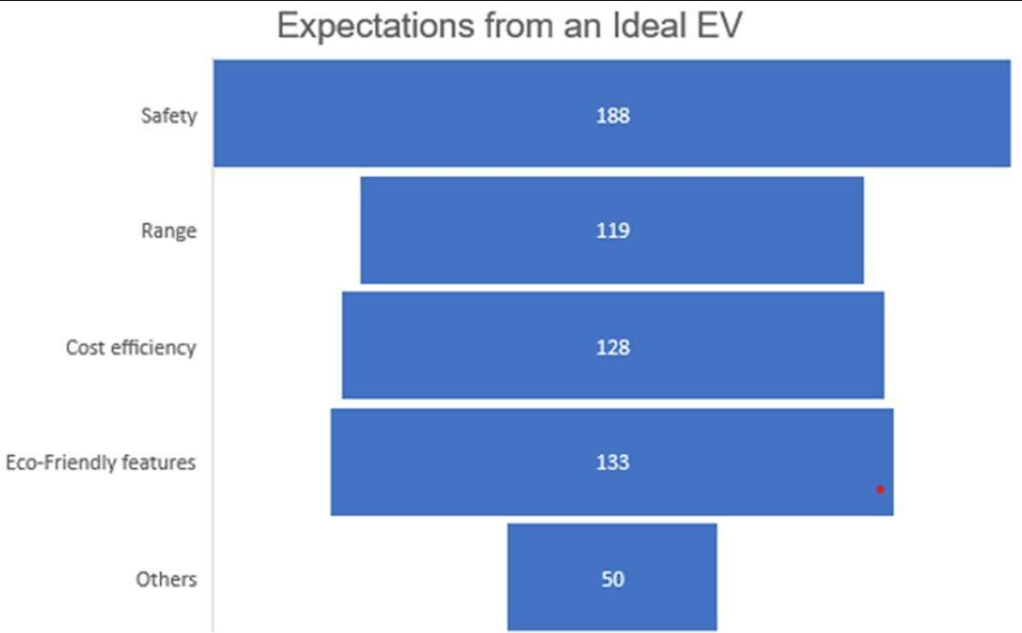

From the graph and the table, the following interpretations can be made :

* Most of the respondents feel safety is a major concern that is impacting their decision to purchase an EV.
* Around a quarter of the respondents expect a good range and Eco-friendly features
* Around a half of the respondents feel that EVs can be more cost efficient and expect them at a much lower price.

## EV PURCHASE PLANS IN THE FUTURE

|  |  |  |
| --- | --- | --- |
| EV Purchasing | | |
| Petrol Segment | People planning to purchase EV in future | 160 |
| People not planning to purchase an EV in future | 111 |
| LPG/CNG  Segment | People planning to purchase EV in future | 7 |
| People not planning to purchase an EV in future | 2 |

|  |  |  |  |  |
| --- | --- | --- | --- | --- |
|  |  |  | | |
|  | 111 | | |
|  |  | | |
|  |  |  |
|  |  |  |
|  |  |  |
|  |  |  |
|  |  |  |
|  |  | 7 2 |

From the above table and graph, the following observations can be made:



EV Purchasing Plans

180

160

160

140

120

100

80

60

40

20

0

Petrol Segment

LPG/CNG Segment

* A major portion of users whose vehicles run on Petrol/Diesel are planning on purchasing an Electric Vehicle in the future
* LPG segment holds a very low portion in this aspect. This could be due to lower volume of users under that segment.
* A very small proportion of the consumers are planning to use their present vehicle and are not ready for a change.

## EV USERS AND ELECTRIC CHARGES:

Although Electric Vehicles are cost efficient, it is subject to the electric charges that the government imposes on its citizens. Considering this aspect, analysis was performed to know whether EV users would stop using them due to an increase in Electricity charges. The following graph gives a detailed analysis of the same:

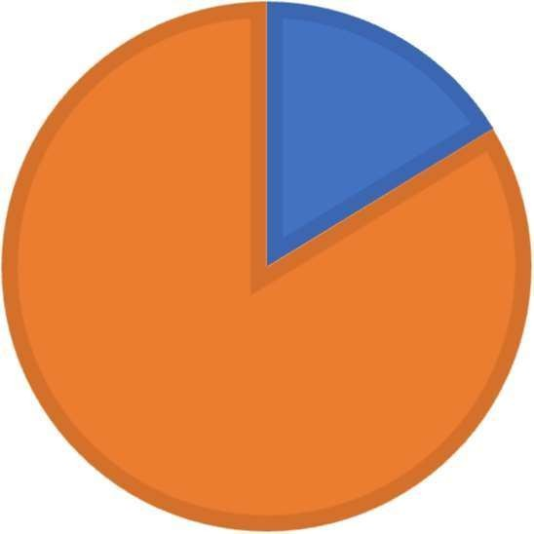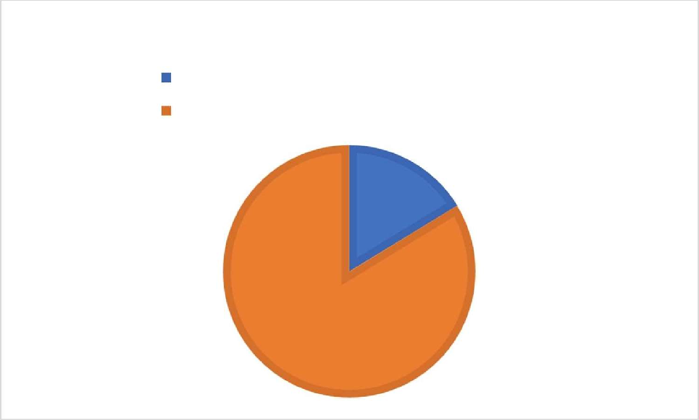

**EV USERS AND ELECTRICITY CHARGES**

Stop using EV with increase in electricity charges Continue using an EV irrespective of electric charges

**16%**

**84%**

From the graph the following observations can be made:

* A major proportion of the consumers would use Electric Vehicle irrespective of the electricity charges.
* A relatively small proportion of the sample would stop using EVs with an increase in the electricity charges.
* This clearly indicates the satisfaction of consumers with Electric Vehicles.

## TESTING OF HYPOTHESIS

To analyse the relation between income and choice of vehicle of a sample, the following assumptions were made:

|  |  |
| --- | --- |
| H0 | There is no significant difference between income level and choice of vehicle |
| H1 | There is a significant difference between income and choice of vehicle |

Chi Square Test for Independence of Variables is one best method for understanding the relation among the categories. The following contingency table is formulated based on the count of various income levels and choice of vehicles.

The actual values which we have obtained from the survey:

|  |  |  |  |  |
| --- | --- | --- | --- | --- |
| Actuals | | | | |
| Count of Your vehicle runs  on | Column  Labels |  |  |  |
| Row Labels | Electricity | LPG /  CNG | Petrol /  Diesel | Grand Total |
| Greater than Rs.10,00,000 | 2 | 0 | 22 | 24 |
| Less than Rs. 5,00,000 | 20 | 2 | 142 | 164 |
| Rs.5,00,000 - Rs.10,00,000 | 14 | 1 | 54 | 69 |
| Grand Total | 36 | 3 | 218 | 257 |

The estimated values were tabulated from the actual values by dividing the grand total with product of corresponding column total and row total:

|  |  |  |  |  |
| --- | --- | --- | --- | --- |
| Expected | | | | |
| Count of Your vehicle  runs on | Column  Labels |  |  |  |
| Row Labels | Electricity | LPG / CNG | Petrol / Diesel | Grand Total |
| Greater than  Rs.10,00,000 | 3.36 | 0.28 | 20.36 | 24 |
| Less than Rs. 5,00,000 | 22.97 | 1.91 | 139.11 | 164 |
| Rs.5,00,000 -  Rs.10,00,000 | 9.67 | 0.81 | 58.53 | 69 |
| Grand Total | 36 | 3 | 218 | 257 |

After applying the formula, the following values were noted

|  |  |
| --- | --- |
| p-value | 0.48 |
| p- Significance Level | 0.05 |
| Decision | Accept H0 |

As we can clearly observe that the P value for the given data is 0.424 which is greater than the significance level which is 0.05

Hence, we accept the null hypothesis

Therefore, there is no significance difference between choice of vehicle and the user income level.

Independent variable is the choice of adoption of electric vehicle and dependent are the benefits or barriers to acceptance of EV. As both, benefits and barriers might be based on Safety, Range (or) Mileage, Service Facilities, Comfort, Design, Environmental Concern for both Electric and Non-Electric Vehicles. We assume that these factors have direct influence on individual choice of vehicle. The first section of questionnaire was related to demographics of respondents. Respondent’s views about various parameters that effect purchase decision was analysed in second section and finally in third section respondents’ expectations from an Ideal Vehicle was recorded

# Discussion

Electric vehicles (EVs) are one of the solutions to the global quest for sustainable transportation, but their adoption is confronted with multiple challenges. The study's findings resonate with previous literature on the major barriers to EV adoption, including high costs, range anxiety, and limited infrastructure. However, the nuances of consumer behavior, as highlighted in this research, reveal deeper layers of resistance that are rooted in psychological and cultural dimensions.

For instance, safety issues and trust issues, especially those related to battery reliability and recent fire incidents, have contributed to negative perceptions. This calls for transparency and targeted education campaigns to reduce consumer anxiety. On the other hand, the data indicates that motivations, such as environmental consciousness and cost savings, resonate strongly with specific demographics, especially younger and eco-conscious consumers. Regional and cultural differences in adoption patterns further drive the need for localized strategies.

Emerging trends like improvements in battery technology, shared mobility, and autonomous driving offer some promising avenues to accelerate adoption. However, all stakeholders must ensure that these innovations address core consumer concerns while enhancing affordability and accessibility. Bridging the gap between expectations and reality requires collaboration between policymakers, manufacturers, and the energy sector.

### Barriers to Adoption

High front-end costs were identified as the most prevalent barrier toward adopting EVs. Although the operating and maintenance costs are less expensive in the long run, the front-end price remains a significant deterrent for many consumers. This is consistent with previous literature on how finances play a significant role in consumer decision making (Breetz et al., 2018). In addition, range anxiety continues to remain an ever-great concern among possible buyers. Many consumers fear that the driving range of electric vehicles may not satisfy their needs, especially for traveling long distances. Moreover, the charging infrastructure is still perceived to be inadequate, further exacerbating a reluctance to accept EVs (Gnann et al., 2018).

The issue of inadequate charging infrastructure is most visible in rural regions, where the availability of charging stations is poor. The unavailability of efficient and easy charging options may discourage people from purchasing electric vehicles as alternatives to the traditional gasoline-powered automobiles (Kley et al., 2011). Moreover, the issues associated with battery durability and efficiency have a significant impact on consumer attitudes. The apprehension regarding battery degradation and the cost of replacement raises concerns among consumers, which results in a hesitance to adopt EVs (Zhang et al., 2019).

### Reasons for Adoption

However, several incentives stimulate the desire for electric cars by consumers. Among the driving factors, there is a huge motivating force towards being environmentally conscious. Rising climate change and poor air quality conditions compel people to consider a viable, environmentally responsible alternative transportation source (Lane & Potter, 2007). Saving fuel can help cut back on money expenditure for other significant costs that often play a decisive role in customer purchasing decisions. Many customers are aware of the long-run cost savings offered by electric vehicles, especially in regions where the fuel price is high (Sierzchula et al., 2014).

Additional aspects that draw customers to electric vehicles are technological innovation and performance features. Advanced technology such as instant torque and silent operation increases the appeal of EVs to technology-savvy consumers (Rezvani et al., 2015). Another significant influence on consumer perception is government incentives and policies. For instance, tax credits and rebates create financial incentives, which may change consumer behavior regarding the purchase of an electric vehicle (Breetz et al., 2018).

### Future Trends

Future trends in the electric vehicle are influenced by various emerging trends, which might eventually influence consumer behavior. Charging infrastructure will increase availability, which means concerns about access over time are reduced. The future will see a boost in investments from governments and private companies, and as that happens, consumers may become more confident about embracing electric vehicles.

Advances in battery technology are also expected to take a significant role in determining consumer attitudes. Improvements such as increased range and reduced charging times can alleviate two major concerns for potential new EV consumers. In addition, an increased awareness of how electric vehicles offer savings as well as environmental benefits should translate to more favorable consumer attitudes to embrace.

# Implications of Consumer Perspectives on Electric Vehicles

The findings of this research about consumer perspectives of electric vehicles are of significant implication to the automobile industry's manufacturers, policymakers, marketers, and consumers. Such implications can further drive the adoption of electric vehicles and create a more sustainable transportation ecosystem.

### Implication for Manufacturers

Manufacturers are very important in the electric vehicle market. The study identifies several barriers to the adoption of EVs, including high upfront costs, range anxiety, and limited charging infrastructure. To overcome these challenges, manufacturers should consider the following strategies:

**Cost reduction:** Economies of scale and advancements in battery technology can reduce the production costs of electric vehicles, which in turn can lower the initial purchase price. This will make EVs more accessible to a wider population, especially the low-income group who may be deterred by high upfront costs.

**Enhanced Range and Performance:** Investing in research and development to improve battery technology will enhance the driving range and performance of electric vehicles. By addressing range anxiety—a significant barrier identified in the study—manufacturers can increase consumer confidence in EVs as a viable alternative to traditional gasoline-powered vehicles.

**Diversification of Product Lines:** The availability of more varieties of electric models in the market is necessary. Consumers have various preferences for size, style, and features. Manufacturers can appeal to a wider number of customers by

offering more varieties of electric models that are tailored to satisfy different consumer requirements.

**User Education:** Manufacturers should invest in educational campaigns that inform consumers about the benefits of electric vehicles, including long-term cost savings and environmental advantages. By addressing misconceptions and providing transparent information about battery performance and charging options, manufacturers can help alleviate consumer concerns.

### Implications for Policymakers

Policymakers play a vital role in creating an environment conducive to electric vehicle adoption. The findings from this research suggest several actions that policymakers can take:

**Incentives and Subsidies**: Implementing financial incentives such as tax credits, rebates, or grants for purchasing electric vehicles can significantly influence consumer decisions. Policymakers should ensure that these incentives are well- publicized and accessible to potential buyers.

Investment in Charging Infrastructure: To mitigate the issue of availability of charging, the government should focus on investments in the expansion of charging infrastructure. This includes not only the urban areas but also the rural areas where the access to charging stations is limited. A strong charging network will build consumer confidence and spur adoption of EVs.

**Public awareness:** The policymaker must introduce public awareness campaigns that focus on the environmental advantages of electric vehicles and the incentives available. Educating consumers regarding the benefits in terms of air quality and climate changes will help in gaining greater acceptance by the consumers.

**Sustainability Goals:** Electric vehicle adoption can be an integral part of broader sustainability goals. Ambitious targets for lowering greenhouse gas emissions and promoting renewable energy sources are likely to stimulate consumers to use electric vehicles in their pursuit of sustainability.

### Implications for Marketers

The strategies of marketers have to be revised according to consumer insights about electric vehicles. From the research findings, it has been identified that the primary reason for purchasing EVs is to promote environmental consciousness and economic benefits. The marketers need to consider the following approaches:

**Targeted Marketing Campaigns:** Targeted marketing campaigns that reach the environmentally conscious consumer will strengthen brand loyalty and increase

sales. Environmental benefits in electric vehicles coupled with advanced technological features will appeal to the buyer's high-tech consciousness.

**Utilizing Social Media:** It is important to leverage social media platforms to reach out to potential customers. Through these platforms, marketers can share success stories of current EV owners, educational content about EV technology, and government incentives.

**Creating Community Engagement:** Community engagement programs that engage local players can help build confidence among the intended buyer. Creating events or workshops on electric vehicle education could further support the relationship between the manufacturer and the consumer.

### Meaning to the Consumer

The consumer, too, plays a role in shaping the future of electric vehicles. Based on this research, there are several aspects where consumers have to act:

**Informed Choice:** The consumer needs to be informed of the pros and cons of electric vehicles. This includes incentives, charging options, and technological developments so that consumers are well-equipped with information when considering the purchase of an EV.

**Advocacy for Infrastructure:** Consumers can also act as advocates for better charging infrastructure in their local communities by discussing this with their local representatives or attending public meetings on sustainable transportation initiatives.

**Participate in Feedback Mechanisms:** Manufacturers can be engaged through feedback mechanisms to determine future product offerings. Consumers should express their preferences on vehicle features, pricing, and sustainability initiatives to influence the decisions of manufacturers.

# Conclusion

In summary, this research gives an all-round review of consumer perceptions of electric vehicles, including barriers, motivations, and future trends that may impact adoption. Findings reveal a growing interest in electric vehicles spurred by environmental concerns and economic incentives but that still, significant barriers remain in widespread adoption. High purchase prices, range anxiety, a limited charging infrastructure, and worries over battery life are the major considerations that buyers look at when thinking of purchasing an EV.

The study establishes that environmental concerns are the first reason for numerous consumers, who become interested in environment-friendly transportation vehicles to reduce the carbon footprint for themselves. Then, there comes the aspect of fuel saving potential and the pull of advanced technology with electric vehicles for consumers. Other than these motivations, government incentives make EVs more attractive through the reduction of some of the financial barriers from the purchase point of view of the consumer.

As the electric vehicle market continues to evolve, there are several future trends that will shape consumer behavior. More investment in charging infrastructure, better battery technology, and greater awareness among consumers are likely to provide a more supportive environment for EV adoption. The integration of smart mobility solutions and autonomous driving technologies may redefine consumer expectations and preferences in the automotive landscape.

# Limitations & Direction For Future Studies

While this research provides valuable insights into consumer perspectives on electric vehicles, it is essential to acknowledge certain limitations. The sample size, although representative of different demographics, may not fully capture the diversity of consumer attitudes across various regions. Additionally, the reliance on self-reported data may introduce biases related to social desirability or inaccurate recall. Future studies should aim for larger sample sizes and consider longitudinal approaches to track changes in consumer attitudes over time.

### Directions for Future Studies

Future studies should look into specific demographic segments to delve deeper into the ways in which age, income level, and geographic location shape consumer behavior regarding electric vehicles. Qualitative studies would be better able to illuminate consumer motivations and barriers by probing more deeply into personal experiences and perceptions. Additionally, understanding the effects of emerging technologies on consumer attitudes will be important as innovations continue to change the face of the automotive landscape.

In conclusion, this research stresses the need for an understanding of consumer perspectives toward electric vehicles in order to foster increased adoption and help create a more sustainable future for transportation. Stakeholders will be able to work together by removing barriers and leveraging motivations from this study in order to facilitate an accelerated transition to electric mobility.

# References

* **Breetz, H. L., M. J. McCoy, and J. A. M. K. (2018).** "The Role of Policy in the Adoption of Electric Vehicles: A Review of the Literature." *Environmental Science & Policy*, 89, 1-10.
* **Egbue, O., and Long, S. (2012). "**Barriers to Widespread Adoption of Electric Vehicles: An Analysis of Consumer Attitudes and Perceptions." *Energy Policy*, 48, 717-729.
* **Gnann, T., Plötz, P., and Wietschel, M. (2018).** "The Role of Charging Infrastructure in the Adoption of Electric Vehicles: A Review of the Literature." *Transportation Research Part D: Transport and Environment*, 62, 1-14.
* **Hall, D., and Lutsey, N. (2017)**. "Emerging Best Practices for Electric Vehicle Charging Infrastructure." *International Council on Clean Transportation*.
* **Lane, B. W., and Potter, S. (2007)**. "The Adoption of Cleaner Vehicles in the UK: A Study of the Role of Consumer Attitudes." *Transportation Research Part D: Transport and Environment*, 12(6), 421-429.
* **Rezvani, Z., Jansson, J., and Bodin, J. (2015)**. "Advances in Consumer Electric Vehicle Adoption Research: A Review and Future Research Directions." *Transportation Research Part D: Transport and Environment*, 34, 122-136.
* **Sierzchula, W., Bakker, S., Maat, K., and van Wee, B. (2014)**. "The Influence of Financial Incentives and Other Socioeconomic Factors on Electric Vehicle Adoption." *Energy Policy*, 68, 183-194.
* **Wang, Y., Zhang, Y., and Wang, Y. (2020)**. "Consumer Perceptions of Electric Vehicle Battery Life and Performance: A Study of the Chinese Market." *Sustainability*, 12(4), 1500
* **Zhang, X., Wang, Y., and Zhang, Y. (2019)**. "Consumer Awareness and Acceptance of Electric Vehicles: A Study of the Chinese Market." *Journal of Cleaner Production*, 210, 123-134.
* **Sovacool, B. K., Axsen, J., & Kempton, W. (2018**). "The Future Promise of Vehicle-to-Grid (V2G) Integration." *Renewable and Sustainable Energy Reviews*, 81, 2644-2651.
* **Nykvist, B., & Nilsson, M. (2015).** "Rapidly Falling Costs of Battery Packs for Electric Vehicles." *Nature Climate Change*, 5(4), 329-332.
* **Axsen, J., Bailey, J., & Castro, M. (2015).** "Preferences for Alternative Fuel Vehicle Policies: Insights from a Choice Experiment." *Transportation Research Part A: Policy and Practice*, 82, 40-53.
* **International Energy Agency (IEA). (2020).** "Global EV Outlook 2020: Entering the Decade of Electric Drive."
* **Berkhout, F., Angel, D., & Wieczorek, A. J. (2019).** "Addressing Socio- Technical Transitions in Developing Countries." *Technology Forecasting and Social Change*, 77(4), 761-774.