**Impact of Product Packaging on Consumer Buying Behaviour**

* **Abstract**

Product packaging plays a pivotal role in shaping consumer purchase decisions by acting as a silent communicator of brand identity, product quality, and value. This study examines the influence of various packaging elements, such as colour, design, material, labelling, and branding, on consumer behaviour. A combination of qualitative and quantitative research methods is used to analyse consumer preferences and psychological triggers affecting their choices. The results highlight that visually appealing and informative packaging significantly impacts consumer buying behaviour, making it a crucial aspect of marketing strategy.

**Keywords:** Packaging influence, consumer decision-making, branding, labelling, marketing strategy, purchase behaviour

* **Introduction**

Packaging is more than just a means of protecting a product; it is an essential component of marketing that influences consumer perceptions and purchasing behaviour. In today’s highly competitive market, businesses utilize packaging as a tool for product differentiation, customer engagement, and brand loyalty enhancement. This study explores how different packaging attributes affect consumer preferences and the extent to which packaging influences buying decisions.

* **Review of Literature**

Several researchers have investigated the connection between packaging and consumer behaviour. Kotler (2010) emphasized that packaging functions as a branding tool that affects customer perceptions and sales. Rundh (2013) explored how packaging design, including colour, shape, and typography, influences consumer emotions and preferences. Silayoi & Speece (2007) identified visual and informational packaging elements as key factors in consumer purchase decisions. This section reviews existing studies related to the marketing and psychological aspects of packaging.

* **Objective**

To examine the impact of packaging on consumer purchase decisions

To identify the most influential packaging elements that drive consumer behaviour

To understand consumer preferences regarding various packaging attributes

To assess the role of packaging in shaping brand perception and customer loyalty

* **Methodology and Data Base Used**

This research employs a mixed-method approach, integrating both qualitative and quantitative techniques. Primary data is collected through surveys and interviews with consumers, while secondary data is sourced from industry reports, scholarly articles, and market studies. The analysis involves statistical tools to interpret consumer responses and understand the effect of packaging on their purchasing choices.

* **Research Analysis**

1.What is your age

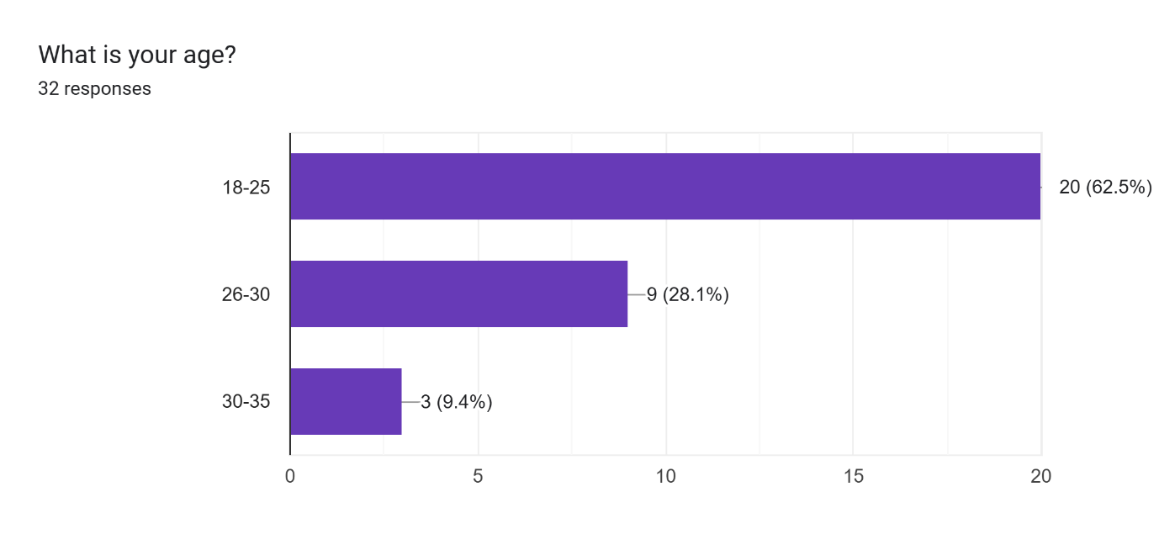

2. What is your gender

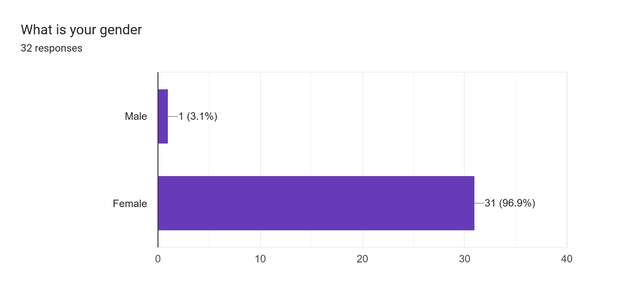

3. Your Family Income

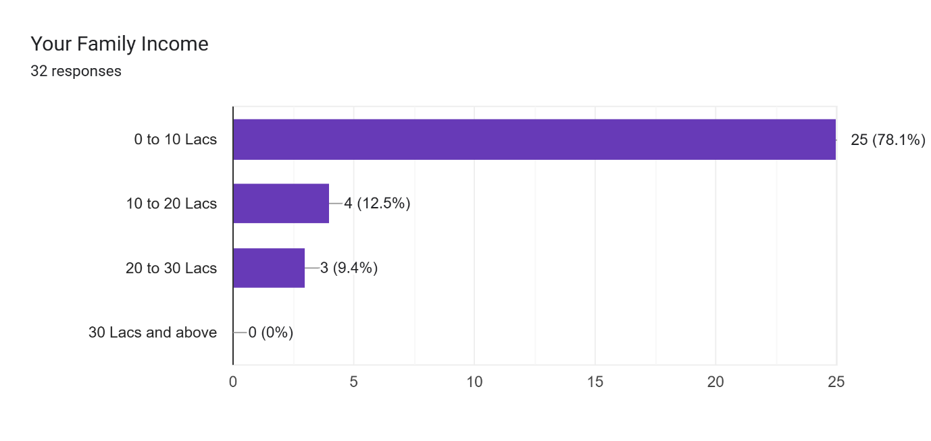

4. What category products is most visible to you in market

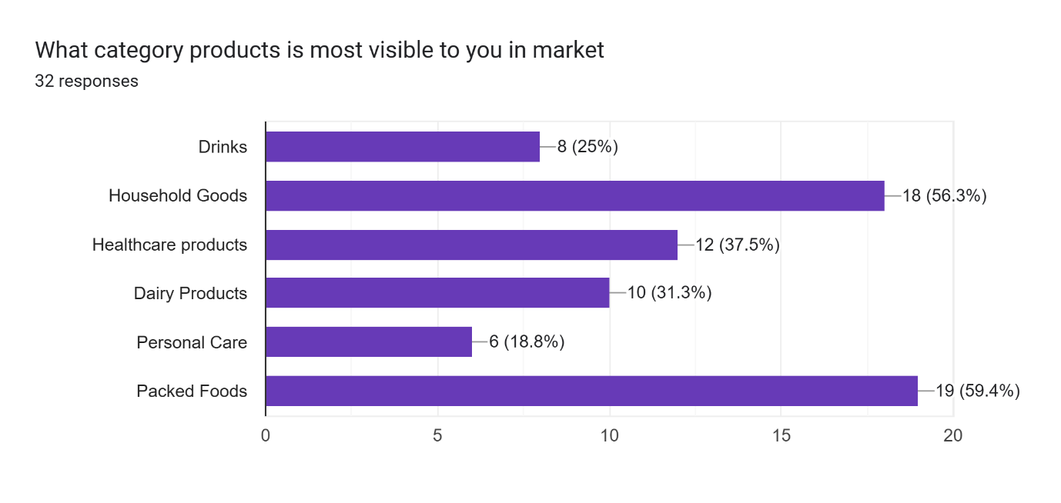

5.How much does packaging of the product influences your buying decision

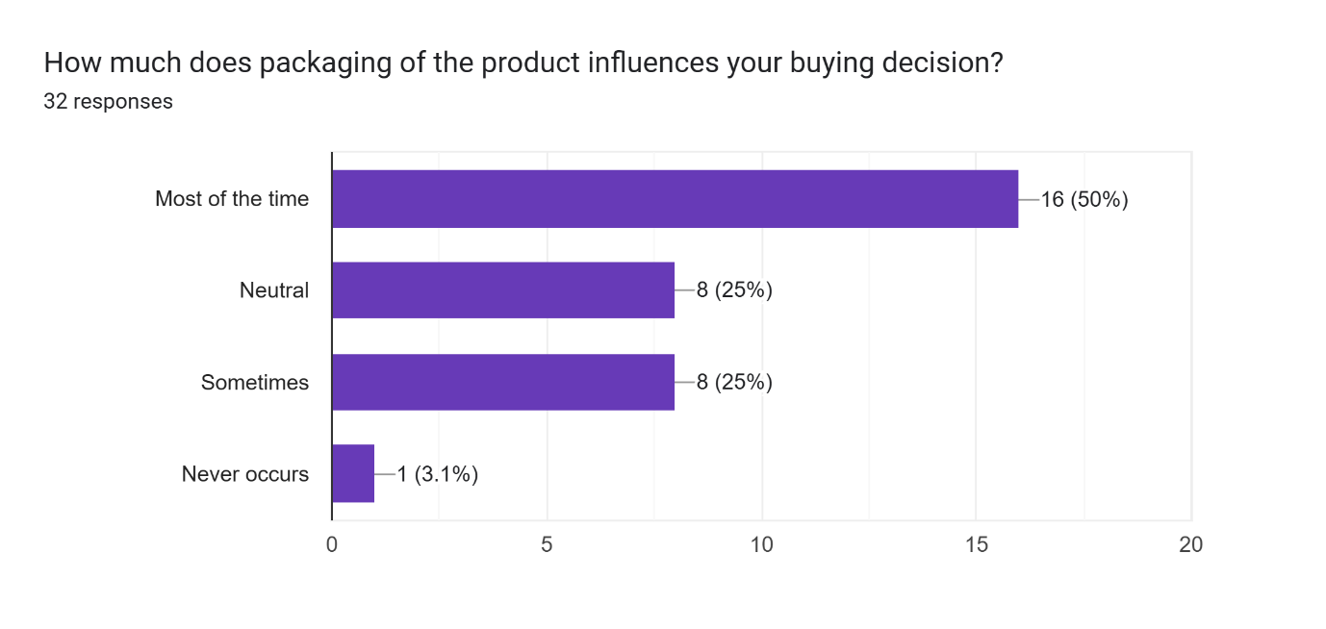

6.Does offer and discounts on products make you choose a inferior product over a superior ones

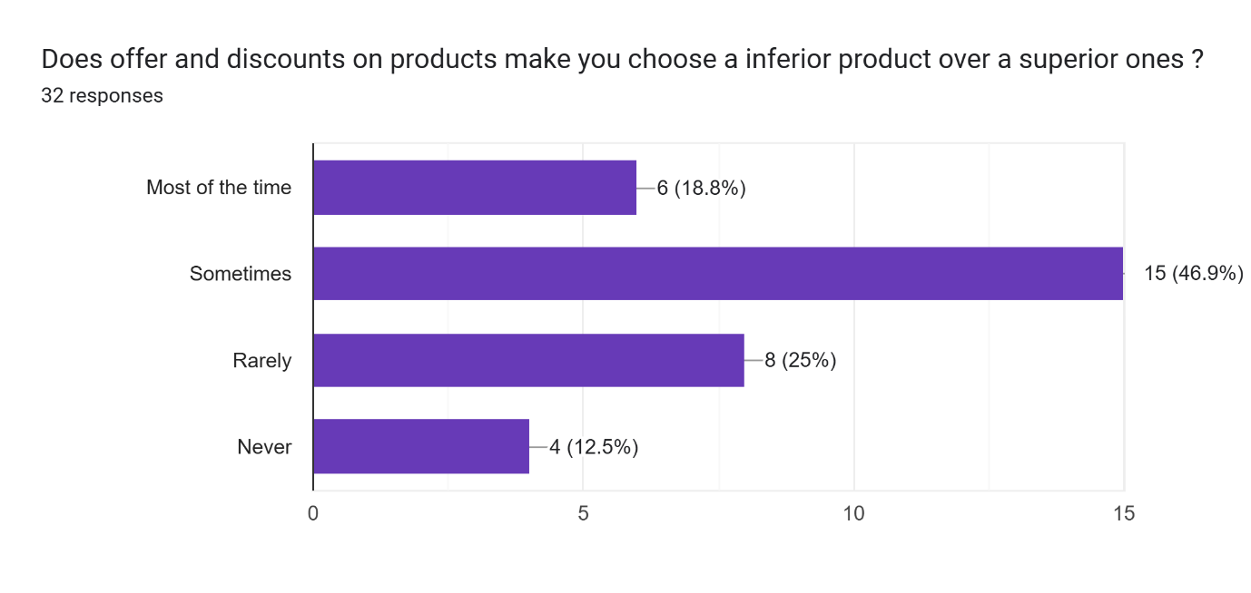

7.Do you feel inclined towards products which have multiple colors in packaging

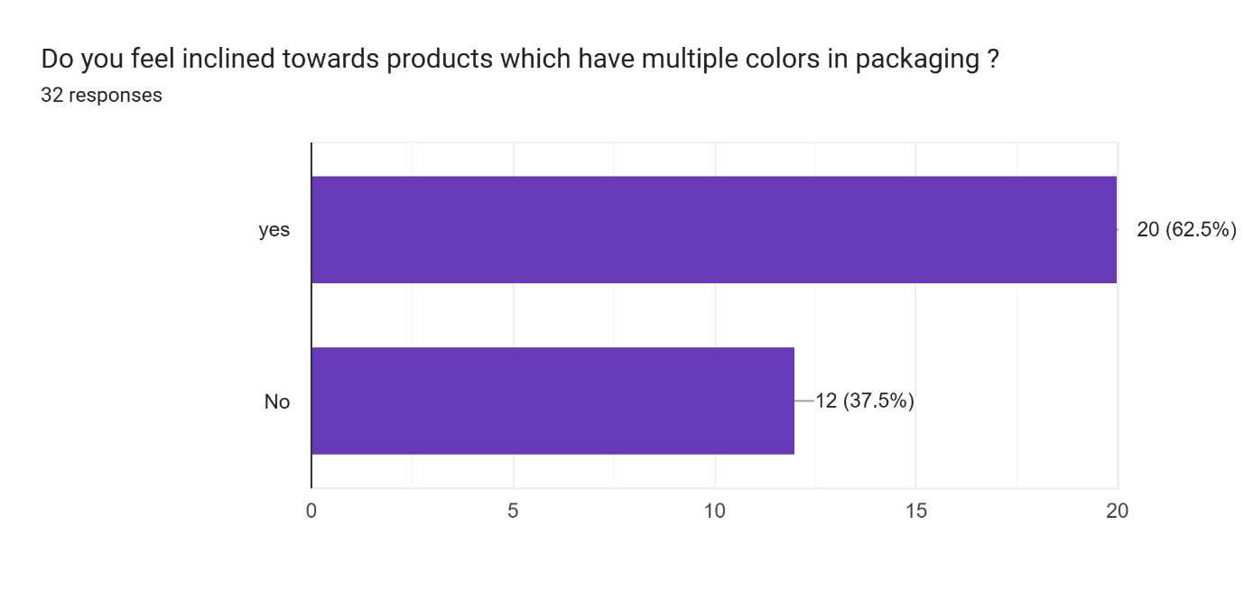

8.Do you feel inclined to the products which have basic packaging and are subtle in nature

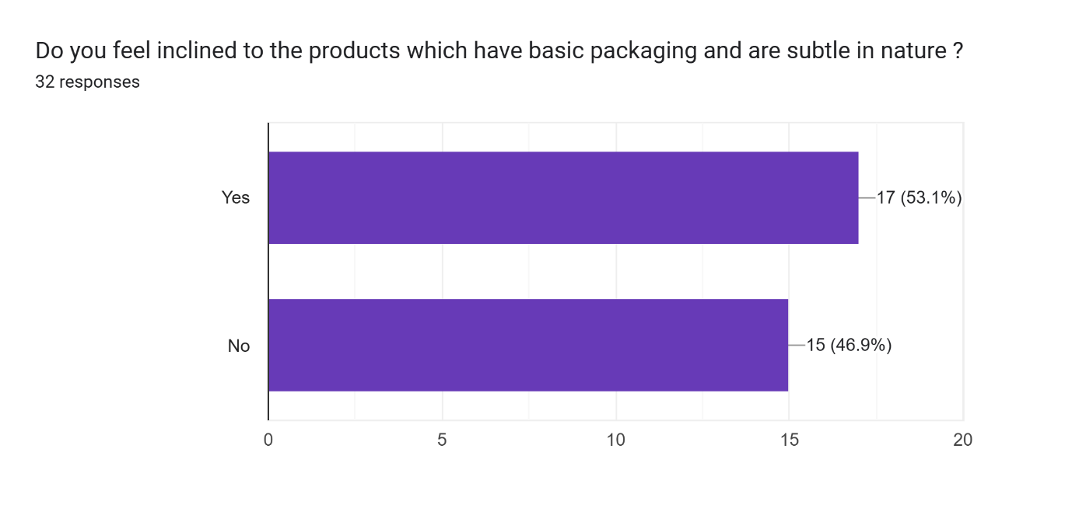

9.What do you prefer more, Quality or Quantity

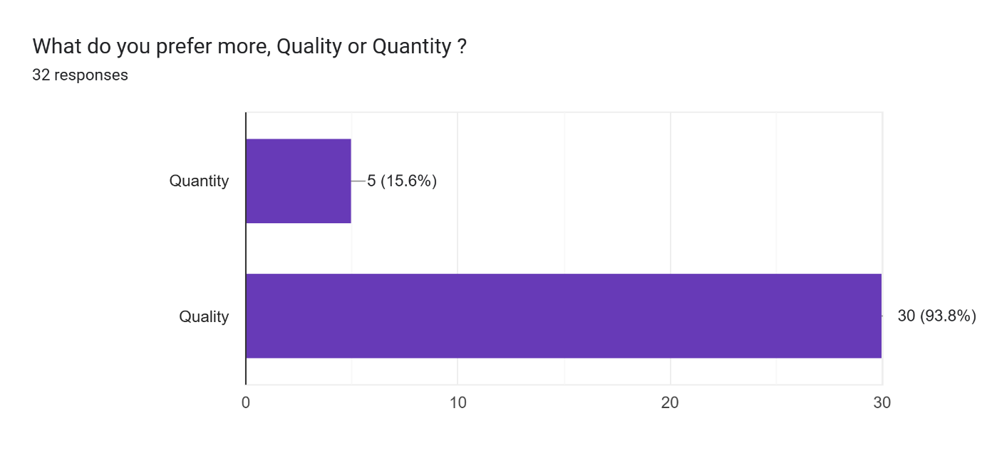

10.Does the feel of packaging matter to you

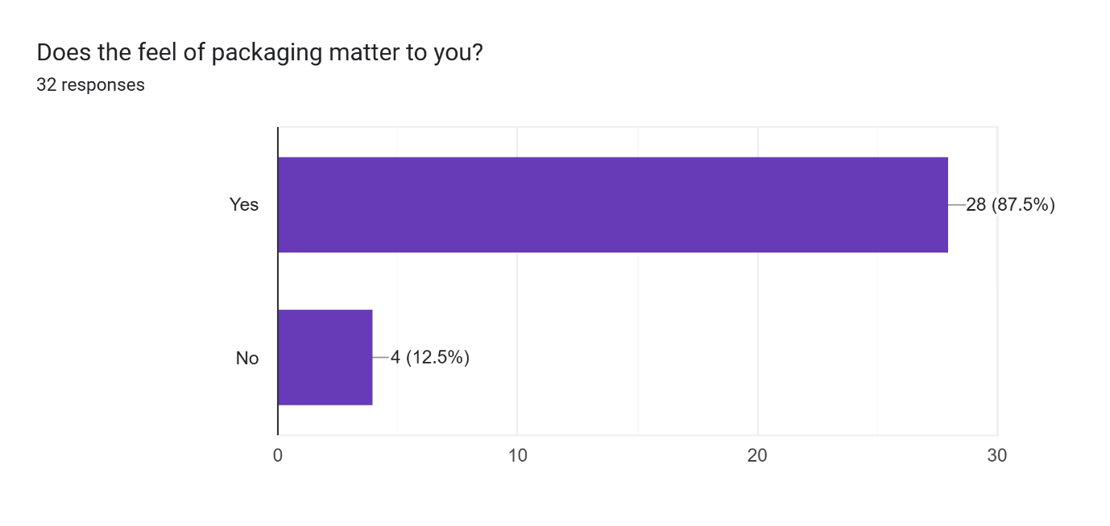

11.Do you read labels on the packaging before or after buying the products

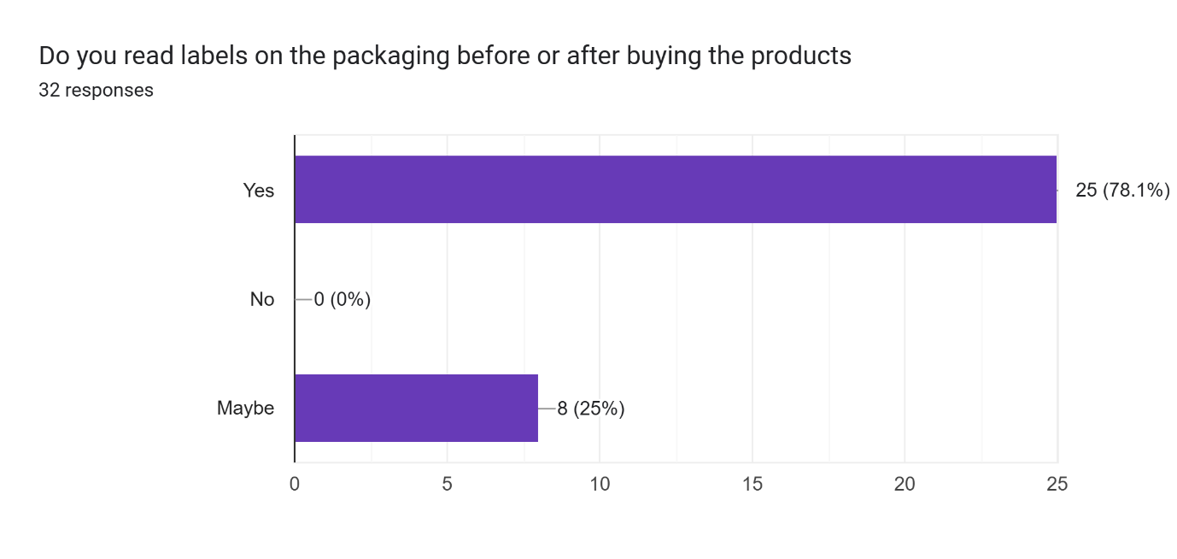

12.If the price increases of the products you are loyal to, will you look for an alternative

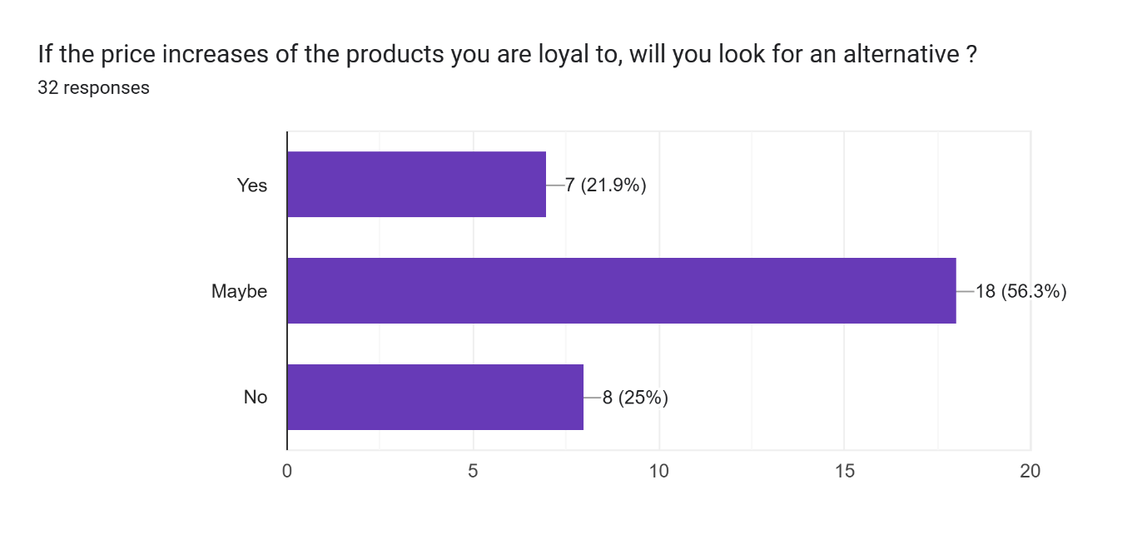

* **Results and Findings**

The study’s findings suggest that:

**Colour and Aesthetics:** Visually appealing and vibrant packaging attracts consumer attention, often leading to impulse purchases.

**Sustainability and Material:** Eco-friendly and sustainable packaging options are increasingly preferred by consumers.

**Labelling and Information:** Transparent and well-detailed labelling enhances consumer trust and confidence in a product.

**Brand Identity:** Packaging plays a vital role in brand recall and distinguishes a product from competitors.

* **Suggestions**

Businesses should prioritize visually attractive and sustainable packaging to increase consumer interest.

Providing clear and comprehensive product information on packaging can help build trust among customers.

Innovative and unique packaging designs should be adopted to enhance product differentiation in the market.

Personalized packaging strategies can strengthen customer loyalty and engagement.

* **Conclusions**

Packaging serves both functional and marketing purposes, significantly influencing consumer buying decisions. A well-designed, informative, and sustainable packaging approach can enhance brand perception, consumer trust, and purchase intent. Companies should strategically invest in packaging to improve their competitive advantage.

* **Citations**

Kotler, P. (2010). Marketing Management. Pearson Education.

Rundh, B. (2013). Linking Packaging to Marketing: How Packaging Is Influencing the Marketing Strategy. British Food Journal, 115(11), 1547–1563.

Silayoi, P., & Speece, M. (2007). The Importance of Packaging Attributes: A Conjoint Analysis Approach. European Journal of Marketing, 41(11/12), 1495–1517.