**FEASIBILITY STUDY ON SMART IRRIGATION SCHEME ON THE JOS PLATEAU USING WIND POWER**

**Samson Daniel, Hassan Aliyu, Buhari Mamman, Yarima Sa’id Musa, D.M. Nazif.**

**Department of Electrical and Electronics Engineering, Abubakar Tafawa Balewa**

**University, Bauchi Nigeria;** *Dept. of Electrical and Electronic Engineering Technology*

*Federal Polytechnic Bauchi Bauchi State, Nigeria.*

**Corresponding author; tsakuma01@gmail.com**

**ABSTRACT**

The over-dependence on rainfall agriculture is affecting crop production in Nigeria today, reducing crop yield and keeping farm output below demand. Irrigation farming is insurance for rain-fed agriculture even during the rainy season. The target site is Jos, Plateau state, with wind speed potential of 3ms-1 to 9.37ms-1 all year round, making it viable to generate power for pumping irrigation water. And also, the nature of the terrain which will enable or support the pump hydro storage technology. In this work, the focus is on the feasibility of a wind-powered pump hydro storage scheme for smart irrigation systems. This provided weekly irrigation water. The wind turbine farm is able to generate electric sufficient power to pump water from a lower reservoir to a higher head reservoir and also charge a battery bank. At the time of irrigation, water is released from the higher reservoir through series of control valves installed in the farm. The battery storage was use as a power source for the irrigation control system which uses the microcontroller to monitor and control the farm parameters using soil moisture sensors, water level sensor for the upper reservoir, and the outlet valve. This system is expected to be fully automatic. The raw wind data collected was upgraded from 10m to a hub height of 50m to improve power generation. The wind turbine (S3-1000-B8) generate power to pump minimum amount of water of 8.7m3 and maximum of 176m3 per week. The power generated from the wind by this turbine was determine using polynomial regression which make it suitable for this work. Twenty (S3-1000-B8) wind turbines where used to supply 180m3 of irrigation water required per week to irrigate 10,000m2 of farmland. For one-month safe irrigation period, 720m3 of storage water is needed. From the wind potential, a single wind turbine is able to generate an average energy of 16kWh in a month and pump 234.864m3 of water. Therefore, in total the wind form will generate 336kWh and pump equivalent of 4,932m3.

1. **INTRODUCTION**

In many third-world nations, agriculture is essential to sustainable development and the reduction of poverty. For a nation to modernize and progress, the issue of sustainable agricultural development must be resolved (Adenugba & Misra, 2019). The greening program was proposed in the Common Agricultural Policy (CAP) 2014–2020 adopted by the European Commission which among other things intends to improve energy efficiency in agricultural production. Using innovative energy technology like renewables in farms can help reach this goal.

In Nigeria, the agricultural industry is essentially organized into four sectors: the production of crops, fish, livestock, and forestry. 87% of the sector's entire output still comes from crop production, which is followed by livestock, fisheries, and forestry with 8.1%, 3.2%, and 1.1% respectively. Nigeria's largest industry, agriculture, has contributed an average of 24% of the country's GDP since 2013. Moreover, the sector is the greatest employer of labor in the nation thanks to its employment of more than 36% of the labor force (Oyaniran, 2020).

Although Plateau State is primarily known for its mining production, agriculture is the state's primary industry and the majority of its resident’s work in it. In the plateau, acha (hungry rice), millet, yam, sorghum, corn (maize), potatoes, cowpeas, rice, fruits, and vegetables are the most widely grown stable crops. The plateau's state agriculture is primarily semi-arid because of the region's unique geography and environment. The greatest strategy to adopt to meet agricultural demand is a smart irrigation system due to the plateau's state farming systems and the lack of adequate rainfall.

Worldwide, wind energy is a growing industry that is mostly employed for two tasks: producing electricity and pumping water(Azad et al., 2015). Wind energy technology is expanding globally due to worries about the environment and energy security, the rising expense of fossil fuels, and even interest in economic development (Mentis et al., 2015). In addition, among renewable energy sources, wind power has emerged as a significant choice for both electricity production and water pumping. It has been gaining popularity in recent years because of its environmental friendliness and ability to supply substantial amounts of electricity to satisfy a country's requirement for irrigation (Ohunakin & Akinnawonu, 2012).

As its name suggests, the plateau state is located on a plateau with a wind speed potential of 3 to 8.6 m/s (NIMET), making it viable to generate electricity for pumping water for irrigation and making use of available water reservoirs from the dams created by mining activities, which hold an ample amount of water that can support irrigation on the plateau. A rain-fed agriculture's ability to withstand unpredictable rainfall is protected by irrigated land area, which also serves as a predictor of agriculture’s ability to withstand the effects of climate change. The impact of climate change is susceptible to the rain-fed agriculture system (Olayide et al., 2016).

Jos, the capital of Plateau state, is a suitable location because it is naturally windy and has an average wind speed above 5 m/s throughout the year. Jos's NIMET meteorological station's coordinates are latitude 09-52 N, longitude 08.45 E, and altitude 1217 m, and these measurements were made at a height of 10 m using a cup-generator anemometer (Ohunakin & Akinnawonu, 2012).

A typical wind turbine is depicted in Fig.1. The most popular types of wind turbines in use today are horizontal axis wind turbines (HAWTs). HAWTs use rotors that can be either upwind or downwind-positioned and are mounted with aerodynamic blades (also known as airfoils). Often having two or three blades, HAWTs move quickly at the blade tips.

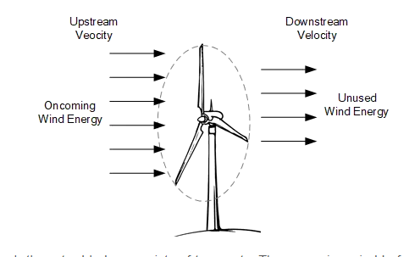 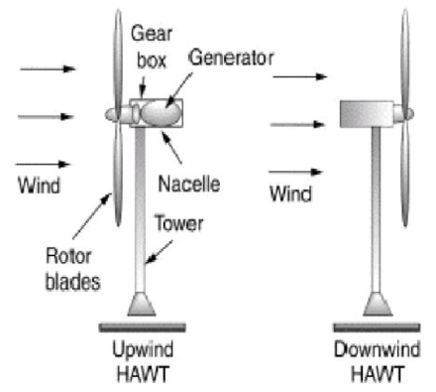

# Fig.1 The horizontal axis wind turbine. (Francisco, 2019).

The downwind rotors feature blades that are coned allowing the turbine to self-orient, machines with upwind rotors need a yaw, or tail vane, to help them orient into the wind. The ability of downwind rotors to produce energy at low wind speeds has been reduced by their tendency to "wander" when attempting to line up with winds in low-speed circumstances (Hyams, 2012).

The following are the advantages and disadvantages of HAWT.

Advantages

1. Excellent efficiency and power output.
2. Excellent operational wind speed reliability.

We have decided to employ a horizontal axis wind turbine based on its efficiency because currently, it can convert 50% of the wind power received into electricity. Also, it should be possible to generate power with the least amount of wind possible to provide effective irrigation water.

This project will employ the principle of pump hydro energy storage (PHES). In this system, water is pumped from a lower reservoir to an upper reservoir by the wind turbine generator, at the time when irrigation is needed, water from the upper reservoir is released through control valves to the required farmland. The wind turbine continues to pump water to the upper reservoir until it is full.

**2. LITERATURE REVIEW**

(Usman et al., 2024). The study draws attention to the ongoing problem of small-scale farmers' lack of access to electricity, which has a negative impact on crop productivity, particularly during dry seasons. It highlights wind energy as a viable substitute that can offer farmers a number of advantages, especially with regard to irrigation, storage, and water management. The study looks into how well a small-scale wind energy conversion device designed for agricultural use performs. The Nigeria Meteorological Agency (NIMET) wind speed data is used to pre-process and analyze the electrical parameters of the system, such as voltage, current, frequency, and power. This allows for the assessment of fluctuations caused by variations in wind speed and guarantees that the system is appropriate for simulation(Saras et al., 2018). Akour et al., (2018) Uses the operational Reynolds number to optimized the blade geometry for average wind speed of 5 m/s along with the blade element momentum theory. The economic feasibility study was conducted using a 3D printed prototype blade. It is concluded by the findings that the ATT (Akour Team Turbine) is efficient and economically feasible to produce energy in low wind speed regions.

The study also discusses the possible advantages of lowering the use of diesel generators, which might result in cheaper generation costs and fewer emissions of greenhouse gases. (Javed et al., 2019). This research reviews hybrid solar-wind power supply systems using pumped hydro storage (PHS), examining their function, installed capacity, upcoming research, and technological challenges. It highlights the importance of energy storage in renewable energy infrastructure, reducing reliance on fossil fuels. (Duker et al., 2020). This article investigates the potential for wind power in the Cauvery Delta, namely in areas such as Cuddalore and Perambalore, with the aim of determining if wind power pumping systems for irrigation could be implemented. It highlights the need to carry out a pre-feasibility study to assess the techno-economic viability of using wind power for agricultural pumping systems in order to lessen reliance on the grid and improve the region's economic sustainability.

**3. Materials and Methods**

* 1. **Wind data acquisition**

The wind data that is used in this project is provided by the Nigeria meteorological agency. The wind data requested from the agency is for 3 years of 15-minute interval data that is from August 2018 to December 2021. The wind data collected will be used to determine the average amount of power that will be able to be generated in Jos, plateau state if it is viable and sustainable to support smart irrigation farming.

**3.2 The prospect of wind power at the site (Jos)**

From the data available for the site (Jos), the wind speed available and viable for the chosen turbine ranges between 1.3ms-1 to 9.37 ms-1. Power from the wind can be estimated by;

 ……………………………………….. (1)

Vm = 1.3ms-1 to 9.37ms-1.

The air density at the site is found to $ρ$ **= 1.21kg/m3**(Ohunakin & Akinnawonu, 2012). This will be used to calculate the energy in the wind and compare it with the turbine energy generated using the same wind speed.

* 1. **Reservoir**

The reservoir system will serve as the water storage unit to replace battery backup unit because of high cost of replacement and maintenance over long period of time.

The reservoir is of two types, the lower-level reservoir, and the upper-level reservoir. The upper reservoir will hold water at a quantity required to cover the water needed during the autonomy period of at least 3 hours daily for 3 days of the week for a month. The lower reservoir will hold water more than the upper reservoir which is expected to be replenished every year during the rainy season.

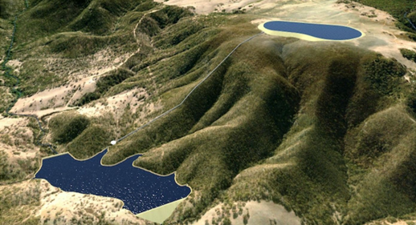

Fig 2. Lower and upper reservoir of a pump hydro storage (<https://www.atco.com/en-au/about-us/stories/atco-pumped-hydro-storage-nsw.html>)

* 1. **Pump**

The pumps are powered by wind turbines. Motorized pumps usually operate on 150V to 450V DC to drive 220V AC water pump or 250V DC to 800V DC drive three phase 380V AC water pump with the help of a variable frequency drive. Or DC pumps powered by 12V, 24V or 48V supply. These pumps are responsible for pumping water to the upper reservoir for storage.

* 1. **Irrigation Control System**

The control system is responsible for the farm irrigation and monitoring of farm parameters. Below is the diagram of the control circuit that monitors and control the irrigation of the farm and the pumping of water to the upper reservoir.

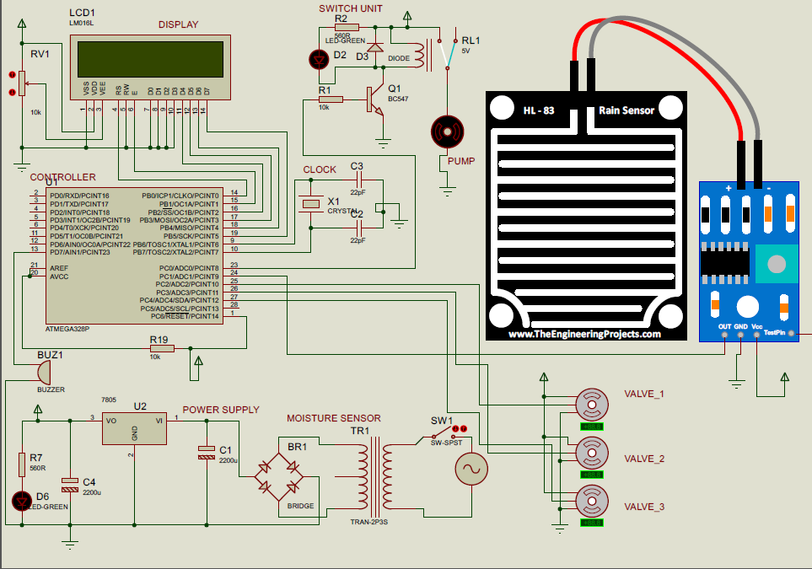

Fig. 3. The Control Circuit

* + 1. **The microcontroller (Arduino UNO)**

A crucial component of this irrigation system is microcontroller. The output of all the sensors had been provided as the analog inputs to the Arduino. Analog inputs are converted to digital outputs by this microcontroller. There is a relay attached to these digital output signals. The program that is already burned into the microcontroller is what generates these digital outputs.

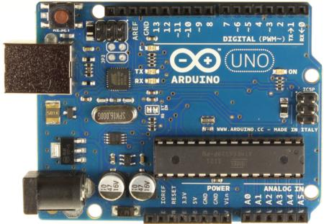

Fig 4. Arduino UNO

* + 1. **Connection of Soil Moisture Sensor to Microcontroller**

The soil moisture sensor is connected to the Arduino using a digital PCB drive. The PCB drive has a digital potentiometer. The digital pot is used to modify the sensor's sensitivity when it is linked in digital mode. The PCB drive out has four connecting pins, according to the chart below.

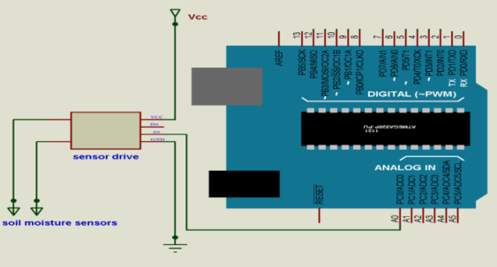

Fig 5.Connection to Arduino board

The sensor's output is a resistance base, which was connected to Arduino analog pin A0. The soil type and moisture content affect the impedance to the current passage between the sensor probes. The current (Iout) passing through the sensor probes for various soil types and soil moisture levels is calculated as follows:

$$Iout = \frac{Vcc}{\{Soil Resistance value (RS)\}}$$

The moisture content of the soil is detected by a soil moisture sensor. The resistance determines how this moisture level sensor responds. Low resistance values indicate that the soil has a high moisture content. High resistance indicates that the soil is dry. This signal is given to the Microcontroller and this makes the relay to be operated.



Fig. 6. Soil Moisture Sensor

Additionally, it determines the volumetric water content of the soil by substituting another soil characteristic, such as electrical resistance, the dielectric constant, or neutron interaction, for the moisture content. It is necessary to calibrate the relationship between the measured property and soil moisture since it can change based on the environment, including the soil type, temperature, and electric conductivity.

* + 1. **Water level detector.**

To gauge the water level, a water level sensor is inserted into the tank or reservoir.

The sensor is provided with the reference value as the minimum necessary level. The user is provided with information about the water level if the water level drops below the reference level.



Fig. 7. Water Level Sensor

* + 1. **The Irrigation Control System block diagram.**

An Arduino Uno is used in this project to control the motor and valve. The schematic is used to connect the Arduino to the motor driver and the driver to the water pump. The motor can be powered by 12, 24, or 48 volts.

The moisture sensor determines how moist the soil is and alerts the Arduino if more watering is required. Up until the necessary moisture level is reached, the plants are given water by gravity.

The gravity tank/reservoir water level sensor aids the microcontroller in keeping track of the reservoir's water level. The water flow valve aids the microcontroller in directing water either to the reservoir for storage or to the farm for irrigation.

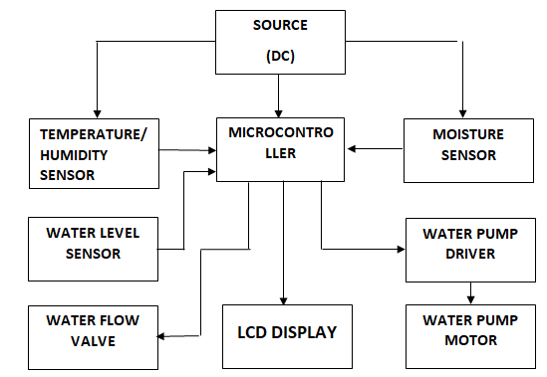

Fig 8. Block diagram of the control unit**.**

* + 1. **The flowchart.**

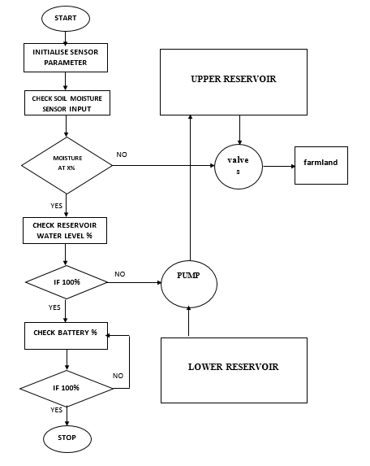

Fig 9 System Flowchart

**4.0 RESULTS AND DISCUSSION**

The result obtained from this research work are presented in this chapter. The wind data collected from Nigeria meteorological agency (NIMET) Jos, is analyzed and upgraded to a hub height for viable power generation and the result of the equivalent power calculated from the upgraded wind speed is presented. The energy and water storage presented and the result from the matlab simulation of the wind data is also presented.

The wind speeds are adjusted to the wind turbine hub height using the power law formulation (Ohunakin et al., 2011),(Ohunakin, 2011),(Ohunakin & Akinnawonu, 2012) of equation 1.

…………………………………………………………………………………...……….1

Where  *Ho* is the reference hub height, *uo* is the reference wind speed, *H* is the new hub height and *u* is the new wind speed.

Figure 10. show the chart of the average wind speed upgrade at 10m and 50m height for the first year (Aug, 2018 to July, 2019). The blue curve at the bottom is the average monthly wind speed at 10 meters height, after upgrading the wind speed for every 10 meters, it is obvious the increase in speeds in the month of august 2018 and February 2019 are the highest for the year. There is also some viable wind speed in the month July and between from October to February for possible generation of power.

Fig 10. chart of average wind speed upgrade for 2018/2019

Figure 11 shows more viable wind speed rise in the month between November and March. For this particular year wind speed is at its high potential at the month between January and February. The chart also shows the rise in wind speed as a result of increase in hub height, and the significant change in wind speed.

Fig 11. chart of average wind speed at different height of 2019/2020

The wind speed upgrade for August to December of 2020 is also represented in a chart in figure 12 below. The curve shows the difference in the change in wind upgrade of the year, which is higher at the month of August and September than the rest of the month.

Fig 12. chart of average wind speed upgrade for August to December of 2020

From the wind upgrade made above hub height of 50 meters is selected for analysis to determine the electrical power output that can be generated from the wind speed at that hub height. The results obtain is compare with the result obtain from the simulation

**4.1 Calculating the Power in the Wind**

Considering the raw data from NIMET we have a reliable wind speed range of 1.3 m/s to 9.37 m/s at most time of the years, this range is reliable for generating power. Using equation (15) the power in the wind is calculated as;

 ………….1

ρ = 1.21 kg/m3

r = 0.6m, A = 1.13112m2.

Table 1. The Analysis of The Power in The Wind.

|  |  |
| --- | --- |
| Wind speed at 10 m hub height (m/s) | Power (w) |
| 1.3 | 1.5 |
| 9.37 | 563 |
| Wind speed at 50 m hub height (m/s) |  |
| 1.6 | 2.8 |
| 11.93 | 1,161 |

The upgraded wind speed and the potential power available in the wind as calculated above in table 1 fit the operational wind speed of the turbine selected for viable output power.

Table 2 shows a detail of 1000W wind turbine generator. The power calculated from the wind data acquired for this research is compared with the manufacturer wind turbine characteristics to see how much power it can generate from the wind energy. The wind turbine parameters are shown in the table below

Table 2. 1kw Qingdao Green New Energy Equipment Co. Ltd Wind Turbine

|  |  |  |  |
| --- | --- | --- | --- |
| **Model** | S3-1000-B8 | **Blade Material** | 8 pcs |
| **Rated Power** | 1000 W | **Rated Voltage** | 12v/24v/48v |
| **Wheel Diameter** | 1.2 m | **Rated Wind Speed** | 13 m/s |
| **Cut-in Wind Speed** | 1.3 m/s | **Survival Wind Speed** | 50 m/s |
| **Blade Length** | 0.58 m | **Height of Tower** | 50 m |

Fig 13. The S3-1000-B8 wind turbine curve

The wind turbine curve in figure 13 is use to derive the power equation of the turbine by curve fitting using polynomial regression.

Table 3. Seasonal Energy Generated from the wind by the S3-1000-B8 Turbine

|  |  |  |  |  |  |  |  |
| --- | --- | --- | --- | --- | --- | --- | --- |
| DRY SEASON | | RAINING SEASON | | DRY SEASON | | RAINING SEASON | |
| DATE | **ENERGY (kWh)** | DATE | **ENERGY (kWh)** | DATE | **ENERGY (kWh)** | DATE | **ENERGY (kWh)** |
| 10/2018 | **22.464** | 04/2019 | **17.979** | 10/2019 | **13.728** | 04/2020 | **20.597** |
| 11/2018 | **14.982** | 05/2019 | **17.701** | 11/2019 | **11.225** | 05/2020 | **16.018** |
| 12/2018 | **22.799** | 06/2019 | **12.812** | 12/2019 | **16.459** | 06/2020 | **13.374** |
| 01/2019 | **17.139** | 07/2019 | **15.785** | 01/2020 | **28.228** | 07/2020 | **15.510** |
| 02/2019 | **20.091** | 08/2019 | **15.164** | 02/2020 | **29.949** | 08/2020 | **18.969** |
| 03/2019 | **18.474** | 09/2019 | **13.837** | 03/2020 | **15.627** | 09/2020 | **20316** |
| TOTAL | **115.949** | TOTAL | **93.278** | TOTAL | **115.216** | TOTAL | **104.784** |

In table 3 we have the seasonal power representation which gives us the amount of power this turbine is generating seasonally

**4.2 Reservoir Storage Capacity**

The total potential energy capacity of a reservoir is calculated using,

$$E\left(kwh\right)=\frac{ ρ \left(kgm^{-3}\right) x V \left(m^{3}\right) x g \left({ms}^{-2}\right) x H \left(m\right)}{3.6 x {10}^{6} J({kwh)}^{-1}}…………..25$$

Where $ρ$ is the air density, $V$ is the wind speed, $g$ is the acceleration due to gravity, $H$ is the reservoir height and $E$ is the potential energy of the store water in the reservoir.

We can use this equation to calculate the volume of water pumped for every kwh of power generated. Simplifying equation (26) we have;

$V\left(m^{3}\right)=E\left(kwh\right) x 14.679$…………… 26.

The curve in figure 14 below shows the volume of water pump for every kwh of power using equation (27).

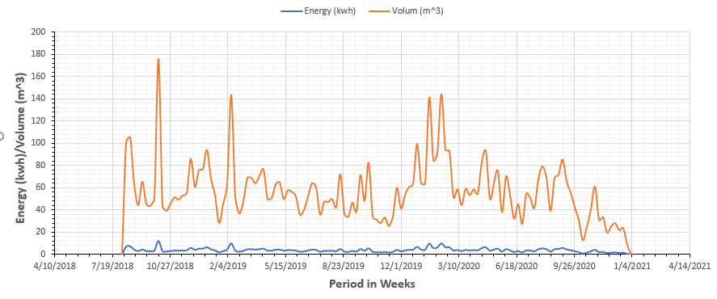

Fig 14. Weekly Energy and Volume of Water Curve

From the table, the minimum volume of water supply to the reservoir from the sum of energy generated weekly by a single S3-1000-B8 wind turbine is 8.765 m3 and 176 m3 at its maximum weekly sum of energy generated.

The volume of water required for irrigation per day is 60 m3 to irrigate a farmland size of 10,000 m2 and 180 m3 for a week and 720 m3 for an autonomous period of a month if no sufficient energy generated for a month. Considering the minimum volume of water pumped in a week, the minimum number of turbines required to pump irrigation water for a week is;

Number of turbines required $=\frac{180m^{3}}{8.765m^{3}}=20.5$

Therefore, a minimum of 21 wind turbine (S3-1000-B8) is required for wind farm.

**4.3 Wind speed and wind power analysis of a wind turbine for Farm irrigation.**

The purpose of this analysis is to study and analyse the nature of the wind speed distribution recorded at the Jos plateau and determine the feasibility of physical implementation of a wind turbine capable of raising water to a tank over a height and using for both irrigation, power accessories.

The selected parameters used for this simulation are given in Table 4 and Table 5 as follows:

|  |  |  |  |  |  |  |  |  |  |  |  |  |  |  |  |  |  |  |  |  |  |  |  |  |  |  |  |  |  |  |  |  |  |  |
| --- | --- | --- | --- | --- | --- | --- | --- | --- | --- | --- | --- | --- | --- | --- | --- | --- | --- | --- | --- | --- | --- | --- | --- | --- | --- | --- | --- | --- | --- | --- | --- | --- | --- | --- |
| |  |  |  | | --- | --- | --- | | No. | Parameter | Value | | 1. | Turbine reference height | 10 m | | 2. | Turbine reference altitude | 50 m | | 3. | Surface wind speed | 3 m/s | | 4. | Turbine radius | 2.8 m | | 5. | Turbine efficiency | 0.7 |  |  |  |  | | --- | --- | --- | | No. | Parameter | Value | | 1. | Selected months | 24 | | 2. | Air density | 1.225 kg/m3 | | 3. | Stability parameter | 0.14 | | 4. | Power coefficient | 0.45 | |  |

Table 4. Turbine physical parameters Table 5. Related parameters

**4.4 The raw wind speed data analysis and power generated.**

Fig. 15 is the time distribution of a raw wind speed recorded over 2-year period between January 2019 to December 2020. The data were recorded at 15 minutes interval resulting in 96 total daily collected samples, 2880 total monthly recorded samples, and a total of 69,120 wind recorded samples.

The 2-year wind speed data is extracted from a previously recorded 3-years full data (over 88,000 samples). The **MATLAB** command [**WindDat**a = **xlsread** (**'PLATEAU.xlsx','C2:C83838'**)] is used to read the raw data. The time wave form shows the very stochastic nature of the wind energy. Fig. 15(**a**) is a raw wind data that has not been processed and the histogram of the wind speed distribution in Fig. 15(**b**) shows that the wind speed is biased and not distributed uniformly throughout the period under consideration while the energy derivable from the wind speed is shown in Fig.15(**c**). The **subsequent sections** is determined to present averages of the wind speed distribution to enable ease of analysis and clear visualisation of kind of wind power that can be derived in every segment period. Thus, the data spit over: I. Hourly averaged, II. Daily averaged and III. Monthly averaged wind speed time waveforms, histograms and wind power.

|  |
| --- |
| Fig 15 (a) Raw Wind Speed Time Waveform.    Fig 15 (b) Raw Wind Speed Histogram.    Fig 15 (c) Raw Wind Speed Energy. |
|  |

**4.5 The monthly averaged wind speed data analysis and power generated.**

Fig. 16(**a**) is the wind speed samples averaged over a month period while Fig. 16(b) shows the distribution histogram and from the histogram, it could be inferred that the energy generation is better by monthly averaging because the mean is moving much closer to the centre of the wind speed distribution. Fig. 16 shows the cumulative sum wind energy in logarithmic scale.

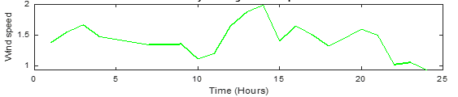

Fig 16(a) Monthly Average Wind Speed waveform

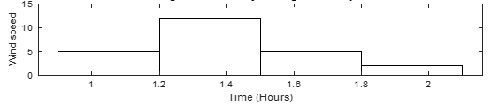

Fig 16(b) Monthly Average Wind Speed Histogram

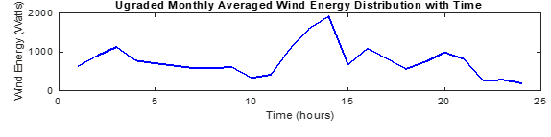

Fig 16(c) Monthly Average Wind Energy



Fig 16 Monthly Average Wind Energy generated

**4.6 Seasonal wind speed data analysis and power generated.**

Fig. 17 is the wind speed measurement considered based on the seasonal period. In Fig. 17(**a**), 17(**b**) and 17(**c**), the wind speed data are recorded based on the seasons within the 2-year period between January 2019 and December 2020 (24 months). The periods of the recorded wind speed data are broken in 6-month bases in table 6:

Table 6 Seasons from Raw Wind Data

|  |  |  |  |
| --- | --- | --- | --- |
| **Season/Range of period** | **Label** | **Time length** | **No. of samples** |
| April 2019 to Sept 2019 | Season 1 | 6 months | 17280 |
| Oct. 2019 to March 2020 | Season 2 | 6 months | 17280 |
| April 2020 to Sept 2020 | Season 3 | 6 months | 17280 |
| Oct. 2020 to March 2021 | Season 4 | 6 months | 17280 |
| TOTAL |  |  | 69120 |

**4.7 Hourly averaged seasonal Upgraded wind speed data analysis and power generated.**

Fig. 17 are the seasonally wind speed distribution while samples Fig. 17 are the corresponding generated wind power over the 3 seasons.

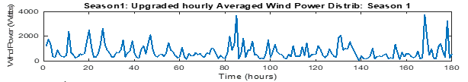

Fig 17(a) Season 1 Upgraded Wind Power Distribution

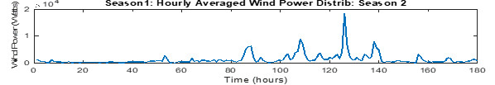

Fig 17(b) Season 2 Upgraded Wind Power Distribution

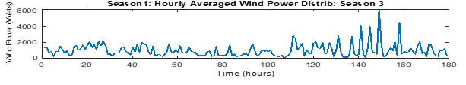

Fig 17 (c) Season 3 Upgraded Wind Power Distribution

**Fig. 17**. Upgraded Averaged Wind Power

ii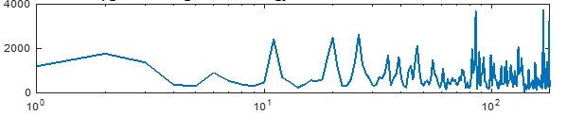

Fig 18(a) Season 1 Upgraded Average Wind Energy Distribution with Time

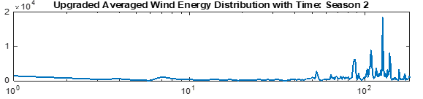

Fig. 18(b) Season 2 Upgraded Average Wind Energy Distribution with Time

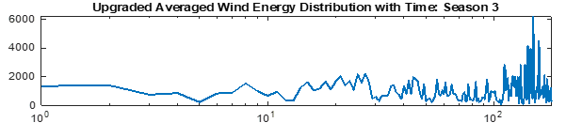

Fig. 18(c) Season 3 Upgraded Average Wind Energy Distribution with Time

**Fig. 18**. Upgraded averaged wind power (logarithmic scale) (W)

**4.8 Raising the water to the upper reservoir**

Raising the water requires the energy generated by the wind turbine to be expelled as work done against the gravity in the presence of raising the water to a predetermined height. Selected parameters are chosen to model the process as shown in Table 7.

Table 7. Related parameters

|  |  |  |
| --- | --- | --- |
| No. | Parameter | Value |
| 1. | Gravity | 9.8 m/s2 |
| 2. | Upper reservoir height | 25 m |
| 3. | reservoir volume | 720 m3 |
| 4. | Turbine efficiency | 0.7 |

 x 104

Fig. 19(a) Power Generated Over the Period of 0ne Year

 x 104

Fig. 19(b) Energy Used Over the Period of One Year



Fig. 20(a) Change in Reservoir Volume Over the Period of One Year



Fig. 20(b) cumulative reservoir volume Over the Period of One Year

1. **Conclusion**

The overall aim of this work is the feasibility study on automatic irrigation scheme on the Jos Plateau using wind power to minimize fuel and labour cost. Furthermore, the following conclusions were arrived at upon completion of this research work;

1. The nature of the terrain at the experimental location will allow the installation of a pump storage hydro system due to the difference in height between the lower and upper reservoir.
2. The single wind turbine is able to generate an average energy of 16kWh in a month and the wind farm of 21 turbine generators is able to generate a combine average energy of 336kWh with the potential to pump water to the upper reservoir for storage.
3. The system is able to collect soil moisture data from the farm and monitors and control irrigation operation.
4. The comparative cost analysis shows that the wind power irrigation system is cheaper with very low maintenance and with a return investment of 4 years.

**Reference**

Adenugba, F., & Misra, S. (2019). *Smart irrigation system for environmental sustainability in Africa : An Internet of Everything ( IoE ) approach*. *16*(December 2018), 5490–5503. https://doi.org/10.3934/mbe.2019273

Akour, S. N., Al-Heymari, M., Ahmed, T., & Khalil, K. A. (2018). Experimental and theoretical investigation of micro wind turbine for low wind speed regions. *Renewable Energy*, *116*, 215–223. https://doi.org/10.1016/j.renene.2017.09.076

Azad, A. K., Rasul, M. G., Islam, R., & Shishir, I. R. (2015). Analysis of wind energy prospect for power generation by three Weibull distribution methods. *Energy Procedia*, *75*, 722–727. https://doi.org/10.1016/j.egypro.2015.07.499

Duker, A., Cambaza, C., Saveca, P., Ponguane, S., Mawoyo, T. A., Hulshof, M., Nkomo, L., Hussey, S., Van den Pol, B., Vuik, R., Stigter, T., & van der Zaag, P. (2020). Using nature-based water storage for smallholder irrigated agriculture in African drylands: Lessons from frugal innovation pilots in Mozambique and Zimbabwe. *Environmental Science and Policy*, *107*(December 2019), 1–6. https://doi.org/10.1016/j.envsci.2020.02.010

Hyams, M. A. (2012). Wind energy in the built environment. *Metropolitan Sustainability: Understanding and Improving the Urban Environment*, 457–499. https://doi.org/10.1533/9780857096463.3.457

Javed, M. S., Ma, T., Jurasz, J., & Amin, M. Y. (2019). Solar-wind-pumped hydro energy storage systems: review and future perspective. *Renewable Energy*. https://doi.org/10.1016/j.renene.2019.11.157

Mentis, D., Hermann, S., Howells, M., Welsch, M., & Siyal, S. H. (2015). Assessing the technical wind energy potential in Africa a GIS-based approach. *Renewable Energy*, *83*, 110–125. https://doi.org/10.1016/j.renene.2015.03.072

Ohunakin, O. S. (2011). Assessment of wind energy resources for electricity generation using WECS in. *Renewable and Sustainable Energy Reviews*, *15*(4), 1968–1976. https://doi.org/10.1016/j.rser.2011.01.001

Ohunakin, O. S., Adaramola, M. S., & Oyewola, O. M. (2011). Wind energy evaluation for electricity generation using WECS in seven selected locations in Nigeria. *Applied Energy*, *88*(9), 3197–3206. https://doi.org/10.1016/j.apenergy.2011.03.022

Ohunakin, O. S., & Akinnawonu, O. O. (2012). Assessment of wind energy potential and the economics of wind power generation in Jos, Plateau State, Nigeria. *Energy for Sustainable Development*, *16*(1), 78–83. https://doi.org/10.1016/j.esd.2011.10.004

Olayide, O. E., Tetteh, I. K., & Popoola, L. (2016). Differential impacts of rainfall and irrigation on agricultural production in Nigeria: Any lessons for climate-smart agriculture? *Agricultural Water Management*, *178*, 30–36. https://doi.org/10.1016/j.agwat.2016.08.034

Oyaniran, T. (2020). Current State of Nigeria Agriculture and Agribusiness Sector. *AfCFTA Workshop*, *September*, 1–14. https://www.pwc.com/ng/en/assets/pdf/afcfta-agribusiness-current-state-nigeria-agriculture-sector.pdf

Saras, I., Mart, G., Platero, C. A., & S, Á. (2018). *Dual Frequency Regulation in Pumping Mode in a Wind – Hydro Isolated System*. https://doi.org/10.3390/en11112865

Usman, H. M., Mahmud, M., Yahaya, M. S., & Saminu, S. (2024). Wind-Powered Agriculture: Enhancing Crop Production and Economic Prosperity in Arid Regions. *Elektrika*, *16*(1), 10. https://doi.org/10.26623/elektrika.v16i1.8999