**SLUMP SALE**

**ABSTRACT**

Slump Sale, a transfer of an entire business as a going concern for a lump sum payment, without assigning individual values to assets and liabilities. It is a key mechanism in business acquisitions. A popular approach for mergers and acquisitions, slump sales are known for their ease of use and tax efficiency. This paper examines the idea of a slump sale and highlights how it is governed by the Companies Act of 2013 and the Income Tax Act of 1961. It explores its benefits, including tax efficiency, regulatory simplicity, and operational continuity, while also recognizing possible drawbacks, such as problems with transparency and hidden liabilities. The paper also compares asset purchases and slump sales, describes the steps in the transaction process, and talks about the regulatory approvals that are needed when financial thresholds are surpassed, including those from the Competition Commission of India. This thorough analysis seeks to offer a clear understanding of slump sale transactions, making it an invaluable tool for corporate law students, legal professionals, and business stakeholders.

**INTRODUCTION**

Slump sale means the sale of any undertaking as a going concern, where consideration is considered in a lump sum and where individual values are not taken into account. In simple terms, slump sale means a sale of a going concern business with all the assets and liabilities, in where going concern means, that the business is in the market, that is, the business is still going. [1]

Slump Sale is a type of a business acquisition, where there is a transfer of a whole or a part of the going concern business in a lump sum consideration, that is in a total amount totaling all the assets and liabilities rather than assigning the value for all the individual assets.

Slump sale is considered to be one of the most preferred ways of carrying out mergers & acquisitions deals. Compared to the other types of mergers/acquisition strategies, slump sale has the least complex yet well-defined tax implications along with other allied law procedures that are simple and time-efficient.

Since slump sale is not a sale of goods it cannot attract TCS under this provision, as, it is a transfer of 'business' and not 'goods'.

Slump Sale delves into the implications, under both, the Companies Act, 2013, and the Income Tax Act, 1961.

Relevant Sections:

* Under the Companies Act, 2013: Section 180(1)(a)
* Under the Income Tax Act, 1961: Sections 2(42C) & 50B

Let us understand it better with an example.

**Ex.:** Mr. X has two ongoing businesses, ‘A’ and ‘B’ where ‘A’ is in profit, while the other one, ‘B’ is going in losses. So, Mr. X decided to sale the business for a total amount of 1 crore (assets **+** liabilities) as a consideration, which is a lump sum consideration for his entire business.

**METHODOLOGY**

This paper examines the idea of slump sale in Indian corporate law using a doctrinal research methodology and primary and secondary legal sources. Statutory provisions from the Companies Act of 2013 and the Income Tax Act of 1961, particularly Sections 180(1)(a), 2(42C), and 50B, are examples of primary sources. Legal commentary, case law, and scholarly publications are examples of secondary sources that offer important insights into the ramifications, benefits, and difficulties of slump sales. In order to distinguish slump sales from other business transfer strategies like asset purchases and arrangement schemes, the study uses a comparative methodology. It also describes the tax implications, regulatory requirements, and procedural framework related to slump sale transactions. A thorough grasp of the subject is ensured by the practical examples and checklists that accompany the analysis. By using this approach, the document is guaranteed to be both educational and practically applicable, meeting the needs of students, business professionals, and attorneys alike.

What is the difference between slump sale and asset purchase?

A slump sale, on one hand, requires the transfer of all assets and liabilities that are necessary for the operation of the business without exception, in contrast to an asset transfer transaction, which allows the parties to choose, that is cherry-pick which assets and liabilities they wish to transfer.[2]

**WHY SLUMP SALE?**

Why is slump sale preferred over others?

* Fast and Simple: Slump Sale could be seen as one of the fastest ways to transfer an ongoing business. It allows the transfer of business of all the assets and liabilities and there is no need of assigning the individual values to each asset.
* Tax effectiveness: The tax rules for slump sales could be seen as straightforward, resulting in time and cost saving when the transaction is happening. Moreover, GST is not levied upon lump sum consideration, leading to very limited compliance requirements.
* Focus on a specific core business: It allows the businesses to focus on one’s core operations by divesting other segments in a slump sale.
* Continuous Operation: The one who acquires the business in the slump sale, he can jump to a business whenever he likes, also he could expand a business into a new location without operational setup from the scratch.
* Ease in regulatory: In the process of lump sum consideration, there is not much regulatory compliances required if compared to other methods of business transfers.

**ANY DOWNSIDES OF SLUMP SALE?**

* Transparency could be lacking: Since there is no individual valuation on the liabilities and assets in slump sale, there may be lack of transparency in the value of any or every component/s.
* Registration fees and stamp duty: Even though the assets and liabilities are not individually assessed, stamp duties, registration fees and some other expenses maybe used to determine the amount payable in it.
* Challenges: In Slump Sale, the buyer has to inherit all the assets and liabilities, which may also include the unwanted, unfavorable or non – performing assets, leading to inefficiency.
* Regulatory Risks: The buyer may also unwillingly inherit some hidden regulatory risks or certain compliance issues that were already associated with the business leading to future liabilities.

**STEPS TO BE TAKEN DURING SLUMP SALE AGREEMENT**

1. Find buyer (Shortlisting) (Primary valuation: that he has to sell in this particular amount.
2. Sign MOU sheet (Memorandum of Understanding; information of diligence, all the information, a proof that both the parties have received all the information).
3. Make Valuation (Since buyer thinks to get the lower cost while seller wants that he gets the maximum price for his business, so makes a deal in way both the parties are satisfied)
4. Deal structuring (makes a deal where decided the transaction cost, stamp cost, transfer of money, consideration etc.)
5. Slump Sale Agreement (by hiring any lawyer, finally indulges in the slump sale agreement).

**CAPITAL GAINS ON SLUMP SALE**

The gain or loss resulting out of a slump sale shall be a Capital Gain/Loss under the Income Tax Act

* Classification of Capital Gain/Loss:

- If the undertaking is held for more than 36 months, the resulting capital gain or loss shall be long-term.

- If the undertaking is held for less than 36 months, the resulting capital gain or loss shall be short-term.

* Calculation of Capital Gain/Loss in Case of Slump Sale (Section 50B):

Particulars:

1. Full value of lump sum consideration

2. Less: Expenditure in relation to the transfer

3. Less: Net worth of the undertaking (being the cost of acquisition and improvement)

4. Resulting: Capital Gain/Loss

(CG = slump sale consideration – Net worth of the undertaking.

Whereas, Net worth = aggregate value of the total assets – value of Liabilities of the undertaking).[3]

**WHO ALL APPROVES FOR SLUMP SALE?**

When it involves a straightforward transfer of assets (slump sale) between two entities, the following approvals and compliance steps are generally required, as opposed to a scheme of arrangement under Sections 230-232 of the Companies Act, 2013:

* Board of Directors:

Approval from the board of directors of both the buyer and the seller is required through board resolution.

* Shareholders:

In certain cases, especially if the transaction involves a substantial portion of the company's assets, approval from the shareholders of the selling company may be necessary through special resolution.

* Regulatory Filings:

Depending on the industry and the nature of the assets being transferred, specific regulatory filings and approvals may be needed. For example, if the assets include immovable property, registration with the relevant state authority and payment of stamp duty may be required.

If the transaction involves the transfer of licenses, permits, or other regulatory approvals, these may need to be reissued or transferred in the name of the buyer, subject to the consent of the issuing authority.

* Competition Commission of India (CCI):

If the transaction meets certain financial thresholds, approval from the Competition Commission of India may be required to ensure that the deal does not create a monopoly or reduce competition in the market.

* Contractual Consents:

If there are contracts or agreements tied to the assets being transferred, the consent of the counter-parties to those contracts may be necessary.

* Lenders and Creditors:

If the assets being transferred are secured by loans or if there are outstanding liabilities, the consent of the lenders and creditors may be required. This ensures that the transfer does not violate any loan covenants or agreements with creditors.

* Employee and Labor Laws:

If the transfer includes a significant number of employees, compliance with labor laws and possibly the consent of the employees may be required.

* Tax Authorities:

Compliance with tax regulations, including the payment of any applicable taxes on the transfer, such as capital gains tax, Goods and Services Tax (GST), and stamp duty, is essential.

Each of these steps ensures that the asset transfer is legally compliant and all stakeholders' interests are protected. It is advisable to consult with legal and financial advisors to navigate the specific requirements and obtain the necessary approvals.

**WHY APPROVAL FROM THE NATIONAL COMPANY LAW TRIBUNAL (NCLT) IN SLUMP SALE ASSETS TRANSFER IS NOT REQUIRED AS OPPOSED TO SCHEME OF ARRANGEMENT UNDER SECTION 230 – 232OF COMPANIES ACT?**

|  |  |  |
| --- | --- | --- |
|  | **SLUMP SALE** | **SCHEME OF ARRANGEMENTS** |
| Nature of the transaction | Involves the sale of an undertaking for a lump sum consideration without assigning values to individual assets and liabilities. It is essentially a business transfer as a going concern and does not inherently require NCLT approval. | This is a more complex restructuring involving compromises, arrangements, mergers, or demergers that typically affect creditors and shareholders. Such schemes usually need the approval of the NCLT to ensure they are fair and equitable to all stakeholders involved. |
| Regulatory Requirements | Governed by Sections 180 and 192 of the Companies Act, 2013, which primarily require board and sometimes shareholder approval, especially if it involves the sale of substantial assets. | Governed by Sections 230-232 of the Companies Act, 2013, requiring a detailed process including applications to the NCLT, meetings of creditors and shareholders, and NCLT's sanction to ensure transparency and fairness. |
| Stakeholder Impact | Typically involves fewer complications since it’s a direct asset transfer, often between two willing parties. The impact on stakeholders is usually limited and straightforward. | Potentially affects a wider array of stakeholders including shareholders, creditors, and employees. Hence, a more rigorous process, including NCLT approval, is in place to protect their interests. |
| Procedural Simplicity | The process is relatively straightforward, involving agreements between the buyer and seller, board resolutions, and regulatory filings, making NCLT approval unnecessary. | Requires a structured process overseen by the NCLT to ensure all procedural requirements are met and the arrangement is just and equitable. |

**IF TRANSACTION IS OF MORE THAN 600 CRORES, THEN IS COMPETITION ACT REQUIRED OR NOT?**

Yes, if the transaction value is more than 600 crores for a slump sale, it is likely that the approval of the Competition Commission of India (CCI) will be required. The CCI approval is necessary if the transaction crosses certain financial thresholds set by the Competition Act, 2002. The key thresholds for mandatory notification to the CCI are as follows:

Parties Test:

* Assets: The combined assets of the parties involved in India exceed INR 2,000 crore, or the combined worldwide assets exceed USD 1 billion, with at least INR 1,000 crore in India.
* Turnover: The combined turnover of the parties involved in India exceeds INR 6,000 crore, or the combined worldwide turnover exceeds USD 3 billion, with at least INR 3,000 crore in India.

Group Test:

* Assets: The group to which the acquired entity belongs has assets in India exceeding INR 8,000 crore, or worldwide assets exceeding USD 4 billion, with at least INR 1,000 crore in India.
* Turnover: The group to which the acquired entity belongs has a turnover in India exceeding INR 24,000 crore, or worldwide turnover exceeding USD 12 billion, with at least INR 3,000 crore in India.

These thresholds ensure that transactions that might significantly impact market competition are reviewed by the CCI. If your slump sale transaction exceeds these thresholds, it will be necessary to notify the CCI and obtain their approval before proceeding.

De Minimis Exemption: Small target exemptions apply if the assets of the target enterprise in India do not exceed INR 350 crore, or the turnover does not exceed INR 1,000 crore.

**A CHECKLIST OF ALL THE DOCUMENTS NEEDED.**

**Transferor Company**

|  |  |
| --- | --- |
|  | Memorandum of Association (MOA)  - Include the power to sell the undertaking/business. |
|  | Audited Balance Sheet:  - For the preceding financial year. |
|  | Slump Sale Agreement:  - Drafted and executed, complying with legal provisions. |
|  | Board Resolution:  - Approving the slump sale. |
|  | Shareholders' Resolution:  - Special resolution, if required. |
|  | Regulatory Filings:  - Forms filed with the Registrar of Companies (ROC), e.g., Form MGT-14. |
|  | Tax Compliance Documents:  - Capital gains tax calculations and any related documentation. |
|  | Due Diligence Reports:  - Legal and financial due diligence reports. |
|  | Employee Notices:  - Documentation related to employee matters, if applicable. |
| 1. **.** | Creditor Consent:  - Consents from creditors and lenders, if required. |

**Transferee Company**

|  |  |
| --- | --- |
|  | Memorandum of Association (MOA):  - Includes provision to carry out the business being acquired. |
|  | Business Transfer Agreement (BTA):  - Executed, outlining terms and conditions. |
|  | Regulatory Approval Documents:  - Approvals from regulatory bodies, e.g., Competition Commission of India (CCI) if applicable. |
|  | Due Diligence Reports:  - Legal and financial due diligence reports on the business being acquired. |
|  | Payment Proof:  - Evidence of payment of the agreed consideration. |
|  | Tax Compliance Documents:  - GST and other applicable tax documents. |
|  | Asset Transfer Documents:  - Documentation related to the transfer and integration of assets. |
|  | Stamp Duty Payment Receipts:  - Receipts for stamp duty paid on transfer documents.[4] |

**PROCEDURE:**

* Verify if the undertaking meets the requirements outlined in section 180(1)(a) in relation to the audited balance sheet from the financial year.
* At least seven days prior to the board meeting, send out a notice calling it.
* Call an EOGM, hold a board meeting, and approve a resolution to sell, lease, or otherwise dispose of the undertaking.
* At least 21 clear days prior to the meeting, send EOGM a notice calling.
* Calling an EOGM meeting and passing a special resolution to authorize the sale, leasing, or other disposal of the undertaking.
* File E-Form MGT-14 within 30 days from the date of passing of Special Resolution with the required fees with the Registrar of Companies.
* Execute necessary agreements, conveyance/ assignment deed.[5]

**AN ILLUSTRARTION UNDER COMPANIES ACT, 2013** [6]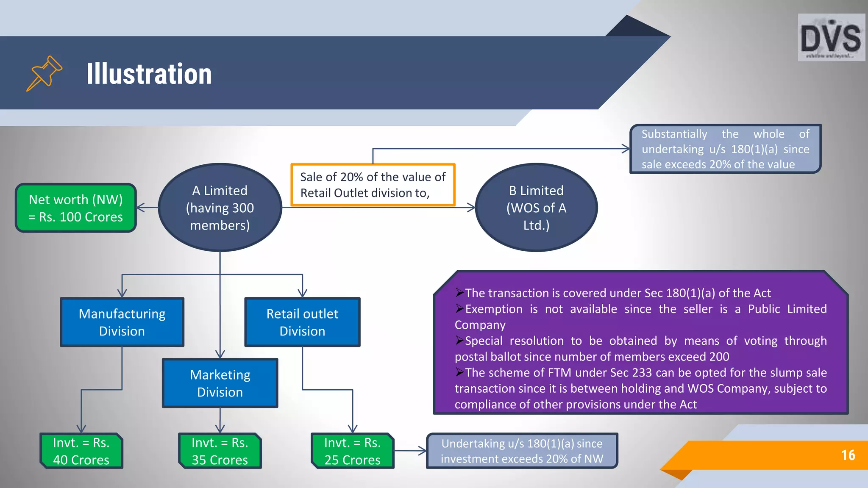

THANK YOU!

Tanvi Goel.

1. <https://tax2win.in/guide/slump-sale>
2. [https://taxguru.in/company-law/slump-sale-merger-implications-companies-act-income-tax-act.html#](https://taxguru.in/company-law/slump-sale-merger-implications-companies-act-income-tax-act.html)
3. <https://www.investopedia.com/terms/c/capitalgain.asp>
4. <https://www.caclubindia.com/articles/details.asp?mod_id=41762>
5. <http://159.65.147.210/governing-laws/the-companies-act-2013/slump-sale/>
6. <https://www.slideshare.net/slideshow/slump-sale-under-companies-act-2013/227117798>