**EXAMINING THE BEHAVIOR OF STRUCTURAL SUPPORT IN MULTI-STOREY BUILDINGS**

Prohit Choukhutiyaa, Dr. Vivek Sonib,

**M.Tech. Scholara, Associate Professorb, **Madhyanchal Professional University**, Faculty of engineering & Technology, School of civil engineering Bhopal, M.P., India. **

**Abstract**

This study examines the behavior of shear walls in multi-story buildings, emphasizing their influence on structural responses to lateral loads across various seismic zones and building configurations. The placement of shear walls within a building significantly affects seismic performance and structural stability, making their optimal positioning a key consideration in structural design. The study further investigates the impact of shear wall configurations, including centrally located walls, corner placements, and distributed arrangements, on the overall seismic resilience of buildings. The influence of wall thickness, material properties, and aspect ratio on lateral load resistance is also explored. This paper highlights the importance of shear walls in multi-story building design, emphasizing their critical role in improving structural resilience against lateral forces.

**Key Words:-** Shear wall, various seismic zones, structural stability, wall thickness, material properties

**Introduction**

Shear walls play a crucial role in enhancing the structural integrity of multi-story buildings by effectively resisting lateral loads induced by wind and seismic forces. Acting as robust vertical diaphragms, these walls efficiently transfer lateral forces from exterior walls, floors, and roofs down to the foundation, thereby improving the overall stability of the structure.

A comprehensive review of previous research is included, focusing on analysis and design comparisons conducted using various design software tools such as ETABS, SAP2000, and STAAD.Pro. These studies provide insights into different approaches used to evaluate shear wall effectiveness in mitigating seismic effects and optimizing building performance.

Findings from existing literature indicate that strategically placed shear walls can significantly enhance a building's lateral stiffness, reduce inter-story drift, and improve overall seismic performance. Case studies and simulation results from various researchers contribute to a nuanced understanding of shear wall behavior under different loading conditions, aiding engineers in making informed design decisions. The study aims to compare the performance of the structure in different seismic zones and determine how variations in seismic intensity influence the overall behavior of the building. Analyzing the structure under both static and dynamic seismic loading, insights can be gained into how lateral forces affect the building’s stability, strength, and deformation characteristics. The Equivalent Static Lateral Force method provides a simplified approach to assessing seismic forces, while the Response Spectrum Method offers a more precise evaluation by considering multiple modes of vibration.

* The study will determine how seismic zones influence structural performance and whether additional reinforcement or design modifications are necessary for higher seismic zones.
* It will provide recommendations for optimizing high-rise structures to enhance seismic resistance, considering factors like structural configuration, lateral strength, stiffness, and ductility.

Shear walls are structural elements used to resist lateral forces, such as those caused by wind and earthquakes, in buildings. They can be classified based on their geometry, structural system, and support conditions. Here’s a breakdown of the classifications you provided:

**Simple Rectangular Types and Flanged Walls**

* These are the most basic types of shear walls, typically rectangular in shape.
* Flanged walls (T, L, C, or I-shaped) provide additional stiffness and strength.
* Commonly used in high-rise buildings and bridges.

**Coupled Shear Walls**

* Consist of two or more shear walls connected by beams or slabs, allowing force transfer between them.
* The coupling action enhances overall stiffness and ductility.
* Found in buildings where architectural constraints require openings, such as doors and windows.

**Rigid Frame Shear Wall**

* A combination of rigid frames and shear walls working together to resist lateral forces.
* Enhances flexibility while maintaining high resistance to bending and shear.
* Often used in tall buildings to improve seismic performance.

**Framed Walls with In filled Frames**

* Consist of a reinforced concrete or masonry wall within a structural frame.
* The infill material improves stiffness and energy dissipation.
* Common in retrofitting projects and medium-rise structures.

**Column-Supported Shear Wall**

* Shear walls supported on columns instead of continuous foundation connections.
* Used in cases where direct foundation connection is not feasible.
* Requires careful design to transfer loads effectively to the foundation.

**Literature Review**

**Seyed Meghdad Ghaseminia et al (2023)** wasstudy on the in-plane behavior of RC shear walls with single and double layered reinforcement offers valuable insights into how reinforcement detailing influences wall performance. Experimental results show that RC shear walls with double-layered reinforcement outperform those with a single layer in both in-plane strength and ductility. The double-layered wall exhibited a 30% increase in in-plane lateral strength compared to the single-layered wall. The displacement ductility of the double-layered wall improved by 9.7%, which is crucial for structures subjected to seismic forces or other dynamic loads. By keeping key structural parameters constant (e.g., reinforcement ratio, concrete strength, axial load, aspect ratio, and slenderness ratio), the study isolates the effects of reinforcement configuration. This controlled approach strengthens the reliability of the observed differences in performance. Developing a comprehensive database from previous experimental studies allowed for a broader validation of your experimental results. By employing design provisions from standards like AS 3600 and ACI 318-19, we created a robust framework to compare predicted load capacities with actual performance, enhancing the practical implications of your findings. The findings underline the significance of reinforcement configuration in the seismic design and overall resilience of RC shear walls. The results also suggest that current design standards effectively predict the in-plane load capacities of RC walls, but additional research could refine these predictions, especially for walls with complex reinforcement detailing.

**Mrugesh D. Shah et al. (2011)** highlighted the complexities of performing nonlinear static analysis, emphasizing that it is an iterative procedure which makes hand calculations impractical. This type of analysis requires specialized software, like ETABS version 9.7, which has built-in capabilities to conduct nonlinear static analysis effectively and efficiently. In nonlinear static analysis, the method’s iterative nature stems from the need to compute final displacements. These displacements influence the effective damping, which is a function of the hysteretic energy loss caused by inelastic deformations. Consequently, the dependence on final displacements makes the analysis inherently iterative. As the structure approaches the ultimate load, challenges arise because the stiffness matrix tends to become singular or ill-conditioned. This behavior near the ultimate load point complicates the solution and can cause convergence issues during the iterative analysis process. Therefore, nonlinear static analysis demands robust numerical methods and computational power, making software tools essential for accurate and efficient analysis.

**Methodology**

Examining the behavior of structural support in multi-story buildings involves analyzing different load-bearing systems, materials, and methods to ensure stability, strength, and efficiency. The **behavior of structural support in multi-story buildings** depends on several factors, including the type of structural system, material properties, load conditions, and lateral stability mechanisms. This study involves analyzing the structural behavior of different support systems, such as columns, shear walls, and cores, under various loading conditions.

**Structural Analysis Methods**

* **Finite Element Analysis (FEA):** Simulates how structures behave under different loads and conditions.
* **Nonlinear Static (Push-over) Analysis:** Evaluates building performance under extreme lateral loads (e.g., earthquakes).
* **Time History Analysis:** Studies how a building responds to dynamic forces over time, such as seismic activity.
* **Response Spectrum Analysis:** Assesses peak responses of structures to earthquake excitations.

**Load-Bearing Systems in Multi-Story Buildings**

* **Moment-Resisting Frames (MRF):** Columns and beams work together to resist lateral and gravity loads.
* **Shear Wall System:** Reinforced concrete or masonry walls provide lateral stability against wind and seismic forces.
* **Braced Frames:** Steel bracings improve lateral resistance, commonly used in high-rise buildings.
* **Tube Structures:** Used in skyscrapers, where exterior columns and beams form a rigid tube for wind and seismic resistance.
* **Core and Outrigger System:** A central concrete core (elevator shaft) provides stability, with outriggers connecting to perimeter columns.

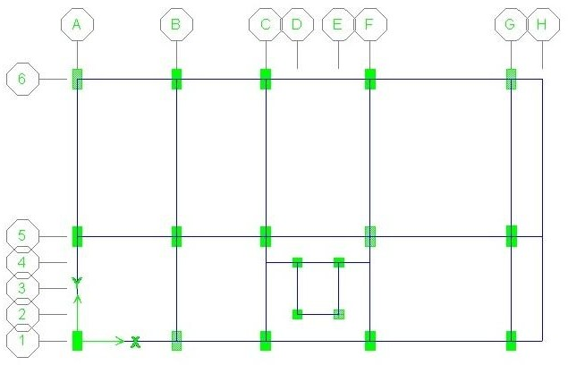

**Figure 1 Plan view of R.C.C Case I**

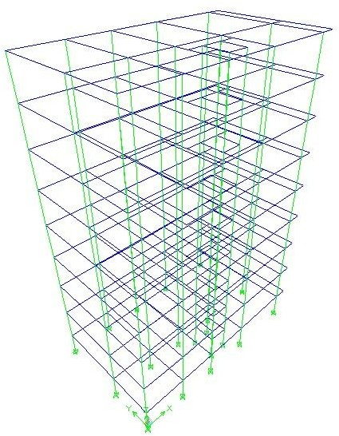

**Figure 2 3D view of R.C.C structure**

**Conclusion**

These are insightful observations about shear wall efficiency and ductility.

**Periphery Shear Walls Efficiency:** Placing shear walls along the periphery provides greater lateral stiffness and stability due to their strategic positioning, effectively resisting lateral forces like wind and seismic loads. This placement optimally utilizes the building's footprint and enhances overall performance.

**Ductility of High-Performance Shear Walls:** The improved ductility of high-performance shear walls (e.g., those reinforced with high-strength materials or composite reinforcements) means they can undergo greater deformation before failure, enhancing energy dissipation and seismic resilience compared to conventional shear walls.

**Mid-Height Shear Wall Sufficiency:** This finding suggests that shear walls may not need to extend through the entire building height to be effective. When placed up to mid-height, they still provide sufficient lateral resistance while potentially reducing material usage and construction costs. However, this would depend on the specific structural system, load distribution, and building height.

**References**

## Seyed Meghdad Ghaseminia a, Tatheer Zahra a, David P. Thambiratnam a, Julian Thamboo “Response of RC shear walls with single and double layers of reinforcements subjected to in-plane cyclic loading” [Volume 56](https://www.sciencedirect.com/journal/structures/vol/56/suppl/C), October 2023, 105005 <https://doi.org/10.1016/j.istruc.2023.105005>.

## Mangulkar Madhuri n. review on shear wall for soft story high-rise buildings. International Journal of Engineering and Advanced Technology (IJEAT), ISSN: 2249 – 8958, Volume-1, Issue-6, August 2012.

## Mohaiminul Haque, Sourav Ray, Amit Chakraborty, Mohammad Elias, Iftekharul Alam. Seismic Performance Analysis of RCC Multi-Storied Buildings with Plan Irregularity. American Journal of Civil Engineering. Vol. 4, No. 3, 2016, pp. 68-73. doi: 10.11648/j.ajce.20160403.11

## D.R. Deshmukh, A.K. Yadav, S. N Supekar, A. B. Thakur, H. P Sonawane, I. M. Jain, “Analysis and Design of G+19 Storied Building Using Staad-Pro”, Pg. 17-19, ISSN: 2248-9622, Vol. 6, Issue 7, (Part-1) July 2016.

## Ankit Purohit, , Lovish Pamecha “Seismic Analysis of G+12 Multistory Building Varying Zone and Soil Type SSRG” , International Journal of Civil Engineering ( SSRG – IJCE ) – Volume 4 Issue 6 – June 2017.

## Patil S.S. (2013), “ Seismic Analysis of High-Rise Building by Response Spectrum Method”, International Journal Of Computational Engineering Research (Ijceronline.Com) Vol. 3 Issue. 3.

## UmamaheswaraRao Tallapalem , Nurulla Shaik , Gopi Pagidimarry, Analysis of “Multi-Storey Building in Different Seismic Zones of India” , International Journal of Research in Advent Technology, Vol.7, No.5, May 2019

## E. Pavan Kumar, A. Naresh , M. Nagajyothi, M. Rajasekhar “ Earthquake Analysis of Multi Storied Residential Building - A Case Study”, Int. Journal of Engineering Research and Applications www.ijera.com ISSN : 2248-9622, Vol. 4, Issue 11( Version 1), November 2014.

## Siddhartha S. Ray, Alkesh S. Bhalerao, Rahul Chandrasekhar, “Earthquake Analysis of Multistory Building”, International Journal of Advanced Science and Technology Vol. 29, No. 4, (2020), pp.7650-7658, ISSN: 2005 -4238 IJAST Copyright @2020 SERSC.

## R.S.Mishra, V. Kushwaha and S.Kumar (Oct-2015) presented a “Comparative Study of Different Configuration of Shear Wall Location in Soft Storey Building Subjected to Seismic Load.”

## P. Mary Williams and R. K. Tripathi (June 2016) studied “Effect of Shear Wall Location on the Linear and Nonlinear Behavior of Eccentrically Loaded Buildings.”

## Varsha R. Harne, “Comparative Study of Strength of RC Shear Wall at Different Location on Multi-storied Residential Building, International Journal of Civil Engineering Research.”