Dashboard for Swachhta and LiFE

Vaishnavi Argade, Sanskruti Fadale, Eesha Raut, Tanvi Sawant, Trupti Dudhat

Student, Information Technology, Vidyalankar Polytechnic, Wadala

|  |  |
| --- | --- |
|  | A B S T R A C T |
| The "AI Swachhta and LiFE Dashboard" is a pioneering AI-based solution designed to address the critical issues of cleanliness and environmental standards in post offices. With the increasing emphasis on sustainable and hygienic practices, our project introduces an intelligent dashboard that leverages image processing technology to provide real-time monitoring and enforcement of cleanliness (Swachhta) and environmental standards (LiFE).  The AI dashboard is equipped to analyse images from post offices, allowing divisional offices to swiftly identify any cleanliness issues. When standards are not met, the system automatically sends alerts to prompt immediate action. By delivering actionable insights through image analysis, the dashboard promotes a culture of environmental responsibility and eco-friendly practices within post offices.  This project underscores the seamless integration of advanced AI technology with practical applications in public service. The AI Swachhta and LiFE Dashboard not only streamlines the process of maintaining hygiene and environmental standards but also fosters a long-term commitment to sustainability. By encouraging responsible behaviour towards the environment, this project makes a significant contribution to the field of AI and public administration. |

**Keywords:** AI Cleanliness Monitoring, Environmental Standards Dashboard, Real-Time Hygiene Alerts, Cleanliness Automation

1. Introduction

This project focuses on creating an AI dashboard to promote cleanliness (Swachhta) and environmental practices (LiFE) in post offices. The AI Swachhta and LiFE Dashboard is a cutting-edge solution designed to ensure that post offices maintain high standards of hygiene and sustainability. Leveraging image processing technology.

Key features to facilitate effective implementation:

* **Real-Time Insight:** It provides immediate feedback on cleanliness and environmental compliance, helping staff respond quickly to issues.
* **Automated Alerts:** The system sends automatic notifications when standards are not met, prompting timely interventions.
* **User-Friendly Interface:** Designed for ease of use, ensuring that staff can navigate and utilize the dashboard effectively.
* **Scalable Solution:** The dashboard can be implemented across the entire post office network, allowing for mass adoption.
* **Support for Training:** The insights gained can inform training programs for staff, promoting a culture of cleanliness and environmental responsibility.
* **Enhanced Governance:** The dashboard facilitates better oversight and accountability in maintaining cleanliness and green practices.

By integrating advanced AI technology with practical applications in public service, the AI Swachhta and LiFE Dashboard aims to foster a culture of cleanliness and environmental responsibility within post offices. This project contributes to sustainable practices and enhanced governance, ensuring that post offices remain clean and eco-friendly. The dashboard not only addresses immediate cleanliness issues but also lays the foundation for long-term sustainability by continuously monitoring and analysing data to inform future improvements. It showcases the potential of AI technology to solve real-world problems, improving public services and setting a model for other institutions. Ultimately, the AI Swachhta and LiFE Dashboard represents a significant step towards creating a cleaner, greener, and more sustainable future for post offices and their communities.

1. Literature Review

|  |  |  |
| --- | --- | --- |
| Aspect | Swachh Bharat Abhiyan | Dashboard for Swachhta & LiFE |
| **Initiatives** | Swachh Bharat Mission (SBM), Smart Cities | Swachhta and LiFE dashboard |
| **AI Applications** | Limited use of AI for monitoring | Advanced AI for real-time monitoring |
| **Waste Management** | Manual inspections and basic categorization | AI-driven waste classification |
| **Operational Efficiency** | Moderate efficiency in monitoring | Enhanced efficiency through automation |
| **Cost Management** | Higher operational costs | Reduced costs via AI integration |
| **Case Studies** | Limited to certain urban areas | Expanded pilot programs in urban and rural areas |
| **Real-Time Monitoring** | Minimal real-time capabilities | Comprehensive real-time AI surveillance |

This comparison highlights the evolution of Swachh Bharat Abhiyan (SBA) into a more technologically advanced approach with the Swachhta & LiFE Dashboard. The traditional SBA initiatives, such as the Swachh Bharat Mission and Smart Cities, laid the foundation for improved sanitation and cleanliness across India. However, the limited use of AI and reliance on manual processes posed challenges in efficiency and real-time monitoring.

In contrast, the Swachhta & LiFE Dashboard leverages advanced AI applications to enhance real-time surveillance, waste classification, and operational efficiency. This modern approach not only reduces operational costs but also expands its impact through comprehensive pilot programs in both urban and rural areas.

By integrating AI, the Swachhta & LiFE Dashboard addresses some of the key limitations of the traditional SBA initiatives, offering a more effective and sustainable solution for maintaining cleanliness and promoting environmental responsibility.

Software

#### ****Front End:****

* **HTML** (HyperText Markup Language)**:** This is the backbone of web content. It defines the structure of your web pages.
* **CSS** (Cascading Style Sheets)**:** CSS is used to style and layout your web pages. It helps make your dashboard visually appealing and responsive.
* **PHP** (Hypertext Preprocessor)**:** PHP is a server-side scripting language used for dynamic web pages and web application development. It will help in handling requests, interacting with the database, and generating dynamic content.

**Back End:**

* **MySQL**: An open-source relational database management system. It is widely used for storing and managing data. MySQL is robust, reliable, and scalable, making it a great choice for your dashboard’s backend.

**Image-Processing: Python**

* **Python**: A versatile programming language that is widely used for image processing tasks. It is known for its simplicity and readability, making it easy to implement complex algorithms.

**Libraries: TensorFlow**

* **TensorFlow**: An open-source machine learning framework developed by Google. TensorFlow is perfect for developing and training machine learning models for image recognition, object detection, and more.

**Location Services: Geolocation / Google Maps API**

* **Geolocation**: Using geolocation APIs, you can determine the geographical location of devices. This can be useful for tracking the location of post offices and monitoring compliance.
* **Google Maps API**: Google Maps provides powerful tools for embedding maps and location-based services into your dashboard. This can help in visualizing the geographical data and providing insights based on location.

**Object Detection: YOLO/SSD Model**

* **YOLO (You Only Look Once)**: A state-of-the-art real-time object detection system. YOLO is fast and accurate, making it ideal for real-time monitoring.
* **SSD (Single Shot MultiBox Detector)**: Another powerful object detection model that balances speed and accuracy. SSD is efficient and can be used for detecting multiple objects in images.

**Communication APIs: Twilio API or Mail API**

* **Twilio API**: Twilio provides a range of communication APIs for sending messages, making calls, and more. It’s great for setting up alerts and notifications via SMS or voice.
* **Mail API**: If you prefer email notifications, you can use a mail API like SendGrid or Amazon SES. These services allow you to send automated emails from your application.

1. Methodology

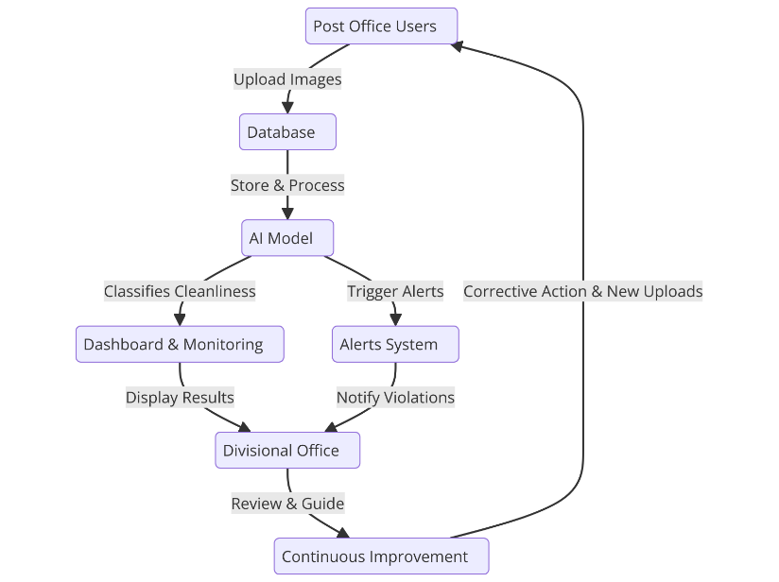The Swachhta and LiFE Dashboard utilizes a client-server architecture to divide tasks between service requesters (clients) and providers (servers). Clients, which are web browsers or mobile apps used by Divisional Office staff, initiate communication by sending requests to the servers over a network. The servers, which are powerful computers or software systems, process these requests and send back the requested information. Communication between clients and servers occurs via protocols such as HTTP or HTTPS, ensuring secure data transmission.

In this architecture, clients handle user interactions, such as viewing the dashboard and responding to alerts. Servers manage data processing, store and retrieve information from the database, and enforce security measures like authentication and encryption to ensure that only authorized users can access resources. This separation of tasks allows for scalability, as multiple clients can interact with multiple servers, distributing requests evenly for optimal performance. Security measures are crucial to maintain the integrity and confidentiality of the data.

By leveraging this architecture, the dashboard can effectively monitor cleanliness and green practices in post offices, providing real-time updates and alerts to prompt on-ground interventions. This flexible and scalable framework ensures the system's reliability and efficiency in various operational scenarios.

Fig. – Client-Server Architecture

1. Illustration

To create the Swachhta and LiFE Dashboard for monitoring cleanliness and green practices in post offices, we will use a client-server architecture. This involves dividing tasks between the client (the user interface accessed by staff) and the server (which processes data and handles backend tasks). The client, a web browser or mobile app, allows users to interact with the system, view real-time data, and receive alerts.

On the server side, PHP processes the requests, interacts with the MySQL database to manage data, and runs Python scripts using TensorFlow and YOLO/SSD models for image analysis and object detection.

We will use HTML and CSS to build a responsive and user-friendly dashboard. Additionally, APIs like Twilio or a mail service will be integrated to send alerts. This system ensures that cleanliness standards are monitored effectively, with secure and scalable operations that handle multiple users and real-time updates.

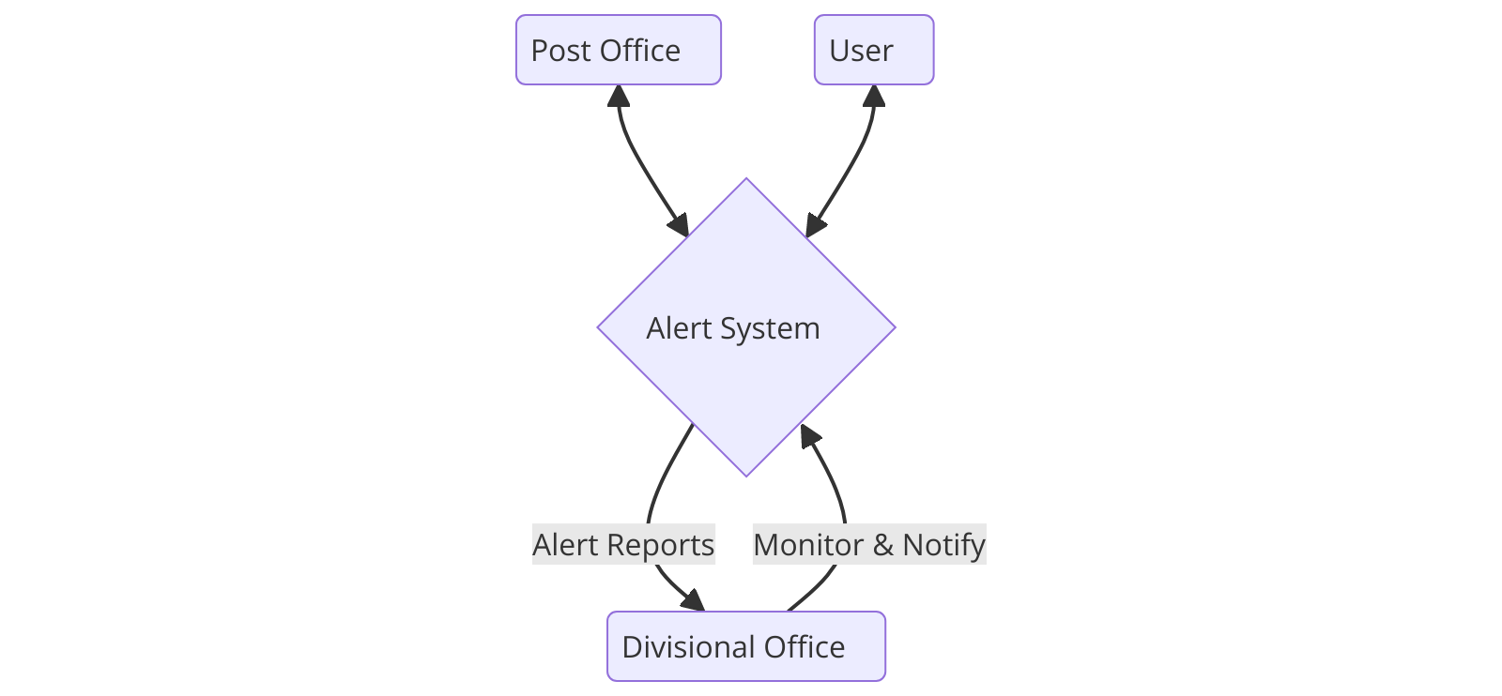

1. Result

The Swachhta and LiFE Dashboard successfully meets the project’s objectives by providing an efficient and user-friendly platform for monitoring cleanliness and green practices in post offices. The client-side interface, accessible via web browsers and mobile apps, allows Divisional Office staff to interact with the system, view real-time data, and receive alerts. The user interface is designed using HTML and CSS, ensuring responsiveness and ease of use across various devices.

On the server side, PHP processes client requests, interacts with a MySQL database for data management, and executes Python scripts using TensorFlow and YOLO/SSD models for image analysis and object detection. This setup allows the system to analyze images from CCTV cameras in real-time, ensuring accurate monitoring of cleanliness standards.

Screenshots of the dashboard illustrate its functionality, including real-time data visualization, alert notifications, and user-friendly data entry forms. The integration of APIs like Twilio enables timely SMS alerts, prompting immediate action when cleanliness standards deviate.

Scalability is achieved through load balancing, allowing the system to handle multiple users without performance degradation. Security measures, including authentication and encryption, ensure that data is protected and accessible only to authorized users.

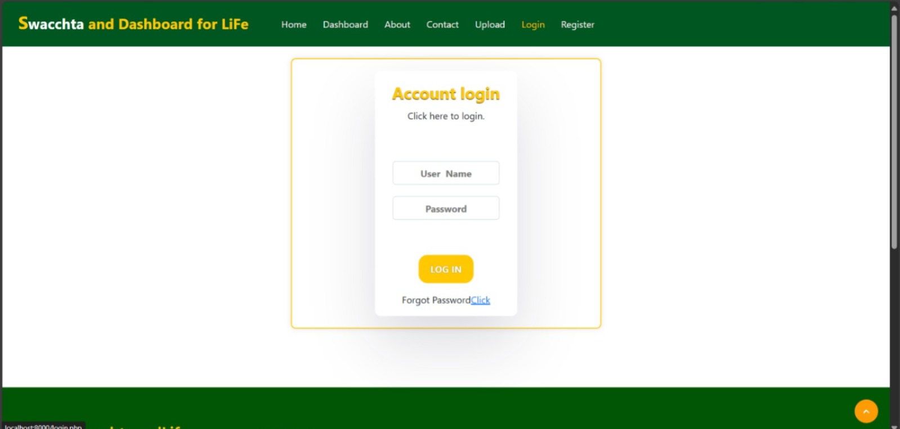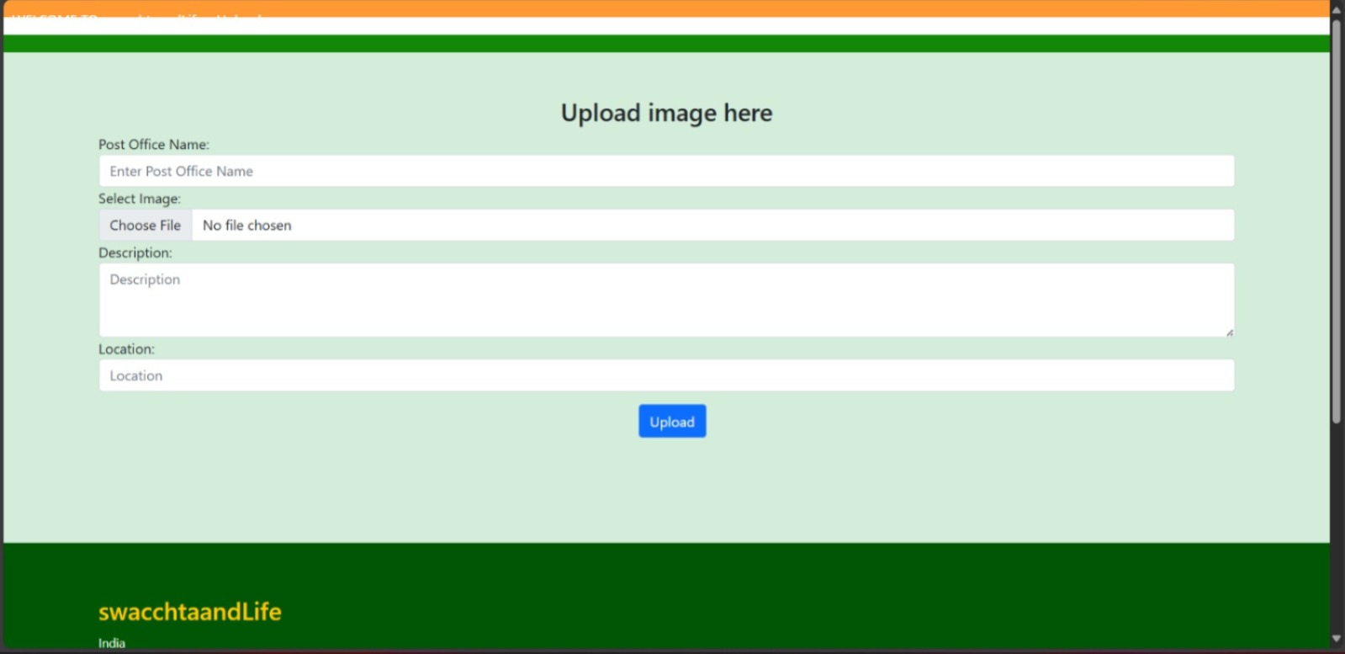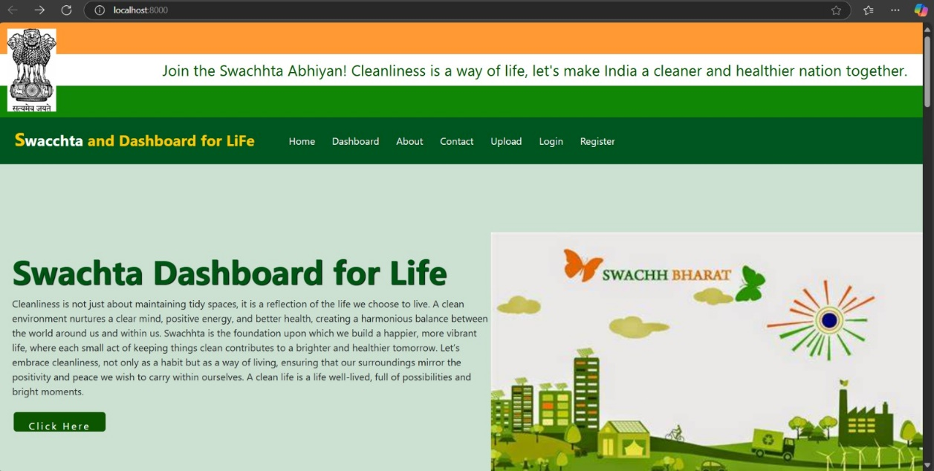

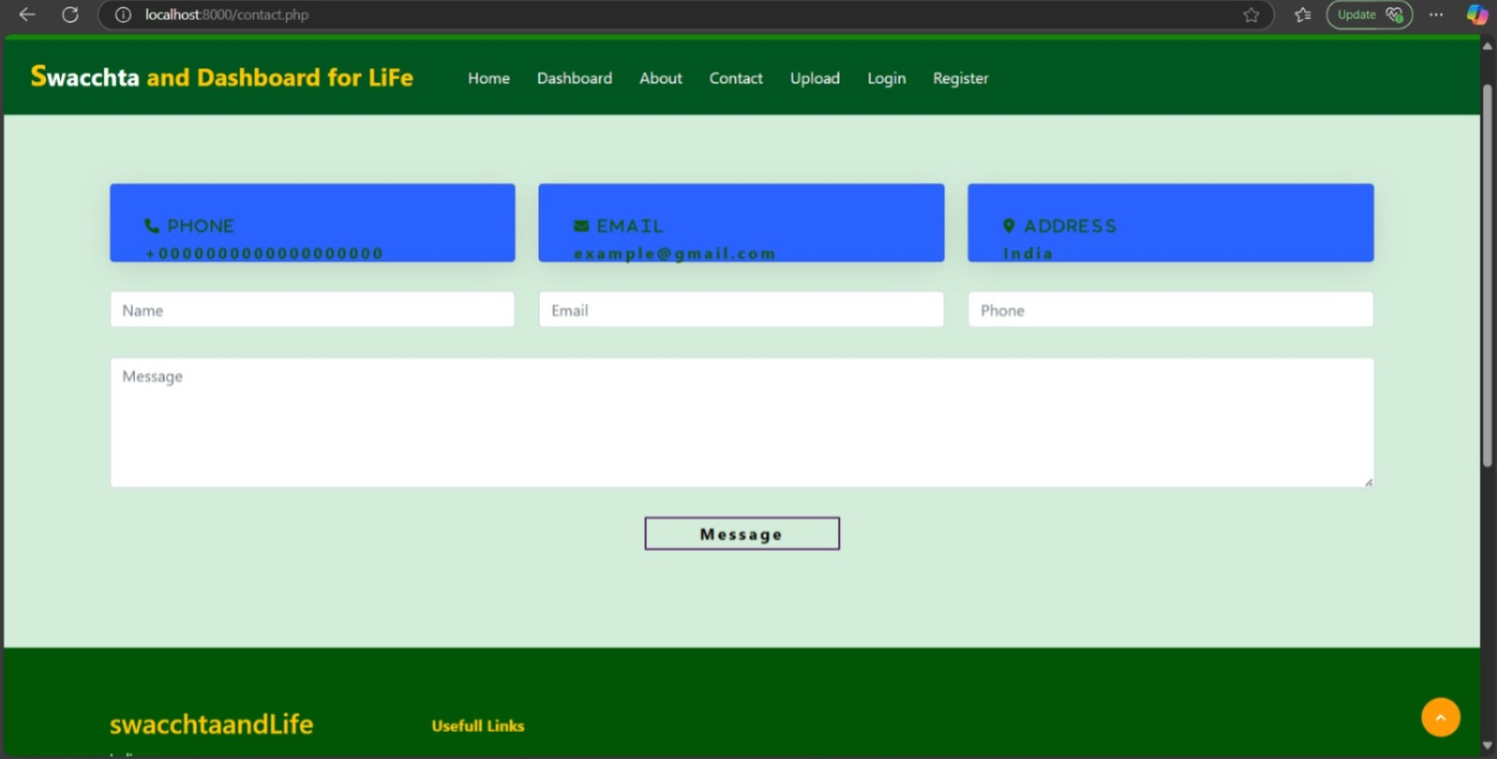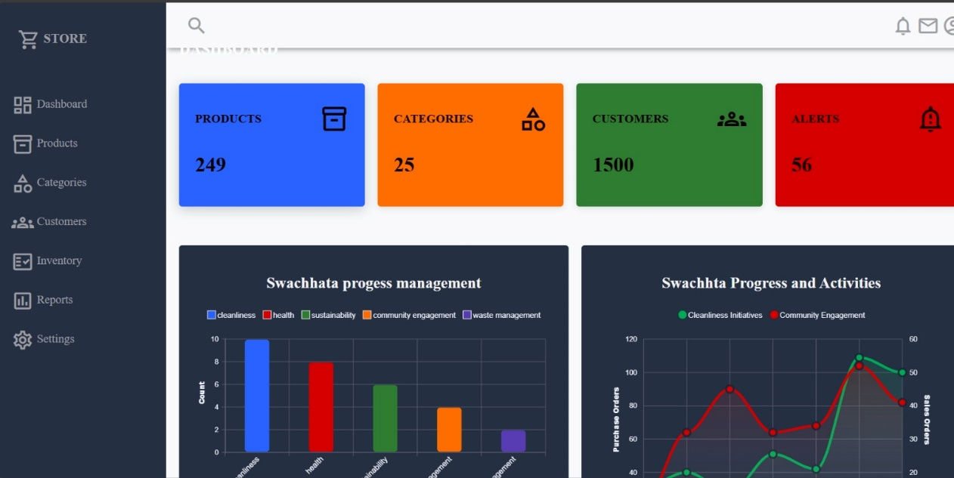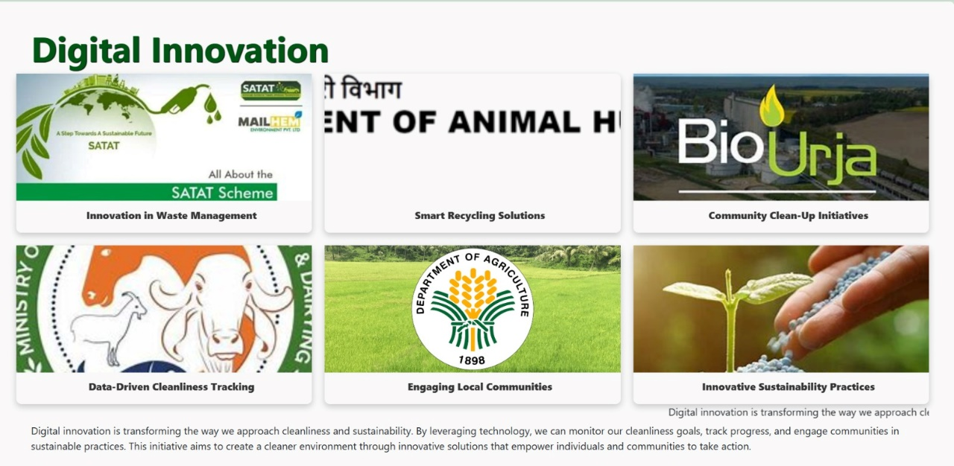

Overall, the Swachhta and LiFE Dashboard provides a robust, secure, and scalable solution for maintaining high standards of cleanliness and sustainability in post offices, significantly enhancing operational efficiency and environmental stewardship.

1. Conclusion

The Swachhta and LiFE Dashboard represents a significant advancement in monitoring and maintaining cleanliness and green practices in post offices. This system is built using a client-server architecture, which divides tasks between the client (user interface) and the server (backend processing).

The client, which can be accessed via web browsers or mobile apps, serves as the primary interaction point for Divisional Office staff. It enables users to view real-time data, receive alerts, and update records related to cleanliness and green practices. The interface is designed using HTML and CSS, ensuring a responsive and user-friendly experience across various devices, including desktops, laptops, tablets, and smartphones. JavaScript may be employed to enhance interactivity and functionality.

On the server side, PHP is utilized to handle the requests from the client. The server interacts with a MySQL database, which is responsible for storing and managing data, such as cleanliness records and related information. For image analysis and object detection, Python scripts are employed, leveraging TensorFlow and models like YOLO (You Only Look Once) or SSD (Single Shot MultiBox Detector). This setup allows the system to analyze images from CCTV cameras in real-time, identifying and monitoring cleanliness standards effectively.

Data flow between the client and server is secured through protocols like HTTP or HTTPS, ensuring that the communication remains secure. Authentication mechanisms are in place to verify user identities and restrict access to authorized personnel only, while encryption protects the data during transmission.

To enhance the system’s functionality, APIs such as Twilio or a mail service are integrated. Twilio can be used to send SMS alerts to staff when cleanliness standards deviate from the set expectations, ensuring prompt notification and action. Alternatively, email service APIs can be used to send notifications via email.

The architecture of the dashboard supports scalability, which means it can handle multiple users simultaneously without degrading performance. Load balancing techniques are employed to distribute incoming requests evenly across multiple servers, ensuring optimal performance even during peak usage times. This capability ensures that the system can handle increased load as user demand grows.

One of the key features of the system is its ability to provide real-time updates and monitoring. As images are processed and analyzed by the Python scripts, the results are immediately available on the dashboard. This allows Divisional Office staff to receive up-to-date information and take timely actions to maintain cleanliness standards. The real-time monitoring ensures that any deviations from prescribed standards are quickly identified and addressed, enabling proactive interventions.

In conclusion, the Swachhta and LiFE Dashboard offers a comprehensive solution for monitoring cleanliness and green practices in post offices. By leveraging advanced technologies and a robust client-server architecture, the system provides a responsive, secure, and scalable platform. It empowers Divisional Office staff with real-time data, timely alerts, and a user-friendly interface, ensuring high standards of cleanliness and sustainability. This innovative platform represents a significant advancement in operational efficiency and environmental stewardship, paving the way for a cleaner and greener future in post office management.

**References**

**Swachh Bharat Abhiyan**: <https://en.wikipedia.org/wiki/Swachh_Bharat_Abhiyan>

<https://pib.gov.in/PressReleasePage.aspx?PRID=1973805>

<https://www.indiapost.gov.in/VAS/Pages/News/National%20cleaning%20Drive%20of%20Post%20offices%20workbook_email_10092014_pub_upload.pdf>

<https://kili-technology.com/data-labeling/machine-learning/yolo-algorithm-real-time-object-detection-from-a-to-z>

<https://www.pmindia.gov.in/en/major_initiatives/swachh-bharat-abhiyan/>

https://sbmurban.org/digital-innovations