SMART BIKE THEFT ALERT SYSTEM

Prof Aher Rahul D ¹, Mr. Adakmol Dipak V ², Mr. Aher Rushikesh R ³,

Mr. Dhanwate Vaibhav A⁴, Mr. Jadhav Prathmesh S ⁵
^{1,}Lecturer, Department of Electrical Engineering, Santosh N Darade Polytechnic, Yeola,Maharastra, India.
^{2,3,4,5} Students, Department of Electrical Engineering, Santosh N Darade Polytechnic, Yeola,Maharastra, India.

ABSTRACT
This project presents a Smart Vehicle Tracking and Safety System that enhances road safety by integrating multiple sensors and communication modules. The system is built using Arduino Uno, GPS module, GSM 900A, alcohol sensor, accelerometer, relay, and ultrasonic sensor to ensure safe and controlled vehicle operation. The alcohol sensor detects alcohol consumption, preventing the vehicle from starting if alcohol is detected. The accelerometer monitors motion patterns to detect sudden movements or accidents. The GPS module continuously tracks the vehicle’s location, while the GSM 900A sends an SMS alert when the vehicle starts moving. An ultrasonic sensor measures the distance of objects in front of the vehicle, and if an obstacle is detected within a critical range, the relay stops the vehicle automatically to prevent collisions. This system is cost-effective, easy to implement, and suitable for motorcycles and other vehicles. It improves road safety by preventing drunk driving, reducing collisions, and enabling real-time tracking and alerts.

Keywords: Arduino Uno, GPS module, GSM 900A, alcohol sensor, accelerometer, relay

INTRODUCTION
Road accidents are a major global concern, causing thousands of deaths and injuries each year. Among the leading causes of these accidents are drunk driving, sudden obstacles, and uncontrolled vehicle movement. To address these issues, a Smart Vehicle Tracking and Safety System is proposed using Arduino Uno, which integrates multiple sensors and modules to enhance road safety and prevent accidents.
This system focuses on three key aspects: drunk driving prevention, obstacle detection, and vehicle tracking. The alcohol sensor (MQ-3) detects the presence of alcohol in the driver’s breath, preventing the vehicle from starting if alcohol levels exceed a safe threshold. This feature helps reduce accidents caused by impaired driving. The ultrasonic sensor (HC-SR04) measures the distance of objects in front of the vehicle. If an obstacle is detected within a predefined range, the system automatically stops the vehicle using a relay, preventing collisions.
Additionally, the GPS module (NEO-6M) tracks the vehicle’s location in real-time, while the GSM 900A module sends an SMS alert when the vehicle starts moving. This feature is beneficial for vehicle security, theft prevention, and fleet management. The accelerometer (MPU6050) detects sudden movements or accidents, adding another layer of safety by monitoring the rider’s behavior.
This project is designed to be cost-effective, easy to implement, and adaptable for various types of vehicles, including motorcycles, cars, and fleet vehicles. With its ability to track, monitor, and the biggest impact of cleaning the chemical wastes can cause respiratory diseases and it plays a challenging issue for the municipality officers Water damage is classified as three types of contaminated water. They are clean water, grey water and black water. Clean water is from a broken water supply line or leaking faucet. If not treated quickly, this water can turn into black water or grey water, depending on length of time, temperature, and contact with surrounding contaminants. Nowadays, even though automation plays a vital role in all industrial applications in the proper disposal of sewages from industries and sewage cleaning is still a challenging task. Drainage pipes are used for the disposal of sewage and unfortunately sometimes there may be loss of human life while cleaning the blockages in the drainage pipes. The municipality workers are only responsible to ensure that the sewage is clean or not. This system offers a practical solution to improve road safety. Future enhancements could include IoT integration, emergency accident reporting, and AI-based driver behavior analysis for more advanced safety measures.

CIRCUIT DIAGRAM

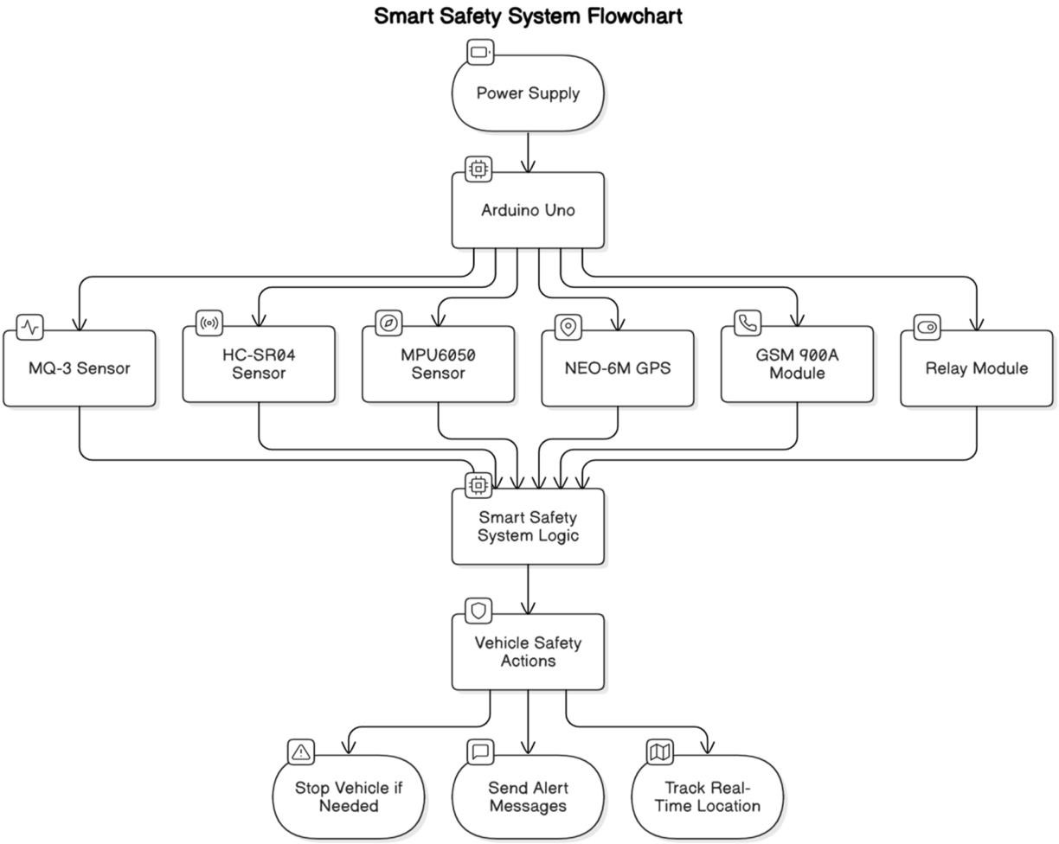

WORKING PROCESS

Installation:

Set up sensors (motion, GPS), microcontroller, and app configuration.

Continuous Monitoring:

Motion sensors detect tampering or unauthorized movement.

GPS tracks the bike's real-time location.

Alert Trigger:

If suspicious movement is detected, the system activates.

GPS data is sent for location tracking.

Notification:

GSM/IoT module sends instant SMS or app notification to the owner.

Bike's exact location is shown on the mobile app.

Sound Alarm:

Alarm or buzzer sounds to alert nearby people of theft.

Tracking:

Owner tracks bike location via the app, enabling recovery.

Power Management:

System operates on a rechargeable battery with long-lasting power.

FUTURESCOPE
- Road Safety Improvement:
  - Reduces accidents caused by drunk driving and sudden obstacles.
  - Can be implemented in public and private vehicles for enhanced safety.
- Vehicle Security and Anti-Theft System:
  - GPS tracking and SMS alerts provide real-time vehicle monitoring. o Helps in theft prevention and quick recovery of stolen vehicles.
- Scalability and Future Enhancements:
  - Can be extended to IoT-based monitoring for remote access via mobile applications.
  - Integration of AI for driver behavior analysis and accident prediction.
- Emergency Response System:
  - Future versions can include automatic emergency alerts to authorities and hospitals in case of accidents.
- Wide Applicability:
  - Can be used in motorcycles, cars, public transport, and fleet vehicles.
  - Suitable for commercial and personal use.

This system provides a comprehensive, low-cost, and effective solution for improving road safety, preventing accidents, and ensuring vehicle security.

CONCLUSION
The Smart Vehicle Tracking and Safety System is an effective solution for enhancing road safety and preventing accidents. By integrating Arduino Uno with alcohol detection, obstacle detection, motion monitoring, GPS tracking, and SMS alerts, this system ensures a safer driving environment.
The MQ-3 alcohol sensor prevents drunk driving by disabling vehicle ignition if alcohol is detected. The HC-SR04 ultrasonic sensor detects obstacles and stops the vehicle using a relay to avoid collisions. The MPU6050 accelerometer monitors vehicle motion and detects sudden movements, which can help in accident detection. The GPS module provides realtime location tracking, while the GSM module sends alerts when the vehicle moves.

This system is cost-effective, scalable, and easy to implement, making it suitable for motorcycles, cars, and commercial vehicles. Future enhancements can include automatic emergency calling, AI-based accident prediction, and cloud-based vehicle tracking.

In conclusion, this project provides an innovative, real-time safety mechanism that can

Reduce road accidents, improve security, and enhance vehicle monitoring for a smarter and

Safer transportation system.

