**The Impact of Environmentally Sustainable Project Management on Financial Profitability Ratios: A Case Study of Toyota Motor Corporation**

**By**

**1Narjes Vahedi, 2Sarita Parhi, 3Kolawole Farinloye, and 4Maryam Hajebi**

**1Business Management, London School of Management Education, London, United Kingdom**

**2Business Management, London School of Management Education, London, United Kingdom**

**3International Tourism and Hospitality Management, London School of Management Education, London, United Kingdom**

**4 Economic Department, Harris Westminster Sixth Form College, London, United Kingdom**

**Abstract**

This paper aims to indicate the impact of the implementation of environmentally sustainable project management practices on the four main financial profitability ratios, namely Gross Margin (GM), Net income Margin (NIM), Operating Margin (OM), and Return on Invested Capital (ROIC) in Toyota Motor Corporation. The effect of the application of environmentally sustainable project management practices application on the core financial profitability ratios of Toyota Motor Corporation was examined. For the sake of the study, Financial Profitability Ratios (FPR) data: GM, OM, NIM, and ROIC, were obtained from Bloomberg and they were subjected to analysis using descriptive statistics with an Excel software package (version 2021). Results revealed that the average of Financial Profitability Ratios (FPR) in the post-sustainability period was higher (39.83%), while this average in the pre-sustainability period was lesser (26.65%), which demonstrates the company witnessed a significant improvement in the profitability ratios, hence the implementation of environmentally sustainable project management practices into its operating activities was determined. This significant rise (49.5%) shows that the key financial metrics of the corporation have been positively affected by the integration of environmentally sustainable project management practices during the post-sustainability period compared to the pre-sustainability period. In conclusion, the overall analysis across all the financial ratios consistently indicated a positive impact of sustainability practices on the company's profitability ratios that represent the financial performance of the corporation. The analysis suggests that the adoption of environmental sustainability initiatives has led to enhanced financial results, providing evidence of the benefits of sustainable business practices. However, for a better understanding and analysis of the relationship between environmentally sustainable project management practices and financial performance in general further investigation and consideration of other influencing factors are vital and advised.

**Keywords:** Environmentally Sustainable Practice, Project Management, Financial Profitability Ratios, Toyota Motor Corporation, Gross Margin, Net income Margin, Operating Margin, and Return on Invested Capital

**Word count:** 282

**Introduction**

Sustainable project management is a practice of planning, monitoring and controlling of project in the organisational context, which considers the environmental, economic and social aspects of the life-cycle of the project and aims to generate benefits and values for stakeholders through transparent, ethical, and equitable manner (Silvius & Schipper, 2014). The implementation of sustainable project management practices on the operation system can minimise negative impacts of environmental, social, and economic aspects and as well as maximising positive results including improved organisation’s reputation, cost reduction, enhanced brand value, social responsibility, managing risk effectively, and environmental preservation (Gareis *et al*., 2013). Sustainable project management plays a key role in enhancing project success and has a significant impact on both sustainable project success and planning (Yu, Zhu and Yang, 2021). The global drive towards sustainability practices has influenced all aspects of society including the economy and in recent years, many businesses have committed to adopting sustainable project management practices in their operations (Gareis *et al*., 2013). Given the stakeholder demands towards resolving global environmental and social issues, organisations have been motivated to adopt sustainability project management initiatives into their business operations to show their commitments and address the current issues (Silvius and van den Brink, 2014). Implementation of sustainability principles into project management practices not only affects the environmental and social well-being but also plays a significant role in the financial health of organisations (Tharp, 2012). To justify investment in sustainability practices and initiatives, there is a need to demonstrate the positive impact of environmentally sustainable project management on financial performance which allows investors, stakeholders and organisations to obtain a comprehensive and deep insight. In addition, understanding the relationship between environmentally sustainable project management and financial performance is crucial to managing the risk effectively, and also for better decision-making in an organisation context. Since profitability ratios are the financial indicators that assess a company's financial health and performance, examining the connection between environmentally sustainable project management practices and profitability ratios can provide valuable insights into how organisations can enhance their financial performance by improving financial ratios by adopting sustainability practices (Kusuma & Koesrindartoto, 2014).

**Brief information about Toyota Motor Corporation**

Currently, Toyota Motor Corporation stands as a prominent automobile manufacturer, with a presence in more than 160 countries. It holds a dominant position in the Japanese and Asian markets and is a leading non-American vehicle seller in the USA. Additionally, Toyota holds the distinction of being the primary Japanese brand in Europe. Notably, the company achieved a significant milestone as a pioneer in the hybrid vehicles market. In 2015, the company introduced its "Environmental Challenge 2050," encompassing six key objectives. These objectives involve the development of innovative products and technologies, efficient recycling practices, responsible use of resources, optimisation of water and energy usage, and the brand's commitment to promoting a positive environmental impact (Simão and Lisboa, 2017).

Therefore, Toyota Motor Corporation can be delineated into three distinct periods: the pre-sustainability phase (2011-2014), the starting date of sustainability (2015) and the post-sustainability phase (2016-2019).

**Statement of the Problem and Objective of the Study**

There is limited research, considering the emergence of sustainability practices, on the influence these practices have on the profitability of Toyota Motor Corporation. While various material concerning the general profitability of Toyota's operation is well documented, little attention is paid to how the integration of environmentally sustainable project management practices influences its financial outcomes. This has created a gap in the literature, hence the need for the present study that tries to establish a link between the implementation of environmentally sustainable project management practices and the company's profitability ratios. Focusing on the case of the Toyota Motor Corporation, this research seeks to fill the void in existing literature with an insightful understanding of how sustainability initiatives may improve financial performance that shall add to the greater understanding of sustainability's role in corporate profitability.

**Methodology**

For the sake of the study, four (4) main Profitability Ratios (PR) data: Gross Margin (GM), Net income Margin (NIM), Operating Margin (OM), and Return on Invested Capital (ROIC), were obtained from Bloomberg. Profitability ratios are the main financial indicators that assess a company's ability to generate profits from its core business activities (Zorn et al., 2018). These four profitability ratios offer deep insights into the financial health and also the overall financial performance of the company, which demonstrates the ability of the company to generate profit and meet its debts. All financial data was obtained from Bloomberg with strict respect to ethical considerations. All utilised data in this study obtained from Bloomberg are available to the public, and no sensitive or personal data were used in this study. Furthermore, any necessary permissions, and licenses for using Bloomberg data have been obtained to fully comply with the respective terms and conditions. For the sake of collecting data with the ethics of this research, the company of choice; Toyota Motor Corporation was delineated into three distinct periods: the pre-sustainability period (2011-2014), the starting date of sustainability (2015) and the post-sustainability period (2016-2019). Hence, the study covered a period of 9 years altogether (2011-2019).

**Data analysis**

Especially, for assessing the relationship between environmental sustainability practices and financial profitability ratios including Gross Margin, Net income Margin, Operating Margin, and Return on Invested Capital, statistical analysis was conducted in Toyota Motor Corporation. All data obtained were subjected to analysis using descriptive statistics (percentages %) with an Excel software package (version 2021).

**Results**

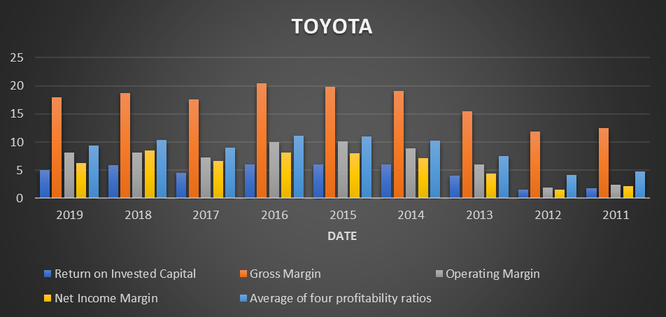

Figure 1: Financial ratios change during the timeline for the study

Source: Data analysis, 2023

|  |  |  |  |  |
| --- | --- | --- | --- | --- |
| **Date** | **ROIC** | **GM** | **OM** | **NIM** |
| post-sustainability | 5.37805 | 74.7313 | 8.40175 | 29.4958 |
| pre-sustainability | 3.33365 | 58.8847 | 4.8218 | 15.1317 |
| **Grand Total** | **8.7117** | **133.616** | **13.22355** | **44.6275** |

Table 1: Table showing the Profitability Ratios (PR) data of all the variables measured

**NB:** *Average of Return on Invested Capital= ROIC, Sum of Gross Margin= GM, Average of Operating Margin= OM, and Sum of Net Income Margin= NIM*

Source: Data analysis, 2023

**Return on Invested Capital (ROIC) Analysis of Changes**

Figure 1 reveals that the average ROIC of the pre-sustainability phase is 3.3%, whereas the average of this metric rose considerably to 5.3% in the post-sustainability phase. This finding signifies that the adopted sustainable project management practices improved the company's ability to make a profit regarding the invested capital, as evidenced by the remarkable improvement of about 2 percentage points in the average ROIC from the start date of 2015 presented in Table 1.

**Gross Margin (GM) Analysis of changes**

Top of Form

The analysis of the Gross Margin reveals that in the pre-sustainability phase, the sum of the Gross Margin was approximately 58.8%, while following the implementation of sustainability practices in 2015, this ratio jumped to 74.7%. This significant increase in the sum of Gross Margin for post-sustainability period reveals that the company experienced enhanced profitability in its core business operations due to the integration of environmentally sustainability practices. These results indicate a positive relation and correlation between the implementation of sustainability initiatives and enhanced gross margin ratio which is one of the four main financial profitability ratios.

**Operating Margin (OM) analysis of changes**

The analysis of the Operating Margin shows that for the pre-sustainability period, the average Operating Margin was 4.8%, while in the post-sustainability period, this Margin increased significantly to 8.4% (see Table 1). It reflects a significant improvement of approximately 57% points in the average Operating Margin after the adoption of sustainability initiatives in 2015. This remarkable improvement also demonstrates the positive impact of the integration of environmentally sustainable project management practices on operating margins.

**Net Income Margin (NIM) analysis of changes**

According to Table 1, the total Net Income Margin for the pre-sustainability phase was about 15.1%, which was relatively lower compared to the post-sustainability period, remarkably increasing to 29.4%. These findings suggest that the adoption and integration of sustainability practices had a positive effect on the company's ability to generate profits after accounting for all relevant costs and financial obligations. This significant improvement in the Net Income Margin indicates a potential link between sustainability initiatives and enhanced financial performance, reflecting the positive impact of sustainability practices on the company's profitability.

**Conclusion**

In this analysis, the aim is to assess the effect of sustainability implementation on the average profitability ratios of Toyota Motor Corporation. This analysis compares the pre-sustainability and post-sustainability average profitability ratios of Toyota Motor Corporation. Toyota Motor demonstrated a substantial increase in average of profitability ratios approximately 49.5% after the implementation of sustainability practices which reveals a significant positive impact from the implementation of sustainability practices. More precisely, Toyota Motor Corporation achieved impressive results of greatly improved average profitability ratios after the implementation of sustainability initiatives and proved that the undertaken sustainability performance indeed was effective in ensuring financial performance.

**Recommendation**

As the company reflected a significant improvement in its financial profitability ratios, after incorporating environmental sustainability practises into its operations, it is considered very essential that the potential risks the company may be exposed to in sustainability efforts, such as supply chain disruption, regulatory change, and brand/reputation risks are analysed. Also, Toyota Motor Corporation should measure how these associated risks could be prevented effectively while pursuing sustainability goals. Yet the foregoing shall be complemented with an extensive economic impact analysis in sustainability initiatives in local communities and regions in terms of creating jobs, developing local economic development, and other trickle-down effects wherein Toyota Motor Corporation has significant business operations.

**References**

[1] Silvius AJG, Schipper RPJ. Sustainability in project management: A literature review and impact analysis. Soc Bus. 2014;4(1):63-96.

[2] Gareis R, Huemann M, Martinuzzi A, Weninger C, Sedlacko M. Project management and sustainable development principles. Project Management Institute; 2013.

[3] Yu M, Zhu F, Yang D. Impact of sustainable project management on project plan and success: An empirical study. Sustainability. 2021;13(22):12651. (Accessed: 22 Aug 2023). Available from: https://pmc.ncbi.nlm.nih.gov/articles/PMC8612515/

[4] Silvius AJG, van den Brink AJ. Sustainable project management: A research agenda. Int J Proj Manag. 2014;32(5):893-904.

[5] Tharp J. Project management and global sustainability. Project Management Institute; 2012.

[6] Kusuma AP, Koesrindartoto DP. Sustainability practices and financial performance: An empirical evidence from Indonesia. In: International Conference on Trends in Economics, Humanities and Management (ICTEHM'14); 2014 Mar 13-14; pp. 13-14.

[7] Simão L, Lisboa A. Green marketing and green brand–The Toyota Case. Procedia Manuf. 2017;12:183-194.

[8] Zorn A, Esteves M, Baur I, Lips M. Financial ratios as indicators of economic sustainability: A quantitative analysis for Swiss dairy farms. Sustainability. 2018;10(8):2942.