**SHOCK ABSORBER THROUGH ELECTRICITY GENERATION SYSTEM**

# Mr. Avhad Deepak R 1, Mr. Rahane Akash R 2, Mr. Pawar Yash S 3,

# Mr. Jadhav Mahesh V 4, Miss. Nagare Sakshi R 5

1 Lecturer, Department of Electrical Engineering, Santosh N Darade Polytechnic, Yeola, Maharashtra, India.

2,3,4,5, Students, Department of Electrical Engineering, Santosh N Darade Polytechnic, Yeola, Maharashtra, India.

# ABSTRACT

The main objective of designed the controller for a vehicle suspension system is to reduce the discomfort sensed by passengers which arises from road roughness and to increase the ride handling associated with the pitching and rolling movements. This necessitates a very fast and accurate controller to meet as much control objectives, as possible. Therefore, this paper deals with an artificial intelligence Neuro-Fuzzy (NF) technique to design a robust controller to meet the control objectives. The advantage of this controller is that it can handle the nonlinearities faster than other conventional controllers. The approach of the proposed controller is to minimize the vibrations on each corner of vehicle by supplying control forces to suspension system when travelling on rough road. The other purpose for using the NF controller for vehicle model is to reduce the body inclinations that are made during intensive man oeuvres including braking and cornering. A full vehicle nonlinear active suspension system is introduced and tested. The results show that the intelligent NF controller has improved the dynamic response measured by decreasing the cost function.

**Keywords:** Shock absorber, vehicle suspension system, NF controller

# INTRODUCTION

We are using the non-renewable energy sources such as petroleum as well as renewable sources like solar, wind, tidal power etc., but still we couldn’t overcome our power needs. So we have to generate electricity through each and every possible ways. Power can be generated through we are two wheeler shock absorber on the bike; the generated power will be stored and can be used for domestic purposes. This system can be installed at homes, colleges, railway stations, where the people move around the clock. The utilization of waste energy of human foot power is very much relevant and important for populated countries like India and China. A special mechanical arrangement such as crankshaft mechanism is employed on the stair case. This arrangement will convert the foot power applied on shock absorber, as a rotary motion. This rotary motion will be used to generate efficient electricity. It’s an eco-friendly; easily accessible and non-conventional power generation system when compared to existing systems.

# BLOCK DIAGRAM

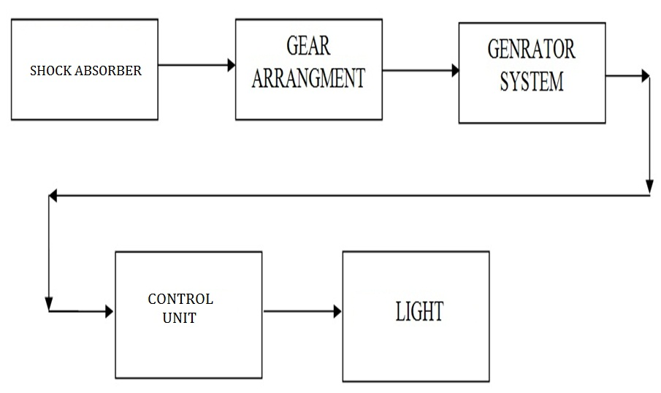

# PROJECT MODEL DIAGRAM

# 11

# WORKING PRINCIPLE

This project is concerned with generation of electricity from ‘power step’ set up. The human load acts upon the Power step-setup will produce linear reciprocating motion on the power step. Here the reciprocating motion of the power step is converted into rotary motion using the crankshaft arrangement. A flywheel is used to produce rotary motion. The flywheel and the power step pedal are connected by means of connecting rod. The rotary motion of large flywheel is given to the small pulley by belt or chain. Hence the speed that is available at the flywheel is relatively multiplied by the rotation of the smaller pulley. This speed is sufficient to rotate the rotor of a 12V generator. The rotor which rotates within a static magnetic stator cuts the magnetic flux surrounding it, thus producing the electro motive force (emf). This generated emf is then sent to an inverter, where the generated emf is regulated. This regulated emf is now sent to the storage battery where it is stored. This current is then used for other purposes. The generator converts the mechanical rotary motion into electrical energy.

# ADVANTAGES

1. The machine has very low error.
2. The size of project made by is more suitable for electricity generation system.
3. The cost of machine is less.
4. It is easy to make.
5. It has low maintenance.
6. The system has worked fully **shock absorber** base operated.
7. Size of machine is small therefore it is easy to install any bike.
8. Weight of machine is low.

# DISADVANTAGES

1. Being semiautomatic we cannot neglect at Staircase.
2. Battery system is required to operate the machine control circuit & motor operate.

Not applicable for all types of two wheelers.

* On smooth road power generation is less than 12 volt.
* Design of the suspension system not suitable for scooter.
* As whole system consist of electric wiring, so that chances of short circuits.

# APPLICATION

Shock absorbers have a great for performance, handling and stability.

* They are best choice for work and severe use vehicles.
* High pressure gas mono tube design- 360psi to prevent aeration and shock fade.
* Low pressure gas twin tube design- These units are good for average, everyday driving.

# CONCLUSION

The proper guidance of project head and the sincere efforts of our group have led to the successfully accomplishment of our concerned projects. The project based on shock absorber through voltage generating system project” was interesting to work on and was also gained in this project work.

Knowledge of project will definitely be helpful in our future. So we must maintain that this final year project was an essential part of our engineering education enhancing our technical knowledge and practical skill.