**IOT-INTEGRATED AUTOMATIC PORTABLE VENTILATOR WITH CPR**

**Hema S1, H S Vyshnavi2, Pavithra G3, Gowari Madhu4, Surya S Balan5**

1Assistant Professor, Department of Electronics and Communication Engineering, LBS Institute of Technology for Women (Affiliated to APJAKTU),Thiruvananthapuram, Kerala, India

2,3,4.5Student, Department of Electronics and Communication Engineering, LBS Institute of Technology for Women (Affiliated to APJAKTU), Thiruvananthapuram, Kerala, India

**ABSTRACT**

The healthcare sector continues to face a critical need for reliable, affordable, and efficient solutions to manage respiratory distress and cardiac emergencies, especially in resource-limited settings. The proposed system, the introduces an innovative solution by combining a mechanical ventilator and an automated CPR device into one compact, IoT-enabled unit. Traditional setups require separate devices for ventilation and chest compressions, often necessitating manual intervention and leading to delays. The integrated system eliminates this issue by allowing seamless transitions between ventilation support and CPR compressions based on real-time patient data, ensuring rapid and effective response. With IoT-based real-time monitoring, healthcare providers can remotely track vital signs such as blood oxygen levels, respiratory rate, and heart rate, and adjust settings for optimal care, making the system suitable for both emergency situations and home care settings. Unlike the base paper, which developed a standalone ventilator with basic monitoring, the proposed project goes further by incorporating an advanced CPR module, enhanced sensor-based controls, and remote monitoring capabilities, creating a more versatile and holistic approach to patient care. By combining two essential life-support functions into a single, cost-effective device, this project aims to improve treatment efficiency, reduce manual workload, and ultimately save more lives, representing a significant leap forward in medical technology.

**Keywords:** Healthcare sector, Respiratory distress, Cardiac emergencies, Mechanical ventilator, Automated CPR device, IoT-enabled unit, Real-time monitoring, Blood oxygen levels, Respiratory rate, Heart rate, Integrated system, Emergency situations, home care settings, Cost-effective device, medical technology.

1. **INTRODUCTION**

The increasing prevalence of respiratory diseases and emergency medical conditions has led to a rising demand for portable and efficient respiratory support systems, especially in emergency, home healthcare, and pre-hospital settings. The IoT-enabled Portable Ventilator with CPR aims to address this critical need by combining advanced medical technologies with the flexibility of portable design. This system ensures that patients, especially those in remote or emergency situations, receive immediate and accurate respiratory assistance, ultimately improving their chances of survival and recovery. Incorporating Internet of Things (IoT) capabilities, the ventilator offers real-time monitoring of vital signs such as oxygen saturation (SpO2), heart rate, temperature, and air quality, providing healthcare professionals and caregivers with continuous insights into the patient's condition. The IoT integration also enables personalized care, allowing for adjustments based on the patient's needs and ensuring optimized respiratory management. The system's unique feature lies in its Cardiopulmonary Resuscitation (CPR) functionality, which provides automatic chest compressions and oxygen delivery during emergencies. By combining mechanical ventilation with CPR support, the device can assist in both routine and life-threatening situations, where immediate intervention is crucial for preserving life. This dual functionality not only enhances the system’s utility in hospitals but also makes it a valuable tool for home care environments and ambulatory applications, where immediate access to advanced medical equipment may be limited. Furthermore, the system’s mobility, user-friendly interface, and cloud-based data analysis ensure it is both practical and effective for use in diverse healthcare settings. By providing critical support in time-sensitive situations, the IoT-enabled Portable Ventilator with CPR offers a promising solution to enhance patient outcomes, particularly in emergencies and resuscitation efforts.

1. **METHODOLOGY**

**2.1 Traditional Ventilators**

Traditional ventilators are essential in supporting patients with respiratory distress by delivering a fixed volume or pressure of air to help maintain adequate oxygen levels. While these devices have proven effective in many clinical settings, they have certain limitations. One significant drawback is the risk of lung over-inflation, as the fixed volume of air delivered can sometimes cause lung injuries. Additionally, traditional ventilators often lack the ability to personalize airflow based on the real-time needs of the patient, which can lead to less optimal care. Furthermore, many ventilators are bulky, limiting their portability and hindering their rapid deployment in emergency situations such as pandemics or natural disasters. Another limitation is the absence of integrated CPR support; traditional ventilators do not provide automatic CPR functionality, which is crucial during cardiac arrest scenarios.

**2.2 Proposed System**

The system is designed to continuously monitor vital signs using various sensors, allowing for real-time tracking and immediate response to changes in the patient’s condition. It incorporates sensors that measure heart rate, respiratory rate, body temperature, and air quality. Predefined threshold values are set for each parameter to detect any deviations. For instance, the normal range for heart rate (BPM) is between 12 and 20, SpO2 levels should be between 95% and 100%, and body temperature is typically around 98.6°F. When any parameter exceeds these thresholds, the system automatically activates specific actions to restore the patient’s condition to normal.

The ventilator function is adaptive, meaning it does not deliver a fixed amount of air but calculates the necessary volume based on real-time measurements, preventing lung over-inflation and ensuring patient comfort. A feedback system continuously monitors the patient's vital signs and adjusts the motor speed of the air pump to provide the required airflow. This real-time adjustment ensures the ventilator’s output is always suited to the patient's current condition.

In the case where vital signs are absent, the system enters an observation phase for a preset duration (typically 5 to 8 minutes). During this period, it monitors for any signs of life. If no vital signs are detected, the system automatically initiates chest compressions using a dc motor. The motor is configured to deliver precise compressions, maintaining both the correct depth (around 2 inches) and rate (100-120 compressions per minute) in accordance with CPR guidelines.

For remote monitoring and logging of patient data, the system is integrated with the ThingSpeak platform. This platform records vital signs such as heart rate, respiratory rate, and body temperature in real-time. Healthcare professionals can remotely monitor the patient’s status and receive instant alerts if any critical parameters are outside the normal range. These alerts are sent to connected devices like smartphones or tablets, enabling immediate intervention when needed.

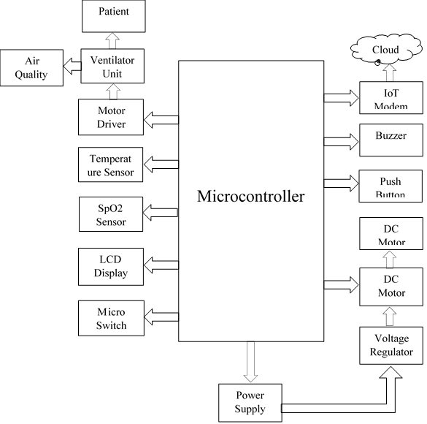

**Figure 2.2.1:** Block Diagram

1. **HARDWARE REQUIREMENTS**

**3.1 ESP32 Microcontroller**

ESP32 is a powerful and robust microcontroller that acts as the main controller of the system. It can send and receive data from the internet and nearby devices by connecting to Wi-Fi and Bluetooth. In this project, it plays an important role in collecting data from sensors, controlling the stepper motors that drive the ventilator, and running the whole process in real time. ESP32 has enough processing power for multiple tasks, which means it can perform multiple tasks at the same time, such as monitoring vital signs and sending updates to the cloud. Wi-Fi allows caregivers to check patient data remotely, while Bluetooth acts as a communication hub when Wi-Fi is not available. In addition, ESP32 has various pins and communication protocols that allow it to be connected to different sensors. Since it can switch to power saving mode when not in use, it also offers a suitable solution for battery-powered devices that consume a lot of power. With easy options such as Arduino IDE, ESP32 makes it easier to develop and ensure the reliability of these smart systems.

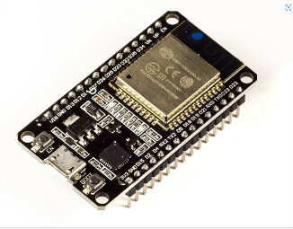  
**Figure 3.1:** ESP32 Microcontroller

**3.2 MAX30100 Sensor**

MAX30100 is a sensor that measures blood oxygen saturation (SpO2) and monitors heart rate. This data is used to calculate SpO2 and heart rate values. This sensor uses two types of light; red for SpO2 and infrared for heart rate. In this program, the sensors continuously provide real-time data, which is essential for monitoring the health of patients with chronic diseases, especially those with respiratory or heart conditions. It also provides accurate readings thanks to its ability to reject interference from ambient light. The sensor’s small size and low power consumption make it ideal for portable medical devices. It also includes a thermometer that helps increase accuracy by adjusting the numbers according to skin temperature.

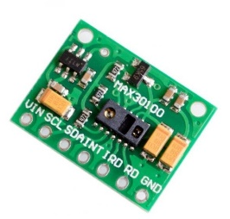  
**Figure 3.2:** MAX30100 Sensor

**3.3 Air Quality Monitoring Sensor**

This sensor is used to monitor the air quality around the patient by detecting pollutants such as carbon monoxide and gases. problem. It ensures that the air coming from the ventilator is safe and clean. The sensor uses advanced technology to measure air pollution and transmit the data to the ESP32. If the air quality falls below a safe level, the system will trigger an alarm, allowing supervisors to take quick action. This is especially important for patients with respiratory conditions, as poor air quality can make their condition worse. Data from sensors can also be sent to the cloud for remote monitoring, helping doctors work in real time.

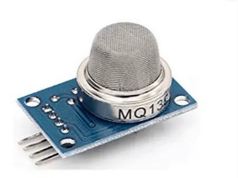  
 **Figure 3.3:** Air Quality Monitoring Sensor

**3.4 Stepper Motor**

The stepper motor is responsible for controlling the bag valve ventilator (BVM) with precise steps. It ensures that the BVM is compressed and released at the right time, ensuring the patient receives the right amount of air. ESP32 controls the motor to adjust the air flow according to the patient's respiratory needs. The body's ability to make small and rapid movements makes it ideal for this task. It also works reliably without having to comment on what it is doing, which makes its job easier. The motor is designed to work continuously and withstand repetitive stress, ensuring reliability even in continuous use.

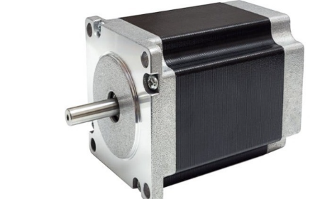

**Figure 3.4:** Stepper Motor

**3.5 Bag Valve Mask (BVM)**

The BVM is a device commonly used in hospitals to assist patients who cannot breathe on their own to breathe. In this project, the BVM can be modified to work by connecting it to a stepper motor. The motor periodically compresses the BVM to provide consistent and controlled air. This frees up caregivers to focus on other tasks. The one-way valve on the BVM ensures that air only enters the patient’s lungs and does not return to the bag, maintaining cleanliness and safety. By automating the BVM, the system can deliver air directly, reducing the risk of overinflating the lungs and causing damage.

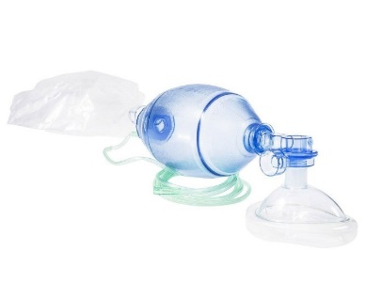  
**Figure 3.5:** Bag Valve Mask (BVM)

**3.6 DS18B20 Temperature Sensor**

The DS18B20 is a digital sensor used to monitor a patient’s temperature. It continuously monitors the patient’s temperature and sends the data to ESP32. ESP32 can alert caregivers if the temperature is too high or too low. It is particularly useful in monitoring conditions such as fever or hypothermia.

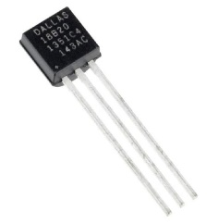  
**Figure 3.6:** DS18B20 Temperature Sensor

**3.7 Buzzer**

In this project, a buzzer is used to sound an alarm system. It makes different sounds to indicate important events such as a poor sensor reading or a problem with the system. For example, if oxygen levels are low or air quality is deteriorating, an audible alert will immediately alert caregivers so they can take action quickly.

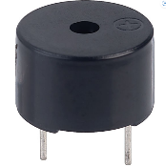  
**Figure 3.7:** Buzzer

**3.8 Buck Converter**

A buck converter ensures that all parts of the system receive the correct amount of power.It converts high voltage to stable low voltage suitable for use with electronic devices such as ESP32 and sensors. This aims to protect the system from damage caused by power surges and to provide stable performance.

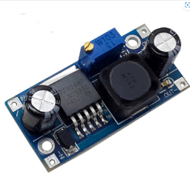  
**Figure 3.8:** Buck Converter

**3.9 LCD Display**

The LCD screen is used to display real-time information about the patient's vital signs such as heart rate, oxygen level and body temperature. The viewer can easily understand what is happening on one side. Even if the network connection is lost, the LCD allows data to be viewed locall*y.*

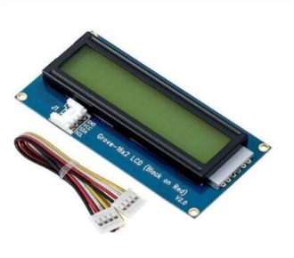  
**Figure 3.9:** LCDDisplay

**3.10 Voltage Regulator**

The voltage regulator (7805) keeps the power supply stable at 5V, protecting the system from voltage spikes or drops that could damage the components.

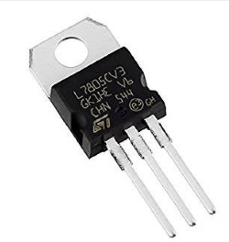  
**Figure 3.10:** Voltage Regulator

**3.11 Microswitch**

A small electronic switch used to control physical interaction. It is often used to determine or activate a function in response to movement. A microswitch is a small, sensitive switch that detects movement or position changes in the CPR system. It allows mechanical equipment to perform as expected.

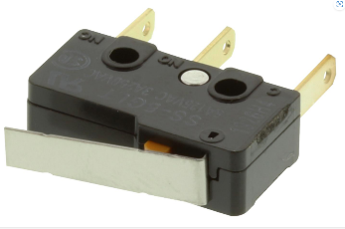

**Figure 3.11:** Microswitch

1. **SOFTWARE REQUIREMENTS**

**4.1 Arduino IDE**

The Arduino IDE is the software used to write and upload the code onto the ESP32 microcontroller. It makes programming easier by offering ready-made functions that help control different parts of the system, like sensors, motors, and displays. This software helps in managing the sensors and cloud connections without needing complex coding, and it also allows developers to debug and check how the system is working in real-time.

**4.2 ESP32 Board Libraries**

These are special software tools that allow the Arduino IDE to communicate with the ESP32. They simplify the use of the ESP32’s built-in features, such as Wi-Fi, Bluetooth, and sensor control. With these libraries, it becomes much easier to send and receive data, manage the ventilation process, and connect the system to the internet, making the development process more efficient and less time-consuming.

**4.3 MAX30100 Sensor Library**

The MAX30100 sensor library handles all the data from the MAX30100 sensor, which measures heart rate and oxygen levels. This library takes care of the complicated calculations that are needed to read and interpret the sensor data, so developers don’t have to do it manually. It helps ensure that the oxygen levels and heart rate are accurately measured and sent to the system for real-time monitoring.

**4.4 Temperature Sensor Library (Dallas Temperature)**

The Dallas Temperature library is designed to simplify reading temperature data from the DS18B20 sensor. This sensor keeps track of the patient’s body temperature, which is critical in health monitoring. The library automatically processes the temperature readings, ensuring they’re easy to display and that any abnormal temperature changes are flagged for caregivers. It helps provide continuous temperature monitoring for patient safety.

**4.5 IoT Platform Integration (ThingSpeak)**

ThingSpeak is a cloud platform that stores the health data received from the sensors. It allows caregivers to monitor patient health remotely by sending vital data such as oxygen levels, heart rate, and temperature to the cloud. ThingSpeak provides tools to create easy-to-read charts and graphs, which show the patient’s health trends over time. It also allows caregivers to set up alerts that notify them if any vital signs go beyond safe limits, ensuring timely responses.

**4.6 Wi-Fi Library for ESP32**

This library helps the ESP32 connect to the internet via Wi-Fi, allowing the system to send sensor data to the cloud in real-time. The Wi-Fi library ensures that the system remains connected, even if the internet connection is temporarily lost, by automatically reconnecting. This ensures that healthcare professionals can monitor the patient’s condition from anywhere, as the system will send updates continuously and reliably.

1. **RESULTS AND DISCUSSIONS**

The system has achieved the ability to provide respiratory support and chest compressions without interruption. Unlike traditional setups that rely on separate devices, the system automatically switches between ventilation and CPR without the need for manual adjustments. This ensures that patients receive uninterrupted care during critical times, which is essential in emergency situations. The IoT-enabled onboard monitoring can monitor patients’ vital data, such as oxygen levels, respiratory rate and heart rate, in real time. This capability allows doctors to respond quickly to changes in the patient’s condition. In addition, the ability to monitor patients remotely means that the system is not only suitable for use in hospitals or ambulances, but can also be used for resuscitation patients who require close observation. The system is compact and easy to use, combining multiple life support functions in a single device. This makes it particularly useful in confined spaces such as ambulances or small medical facilities. Overall, the project has been successful in making emergency medical equipment faster, easier and more efficient. The ability to manage both respiratory and cardiac support in a single room with emergency care shows how important it is to improve care, especially in low-cost settings.

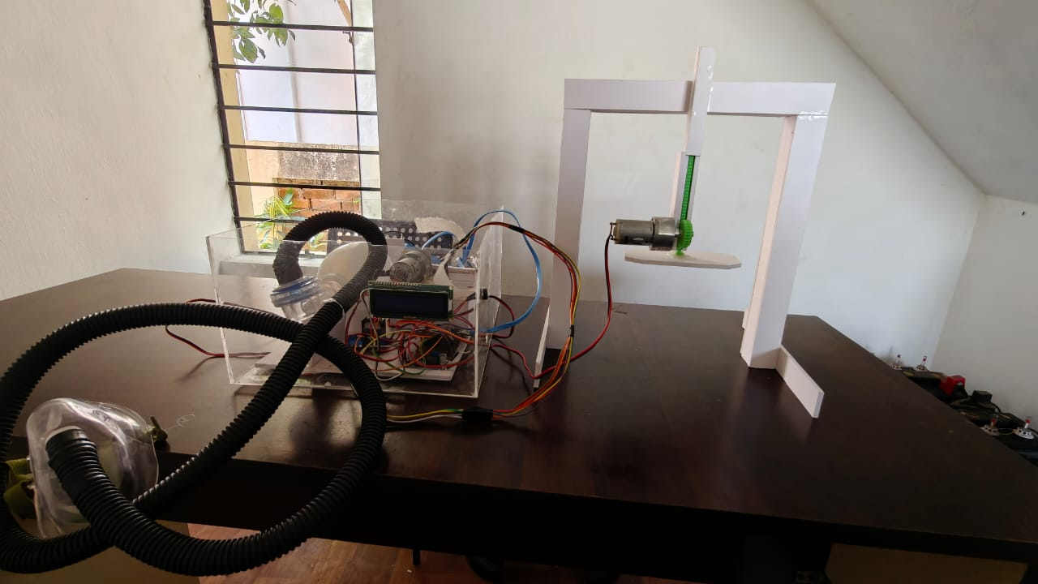  
**Figure 5.1:** Ventilator Unit integrated with CPR

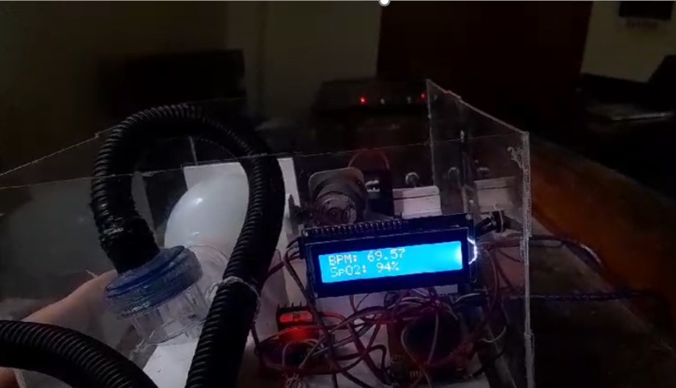  
**Figure 5.2:** Ventilator Unit

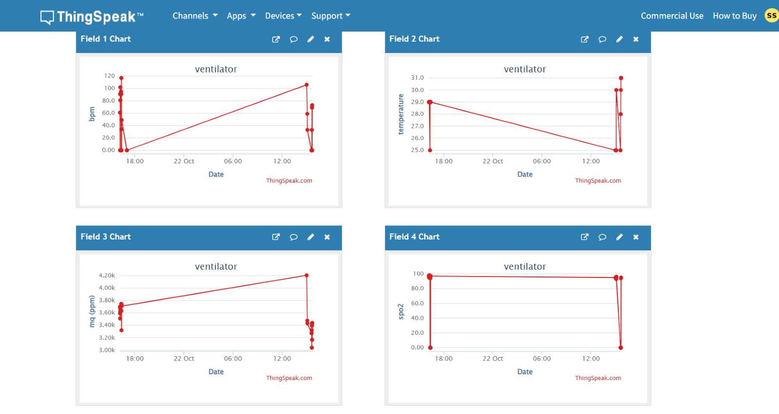

**Figure 5.3:** ThingSpeak

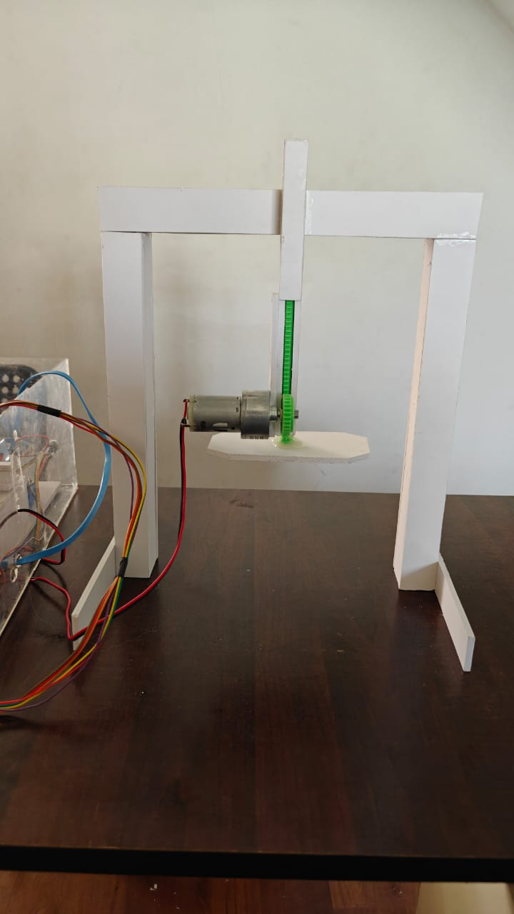 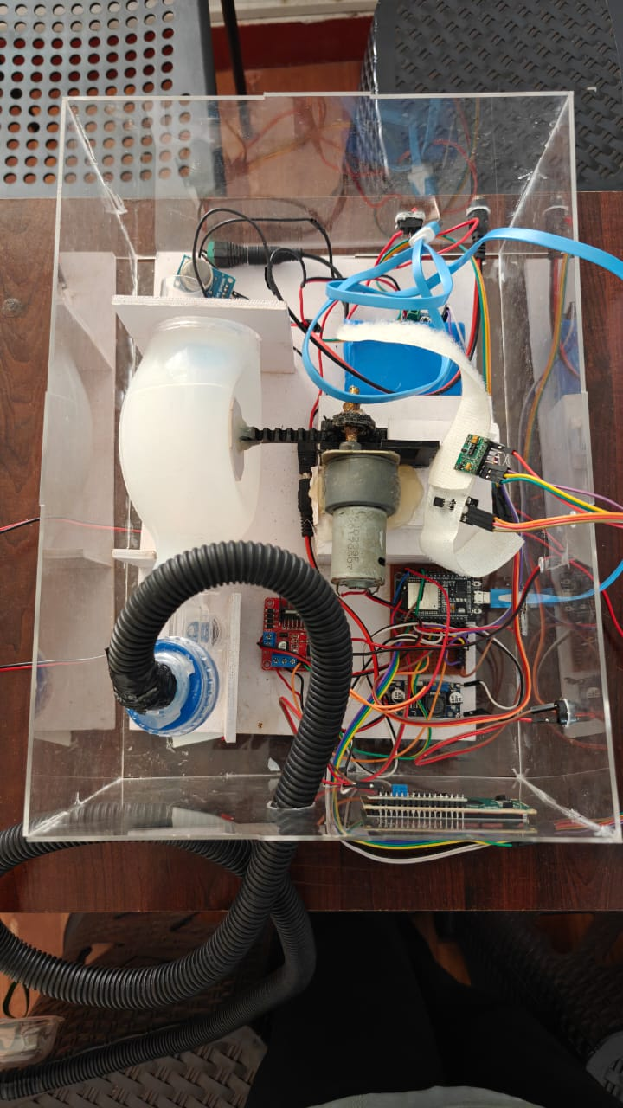

**Figure 5.4:** CPR **Figure 5.5:** Ventilator

1. **CONCLUSION**

In conclusion, the IoT-enabled automatic portable ventilator with integrated CPR functionality offered a comprehensive and innovative solution to address the critical challenges in emergency respiratory and cardiac care. By providing real-time monitoring, automated ventilation, and mechanical CPR, the system enhances patient safety, improves accessibility to life-saving interventions, and ensures timely medical response. The integration of IoT technology enabled seamless remote monitoring, making it a reliable and efficient tool for both clinical and emergency applications, ultimately contributing to improved healthcare outcomes.

**ACKNOWLEDGEMENTS**

Gratitude is extended to APJ Abdul Kalam Technological University and LBS Institute of Technology for Women for the support and guidance provided throughout this work. Appreciation is also conveyed to all individuals who contributed, even in the smallest way, to the successful completion of this research

1. **REFERENCES**
2. Bless, S.Q., Abed, J.K. and Mnati, M.J., 2023, November. Developing a Portable Smart Ventilator: A Prototype that Balances Cost and Functionality. In 2023 7th International Symposium on Innovative Approaches in Smart Technologies (ISAS) (pp. 1-6). IEEE.
3. Rajalakshmi, S., Kavipriyabai, S., Vinodhini, S. and Krithika, S., 2022, March. Ventilator Using Arduino with Blood Oxygen Sensor. In 2022 International Conference on Communication, Computing and Internet of Things (IC3IoT) (pp. 01-05). IEEE
4. Prabha, P.L., Atluri, K., Varughese, N. and Roopesh, R., 2022, September. A Low-Cost Portable Ventilator Using IoT. In Journal of Physics: Conference Series (Vol. 2335, No. 1, p. 012061). IOP Publishing.
5. Barrow, M., Restuccia, F., Gobulukoglu, M., Rossi, E. and Kastner, R., 2021. A remote-control system for emergency ventilators during SARS-CoV-2. IEEE embedded systems letters, 14(1), pp.43-46.
6. Al Husseini, A.M., Lee, H.J., Negrete, J., Powelson, S., Servi, A.T., Slocum, A.H. and Saukkonen, J., 2010. Design and prototyping of a low-cost portable mechanical ventilator. Transactions of the ASME-W-Journal of Medical Devices, 4(2), p.027514.
7. Haque, M.F.I.U., Sabina, S., Khan, M.M. and Nanda, I., 2022, March. Arduino based Smart Design of a Cheaper and Portable Automated Cardiopulmonary Resuscitation (CPR) Device. In 2022 6th International Conference on Computing Methodologies and Communication (ICCMC) (pp.1098-1105). IEEE
8. Khan, M.M. and Alam, M.M., 2020, November. Research and Development of a Low-Cost Smart Cardio-Pulmonary Resuscitation (CPR) Device Using Locally Available Raw Materials for Cardiac Arrest Patients. In Proceedings (Vol. 67, No. 1, p. 10). MDPI.
9. Gupta, N.K., Dantu, V. and Dantu, R., 2014. Effective CPR procedure with real time evaluation and feedback using smartphones. IEEE journal of translational engineering in health and medicine, 2, pp.1-11.
10. Xie, J. and Wu, Q., 2023. Design and Evaluation of CPR Emergency Equipment for NonProfessionals. Sensors, 23(13), p.5948.