***Title :- Review Article on Neurodegenarative Disease (Parkinson's disease )***

***Student Name:- 1. Nikhil Antim Gaikwad***

***2. Manisha Bhagwan Chaudhari***

1. ***Mayur Antim Gayakwad***
2. ***Roshani Sunil Patil***
3. ***Mangesh Goverdhan Rathod***

***Guidance by:- Mr. Awais Mohammad***

### Mr. Nazir Ahmed

### Abstract:-

Parkinson's disease is the second most common neurodegenerative disease affecting older Americans, and its prevalence is expected to increase as the American population ages. Idiopathic Parkinson's disease results from the pathophysiological loss or degeneration of dopaminergic neurons in the substantia nigra region of the brain's midbrain and the development of neural Lewy bodies and is associated with risk factors such as aging, family history, pesticides, and environmental chemicals (e.g., synthetic heroin use). Its exact origin is not yet known. Individuals with Parkinson's disease present with motor and nonmotor symptoms, most commonly characterized by resting tremor, rigidity, bradykinesia, and stooped posture. PD may also be associated with neurological disorders (depression, anxiety), cognitive impairment (dementia), and functional impairment (e.g., orthostatic hypotension and hyperhidrosis). In recent years, we have seen an increase in new medical and

surgical treatments, such as deep brain stimulation (DBS). However, definitive treatment options are still lacking. Clinical trials have been designed and tested, but the results have been limited. Understanding strategies to improve the quality of life for people with Parkinson's disease is important for caregivers, physicians, and patients themselves.

### Introduction:-

Parkinson's disease (PD) is an idiopathic neurological disorder characterized by motor and non-motor symptoms. It is a progressive neurodegenerative disease that is more common in older patients, but can also be seen in younger patients. It is the second most common neurodegenerative disease (1). Other neurodegenerative diseases can also resemble idiopathic PD. These include Dementia with Lewy Bodies (DLB), Corticobasal Degeneration (CBD), Multiple System Atrophy (MSA), and Progressive Supranuclear Palsy (PSP).This review focuses on idiopathic Parkinson's disease rather than other Parkinson's syndromes.

Parkinson's disease has been known since the early 19th century, when the physician who gave it its name first described the disease. Parkinson's disease, sometimes called "parkinsonism," is rare in young people, especially those under the age of 40 (/).

Approximately one million Americans are affected by PD, and approximately 60,000 new cases are diagnosed each year. It is estimated that between 7 and 10 million people are affected worldwide. Men are 1.5 times more likely to develop PD than women (3). A population-based study of Medicare beneficiaries in the United States found that the mean prevalence of PD in the population aged 65 and older was 1.6%. Black and Asian Americans were less affected than whites. The incidence of PD is higher in the Midwest/Great Lakes region of the United States and in coastal areas of the Northeast of the United States.

Exposure to environmental toxins has been suggested as a possible etiologic factor in these regions (4, 5).

As the American population ages, the prevalence of PD is expected to increase significantly over the next /0 years.As such, it will continue to pose significant health problems and a significant economic burden due to its direct and indirect costs(1). The economic and humanitarian burden may be significant, especially in developing countries where life expectancy is increasing (6).

Parkinson's disorder (PD) is a revolutionary, neurodegenerative flow-ment disorder,

which in its maximum classical manifestation is characterized via motor signs and symptoms (Kalia & Lang, /015). although it is now widely frequent that PD pathology is extensive (Braak & Braak, /000) and consequently offers upward push to a number of nonmotor signs (Zis, Erro, Walton, Sauerbier, & Chaudhuri, /015), the clinical analysis of PD has been always centered on a specific motor syndrome that functions the presence of or greater signs/signs amongst bradykinesia, rest tremor, muscle pressure, and postural instability.

(11)even as the definitive prognosis of PD relies on postmortem confirmation of cell loss within the sub-stantia nigra along with the presence of Lewy body (Kalia & Lang, /015), the clinical diagnosis is in fact based at the presence of the aforemen-tioned clinical features. numerous tries have been therefore made to define medical diagnostic standards, e.g.. by

means of the UK Parkinson's disorder Society mind financial institution (Hughes, Daniel,

Kilford, & Lees, 199/) or the country wide Institute of Neurological disorders and Stroke

(Gelb, Oliver, & Gilman, 1999). greater these days, novel diagnostic criteria have been

proposed with the aid of the worldwide PD and motion ailment Society (MDS-PD standards) (Postuma, Berg, Stern, et al., /015).(1/)

|  |  |  |  |
| --- | --- | --- | --- |
| ***Pathophysiology:-***  ***The pathological definition of PD is loss or degeneration of the dopaminergic (dopamine- producing) neurons in the substantia nigra and improvement of Lewy our bodies (a pathologic*** | | | |
| ***hallmark) in dopaminergic neurons (7). Pathologic changes might also precede apparent signs*** | | |  |
| ***with the aid of two decades or more (8). This preferential lack of dopamine producing*** |  | | |
| ***neurons outcomes in marked impairment of motor control. Lewy our bodies, or atypical*** | |  | |

intracellular aggregates, incorporate various proteins which include alpha-synuclein and

|  |  |  |
| --- | --- | --- |
| ***ubiquitin that impair best neuron functioning.***  ***current guides advocate that environmental strain and getting old itself might also*** |  | |
| ***promote neuropathology. specifically, exposure to environmental pollutants (e.g., pesticides)*** | |  |
| ***(nine), tablets of abuse, or the pressure of the growing older technique promotes a chronic*** | | |

low-level inflammation in the brain ("Inflammaging"). This inflammatory process through the

years generates cellular senescence in brain neurons (6, 10).

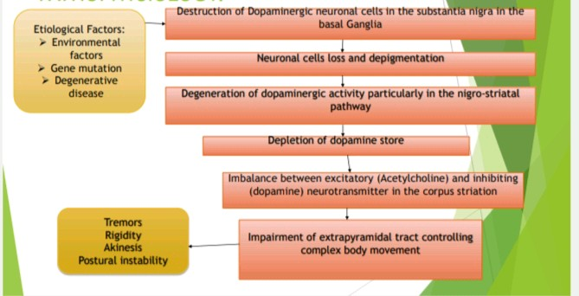

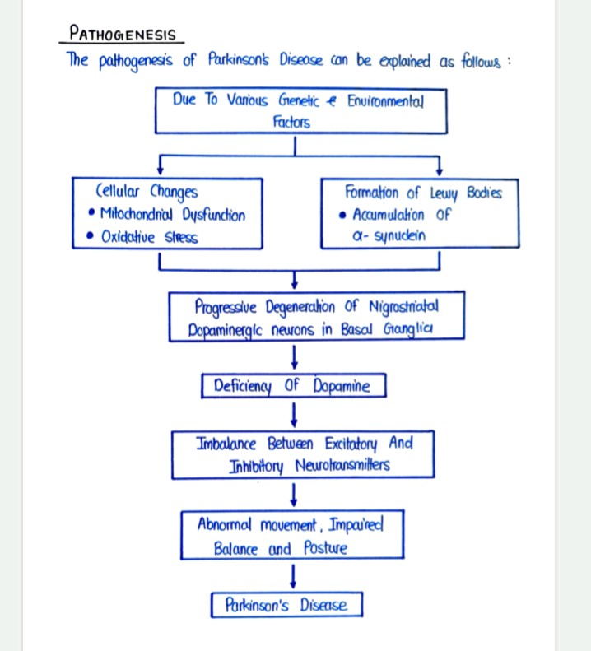

# Risk factor :-

Environmental chance elements The potential reason and impact relationship between etiologic factors and disorder has been traditionally explored via clinical affiliation research the use of a pass-sectional (clinic and network-based) or potential (populace-based totally) technique. several hazard factors had been implicated together with pesticide and heavy metallic exposure, rural residing, agricultural career, disturbing head injury, records of melanoma, consumption of dairy products, type / diabetes mellitus (reduced through the use of antidiabetic capsules), amongst many others(13) (discern /).

despite the fact that these hyperlinks are supported through underling biological plausibility, a number of the observations can not be continually replicated. A recent meta- evaluation which worried each quantitative and qualitative analyses of diverse environmental exposures suggests a loss of sturdy consistency in some of these associations (inclusive of rural residing, well-water consumption, farming and pesticide publicity).(14) while other meta

-analyses reaffirmed a fine affiliation with pesticide exposure,(15)others determined lack of support for a link with traumatic head injury.(16)because of several challenges and inherent boundaries, it isn't always sudden that such epidemiological studies every so often supply conflicting effects.

## Age

the biggest chance thing for Parkinson's is aging, with the common age of onset round 70 Parkinson's can occur in younger adults, but it is rare

## Genetics

Having a discern or sibling with Parkinson's disease will increase your riskbut, it's uncommon for the disease to be inherited this manner

## Environmental publicity

exposure to insecticides, herbicides, and other pollutants may additionally boom your chancesite visitors or industrial pollution can also make a contribution

## Head trauma

Repeated blows to the head might also increase your dangerwear shielding headgear during contact sports

## CLINICAL PRESENTATION

The clinical presentation of PD represents a nexus of four major components: motor symptoms, cognitive changes, behavioral/neuropsychiatry changes, and symptoms related to autonomic nervous system failures. Individual variation affects the area(s) that becomes) more prominent. Each aspect will be discussed.The cardinal motor features of PD are tremor, bradykinesia, rigidity and postural instability.

The latter symptom develops more with disease progression over time (/). A mnemonic is sometimes used to encapsulate the major motor symptoms T-R-A-P. It stands for Tremors (resting), Rigidity (possibly cogwheel jerking), Akmesia (or Bradykinesia), and Posture (stooped shuffling gait) (17), Pathological and neuroimaging studies suggest that motor signs of PD only develop when 50-70% of substantia nigru neurons have degenerated

(18). LBD, PSP, CBD, and MSA are clinical syndromes that have differing clinical presentations from classic PD. Key differences among the disorders are discussed in these references (/, 4, 8, 19,/0) and are beyond the scope of this article.

The "pill rolling rest tremor of idiopathic PD is most noticeable when the body part is not engaged in purposeful movement. Usually unilateral initially, PD often progresses to bilateral rest tremor overtime. Rest tremor is the presenting symptom in over 70 percent of PD patients (/) Bradykinesia or slowness of movement in often described as tiredness or weakness by patients. It is manifested in lessened finger manual dexterity shuffling steps or difficulty getting out of a chair (/). Difficulty with opening packages or contamers is commonly reported. Rigidity is seen almost all PD patients. It can begin unilaterally but moves to the other side. When joint range of motion is examined, the PD patient often demonstrates a "cogwheel" rigidity that is similar to the ratchet pattern of a gear.

Later in the disease course, patients with PD will likely display postural instability with an increased risk of falling. Falling early in the course of FD suggests another disorder such as PSP. Another manifestation may be "festination where patients take much quicker and

shorter steps, assuming a running gait. Notably, postural instability responds least well to dopamine treatments.Interestingly a prodrome of non-motor Seatures may precede motor symptoms of FD by many years. These include: constipation, hyposmia (altered sense of smell), REM sleep disorder, orthostatic hypotension, depression, urge urinary incontinence, and erectile dysfunction (//) Since no biomarkers exist for PD, neuroprotective agents (if they were available) cannot be used to prevent further neurodegeneration.

## Motor symptoms

PD is associated with resting tremor (initially unilateral), bradykinesia (slow movements), rigidity, shuffling gait, and postural instability. The onset is insidious where individuals may attribute the symptoms to aging processes. PD symptoms are progressive but rates of motor progression are highly variabile (4). Also, subtypes of FD occur wherein tremor, rigidity, or postural instability dominate (/)

In addition to the "classic" motor symptoms previously described, other motor manifestations are observed. These include masked facial expression (hypomimia), decreased eye blink rate, blurred vision, impaired upward gaze, dystonia, stooped posture, difficulty turning in bed, kyphosis, scolosis, shuffling gait, "freezing" (inability to move) and speech impairment, such as hypophonia (increasingly soft voice), or palilalia (repetition of word or phrase) (/).

## Non-motor symptoms

Non-motor symptoms of PD include cognitive changes, behavioral/neuropsychiatric changes autonomic nervous avstem failure, sensory and sleep disturbances (/1) (See Table 1). Non-motor symptoms can represent some of the greatest challenges to quality of life and appropriate management in PD since they usually do not respond to dopamine therapy as well as motor symptoms (//). Notably, a number of non-motor features can precede the motor symptoms of PD by years, even decades. However, it is known that almost 90% of PD patients experience non-motor symptoms during the course of the disease (/).

In addition to the development of non-motor symptoms of PD as a component of the disease, therapy used in PD can exacerbate or cause the symptoms. For example, psychosis, orthostatic hypotension and, sleep attacks may relate to L-dopa dosing or side effects (//).

Cognitive dysfunction and dementia are common in PD, but develop over time. The dementia of PD is subcortical with altered personality, psychomotor retardation, and memory problems.

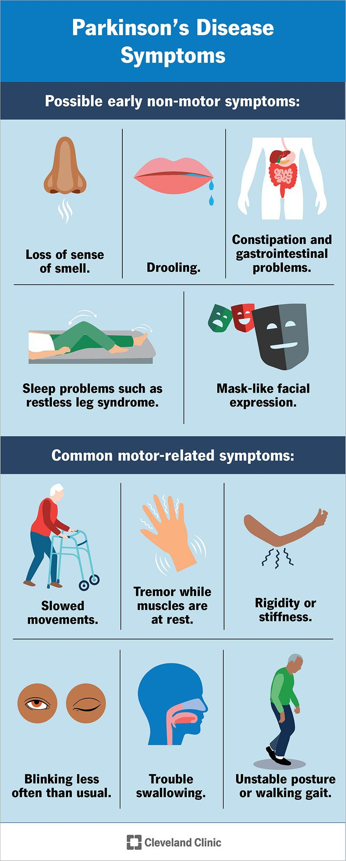

## treatment

PD is a complicated neurodegenerative ailment with a broad spec-trum of motor and non- motor capabilities that require individu-alised healing approach. medical trials designed to provide proof-based totally statistics should both include a well-defined population of patients and controls and must additionally utilise the maximum objec-tive, reliable and demonstrated tools to assess the effects of the ther-apeutic and intervention. although a variety of clinical score scales and other gadgets were utilised in assessing response to numerous healing procedures, the UPDRS is used most often as the primary outcome degree in diverse scientific trials. (/3) an overview of clinical and surgical healing alternatives for patients with PD in various degrees in their ailment is highlighted in desk 1 and figure four. further to traditional treatments, we additionally offer insights into proof-primarily based in addition to rising and experimental therapeutics of PD.

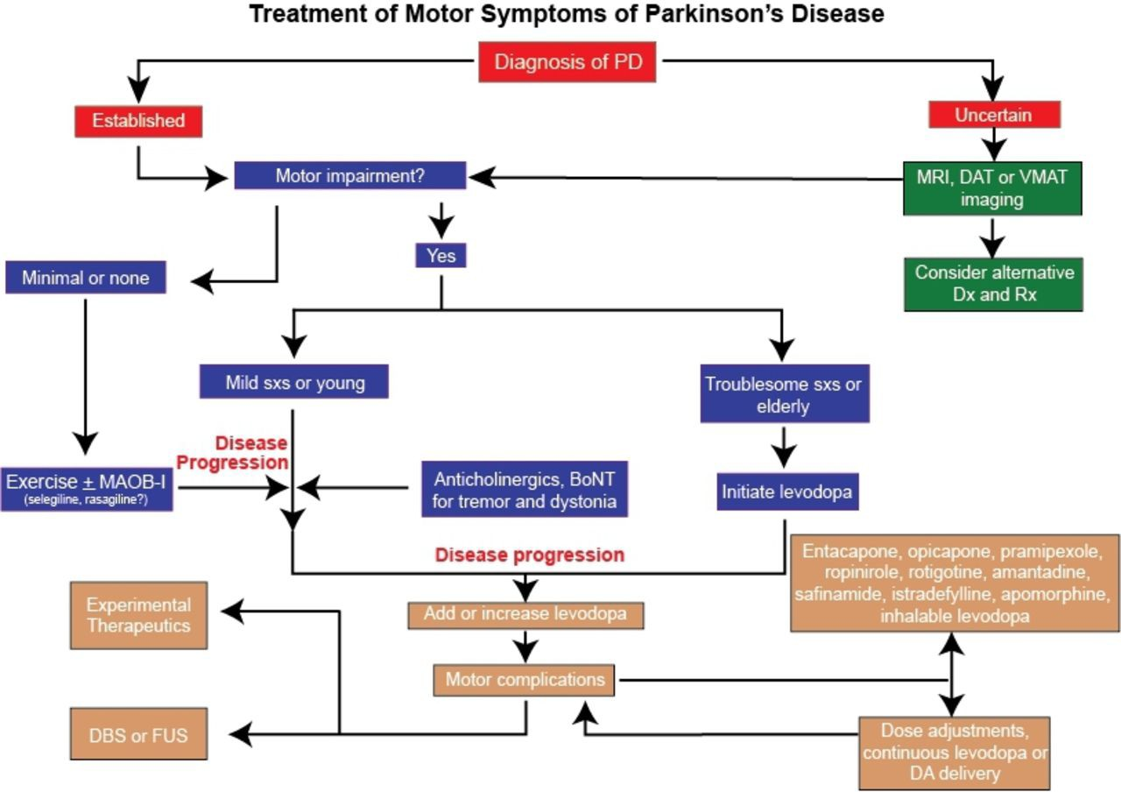

## Medical Therapy

scientific remedies are the mainstay of treatment for PD. They consist of pharmacotherapy and non-pharmacological alternative procedures which include exercise, training, guide companies speech remedy and nutrients. therapeutic methods rely on patient's age, disorder level, troubling signs, and the benefit/risk ratios of treatments (/4). considering the fact that pharmacotherapy for PD has expanded substantively in its array of options, non-pharmacological methods will be mentioned first

sufferers with new onset PD can be apprehensive on the destiny laid low with a chronic progressive sickness of the fearful device. targeted training on symptoms and introduction to the ailment system over time can act to decrease fear and help version (forty six). training approximately a way to deal with the disease can sell improved self-care inside the lengthy-term (/5)

Non-pharmacological alternative treatments consist of exercise, training, help organizations, speech therapy and vitamins. whilst no longer slowing the inexorable direction of PD, each gives advantage to some aspects of the sickness and/r address its pathophysiologic effect. A clear message pervades the literature approximately their use: start their utilization early in the disease path (/6).

ordinary exercise and bodily remedy can honestly help with a number of the physical results of PD which includes joint pressure and flexed posture. sporting events that concentrate on advanced flexibility, strength, and stability need to be emphasized. sufferers may gain a sense of manipulate over a few additives of the sickness.

patient and family/caregiver schooling is crucial however significantly wanted in a persistent modern neurologic disease. Key to achievement is balancing want to understand as opposed to readiness to absorb probably disturbing facts (/6). a few programs were advanced which delineate subjects vital for particular neurologic conditions like PD (/5).

## Surgical treatment

notwithstanding eptimal medical therapy, many sufferers with moderate to superior disease have a terrible nice of lite became of fluctu ating response, difficult dyskinesia or levodopa-unesspensive signs and symptoms. Ablative surgical methods along with stereotactic destruction of physiologically described overactive mind maclei. (thalamotoms, pallidotomy) were largely replaced by way of DBS the usage of implanted pulse turbines. The chief gain of DBS over ablative lesioning is that the stimulation parameters can be customised to the wishes of the affected person for you to optimise the blessings.

Thalamic DIIS is maximum regularly used to manipulate excessive-amplitude tremor in patients with vital tremor, but STN or globus pallidus interna (GP) are the maximum common targets for DBS treatment of sufferers with PD with disabling tremor and/or levodopa- related moter complications. To deal with the query whether or not optimal medical remedy or DBS prevides extra sturdy improvemem, /55 sufferers at seven Veterans Affairs and six college humpitals had been enrolled in a randomised managed trial designed to evaluate the outcomes of DIS (STN, 60; Gi, 611 and "exceptional scientific remedy (n=134) after 6 months of remedy.(/7) sufferers treated with DBS won a median of 4.6 hours/day of en time with out troubling dyskinesia, compared with 0 hours/day for patients who received hest scientific remedy (p<0.001). furthermore, motor function progressed with the aid of five or greater points en the moter UPDRS in 71% of DBS and 1/% of medical therapy sufferers.

This was observed through improve ments in most people of PD-related health-associated excellent of lifestyles measures and best minimal decrement in neurocognitive. checking out.

the general risk ef experiencing a extreme unfavorable occasion, but, become 3.8 times higher within the DBS than within the medical therapy group one hundred forty% 11. The relative efficacy of STN and GP as therapeutic targets has been debated considering the arrival of DBS The Veterans Affairs Cooperative Stody investigated STN and GPI DBS cutcomes after /4 months in /99 sufferers, and there have been no differences in suggest changes inside the meter (element III UPDRS among the twe goal .(/8)patients present process STN required a lewer dose of DAs than the ones present process pallidal stimulation (p=zero.0/), and visunmotor precesing speed declined greater after STN than after GPi stimulation (p-0.03). on the other hand, there was wors ening of melancholy after STN DBS, however temper advanced after GPS DBS (p=0.0/).

barely extra than half of of the patients expe rienced sericus unfavourable crents, however there was no distinction within the fresquency of these events between the two businesses. based totally on these and other research, there's rising evidence that GIS DBS can be especially appropriate for sufferers who may additionally have trouble-some dyskinesias as well as slight cognitive or behavioural impair ment, while bilateral STN DBS can be the surgical preference for patients who're cognitively intact but in whom reduction in levodopa dosage is the number one intention. in comparison with GPi, STN DBS appears to have a more beneficial impact on off durations but is much more likely related to adverse results together with ICD.

One commonplace medical question is whether or not DBS surgical procedure at an in advance degree of PD or at a younger age can result in comparable posi-tive outcome.(/9) In a randomised trial related to /51 incredibly younger (suggest age fifty two years) PD with early motor headaches, STN DBS plus medical therapy became in comparison with clinical remedy by myself. The pleasant of lifestyles rankings mean rating stepped forward by way of 7.eight points in DBS institution as compared with 0./ point worsening in medical group. Motor disability, sports of day by day residing, levodopa-associated motor complications were better inside the surgical operation group. (30) when thinking about early DBS, it is critical to first optimise clinical remedy, which include strategies to enhance motor fluctuations and dyskinesia and to don't forget the risks of surgical treatment and different elements, (31)(3/) at the same time as DBS is a confirmed powerful therapeutic approach, its fulfillment relies upon on the appropriate choice of patients and the experience and skill of the stereotactic physician a good way to opti-mise the effects and minimise complications.

Advances in DBS generation, together with the usage of adaptive stimulation, improving connectivity, directional stimulation and an exploration of for new goals will likely preserve to improve. (33)(34)

## Cell Replacement Therapies

The results of previous fetal tissue-derived mobile transplants in PD were variable. although some transplanted sufferers showed a few initial development, many evolved 'off' dyski-nesias in spite of sturdy graft survival. (35) The presence of troubling dyskinesias in some patients, ethical worries and the constrained availability of the tissues restricted the medical applicability of fetal transplantation.

Advances within the generation dopaminergic neurons from somatic human cells and improvement in the efficacy of differen-tiation protocols have caused a resurgence of cell transplantation in PD. (36)(37) Human embryonic stem cellular traces and somatic cells which may be converted into true midbrain dopaminergic cells that fulfill top production practice grade standards may be generated in unlimited quantities for medical application. (36)(37).

# Conclusion:-

PD is a complex neurodegenerative situation, for which the etiology and patho-genic mechanisms stay incompletely understood. while a small percentage of PD patients have a monogenic reason for his or her disorder, most of the people of cases prob-ably aren't associated with a specific genetic abnormality as an alternative, it is in all likelihood that the risk of PD is in element, determined by way of a aggregate of polygenic susceptibility factors. Environmental impacts can also make a contribution to PD threat, despite the fact that the connection between the improvement of the disorder and elements which include smoking, caffeine, and pesticide publicity remains poorly understood. Pathologically, the motion disease happens because of lack of dopaminergic neurons in the SNpc, with some of different mind regions additionally being involved. The histopathological hallmark of PD are LBs, which predominantly include aggregated a-synuclein, but it is not clean how those may additionally result in neurodegeneration. know-how those pathogenic tactics can permit for the identification of novel healing goals, and, hopefully, the improvement of sickness-enhancing treatments inside the future.

## Refference:-

1. Sherer TB, S Chowdhury, K Peabody, D Brooks Overcoming obstacles in Parkinson's Disease. Movement Disorders /7(13), 1606-1611 (/01/)

/. Chou K: Clinical manifestations of Parkinson Disease. UpToDate Retrieved [www.uptodate.com.](http://www.uptodate.com/) (/013) on 7/////013 from

1. ***Parkinson's Disease Foundation: Parkinson's Retrieved Statistics on from*** [***http://www.pdf.org/en/parkinson_statistics.***](http://www.pdf.org/en/parkinson_statistics) ***(/013)***
2. ***Fritsch T, K Smyth, M Wallendal, T Hyde, G Leo, D Geldmacher: Parkinson Disease: Research update and clinical management. Southern Medical Association 105(1/), 650-656 (/01/)***
3. ***Wright Willis A, B Evanoff, M Lian, S Criswell, B Racette: Geographic and ethnic variation in Parkinson Disease: A population-based study of US Medicare Beneficiaries. Neuroepidemiology, 34, 143-151 (/010)***
4. ***Chinta S, C Lieu, M Demaria, R. Laberge, J Campisi, J Anderson: Environmental stress, ageing, and glial cell senescence: A novel mechanistic link to Parkinson's Disease? Journal of Internal Medicine /73, 4/9-436 (/013)***
5. ***MacPhee G. D Stewart: Parkinson's Disease. Reviews in Clinical Gerontology 11, 33-49 (/001)***
6. ***Gazewood J, D Richards, K Clebak: Parkinson Disease An update. American Family Physician 87(4), /67-/73 (/013)***
7. ***Brown T, P Rumsby, A Capleton, L. Rushton, L. Levy: Pesticides and Parkinson's Disease: Is there a link? Environmental Health Perspectives 14(/), 156-164 (/006)***
8. ***Ceccatelli S: Mechanisms of neurotoxicity and implications for neurological disorders. Journal of Internal Medicine /73, 4/6-4/9 (/013***
9. ***The book of International Review of Neurobiology written by Kailash.P.Bhatia, . K. Ray chaudhari, Maria stamelou , Parkinson's disease Volume 13/, Page No. /6.***

1/. The book of International Review of Neurobiology written by Kailash.P.Bhatia, . K. Ray chaudhari, Maria stamelou , Parkinson's disease Volume 13/, Page No. /6.

1. ***Ascherio A, Schwarzschild MA. The epidemiology of Parkinson's disease: risk factors and prevention. Lancet Neurol /016;15:1/57-7/.***
2. ***Breckenridge CB, Berry C, Chang ET, et al. Association between Parkinson's disease and cigarette smoking, rural living, well-water consumption, farming and pesticide use: systematic review and meta-analysis. PLoS One /016;11:e0151841.***
3. ***Yan D, Zhang Y, Liu L, et al. Pesticide exposure and risk of Parkinson's disease: dose- response meta-analysis of observational studies. Regul Toxicol Pharmacol /018;96:57-63.***
4. ***Huang C-H, Lin C-W, Lee Y-C, et al. is traumatic brain injury a risk factor for neurodegeneration? A meta-analysis of population-based studies. BMC Neurol /018;18:184.***
5. ***Frank C, G Pari, J Rossiter: Approach to diagnosis of Parkinson Disease. Canadian Family Physician 5/(7), 86/-866 (/006)***
6. ***Postuma R, J Gagnon, J Montplaisir: Clinical prediction of Parkinson's Disease: Planning for the age of neuroprotection. Journal of Neurology (81)9, 1008-1013 (/009)***
7. ***Chou K: Diagnosis of Parkinson Disease UpToDate. Retrieved on 7/////013 from*** [***www.uptodate.com.***](http://www.uptodate.com/) ***(/013)***

/0. Lew M. Overview of Parkinson's Disease Pharmacotherapy /7(1/ Pt /), 155S-160S (/007)

/1. Jain S: Multi-organ autonomic dysfunction in Parkinson Disease. Parkinsonism and Related Disorders 17, 77-83 (/011)

//. Lim S, A Lang: The nonmotor symptoms of Parkinson's Disease-An overview. Movement Disorders /5(Suppl 1), $1/3-8130 (/010)

/3. Tarakad A. Clinical rating scales and quantitative assessments of movement disorders. Neurol Clin. In Press /0/0;38:/31-54.

/4. Ferreira J, R Katzenschlager, B Bloem, U Bonuccelli, D Burn, G Deuschl, E Dietrichs, G Fabbrini, A Friedman, P Kanovsky, V Kostic, A Nieuwboer, P Odin, W Poewe, O Rascol, C Sampaio, M Schupach, E Tolosa, C Trenkwalder, A Schapira, A Berardelli, W Oertel: Summary of the recommendations of the EFNS/MDS-ES review on therapeutic management of Parkinson's Disease. European Journal of Neurology /0, 5-15 (/013)

/5. Chaplin H, J Hazan, P Wilson: Self-management for people with long-term neurological conditions. British Journal of Community Nursing 17(6), /50-/57 (/01/)

/6. Tarsy D. Nonpharmacologic management of Parkinson Disease. UpToDate Retrieved 7/////013 from <http://www.uptodate.com/contents/nonpharmacologic-management> of

parkinson-disease? (/013)

/7. Weaver FM, Follett K, Stern M, et al. Bilateral deep brain stimulation vs best medical therapy for patients with advanced Parkinson disease: a randomized controlled trial. JAMA

/009;301:63-73.

/8. Follett KA, Weaver FM, Stern M, et al. Pallidal versus subthalamic deep-brain stimulation for Parkinson's disease. N Engl J Med /010;36/:/077-91.

/9. Armstrong MJ, Okun MS. Diagnosis and treatment of Parkinson disease. JAMA

/0/0;3/3:548-60.

1. ***Schuepbach WMM, Rau J, Knudsen K, et al. Neurostimulation for Parkinson's disease with early motor complications. N Engl J Med /013;368:610-//.***
2. ***Kim HJ, Jeon B. Decision under risk: argument against early deep brain stimulation in Parkinson's disease. Parkinsonism Relat Disord /019:69:7-10.***

3/. Dafsari HS, Martinez-Martin P, Rizos A, et al. EUROPAR and the International Parkinson and movement disorders Society non-motor Parkinson's disease Study Group. Euroinf /: subthalamic stimulation, apomorphine, and levodopa infusion in Parkinson's disease. Mov Disord /019:34:353-65.

1. ***Okun MS. Tips for choosing a deep brain stimulation device. JAMA Neurol***

/019;76:749-50.

1. ***Martinez-Fernández R, Rodríguez-Rojas R, Del Álamo M, et al. Focused ultrasound subthalamotomy in patients with asymmetric Parkinson's disease: a pilot study. Lancet Neurol /018;17:54-63.***
2. ***Kordower JH, Goetz CG, Chu Y, et al. Robust graft survival and normalized dopaminergic innervation do not obligate recovery in a Parkinson disease patient. Ann Neurol***

/017;81:46-57.

1. ***Barker RA, Barrett J, Mason SL, et al. Fetal dopaminergic transplantation trials and the future of neural grafting in Parkinson's disease. Lancet Neural /013;1/:84-91.***
2. ***Jankovic J, Okun MS, Kordower JH, et al. Stem cells: scientific and ethical quandaries of a personalized approach to Parkinson's disease. Mov Disord /0/0;10. doi:10.100//mds./8187. [Epub ahead of print: 1/ Jun /0/0].***