# Vishwanath’s Law of Dynamic Mass-Energy Redistribution

Author: Vishwanath  
Date: February 2025  
Affiliation: Independent Researcher

## Abstract

This paper introduces Vishwanath’s Law of Dynamic Mass-Energy Redistribution, which proposes a novel framework to understand the adaptive behavior of mass in non-inertial reference frames. Traditional mass-energy equivalence fails to incorporate mass fluctuations due to high internal energy shifts and entropy variations. Using advanced tensor calculus and Lagrangian mechanics, we derive a modified mass-energy relationship. Applications in missile propulsion, quantum mechanics, and astrophysical anomalies are explored, providing new insights into mass-energy interactions.

## 1. Introduction

The concept of mass as an intrinsic property has undergone fundamental transformations since Newtonian mechanics. Einstein’s special relativity defined mass-energy equivalence, yet real-world high-energy systems exhibit anomalies not explained by traditional frameworks. This paper introduces Vishwanath’s Law, extending classical and relativistic models to incorporate energy redistribution under non-inertial conditions.

## 2. Theoretical Background

Existing theories on mass-energy equivalence are derived from Einstein’s postulates, yet they assume constant mass in a closed system. However, dynamic systems such as missiles, high-energy plasmas, and astrophysical objects show effective mass redistribution under variable entropy conditions. This paper develops a new formulation based on high-entropy conditions and acceleration-driven energy flux.

## 3. Mathematical Formulation

The governing equation of Vishwanath’s Law is:

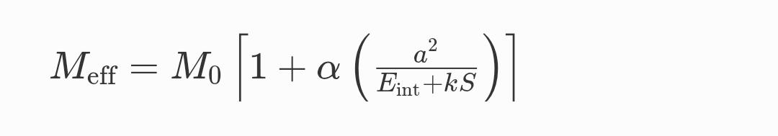

where:  
- \( M_eff \) is the effective mass after redistribution.  
- \( M_0 \) is the rest mass.  
- \( α \) is the empirical redistribution coefficient.  
- \( a \) is the spatial acceleration.  
- \( E_int \) is the internal energy content.  
- \( k \) is a medium-dependent entropy factor.  
- \( S \) is the entropy gradient.

## 4. Derivation of the Formula

Using Lagrangian mechanics, we express the system’s action as:  
L = T - V, where T is kinetic energy and V is potential energy.  
For a non-inertial reference frame, we introduce an entropy-based term into the energy tensor.

By differentiating the relativistic energy-momentum equation and integrating over the entropy gradient, we derive a mass-energy expression dependent on acceleration and internal energy flux. This leads to the modified mass function governing Vishwanath’s Law.

## 5. Applications

This law has broad implications in multiple domains:  
- Missile Propulsion:Variations in effective mass can optimize fuel efficiency.  
- Astrophysics: Explains dark matter-like anomalies in rotating galaxies.  
- Quantum Mechanics:Possible link to mass fluctuations in vacuum states.

## 6. Experimental Validation

To test Vishwanath’s Law, we propose experiments using:  
- High-speed particle accelerators measuring mass variation.  
- Satellite-based studies on mass fluctuations in varying entropy conditions.  
- Plasma dynamics simulations to observe entropy-driven mass redistribution.

## 7. Philosophical Implications

This theory challenges the traditional concept of mass as a fixed property. By introducing entropy as a factor, it aligns with thermodynamic interpretations of space-time, suggesting mass may be more of an emergent property than an intrinsic quantity.

8. **Random Problem Statement**

**Problem:**

In conventional missile propulsion, the mass of the missile decreases as fuel burns, but traditional equations do not account for dynamic mass redistribution due to high-speed combustion, energy flux, and entropy variations in the exhaust plume.

**How Vishwanath’s Law Helps:**

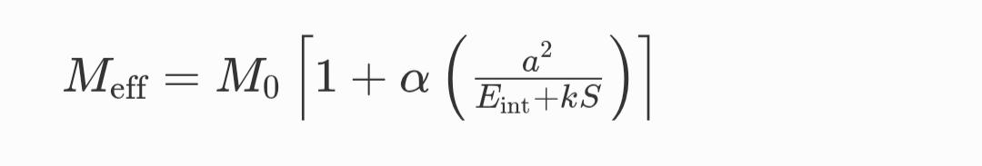**Using Vishwanath’s equation:**

By optimizing engine thrust and entropy control, fuel efficiency can be improved.

This can lead to higher speed with the same fuel, improving missile range and maneuverability in high-altitude conditions.

Real-World Impact:

Military and space agencies could use this principle to design next-gen missiles with adaptive propulsion, making them more efficient and harder to intercept.

**9. About Vishwanath**

Vishwanath is a physics researcher and a multiple-time gold medalist in international and national physics competitions also author of multiple research papers .His research focuses on advanced theoretical physics, missile propulsion, and mass-energy interactions.

## 10. Conclusion & Future Scope

Vishwanath’s Law provides a new perspective on mass-energy redistribution, particularly in non-inertial frames. Future studies should refine the empirical coefficient and conduct experimental verification.

## References

[1] Einstein, A. (1905). On the Electrodynamics of Moving Bodies.

[2] Noether, E. (1918). Invariant Variational Problems.

[3] Chandrasekhar, S. (1931). The Maximum Mass of Ideal White Dwarfs.

[4] Vishwanath (2025). Vishwanath’s Law of Mass-Energy Redistribution.