# PASSWORD BASE CIRCUIT BREAKER PROTECTION CIRCUIT

# Mr. Avhad Deepak R 1, Mr. Somase Abhay R 2, Mr. Nikam Om R 3,

# Mr. Wadge Raj S 4, Mr. Shewale Durgesh N 5

1,Lecturer, Department of Electrical Engineering, Santosh N Darade Polytechnic, Yeola,Maharastra, India.

2,3,4,5 Students, Department of Electrical Engineering, Santosh N Darade Polytechnic, Yeola,Maharastra, India.

# ABSTRACT

The password-based circuit breaker is a smart protection system designed to enhance electrical safety by incorporating digital security. The system operates by requiring a password authentication process before allowing the circuit to close or supply power. It aims to prevent unauthorized access, accidental activation, and electrical mishaps, ensuring controlled and secure use of electrical circuits.

The system comprises a microcontroller-based unit interfaced with a keypad or other input methods for password entry, a relay to control the circuit, and an LCD/LED display for user feedback. When the correct password is entered, the microcontroller activates the relay, allowing current to flow through the circuit. If an incorrect password is entered multiple times, the system can trigger additional safety mechanisms, such as locking out further attempts or sending an alert signal.

This technology finds applications in various domains, including residential, commercial, and industrial settings, where access to electrical circuits needs to be restricted or controlled. It can also be integrated with iot platforms to enable remote monitoring and control, enhancing its functionality and scalability. The password-based circuit breaker contributes to improved safety, energy conservation, and access management in modern electrical systems.

**Keywords:** Circuit breaker, digital security, electrical circuits, microcontroller

# INTRODUCTION

A password-based circuit breaker is an electronic device designed to enhance electrical safety by incorporating password protection as a control mechanism for operating the circuit. This system allows only authorized personnel to turn the circuit on or off, preventing unauthorized access and misuse.

**Key Features and Applications:**

1. **Password Protection**:
   * The circuit breaker operates only when the correct password is entered.
   * Typically implemented using a microcontroller or microprocessor.
2. **Enhanced Security**:
   * Prevents unauthorized individuals from tampering with the electrical system.
   * Useful in environments where sensitive equipment or systems are involved.
3. **Automation and Control**:
   * Can be integrated with IoT for remote monitoring and control.
   * Alerts can be sent if there is an attempt to access the system without authorization.
4. **Applications**:
   * Industrial setups to control high-power equipment.
   * Smart homes for managing sensitive devices.
   * Commercial and public installations to enhance electrical safety.

**How It Works:**

* A keypad or touch interface is used for entering the password.
* The entered password is processed by a microcontroller, which compares it with a stored password.
* If the password matches, the microcontroller triggers a relay or electronic switch to connect or disconnect the circuit.
* If the password is incorrect, the system remains inactive and may issue an alert.

**Benefits:**

* Reduces the risk of accidents due to unauthorized access.
* Ensures safety in environments with high electrical hazards.
* Allows for centralized and secure control of electrical systems.

# BLOCK DIAGRAM

Next Time Password Wrong Enter To Supply Off

START

STOP

Password Enter Correct To Power On

Password Enter Correct To Power On

Display Show to Enter Password Circuit Breaker

# CIRCUIT DIAGRAM

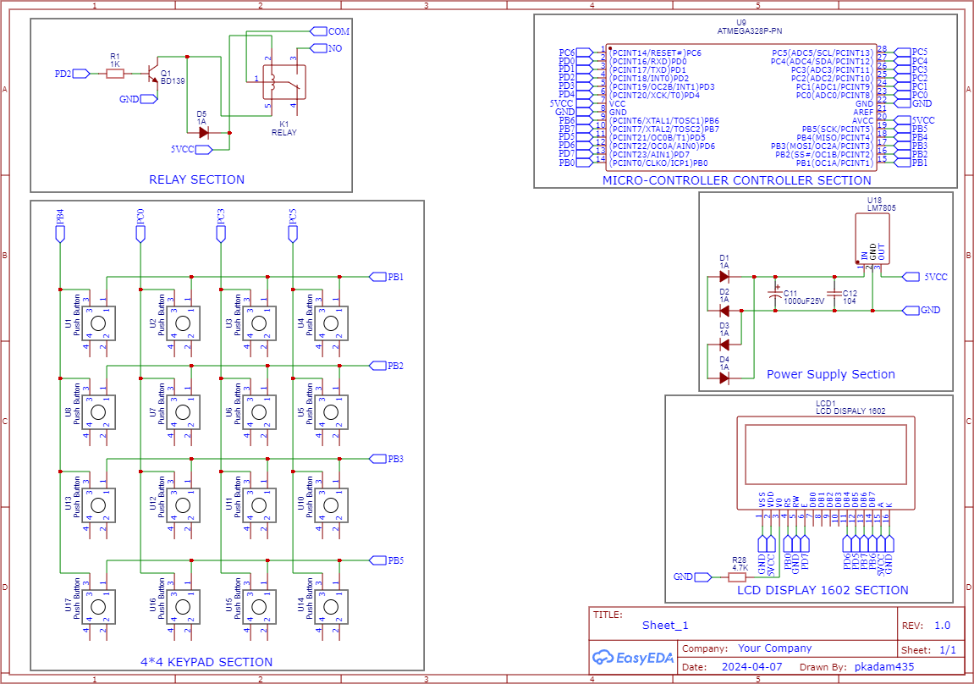

# Fig: Password Base Circuit Breaker

# WORKING

A **password-based circuit breaker** is an electronic device that uses a password authentication system to control the activation or deactivation of an electrical circuit. It is commonly used for security, safety, and controlled access to electrical systems. Here’s a breakdown of its working:

**Components**

1. **Microcontroller (e.g., Arduino, PIC, or AVR)**: Processes the input password and controls the circuit breaker.
2. **Keypad (4x4 or 3x4)**: Used to input the password.
3. **Display (LCD/OLED)**: Shows messages like "Enter Password" or "Access Granted."
4. **Relay Module**: Acts as the switch to control the electrical circuit.
5. **Circuit Breaker**: Disconnects or connects the electrical load.
6. **Power Supply**: Supplies power to the system.
7. **Buzzer or LED**: Provides feedback for incorrect password attempts or confirmation signals.

**Working Principle**

#### Initialization:

* + The system initializes the microcontroller, display, and other peripherals.
  + A predefined password is stored in the microcontroller's memory.

#### Password Input:

* + The user inputs the password through the keypad.
  + The microcontroller reads the input characters one by one.

#### Password Verification:

* + The entered password is compared with the stored password.
  + If the password matches, the microcontroller triggers the relay to close the circuit (activating the breaker).
  + If the password is incorrect, an alert is triggered (buzzer sound, blinking LED, or "Access Denied" message).

#### Circuit Control:

* + **Correct Password**: The relay energizes, completing the circuit and supplying power to the load.
  + **Incorrect Password**: The relay remains de-energized, keeping the circuit open.

#### Lockout or Retry Mechanism:

* + Some systems may have a limit on the number of incorrect attempts. After exceeding this limit, the system locks for a specified period or triggers an alarm.

1. **Reset or Change Password** (Optional):
   * The system can include a feature to reset or change the password using an administrator password or a hardware reset button.

# APPLICATION

A **password-based circuit breaker** has versatile applications across industries, homes, and educational settings. Here are some of its common and practical uses:

1. **Industrial Applications**
   * **Controlled Access to Machines**:
     + Prevents unauthorized personnel from operating heavy machinery or sensitive equipment.
   * **Safety Mechanism**:
     + Ensures that only authorized users can activate power to hazardous circuits.
   * **Energy Management**:
     + Provides controlled access to high-power systems, minimizing accidental or unauthorized energy usage.
2. **Home Automation**
   * **Smart Home Security**:
     + Restricts access to high-power devices like air conditioners, geysers, or electric ovens.
   * **Child Safety**:
     + Prevents children from turning on electrical appliances accidentally.
   * **Customized Appliance Access**:
     + Allows personalized access for different household members.
3. **Educational Projects**
   * **Demonstration of Security Systems**:
     + Illustrates the integration of electronics, programming, and electrical safety in a single project.
   * **Practical Learning**:
     + A great way for students to understand microcontroller-based authentication systems.
4. **Commercial Applications**
   * **Retail or Office Equipment Control**:
     + Limits access to electrical equipment in offices, stores, or commercial buildings.
   * **ATM Power Control**:
     + Protects sensitive devices like ATMs from unauthorized tampering.
5. **Public Facilities**
   * **Secure Charging Stations**:
     + Ensures only authorized individuals can access public charging systems.
   * **Community Power Systems**:
     + Prevents misuse of shared electrical systems in community or public spaces.
6. **Critical Systems Protection**
   * **Medical Equipment**:
     + Secures access to sensitive medical devices to prevent misuse or accidental operation.
   * **Research Labs**:
     + Ensures that only authorized personnel can operate specialized equipment.
7. **Emergency Scenarios**
   * **Power Isolation**:
     + Can act as a quick, password-protected power cut-off system during emergencies.
   * **Disaster Response**:
     + Ensures critical circuits are accessed only by trained professionals.

# ADVANTAGES

A **password-based circuit breaker** offers several advantages, particularly in applications requiring controlled access to electrical circuits and systems. Here are the key benefits:

### Advantages

#### Enhanced Security:

* + Prevents unauthorized access to the electrical system.
  + Only users with the correct password can operate the circuit breaker.

1. **Remote Access** (Optional with IoT Integration):
   * Can be paired with IoT devices or wireless modules for remote control and monitoring.
   * Provides flexibility in managing circuits from a distance.

#### Customizability:

* + Passwords can be easily changed as needed, adding another layer of security.
  + Advanced systems can include features like multi-factor authentication.

#### Safety:

* + Reduces the risk of accidents by ensuring only authorized personnel can operate the system.
  + Ideal for industrial and high-power applications where safety is critical.

#### User-Friendly:

* + Simple input mechanisms (keypads or touch screens) make operation intuitive.
  + Status messages (e.g., "Access Denied" or "Circuit ON") provide clear feedback.

#### Cost-Effective:

* + Provides a reliable security solution without the need for expensive mechanical locks or specialized keys.

#### Scalability:

* + Can be integrated into larger systems for multi-zone access control.
  + Supports hierarchical access (e.g., admin vs. user-level control).

1. **Data Logging** (Optional with Microcontroller Integration):
   * Can log usage data (e.g., who accessed the system and when) for auditing and troubleshooting.
   * Helps in tracking attempts and analyzing system usage patterns.

#### Low Maintenance:

* + Digital password systems require minimal maintenance compared to physical lock-and-key mechanisms.

#### Programmable Features:

* + Can incorporate additional features like:
    - Alarm activation after multiple incorrect attempts.
    - Automatic lockout periods to deter unauthorized access.

#### Versatile Applications:

* + Suitable for homes, offices, industrial environments, and educational projects.

#### Energy Efficiency:

* + Consumes minimal power when in standby mode, making it suitable for continuous operation.

# DISADVANTAGES

While a **password-based circuit breaker** has several advantages like enhanced security and controlled access, it also has some disadvantages. Here’s a list of the potential drawbacks:

### Dependency on Electronics

* + **Failure Risk**: The system relies on electronic components like microcontrollers, which may fail due to power surges, faults, or environmental conditions.
  + **Maintenance**: Requires regular maintenance to ensure the keypad, microcontroller, and display work properly.

### Password-Related Issues

* + **Forgotten Password**: Users may forget the password, leading to delays or requiring a reset mechanism.
  + **Hacking Risk**: If the password system is not secure, it may be vulnerable to unauthorized access through brute force or other hacking methods.
  + **Limited Input Attempts**: Without proper design, repeated incorrect inputs could lock the system unnecessarily.

### Power Dependency

* + **Electricity Requirement**: The system needs a continuous power supply to function. A power failure can render the circuit breaker inoperable unless a backup system is available.
  + **Battery Backup Issues**: If the system has a battery backup, maintenance of the battery adds complexity.

### Complexity Compared to Manual Systems

* + **Higher Cost**: Electronic systems are more expensive to build and implement compared to traditional manual circuit breakers.
  + **Installation Challenges**: Requires skilled labor for installation and programming.

### Environmental Sensitivity

* + **Temperature and Humidity**: Extreme conditions may affect the electronic components, causing malfunction.
  + **Dust and Debris**: In industrial environments, dust or debris could interfere with the keypad or display.

### Response Time

* + **Lag in Operation**: Processing the password and actuating the circuit breaker may take a few seconds, which could be critical in some emergency situations.

### Limited Scalability

* + **Single Point of Control**: If multiple users need access, the system may require a more complex password-sharing or multi-user management mechanism, which increases complexity.

### Hardware Limitations

* + **Keypad Durability**: Continuous use of the keypad may lead to wear and tear, requiring replacement.
  + **Relay Wear**: Repeated switching can wear out the relay over time.

### User Dependency

* + **Human Error**: Users may accidentally enter incorrect passwords, leading to lockouts or system alerts.
  + **Learning Curve**: Some users may find it difficult to adapt to electronic control systems

# CONCLUSION

The password-based circuit breaker is an effective solution for ensuring controlled access and enhanced safety in electrical systems. It integrates a secure authentication mechanism with the functionality of a circuit breaker, making it a versatile device for various applications.

### Key Takeaways:

#### Enhanced Security:

* + Prevents unauthorized access to electrical circuits by requiring a password for operation.

#### User-Friendly:

* + Easy to operate with a simple interface like a keypad and display.

#### Safety:

* + Protects sensitive equipment and systems by allowing only authorized personnel to access the circuit.

#### Versatility:

* + Can be implemented in industrial, commercial, and residential settings.

#### Scalability:

* + The system can be enhanced with additional features like remote control, multiple user access, or biometric authentication.

By combining electronics and security measures, this system demonstrates how technology can improve traditional circuit control mechanisms. It is also an excellent project for understanding microcontroller programming, relay operations, and embedded systems.