FUTURE TRENDS IN SWITCHGEAR TECHNOLOGY IOT BASED

Mr. Jaybhaye Sumit R ¹, Mr. Borse Roshan R ², Miss. Ghusale Mrunal D ³,

Mr. Deshmukh Omraj D ⁴, Miss.Khokale Kirti S ⁵
^{1,}Lecturer, Department of Electrical Engineering, Santosh N Darade Polytechnic, Yeola,Maharastra, India.
^{2,3,4,5} Students, Department of Electrical Engineering, Santosh N Darade Polytechnic, Yeola,Maharastra, India.

ABSTRACT
Switchgear technology is providing insuring the safe and efficient distribution of electrical energy making advancement in this filed essential for this filed essential for the reliability of power system.
The future trend in switchgear technology is drive by the repaid evolution of energy of need
Digitalized. Distribution efforts and integration of renewable energy sours
Key development includes the adoption of eco-friendly insulation and switchgear that reduces greenhouse gas emissions.
A significant shift from trading sulfur hexafluoride (sf6) based system
Additionally the rise of digital switchgear equipment with smart sensor and lot capabilities enable real time monitoring. Predictive maintenance. And enhanced faulty determine. Significance improving operation efficiency and safety keep pace with global energy efficiency trends and, in particular, emission reduction targets in the maritime sector, both onshore and maritime power distribution systems need to be adapted to the relevant new technologies and concepts. As an important link in the distribution chain, medium voltage switchgear (MV) is expected to be stable and reliable while operating as efficiently as possible. Failures of MV equipment, while rare because the equipment must be safe to handle and use, have far-reaching consequences. The consequences of such failures, whether to the shore or marine power system, present risks to the entire power plant, so an accurate assessment of equipment condition is required to identify potential failures early. The solution is an emerging concept of digital switchgear, where the implementation of sensor technology and communication protocols enables effective condition monitoring, and the creation of a database that, when combined with machine learning algorithms, enables predictive maintenance and/or fault detection. This paper presents, step by step, the previous challenges, the current research (divided into predictive maintenance, condition monitoring, and fault detection categories),

Keywords: Switchgear, electrical energy, power system. Renewable energy sours.

INTRODUCTION
Sustainability and circulate economy considered are shaping the manufacturing and end of life management of switchgear. Economy that use of recycle material and design that simplify dissemination and recycling. As industry move towards more stringent environment process and encaging the energy efficiency of their carbon footprint of productivity process and enchasing the energy efficiency of their product
According to the reports of the International Energy Agency (IEA), despite the destabilization of global energy consumption due to the pandemic, electricity demand will reach pre-pandemic levels in 2022, and continue to increase [1]. Analogous to the increase in demand on land, the demand for electricity on board ships will also increase, due to the ongoing electrification of ships and a growing number of electricity-based technologies [2,3,4], the implementation of which contributes to the International Maritime Organization’s (IMO) goal of reducing greenhouse gas emissions by 2050 [5] while increasing energy efficiency.
Consequently, the increasing demand requires improvements in two areas: power generation and power distribution. It should be noted that, due to functional similarities, the advances in land-based distribution systems can also be considered as improvements in shipboard distribution systems, focusing on increasing efficiency and reliability, as it is an independent, closed system that can be considered as an islanded micro grid at sea [6]. The inefficiency of the power distribution system, if not at an appropriate level, can outweigh the efficiency of the power generation system, which is why it is important to link the improvements in both areas. Switchgear, as an essential component of the distribution system, is used to control, protect, and isolate power systems, as well as disconnect equipment for repair, maintenance, and testing purposes. Considering the role of switchgear and the usually high current flow loads to which the equipment is subjected, especially in medium voltage networks, maintenance strategies are required, the optimization of which would be of great benefit for real-time condition monitoring and diagnosis [7]. The procedures now mostly rely on predefined maintenance intervals and observing the thermal effects by means of manual IR temperature measurements. With this in mind, several studies and experiments have been conducted to leverage the recent beneficial results of deep learning based methods and Internet-of-Things (IoT) to create solutions for efficient power distribution monitoring. In [8], deep learning was used to diagnose power quality disturbances in electric power systems to reduce existing delayed actions based on mathematical calculations. The implementation resulted in over 99% accuracy using simulated data. Another study, [9], proposed a high-throughput, low-latency deep-learning-based approach in an edge device to detect high-impedance faults on overhead power lines in real time. The approach was validated under laboratory conditions and showed reduced detection latency and high detection accuracy of 96.67%. Additionally, in [10], an intelligent device was presented for monitoring polluted high voltage insulators in overhead transmission lines to prevent power outages before they occurred.

LITERATURE REVIEW

The longest standing method for the development of switchgear was based on optimizing the physical and electrical properties of the components that make up the current path. Some examples of previous and still ongoing optimization efforts of the bus bar configuration are achieved either by geometric distribution to reduce losses [18], reduction of electrodynamics forces in case of faults [19], and analysis of various other factors that contribute to increased energy efficiency, reduction of dimensions, weight reduction, etc. The measurement equipment was limited to conventional instrument transformers (IT) and “hardwires” transmission of measurement data to analog panel meters and protection relay circuits. Considering the disadvantages of these devices, such as high losses, large weight, lower accuracy, and various hazards resulting from their operating principles [20], the equipment had to be revised and updated or replaced by more effective solutions. The progress in this field, with respect to MV switchgear, is mainly due to the development of microcontroller-based protection relays, i.e., intelligent electronic devices.

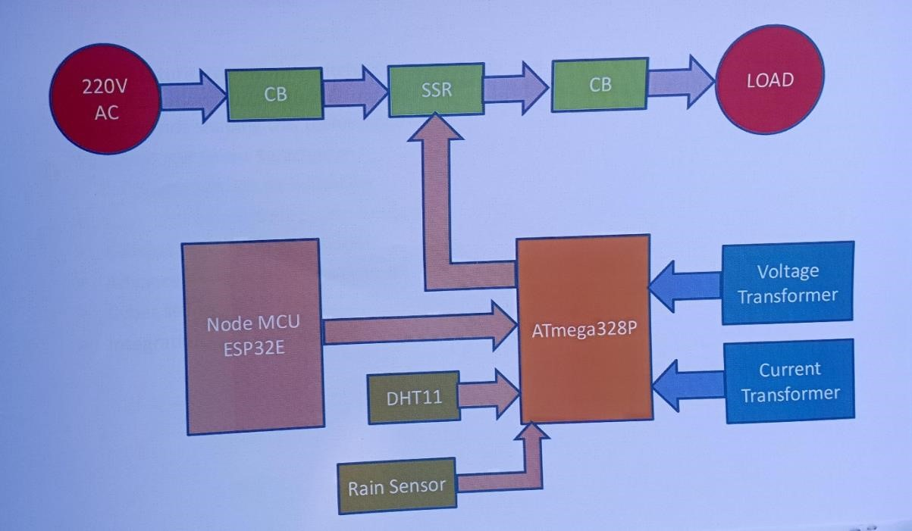
BLOCK DIAGRAM

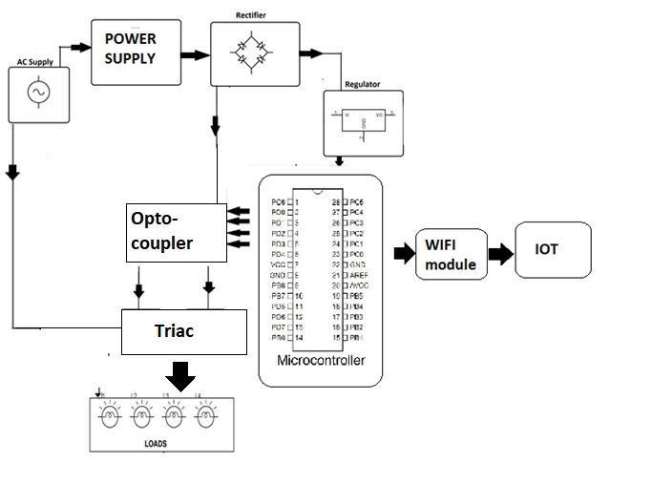
CKT DIGRAM

WORKING
Switchgear is one of the most important components in an electrical system. It includes all the devices that ensure power system protection and regulate power supply. Switchgear reenergizes equipment and clears faults in the system, thereby ensuring reliable power supply.
The switchgear industry in India mainly covers low voltage (LV) switchgear (with a rating below 1 kV) products. With huge emphasis on electrification, the medium voltage (MV) switchgear (with ratings between 1 kV and 33 kV) market is expanding at a rapid pace. The demand for high voltage (HV) and ultra HV (UHV) switchgear is also picking up on the back of investments being undertaken by the government for the development of HV and UHV transmission infrastructure. In addition, with the continuously increasing renewable energy capacity, switchgear has become pivotal in ensuring that networks operate in a synchronous manner with minimum faults. Further, modern business requirements call for upgraded switchgear that can ensure safety, reliable power supply and continued business operations. The switchgear industry has witnessed technological advancements across all voltage levels. Industry players are constantly trying to develop different kinds of switchgear that is more compact, reliable and environment friendly, and require minimum installation and commissioning time. Power Line takes a look at the key switchgear technologies.

ADVANTAGES

Automated system can isolate faults quickly without human intervention.

Better monitoring helps optimize energy usages

Development of eco- friendly switchgear that uses sustainable insulation and avoids greenhouse gases like SF6.

Use of alternatives like vacuum and dry air reduces carbon footprint.

Modular components make it easier to upgrade or expand systems.

HVDC is more efficient for long distances compared to AC.

APPLICATION
The digital applications used in the “smart grids” n intertwined term used to describe the digital distribution network, i.e. all distribution components including the switchgear,
Highlight and divide the research conducted in the field of digital applications in condition monitoring and predictive maintenance in distribution networks and its included subcomponents.

FUTURE SCOPE

Future trends in switchgear technology are driven by advancements in digitalization, smart grids, and sustainability. Here are key future trends and potential scopes in the field.

Digitalization and smart monitoring.

Eco-friendly and sustainable solutions

Compact and modular designs

Integration with renewable energy sources

Advanced safety features

Cyber security and connectivity

AI and Machine Learning

CONCLUSIONS
This paper describes and analyzes the path of switchgear digitization, divided into past challenges and their solutions, past and current research on their applications, and further divided into condition monitoring, fault detection, and predictive maintenance. The use of machine/deep learning in predictive maintenance is highly appreciated as it enables effective prediction of potential faults by removing the major obstacle of reliance on manual labor for data analysis. The conclusions from this work can be summarized as follows.
Since the framework for conducting experimental studies varies, there is an obvious need to “standardize” the procedures, which are also categorized by the type of data used (temperature, partial discharge, voltage/current, etc.).
“Standardization” would lead to a universal framework for data collection (creation of a freely accessible database) that could be used to accurately compare the developed algorithms, and adequately monitor improvements in the application of machine/deep learning algorithms in prediction maintenance.
The developed dataset could also be used in digital twin simulations of both shore and marine power grids to increase the overall model accuracy, as real data would be implemented, and as the complex dynamics of switchgear are mostly ignored today. Overall, digital twin models offer great optimization opportunities, especially in the maritime domain, which are in line with IMO’s future goals.
The development of digital switchgear will lead to an effective predictive maintenance plan that will be continuously optimized with the growing measurement database and machine/deep learning analysis. Repair procedures are optimized, as the source of PD is automatically located, reducing labor and replacement costs. In summary, digital switchgear provides a safer and more cost-effective distribution system compared to its “analog” counterparts. Safety and reliability are enhanced by the active monitoring of equipment to predict failures, and there is a reduction in manpower requirements for data interpretation and equipment monitoring/repair procedures.
As mentioned, the biggest barriers to machine/deep learning adaptation are unbalanced, inconsistent, and limited data sets. The significant lack of data directs research toward generating data that mimics real-world data, but the methods are also inconsistent. Therefore, future work should address the development of a universal dataset, as all studies consequently lack the important step of validation through direct comparison of the proposed methods, which prevents tracking progress and consequently slows it down. The author’s future work will include a further investigation of feasible file systems with the aim of solving this.
REFERENCES
- 62.Li L., Tang J., Liu Y. Partial Discharge Recognition in Gas Insulated Switchgear Based on Multi-Information Fusion. IEEE Trans. Dielect. Electr.
- Insul. 2015;22:1080–1087. doi: 10.1109/TDEI.2015.7076809. [DOI] [Google Scholar]
- 63.Si W., Li J., Li D., Yang J., Li Y. Investigation of a Comprehensive Identification Method Used in Acoustic Detection System for GIS. IEEE Trans. Dielect. Electr. Insul. 2010;17:721–732. doi:
- 10.1109/TDEI.2010.5492244. [DOI] [Google Scholar]
- 64.Chang C.S., Jin J., Chang C., Hoshino T., Hanai M., Kobayashi N. Separation of Corona Using Wavelet Packet Transform and Neural Network for Detection of Partial Discharge in Gas-Insulated Substations. IEEE Trans.
- Power Deliv. 2005;20:1363–1369. doi: 10.1109/TPWRD.2004.839187. [DOI] [Google Scholar]
- 65.Nguyen M.-T., Nguyen V.-H., Yun S.-J., Kim Y.-H. Recurrent Neural Network for Partial Discharge Diagnosis in Gas-Insulated Switchgear.
- Energies. 2018;11:1202. doi: 10.3390/en11051202. [DOI] [Google Scholar]
- 66.Song H., Dai J., Sheng G., Jiang X. GIS Partial Discharge Pattern
- Recognition via Deep Convolutional Neural Network under Complex Data Source. IEEE Trans. Dielect. Electr. Insul. 2018;25:678–685. doi:
- 10.1109/TDEI.2018.006930. [DOI] [Google Scholar]
- 67.Goodfellow I., Bengio Y., Courville A. Deep Learning. MIT Press; Cambridge, MA, USA: 2016. [Google Scholar]
- 68.Mantach S., Lutfi A., Moradi Tavasani H., Ashraf A., El-Hag A., Kordi B.
- Deep Learning in High Voltage Engineering: A Literature Review. Energies. 2022;15:5005. doi: 10.3390/en15145005. [DOI] [Google Scholar]
- 69.Ardila-Rey J.A., Ortiz J.E., Creixell W., Muhammad-Sukki F., Bani N.A.
- Artificial Generation of Partial Discharge Sources Through an Algorithm
- Based on Deep Convolutional Generative Adversarial Networks. IEEE
- Access. 2020;8:24561–24575. doi: 10.1109/ACCESS.2020.2971319. [DOI] [Google Scholar]
- 70.Hoffmann M.W., Wildermuth S., Gitzel R., Boyaci A., Gebhardt J., Kaul H., Amihai I., Forg B., Suriyah M., Leibfried T., et al. Integration of Novel
- Sensors and Machine Learning for Predictive Maintenance in Medium Voltage Switchgear to Enable the Energy and Mobility Revolutions. Sensors.
- 2020;20:2099. doi: 10.3390/s20072099. [DOI] [PMC free article] [PubMed] [Google Scholar]
- 71.Gitzel R., Amihai I., Garcia Perez M.S. Towards Robust ML-Algorithms for the Condition Monitoring of Switchgear; Proceedings of the 2019 First International Conference on Societal Automation (SA); Krakow, Poland. 4–6
- September 2019; Piscataway, NJ, USA: Institute of Electrical and
- Electronics Engineers (IEEE); 2019. pp. 1–4. [Google Scholar]
- 72.IEEE SA—IEEE C37.111-1991. [(accessed on 5 October 2022)]. Available online: https://standards.ieee.org/ieee/C37.111/2644/
- 73.Hong J., Kim Y.-H., Nhung-Nguyen H., Kwon J., Lee H. Deep-Learning Based Fault Events Analysis in Power Systems. Energies. 2022;15:5539. doi: 10.3390/en15155539. [DOI] [Google Scholar]
- 74.Bhatt A., Karthikeyan V. Digital Twin Framework and Its Application for
- Protection Functions Testing of Relays; Proceedings of the 2022 3rd
- International Conference on Electronics and Sustainable Communication
- Systems (ICESC); Coimbatore, India. 17–19 August 2022; Piscataway, NJ,
- USA: Institute of Electrical and Electronics Engineers (IEEE); 2022. pp. 682– 687. [Google Scholar]

