**Securing the Digital World: Cyber Threats and Solutions**

Garima Maurya*1, Maitri*2 , Mr. Mahesh Kumar Tiwari*3

*1 Scholar, Computer Science, National P.G. College, Lucknow, Uttar Pradesh, India

*2Scholar, Computer Science, National P.G. College, Lucknow, Uttar Pradesh, India

*3Assistant Professor, Computer Science, National P.G. College, Lucknow, Uttar Pradesh, India

**Abstract**

In a world increasingly shaped by digital interactions, this research examines the interconnected issues of cyber security, cybercrime, and the critical role of social media, while emphasizing the importance of ethical considerations. As cyber threats grow more sophisticated, understanding the complexities of cyber security becomes essential. The study focuses on the rise of cybercrime, particularly on social media platforms, which have become hotspots for a wide range of online threats. It also delves into the ethical challenges surrounding cybersecurity, stressing the need for responsible digital behavior and the adherence to ethical guidelines. Through an interdisciplinary lens, this research aims to clarify the complexities of protecting digital spaces, advocating for a balance between technological defenses and ethical standards. The study underscores the importance of integrating cyber security, cyber ethics, and social media resilience to foster a secure and trustworthy online environment.

**Keywords**

Cyber Security, Cyber Crime, Social Media ,Cyber ethics, Digital Threat

**Introduction**

As the digital world expands, so too does the complexity and scale of cyber threats. From data breaches to cybercrimes on social media platforms, safeguarding cyberspace has become an urgent priority for individuals, organizations, and governments alike. This research examines the evolving challenges of cybersecurity, focusing on the technological, legal, and ethical dimensions of protecting digital environments. It explores the need for advanced security measures while addressing the ethical responsibilities tied to privacy, online behavior, and user rights. By integrating technological solutions with ethical principles, this study aims to offer a comprehensive approach to securing the cyber frontier in a rapidly changing digital landscape.

**Cybersecurity**

Cybersecurity involves protecting digital systems, networks, and data from cyber threats such as hacking, malware, and data breaches. It includes technologies like firewalls, encryption, and antivirus software, as well as practices for secure access and risk management. With the growing sophistication of cyberattacks, cybersecurity has become essential for safeguarding personal, corporate, and government data. Beyond technical measures, it also addresses ethical and legal issues, aiming to balance security, privacy, and user rights in an increasingly connected world.

**Cyber crime**

Cybercrime refers to illegal activities conducted via the internet or digital technologies, targeting individuals, organizations, or governments. It includes crimes like hacking, identity theft, online fraud, phishing, and the distribution of malware or ransomware. As technology advances, cybercriminals are using increasingly sophisticated methods to exploit vulnerabilities in digital systems, leading to significant financial, reputational, and security risks. Cybercrime poses a growing challenge to law enforcement, requiring international cooperation and specialized expertise to combat effectively.

**Types of cyber crimes**

**Hacking** is the act of intentionally bypassing or circumventing security controls of digital systems to gain unauthorized access, manipulate data, or disrupt services. It is a broad term that encompasses various techniques used to exploit vulnerabilities in software, hardware, or network configurations. While it can be performed for malicious reasons like cybercrime, hacking can also be used for ethical purposes (e.g., penetration testing or security research).

* Threat: Hacking compromises system security, exposing data to theft, manipulation, or destruction.
* Impact: It can result in financial loss, reputational damage, legal consequences, and disruption of critical services

**Phishing** is a cyberattack where attackers impersonate trusted organizations or individuals to deceive victims into sharing sensitive information, such as passwords, credit card details, or personal data. This is often executed via fraudulent emails, text messages, or websites designed to appear legitimate. The primary aim of phishing is to manipulate users into revealing confidential information, which can then be exploited for malicious purposes, including identity theft, financial fraud, or unauthorized access to systems.

* Threat: Deceptive tactics to lure individuals into disclosing sensitive information.
* Impact: Identity theft, financial fraud, and unauthorized access to accounts or systems.

**Ransomware** is a type of malicious software that encrypts a victim's files or locks their system, demanding a ransom (often in cryptocurrency) for the decryption key or to restore access. It spreads through malicious emails, compromised websites, or software vulnerabilities, causing data loss, financial harm, and operational disruptions.

* **Threat**: Ransomware locks or encrypts critical data, holding it hostage until a ransom is paid.
* **Impact**: It can lead to data loss, financial costs from ransom payments, operational disruptions, and long-term reputational damage.

**Malware** refers to any software intentionally created to damage, disrupt, or gain unauthorized access to computer systems, networks, or devices. It encompasses a range of harmful programs, including viruses, worms, Trojans, spyware, adware, and ransomware. Malware typically infiltrates systems through email attachments, malicious links, compromised websites, or by exploiting software vulnerabilities. The consequences of malware infections can include data theft, financial losses, system damage, and operational disruptions. Effective protection against malware involves using antivirus and anti-malware tools, keeping software up to date, following safe browsing practices, and regularly backing up important data.

* **Threat**: Software designed to harm, exploit, or disrupt systems.
* **Impact**: Data theft, system damage, and unauthorized access to sensitive information.

**Identity Theft** occurs when an individual’s personal information is stolen and used for fraudulent purposes, often for financial gain. The stolen data can be used to open new accounts, make unauthorized purchases, or commit other illegal activities. To prevent identity theft, individuals should protect their personal information, monitor financial accounts regularly, and adopt strong security measures, such as two-factor authentication and password managers.

* **Threat**: Stealing personal data to impersonate someone for fraudulent activities.
* **Impact**: Financial loss, damage to reputation, and potential legal consequences.

**Cyberbullying** involves the use of digital platforms to harass, intimidate, or embarrass individuals, often through repeated attacks meant to cause emotional harm. It can manifest in various ways, such as sending harmful messages, spreading false rumors, sharing embarrassing content, or impersonating someone online. Cyberbullying can occur on social media, messaging apps, gaming platforms, or online forums, and it can have serious emotional and psychological effects on victims, including anxiety, depression, and in extreme cases, suicidal thoughts. Preventative measures include promoting awareness of responsible online behavior, fostering empathy and respect in digital spaces, encouraging victims to seek help, and implementing effective policies and tools to handle cyberbullying incidents.

* **Threat**: Digital harassment or intimidation aimed at causing harm.
* **Impact**: Emotional distress, reputational damage, and potential legal ramifications.

**Rising Trends of Cybercrime on Social Media**

The rise of cybercrime on social media is marked by two key trends. First, phishing and fraud have become prevalent, as cybercriminals use fake profiles and deceptive messages to steal personal information or trick users into participating in scams. Second, social engineering tactics are being increasingly employed, where attackers exploit users' trust to gather sensitive data by posing as trusted individuals or organizations. These growing threats underscore the significant risks associated with social media, including privacy violations, identity theft, and financial losses.

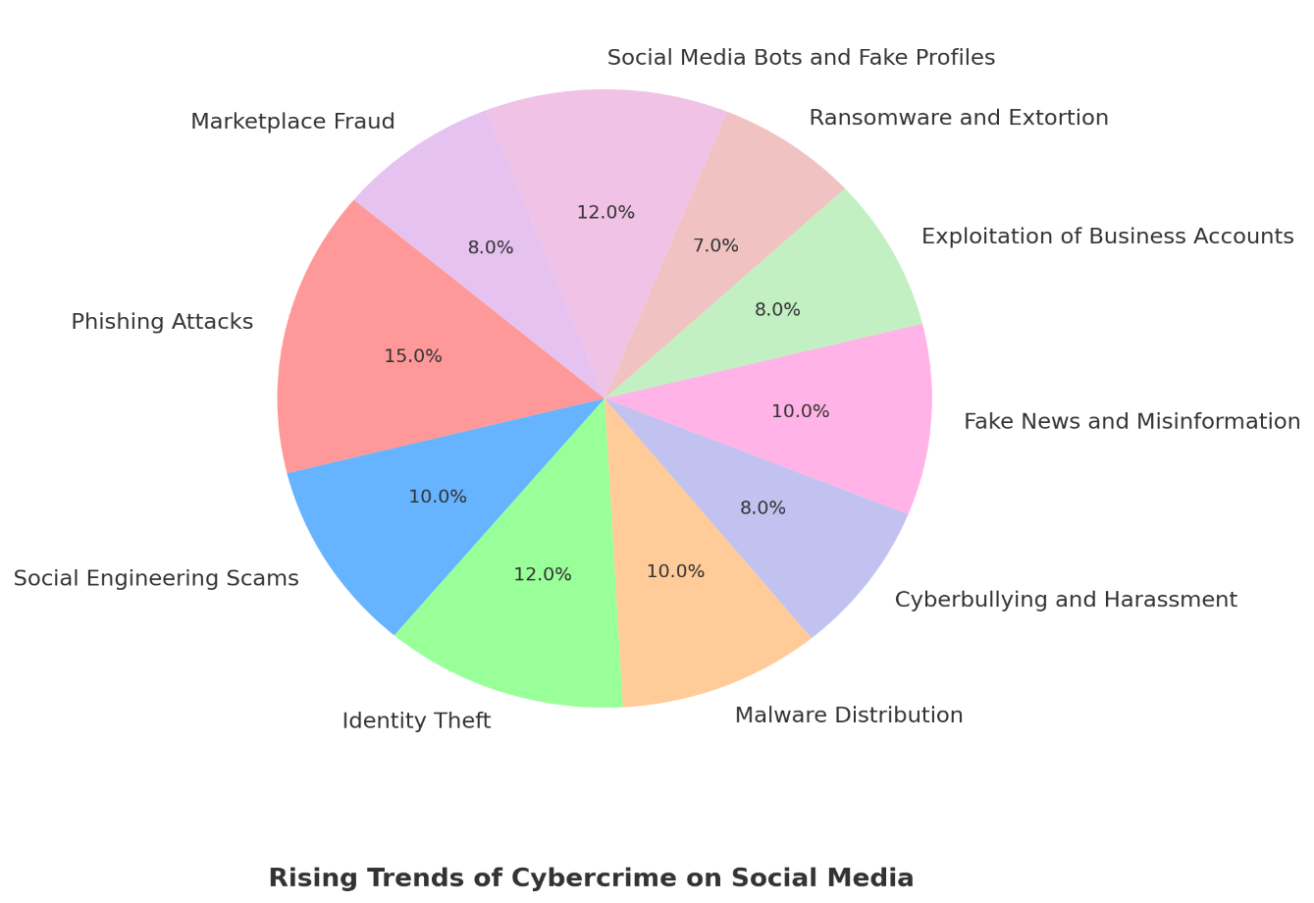

**How Is Cybercrime Evolving in the Internet of Things (IoT)?**

The latest trends in cybercrime targeting the Internet of Things (IoT) highlight several emerging threats. One major concern is the rise of ransomware attacks on IoT devices, where cybercriminals lock users out of systems like smart homes, medical devices, or industrial equipment and demand a ransom for access.

Another growing issue is the use of IoT-powered botnets to launch large-scale Distributed Denial-of-Service (DDoS) attacks, causing service disruptions by overwhelming networks. Additionally, the exploitation of weak security in many IoT devices remains a critical vulnerability, with attackers taking advantage of outdated software, weak passwords, and insufficient encryption to gain unauthorized access. Finally, the collection of sensitive personal data by IoT devices makes them prime targets for data privacy breaches, often resulting in identity theft and blackmail. These evolving threats underscore the urgent need for stronger security protocols and proactive measures to safeguard the increasingly connected IoT ecosystem.

**Cyber Threats Based on Age Groups: Risks for Adolescents and the Elderly**

Cyber threats vary significantly across different age groups, with distinct risks faced by adolescents and the elderly. The following categories highlight these differences:

**Adolescents:**

* **Cyberbullying**:  
  Adolescents are particularly vulnerable to online harassment and bullying, which can have severe emotional and psychological impacts, such as anxiety, depression, and low self-esteem.
* **Identity Theft**:  
  Young people, often active on social media, may unknowingly share too much personal information, making them targets for identity theft and fraud.
* **Exposure to Inappropriate Content**:  
  Adolescents may encounter explicit or harmful content online, which can affect their mental well-being and expose them to further online dangers, such as grooming or exploitation.
* **Online Predators**:  
  Adolescents, especially those using social media or gaming platforms, are at risk of being targeted by online predators who exploit their vulnerabilities.

**Elderly:**

* **Scams and Phishing**:  
  Older adults often lack familiarity with digital threats, making them prime targets for phishing emails, fake tech support calls, and other online scams that exploit their trust, leading to financial loss.
* **Online Fraud**:  
  The elderly are frequently targeted by fraudsters who exploit their lack of digital literacy, often resulting in unauthorized transactions, financial theft, or manipulation.
* **Digital Literacy Gaps**:  
  Due to limited experience with technology, older individuals may not recognize the warning signs of cyber threats, such as suspicious emails, fake websites, or insecure software, leaving them vulnerable to attacks.
* **Health-Related Exploitation**:  
  Older adults, especially those who rely on digital health services, may be at risk from cybercriminals who exploit sensitive health information or impersonate legitimate medical providers for fraud.

The cyber threats faced by adolescents and the elderly are distinct but equally dangerous. Adolescents are at risk of emotional and psychological harm from cyberbullying and exploitation, while the elderly are often targeted by financial scams and online fraud due to digital literacy gaps. Tailored cybersecurity education and awareness campaigns are essential to mitigate these risks and protect both age groups from the evolving landscape of cyber threats.[1]

**Types of Cybersecurity Measures**

Cybersecurity encompasses a wide range of protective technologies, practices, and strategies designed to defend digital systems, networks, and data from cyber threats. Below are the primary types of cybersecurity measures used to secure digital environments:

**1. Firewalls**

Firewalls act as a barrier between trusted internal networks and untrusted external networks (such as the internet). They monitor and control incoming and outgoing network traffic based on predefined security rules. Firewalls are essential for preventing unauthorized access and blocking malicious traffic before it reaches the internal network.

**2. Antivirus and Anti-malware Software**

Antivirus software detects and removes malicious programs, such as viruses, worms, Trojans, and ransomware. These tools regularly scan systems for known threats and offer real-time protection, ensuring that devices remain secure against known types of malware.

**3. Encryption**

Encryption is the process of converting sensitive data into an unreadable format to prevent unauthorized access. Only authorized users with the proper decryption key can access the original data. Encryption protects data at rest (e.g., stored on servers or databases) and in transit (e.g., transmitted over networks), ensuring confidentiality and integrity.

**4. Intrusion Detection and Prevention Systems (IDS/IPS)**

IDS and IPS systems monitor network traffic for signs of suspicious or malicious activity. An **Intrusion Detection System (IDS)** identifies potential threats or attacks, while an **Intrusion Prevention System (IPS)** actively blocks or mitigates attacks by taking corrective actions, such as isolating affected systems or blocking malicious traffic.

**5. Multi-factor Authentication (MFA)**

MFA is a security process that requires users to provide multiple forms of identification before gaining access to a system. Typically, this involves a combination of something the user knows (password), something the user has (a token or smartphone), and something the user is (biometric data, such as fingerprints or facial recognition). MFA greatly enhances account security by making it more difficult for attackers to gain unauthorized access.

**Cybersecurity in India: Addressing the Growing Cybercrime Crisis**

As of 2024, cybercrime in India continues to be a significant concern, with a marked increase in various cyber threats driven by the country's rapid digitalization and growing internet penetration. Key areas of concern include:

* **Phishing and Online Fraud**: Phishing attacks, especially targeting individuals and financial institutions, have surged. Fraudsters are increasingly using social engineering tactics to deceive victims and steal sensitive information, often leading to financial losses.
* **Ransomware Attacks**: Ransomware remains a prominent threat, with both individuals and organizations facing the risk of critical data being held hostage. High-profile cases have impacted businesses, government agencies, and healthcare sectors.
* **Identity Theft and Financial Fraud**: Financial crimes, including banking fraud and payment fraud, continue to rise. Cybercriminals exploit weak security practices and vulnerabilities in online payment systems to steal funds and personal information.
* **Data Breaches and Cyber Espionage**: Data breaches remain a serious threat, with attackers targeting personal data, government databases, and corporate information. The risk of cyber espionage also looms, particularly involving sensitive national and corporate data.

*Government and Legal Measures*:

The Indian government has been actively strengthening its cybersecurity framework. The **National Cyber Security Policy** (2020) and the **Personal Data Protection Bill** (still under review) aim to enhance security and data privacy. The government has also set up a **Cyber Crime Reporting Portal** to facilitate the reporting of cybercrimes.

**Key Statistics**:

* The **National Crime Records Bureau (NCRB)** reported a 5-10% increase in cybercrimes in recent years.
* In 2023, India saw over **50,000 cybercrime cases** reported under the **Information Technology Act** and other related laws.
* Financial frauds account for a significant proportion, with losses from online banking frauds alone estimated at **₹2,000 crore** annually.

**Cyber Laws in India: Key Updates (2024)**

* **Information Technology Act, 2000 (IT Act)**:
* **Cybercrimes** like hacking, data breaches, and identity theft are criminalized.
* **Section 66A** (offensive online communication) was struck down by the Supreme Court in 2015.
* **Section 43A** mandates penalties for failure to protect sensitive data.
* **Data Protection**:
* The **Personal Data Protection Bill (PDPB)** aims to regulate data privacy and security, including stricter penalties for breaches.
* New **cybersecurity and privacy rules** focus on data protection standards.
* **National Cyber Security Policy (2013)**:
* Aims to enhance national cybersecurity, with a focus on securing **Critical Information Infrastructure (CII)**.
* **CERT-In**:
* Plays a key role in responding to cybersecurity incidents and issuing **1,000+ advisories** annually on emerging threats.
* **Network and Information Security Directive (NISD)**:
* New directive under review to secure critical infrastructure like banking and telecommunications.
* **Emerging Threats**:
* Ransomware attacks increased by **40%** in 2023, with **₹4,000 crore** in estimated losses.
* **Cybercrime cases** have risen by **15%** in 2023.
* **Recent Legal Developments**:
* Ongoing review of **cybersecurity laws** to address AI-driven attacks and evolving digital threats.
* **Indian Cybercrime Coordination Centre (I4C)** processed **1,50,000** cybercrime complaints in 2023.

**Role of Cyber Ethics:**

Cyber ethics, also known as *internet ethics or digital ethics*, refers to the set of ethical principles that guide the actions of individuals and organizations in the digital realm. These principles include values and standards that promote responsible and ethical behavior in online interactions, cybersecurity practices, and the use of digital technologies

In an ever-changing digital landscape, cyber ethics offer a framework for addressing ethical challenges, encouraging responsible behaviour, and creating a secure online environment. By incorporating ethical considerations into digital activities, cyber ethics contribute to the creation of a trustworthy and sustainable digital society.

Cyber ethics are crucial in preventing cybercrimes and strengthening cybersecurity. By promoting responsible online conduct, respecting privacy, and maintaining integrity, cyber ethics help cultivate a culture of digital responsibility. They guide individuals and organizations in adopting secure practices, raising awareness about cyber threats, and reducing risks.

**Conclusion:**

In conclusion, the rapidly evolving landscape of cyber threats demands continuous vigilance and proactive strategies. This paper has explored the multifaceted challenges of cybercrime, the role of social media in amplifying risks, and the importance of ethical standards in cybersecurity. It also underscores the need for targeted approaches to protect vulnerable groups, such as adolescents and the elderly, who face distinct digital risks.

As technology continues to advance, the core principles of **confidentiality**, **integrity**, and **availability** must remain central to cybersecurity efforts. A holistic approach that integrates technological solutions with ethical considerations is essential for building robust defenses. Ultimately, a collaborative effort across governments, businesses, and individuals is crucial to creating a secure and resilient digital ecosystem.

To stay ahead of the ever-growing threat landscape, continuous education, adaptive policies, and international cooperation are necessary. By fostering a culture of responsibility, innovation, and awareness, we can ensure that the digital future remains safe, secure, and accessible to all. The journey toward comprehensive cybersecurity is ongoing, but through collective action and shared commitment, we can build a safer online world

**References**

1. **Bada, M, & Sasse , M. A:**"Cybersecurity Awareness Campaigns: The Challenges of Changing Human Behavior." *Journal of Cybersecurity*.

2. **Chawla, D., & Sharma, V:** *Cybersecurity and Data Protection: Laws and Policies in India*. Oxford University Press.

3. **Kaspersky. (2023).** Social Media and Cybercrime: A Growing Threat.

4. Roman, R., Zhou, J., & Lopez, J. (2013). "On the security and privacy of internet of things." *International Journal of Computer Science and Information Security*

5. **Wagner, M., & Maughan :** The Role of Social Media in Cybercrime: A Comprehensive Overview, *Cybersecurity Review*

6. **Sharma, S & Verma, R. (2021):** Cybercrime Trends in India: The Growing Threat of Social Media and Online Fraud , *Indian Journal of Cybersecurity*

7. **Reddy, N., & Bansal, S. (2022):** Legal Frameworks for Cybersecurity in India: An Overview of the IT Act and Data Protection Laws, *Indian Cyber Law Review*