**THE PHARMACOLOGICAL SIGNIFICANCE OF TRADITIONAL MEDICINAL PLANTS: A REVIEW**

Shivangi

Research Scholar

Department of Biotechnology

NIILM University, Kaithal (Haryana)

**Abstract**

Since the Vedic era, medicinal plants have been employed. For thousands of years, they have been employed to heal and prevent a variety of maladies, as well as epidemics. Certain medicinal plants are also employed as delectable condiments, to flavor, to pigment, and to preserve food. The plant's medicinal properties are present in nearly every part. Many varieties of secondary metabolites are present in medicinal plants, and they are used to manufacture remedies and play a significant role in the treatment of various diseases. A significant number of the plants are also reported to have a variety of other properties, such as anti-oxidant, anti-inflammatory, anti-insecticidal, anti-parasitic, antibiotic, and anti-hemolytic properties. These properties are also extensively used by tribal peoples worldwide. This review article details the traditional medicinal applications of 21 plant species from various families.

**Keywords-** Efficacy, Phytochemicals, Traditional Uses, Safety.

**Introduction**

There is evidence of the therapeutic potential of plant products being used in the treatment of maladies and for the revitalization of body systems in Indian, Egyptian, Chinese, Greek, and Roman civilizations dating back more than five thousand years. In India, plants with therapeutic potential are extensively utilized by all demographics, both as traditional remedies in various indigenous medical systems such as Siddha, Ayurveda, and Unani, and as refined products in the pharmaceutical industry. Phytochemical investigations for biological or pharmacological activity have been conducted on only 250,000-500,000 of the approximately 4.5 million plant species in India. The bioactive constituents or plant extracts may be employed to treat a variety of diseases, and they would serve as a new formulation for the discovery of novel drugs in the pharmaceutical industry. A person's vitality level is increased, nutrients are increased, body cells are restored, and immunity is enhanced by herbal medicines like Brahmi and Ashwagandha. In an environmentally sustainable manner, medicinal and aromatic plants can significantly contribute to the improvement of the subsistence livelihoods of rural individuals, particularly women, while preserving the biodiversity of these natural products. Currently, the World Health Organization (WHO) estimates that traditional medicine is the primary source of healthcare for up to 80% of the global population. The development of indigenous remedies and the utilization of medicinal plants for the treatment of a variety of diseases offer substantial economic advantages. As a result of the scarcity of modern health facilities, poverty, ignorance, and the limited availability of communication means, the majority of individuals, particularly those in rural areas, are still compelled to use traditional remedies for their everyday afflictions. The health of individuals and communities is significantly influenced by medicinal plants. Some chemical active substances in plants cause a defined physiological effect on the human body, which is the source of their medicinal value. Plants are regarded as a plethora of bioactive compounds and may serve as an alternative source of mosquito control agents. The pharmacological activities of secondary metabolites or phytochemicals from plants are noteworthy, including anti-oxidative, anti-allergic, antibiotic, hypoglycaemic, and anti-carcinogenic properties. These secondary metabolites safeguard the cells from the harm inflicted by unstable molecules known as free radicals. There is an increasing interest in the use of natural antimicrobial compounds, particularly those extracted from plants, to preserve food. It is therefore imperative to conduct a search for plants that possess medicinal properties.

Nevertheless, elder males and females aged 41-70 possess both knowledge and awareness regarding herbal remedies. Currently, the gradual extinction of medicinal plants may be a result of the decrease in their use by the younger generation.

**Medicinal values**

**Abrus precatorius Linn-** Abrus precatorius plants have developed under favorable conditions; however, their deep roots are exceedingly challenging to eradicate. Additionally, the plant's aggressive growth, hard-shelled seeds, and capacity to sucker render an infestation exceedingly challenging to eradicate and prevent re-infestation. Glyphosate and other herbicides are efficient; however, they necessitate precise application to prevent them from causing more damage than good.

**Aegle marmelos (Linn.) Correa-** The bael tree is a source of furocoumarins, such as xanthotoxol and the methyl ester of alloimperatorin, as well as flavonoids, rutin, and marmesin. It also contains a variety of essential oils and alkaloids, including á-fargarine (allocryptopine), O-isopentenylhalfordinol, and O-methylhafordinol. Bael fruit is a gift from the environment that provides humanity with significant medicinal benefits. For an extended period, all components of this tree, including the stem, bark, root, foliage, and fruit, have been utilized as medicinal substances. The Tree of the Bael is a blessed tree that possesses a variety of therapeutic properties. However, the practical applications of these properties are still being evaluated. In addition to the aforementioned activity, there are a few additional activities that are of significance. The leaves of Aegle marmelos are beneficial for the treatment of jaundice, leucorrhea, conjunctivitis, and defenses. Energy and nutrition are provided by fruits. It is employed as a carminative and astringent, as well as a viable treatment for serpent bites.

**Allium sativum Linn-** Alliin, ajoene, diallyl polysulfides, vinyldithiins, and S-allylcysteine are sulfur-containing chemicals that may be obtained from fresh or crushed garlic; other compounds that can be obtained include enzymes, saponins, flavonoids, and Maillard reaction products.

**Aloe barbadensis Mill-** Aloe vera is employed on facial tissues as a moisturizer and anti-irritant to alleviate irritation of the nostrils. Cosmetic companies frequently incorporate exudate or other derivatives from Aloe vera into a variety of products, including cosmetics, tissues, moisturizers, detergents, sunscreens, incense, grooming lotion, and conditioners.

**Butea monosperma Linn-** Timber, resin, forage, medicine, and pigment are all products of Butea monosperma. The wood, which is supple and dingy white, is durable under water and is employed for water scooping and well-curbs. Ghee is poured into the fire using spoons or ladles made of this tree in a variety of Hindu rituals. It is possible to obtain high-quality charcoal from it.

**Calotropis procera R. Br-** "Cardiac aglycones" are steroidal heart poisons that are present in the watery fluid. These chemicals are members of the same chemical family as those found in foxgloves (Digitalis purpurea). The steroidal component consists of a C/D-cis ring junction, a second hydroxyl group affixed to the C14 carbon, an α,β-unsaturated-γ-lactone in the C17 position, and a hydroxyl group in the C3β position.

**Carica papaya Linn-** Raw papaya fruit, devoid of seeds and epidermis, is frequently consumed. The immature green fruit can be consumed when prepared, typically in the form of stews, salads, and curries. Green papaya is employed in Southeast Asian cuisine in both fresh and prepared forms. The epidermis, interior, and seeds of papayas contain a variety of phytochemicals, such as carotenoids and polyphenols, as well as benzyl isothiocyanates and benzyl glucosinates. The levels of these compounds increase as the papaya ripens. The cyanogenic substance prunasin is also present in papaya seeds.

**Cuscuta reflexa Roxb-** Many alpha-glucosidase inhibitors are found in Cuscuta reflexa. A novel flavanone-reflexin, tetrahydrofuran derivatives, and coumarin were extracted from Cuscuta reflexa stems. Anti-steroidogenic and antimicrobial properties were found in stem methanol extracts. Cuscuta reflexa is used in Ayurvedic medicine for eye and heart disorders. Constipation, gas, liver problems, and bilious affection benefit from decoction stems.

**Hibiscus rosa-sinensis Linn -** An extract from Hibiscus rosa-sinensis flowers absorbs UV radiation and may be useful in cosmetic skin care.

**Mentha spicta Linn-** Spearmint oil comes from Mentha spicta. The primary ingredient in spearmint oil is R-(–)-carvone, which gives it its fragrance. Limonene, dihydrocarvone, and 1,8-cineol are abundant in spearmint oil. Spearmint oil has less menthol and menthone than peppermint oil. Sometimes used to shampoos and soaps, it flavors tooth paste and candy. Spearmint essential oil fumigant kills adult moths.

**Nerium oleander Linn-** Nerium oleander has been considered dangerous because several of its components may be hazardous, particularly to animals, in high concentrations. Ingesting cardiac glycosides like oleandrin and oleandrigenin may be harmful and have a restricted therapeutic index.

**Acacia mormelos Linn-** Lemons provide 64% of the Daily Value of vitamin C in 100 g. Insignificant amounts of other vital nutrients. Lemons contain polyphenols, terpenes, and tannins. Citric acid is high (47 g/l in juice) like other citrus fruits.

**Mimosa pudica Linn-** Mimosine, a poisonous alkaloid in Mimosa pudica, exhibits antiproliferative and apoptotic properties. D-glucuronic acid and D-xylose form Mimosa pudica seed mucilage.

**Syzygium cumini (Linn.) Skeels-** Chinese and Unani digestive medicine. Fruit vinegar and wine are made. Its vitamin A and C content is high.

**Evolvulus alsinoides Linn-** This plant is utilized in East Asian traditional medicine for its psychoactive and nootropic characteristics.[28] Claims are not medically confirmed. E. alsinoides produces scopoletin, umbelliferone, scopolin, and 2-methyl-1,2,3, 4-butanetetrol.

**Dalbergia sissoo Roxb. Ex. DC-** The freshwater snail Biomphalaria pfeifferi eggs were killed by Dalbergia sissoo fruit ethanol.

**Curcuma longa Linn-** Turmeric has been used in Ayurvedic and Siddha medicine to treat dyspepsia, throat infections, colds, and liver diseases, as well as wounds and skin sores.

**Tagetus erecta Linn-** When yellow maize is scarce, dried flower petals crushed to a powder are added to chicken feed to color egg yolks and broiler skin.

This is still used, but now as an extract, which may have cheaper transit and storage costs, higher stability, and better usage. It also improves crustacean coloration.

**Withania somnifera Linn. Dunal-** Traditional Indian medicine has employed the plant's long, brown, tuberous roots for millennia. Yemenis call it ubab and grind the dried leaves into a powder to make a treatment for burns and wounds. Withania somnifera leaves reduce edema and joint discomfort.

**Bacopa monnieri (**[**L.**](https://en.wikipedia.org/wiki/Carl_Linnaeus)**)-** Ayurvedic asthma and epilepsy treatments include bacopa. In Ayurveda, it treats ulcers, tumors, ascites, enlarged spleen, inflammations, leprosy, anemia, and gastroenteritis. Many health issues may be treated with the herb. The herb reduces stress, neutralizes allergies, treats indigestion, and improves memory.

**Ficus racemosa Wau. Cat-** Ayurvedic texts mention Ficus racemosa Linn. (FR) (Family Moraceae). F. racemosa fruits, bark, and root are used in traditional medicine to treat diabetes and other ailments. F. racemosa has anti-inflammatory, hepatoprotective, and hypoglycemic properties in experiments.

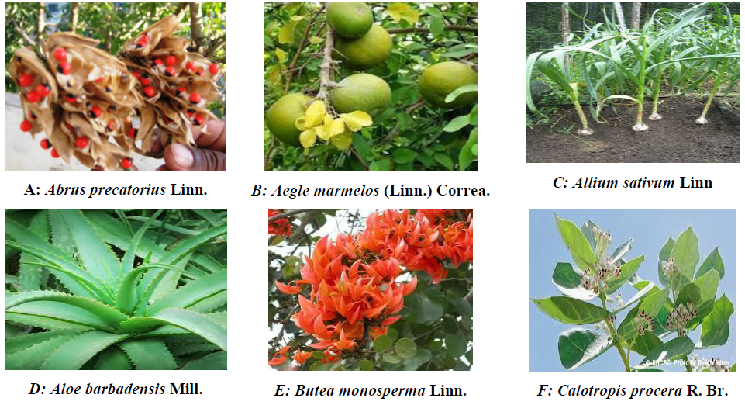

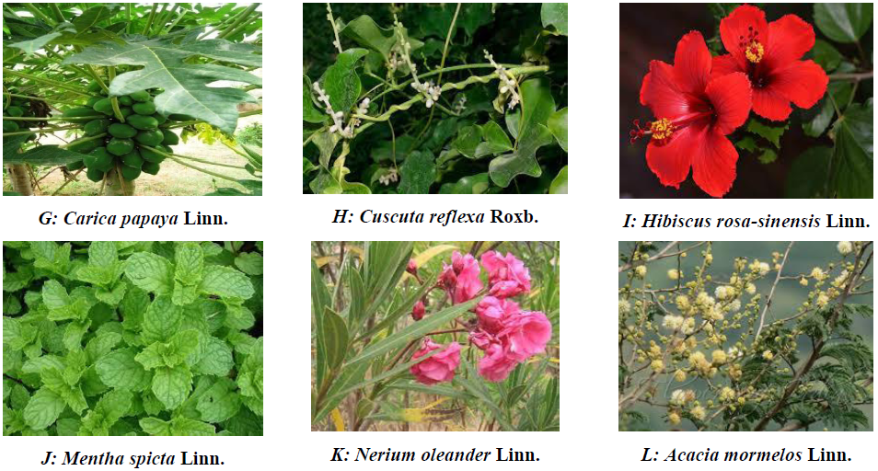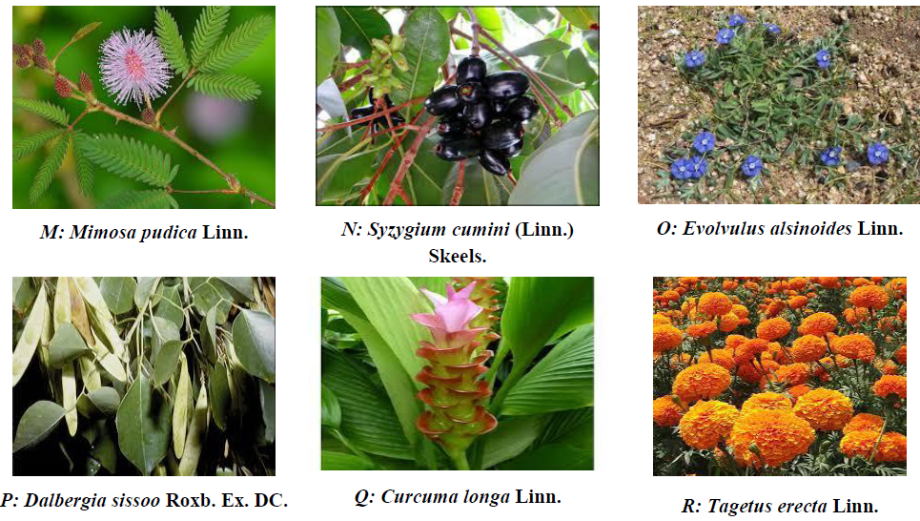 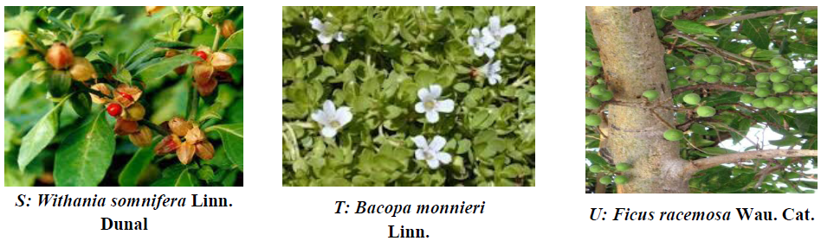

**Fig. 1: Photographs of the traditionally used some Medicinal plants**

**Table 1: Traditional medicinal plants used in the treatment of human and animals ailments**

|  |  |  |  |  |  |  |
| --- | --- | --- | --- | --- | --- | --- |
| **S.**  **No.** | **Botanical Name** | **Common Name** | **Family** | **Used Part** | **Habit** | **Plant Properties** |
| 1. | Abrus precatorius  Linn. | Ghunchu | Fabaceae | Leaves | Shrub | Leaf juice is mixed with coconut oil and applied over the painful swellings of the body |
| 2. | Aegle marmelos  (Linn.) Correa. | Bel | Rutaceae | Fruit | Tree | Half of a ripe fruit is eaten twice a day for 3-4 days to cure constipation |
| 3. | Allium sativum  Linn. | Lahshun | Amaryllidaceae | Bulb | Herb | 3-4 cloves are taken raw twice a day for a week to get relief from stomach pain and gastric |
| 4. | Aloe barbadensis  Mill. | Gwarpatha | Liliaceae | Leaf pulp | Herb | About 2 teaspoons of juice is taken thrice a day for 3-4 days to cure fever |
| 5. | Butea monosperma  Linn. | Palas | Fabaceae | Root | Tree | Root are used in tuberculosis |
| 6. | Calotropis procera  R. Br. | Madar | Asclepiadaceae | Latex of whole plant | Shrub | The latex is useful in the treatment of the ringworm and skin disease |
| 7. | Carica papaya  Linn. | Papita | Cariaceae | Latex of fruit | Tree | Latex fruit is used in ringworm and eczema |
| 8. | Cuscuta reflexa  Roxb. | Amarbel | Convolvulaceae | Whole plant | Parasitic Herb | Juice of the plant mixed with juice of Saccharum officinarum is given in doses of about 3-4 teaspoons twice a day is given for 10-12 days to treat jaundice |
| 9. | Hibiscus rosa- sinensis Linn. | Gudhal | Malvaceae | Root | Shrub | Juice of the root about 3 teaspoons is given 3 times a day for 3-4 days in case of cough and cold |
| 10. | Mentha spicta  Linn. | Pudina | Lamiaceae | Leaf | Herb | 2-3 teaspoons of leaf juice is given thrice a day for 3-4 days to treat bloody dysentery |
| 11. | Nerium oleander  Linn. | Kaner | Apocynaceae | Latex of plant | Tree | Latex applied on muscles pain of limbs |
| 12. | Acacia mormelos  Linn. | Babool | mimosaceae | Flower | Tree | Flower powder mixed with water is given orally to animal twice a day to cure jaundice |
| 13. | Mimosa pudica  Linn. | Lajwanti | Mimosaceae | Roots and leaves | Hurb | Roots and leaves are crushed and filtered; one teaspoon of filtrate is taken with water twice a day to cure loose motion |
| 14. | Syzygium cumini  (Linn.) Skeels. | Jamun | Myrtaceae | Bark | Tree | Crush its bark with the bark of bamura (Acacia catechu) in equal amount and filter it. Take 5 ml. of filtrate with 5 ml. water twice a day in gripping and indigestion |
| 15. | Evolvulus alsinoides Linn. | Shankhahuli | Convolvulaceae | Leaves | Herb | 20-25 leaves are crushed and mixed in 200 ml. whey and taken orally twice a day for 2 days in gripping |
| 16. | Dalbergia sissoo  Roxb. Ex. DC. | Shisham | Fabaceae | Leaves | Tree | Leaf paste mixed with water is given to animal twice a day to cure blisters and leg sore |
| 17. | Curcuma longa  Linn | Haldi | Zingiberaceae | Rhizome | Herb | Rhizome powder with rock salt and pure ghee is to cure the swelling of nipple for animals |
| 18. | Tagetus erecta  Linn. | Genda | Asteraceae | Flower | Herb | Powder mixed with water is given to animals to cure hydrophobia |
| 19. | Withania somnifera Linn.  Dunal | Ashwagandh a | Solanaceae | Root | Herb | Given to animals to cure retard placenta |
| 20. | Bacopa monnieri  Linn. | Brahmi | Plantaginaceae | Leaves | Herb | Boosting memory |
| 21. | Ficus racemosa  Wau. Cat. | Gular | Moraceae | Root | Tree | The sap of root is given in diabetes |

**Conclusions**

The aforementioned research shows that plants are incredibly adaptable. Every plant component benefits all life in the cosmos. These 21 medicinal plants were examined for treating human and animal problems such stomach ache, constipation, piles, dysentery, jaundice, diabetes, fever, asthma, menstruation disorders, snake bites, skin diseases, and more in this brief review effort. These plants are natural and cultivated. More herbs than shrubs, trees, or climbers were therapeutic. The medicinal parts of plants were leaves, roots, flowers, bark, fruits, rhizomes, etc.

**References**

1. Mahesh B and Satish S. Antimicrobial activity of some important medicinal plant against plant and human pathogens. WJAS, 2008; 4:839–843.
2. Srinivasan D, Nathan S, Suresh T. Antimicrobial of certain Indian medicinal plants used in folkloric medicine. Journal of Ethnopharmacolog, 2007; 74:217- 220.
3. Singh V, Kumar R. Study of Phytochemical Analysis and Antioxidant Activity of Allium sativum of Bundelkhand Region. Int. J. Life. Sci. Scienti. Res., 2017; 3(6): 1451-1458.
4. Singh P, Singh R, Sati N, Sati O P, Ahluwalia V. Phytochemical and Pharmacological Significance of Genus: Impatiens. Int. J. Life. Sci. Scienti. Res., 2017; 3(1):868-881.
5. P Nishant. Role of Medicinal Plants (Brahmi and Ashwagandha) in the Treatment of Alzheimer’s Disease Int. J. Life. Sci. Scienti. Res., 2016; 2(1):15-17.
6. Sharma A, Singh H, Kumar N. Studies on Traditional Knowledge of Medicinal Flora and its Contribution to Livelihood Enhancement in the Doon-Valley, Uttrakhand (India). Int. J. Life. Sci. Scienti. Res., 2017; 3(2):951-960.
7. Sarad S, Sharma A, Kumar N. Distribution, Diversity, Indigenous Use and its Utilization of the Ethno medicinal Flora of Rajouri District, J & K, India. Int. J. Life. Sci. Scienti. Res., 2017; 3(1):820-827.
8. Yadav R, Khare RK, Singhal A. Qualitative Phytochemical Screening of Some Selected Medicinal Plants of Shivpuri District (M.P.). Int. J. Life. Sci. Scienti. Res., 2017; 3(1): 844-847.
9. Narendiran S, Janani D, Keerthana M, Nivethitha KS, Nirmala Devi S, Padmavathy S, Supraja TS, Sayeedur Rahman H, Velvizhi R, Swathi N, Yasaswini KG. Comparative Studies on in-vitro Phytochemicals Analysis and Larvicidal Efficacy of Medicinal Plant Extracts against Culex quinquefasciatus. Int. J. Life. Sci. Scienti. Res., 2016; 2(6): 742-748.
10. Harini K, Nithyalakshmi V: Phytochemical Analysis and Antioxidant Potential of Cucumis Melo Seeds. Int. J. Life. Sci. Scienti. Res., 2017; 3(1): 863-867.
11. Chavan PA: Evaluation of Antimicrobial activity of Various Medicinal Plants Extracts of Latur Zone against Pathogens. Int. J. Life. Sci. Scienti. Res., 2016; 2(5): 612-618.
12. Sharma N. Ethno-medicinal Survey of Area under Aritar Gram Panchayat Unit, East Sikkim, India. Int. J. Life. Sci. Scienti. Res., 2017; 3(3): 1007-1015.
13. Langeland, K.A et al. Identification and Biology of Nonnative Plants in Florida's Natural Areas- Second Edition (PDF). University of Florida- IFAS Pub SP. Center for Aquatic and Invasive Plants, 2008; pp: 257.
14. Rasadah Mat Ali, Zainon Abu Samah, Nik Musaadah Mustapha, Norhara Hussein. ASEAN Herbal and Medicinal Plants. Jakarta, Indonesia: Association of Southeast Asian Nations, 2010; pp. 43.
15. Gurjar PS, Lal N, Gupta AK, Marboh ES. A Review on Medicinal Values and Commercial Utility of Bael. International Journal of Life-Sciences Scientific Research, 2015; 1(1):5-7.
16. Reynolds T. Aloes: The genus Aloe. Medicinal and Aromatic Plants- Industrial Profiles. CRC Press. Ed., 2004.
17. Natty Netsuwan. [Green Papaya Salad Recipe.](http://www.thaitable.com/Thai/recipes/Green_Papaya_Salad.htm) ThaiTable.com. Retrieved, 2013-06-15.
18. Rivera-Pastrana DM, Yahia EM, González-Aguilar GA. Phenolic and carotenoid profiles of papaya fruit (Carica papaya L.) and their contents under low temperature storage. J Sci Food Agric. 2010; 90:2358–65.
19. Rossetto MR, Oliveira do Nascimento JR, Purgatto E, Fabi JP, Lajolo FM, Cordenunsi BR. Benzylglucosinolate, benzylisothiocyanate, and myrosinase activity in papaya fruit during development and ripening. J Agric Food Chem. 2008; 56(20): 9592–9.
20. Chopra RN, Chopra IC, Handa KL, and Kapur LD. Tribulus terrestris. Chopra’s Indigenous Drugs of India. U N Dhur & Sons Private Limited, Kolkata, 1958; pp: 430.
21. [Nevade Sidram A., Sachin G. Lokapure and N.V. Kalyane.](http://www.rjptonline.org/RJPT/RJPT_4_3_2011_Abstract.pdf) [Study on anti-solar activity of ehanolic extract of flower of](http://www.rjptonline.org/RJPT/RJPT_4_3_2011_Abstract.pdf) [Hibiscus rosa-sinensis Linn. Research Journal of](http://www.rjptonline.org/RJPT/RJPT_4_3_2011_Abstract.pdf) [Pharmacy and Technology, 2011; 4(3):472-473.](http://www.rjptonline.org/RJPT/RJPT_4_3_2011_Abstract.pdf)
22. Hussain, Abdullah I, Anwar, Farooq, Nigam, Poonam S, Ashraf, Muhammad, Gilani, Anwarul H. Seasonal variation in content, chemical composition and antimicrobial and cytotoxic activities of essential oils from four Mentha species. Journal of the Science of Food and Agriculture, 2010; 90(11):1827–36.
23. Dua, J. S., Prasad, D. N., Tripathi, A. C., and Gupta, R. Role of traditional medicine in europsychopharmacology. Asian J Pharm Clin Res, 2009; 2(2):72-76.
24. Li RW, Leach DN, Myers SP, Lin GD, Leach GJ and Waterman PG. A new anti-inflammatory glycoside from Ficus racemosa (L.). Planta Med. 2004; 70: 421-426.