URBAN DEVELOPMENT AND ITS ENVIRONMENTAL IMPACT ON MANDIDEEP CITY
ANKIT MEHARE ¹, Prof. RAKESH SAKALE², Prof. HIRENDRA PRATAP SINGH³
PG Scholar¹, HOD² & Asst. Prof.³
School of Research & Technology, People’s University Bhopal (M.P.)
ABSTRACT

The rapid urbanization of Mandideep city has led to significant environmental concerns. This study investigates the impact of urban development on the city’s environment, focusing on issues such as water pollution, air quality and waste management. Using a combination of primary and secondary data, the research reveals that the city’s environmental degradation is closely linked to its urban development patterns. The findings highlight the need for sustainable urban planning and management strategies to mitigate the adverse environmental impacts of urbanization in Mandideep city. The study recommends the implementation of green infrastructure, waste reduction and recycling programs and stricter regulations on industrial emmisions to ensure a more environmentally sustainable future for the city.
CHAPTER 1

INTRODUCTION
Cities, home to populations numbering 500,000 to over 10 million (mega-city), currently accommodates more than 50% of the world’s total population (World Urbanization Prospects, 2009). There is going to be a significant rise in number of mega- cities by the year 2050 (Alison et al. 2011). The rate of urbanization is much higher in developing countries as compared to developed countries. A growth in urbanisation of nearly 25% is expected in Asia and Africa between years 2010 and 2050, whereas the growth expected in Europe is a mere 2% during the same period (World Urbanization Prospects, 2009). Such rapid rate of urbanisation brings with it a host of problems.
Urban India is experiencing, unprecedented expansion at rates unlike anything the world has seen before (Planning commission report). Between years 1971 and 2008, the urban population grew by 230 million. However, it will take less than half that time to add the next 250 million. Cities are engines of economic growth and need to be managed extremely well to maximize the economic opportunity it offers. Recently the Prime Minister (PM) of India announced that the AMRUT (Atal Mission for Rejuvenation and Urban Transformation) is aiming to establish 100 smart cities in the next five years and to build twenty million homes in urban areas in the next seven years. The PM was also particular that it should be the city leadership that decides the direction of growth and not the city developers. The haphazard growth along with huge population growth often leads to a virtual collapse of the urban services, thereby affecting the quality of life. As cities expand, the potential of economic opportunity that a city can offer also multiplies. So India is in urgent need of a new and favourable approach to address the challenges of urbanization. A planned city can offset the negative implications of urbanization. As of year 2014 there are 28 mega-cities (World Urbanization Prospects, 2014). By the year 2030 this number is expected to grow to 41. Most of the new mega-cities will be coming up in Asia and Africa. With India expected to surpass the population of China by year 2022 (World Population Prospects, 2015), a number of new mega-cities are likely to come up in India. This research aims at quantifying the growth patterns of the city of Mandideep using Remote Sensing and GIS tools apart from evaluating the trajectory of urbanization by studying the dynamics of urban expansion and distribution, spatially as well as temporally. The implications of urbanization are also evaluated and some mitigation measures are suggested.
Urban growth or urbanization is the result of migration of rural population to cities, the pull factor being better employment opportunities, higher incomes and better education facilities. The eleventh five year plan promoted urbanization with the aim of developing India economically. The infrastructure facilities available in cities and the growth of the private sector, post the year 1990, encouraged people to migrate to cities. Indian city population is expected to cross 850 million by the year 2050 (The Economic Times, 22.06.2012). McKinsey global Institute research suggests that Indian cities have a potential to generate almost 70% of all jobs created by year 2030 (McKinsey Global Institute Report). Currently the most momentous shift in the earth's economic gravity in the history of the world, is taking place in favour of cities.
According to Census, 2011, 31% of Indian population live in urban areas. Urbanization, an instrument of economic, political and social progress has become the cause for serious socio-economic problems, thanks to the magnitude of population growth, haphazard development and severe lack of infrastructure. This has put pressure on public utilities like transport, housing, water, sanitation, health, education etc. This form of urbanization is even capable of altering the global climate apart from affecting the ecosystems (Karthika et al. 2015). Hence many studies have been undertaken to understand the extent, pattern and changes taking place in urban regions (Durieux et al. 2008; Haack et al. 1987; Masek et al. 2000; Ji et al. 2001; Seto et al. 2002; Liu et al. 2005a; Liu et al. 2005b). Urbanization though a socio-economic topic is also considered an important topic as far as changes in land use and land cover (LULC) are concerned and inexpensive but effective tools like Remote Sensing and Geographical Information System (GIS) can be used to monitor and evaluate large scale changes in LULC (Hu et al. 2009). The type of urbanization in Asian countries is unique wherein the rural areas are getting converted to urban areas at unprecedented rates, affecting the functioning of the natural ecosystems (Turner, 1994). There is considerable increase in impermeable surfaces as a result of transformation of rural areas to urban (Atiqur, 2007). Cities are a product of persistent processes inducing people to amass in large numbers in geographically small areas. The area occupied by cities amounts to just 2% of the earth's surface, while the city dwellers consume nearly 75% of the energy resources of the world (Gago et al. 2013). The present study focuses on the perception of the population about changes that have occurred because of urbanization and highlights their opinions about the infrastructure development and quality of life. The study also aims to evaluate the growth trajectory on a per kilometer basis while introducing certain indices such as the urbanization index, the urban sprawl index, the urban expansion index and the urban population growth index.
Haphazard unplanned growth coupled with huge population growth can virtually collapse the city administrations ability to provide services and amenities to its people. This can affect the quality of life of the people to a great extent. Sustainable development challenges will be concentrated in lower middle income countries (World Urbanization Prospects, 2014). The city of Mandideep is in the midst of a bifurcation row. CHAPTER 2

LITERATURE REVIEW

INTRODUCTION
Urbanization in India is radically changing the land cover and very often resulting in sprawl. Sprawl leads to development of urban forms, thereby destroying the natural landforms and ecology (Ramachandra et al, 2014). Regular monitoring and understanding of the rate of urban development is therefore necessary to ensure the sustenance of such regions. The understanding of urban area, especially the magnitude of growth, shape geometry, and its spatial pattern is crucial to understand the growth and characteristics of the process of urbanization. The shape and growth of urban pattern can be quantified using spatial metrics (Ramachandra et al, 2014). Spatial data of four decades were analyzed to understand land cover and land use dynamics. Further the region was divided into 4 zones and into circles of 1 km incrementing radius to understand and quantify the local spatial changes.

STUDY AREA

Mandideep city located in District Raisen currently serves as the industrial area state of Madhya Pradesh. The metropolitan area of the capital city is spread over an area of 2.85 km2 (Koel et al. 2011) and lies in the Deccan Plateau. Mandideep lies at 23° 05' 40" North latitude and 77°31' 5" East longitude (figure 2.1) and is bounded in the west by Sehore District, in the north by Vidisha District, in the east and southeast by Sagar District, and in the south by Hoshangabad and Sehore districts. The city is famous for its electrical goods production, ancient temples and proximity to capital of M.P. Bhopal. The soil in the city is mostly fine sandy soil, Sandstone and weathered rock. It is least exposed seismically as it falls in zone-II of the seismic classification. The average altitude is 449 m above sea level. The city was originally formed on the banks of the river Kaliasoat. As per the Census of India, 2011, the population of Mandideep in 2011 is 59654 whereas the with an average literacy rate of 83.76 %.
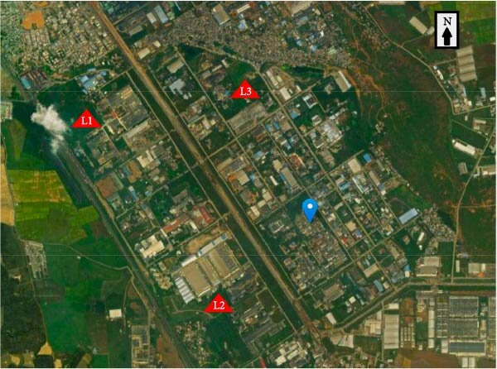
Figure 1 Location of Study Area

DATA USED
The aim of the study being evaluation of changes in the last 3 decades, Landsat 5, thematic mapper was preferred as it was available through most of the study period. Landsat 8, Operational Land Imager (OLI) data of 2014 was also used in the study. All these data were downloaded from USGS (United States Geological Survey). The dates of acquisition and resolution details are given in table 2.1. Topo-sheets of Survey of India of scales 1:50000 and 1:250000 have been digitized in order to arrive at the base layers.
Table 1 Details of acquired satellite data

Image Acquisition Date | Sensor | Spatial Resolution
21-11-1989 | Landsat 5 TM | 30m
07-04-1999 | Landsat 5 TM | 30m
27-10-2009 | Landsat 5 TM | 30m
28-12-2014 | Landsat 8 OLI | 30m

CHAPTER 3

METHODOLOGY ADOPTED AND ANALYSIS

INTRODUCTION
Urbanization refers to accumulation of human population in discrete areas, resulting in transformation of land for industrial, commercial, residential and transportation purposes. The 21st century is experiencing unprecedented scales of
urbanization as the urban population has risen dramatically from 30% in 1950 to 54% in 2014 and is expected to rise to 66% by 2030. Asia and Africa are urbanizing faster than other regions of the world and it is projected to be 64% and 56% urban by 2050. (World Urbanization Prospects, 2014). The city planners are facing serious challenges in the form of traffic congestion, development of infrastructure and provision of basic amenities such as water, sanitation and electricity (Kulkarni and Ramachandra, 2006). Other implications include loss of aquatic ecosystems and creation of heat islands due to discharge of heat from anthropogenic activities and reduction of water pervious surfaces and vegetation. The surroundings of built up areas in cities are cooler as compared to interiors of cities (Landsberg, 1981). Global warming and urban heat island cause the increase of near surface ambient temperature in cities (Santamouris, 2001). For most of the major cities in the world Urban Heat Island (UHI) is well documented (Santamouris, 2007). Land Surface Temperature (LST) plays a crucial role in monitoring surface heat islands (Voogt and Oke, 2003; Weng et al. 2004). LST can also be used to monitor vegetation physiology (Karnieli et al. 2006). The high resolution data includes, the Landsat-5 Thematic Mapper (TM) which has a 30m resolution, and repeat cycle of 16 days (Li et al. 2004; Ramachandra and Uttam Kumar, 2009) apart from Landsat-8. Landsat’s 4 and 5 carried on-board the Landsat Thematic Mapper sensor from July 1982 to May 2012. The bands 1-5 and 7 were of 30m resolution whereas band 6 was collected at 120 m and resampled to 30 m, with a scene size of approximately 170 km (N-S) and 183km (E-W).

The study of UHI remotely on global scales has been made possible due to the advent of satellite remote sensing technology (Streutker, 2002). Stathopoulou and Cartalis (2007) identified daytime UHI using Landsat ETM+ data for major cities in Greece. Weng (2001, 2003) examined land cover (LC) and its influence on LST in the urban clusters in China’s Zhujiang Delta and in Guangzhou. Ramachandra and Uttam Kumar (2010) studied the growth of Bangalore and its influence on the local climate using Landsat TM, Landsat ETM+,LISS (Linear Imaging Self Scanner)-III and MODIS (Moderate Resolution Imaging Spectroradiometer). Landsat TM data of the years 1989, 1999, 2009 and Landsat-8 data of 2014 were used in the present study of Mandideep City. Karthika et al. (2015) utilized Landsat-8 data along with hyperspectral imaging sensors to study the causes of climate change and to understand the influence of various urban building materials, LULC and the wind direction on urban climate. The climatic variability studies evaluate the temperature profile of the study area in order to understand the influence of water bodies and vegetation on prevalent temperature. The influence of NDVI over LST is also studied. Day to day maximum recorded temperatures of the month of May for the last four decades is also analyzed.

TEMPERATURE PROFILE
The temperature profile was analyzed in different directions by overlaying the land surface temperature (LST) map over the classified map of Mandideep in order to envision the effect of built-up areas, water bodies, vegetation, open ground and rocky areas on temperature. Transects were drawn across the city in various directions north (N), northeast (NE), east (E), southeast (SE), south (S), southwest (SW), west (W), northwest (NW) and the LST was analysed. The profile plot fell below mean while encountering water bodies or green patches of vegetation on the transect starting at the centre of the city and moving along the transect in different directions. The corresponding profile plots are shown in figure 3.1. The temperature profiles indicate a dip in temperatures over water bodies and green areas. The major water bodies and parks are marked in the figure 2

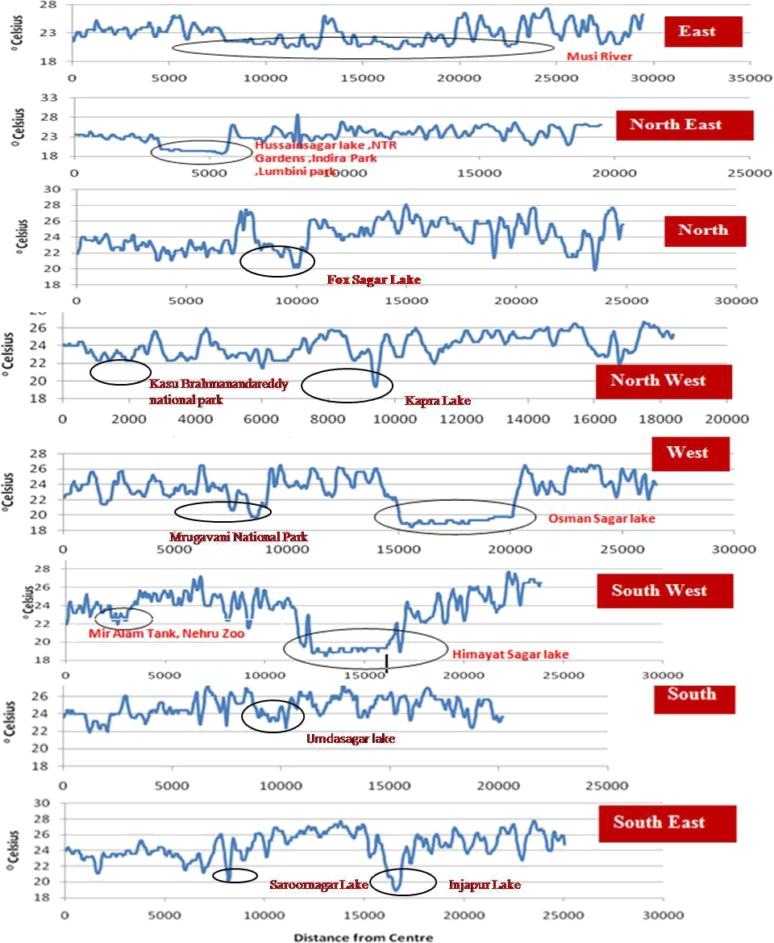
Figure 2 Temperature profile over different land use / land covers along different directions

LAND SURFACE TEMPERATURE (LST)
The thermal band of the satellite data is used to evaluate the land surface temperature (LST), i.e., the temperature at the interface between the earth's surface and its atmosphere. LST is a critical variable to understand land atmosphere interactions and is a key parameter in meteorological and hydrological studies which involve energy fluxes. The relation between LST and vegetation has been studied using Normalised Difference Vegetation Index (NDVI) as an indicator of abundance or scarcity of vegetation (Balling and Brazell, 1988). Venkatesh et al. (2015) studied the influence
of CO2 on LST by using bands 10 and 11, the thermal bands of Landsat-8 and it was also observed that band 10 was more suitable for determining the air temperature while band 11 was ideal for estimation of greenhouse gases. The Landsat-5 TM, TIR band 6 and Landsat-8 TIR band 10 were used to calculate the surface temperature of the area. Brightness temperature can be derived in two steps (Chen et al; 2002).

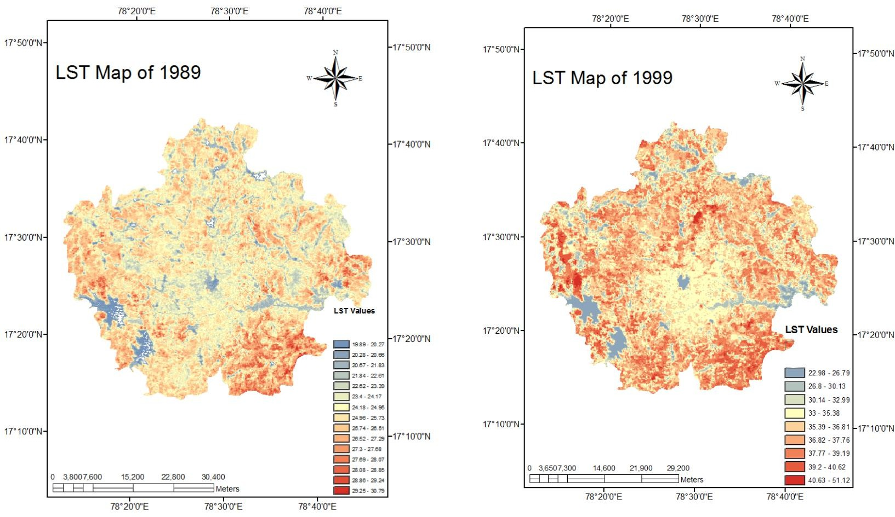

Figure 3 Land Surface Temperature for the year 1989 Figure 3.2.b: Land Surface Temperature for the year 1999

Table 2 Monthly Mean of Maximum temperatures in May in oC (1973- 2014)

Year | Temp | Year | Temp | Year | Temp | Year | Temp | Year | Temp
 |  | 1981 | 37.87 | 1991 | 38.68 | 2001 | 39.19 | 2011 | 38.81
 |  | 1982 | 36.00 | 1992 | 37.97 | 2002 | 38.39 | 2012 | 40.97
1973 | 39.19 | 1983 | 37.90 | 1993 | 38.65 | 2003 | 40.39 | 2013 | 42.36
1974 | 36.58 | 1984 | 40.26 | 1994 | 38.65 | 2004 | 35.65 | 2014 | 39.90
1975 | 38.00 | 1985 | 38.65 | 1995 | 36.16 | 2005 | 39.45
1976 | 37.77 | 1986 | 39.23 | 1996 | 39.90 | 2006 | 37.68
1977 | 36.13 | 1987 | 37.19 | 1997 | 38.55 | 2007 | 39.65
1978 | 37.87 | 1988 | 40.23 | 1998 | 39.48 | 2008 | 39.36
1979 | 37.65 | 1989 | 39.23 | 1999 | 36.42 | 2009 | 40.00
1980 | 39.71 | 1990 | 33.03 | 2000 | 36.32 | 2010 | 39.03
Average | 37.86 |  | 37.96 |  | 38.08 |  | 38.88 |  | 40.51

CHAPTER 4

RESULT ANALYSIS AND DISCUSSION

INTRODUCTION
Mandideep is a small industrial town having electrical, pharmaceutical and auto industries. The urbanization process is an on-going process that has resulted in depletion of ground water levels, denser population, air and water pollution while changing the socio-economic scenario of peri-urban areas. The objective of this chapter includes socio-economic assessment of the population and their perception regarding changes that occurred due to urbanization, in fields such as infrastructure facilities, transport facilities, job opportunities, income levels, pollution and impact on health, water availability, housing and standard of living.

RESEARCH DESIGN AND METHODOLOGY
The Survey research design has been followed employing both primary and secondary data. Questionnaire survey was administered for collection of primary data while secondary data was obtained from existing literature like journals, periodicals and Census data. The design was descriptive and the main purpose was to explain the socio-economic situation of the people of Mandideep city under the jurisdiction of Mandideep city. The survey method was adopted and data was collected from field by conducting personal interviews of the respondents. Probability sampling method was adopted using proportionate stratified random sampling process.

UNIVERSE AND UNIT OF STUDY
The universe of the study included all the households in Mandideep city and a single household was considered as unit of study.

SAMPLE SIZE
Door to door survey was conducted in areas surrounding, which were brought into the urban limits in the last decade. Figure 4.1 gives the images of the areas covered in the survey. The respondents were asked questions related to living conditions prior to urbanization and post urbanization. The number of respondents required for the survey was estimated using the Slovin's formula
Where N = the Population size, n = the number of respondents, e = margin of error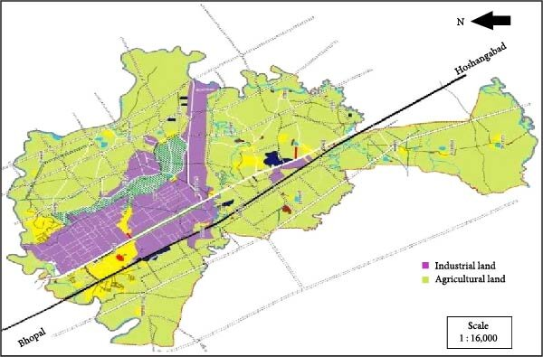

Figure 4 Overview of study area on google map, to identify various zones for door to door survey
A total of 202 respondents (households) were surveyed forming a margin of error of + or - 7% or a 93% level of confidence. The city municipality area has an astounding 0.507 million slum households and 2.27 million slum dwellers which constitutes nearly 30% of the total population (Census, 2011). The sample was hence drawn from 142 households in the planned housing areas while 60 households were selected from slum areas.

LIMITATIONS OF THE STUDY
The political situation being volatile due to the recent bifurcation of the state, the respondents were highly apprehensive and suspicious and not forthcoming in divulging information. The questionnaire had to be so modified as to collect as much information without inducing any cause for suspicion or conflict. The slum area respondents were interested to know as to what would be their gain by divulging information. The respondents belonged to both Mandideep and surrounding area and some of them were reluctant to divulge accurate information for fear of eviction. These are some of the limitations of the study.

DATA ANALYSIS
The surveyed regions included Bhopal and Raisen to the north of the city, Rehti and Hoshangabad to the east, Shamshabad, Sanchi and Vidisha to the south and Sultanpur and Sehore to the west (as shown in figures 4.1). 63 % of the respondents were male while 37% were female. Questionnaire was prepared in such a way as to compare the living conditions before and after urbanization. An astonishing 52% of the respondents preferred rural surroundings to urban while 31% preferred urban surroundings and 17% preferred semi-urban environment. 76% of the respondents agreed that the cost of living has gone up due to urbanization while 50% believed that their standard of living was of moderate level and reported no change due to urbanization. 83% reported improvement in transport facilities while 66% believed that the income levels remained moderate and did not change due to urbanization. 60% of respondents felt a rise in pollution levels, but most reported of no consequential health issues. Water problem has risen tremendously as 69% of respondents believed while 74% reported steep hike in house rents. The Mandideep metropolitan water supply and sewerage.
The board has itself admitted to a shortfall of 140 MGD (million gallon per day) or 530 MLD (mega litres per day) in its water supply capability. There seems to be a marginal rise in job opportunities as 61% prior to and 46% post urbanization felt a lack of job opportunities. In this regard the bifurcation of the state and the sharing of the capital has added to the confusion and multiplied the woes of the public. A graphical representation of the survey results is presented in figures 4.4. a & b.
Before Urbanization

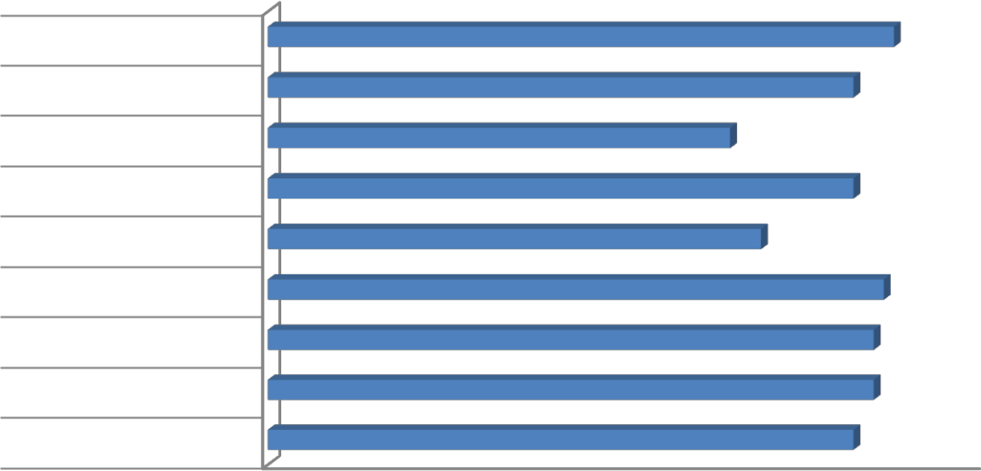
Job Opportunity 61% Low
House Rent 57 % Moderate
Water Problem 45 % Moderate
Health Issues 57 % Low
Pollution 48 % Low
Income Levels 60% Moderate
Transport Facility 59 % Moderate
Std of Living 59 % Moderate
Cost of Living 57 %Moderate
0 10 20 30 40 50 60 70

Figure 5 Survey results of living conditions prior to urbanization
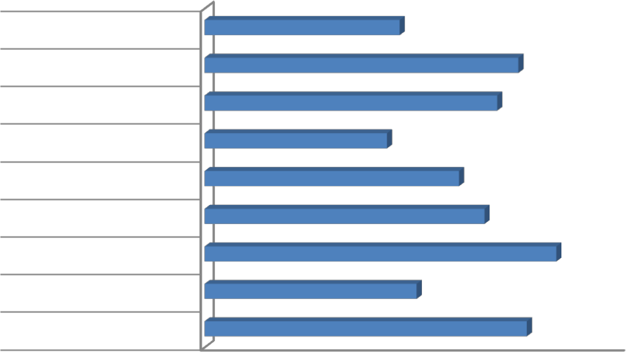
Job Opportunity
After Urbanization
46% Low

House Rent
74% High
Water Problem
69% High
Health Issues
43% Moderate
Pollution
60 % High
Income Levels
66 % Moderate
Transport Facility
83 % High
Std of Living
50 % Moderate
Cost of Living
76 % High

0 20 40 60 80 100

Figure 6 Survey results of living conditions after urbanization

CONCLUSION
The door to door survey presents interesting results. The positive outcomes of urbanization are the improvement in transport facility and a marginal rise in job opportunities, while the negatives piled up against it include water problems, increased pollution levels and cost of living, apart from increased house rents to be shelled out by people who do not own a home. A concerted effort on the part of Government and Private agencies is necessary to mitigate the harmful effects of sprawl and urbanization.
CHAPTER 5

CONCLUSIONS AND RECOMMENDATIONS

INTRODUCTION
The finding of each of the objectives is summarized below. The importance of addressing these objectives is discussed briefly. This chapter also highlights the major outcomes and contributions of this research work apart from suggesting potential areas of research. Major outcomes of this research work can be summarized as below.

    - LULC Classification
Land use analysis was done for the period 1989 to 2014, using various classification techniques among which Support Vector Machine classifier was observed to give more accurate results for urban planning. The temporal land cover analysis shows a growth of 210%, almost a 140% growth in urban built up areas
during the two and a half decade study period. The water bodies show a 67% decline. In a period of 25 years 45% of water bodies have been lost. Planned vegetation is almost non-existent in the region. The observed vegetation is mostly shrubs and rugged growth, which is seasonal. Most of the water bodies and surrounding areas of vegetation have been encroached upon.

LST/ NDVI / CLIMATIC CHANGES
This study reveals the relation between LST and NDVI. A marginal increase in NDVI can greatly influence the LST. The current analysis highlights the influence of vegetation cover on LST. Micro-climatic studies also reveal an increase in temperature of 1.5oC over the last four decades. An integrated approach to urban planning is needed to ensure moderation of micro-climate and sustenance of water.

LANDSCAPE METRICS FOR URBAN GROWTH
Spatial metrics obtained by considering the area, shape, edge and aggregation was used to compute the urban built-up land-density and it is an efficient method for the prediction of urban growth pattern. It helps visualize and quantify the rapidly enlarging urban footprint at Mandideep. LSM reveals the pattern of growth on a per
km basis, in terms of class area, number of patches, NLSI, Clumpiness index, mean patch size and PLAND. The patch numbers are expected to greatly reduce by 2030 while the mean patch size will be increased to a great extent. A lot of aggregation can be expected.

CELLULAR AUTOMATA TO PREDICT URBAN GROWTH
The cellular automata model predicts 27.26% of the total area to be urbanized by 2020 and 35.80% by 2030.The growth model is validated against the actual and predicted growth of 2009.

SOCIO ECONOMIC SURVEY
The impact of urbanization felt by the public is revealed, rise in cost of living, house rents, pollution levels and acute water problem. On the plus side is better transport facility and marginal increase in job opportunities.

MITIGATION MEASURES
The road transport sector in 2014-2015 emitted 3.45 Tg of CO2 as compared to the 258.3 Tg CO2 emitted by the transport sector of the whole country in 2003-04. CO2 emissions from 30000000 kWh (30 mu) is 26.1 X 106 g or 26.1 Tg per day or 9526.5 Tg for the year 2014-15, if the entire power required in Mandideep city is produced in a thermal power plant. The emission from electricity is far greater than that emitted by the transport sector. Hence calculations were made to totally replace the source of electricity using solar PV. The bright roof area necessary to meet the Power demand of Mandideep city is 10 km2 so as to generate 30 million units of solar electricity. The city has a bright roof area of 10.5 km2 for solar electricity, capable of meeting 64% of the power requirement of the city. The simulation is validated using case studies from literature. A 1MW power plant requires an area of 9143 m2 for 14286 solar modules.

MAJOR CONTRIBUTIONS OF THIS RESEARCH
- Studied land use and land cover classification using various classifiers and based on accuracy assessment & field study it was concluded that Support Vector Machine classification was found to be apt for classifying urban areas.
- Developed relation between LST and NDVI towards micro-climatic effects of urbanization.
- Determined the pattern of growth using Landscape Metrics and it will be useful for urban landscape planning and policy making.
- Predicted the growth of Mandideep using Cellular Automata for the year 2020 and 2030.
- Determined the temperature changes in the last four decades to understand the urbanization effects on climate.
- Determined the impact of urbanization through field survey especially to understand the socio-economic effects.
- Evaluated the emissions in the transport sector in order to quantify the GHGs in the urban areas.
- Developed the method to evaluate the Urban Sprawl Index which can be applied to other Cities.
- Modelled 1MW solar power plant and also for the entire power demand of Mandideep City towards mitigation measures.

SCOPE FOR FURTHER RESEARCH AND RECOMMENDATIONS

Predicting and visualising the growth of cities and understanding the level and direction of growth and its impacts, is highly beneficial to city planners and decision makers in formulating highly appropriate and suitable development strategies. This can help mitigate potential implications on the environment. This type of studies should be extended to all cities especially because it makes use of freely available open source data. Each and every smart city project in India can be better planned and implemented if these cities are subjected to this type of study. A pivotal role has to be played by the government in planning and developing sustainable cities, with a healthy environment, at the same time help sustain the natural resources.
REFERENCES
[1] Chattopadhyay S., Gupta S. and Saha R. N. (2010), Spatial and Temporal Variation of Urban Air Quality: A GIS Approach. Journal of Environmental Protection, 1: 264-277.
[2] Bortnick, S. M., Coutant, B. W. and Eberly. S. I. (2002). Using Continuous PM2.5 Monitoring Data to Report an Air Quality Index. J. Air Waste Manage. Assoc. 52: 104-112.
[3] http://cpcb.nic.in/About_AQI.pdf
[4] D S Khandbahale and R S Saler. (2013) Ambient Air Quality Monitoring in Nashik city (Maharashtra, India) Bionano Frontier. 6: 2.
[5] P. Balashanmugam, A. R. Ramanathan and V. Nehru Kumar (2012). Ambient Air Quality Monitoring in Puducherry. Int J of Eng Res and Appli. 2.
[6] Kassomenos, P., Skouloudis, A. N., Lykoudis, S. and Flocas, H. A. (1999). Air-Quality Indicators” for Uniform Indexing of Atmospheric Pollution Over Large Metropolitan Areas. Atmos. Environ. 33: 1861-1879.
[7] Malakos, M. and Wong, K-F. V. (1999). Proposed Pollutant Index to Incorporate Synergistic Effects. Int. J. Environ. Poll. 12: 2-10.
[8] Swamee, P. K. and Tyagi, A. (1999). Formation of an Air Pollution Index. J. Air Waste Manage. Assoc. 49: 88-91.
[9] Trozzi, C., Vaccaro, R. and Crocetti, S. (1999). Air Quality Index and its Use in Italy‟s Management Plans. Sci. Total Environ. 235: 387-389.
[10] Khanna, N. (2000). Measuring Environmental Quality: an Index of Pollution. Ecol. Econ. 35: 191-202.
[11] Cogliani, E. (2001). Air Pollution Forecast in Cities by an Air Pollution Index Highly Correlated with the Meteorological Variables. Atmos. Environ. 35: 2871-2877.
[12] World Health Organization (WHO) (1996) Revised WHO Air Quality Guidelines for Europe.
[13] Jiang, D., Zhang, Y., Hu, X., Zeng, Y., Tan, J. and Shao, D. (2004). Progress in Developing an ANN Model for Air Pollution Index Forecast. Atmos. Environ. 38: 7055-7064.
[14] Longhurst, J. (2005). Creating an Air Quality Index in Pittsburg. Environ. Monit. Assess. 106: 27-42.
[15] Sawamura, P. and Uehara, S. T. (2007). Air Quality Assessment Using a MultiInstrument Approach and Air Quality Indexing in an Urban Area. Atmos. Res. 85: 98-111.
[16] Mayer, H. and Kalberlah, F. (2008). Two Impact Related Air Quality Indices as Tools to Assess the Daily and Long-Term Air Pollution. Int. J. Environ. Poll. 32: 232-243.
[17] Elshout, S. van den, Leger, K. and Nussio, F. (2008). Comparing Urban Air Quality in Europe in Real Time A Review of the Existing Air Quality Indices and the Proposal of a Common Alternative. Environ. Int. 34: 720-726.
[18] Joel Macwan and Pratik N. Ruparel. Urban Corridor Noise Pollution: A case study of Surat city, India International Conference on Environment and Industrial Innovation IPCBEE. 2011, vol.12, Singapore.
[19] https://en.wikipedia.org/wiki/Mandideep
[20] Guidelines for the Measurement of Ambient Air Pollutants Volume-I, Central Pollution Control Board.
[21] Hashim, B.M. (2009) Measurement and Study Concentrations Some Air Pollutants in Baghdad City. M.Sc. Thesis, College of Science Al-Mustansiriyah Univ. in Atmospheric Sciences, 95 p.
[22] Al-Saadi, G.M. (2012) Assessment of Air and Water Pollution Due to Operation South of Baghdad Power Plant. M.Sc. Thesis, Building and Construction Engineering Department, University of Technology, 147 p.
[23] Leili, M., Naddafi, K., Nabizadeh, R. and Yunesian, M. (2008) The Study of TSP and PM10 Concentration and Their Heavy Metals Content in Central Area of Tehran, Iran. Air Quality Atoms Health, 1, 159-166. http://dx.doi.org/10.1007/s11869-008-0021-z.
[24]McCubbin, D.R. and Delucchi, M.A. (1999) The health cost of motor vehicle related air pollution. Journal of Transport Economics and Policy. 33 (3) : 253 -286. [25] CIESIN (Center for International Earth Science Information Network), Columbia Universit and Centro International de Agriculture Tropical, CIAT) (2004) Gridded Population of the World (GPW), Version 3.
[26] Zhang Jin Tun, R. Pouyat and J.T. (2000) Zhang. Effects of urbanization on the concentrations of heavy metals in deciduous forest floor in a case study of New York City. Scientia Silvae Sinicae. 36 (4) : 42-45.
[27] S. Cheng, and K.C. Lam. (1997) Climatic Impact on air pollution concentrations in Hong Kong. Department of Geography, Occasional paper, The Chinese University of Hong Kong, Hong Kong.

