ADVANCED MOTION DETECTION IN LIGHTING SYSTEM

Mr. Chavan Ganesh P ¹, Mr. Gajare Shivam S ², Mr. Chavan Vijay B ³,

Mr. Kokane Gaurav V ⁴, Mr.Bhagat Aaditya S ⁵
¹ Head Of The Department, Department of Electrical Engineering, Santosh N Darade Polytechnic, Yeola, Maharashtra, India.
^{2,3,4,5,} Students, Department of Electrical Engineering, Santosh N Darade Polytechnic, Yeola, Maharashtra, India.

ABSTRACT
The proposed work is based on to monitor the energy consumption and energy management through Internet of Things (IoT). Electricity is one of the key factors in human life to survive on the earth. Most of our work requires electricity so it’s important to save electricity. Without electricity life will be like heart without heartbeats. Energy saving is one of the main challenge in our day to day life. Energy saving can be done only when the energy consumed by the load is monitored. Once the load is monitored, suitable control methods can be adopted to operate the load in the optimized way to save energy. Even though there are lot of technologies and solutions available to effectively monitor, control and save energy consumption of load in a house or an industry, the Internet of Things technology is proposed to monitor, control and minimize energy consumption of load. The proposal is to design and develop an Internet of Things based Energy Management System in which the data is collected from smart energy meter using GPRS network and displayed on web page. The proposed system is suitable for data collection and Control the load in the Internet of Things environment.
Keywords: Automation, Electrically, GPRS Network, Energy Meter.

INTRODUCTION
You can use smart mobile apps or connect products to a Wireless gateway to communicate with them to start you Home automation journey. In plug and play segment you can start with Wi-Fi smart plugs. A smart plug converts an Ordinary power outlet into a smart one without any Installation hustle. You can automate a device or power outlet one at a time and start building your automation network around it. Execute tasks like turn on and off a device or set Rules to operate the device automatically from your Smartphone. You can find smart plugs available in the market
At a very affordable price, so beginners and enthusiasts can enter in to home automation segment and experiment with Smart plugs. There are overwhelming number of service Providers from start-up companies to home security Companies to tech innovators, these companies can design and install a custom system to suits your home. Professional installation can come especially in
Handy for those who need to retrofit older homes and can’t Use a standard plug-and-play setup. Major home automation Systems works around a gateway, or hub. The hubs act as a Central command post to communicate between the Controller and the controlled i.e., computer or mobile device Used for control and monitoring. Stand-alone hubs are readily available in the market, you
Can select a hub based on range of products you are using and The tasks you are aiming to execute home automation Systems will usually have their own hub, and products are Built around the hub so configuration and installation will be Simple and can be done by yourself or a technician will be Provided to you. A home automation system consists of a Device which communicates to a gateway or a hub. The Number of devices required in your home depends on the Degree of control you wish to have in your home. In light of the increasing cost of electricity and the global
Warming campaigns to reduce general electricity usage, there is a growing interest in analyzing power consumption in Households. By analyzing the electricity usage of each
Individual appliance separately, more accurate conclusions Can be drawn on their efficiency and need for replacement. Furthermore this can also determine whether an appliance is drawing unusually high amounts of power when turned off and whether it should rather be unplugged. In this way Electricity consumption and cost can be reduced. Most Conventional prepaid power meters currently installed in Households only display the total real time usage of its power and the amount of electricity available.

BLOCK DIAGRAM
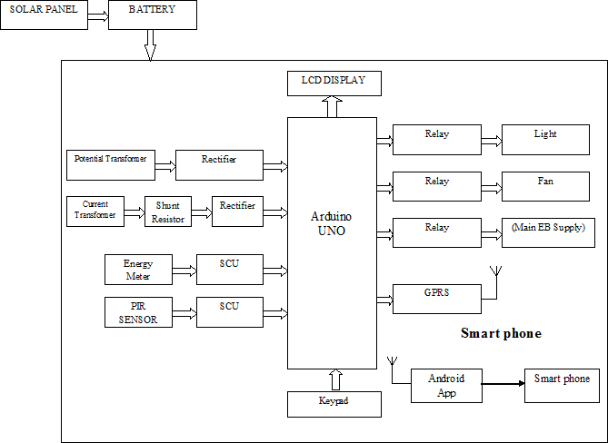

Fig: 1 Proposed Block Diagram

PROGRESS OVERVIEW

A. Motion Detection Lighting System

✔ Sensor integration completed.
✔ Code implementation for motion detection and light control tested successfully.
✔ Optimized sensitivity and delay settings.
⏳ Pending: Fine-tuning detection range for optimal efficiency.

B. Temperature Controller with DC Fan

✔ Sensor successfully reads temperature and sends data to the microcontroller.
✔ DC fan activation tested based on temperature threshold.
✔ Code optimization for smooth fan speed variation.
⏳ Pending: Calibration for accurate temperature response.

C. Hardware & Software Integration

✔ Microcontroller programmed and interfaced with sensors and actuators.
✔ Initial testing completed for both subsystems.
⏳ Pending: Final debugging and system efficiency improvement.

LEADING TECHNOLOGIES AND INNOVATIONS

Adaptive Lighting & Cooling: Systems that learn user behaviour and adjust lighting and fan operation automatically.

Energy-Efficient DC Fans: Brushless DC (BLDC) fans offer lower power consumption and longer lifespan.

Smart Home & Industrial Integration: These systems are increasingly used in smart homes, offices, and industrial settings for energy conservation.

Renewable Energy Compatibility: Some systems integrate with solar panels for sustainable operation.

CONCLUSION

Advanced motion detection in lighting system is current trend with the development of IoT. Lot of work been reported in regards to controlling the appliances of home and also on monitoring the electrical parameters towards hazard. Also work reporting in controlling the appliance for energy consumption. So with all these work reported, we here have developed an better IoT system for Energy Management which takes the Humidity, Temperature and light intensity into consideration and accordingly interfaced with Arduino Microcontrollers for controlling the usage of appliance like speed of fan, light intensity rather than just switch on or off. Also the prototype system computes the current drawn from each appliance based on appliance usage and send to Android Smartphone where total power consumed of appliances computed against time.

REFERENCES
- Tsirmpas, A. Anastasiou Member, P. Bountris and D.Koutsouris Member “A new method for profile generation in an Internet of Things environment: An application in ambient assisted living” IEEE Internet of Things Journal, 2015.
- Gomes, T. ; Centro Algoritmi - University of Minho, Portugal ; Pinto, S. ; Gomes, T. ; Tavares, A.” Towards an FPGA-based edge device for the Internet of Things”Emerging Technologies & Factory Automation (ETFA), 2014.
- Jeya Padmini, J.; Kashwan, K.R.” Effective power utilization and conservation in smart homes using IoT," in Computation of Power, Energy Information and Commuincation (ICCPEIC), 2015 International Conference on , vol., no., pp.0195-0199, 22-23 April 2015.
- Jinsoo Han; Chang-sic Choi; Wan-Ki Park; Ilwoo Lee; Sang-Ha Kim,” Smart home energy management system including renewable energy based on ZigBee and PLC in 2014 .
- JoséG. de Matos, Member, IEEE, Felipe S. F. e Silva, Student Member, IEEE, and Luiz A. de S. Ribeiro, Member, IEEE “Power Control in AC Isolated Microgrids with Renewable Energy Sources and Energy Storage Systems” IEEE Transactions on Industrial Electronics 10.1109/TIE.2014.
- Shiu Kumar “Ubiquitou Smart Home System Using Android Application” International Journal of Computer
- Networks & Communications (IJCNC) Vol.6, No.1, January 2014.
- Mohanty, S.; Panda, B.N.; Pattnaik B.S., "Implementation of a Web of Things based Smart Grid to remotely monitor and control Renewable Energy Sources," in Electrical, Electronics and Computer Science (SCEECS),2014 IEEE Student Conference on vol no pp,1-5,1-2

