**SHOCK ABSORBER THROUGH ELECTRICITY GENERATION SYSTEM**

# Mr. Avhad Deepak R 1, Mr. Rahane Akash R 2, Mr. Pawar Yash S 3,

# Mr. Jadhav Mahesh V 4, Miss. Nagare Sakshi R 5

1 Lecturer, Department of Electrical Engineering, Santosh N Darade Polytechnic, Yeola, Maharashtra, India.

2,3,4,5, Students, Department of Electrical Engineering, Santosh N Darade Polytechnic, Yeola, Maharashtra, India.

# ABSTRACT

We are using the non-renewable energy sources such as petroleum as well as renewable sources like solar, wind, tidal power etc., but still we couldn’t overcome our power needs. So we have to generate electricity through each and every possible ways. Power can be generated through we are two wheeler shock absorber on the bike; the generated power will be stored and can be used for domestic purposes. This system can be installed at homes, colleges, railway stations, where the people move around the clock. The utilization of waste energy of human foot power is very much relevant and important for populated countries like India and China. A special mechanical arrangement such as crankshaft mechanism is employed on the stair case. This arrangement will convert the foot power applied on shock absorber, as a rotary motion. This rotary motion will be used to generate efficient electricity. It’s an eco-friendly; easily accessible and non-conventional power generation system when compared to existing systems.

**Keywords:** Shock absorber, solar, wind, tidal power, rotary motion

# INTRODUCTION

This project attempts to show how energy can be tapped and used at a commonly used floor steps. The usage of steps in every building is increasing day by day, since even every small building has some floors. A large amount of energy is wasted when we are stepping on the floors by the dissipation of heat and friction, every time a man steps up using stairs. There is great possibility of tapping this energy and generating power by making every staircase as a power generation unit. The generated power can be stored by batteries, and it will be used for lighting the building.

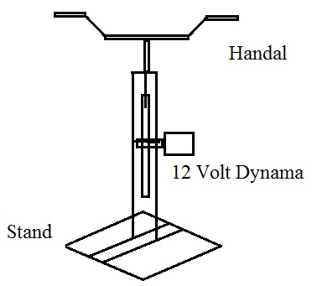

# WORKING PRINCIPLE

This project is concerned with generation of electricity from ‘power step’ set up. The human load acts upon the Power step-setup will produce linear reciprocating motion on the power step. Here the reciprocating motion of the power step is converted into rotary motion using the crankshaft arrangement. A flywheel is used to produce rotary motion. The flywheel and the power step pedal are connected by means of connecting rod. The rotary motion of large flywheel is given to the small pulley by belt or chain. Hence the speed that is available at the flywheel is relatively multiplied by the rotation of the smaller pulley.This speed is sufficient to rotate the rotor of a 12V generator. The rotor which rotates within a static magnetic stator cuts the magnetic flux surrounding it, thus producing the electro motive force (emf). This generated emf is then sent to an inverter, where the generated emf is regulated. This regulated emf is now sent to the storage battery where it is stored. This current is then used for other purposes. The generator converts the mechanical rotary motion into electrical energy.

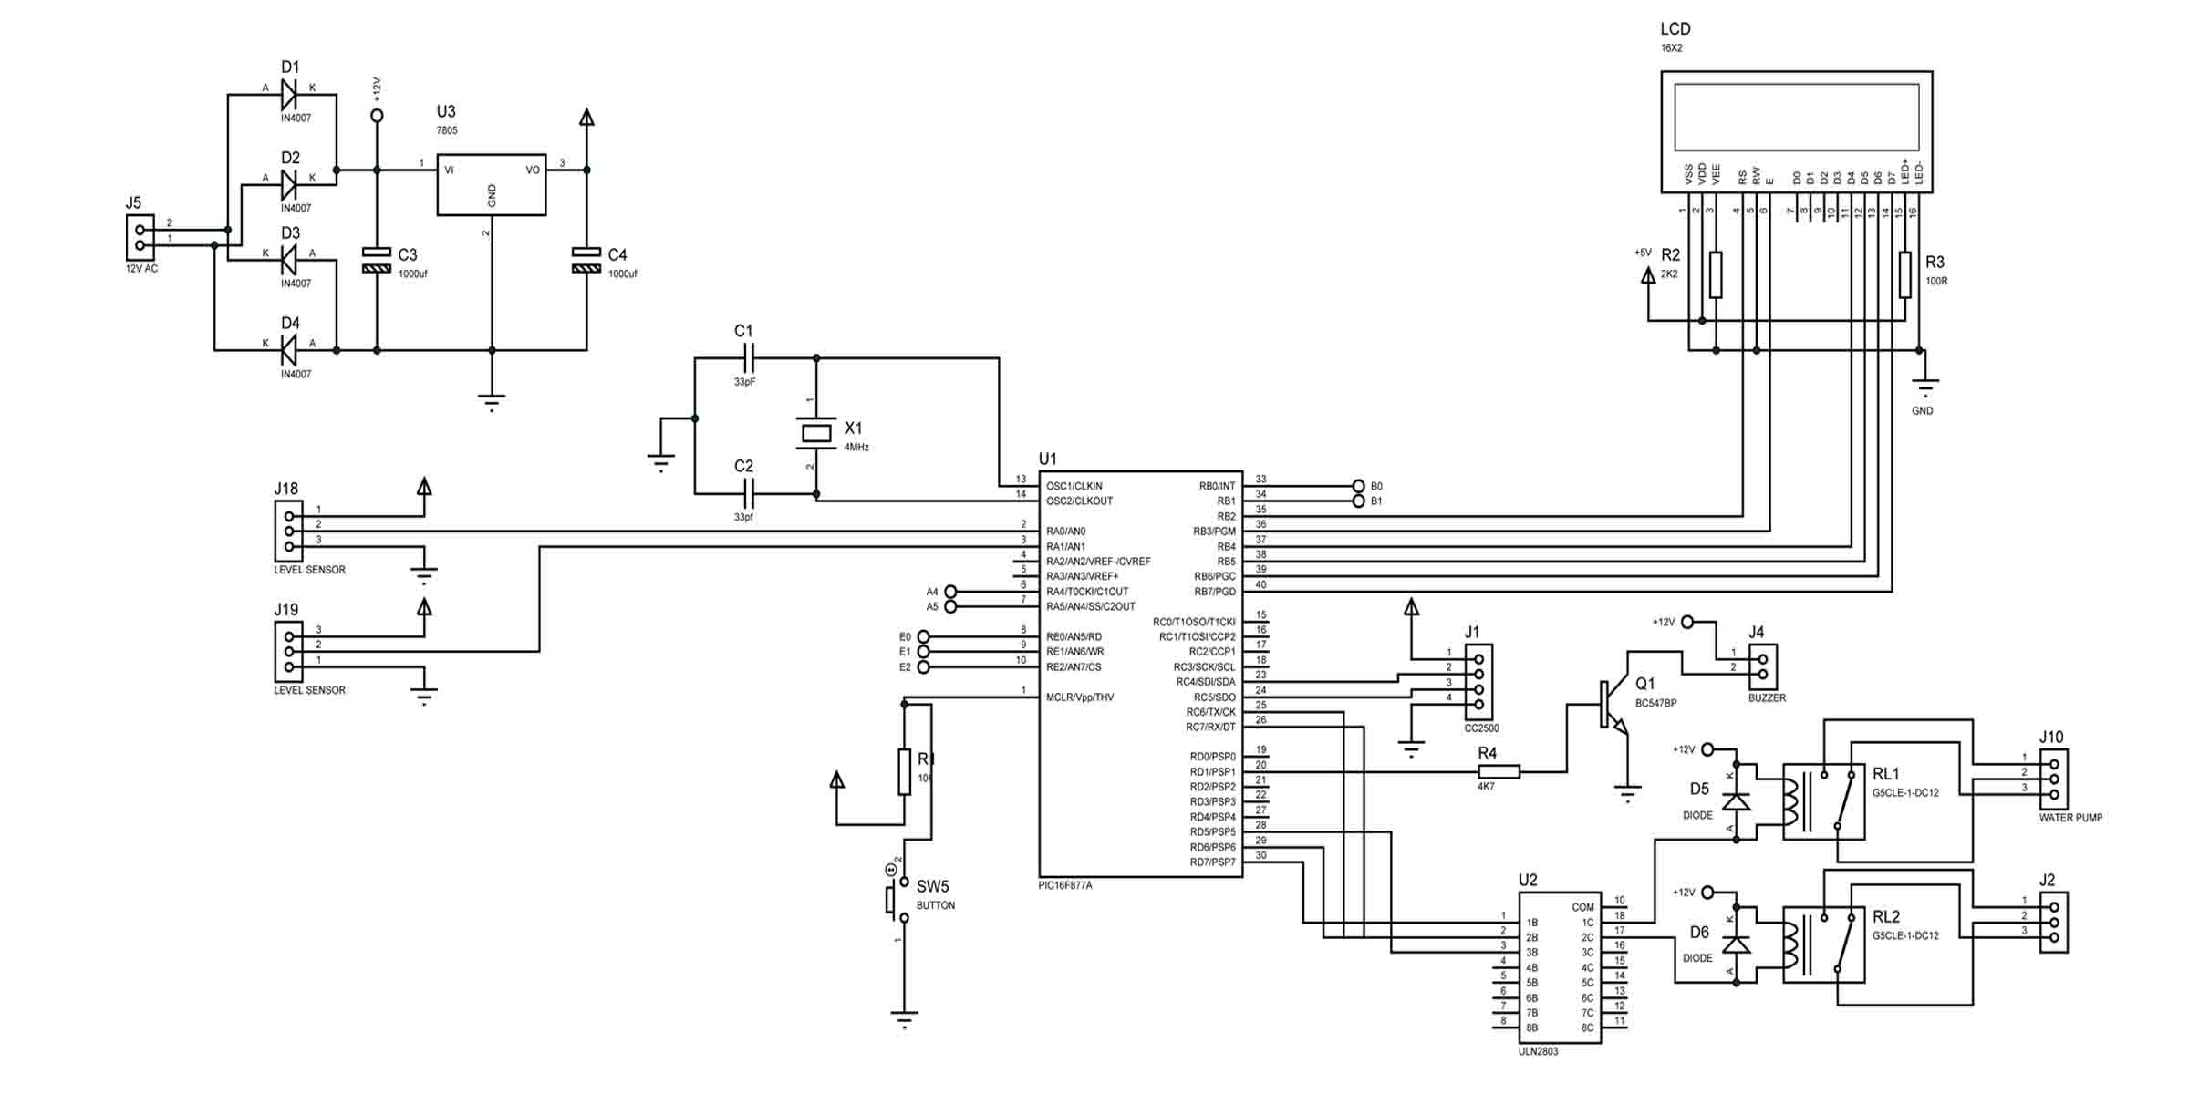

# ADVANTAGES

1. The machine has very low error.
2. The size of project made by is more suitable for electricity generation system.
3. The cost of machine is less.
4. It is easy to make.
5. It has low maintenance.
6. The system has worked fully **shock absorber** base operated.
7. Size of machine is small therefore it is easy to install any bike.
8. Weight of machine is low.

# DISADVANTAGES

1. Being semiautomatic we cannot neglect at Staircase.
2. Battery system is required to operate the machine control circuit & motor operate.

# TECHNICAL SPECIFICATION

1. Selection of the motor system.
2. Selection of the wheel assembly system.
3. Selection of the control box.
4. Selection of the hand control switches section & battery system.

# MACHINE REQUIRED FOR COMPLETION OF ABOVE PROJECT

1. ARC Welding Machine.
2. Drilling Machine, Grinder.

# PARTS LISTS

1. Control unit = 1
2. Battery = 1
3. Step system = 1
4. Mounting Fabrication = 1
5. Motor = 1
6. Other material as requirement.

# APPLICATION OF PROJECT

1. Use in moll purpose.
2. Used balding step.
3. In industries purpose.
4. Can be used in engg.workshop.
5. Use in domestic purpose.

# SALIENT FEATURES

1. Fully automation.
2. Simple in operation.
3. Maintenances less.