# Advancements in 3D Printing for Pharmaceutical Applications: A Systematic Review

**Vaibhav S. Shikare1*, Tushar G. Bodade2, Ganesh D. Raundale2, Shreyash V. Raundale2, Abhinav K. Wankhade2, Sumedh D. Mhaske2**

**1.** M.Pharm. Scholar, Dept. of Quality Assurance, Rajarshi Shahu College of Pharmacy, Buldhana, Dist-Buldana, MS, India

**2**.Bpharm first year, Rajarshi Shahu College of Pharmacy, Buldhana, Dist-Buldana, M.S.

India 443001

**Address of Corresponding Author\***: M.Pharm. Scholar, Dept. of Quality Assurance, Rajarshi Shahu College of Pharmacy, Buldhana, Dist-Buldana, MS, India, Email: vaibhavshikare45@gmail.com

**ABSTRACT**

The advent of three-dimensional (3D) printing technology in medicine allows the pharmaceutical sector to participate in the fourth industrial revolution. 3D printing technology is a groundbreaking and essential method for fabricating solid objects through the layer-by-layer deposition process under computer supervision. Three-dimensional (3D) printed medicines may serve as an essential instrument for comprehending individualized treatments tailored to the distinct needs of each patient, encompassing factors such as age, weight, co-morbidities, and pharmacogenetic and pharmacokinetic attributes. 3D printing technology provides a distinct advantage over traditional methods in the domain of new drug delivery systems (NDDS). Many 3D printing techniques utilized encompass inkjet printers, thermal inkjet printers, fused deposition modeling, and hot melt extrusion, among others. The uses of 3D printing in the pharmaceutical sector are many, including lab-grown organs, drug delivery systems, anatomical models, and customized medications, among others.3D printing is considered a valuable, efficient, and economical instrument with the capacity to transform the future of general pharmacy practice, particularly in pharmacological therapy.

**Keywords:** Three-Dimensional Printing (3DP), Personalized Medicine,Drug Delievery, Innovation,Drug-Release Profiles

## INTRODUCTION

Medicine delivery refers to the efficient and secure transportation of a pharmacologically active substance, specifically a medication, within the body to achieve the desired therapeutic effect. Modifying the pharmacokinetics of the drug through the regulation of its release profile enhances both efficacy and safety.[1] Three-dimensional printing has become a prominent technology in the domain of pharmaceuticals. It offers considerable potential in personalized dosage formulation. [2] It is a distinctive, innovative rapid prototyping method for creating solid items via the sequential deposition of several layers.Three-dimensional (3D) printing is a manufacturing technique that involves the successive fusion or deposition of materials, including plastics, metals, ceramics, powders, liquids, or biological cells, to create a three-dimensional item.[3]Rapid prototyping denotes the creation of physical models by three-dimensional computer-aided design (CAD). This process is commonly known as additive manufacturing, in which materials are deposited in layers under computer control, enabling solid free-form production.[2]

## HISTORY

The 3D printing technique was initially acknowledged by Hideo Kodama of the Nagoya Municipal Industrial Research Institute when he created a 3D plastic sculpture using photo-hardening polymer. The notable breakthrough transpired in 1984 when Charles Hull, who subsequently co-established 3D Systems, developed stereolithography.[4]

Table 1: Historical Development in the Field of 3D Printing [5]

|  |  |
| --- | --- |
| **Year** | **Major development** |
| 1992 | First SLA machine was produced using 3D system |
| 1993 | 3D printing patent was granted to E.M Sachs |
| 1996 | Clinical application of biomaterials for tissue regeneration |
| 1999 | Luke Massella received first 3D printed bladder which was an amalgamation of 3D printed biomaterials and his own cells |
| 2000 | MCP technologies introduced the SLM technology |
| 2002 | Miniature functional kidney was fabricated |
| 2003 | Term organ printing was coined |
| 2004 | Dr. Bowyer conceived the RepRap concept of an open-source, self-replicating 3D printer |
| 2005 | First color 3D printer was introduced by Z Corp |
| 2007 | Selective layer customization and on-demand manufacturing of industrial parts |
| 2009 | Organovo, Inc., announced the release of data on the first fully bioprinted blood vessels |
| 2011 | 3D printing was applied in gold and silver  World’s first 3D printed car, robotic aircarft was introduced |
| 2012 | Extrusion-based bioprinting for an artificial liver 3D printed prosthetic jaw was implanted |
| 2013 | SolidConcepts produced a 3D printed metal gun |
| 2014 | Implementation of multi-arm bioprinter to integrate tissue fabrication with printed vasculature |
| 2015 | First 3D printed pill was approved by US FDA  Organovo announced the release of data on the first fully bioprinted kidney |

### **ADVANTAGES** [1, 5, 6]

* Exact and accurate administration of powerful pharmaceuticals.
* The cost of production diminishes due to negligible wastage.
* Limited therapeutic range.
* Customized and tailored pharmacotherapy.
* Elevated drug loading relative to traditional dose forms.
* 3D printers are economical and require minimal space.
* Small batch manufacturing is feasible.
* 3DP facilitates the regulation of droplet dimensions, intricate drug release patterns, dose potency, and multiple dosing capabilities.

### **DISADVANTAGES** [5-6]

* Inkjet printers can only utilize ink with high precision viscosity.
* Ink formulation materials must possess self-binding properties while remaining non-adhesive to other printer components.
* The medication release rate is affected when ink sticks to printer components.
* The printing of large objects is impractical.
* Only a limited selection of raw materials may be employed.

## TYPES OF 3D PRINTING TECHNOLOGIES

1. Thermal Ink-Jet Printing [5, 7]

Thermal inkjet printing use a micro-resistor to heat ink, transforming it from liquid to vapor, which expands and ejects an ink droplet through a nozzle. It is utilized in the formulation of drug-encapsulated biodegradable microspheres.Drug-encapsulated liposomes, microelectrode arrays for patterning, and the coating and loading of drug-releasing stents.

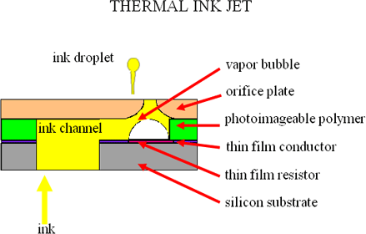

Figure 1: Thermal Inkjet Technique in 3D Printing [7]

1. Inkjet printing

This is a powder-based 3D printing method that utilises powder as a substrate, onto which diverse combinations of active chemicals and ink are applied in layers, using droplets of varying sizes, ultimately solidifying into a solid dosage form.[5] In pharmaceutical applications, the ink is replaced with pharmaceutical solutions containing active chemicals, and edible substrates are utilised in place of traditional paper. [4, 8] Inkjet printing offers high-resolution capabilities by applying ink to the substrate through Continuous Inkjet printing (CIJ) or drop on Demand (DoD) techniques. Inkjet printing is sometimes known as a 'maskless' or 'toolless' technique. [7]

Advantages of inkjet printing include [9]

* + minimal processing expenses expeditious processing speeds
  + production of minimum waste
  + It provides CAD information in a 'direct write' format and processes material over extensive areas with minimal contamination.

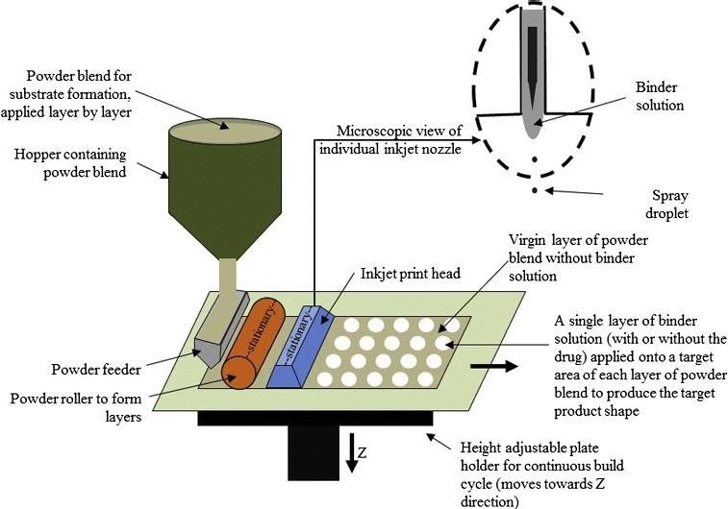

Figure 2:Inkjet Printing in Three-Dimensional Printing [7]

1. **Selective Laser Sintering (SLS)**

Selective laser sintering is characterized as a rapid manufacturing technique that employs powder-coated metal additives, commonly used for swift prototyping. SLS utilizes a continuous laser beam as a heat source to consolidate powder particles within a powder bed. In the printing process, the laser targets a specific pattern on the powder bed's surface, creating a three-dimensional structure. The laser beam sinters the powder, fusing it in a sequential layer-by-layer process. [1, 4, 7, 10]

1. **Fused Deposition Modeling**

Fused Deposition Modeling Printers are ubiquitous and more economical than Selective Laser Sintering printers. In fused deposition modeling printers, heated plastic pellets are extruded from the print head rather than ink, thereby fabricating the item in thin layers. One, Eleven Upon solidification, the polymer, applied in successive layers, acquires the precise form delineated by computer-aided design models. [5]

FDM 3D printing offers several limitations such as- [7]

* + lack of suitable polymers
  + slow and sometimes incomplete drug release because the drug remain trapped in the polymers, and

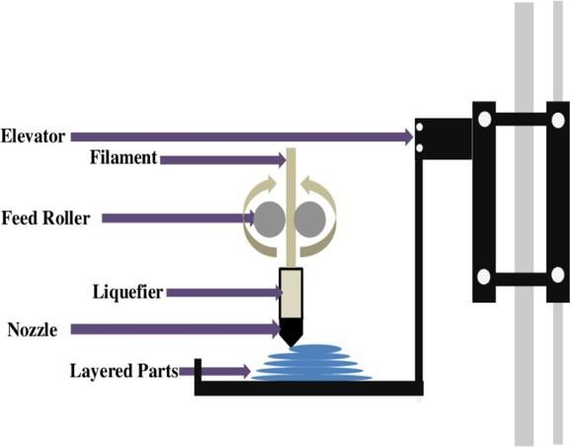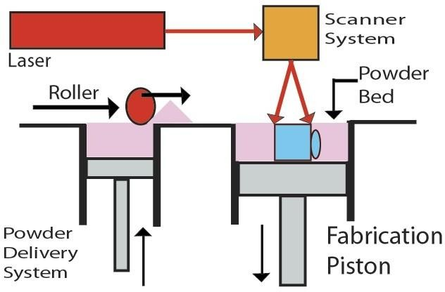

Figure 3: Selective Laser Sintering (left) and Fused Deposition Models (right) in 3D printing [7]

1. **Stereo Lithography [4, 7]**

Stereolithography was developed by Charles Hull in 1988. The procedure involves the solidification of liquid polymer or resin using a computer-controlled laser beam, producing a three-dimensional structure.This method yields exceptionally precise and intricate polymer components.

1. **Hot melt extrusion** [4]

This 3D printing method entails the high-temperature melting of polymer and medicament under pressure for integration. It includes many actions such as feeding, heating, mixing, and sculpting. The hot melt extrusion method often improves the solubility and bioavailability of poorly soluble drugs.

1. **Extrusion 3D Printing** [4]

Only tablets that contain Guaifenesin as an expectorant can be manufactured using extrusion 3D printing. The material is extruded from the automated nozzle onto the substrate, obviating the necessity for supplementary support material. Extruded substances comprise molten polymers, suspensions, semisolids, and pastes.

1. **Zip dose** [7]

The Zip dose 3D printing process is purported to be the sole FDA-validated, commercial-scale 3D printing solution for pharmaceutical manufacturers. This technique offers a unique digitally coded layering and zero-compression methods for the creation of a high-dose tablet with rapid disintegration. Consequently, it assists in alleviating dysphagia. Spritam® is an orodispersible tablet employed in the management of epilepsy and is distributed by Aprecia Pharmaceuticals.

Table 2: Pharmaceutical Preparations Developed Using 3D Printing Technology [5]

|  |  |  |
| --- | --- | --- |
| **3D Printing Technology** | **Formulations** | **API** |
| Semi-Solid Extrusion (SSE) | Bi-layered tablets (polypill) | Guaifenesin |
| Multiactive tablets (polypill) | Nifedipine, Glipizide, and Captopril |

|  |  |  |
| --- | --- | --- |
| **3D Printing Technology** | **Formulations** | **API** |
| Stereolithography (SLA) | Hydrogels | Ibuprofen |
| Facial mask | Salicylic acid |
| Selective Layer Sintering (SLS) | Tablets | Paracetamol |
| Drug delivery device | Progesterone |
| Fused Deposition Modeling (FDM) | Caplets | Caffeine |
| Tablets | Hydrochlorothiazide |
| Oral films | Aripiprazole |
| Binder Jet Printing | Tabular devices | Methylene Blue and Alizarin Yellow (dyes) |
| Cubic tabular devices | Pseudoephedrine |
| Tablets | Chlorpheniramine Maleate and Fluorescein |
| Oro-dispersible tablets | Levetiracetam |
| Inkjet 3D Printing | Implant | Levofloxacin |
| 3D Printing Machine | Multidrug implant | Rifampicin and Isoniazid |
| Inkjet 3D Printing | Nano-suspension | Folic Acid |
| Thermal Inkjet (TIJ) Printing | Solution | Salbutamol Sulfate |
| Inkjet 3D Printing | Nano-particle | Rifampicin |

### **3D PRINTER MATERIALS** [4, 12]

For pharmaceutical purposes, materials used in 3D printing are:-

1. Acrylonitrile Butadiene Styrene

This is one of the most often employed materials in 3D printing. It is exceptionally durable, moderately pliable, and lightweight, enabling effortless extrusion, therefore making it appropriate for 3D printing. The only limitation of Acrylonitrile Butadiene Styrene is its necessity for elevated temperatures. The temperature range of 210˚C to 250˚C is typically utilized for printing using Acrylonitrile Butadiene Styrene materials, which possess a glass transition temperature of around 105˚C.

1. **Poly Lactic Acid**

Polylactic acid is a biodegradable thermoplastic derived from corn, rendering it more environmentally sustainable than alternative plastic polymers. Polylactic acid demonstrates substantial biocompatibility with the human body. Poly lactic acid exhibits a more rigid structure compared to Acrylonitrile Butadiene Styrene and has a melting point ranging from 180 to 220˚C, which is lower than that of Acrylonitrile Butadiene Styrene. The glass transition temperature of polylactic acid varies between 60 and 65˚C.

1. **High Impact Polystyrene**

High Impact Polystyrene filament is biodegradable and does not exhibit negative effects upon contact with humans or animals. The curling and adhesion problems associated with High Impact Polystyrene filaments can be alleviated by employing a heated bed during the printing process.

## APPLICATIONS

3D printing has long been utilized in medicine for the fabrication of dental implants and personalized prosthetics. [4] Currently, this technology is utilized throughout extensive domains, including tissue and organ creation, as well as diverse pharmaceutical research focused on drug discovery, delivery, and dosage forms. [13]

1. **Bio printing of tissues and organs**

Organ and tissue failure due to accidents, aging, or congenital defects remains a major unresolved medical issue worldwide. The quantity of persons receiving organ transplants is limited due to the prohibitive expense and the shortage of donors. The resolution to the present quandary is generating the requisite tissue or organ utilizing the patient's own cells, so significantly reducing the likelihood of tissue or organ rejection. [14-15] 3D printers can be employed in the production of heart valves, spinal discs, knee menisci, various bone and cartilage types, and prosthetic ears, among other applications. [16-17]

1. **Unique dosage forms**

Inkjet-based and inkjet-powered 3D printing technologies are the predominant types utilized in the pharmaceutical sector. Advanced dosage forms, including nanosuspensions, microcapsules, mesoporous bioactive glass scaffolds, hyaluronan-based synthetic extracellular matrices, multilayered drug delivery systems, and antibiotic-printed micro-patterns, are often produced using 3D printing technology. [15, 18]

1. **Hearing aids**

Hearing aids can be produced with 3D printing technology in three stages: scanning, modeling, and printing. Printers can produce 65 hearing aid shells or 47 hearing aid molds within a timeframe of 60 to 90 minutes. The printing speed enables firms to align supply with demand. [3]

1. **Anatomical Models**

Anatomical variances differ among individuals. Consequently, possessing precise understanding of the patients' unique anatomy is essential prior to surgery.3D printed models have significantly contributed in this regard, rendering them a crucial instrument for surgical techniques. [13, 19] For example;

* + Neuroanatomical models produced through 3D printing aid neurosurgeons by offering a depiction of some of the most intricate structures in the human body. [19]
  + Kobe University Hospital in Japan employed 3D printed representations of patients' own organs to identify a donor liver with minimal tissue damage. [5]
  + The airways of a preterm infant were reconstructed to investigate aerosol medication delivery to the lungs..[5]

1. **Personalized medicine**

The 3D printing of tailored pharmaceuticals enhances treatment efficacy while minimizing the likelihood of adverse reactions. Drugs with a narrow therapeutic index can be produced via 3D printing, and by understanding the patient's pharmacogenetic profile and other features, optimal dosages can be administered. [14, 15, 20]

Personalized medicine involves customizing medical treatments to meet the specific needs and preferences of individual patients. It entails the intentional execution of diagnosis, treatment, and subsequent monitoring. It may also encompass preventive medicine designed to mitigate the risk of diseases to which an individual is predisposed, by modifications in lifestyle, nutrition, and habits, as well as recommendations for specific supplements or medications. [21]

## CHALLENGES

3D printing technology has shown promising results in pharmaceutical drug research and delivery; yet, it is still in the developmental phase. Various challenges arise in the optimization process, such as improving device performance for different applications, choosing appropriate excipients, and applying post-treatment techniques to enhance the efficacy of 3D printed products, thus expanding their utility in advanced drug delivery systems. [7, 22]

A multitude of essential elements, including as printing passes, printing rate, print head line velocity, interlayer time, nozzle spacing, and powder layer thickness, must be precisely calibrated to achieve high-quality 3D products. [23-24] The binder's chemistry and formulation must be sufficiently prioritized to achieve superior quality in 3D printed products. The selected binder in the 3D printing process must be compatible with the printer head components. [22] To augment the drug loading capacity in 3D printed tablets, uniaxial compression and suspension dispersion techniques are utilized; nevertheless, these procedures exhibit drawbacks, including heightened complexity and the potential for spray nozzle obstruction. [4, 22]

## CONCLUSION

3D printing technology has shown to be a valuable asset for the pharmaceutical business, enabling personalized treatment customized to patients' requirements. The versatility of 3D printing offers numerous benefits, such as improved cost-effectiveness and increased production speed.Although the 3D printing pharmaceutical industry is in its infancy, it is expected that this method will soon be utilized to manufacture and develop various innovative dosage forms, enhance drug release profiles, produce customized medications, alleviate incompatibilities among multiple drugs, design multi-release dosage forms, and diminish the degradation of biological molecules, among other uses. However, a significant challenge must be overcome to ensure that 3D printed pharmaceuticals exhibit comparable efficacy, safety, and stability to those manufactured by conventional pharmaceutical processes.

### **ACKNOWLEDGEMENT**

The authors would like to thank the Library of Rajarshi Shahu College of Pharmacy, Buldana for the literature survey.

### **CONFLICT OF INTEREST**

The author declares that there is no conflict of interest.

### **REFERENCES**

1. Preethy Ani Jose. 3D Printing of Pharmaceuticals- A Potential Technology in Developing Personalized Medicine. Asian Journal of Pharmaceutical Research and Development. 2018; 6(3): 46-54. DOI: <http://dx.doi.org/10.22270/ajprd.v6.i3.375>
2. Mathew E, Pitzanti G, Larraneta E, et al. 3D Printing of Pharmaceuticals and Drug Delivery Devices. Pharmaceutics. 2020; 12: 266.
3. Ubaid T, Mohammed M. Three Dimensional Dug Printing: A Revolution in Pharmaceutical Science. PharmaTutor. 2019; 7 (3): 19-25. <http://dx.doi.org/10.29161/PT.v7.i3.2019.19>
4. Gujrati A, Sharma A, Mahajan SC. Review on Applications of 3D Printing in Pharmaceuticals. Int. J. Sci. Rev. Res. 2019; 25: 148 -154.
5. Asad Ali, Usama Ahmad and Juber Akhtar. 3D Printing in Pharmaceutical Sector: An Overview, Pharmaceutical Formulation Design - Recent Practices, Usama Ahmad and Juber Akhtar, IntechOpen, DOI: 10.5772/intechopen.90738. Available from: https://[www.intechopen.com/books/pharmaceutical-formulation-design-recent-practices/3d-printing-in-pharmaceutical-sector-an-overview](http://www.intechopen.com/books/pharmaceutical-formulation-design-recent-practices/3d-printing-in-pharmaceutical-sector-an-overview)
6. Ghadge S, Nagesh A, Suresh S. A Decisive Overview on Three Dimensional Printing in Pharmaceuticals. Journal of Drug Delivery and Therapeutics. 2019; 9(3): 591-598.
7. L. Srinivas et al. 3D Printing in Pharmaceutical Technology: A Review. Int. Res. J. Pharm. 2019; 10(2): 8-17 <http://dx.doi.org/10.7897/2230-8407.100234>
8. Meléndez PA, Kane KM, Ashvar CS, et al. Thermal Inkjet Application in the Preparation of Oral Dosage Forms, Dispensing of Prednisolone Solutions and Polymorphic Characterization by Solid State Spectroscopic Techniques; Journal of Pharmaceutical Sciences. 2008; 97(7): 2619-2636.
9. M. Singh, et al. Inkjet Printing—Process and its Applications; Advanced Materials. 2010: 673-685
10. Fina F, Madla CM, Goyanes A, et al. Fabricating 3D Printed Orally Disintegrating Printlets Using Selective Laser Sintering. International Journal of Pharmaceutics. 2018; 541(1–2): 101–107.
11. Hoy MB. 3D Printing, Making Things at the Library; Med Ref Serv Q. 2013; 32(1):94-99.
12. Gokhare Vinod G, Dr. Raut D.N, Dr. Shinde D.K. A Review paper on 3D-Printing Aspects and Various Processes Used in the 3D-Printing. International Journal of Engineering Research & Technology. 2017; 6(6): 953-958.
13. Klein GT, Lu Y, Wang MY. 3D Printing and Neurosurgery-Ready for Prime Time? Word Neurosurg. 2013; 80(3-4): 233-235.
14. Schubert C, Van Langeveld MC, Donodo LA. Innovations in 3D Printing: A 3D Overview from Optics to Organs. The British Journal of Ophthalmology. 2014; 98(2): 159-161.
15. Ozbolat IT, Yu Y. Bioprinting towards Organ Fabrication: Challenges and Future Trends. IEEE Transactions on Biomedical Engineering. 2012; 60(3): 691-699.
16. Mertz L. Dream It, Design It, Print It In 3-D, What Can 3D Printing Do For You? IEEE Pulse. 2013; 4(6): 15-21.
17. Bartlett S. Printing Organs on Demand. Lancet Respiratory Medicine. 2013; 1(9): 684.
18. Ursan I, Chiu L, Pierce A. Three Dimensional Drug Printing, a Structured Review. J. Am Pharma Assoc. 2013; 53(2): 136-144.
19. Lipson H. New World of 3D Bioprinting Offers Completely New Ways of Thinking: Q & A with Author, Engineer, and 3 -D Printing Expert Hod Lipson. IEEE Pulse. 2013; 4(6): 12-14.
20. Gu Y, Chen X, Lee JH et al. Inkjet Printed Antibiotic- and Calcium-Eluting Bioresorbable Nanocomposite Micropatterns for Orthopedic Implants. Acta Biomaterialia. 2018; 8(1): 424-431.
21. Agrawal A, Gupta AK. 3D Printing Technology in Pharmaceuticals and Biomedical: A Review. Journal of Drug Delivery and Therapeutics. 2019; 9(2-A): 1-4.
22. Maulvi FA, Shah MJ, Solanki BS, et al. Application of 3D Printing Technology in the Development of Novel Drug Delivery Systems. Int J Drug Dev & Res. 2017; 9: 44-49.
23. Wu BM, Cima MJ. Effects of Solvent-Particle Interaction Kinetics on Microstructure Formation during Three-Dimensional Printing, Polymer Engineering & Science. 1999; 39: 249-260.
24. Kulkarni P, Marsan A, Dutta D. A Review of Process Planning Techniques in Layered Manufacturing, Rapid Prototyping Journal. 2000; 6: 18-35.